
Spring Boot Microservice
Assignment

Table of Contents
1 Background and Introduction 3
1.1 Introduction 3
1.2 Reference Documents 3
2 Design Overview 4
2.1 Tools and Technologies used 4
2.2 Creating and importing a project.........................................................................................4
2.3 Design ..............................................................................................................................................5
2.4 Packaging Structure..............................................................................................................5
2.5 Testing............ ............................................................................................................ .................6
2.6 Possible errors ........7

Background and Introduction

Introduction
The purpose of this document is to work with an embedded H2 in-memory database in a Spring Boot application The document contains the design details of the service which are useful for developers and testers of the service.

Reference Documents
Document Title | Author | Date
Springboot/h2 | Jan bodnar | 08-04-2018
Building webservice with spring boot h2 database | Marc Lameriks | 08-04-2018

2 Design Overview
2.1 Tools and technologies used
- JDK - 1.8 or later
- Spring Boot - 2.0.4.RELEASE
- Spring Framework - 5.0.8 RELEASE
- Hibernate - 5.2.17.Final
- JPA
- Maven - 3.2+
- IDE - Eclipse or Spring Tool Suite (STS)

2.2 Creating and importing a project
There are many ways to create a Spring Boot application. The simplest way is to use Spring Initializr at http://start.spring.io/, which is an online Spring Boot application generator.

- Generate: Maven Project
- Java Version: 1.8 (Default)
- Spring Boot:2.0.4
- Group: net.guides.springboot2
- Artifact: springboot2-jpa-crud-example
- Name: springboot2-jpa-crud-example
- Description: Rest API for a Simple Employee Management Application
- Package Name : net.guides.springboot2.springboot2jpacrudexample
- Packaging: jar (This is the default value)
- Dependencies: Web, JPA, MySQL, DevTools

2.3 Design
1. Spring initializer:
Spring initializer is a convenient way of generating Spring Boot projects and is managed by spring.io. This helps to generate a Spring Boot project online, without needing to download any tools
Extracted zip file can be easily imported as "Existing Maven Project" in Eclipse
2. Defining an Entity:
We will be performing CRUD operations on the created object.
3. Defining Repository
we will be exposing methods that will be called from the controller which interact with the repository

4.Defining Controller
Contains controller methods that will be called by different endpoints calls
2.4 Packaging structure
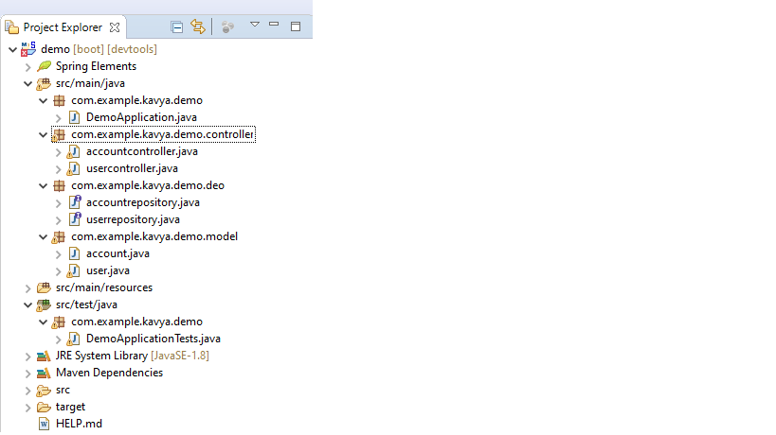

2.5 Testing

Test Case 1: Creating new Person Object
Open using Postman
- Set Request Type: POST
- Set URL: http://localhost:8080/table
- Set Request Header: Content-Type:application/json

Test Case 2: Retrieving the new Person Object
Open using Postman
1.Set Request Type: GET
2.Set URL: http://localhost:8080/table/{id}
3.Set Request Header: Content-Type:application/json

Test Case 3: Deleting a Person Object
Open using Postman
1.Set Request Type: DELETE
2.Set URL: http://localhost:8080/table/{id}
3.Set Request Header: Content-Type:application/json

2.6 Possible errors:
1. bad_request : when the request is not well structured.
2. Cannot determine embedded database driver class for database type NONE
when H2 dependency not added in pom.xml
3. H2 Console is not Launched up
Try enabling it in the application.properties
Set spring.h2.console.enabled=true
4. table not found.
table not cerated

