1. **Site Analysis Report: Ambey Valley Region, Maharashtra**
2. **Location and Topography**

* **Study Area**: 5km radius around coordinates 18°35'39.0"N 73°22'03.0"E
* **Elevation Range**: 53m - 1120m above sea level
* **Topographic Features**:
  + Distinct west-to-east elevation gradient
  + Prominent ridge line running southeast to northwest
  + Complex terrain with varied slopes and aspects

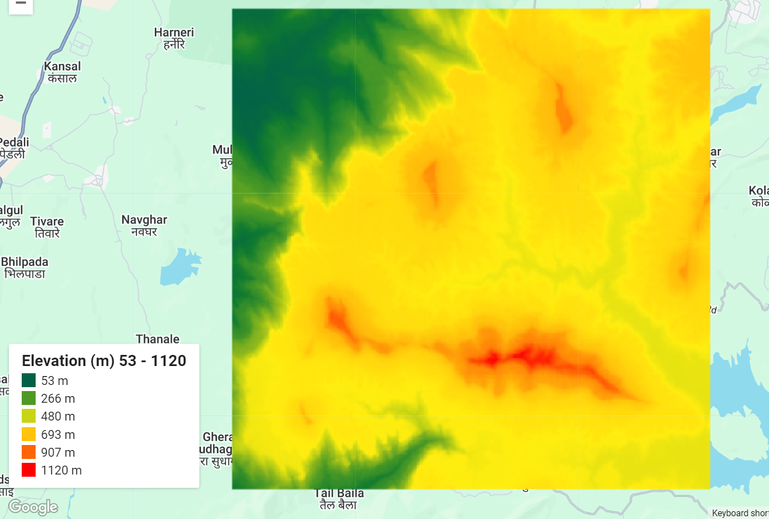

*Figure 1: Digital Elevation Model showing topographic variation across the study area*

1. **Land Cover Composition (2023)**

* **Forest Cover**: 4,427.13 ha (44.7%) - Dominant land cover type
* **Rangeland**: 4,322.51 ha (43.6%) - Second most prevalent
* **Water Bodies**: 496.24 ha (5.0%) - Significant water presence
* **Built Area**: 390.48 ha (3.9%) - Limited urban development
* **Agricultural Land**: 278.23 ha (2.8%) - Minor cropland presence

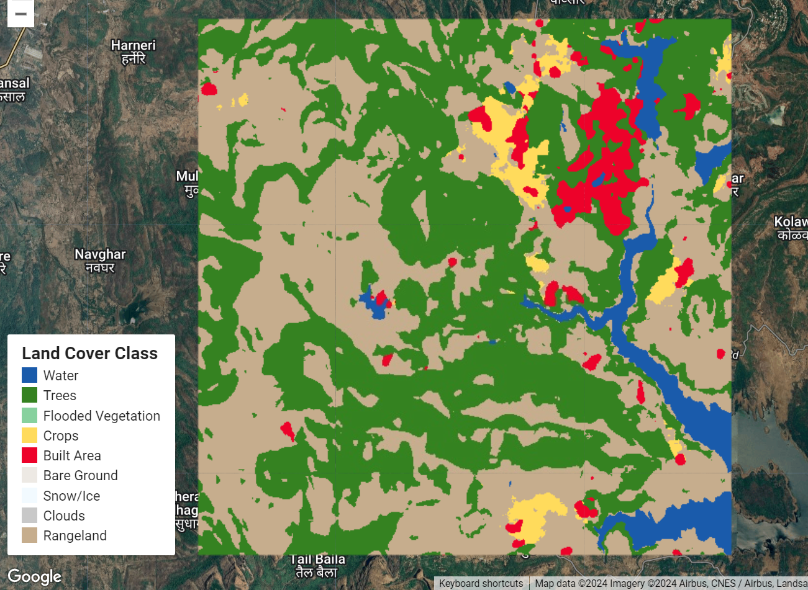

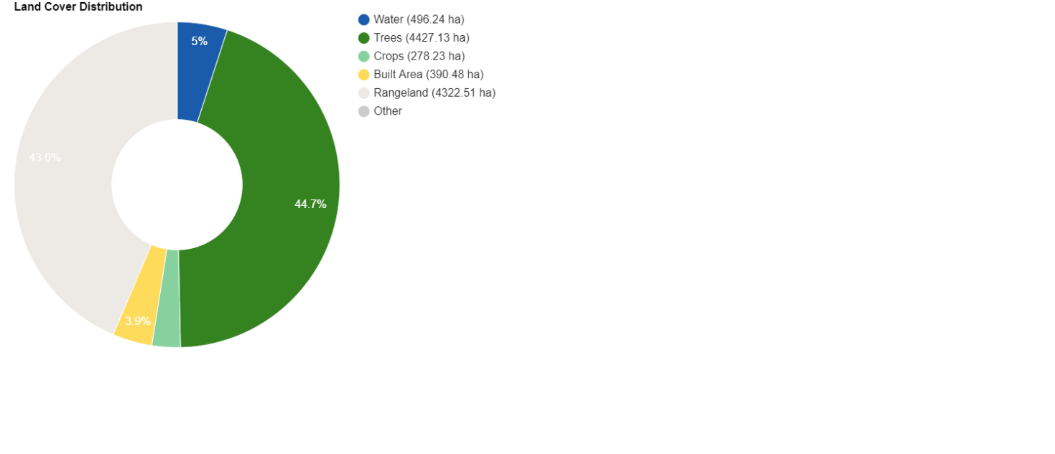

*Figure 2: Distribution of Land Cover Classes*

1. **Climate Characteristics**
2. **Precipitation (2023)**

* **Annual Total**: 1,686.66 mm
* **Pattern**: Monsoon-dominated rainfall regime
* **Distribution**: Concentrated in monsoon months

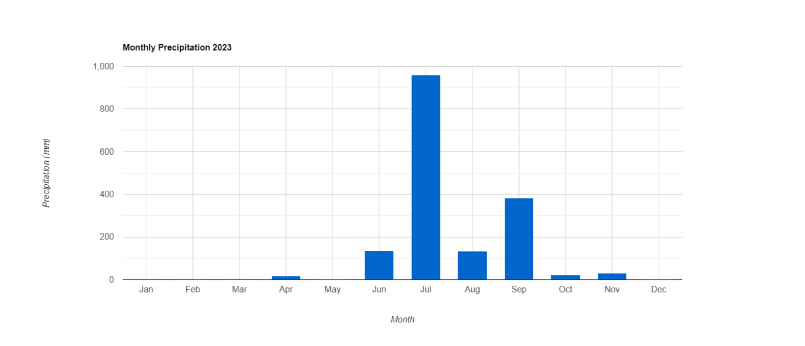

*Figure 4: Monthly Precipitation Pattern (2023)*

1. **Temperature**

* **Diurnal Variation**: Significant difference between day and night temperatures
* **Seasonal Pattern**:
  + Higher temperatures in pre-monsoon months
  + Moderated by elevation and vegetation cover
  + Cooler temperatures in higher elevation zones

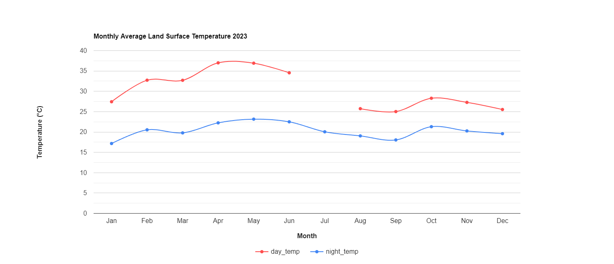

*Figure 5: Monthly Average Day and Night Temperature Variation (2023)*

1. **Environmental Significance**

* High forest cover indicates good ecological health
* Diverse elevation range supports varied ecosystems
* Substantial water resources present
* Limited urban footprint preserves natural character

1. **Development Considerations**

* **Opportunities**:
  + Rich natural resources
  + Existing water bodies
  + Diverse topography
  + Good vegetation cover
* **Constraints**:
  + Steep slopes in eastern section
  + Limited flat terrain
  + Need for ecological preservation

1. **Conclusion**

This site demonstrates characteristics typical of Western Ghats landscape, with significant ecological value and development potential that needs to be balanced with environmental conservation. The combination of varied topography, substantial forest cover, and adequate water resources makes it an environmentally significant area requiring careful management for any future development initiatives.

*Note: All data and analysis based on 2023 satellite observations and ground measurements.*