Stock Analysis Automation System

# 1. Data Collection Agent

- Integrated multiple datasets using HTTP Request nodes and Google Drive download links.  
- Sources used:  
 - Alpha Vantage (Stock prices, RSI, Volume, MACD)  
 - FRED (Interest rates, inflation, recession)  
 - Kaggle datasets (HR analytics, sentiment analysis,stock market data)  
- Used CSV Parse node after each data fetch to convert API/CSV responses into structured format.

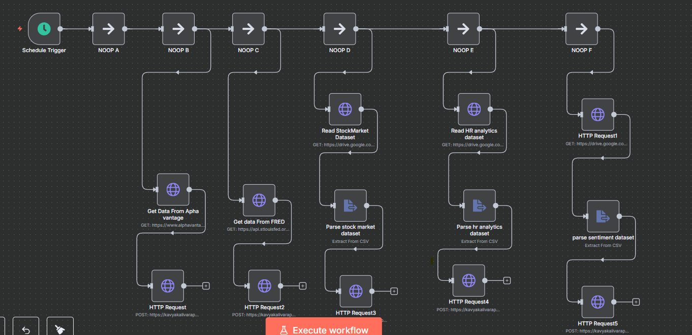  
  
Nodes used for this workflow are

Schedule trigger(trigger Node), No Operation nodes to separate the parsing of each data source. Two Http request nodes using API keys(Alpha Vantage and FRED). Three Http request Nodes for datasets(downloaded from Kaggle and stored in google drive).

# 2. Storage Agent

- Used Webhook to receive parsed results.  
- Connected to Google Sheets using 'Append Row' operation.  
- Field names created manually in Google Sheet (e.g., Date, RSI, MACD, Sentiment, Inflation).  
- HTTP Request nodes were used to send parsed data to webhook.

Nodes used in this storage agent workflow are : webhook to get the parsed data and google sheet node to add the parsed data.

# 3. Analysis Agent

- Created a new workflow triggered by webhook.  
- Added Agent AI node using OpenAI Chat Model.  
- Defined prompt to perform analysis on financial data.

**System message for analysis agent:**

You are a financial analyst AI assistant.

You will be given JSON data that contains economic indicators like date, RSI, inflation, job change scores, and sentiment scores.

Analyze the data and return:

- A short summary of the market trend

- If any indicators suggest a warning or alert

- A signal: “Buy”, “Sell”, or “Hold” based on the data

Keep the tone professional and concise.  
- Logic included basic analysis on RSI, inflation, volume, etc.

# 4. Alert Agent

- Integrated alert system using IF node based on analysis results.  
- Connected Twilio SMS API to send alerts.  
- Used verified Twilio number to send SMS.

**System message for alert agent:**  
You are a stock analysis assistant. Based on technical indicators like RSI, MACD, sentiment score, and price, generate a brief analysis and determine if an alert should be raised. Alert should be true if RSI > 70 or sentiment_score < -0.5.

Return a JSON with: analysis_summary, alert: true/false

# 5. Reporting Agent

- Used Google Sheets to log analysis results.  
- Added a path to reporting branch from IF Node (False condition) of alert.  
- Simplified reporting via sheets.

**System message for reporting agent:**

You are a financial analysis assistant. Based on the parsed stock market data provided to you:

1. Generate a concise daily market summary, including key stock movements or index changes.

2. Include a brief portfolio performance analysis based on any relevant price or trend data.

3. Identify any observable market trends and offer short-term predictions if possible.

Ensure the output is simple, readable, and suitable for sharing in a daily report.

Figure: Workflow of Analysis, Alert and Reporting agents.

# 6. Chatbot Integration (Minimum Viable)

- Used a Webhook node to simulate chatbot interaction.  
- Allowed user to send commands like 'analyze', 'report', 'alert'.  
- Used Switch node to route user inputs to respective workflows.

# 7. Technical Stack

- Platform: n8n.io (cloud)  
- Data Sources: Alpha Vantage, FRED, Kaggle, Google Drive  
- Storage: Google Sheets  
- Analysis: OpenAI via Agent AI node  
- Alerts: Twilio SMS API  
- Reporting: Google Sheets  
- Communication: Webhook + Chat-based simulation