1. General QandA chatbot. 2. Parts Specific Chatbot.

1. Streamlit run Task1_app.py
2. Streamlit run Task3_main.py

ChatBot Project Structure.

Github Repo https://github.com/kavyaktj1/bmw-tasks-solution

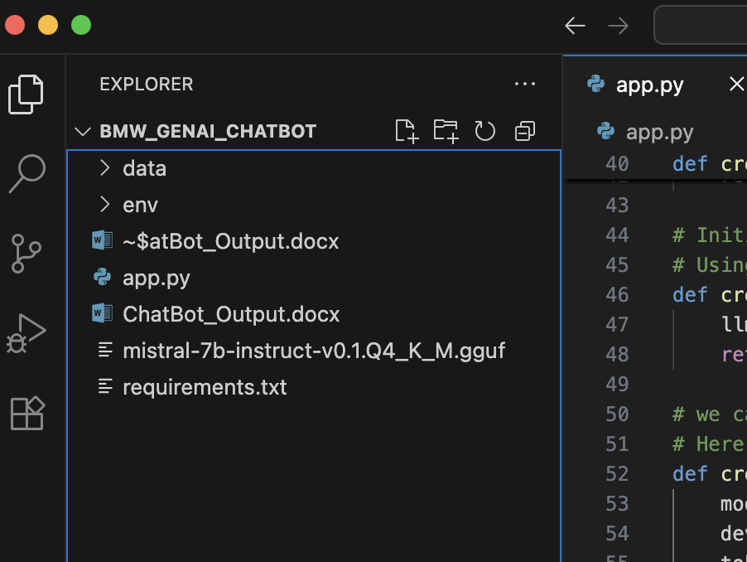

Successful Run.

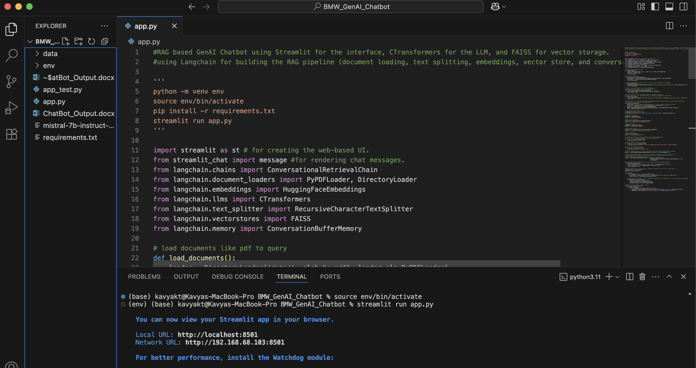

Output

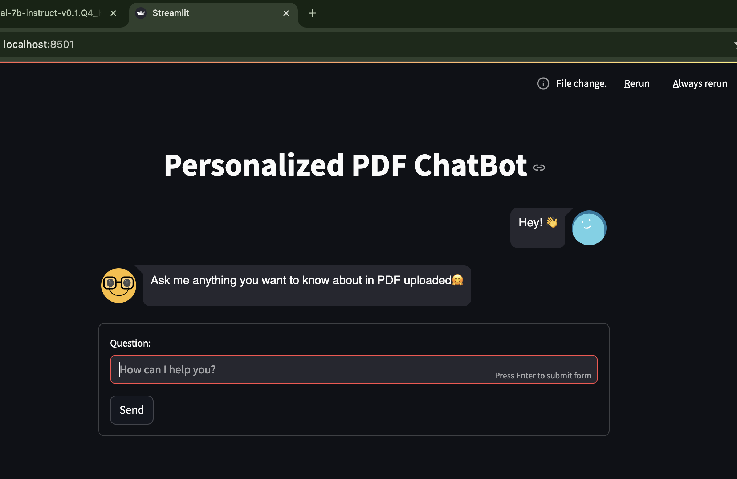

Response after asking Question.

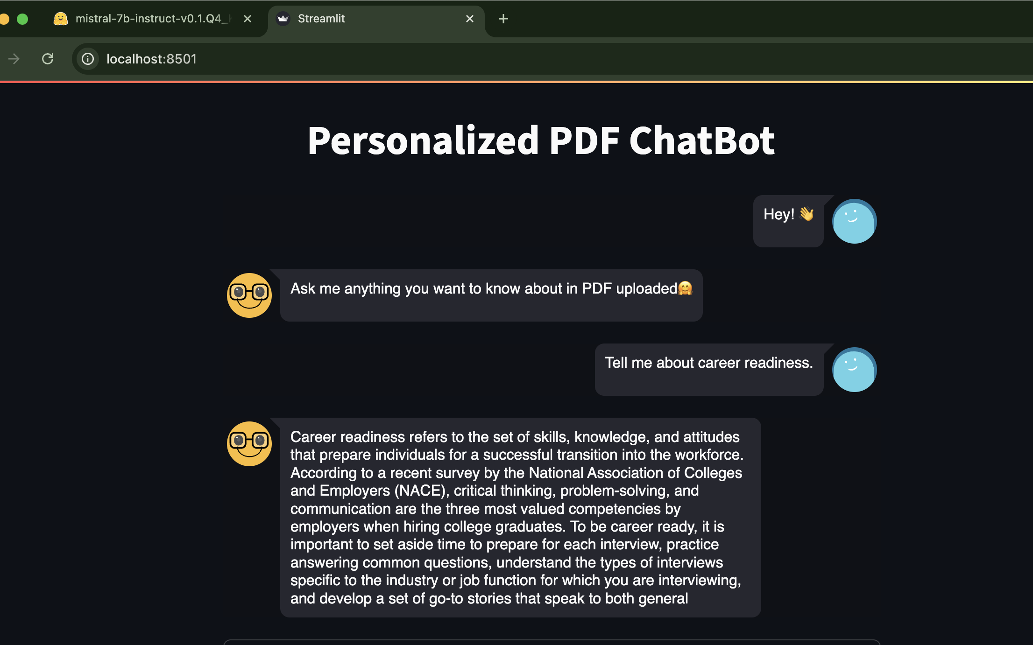

Task3 = Parts.csv Specific Chatbot.

