LETS UPGRADE

AWS ESSENTIALS –BATCH 1

NAME: K KAVYA

EMAIL : [kavya.kguru@gmail.com](mailto:kavya.kguru@gmail.com)

PROJECT 1:

DEPLOYING A WEB SERVER IN WINDOWS INSTANCE

Task 1:Create a windows instance using AMI :Windows 2012 R2 base

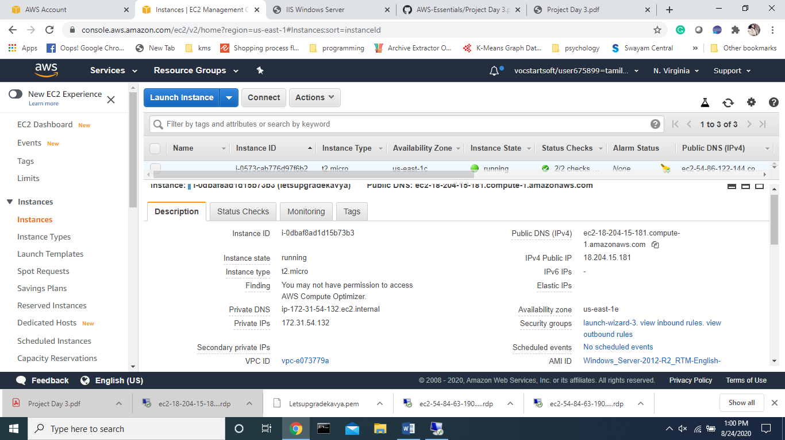

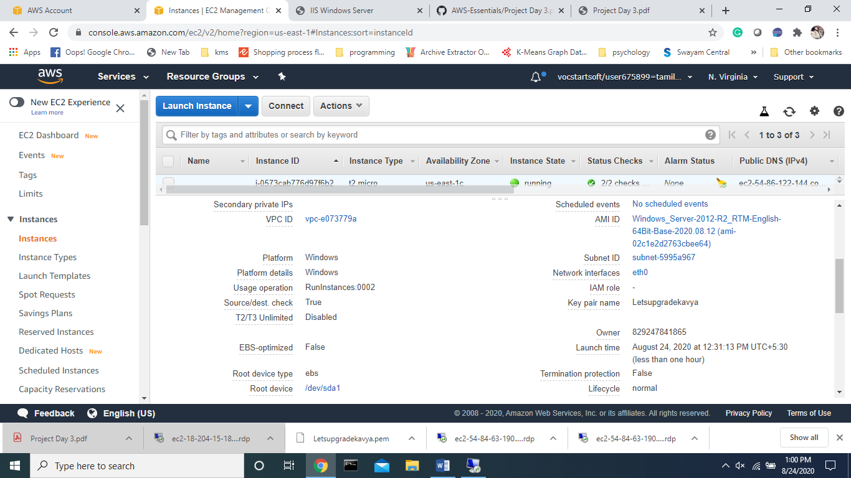

Task 2:Launch the Windows instance using RDP

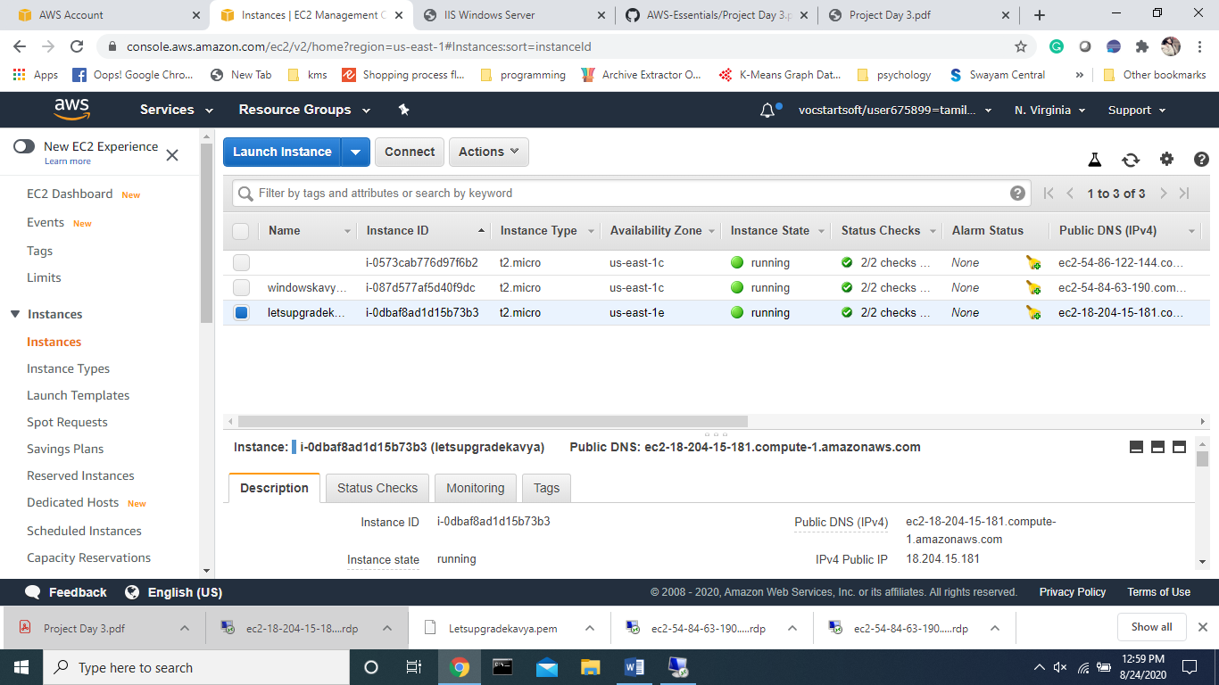

Task 3:Install IIS web server using Powershell ISE Note:Simply copy the command below and paste in the powershell ISE to install the IIS web server. !!!!Powershell is case sensitive. Install-WindowsFeature -name Web-Server -IncludeManagementTools

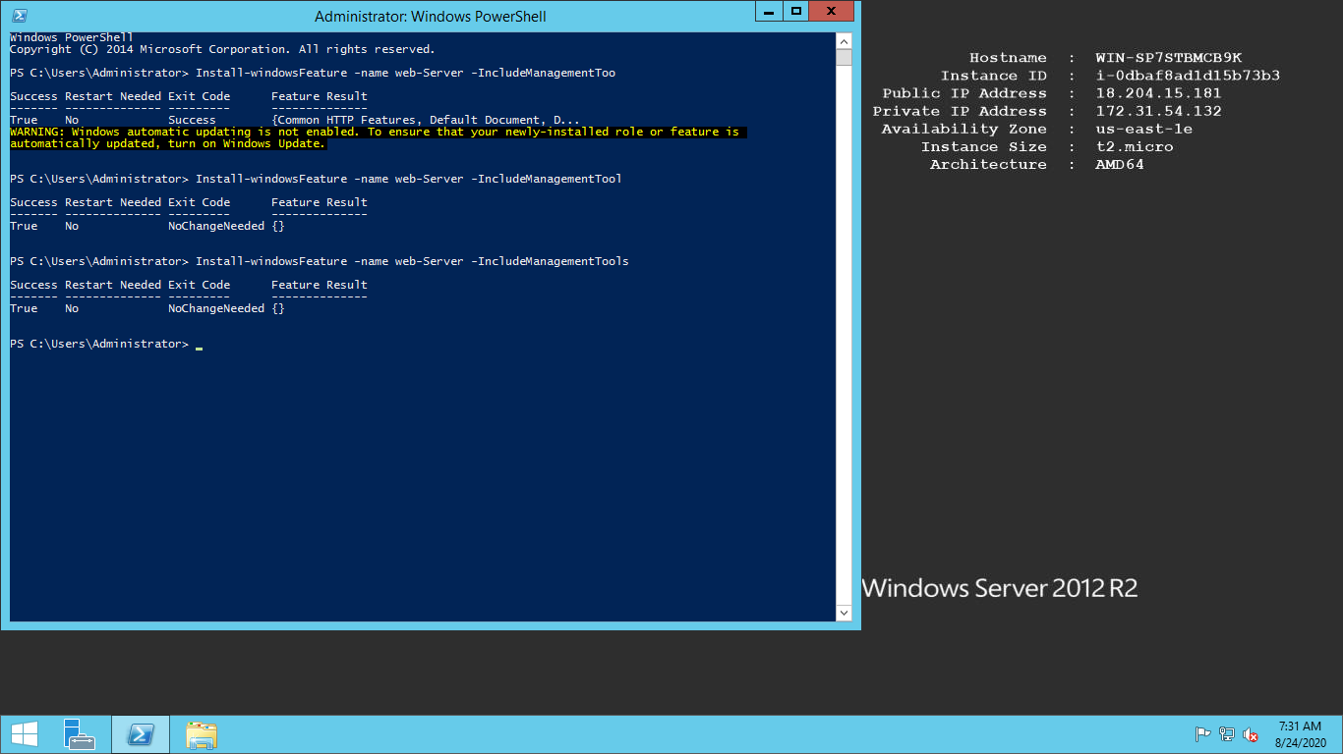

Task 4:Verify successful installation of IIS Web Server

Note :You should be able to see the Internet Information Services Web page when you paste the public IP into the browser.

Ip : <http://18.204.15.181/>

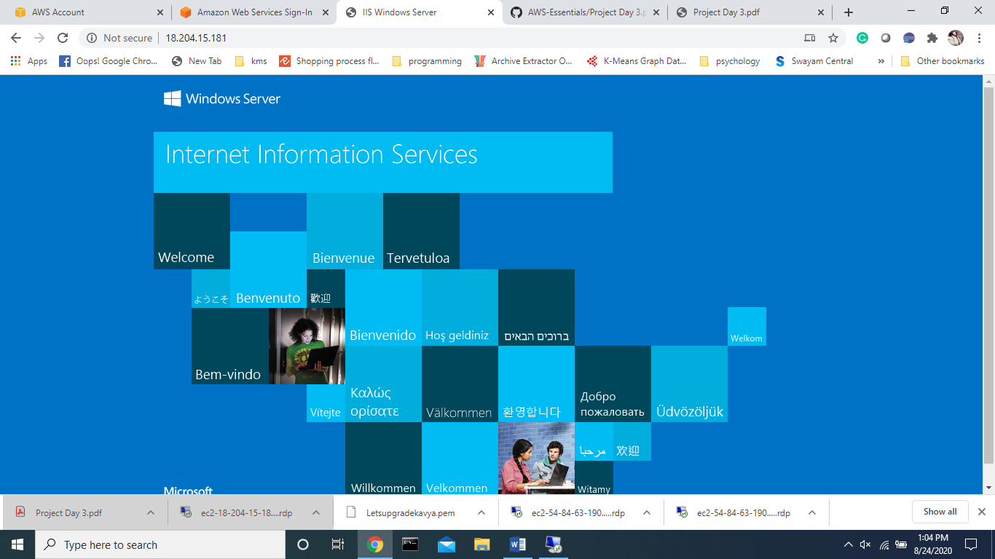

Optional: In lnux machine

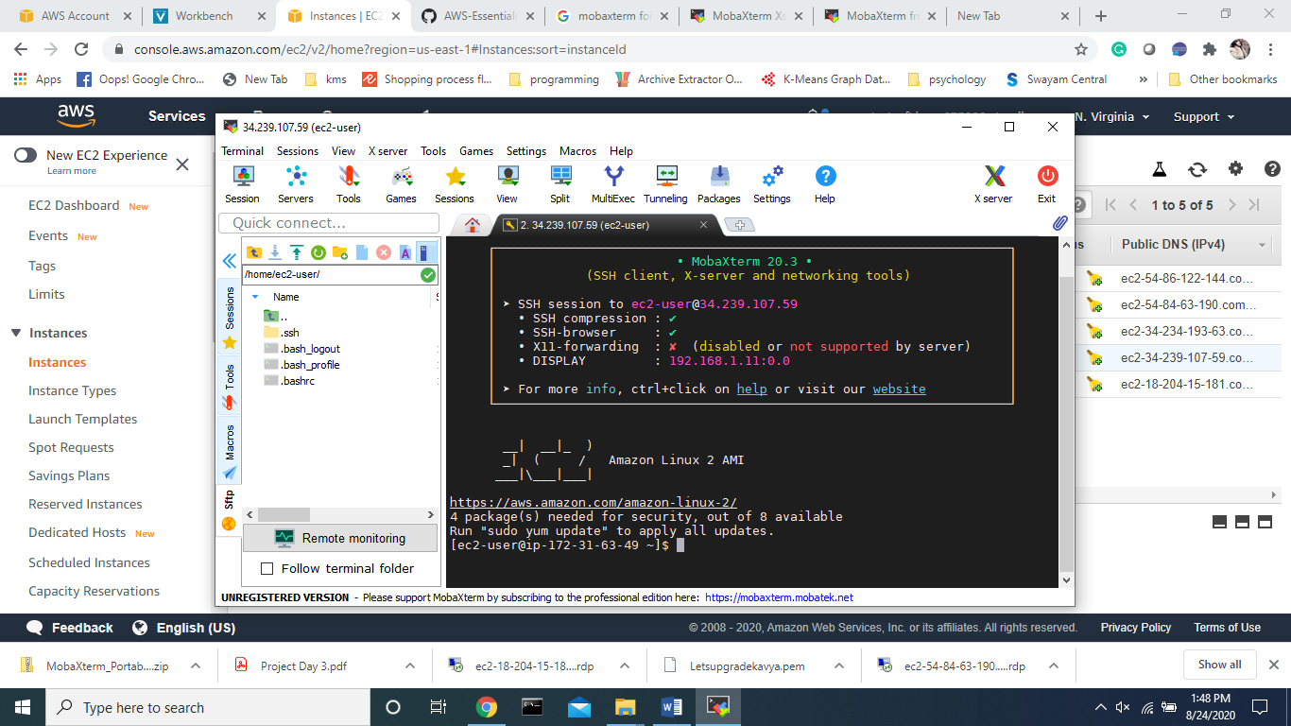

PROJECT 2: Deploying a web server in Windows instance

Task 1:Create a windows instance using AMI :Ubuntu Server 18.04 LTS (HVM)

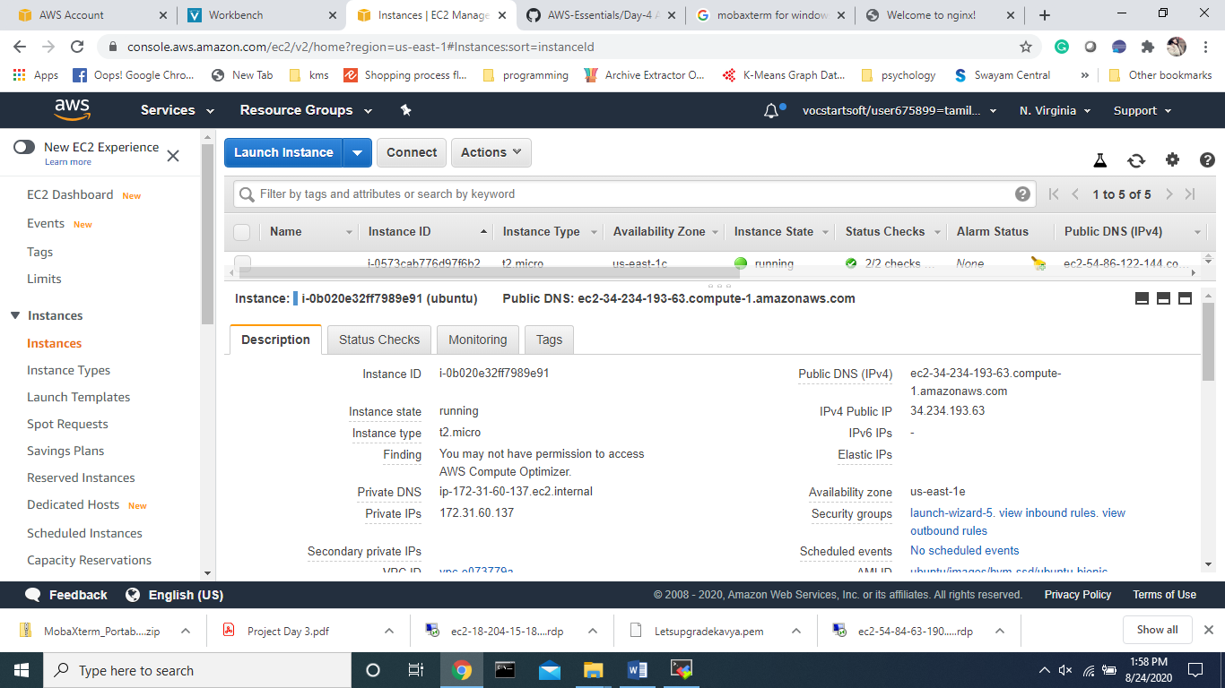

Task 2:Download and install MobaXterm Portable Edition

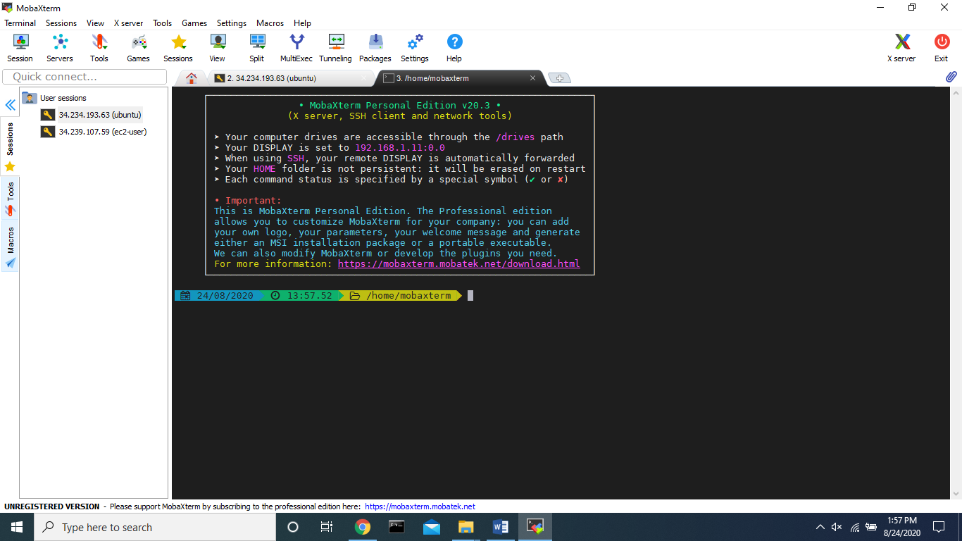

Task 2:Launch the Ubuntu instance using SSH Note:Username is ubuntu

Task 3:Install ngnix web server using bash Note:Simply copy the command below and paste in the bash to install the ngnix web server. sudo apt-get -y update sudo apt-get -y install nginx

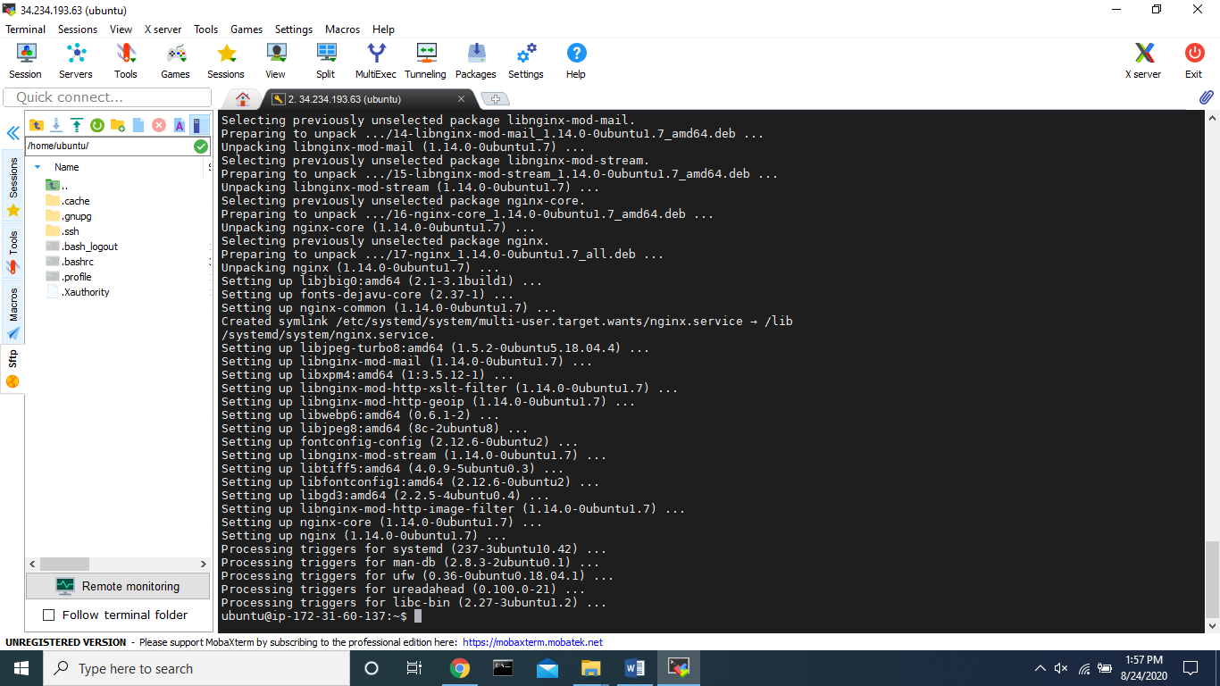

Task 4:Verify successful installation of ngnix

Note :You should be able to see the Welcome to ngnix Web page when you paste the public IP into the browser.

Ip4 : <http://34.234.193.63/>

