Title : Implement and Manage Zero Trust Network Access (ZTNA) using Zscaler

Group details

Name: M. Kavya
P. R. Rajana
M. J. Prabhakaran
K. S .Dharaneesh
S. Irfan Ahamed
College Name : Shri Nehru Maha Vidyalaya College of Arts and Science
Contact : kavyamahalaxmi2006@gmail.com
rajanaammuzzz@gmail.com
mjprabhakaran8406@gmail.com
dharaneesh005s@gmail.com
Irfanirfanahamed77@gmail.com
Project Details:
Title: Implement and Manage Zero Trust Network Access (ZTNA) using Zscaler

Introduction:
AI-Enhanced User Protection (AIUP) is a next-generation security framework that leverages artificial intelligence and machine learning to verify user identities and protect online platforms from cyber threats. Unlike traditional security measures that rely on static credentials like passwords or even two-factor authentication (2FA), AIUP continuously analyzes user behavior to create a dynamic, evolving "trust score" for each individual. AIUP is essential for modern online security because it addresses the limitations of perimeter-based defenses. As cyber threats become more sophisticated—with attackers using stolen credentials, phishing, and social engineering—relying solely on "what you know" (passwords) or "what you have" (tokens) is no longer sufficient. AIUP adds a third, continuous layer: "who you are" based on how you behave. This system helps organizations prevent account takeovers, reduce fraud, and ensure that the person interacting with a platform is genuinely who they claim to be, throughout their entire session.

Abstract:
The limitations of legacy VPN architectures in addressing modern security threats, particularly lateral movement and over-privileged network access, necessitate a paradigm shift towards Zero Trust principles. This project details the comprehensive design, deployment, and management of a Zero Trust Network Access (ZTNA) solution leveraging Zscaler Private Access (ZPA) within a largescale institutional network. The project aims to replace broad network-level access with application-specific, identity-driven connectivity. By deploying Zscaler App Connectors within the data center and integrating the platform with existing Identity Providers (Azure AD) and endpoint security tools, the architecture ensures that all user-to-application connections are established through a cloud-native broker. This approach renders internal applications "invisible" to the internet, eliminating the attack surface. Furthermore, the project explores the integration of Zscaler with security ecosystems, including SIEM platforms (like QRadar) for centralized logging and MISP for consuming threat intelligence to enable adaptive access policies. The result is a robust, scalable security framework that enforces least-privilege access, provides comprehensive audit trails, and significantly enhances the institution's resilience

Use Case Scenarios:
Scenario 1: Secure Remote Access for Faculty to ERP System
A faculty member working from home needs to access the university's ERP system to upload student grades. Using Zscaler Private Access (ZPA), they connect securely without being placed on the internal network. The system verifies their identity via Azure AD MFA and checks their device posture before granting access.
Output:
• User identity verified (Faculty Group)
• Device posture compliant (AV active, OS up-to-date)
• Secure micro-tunnel established to ERP Application only
• Network remains completely invisible to the user
Scenario 2: External Researcher Accessing a Specific Database
An external research collaborator from another institution requires temporary access to a single research database hosted on VIT's servers. The administrator creates a time-limited, application-specific policy in Zscaler. The researcher accesses only the authorized database without any visibility into the rest of the VIT network.
Output:
• External user identity verified via temporary credentials
• Access policy enforced (Time-limited: 7 days, Application: Research-DB only)
• Database server remains hidden from internet scanners
• Session automatically terminates after policy expiry
Scenario 3: Student Access to Online Examination Portal
During final exams, thousands of students simultaneously access the internal online examination portal from various locations. Zscaler ZPA ensures that only authenticated students with compliant devices can reach the exam server. The system prevents DDoS attacks on the login page and blocks any attempts to access other internal resources.
Output:
• Mass user authentication handled via cloud scalability • Each student connected only to the exam application
• Lateral movement to grade database or other servers blocked
• Exam server IP address remains concealed from the internet
Scenario 4: IT Administrator Performing Server Maintenance
An IT administrator needs to perform critical updates on an internal application server. Instead of connecting via VPN and gaining full network access, they use ZPA to connect directly to the specific server's management interface. The session is monitored in real-time, and any anomalous behavior (e.g., accessing unauthorized servers) is automatically terminated.
Output:
• Admin identity verified with MFA
• Direct micro-tunnel to Server-Management-Interface only
• All admin keystrokes and commands logged for audit
• Attempt to access another server automatically blocked

Scenario 5: Mergers and Acquisitions – Temporary Contractor Access
A contractor hired during a university system upgrade needs temporary access to a specific file server to migrate data. Using Zscaler ZPA, the contractor is granted application-specific access without being added to the university's Active Directory or given VPN credentials. The access is revoked automatically after the project timeline.
Output:
• Contractor identity verified via separate IdP integration
• Access granted to File-Server-Migration share only
• All file transfer activities logged in Zscaler and SIEM
• Access automatically revoked after 30-day project end date

STAGE – 1
Title : Zero Trust Network Access (ZTNA) with Zscaler: Securing User-to-Application Connectivity.
OVERVIEW :
The project aims to develop an AI-driven identity verification system that enhances online security by analysing and verifying user identities based on their online behaviour patterns. This system uses advanced machine learning techniques to create a robust user profile, distinguishing between legitimate users and suspicious activities. It addresses the pressing issue of unauthorised access, fraudulent transactions, and cyber threats across various online platforms and services. The primary objective is to enhance online security significantly by scrutinising and validating user identities through their online behaviour. The system employs advanced machine learning techniques such as deep learning, neural networks, and natural language processing to establish comprehensive behavioural profiles for each user, which adapt and evolve with the user's behaviour over time. Real-time anomaly detection is a key feature of the system, identifying deviations from established user behaviour profiles and responding promptly to mitigate potential security threats. Multi-factor verification is also implemented to bolster security, triggering additional verification steps when anomalies are detected. User and administrator alerts ensure transparent communication and provide guidance on resolving potential security issues. Secure data storage and management components are included to protect sensitive user profiles and anomaly data. The system includes an integration layer for seamless interaction with various online platforms and services. Monitoring and reporting are integrated for performance and security, providing transparency and accountability. Scalability and load balancing are designed to handle growing user bases, while security and compliance are prioritised by encrypting data in transit and at rest, employing firewalls, intrusion detection systems, and adhering to data protection and privacy regulations. Cloud infrastructure is an optional option for flexibility and scalability. Continuous training and optimization of machine learning models ensure the system remains effective against evolving threats and user behaviours. Geographic distribution can enhance redundancy and performance by deploying components in multiple geographic regions. Multi-factor verification is also implemented to bolster security, triggering additional verification steps when anomalies are detected. User and administrator alerts ensure transparent communication and provide guidance on resolving potential security issues. Secure data storage and management components are included to protect sensitive user profiles and anomaly data. The system includes an integration layer for seamless interaction with various online platforms and services. Monitoring and reporting are integrated for performance and security, providing transparency and accountability. Scalability and load balancing are designed to handle growing user bases, while security and compliance are prioritised by encrypting data in transit and at rest, employing firewalls, intrusion detection systems, and adhering to data protection and privacy regulations. Cloud infrastructure is an optional option for flexibility and scalability. Continuous training and
optimization of ensures learning models ensure the system remains effective against evolving threats and user behaviors. Geographic distribution can enhance redundancy and performance by deploying components in multiple geographic

List of Vulnerability Table:

Practice Website:

S.NO | VULNERABILITY’S NAME | CWE/CVE no.
1 | Improper Sanitization of File Paths | CWE- 284: Improper Access Control
2 | Invalid Certificate | CWE-395: Improper Certificate Validation
3 | Missing X-frame Options Header | CWE-1021: Design Improper Restriction of Rendered UI Layers or frames
4 | X- Content-Type options Header Missing | CWE -918: Server-Side Request Forgery (SSRF)
5 | Drupal Ajax API Shows JSONP not disabled by default | CWE-937,1035: OWASP Top Ten 2013,2017 Category A9 - Using Components with Known Vulnerabilities

6 | Drupal Api Vulnerability | CWE-20: Improper Input Validation
7 | Improper API Filtration | CWE-79: Improper Neutralisation of Input During Web Page Generation ('Cross-site Scripting')
8 | Denial of Service | CWE -400: Uncontrolled Resource Consumption
9 | TLS Version 1.0 Protocol Detection | CWE-327: Use of a Broken or Risky Cryptographic Algorithm
10 | web.config File Information Disclosure | CWE-497: Exposure of Sensitive System Information to an Unauthorised Control Sphere

REPORT:
- Vulnerability name: Improper Sanitization of File Paths
CWE/CVE number: Improper Access Control
OWASP category: A01:2021-Broken Access Control
Description: The product does not restrict or incorrectly restricts access to a resource from an unauthorized actor.
Business Impact: This vulnerability is significant, as it can lead to unauthorized access to sensitive data or files, potentially causing data breaches, privacy violations, and loss of user trust. Affected sites may also require configuration changes after applying a security release.
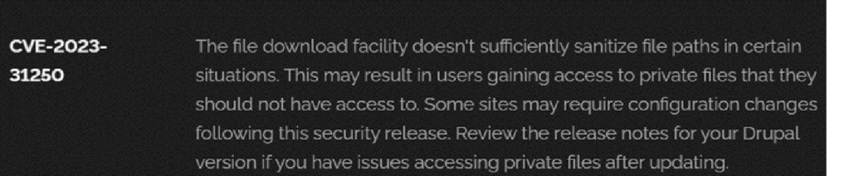

- Vulnerability Name: Invalid Certificate
CWE-395: Improper Certificate Validation
OWASP Category: A07:2021 – Identification and Authentication Failures
Description: When a certificate is invalid or malicious, it might allow an attacker to spoof a trusted entity by interfering in the communication path between the host and client. The product might connect to a malicious host while believing it is a trusted host, or the product might be deceived into accepting spoofed data that appears to originate from a trusted host.

Business Impact: Improper certificate validation can lead to a range of security threats which includes Man-in-the-middle attacks(Attackers can intercept communication between two parties and read or modify the data exchanged between them),Data breaches:(Attackers can gain unauthorized access to sensitive information or sensitive systems, leading to data breaches),Malware distribution(Attackers can use fake digital certificates to distribute malicious software or infect systems with malware)

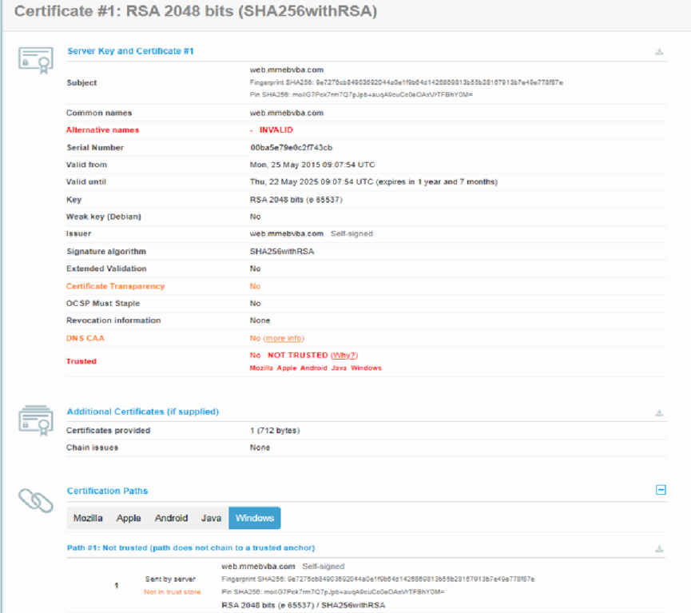

- Vulnerability Name: Missing X-Frame-Options Header
CWE-1021: Design Improper Restriction of Rendered UI Layers or Frames
OWASP Category: A04:2021-Insecure Design

Description: A web application is expected to place restrictions on whether it is allowed to be rendered within frames, iframes, objects, embed or applet elements. Without the restrictions, users can be tricked into interacting with the application when they were not intending to.

Business Impact: This enables path to the attackers to manipulate or gain unauthorized access to user interface elements, potentially leading to deceptive or malicious user interactions. This can result in data leakage, fraud, user distrust, and reputational damage, undermining the integrity and trustworthiness of the application and causing financial losses.

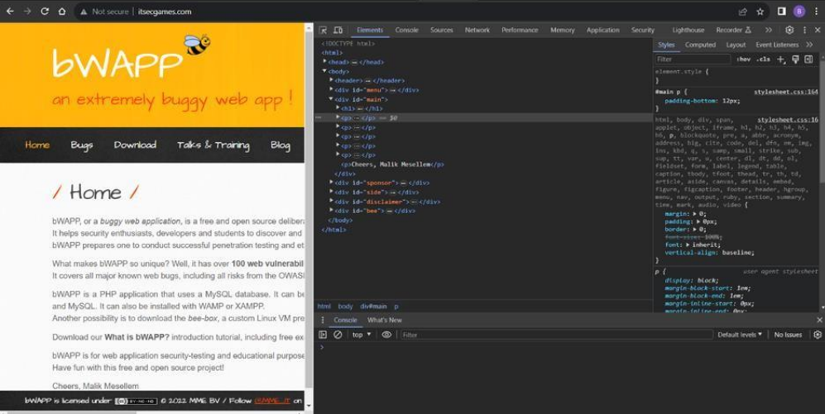
- Vulnerability Name: X-Content-Type Options Header Missing

CWE -918: Server-Side Request Forgery (SSRF)

OWASP Category: A10:2021 – Server-Side Request Forgery (SSRF)

Description: The web server receives a URL or similar request from an upstream component and retrieves the contents of this URL, but it does not sufficiently ensure that the request is being sent to the expected destination.

Business Impact: The header missing impact Data Exposure(Attackers might force the server to render sensitive data as HTML, leading to data exposure),Security Risks(Content type manipulation can increase security risks, potentially leading to breaches, data leaks, and unauthorized access), Brand and Reputation Damage(Successful attacks that exploit SSRF vulnerabilities can harm the organization's reputation and trustworthiness)

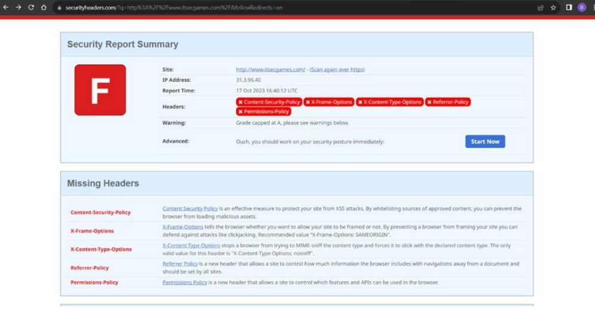
- Vulnerability Name: Drupal Ajax API shows JSONP not disabled by default

CWE-937,1035: OWASP Top Ten 2013,2017 Category A9 - Using Components with Known Vulnerabilities

OWASP Category: A06:2021-Vulnerable and Outdated Components

Description: Vulnerable and outdated components refer to using software libraries, modules, or dependencies within a web application that have known security issues or are not updated to the latest secure versions. This can include plugins, frameworks, or APIs that are no longer maintained or have publicly documented vulnerabilities.

Business Impact: The presence of vulnerable and outdated components in a web application poses significant security risks. Attackers can exploit these weaknesses to gain unauthorized access, inject malicious code, steal sensitive data, or disrupt the system's operation. The potential business impacts include compromised user data, damaged reputation, legal consequences, and financial losses due to breach recovery and remediation efforts.

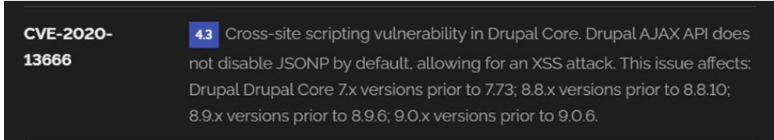

- Vulnerability Name: Drupal Api Vulnerability

CWE-20: Improper Input Validation

OWASP Category: A03:2021 – Injection

Description: The product receives input or data, but it does not validate or incorrectly validates that the input has the properties that are required to process the data safely and correctly.

Business Impact: The impact of a successful SQL injection attack can be devastating for businesses. It can result in unauthorized access to sensitive information, data theft, financial losses, damage to reputation, and legal consequences. Depending on the nature of the application and data involved, SQL injection can lead to compliance violations, customer trust erosion, and operational disruption.
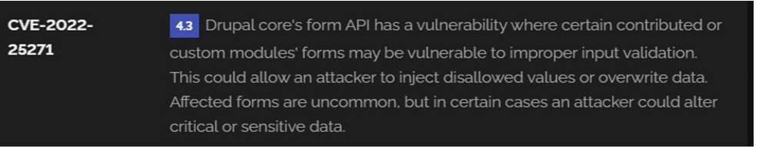
- Vulnerability Name: Improper API Filtration

CWE-79: Improper Neutralization of Input During Web Page Generation ('Cross-site Scripting')

OWASP Category: A07-2017: Cross-site Scripting (XSS)

Description: The product does not neutralize or incorrectly neutralizes user-controllable input before it is placed in output that is used as a web page that is served to other users.

Business Impact: If exploited, this vulnerability allows attackers to inject malicious scripts into web pages, which can be viewed by other users. The potential business impacts include data theft, unauthorized access, compromised user accounts, damaged reputation, and financial losses. Attackers can use XSS to steal sensitive information, such as user credentials, personal data, or financial details, leading to regulatory compliance violations and legal liabilities. Additionally, defacement or manipulation of website content can erode customer trust and result in lost revenue.

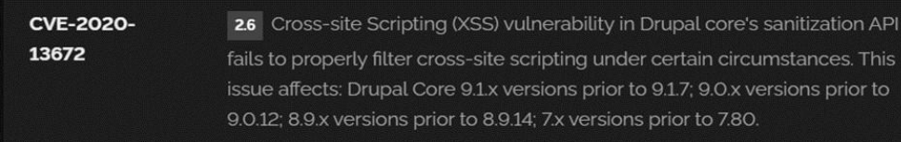
- )Vulnerability Name: Denial of Service

CWE -400: Uncontrolled Resource Consumption

OWASP Category:
Description: The Denial of Service (DoS) attack is focused on making a resource (site, application, server) unavailable for the purpose it was designed. There are many ways to make a service unavailable for legitimate users by manipulating network packets, programming, logical, or resources handling vulnerabilities, among others. If a service receives a very large number of requests, it may cease to be available to legitimate users.
In the same way, a service may stop if a programming vulnerability is exploited, or the way the service handles resources it uses. Sometimes the attacker can inject and execute arbitrary code while performing a DoS attack in order to access critical information or execute commands on the server. Denial-of-service attacks significantly degrade the service quality experienced by legitimate users. These attacks introduce large response delays, excessive losses, and service interruptions, resulting in direct impact on availability.

Business Impact: If successfully exploited, it involves overwhelming a system or application with excessive demands on its resources. This can lead to a range of disruptive consequences. The targeted system may experience significant slowdowns, or even complete unresponsiveness, making it difficult or impossible for legitimate users to access. Critical resources like CPU, memory, and network bandwidth can become depleted, causing further degradation in performance. In severe cases, the exploited vulnerability may lead to system crashes or failures, potentially resulting in data loss. This disruption not only impacts business productivity and financial stability but also risks reputational damage, eroding customer trust and confidence. Additionally, organizations may face regulatory compliance issues if the uncontrolled resource consumption leads to violations of service level agreements or industry standards. Mitigating this vulnerability requires proactive resource management practices and a well-prepared incident response plan to minimize the potential impacts on business operations and customer satisfaction.

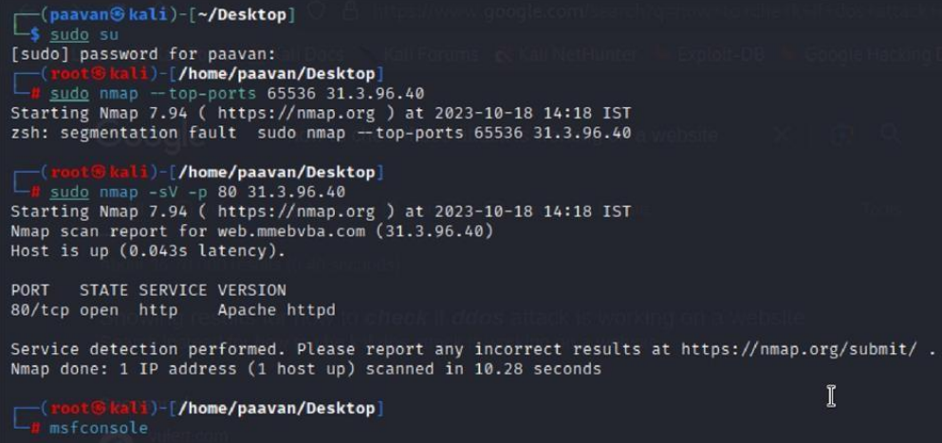
- Vulnerability Name: TLS Version 1.0 Protocol Detection

CWE-327: Use of a Broken or Risky Cryptographic Algorithm

OWASP Category: A02:2021-Cryptographic Failures

Description: The product uses a broken or risky cryptographic algorithm or protocol.

Business Impact: TLS 1.0 is an outdated and vulnerable encryption protocol, and its use can expose sensitive data to potential security threats. This not only jeopardizes the integrity of customer information and payment details but also tarnishes the company's reputation. The business may face legal consequences, loss of customer trust, and decreased revenue as security conscious users avoid the site due to its security vulnerabilities. Immediate action is necessary to upgrade to a more secure TLS version to safeguard data, ensure compliance, and maintain customer confidence.

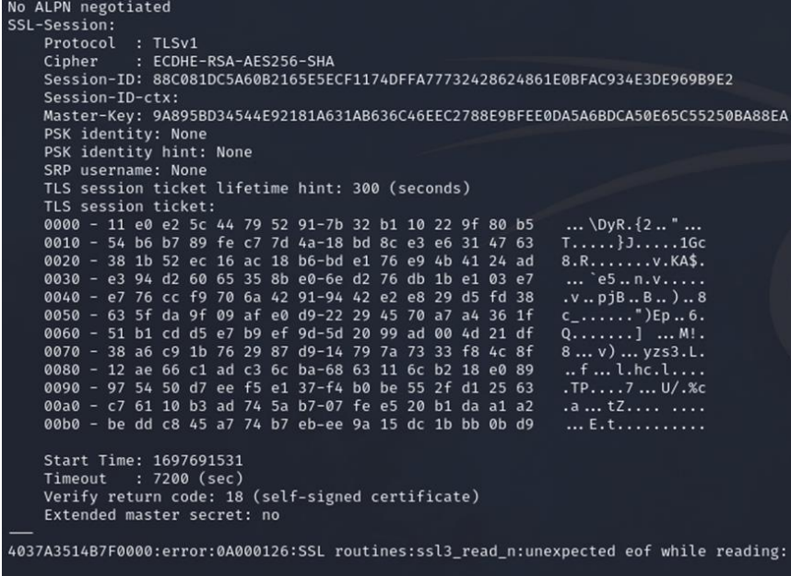
- Vulnerability Name: web.config File Information Disclosure

CWE-497: Exposure of Sensitive System Information to an Unauthorized Control Sphere

OWASP Category: A3:2017-Sensitive Data Exposure

Description: An information disclosure vulnerability exists in the remote web server due to the disclosure of the web.config file. An unauthenticated, remote attacker can exploit this, via a simple GET request, to disclose potentially sensitive configuration information.

Business Impact: It exposes sensitive configuration details, including database connection strings and encryption keys, to potential attackers. This could lead to unauthorized access, data breaches, and system compromise. The impact includes financial losses, damage to reputation, and legal liabilities as the organization's security and customer trust are compromised.

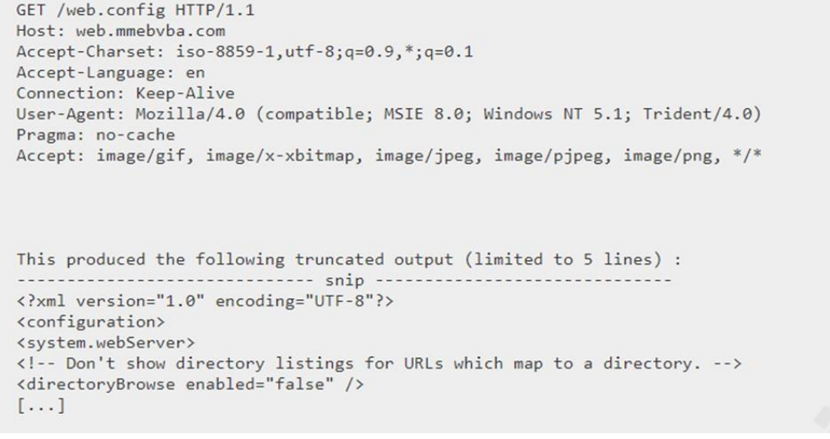

STAGE: 2
TITLE : Implement and Manage Zero Trust Network Access (ZTNA) using Zscaler
Overview:
Nessus is a vulnerability scanner developed by Tenable, Inc. It is a remote scanner, meaning that it does not need to be installed on the target host to scan it. Nessus works by sending a variety of probes to the target host in order to identify vulnerabilities. These probes can include network traffic, operating system commands, and application requests. Nessus uses a plugin-based architecture. Plugins are small pieces of code that are designed to identify specific vulnerabilities. There are over 1200 plugins available for Nessus, covering a wide range of vulnerabilities in operating systems, applications, and network devices. When Nessus scans a host, it first uses a discovery plugin to identify the operating system and services running on the host. Once the host has been discovered, Nessus runs a series of plugins to test for vulnerabilities. For each vulnerability that Nessus finds, it provides a detailed report that includes the severity of the vulnerability, the steps to reproduce the vulnerability, and the steps to remediate the vulnerability. Nessus can be used to scan a variety of targets, including single hosts, networks, and web applications. It can also be used to scan specific ports and services. Nessus can be configured to run scans on a schedule or manually.

List of Vulnerability:

S.NO | VULNERABILITY’S NAME | Severity | plugins
1 | TLS Version 1.0 Protocol Detection | MEDIUM | 104743
2 | TLS Version 1.1 Protocol Deprecated | MEDIUM | 157288
3 | SSL/TLS Diffie-Hellman Modulus <= 1024 Bits (Logjam) | INFO | 833875
4 | ICMP Timestamp Request Remote Date Disclosure | INFO | 10114
5 | Additional DNS Hostnames | INFO | 46180
6 | Apache Tomcat Detection | INFO | 39446
7 | Common Platform Enumeration (CPE) | INFO | 45590
8 | Device Type | INFO | 54615
9 | HSTS Missing From HTTPS Server | INFO | 84502
10 | HTTP Server Type and Version | INFO | 10107

Report:
- Vulnerability Name: - 104743 - TLS Version 1.0
Protocol Detection Severity: - MEDIUM
Plugin: - 104743
Port: - 443
Description: - The remote service accepts connections encrypted using TLS 1.0. TLS 1.0 has a number of cryptographic design flaws. Modern implementations of TLS 1.0 mitigate these problems, but newer versions of TLS like 1.2 and 1.3 are designed against these flaws and should be used whenever possible. As of March 31, 2020, Endpoints that aren’t enabled for TLS 1.2 and higher will no longer function properly with major web browsers and major vendors. PCI DSS v3.2 requires that TLS 1.0 be disabled entirely by June 30, 2018, except for POS POI terminals (and the SSL/TLS termination points to which they connect) that can be verified as not being susceptible to any known exploits.
Solution: - Enable support for TLS 1.2 and 1.3, and disable support for TLS 1.0.
Business Impact: -Continued use of TLS 1.0's encryption, known for its inherent cryptographic flaws, exposes the organization to heightened security risks, increasing the likelihood of data breaches and cyberattacks. This vulnerability jeopardizes compliance with industry standards, specifically PCI DSS v3.2, which mandates the complete cessation of TLS 1.0 use. Noncompliance risks regulatory penalties and erodes customer trust. Moreover, endpoints that lack support for TLS 1.2 and higher will experience impaired functionality with major web browsers and vendors, potentially leading to lost business opportunities and damage to the organization's reputation. Addressing this vulnerability is imperative to mitigate these multifaceted risks and maintain a secure and trustworthy online presence.
- Vulnerability Name: - 157288 - TLS Version 1.1 Protocol Deprecated

Severity: - MEDIUM

Plugin: - 157288

Port: - 443

Description: - The remote service accepts connections encrypted using TLS 1.1. TLS 1.1 lacks support for current and recommended cipher suites. Ciphers that support encryption before MAC computation, and authenticated encryption modes such as GCM cannot be used with TLS 1.1 As of March 31, 2020, Endpoints that are not enabled for TLS 1.2 and higher will no longer function properly with major web browsers and major vendors.

Solution: - Enable support for TLS 1.2 and/or 1.3, and disable support for TLS 1.1.
Business Impact: -The continued use of TLS 1.1 with its lack of support for modern cipher suites and advanced encryption methods jeopardizes the organization's security posture, increasing vulnerability to cyber threats and potential data breaches. Additionally, endpoints not upgraded to support TLS 1.2 and higher will encounter compatibility issues with major web browsers and vendors, impacting user experience and potentially leading to missed business opportunities. Swift remediation of this vulnerability is essential to mitigate security risks and ensure seamless interactions with web browsers and vendors, preserving the organization's reputation and operational efficiency.

- Vulnerability Name: - 83875 - SSL/TLS Diffie-Hellman Modulus <= 1024 Bits (Logjam)

Severity: - LOW

Plugin: - 83875

Port: - 443

Description: - The remote host allows SSL/TLS connections with one or more Diffie-Hellman moduli less than or equal to 1024 bits. Through cryptanalysis, a third party may be able to find the shared secret in a short amount of time (depending on modulus size and attacker resources). This may allow an attacker to recover the plaintext or potentially violate the integrity of connections.

Solution: - Reconfigure the service to use a unique Diffie-Hellman moduli of 2048 bits or greater.

Business Impact: - Allowing SSL/TLS connections with weak Diffie-Hellman moduli raises security concerns. An attacker with sufficient resources and computing power could compromise the shared secret relatively quickly, potentially leading to the decryption of sensitive data or the violation of connection integrity. While the severity is low, the risk of data breaches and integrity compromise should not be underestimated, and it is essential to address this vulnerability to maintain data security and user trust.

- Vulnerability Name: - 10114 - ICMP Timestamp Request Remote Date Disclosure

Severity: - INFO

Plugin: - 10114

Port: - 0

Description: - The remote host answers to an ICMP timestamp request. This allows an attacker to know the date that is set on the targeted machine, which may assist an unauthenticated, remote attacker in defeating time-based authentication protocols. Timestamps returned from machines running Windows Vista / 7 / 2008 / 2008 R2 are deliberately incorrect, but usually within 1000 seconds of the actual system time.

Solution: - Filter out the ICMP timestamp requests (13), and the outgoing ICMP timestamp replies (14).

Business Impact: -This does not pose an immediate threat to business operations or data security. This vulnerability allows external parties to request the system's date and time information remotely. While it does not present a significant risk, it could potentially be used by attackers for reconnaissance purposes. Therefore, it is advisable to address this vulnerability as part of a broader security posture to reduce the risk of unauthorized data gathering and protect against potential future threats

- Vulnerability Name: - 46180 - Additional DNS Hostnames

Severity: - INFO
Plugin: - 46180

Port: - 0

Description: - Hostnames different from the current hostname have been collected by miscellaneous plugins. Nessus has generated a list of hostnames that point to the remote host. Note that these are only the alternate hostnames for hosts discovered on a web server. Different web servers may be hosted on name-based virtual hosts.

Solution: - If you want to test them, re-scan using the special vhost syntax, such as : www.example.com [192.0.32.10]

Business Impact: -This does not pose an immediate threat to business operations or data security. It indicates the discovery of hostnames that are associated with the remote host, particularly in cases of web servers utilizing name-based virtual hosts. While not a security risk on its own, it could be useful for understanding the server's configuration and infrastructure. Organizations should consider this information as part of their network documentation but do not need to take immediate action to mitigate it as a security threat.

- Vulnerability Name: - 39446 - Apache Tomcat Detection

Severity: - INFO

Plugin: - 39446

Port: - 80

Description: -Nessus was able to detect a remote Apache Tomcat web server.

Solution: - n/a
Business Impact: -Is an informational finding that identifies the presence of a remote Apache Tomcat web server. While this information itself does not indicate a security threat or impact on business operations, it can be useful for network administrators and security professionals to be aware of the technologies in use on their network. Understanding the presence of an Apache Tomcat server can be valuable for maintaining and securing web applications, but it does not require immediate action to mitigate a security risk.

- Vulnerability Name: - 45590 - Common Platform Enumeration (CPE)

Severity: - INFO

Plugin: - 45590

Port: - 0

Description: - By using information obtained from a Nessus scan, this plugin reports CPE (Common Platform Enumeration) matches for various hardware and software products found on a host. Note that if an official CPE is not available for the product, this plugin computes the best possible CPE based on the information available from the scan.

Solution: - n/a

Business Impact: - This provides insights into hardware and software products identified on a host through a Nessus scan. It reports CPE matches, which are standardized identifiers for these products. This information is valuable for asset management and inventory purposes. While it doesn't signify a security threat, it aids administrators in understanding the components within their network, contributing to effective resource management and facilitating future system maintenance.

- Vulnerability Name: - Device Type
Severity: - INFO

Plugin: - 54615

Port: - 0

Description: - Based on the remote operating system, it is possible to determine what the remote system type is (eg: a printer, router, general-purpose computer, etc).

Solution: -

Business Impact: - It allows for the identification of the remote system type, such as a printer, router, or general-purpose computer, based on the remote operating system. While this doesn't pose a direct security threat, it offers valuable insights for network administrators to better understand and classify the devices in their network. This information aids in network management, optimization, and ensures that the right security measures are in place for each device type.

- Vulnerability Name: - 84502 - HSTS Missing From HTTPS Server

Severity: - INFO

Plugin: - 84502

Port: - 443

Description: -The remote HTTPS server is not enforcing HTTP Strict Transport Security (HSTS). HSTS is an optional response header that can be configured on the server to instruct the browser to only communicate via HTTPS. The lack of HSTS allows downgrade attacks, SSLstripping man-in-the-middle attacks, and weakens cookie-hijacking protections.

Solution: - Configure the remote web server to use HSTS.

Business Impact: -Indicates that the remote HTTPS server does not enforce HTTP Strict Transport Security (HSTS). HSTS is a crucial security feature that, when configured on the server, instructs web browsers to communicate exclusively via HTTPS, enhancing security. The absence of HSTS potentially exposes the server to downgrade attacks, SSL-stripping man-in-the middle attacks, and weakens protections against cookie hijacking, posing risks to data confidentiality and user security. Enabling HSTS is essential to ensure a higher level of protection for data transmitted between clients and the server.

- Vulnerability Name: - 10107 - HTTP Server Type and Version

Severity: - INFO

Plugin: - 10107

Port: - 443

Description: - This plugin attempts to determine the type and the version of the remote web server.

Solution: - N/A

Business Impact: -This relates to the identification of the remote web server's type and version. While this issue doesn't pose an immediate security threat, it can provide valuable information to potential attackers about the server's software stack. Knowledge of the server type and version may aid attackers in exploiting known vulnerabilities specific to that software, making it important to restrict such information from being easily accessible to enhance the server's overall security posture.

STAGE: 3
Title : Implement and Manage Zero Trust Network Access (ZTNA) using Zscaler
Overview : Zero Trust Network Access (ZTNA) is an IT security framework that provides secure remote access to an organization's internal applications and data based on clearly defined access control policies. Unlike traditional Virtual Private Networks (VPNs), which grant users broad access to the entire network, ZTNA operates on a "never trust, always verify" principle. It grants users access only to the specific applications they need, and only after their identity and device have been verified. ZTNA is a critical component of modern security architecture. It helps organizations move away from the concept of a trusted internal network and an untrusted external network (the "castleand-moat" model). By hiding the internal network from the internet and establishing one-to-one, encrypted connections between users and applications, ZTNA drastically reduces the attack surface and stops common threats like lateral movement by attackers.

1. Identity Providers (IdP): Such as Azure AD, Okra, or Ping Identity, to verify user identities.

2. Device Posture Partners: Such as CrowdStrike, Tanium, or Microsoft Defender for Endpoint, to check the health of the endpoint.

3. Business Applications: The internal web apps, file servers, and legacy applications hosted in data centers or public clouds (e.g., AWS, Azure).

4. Zscaler App Connectors: Lightweight software components deployed in the data center or cloud that initiate outbound connections to the Zscaler cloud, making internal servers invisible to the internet .

Conclusion :

Stage 1 :understanding web application testing unveiled the critical importance of assessing vulnerabilities and ensuring the security of web-based systems. This foundational knowledge served as a cornerstone for comprehending the subsequent stages.

Stage 2 : delved into the intricacies of Nessus reports, emphasizing the significance of detailed vulnerability assessments. Analyzing these reports provided valuable insights into potential threats, enabling informed decision-making for robust security measures.

Stage 3 : introduced the pivotal concept of Zero Trust Network Access (ZTNA) and its implementation using Zscaler Private Access (ZPA). It demonstrated a paradigm shift from traditional VPN-based network access to secure, identity-based user-to-application connectivity. The solution showcased the power of hiding internal applications from the internet, enforcing granular access policies, and eliminating lateral movement.

FUTURE SCOPE:

Stage 1 : illuminated the evolving landscape of web application testing. With advancements in AI, there is a promising avenue for more sophisticated testing methodologies, ensuring even higher levels of security for web applications.

Stage 2 : highlighted the future trajectory of the testing process, indicating a shift towards more automation and integration of AI-driven tools. This evolution promises quicker, more accurate vulnerability assessments, enhancing overall cybersecurity postures.

Stage 3 : illuminated the future potential of Zero Trust Network Access (ZTNA) and Zscaler technologies. With AI integration and machine learning, these systems are poised to become more intelligent and adaptive, enabling real-time risk assessment based on user behavior and device posture. Enhanced automation in policy enforcement, predictive analytics for threat detection, and improved scalability are anticipated, empowering organizations to stay ahead of sophisticated cyber threats in an increasingly distributed world.

Topics explored: - Data Collection and Aggregation, Standardization and Normalisation, Enrichment and Analysis, Sharing and Distribution, Integration with Security Tools, Customization and Flexibility, Automation and Orchestration, Community Involvement, Incident Response Support, Threat Intelligence Feeds, Soc and Siem

Tools explored: - Nmap, Metasploit, Nessus, Kali Linux, OWASP ZAP, Burp Suite

