SoapUI

Created Soap project with the help of wsdl file. Created Test Suite, Test Case, Test Steps. Gave a soap and verified the response

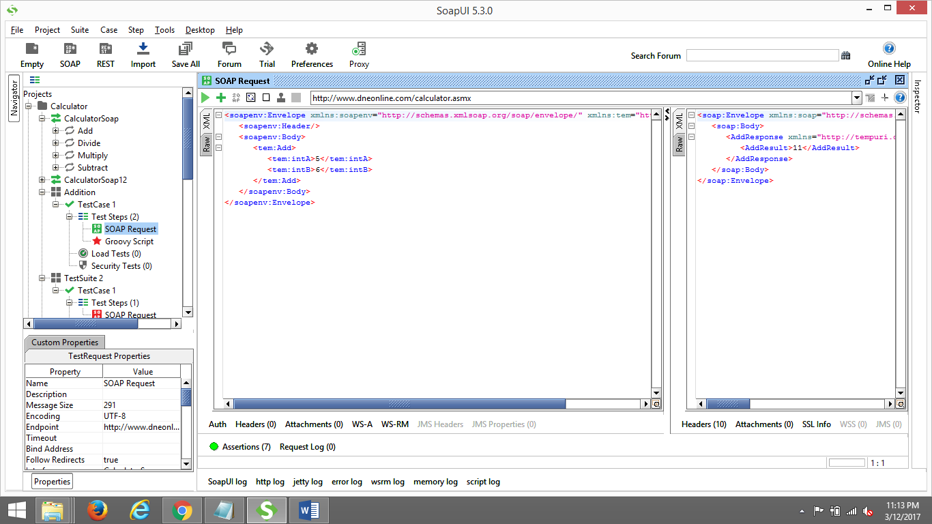

Verified Assertions like contains, not contains, xpath match. Used xpath match to verify exits, count, unique name, return

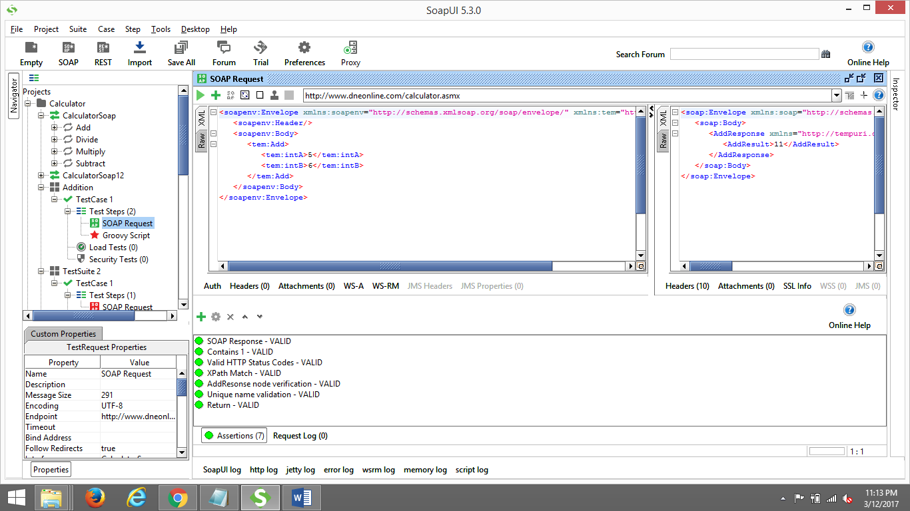

Performed Addition, loops in groovy scripting

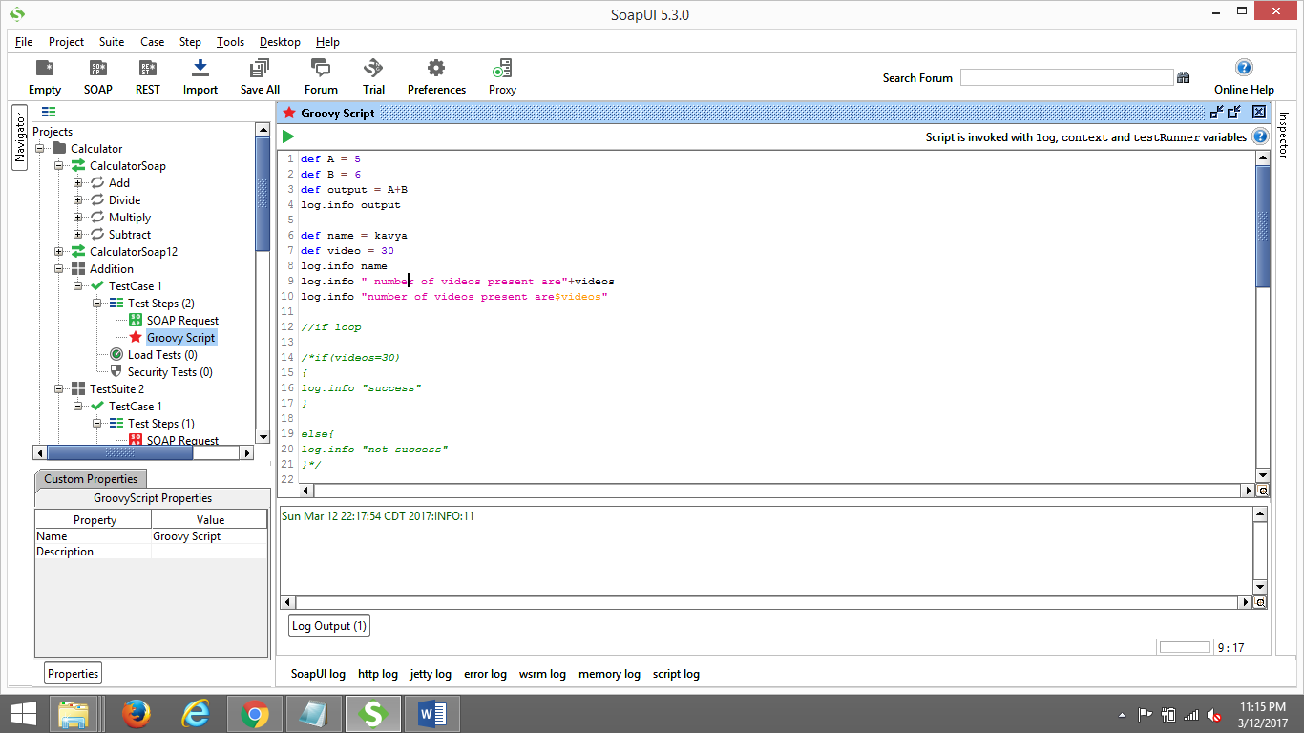

Created Custom Properties ( We can create custom properties Suite level, Case level also)

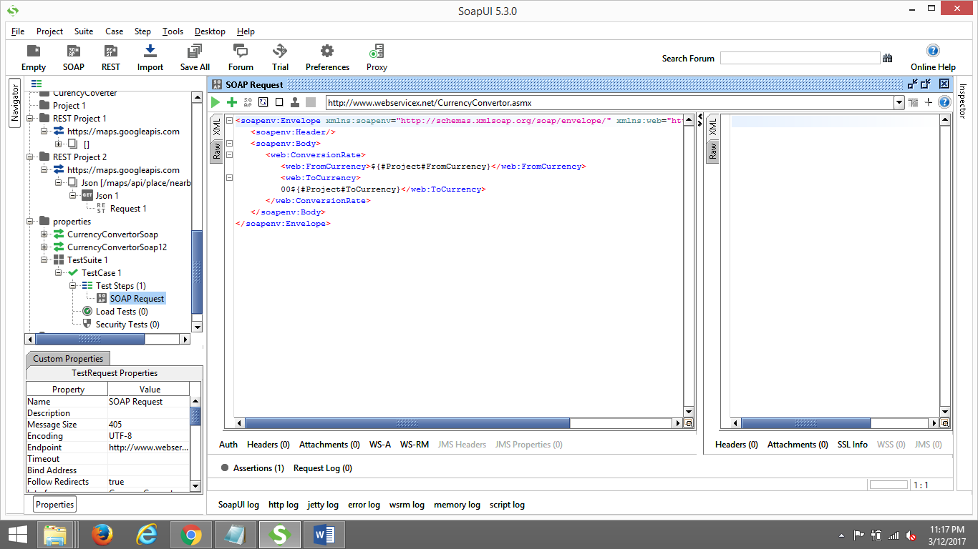

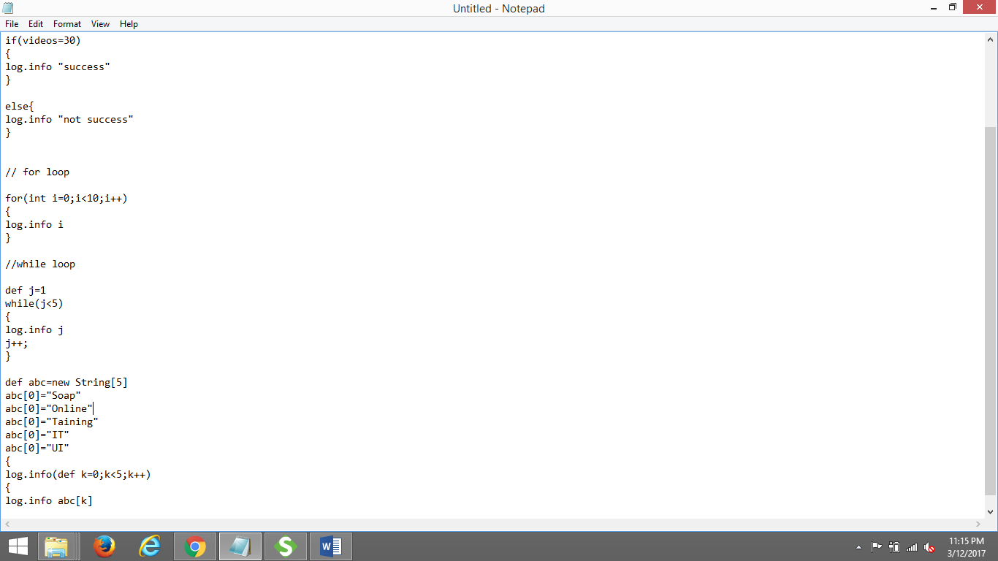

Created Rest file by generating rest API key

