NAME : Mandla Kavya

ID : AF0401166

LAB 4 :

1) write a query to display the instructor's last name whose mail ID starts with 'b' from the instructor table.

mysql> select LastName from instructor where Email LIKE 'B%';



2)write a query to display the details of the student whose first name ends with the vowels from the student table.

mysql> select *from std_details where FirstName LIKE '%A' OR FirstName LIKE '%E' OR

FirstName LIKE '%I' OR FirstName LIKE '%O' OR FirstName LIKE '%U';



3)write a query to display the details of the student whose first name contain the vowels from the student table.

mysql> SELECT *from std_details WHERE FirstName LIKE '%A%'

-> OR FirstName LIKE '%E%'

-> OR FirstName LIKE '%I%'

-> OR FirstName LIKE '%O%'

-> OR FirstName LIKE '%U%';

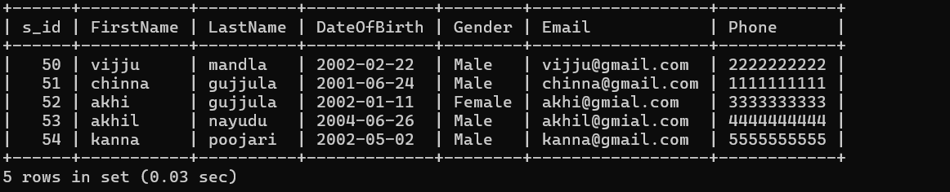

4)write a query to display the details of the student whose last name ends with the other than vowels from the student table.

mysql> SELECT *from std_details WHERE LastName NOT LIKE '%A'

-> AND LastName NOT LIKE '%E'

-> AND LastName NOT LIKE '%I'

-> AND LastName NOT LIKE '%O'

-> AND LastName NOT LIKE '%U';

