1. **Star program to print 3 *3 stars.**

class star1

{

public static void main(String args[])

{

int i,j;

for(i=1;i<=3;i++)

{

for(j=1;j<=3;j++)

{

System.out.print("*");

}

System.out.println();

}

}

}

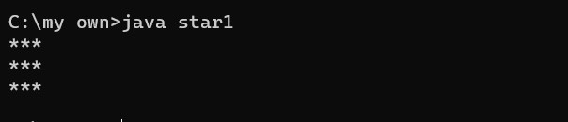

1. **Second star program**

class star2

{

public static void main(String args[])

{

int i,j;

for(i=1;i<=3;i++)

{

for(j=1;j<=i;j++)

{

System.out.print("*");

}

System.out.println();

}

}

}

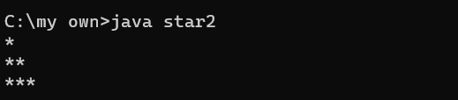

1. **Third star program**

class star3

{

public static void main(String args[])

{

int i,j; for(i=3;i>=1;i--)

{

for(j=1;j<=i;j++)

{

System.out.print("*");

}

System.out.println();

}

}

}

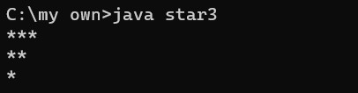

1. **Fourth star program**

class star4

{

public static void main(String args[])

{

int i,j,k;

for(i=3;i>=1;i--)

{

for(j=1;j<i;j++)

{

System.out.print(" ");

}

for(k=3;k>=i;k--)

{

System.out.print("*");

}

System.out.println();

}

}

}

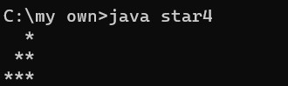

1. **Fifth star program.**

class star5

{

public static void main(String args[])

{

int i,j,k; for(i=3;i>=1;i--)

{ for(j=3;j>i;j--)

{

System.out.print(" ");

}

for(k=1;k<=i;k++)

{

System.out.print("*");

}

System.out.println();

}

}

}

