





Handbook SmartBridge Educational Services Pvt. Ltd.

A Sleep Tracking App for a Better Night's Rest

A project that demonstrates the use of Android Jetpack Compose to build a UI for a sleep tracking app. The app allows users to track their sleep.With the “Sleep Tracker” app, you can assess the quality of sleep they have had in a day. It has been time and again proven that a good quality sleep is pretty essential for effective functioning of both mind and body.

“Sleep Tracker” application enables you to start the timer when they are in the bed and about to fall asleep. The timer will keep running in the background until it is stopped, whenever the user wakes up. Based on the sleep experience, you can rate your sleep quality. Finally , the app will display an analysis of the kind of sleep , you had the previous night.

# Architecture

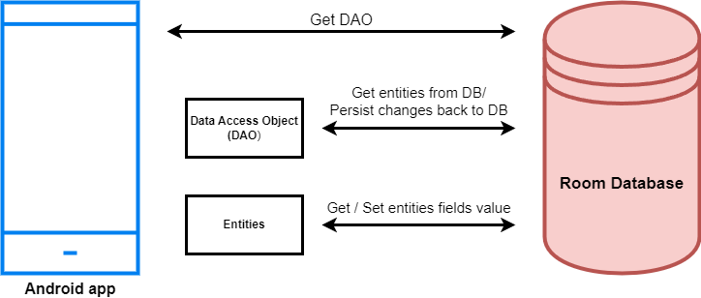

**Learning Outcomes :**

By end of this project:

* You’ll be able to work on Android studio and build an app.
* You’ll be able to integrate the database accordingly.

# Project Workflow:

* Users register into the application.
* After registration , user logins into the application.
* User enters into the main page
* User can track the sleep timing and he record the time

# Tasks:

1.Required initial steps 2.Creating a new project. 3.Adding required dependencies. 4.Creating the database classes.

5.Building application UI and connecting to database. 6.Using AndroidManifest.xml

7.Running the application.

# Task 1:

Required initial steps : <https://developer.android.com/studio/install>

# Task 2 :

Creating a new project.

Step 1 : Android studio > File > New > New Project > Empty Compose Activity Step 2 : Click on **Next** button.

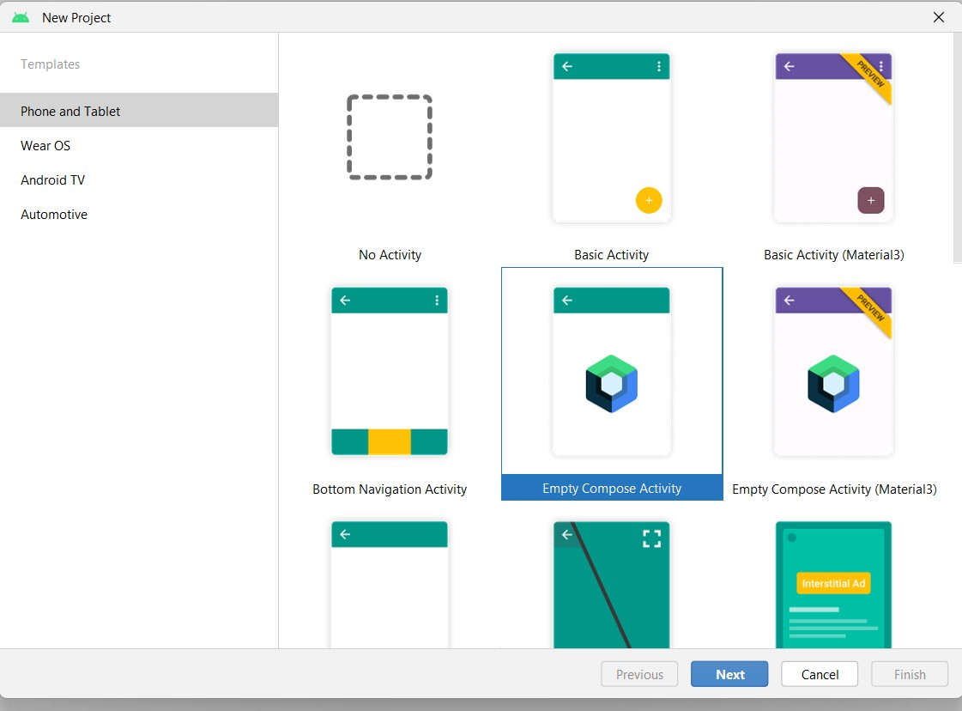

Step 3 : Give name to the new project.

Step 4 : Give the Minimum SDK value Step 5 : Click Finish

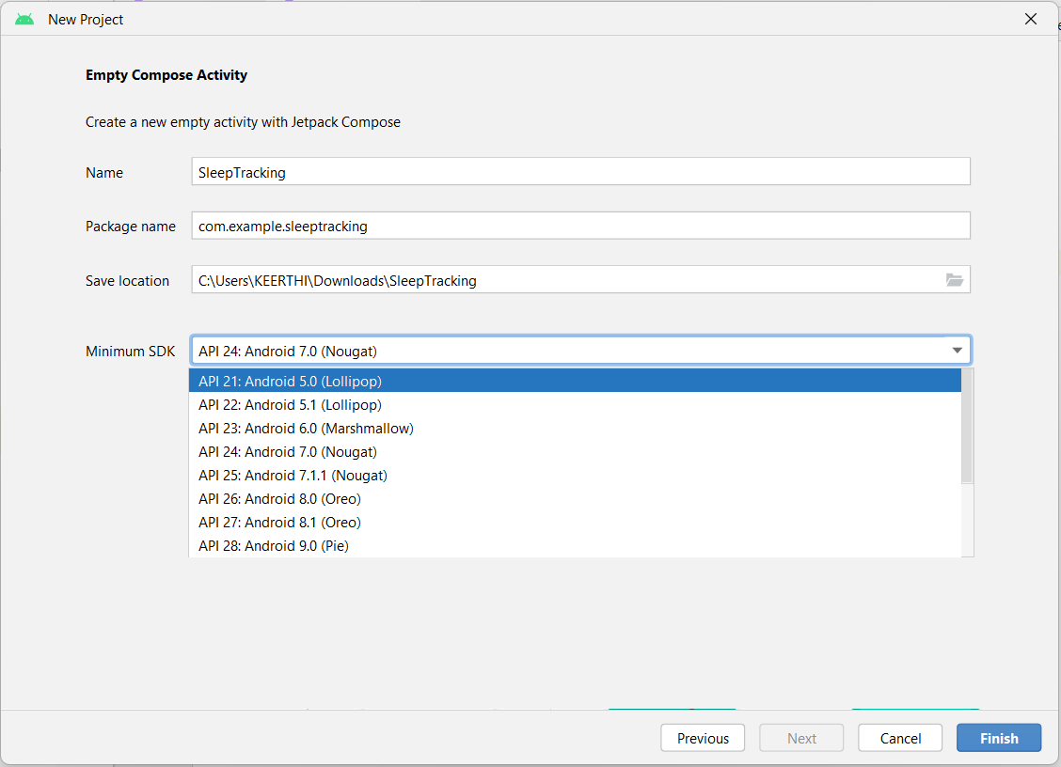

Main activity file

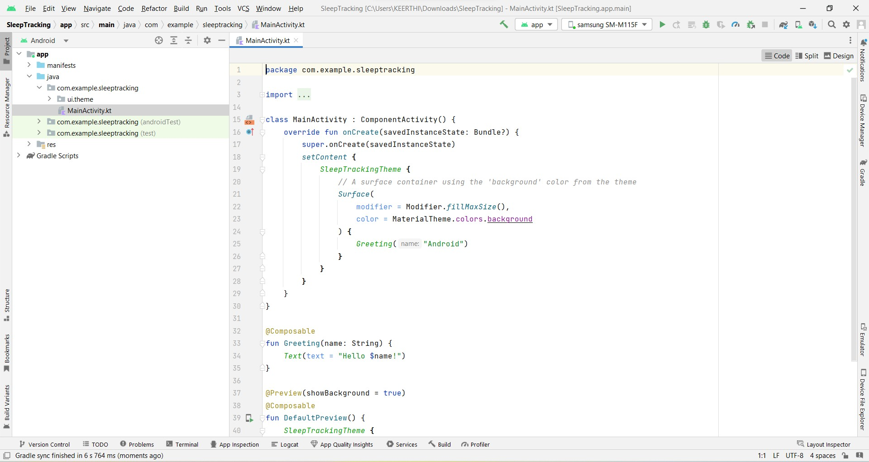

# Task 3 :

Adding required dependencies.

Step 1 : Gradle scripts > build.gradle(Module :app)

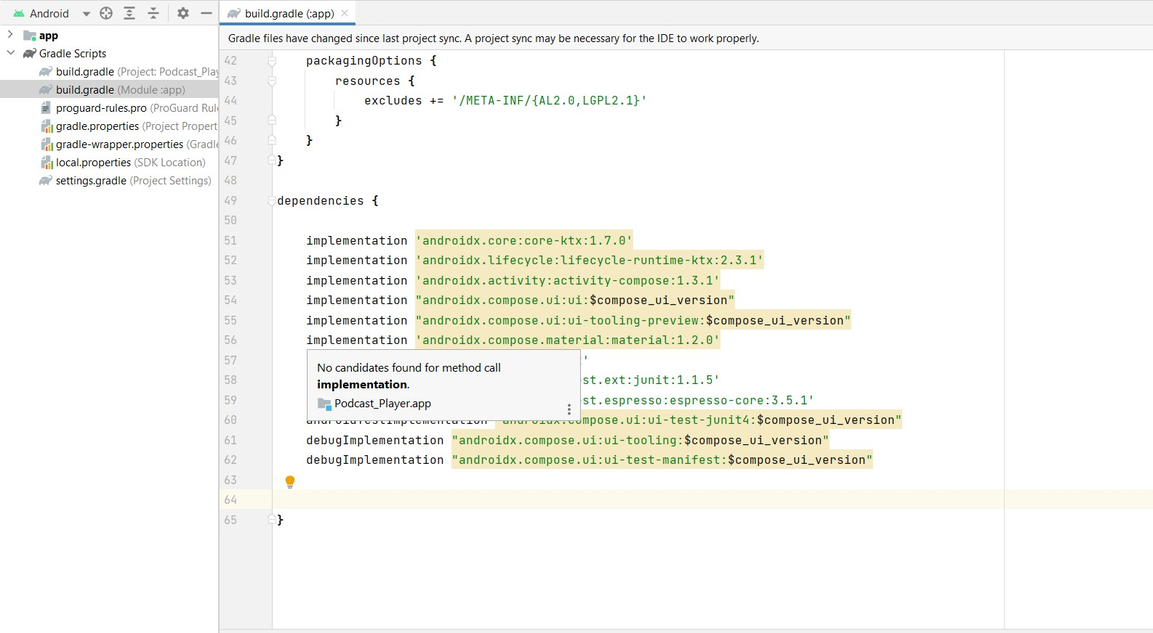

Step 2 : Adding room dependencies. Add the below code in dependencies

*// Adding Room dependencies*

implementation 'androidx.room:room-common:2.5.0' implementation 'androidx.room:room-ktx:2.5.0'

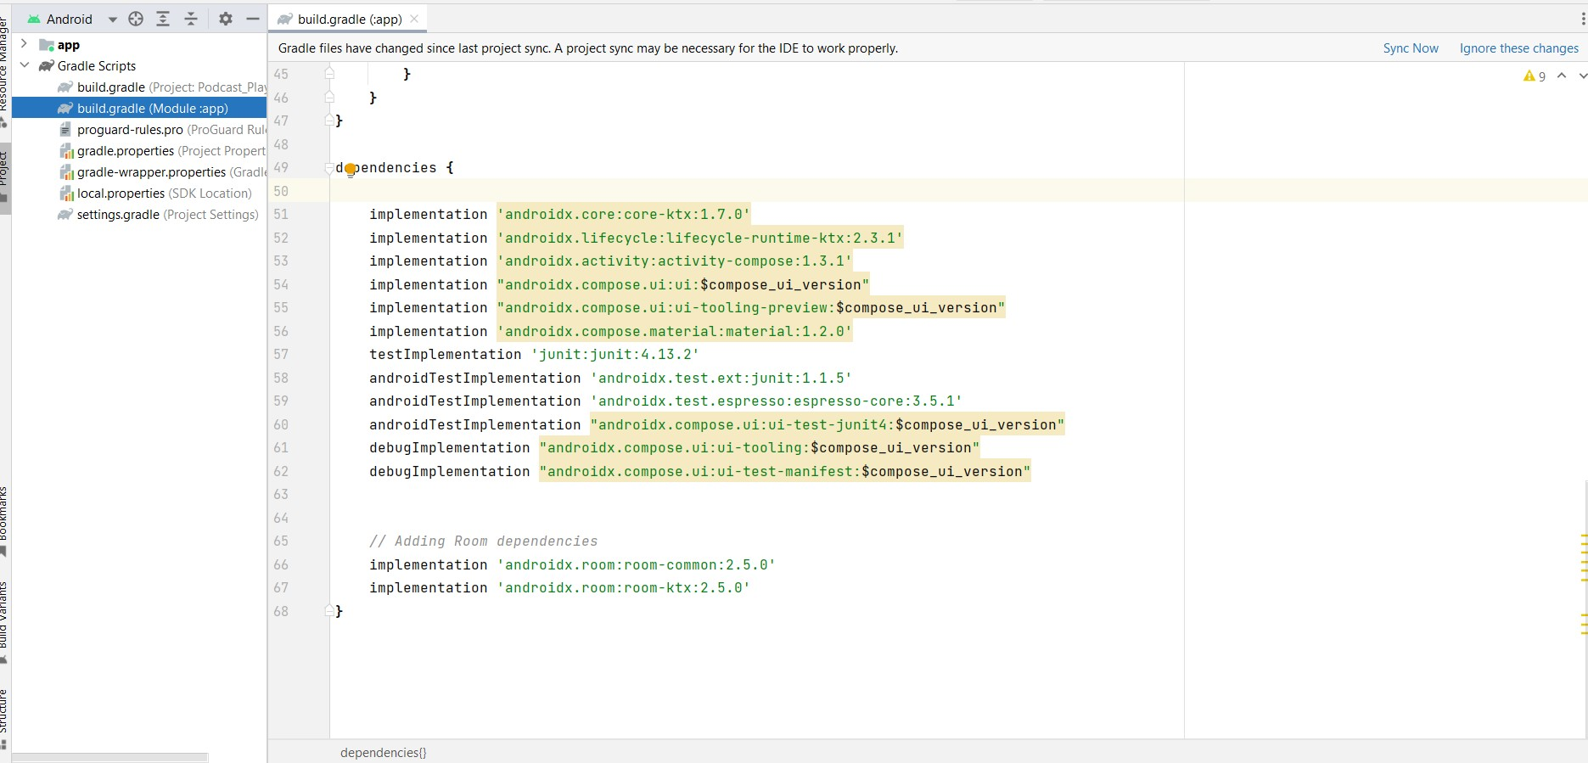

Step 3 : Click on Sync now

# Task 4:

Creating the database classes.

In this project we will be having two databases, one is for user registration and login and other is for tracking the sleep of the user.

Database 1

Step 1 : Create User data class

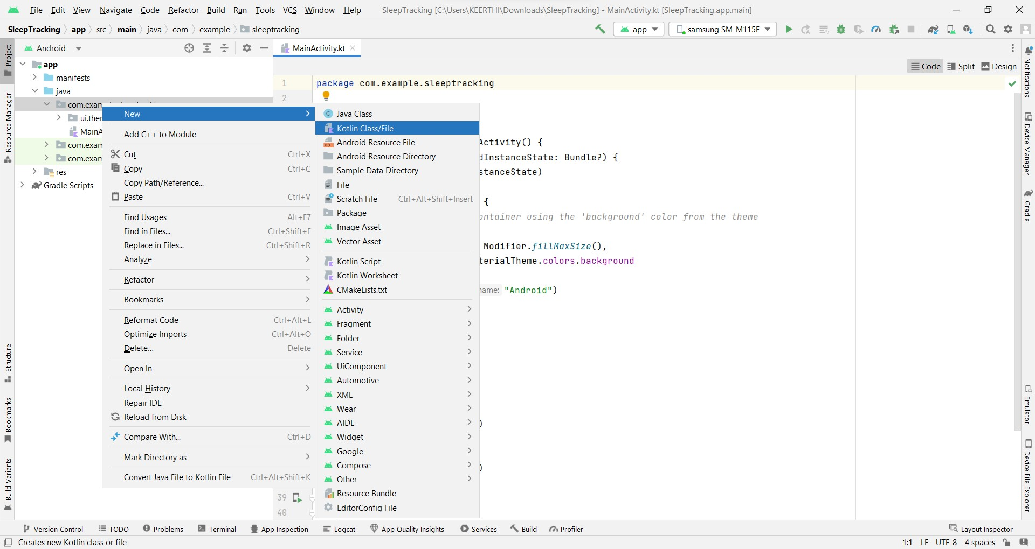

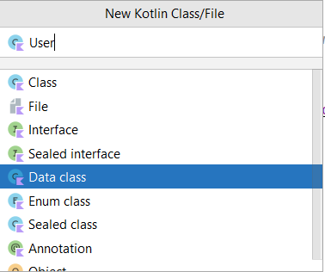

User class code:

<https://github.com/kavyamedikurthi/A-Sleep-Tracking-app-for-a-Better-Night-s-Rest>

Step 2 : Create an UserDao interface



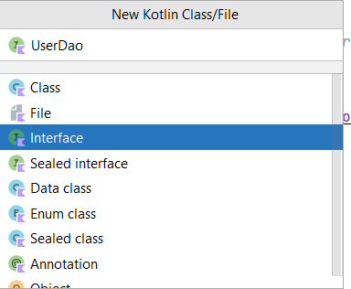

UserDao interface code:

<https://github.com/kavyamedikurthi/A-Sleep-Tracking-app-for-a-Better-Night-s-Rest/blob/master/app/src/main/java/com/example/sleeptracking/UserDao.kt>

Step 3 : Create an UserDatabase class



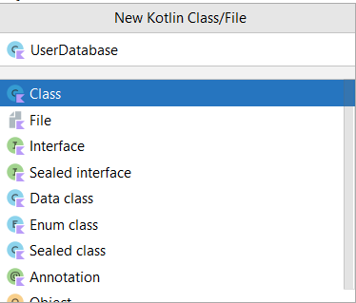

UserDatabase class code :

<https://github.com/kavyamedikurthi/A-Sleep-Tracking-app-for-a-Better-Night-s-Rest/blob/master/app/src/main/java/com/example/sleeptracking/UserDatabase.kt>

Step 4 : Create an UserDatabaseHelper class



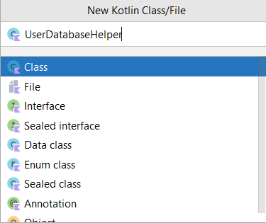

UserDatabaseHelper class code :

<https://github.com/kavyamedikurthi/A-Sleep-Tracking-app-for-a-Better-Night-s-Rest/blob/master/app/src/main/java/com/example/sleeptracking/UserDatabaseHelper.kt>

Database 2

Step 1 : Create TimeLog data class



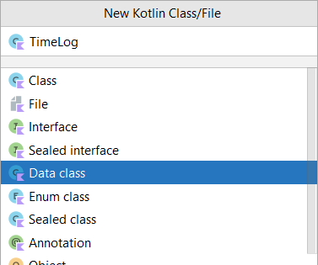

TimeLog data class code:

<https://github.com/kavyamedikurthi/A-Sleep-Tracking-app-for-a-Better-Night-s-Rest/blob/master/app/src/main/java/com/example/sleeptracking/TimeLog.kt>

Step 2 : Create an TimeLogDao interface



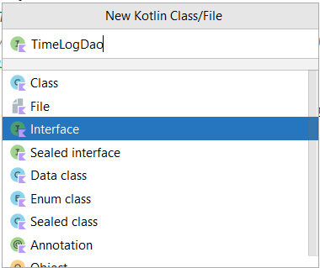

TimeLogDao interface code:

<https://github.com/kavyamedikurthi/A-Sleep-Tracking-app-for-a-Better-Night-s-Rest/blob/master/app/src/main/java/com/example/sleeptracking/TimeLogDao.kt>

Step 3 : Create an AppDatabase class



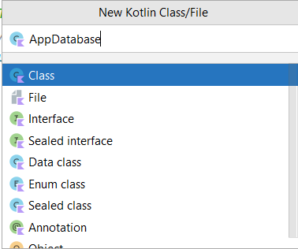

AppDatabase class code:

<https://github.com/kavyamedikurthi/A-Sleep-Tracking-app-for-a-Better-Night-s-Rest/blob/master/app/src/main/java/com/example/sleeptracking/AppDatabase.kt>

Step 4 : Create an TimeDatabaseHelper class



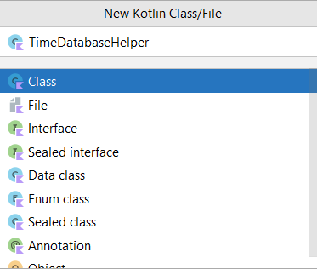

TimeDatabaseHelper class code:

<https://github.com/kavyamedikurthi/A-Sleep-Tracking-app-for-a-Better-Night-s-Rest/blob/master/app/src/main/java/com/example/sleeptracking/TimeDatabaseHelper.kt>

# Task 5:

Building application UI and connecting to database. Step 1: Creating LoginActivity.kt with database

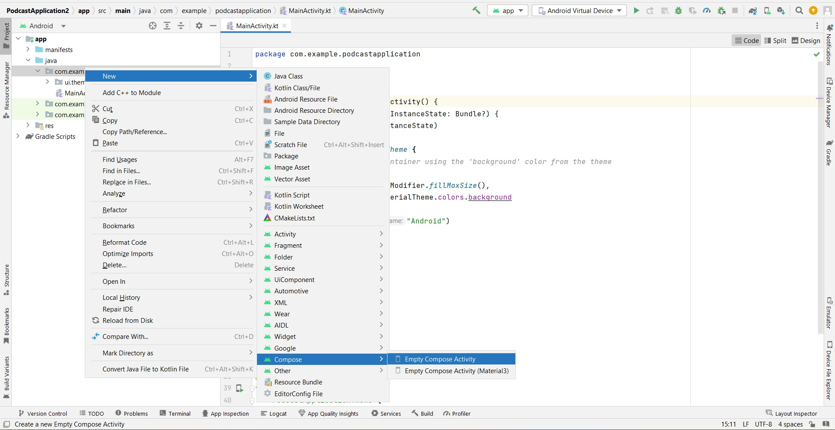

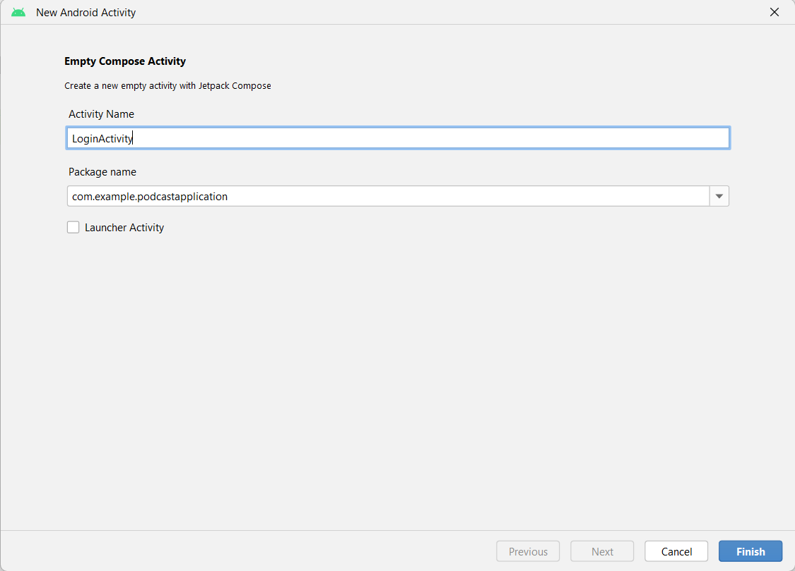

Database connection in LoginActivity.kt

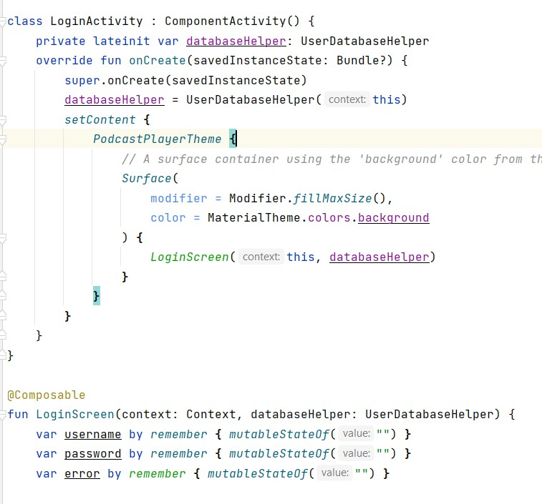

Complete code in below link:

[https://github.com/smartinternz02/Sleep-tracking/tree/main/app/src/main/java/com/ex](https://github.com/smartinternz02/Sleep-tracking/tree/main/app/src/main/java/com/example/projectone/LoginActivity.kt) [ample/projectone/LoginActivity.kt](https://github.com/smartinternz02/Sleep-tracking/tree/main/app/src/main/java/com/example/projectone/LoginActivity.kt)

Step 2 : Creating RegistrationActivity.kt with database



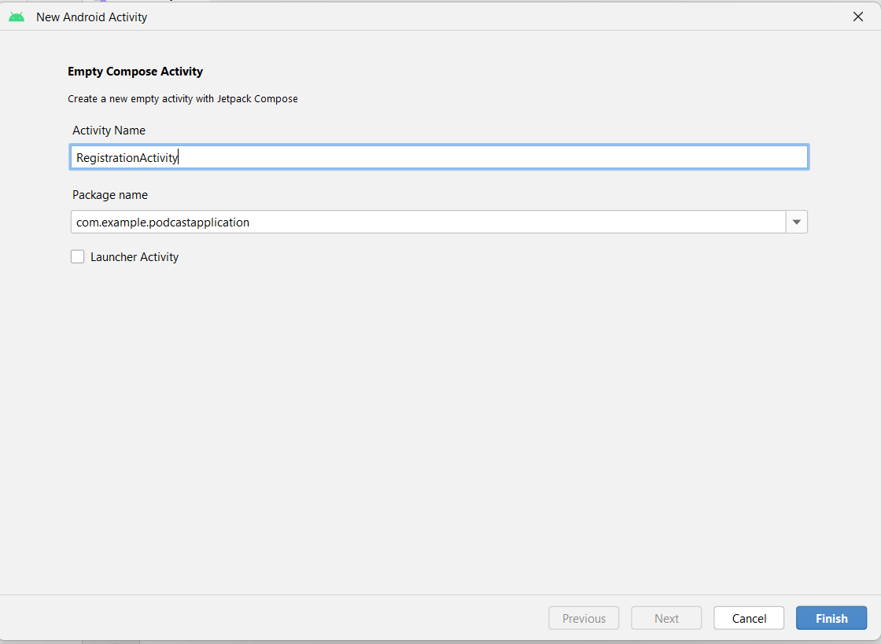

Database connection in RegistrationActivity.kt

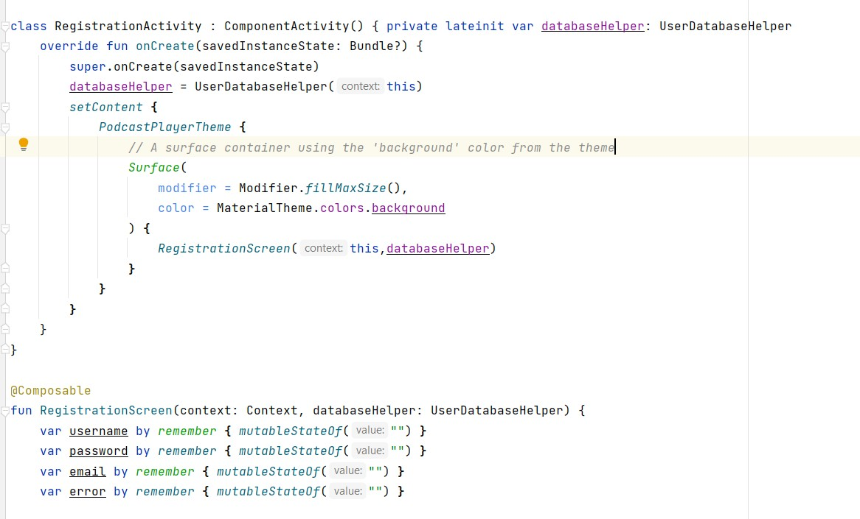

Complete code in below link:

[https://github.com/smartinternz02/Sleep-tracking/tree/main/app/src/main/java/com/ex](https://github.com/smartinternz02/Sleep-tracking/tree/main/app/src/main/java/com/example/projectone/RegisterActivity.kt) [ample/projectone/RegisterActivity.kt](https://github.com/smartinternz02/Sleep-tracking/tree/main/app/src/main/java/com/example/projectone/RegisterActivity.kt)

Step 3 : Creating MainActivity.kt file

In MainActivity.kt file the main application is developed

* Before creating UI we need to add some images in drawables which are in res

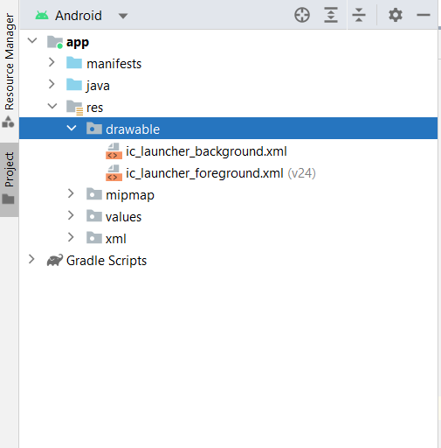

Download the required drawable from the code: [https://github.com/smartinternz02/Sleep-tracking/tree/main/app/src/main/res/drawabl](https://github.com/smartinternz02/Sleep-tracking/tree/main/app/src/main/res/drawable-nodpi) [e-nodpi](https://github.com/smartinternz02/Sleep-tracking/tree/main/app/src/main/res/drawable-nodpi)

Required drawables

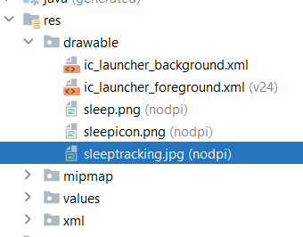

MainActivity.kt

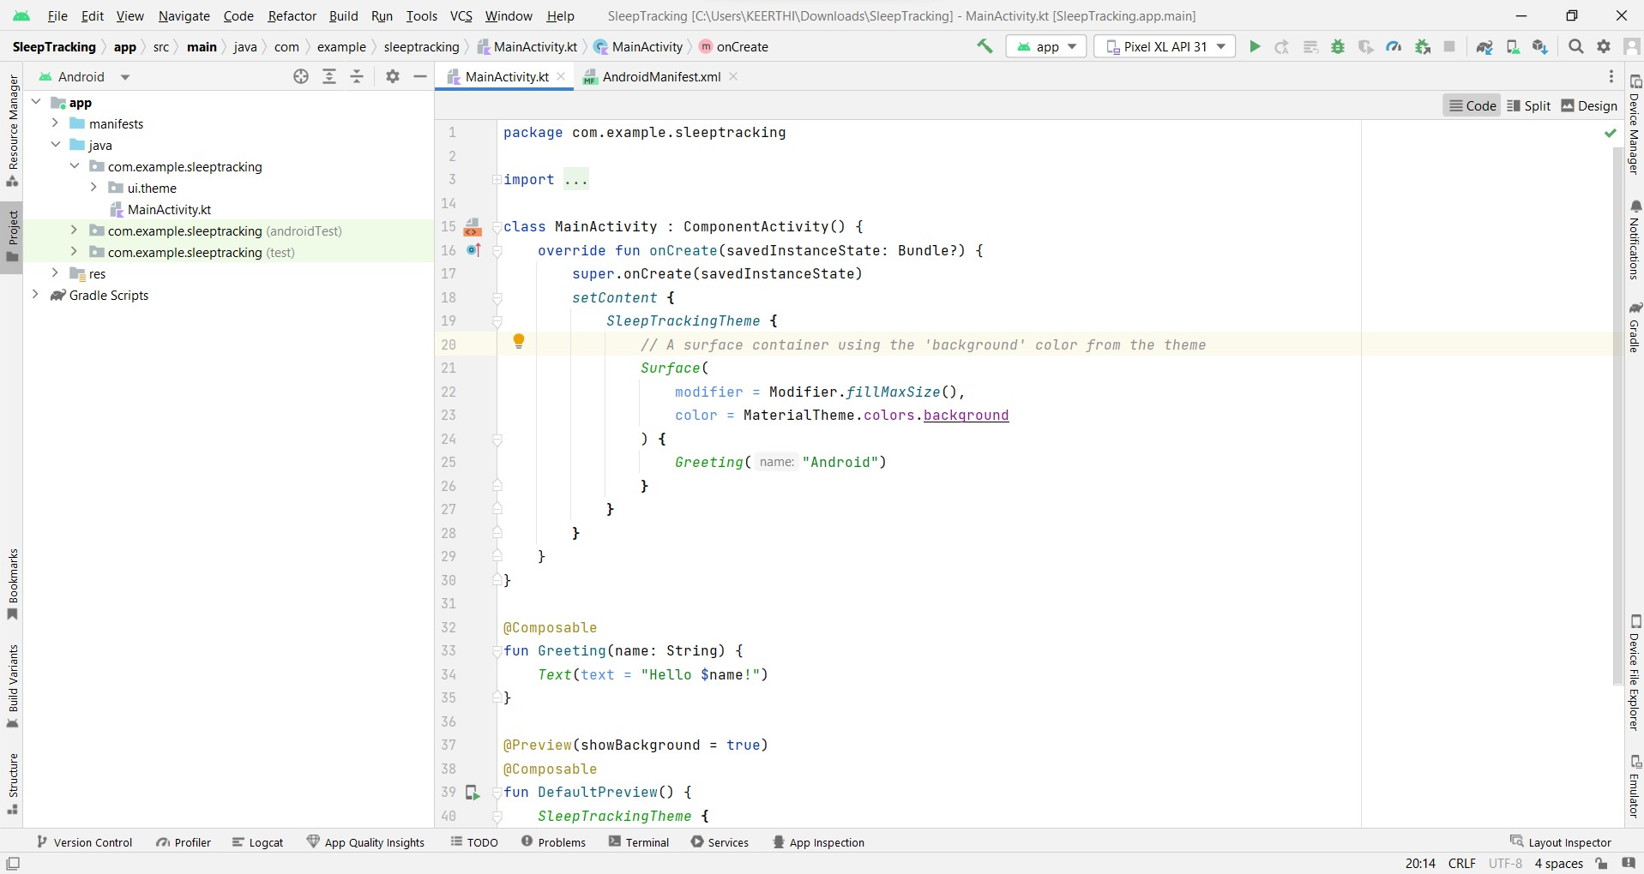

Complete code in below link:

[https://github.com/smartinternz02/Sleep-tracking/tree/main/app/src/main/java/com/ex](https://github.com/smartinternz02/Sleep-tracking/tree/main/app/src/main/java/com/example/projectone/MainActivity.kt) [ample/projectone/MainActivity.kt](https://github.com/smartinternz02/Sleep-tracking/tree/main/app/src/main/java/com/example/projectone/MainActivity.kt)

Step 4 : Creating TrackActivity.kt file



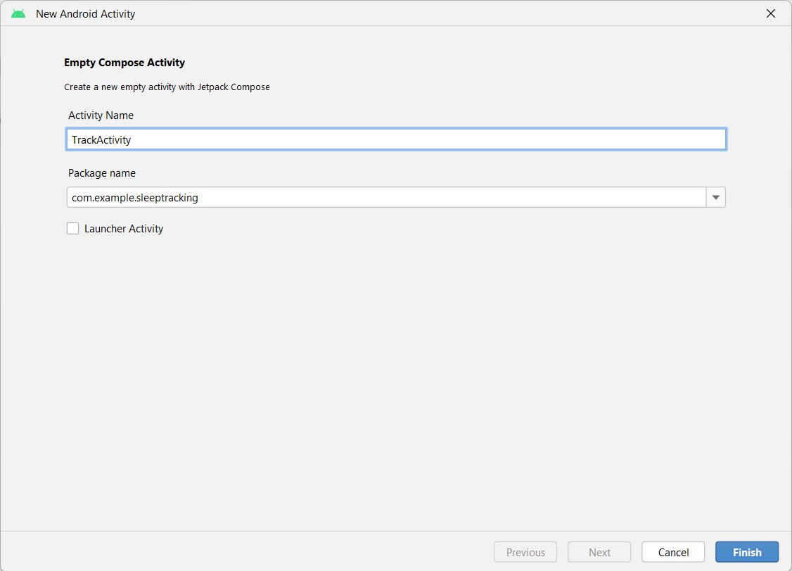

Database connection and fetching in TrackActivity.kt

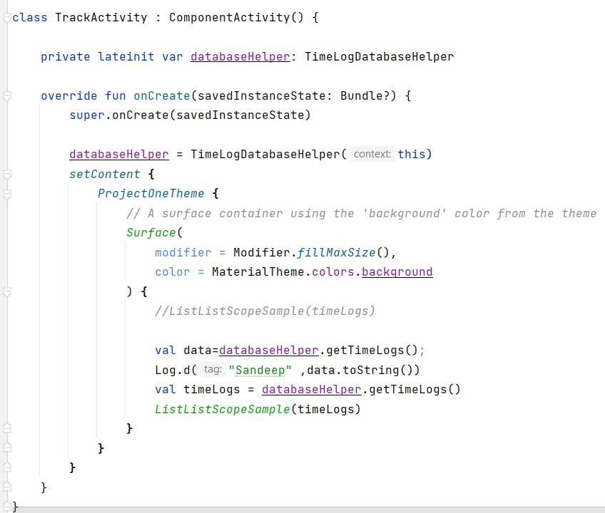

Complete code in below link:

[https://github.com/smartinternz02/Sleep-tracking/tree/main/app/src/main/java/com/ex](https://github.com/smartinternz02/Sleep-tracking/tree/main/app/src/main/java/com/example/projectone/TrackActivity.kt) [ample/projectone/TrackActivity.kt](https://github.com/smartinternz02/Sleep-tracking/tree/main/app/src/main/java/com/example/projectone/TrackActivity.kt)

# Task 6:

Modifying AndroidManifest.xml

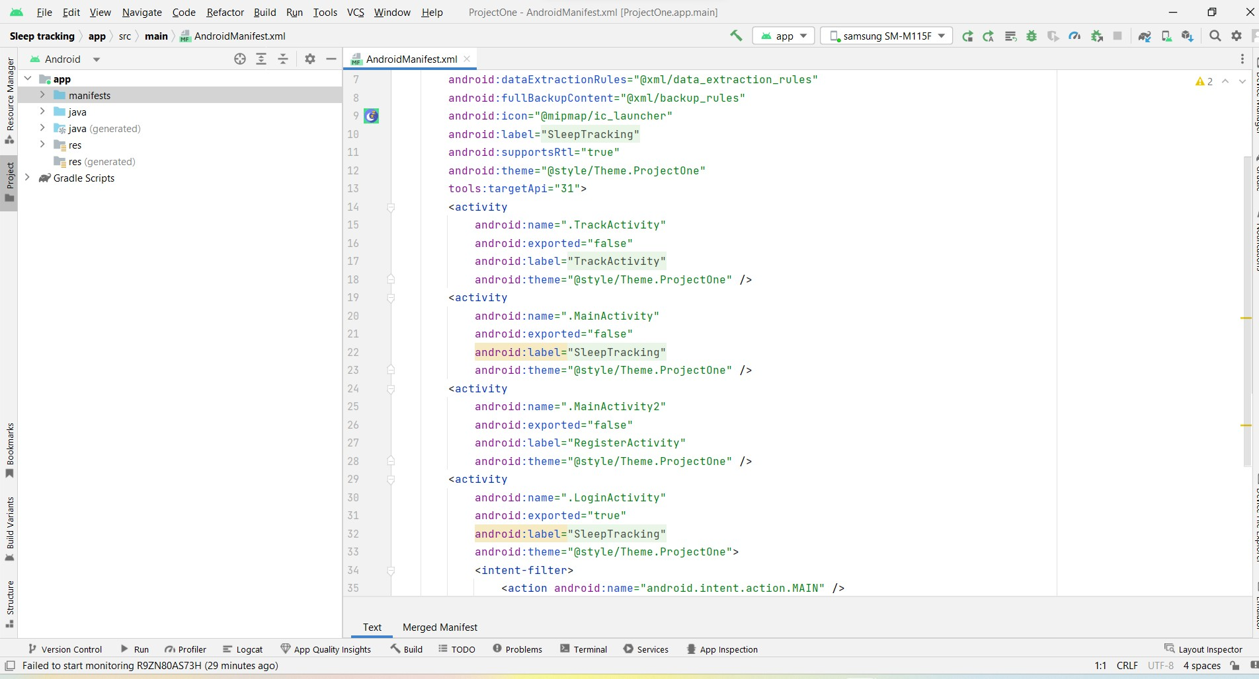

When we run the app we will get the MainActivity.kt file as our first screen , but we want LoginActivity.kt , So we need to change in AndroidManifest.xml.

Changed AndroidManifest.xml.

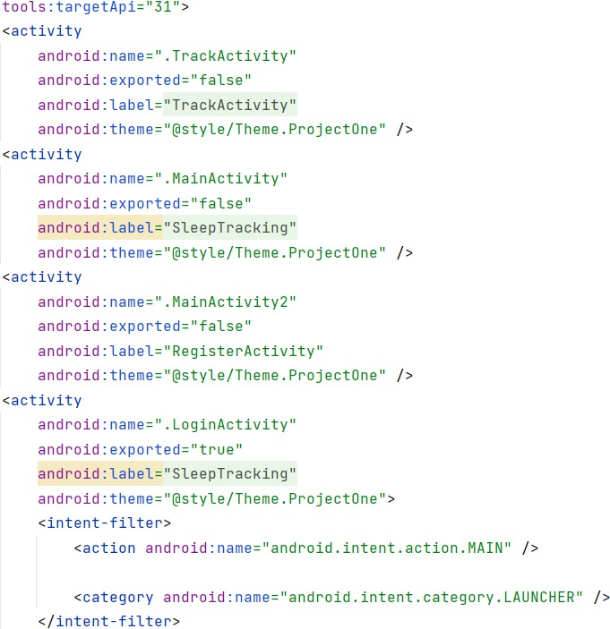

Complete AndroidManifest.xml code:

[https://github.com/smartinternz02/Sleep-tracking/blob/main/app/src/main/AndroidMa](https://github.com/smartinternz02/Sleep-tracking/blob/main/app/src/main/AndroidManifest.xml) [nifest.xml](https://github.com/smartinternz02/Sleep-tracking/blob/main/app/src/main/AndroidManifest.xml)

# Task 7:

Running the application.

Step 1: Run apps on a hardware device <https://developer.android.com/studio/run/device>

Step 2: Run the application in Mobile

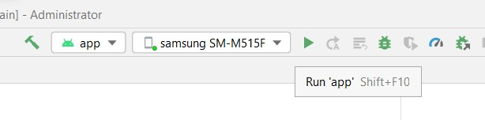

**Complete Project Link:** [**https://github.com/smartinternz02/Sleep-tracking**](https://github.com/smartinternz02/Sleep-tracking)

# Final Output of the Application :

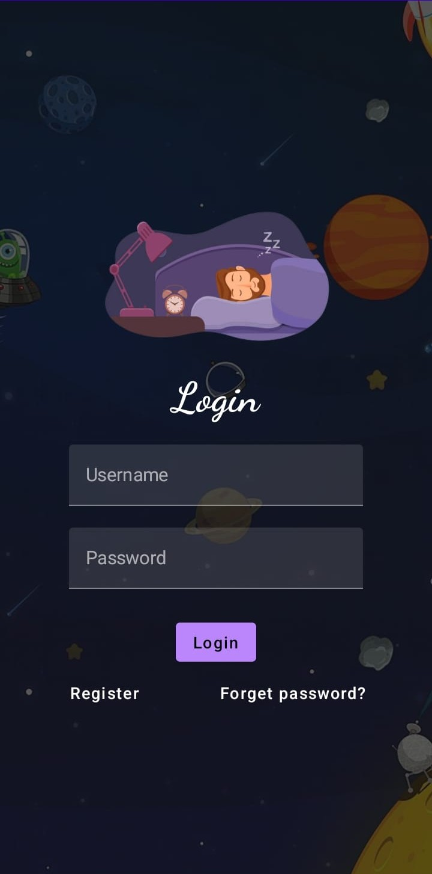Login Page :

Registration Page:

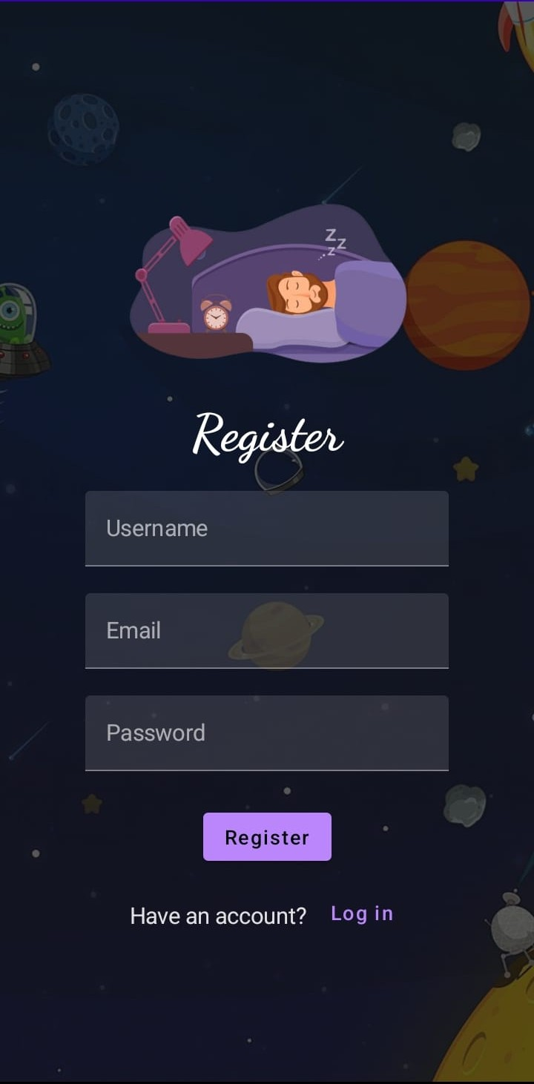

Main Page:

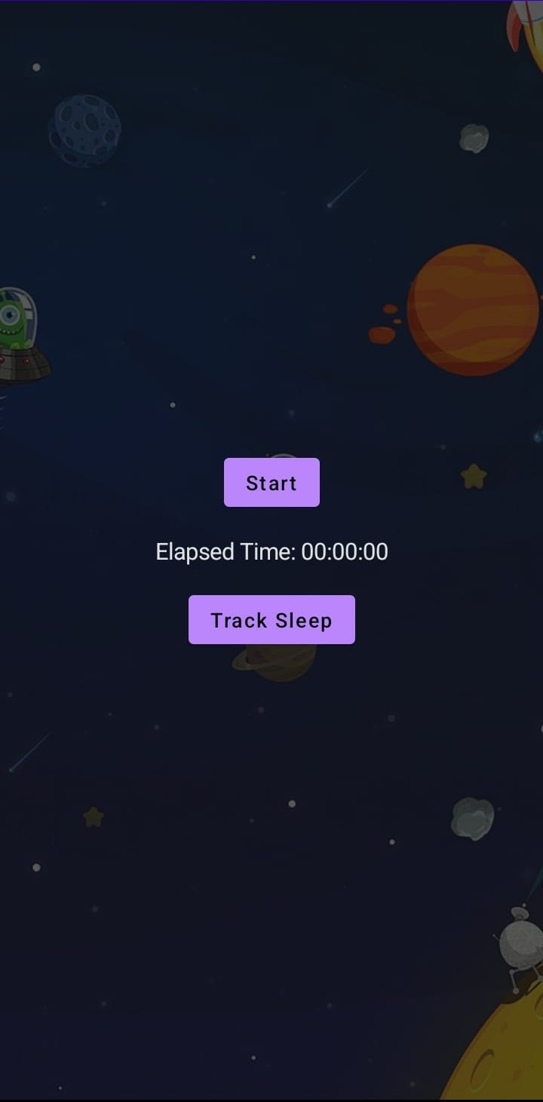

Track Sleep Page:

