
Development of Web Application:
Real-Time API Performance Monitoring & Diagnostic Dashboard

A MINI PROJECT REPORT

Submitted by

KAVYANAND J (24CS096)

U21CS504- Web technologies Lab

in

DEPARTMENT OF COMPUTER SCIENCE AND ENGINEERING

KPRIET

BONAFIDE CERTIFICATE

Certified that this project report "REAL-TIME API PERFORMANCE MONITORING & DIAGNOSTIC DASHBOARD" is the bonafide work of "KAVYANAND J (24CS096)" who carried out the project work under my supervision.

Dr. MIRUNA JOE AMALI RAJESHKUMAR S

HEAD OF THE DEPARTMENT SUPERVISOR,
Professor Assistant professor III
Computer Science and Engineering Computer Science and Engineering
KPR Institute of Engineering and KPR Institute of Engineering and
Technology Technology
Arasur, Coimbatore – 641407 Arasur, Coimbatore – 641407

Submitted for the University Mini project Viva – Voce held on

INTERNAL EXAMINER EXTERNAL EXAMINER

TABLE OF CONTENTS
CHAPTER | TITLE | PAGE NO
 | ABSTRACT | iii
1 | INTRODUCTION: ABOUT PROJECT NEED AND PLANS | 1
 | 1.1 Project Need & Background | 1
 | 1.2 Objectives & Development Plans | 1
2 | IMPLEMENTATION | 2
 | 2.1 Tech Stack -- Explanation of Technologies Used | 2
 | 2.2 Modules -- Explanation of Each Module | 3
 | 2.2.1 Authentication & Multi-Tenant User Isolation | 3
 | 2.2.2 API Endpoint Registry & CRUD Management | 3
 | 2.2.3 Asynchronous Health Probing & Latency Engine | 3
 | 2.2.4 Diagnostic Audit Logging & Query Filter | 4
 | 2.2.5 Visual Analytics & Custom Glassmorphism Dropdown | 4
 | 2.2.6 Comprehensive Security Implementation | 4
 | 2.2.7 Website Performance Analysis using Open-Source Tool | 5
3 | OUTCOME - EXPLANATIONS OF OUTCOMES WITH SCREEN SHOTS | 6
 | 3.1 Overview of Functional Outcomes | 6
 | 3.2 High-Resolution Visual Outcomes | 6
4 | CONCLUSION | 10

LIST OF FIGURES
FIGURE NO | FIGURE NAME | PAGE
Figure 4.1 | Real-Time API Performance & Health Monitoring Dashboard | 6
Figure 4.2 | User Authentication Modal & Multi-Tenant Profile Popover | 7
Figure 4.3 | API Endpoint Registration & CRUD Management Interface | 7
Figure 4.4 | Live Diagnostic Monitor Cards with Real-Time Ping Actions | 8
Figure 4.5 | Diagnostic Audit History Logs and Query Filter System | 8
Figure 4.6 | Performance Analytics Breakdown & Custom Glassmorphism Dropdown | 9
Figure 4.7 | Google Lighthouse Open-Source Audit & Core Web Vitals Benchmark | 9
LIST OF ABBREVIATIONS
API : Application Programming Interface
REST : Representational State Transfer
HTTP / HTTPS : HyperText Transfer Protocol / Secure
CORS : Cross-Origin Resource Sharing
PDO : PHP Data Objects
FCP : First Contentful Paint
LCP : Largest Contentful Paint
TBT : Total Blocking Time
CLS : Cumulative Layout Shift

ABSTRACT - SUMMARY OF APPLICATION DEVELOPMENT
In the contemporary landscape of microservices, cloud-native platforms, and distributed web architectures, application reliability is critically tethered to the availability, response speed, and error resilience of underlying Application Programming Interfaces (APIs). Unexpected latency degradation, silent endpoint terminations, and server outages directly compromise user retention, degrade operational throughput, and incur severe financial and technical debt. To address these systemic vulnerabilities, this project presents the design and implementation of an enterprise-grade, high-performance Real-Time API Performance Monitoring & Diagnostic Dashboard.
The application is engineered on a versatile, dual-mode operational architecture. On the client side, it functions as a zero-dependency, zero-setup platform capable of executing seamlessly in any modern web browser without requiring web server daemons, database servers, or software runtime installations (such as XAMPP, Apache, or Node.js). Persistent state management is accomplished via the browser's Web Storage API (localStorage), while high-resolution latency evaluation is executed asynchronously using JavaScript's native Performance API (performance.now()) alongside AbortController-enforced timeout safeguards and CORS-resilient probing.
To satisfy rigorous enterprise criteria and academic evaluation standards, the application further includes a robust, decoupled server backend built with PHP (PHP Data Objects - PDO) and a relational MySQL schema. The platform provides end-to-end multi-tenant isolation, ensuring that multiple authenticated developers (e.g., User 1 vs. User 2) retain strictly partitioned endpoint registries, isolated diagnostic histories, and customized visual analytics. Real-time data visualization is powered by six dynamic Chart.js canvas components, complemented by an adaptive dark/light glassmorphism user interface.
Rigorous empirical evaluation conducted using open-source audit tooling (Google Lighthouse) demonstrates outstanding performance, registering a 98/100 Performance Score, 100/100 Accessibility, 100/100 Best Practices, and 100/100 SEO, coupled with a sub-0.5 second First Contentful Paint (FCP) and zero millisecond Total Blocking Time (TBT). The resulting system establishes a portable, highly reliable, and aesthetically sophisticated diagnostic solution for developers, DevOps engineers, and system administrators.

1. INTRODUCTION: ABOUT PROJECT NEED AND PLANS
1.1 Project Need & Background
Modern digital ecosystems have transitioned decisively from monolithic codebases toward decoupled, API-centric microservice architectures. Modern web and mobile applications routinely interact with dozens—frequently hundreds—of heterogeneous REST endpoints, encompassing external payment gateways (e.g., Stripe, Razorpay), authentication services (e.g., OAuth, Auth0), third-party data providers (e.g., GitHub, cloud ingestion pipelines), and internal business microservices. In such tightly coupled distributed networks, an unmonitored failure or latency spike in a single dependency often precipitates catastrophic cascading failures across the entire software application.
Conventionally, engineering teams rely on heavy enterprise Application Performance Monitoring (APM) suites such as Datadog, New Relic, or Dynatrace. While comprehensive, these platforms introduce substantial architectural friction: they require dedicated server daemons, invasive instrumentation agents, continuous external network telemetry, and exorbitant recurring subscription fees. Conversely, lightweight developer tools frequently lack persistent multi-user workspaces, visual trend analytics, and cross-platform portability. There exists an acute engineering requirement for a lightweight, zero-configuration diagnostic platform that can be launched instantly on any machine—from a developer's local laptop to air-gapped evaluation environments—without sacrificing analytical depth, relational data modeling, or visual elegance.
1.2 Objectives & Development Plans
The primary objective of this project is to develop a lightweight, self-contained, real-time web application capable of monitoring, diagnosing, and visually presenting API performance metrics. The concrete development plans and objectives established for this engineering project comprise:
• Zero-Setup Portability: Enable the application to run out-of-the-box by directly opening index.html in any browser, eliminating mandatory server stacks like XAMPP while preserving permanent local persistence.
• Precision Network Probing: Implement asynchronous client-side and server-side probing engines measuring latency down to sub-millisecond precision, utilizing high-resolution performance timers and abortable connection thresholds.
• Multi-Tenant Data Isolation: Engineer a partitioned data model where authenticated users maintain completely separate API catalogs, test records, and performance metrics, preventing cross-tenant data leakage.
• Interactive Visual Analytics: Develop six responsive visual analytics components (wave latency charts, health donut breakdowns, weekly distributions, latency bars, status ratio doughnuts, and comparative horizontal bars) with an integrated custom glassmorphism dropdown filter.
• Enterprise Architectural Depth: Provide a fully realized MySQL relational database schema with foreign key constraints, coupled with secure, SQL-injection-resistant PHP PDO REST controllers for full-stack deployment.
• Open-Source Performance Benchmarking: Subject the application to rigorous industry-standard performance and accessibility audits using Google Lighthouse, validating sub-second load times and flawless UI responsiveness.

2. IMPLEMENTATION
2.1 Tech Stack -- Explanation of Technologies Used
To fulfill the dual requirements of zero-dependency portability and enterprise architectural compliance, the system was implemented using a carefully selected suite of modern, standard web technologies. Table 2.1 details the technology stack employed across the frontend, data, and backend layers.
LAYER / COMPONENT | TECHNOLOGY EMPLOYED | TECHNICAL RATIONALE & FUNCTION
Frontend Structure | Semantic HTML5 | Provides accessible, standards-compliant single-page application (SPA) layout containing distinct viewports for Dashboard, APIs, Monitor, History, and Analytics.
Styling & Aesthetics | Modern CSS3 (Custom Properties & Flex/Grid) | Employs CSS Custom Properties (CSS variables) for instantaneous dark/light theme switching, glassmorphism backdrop filters, fluid Flexbox alignments, and CSS Grid layouts.
Client-Side Logic | Vanilla JavaScript (ES6+) | Executes asynchronous network probing, event handling, DOM manipulation, state hydration, and authentication flow without heavy third-party framework overhead.
Data Visualization | Chart.js (v4.4.1) | Renders hardware-accelerated, responsive canvas charts for real-time latency trends, health ratios, weekly diagnostics, and comparative API performance.
Typography & Icons | Google Fonts & FontAwesome 6 | Utilizes Plus Jakarta Sans and Inter font pairings alongside FontAwesome 6 vector glyphs for high-legibility developer-centric visual hierarchy.
Local Persistence | Web Storage API (localStorage) | Stores JSON-serialized arrays of user accounts, API endpoint catalogs, and diagnostic historical audit logs directly within the browser client.
Relational Database | MySQL 8.0 (InnoDB Engine) | Defines normalized relational entities (users, apis, api_history) enforcing ON DELETE CASCADE foreign key constraints and indexed lookups.
Backend Controller | PHP 8.x (PDO Extension) | Provides server-side REST API handlers using prepared parameterized SQL statements, cURL network probing with DNS pre-resolution, and JSON payloads.
Audit & Evaluation | Google Lighthouse (Open-Source) | Audits the application against Core Web Vitals, performance bottlenecks, accessibility rules, and modern web best practices.
Table 2.1: Complete Technology Stack and Implementation Rationale

2.2 Modules -- Explanation of Each Module
The application architecture is decomposed into seven cohesive, loosely coupled functional modules. Each module encapsulates distinct responsibilities spanning authentication, endpoint lifecycle management, network health probing, audit logging, visual analytics, security defense mechanisms, and automated performance auditing.
2.2.1 Authentication & Multi-Tenant User Isolation Module
The authentication module enforces secure workspace separation across distinct engineering profiles. Located on the top-right navigation bar, an interactive user avatar button triggers an authentication popover or modal. The system accommodates existing accounts (seeded with User 1: user1@demo.com and User 2: user2@demo.com) as well as real-time user registration.
Data isolation is enforced through contextual scoping: every registered API and historical ping record is explicitly assigned a user_id attribute. When an active session is loaded, accessor functions (getActiveAPIs() and getActiveHistory()) filter client storage strictly to records matching the logged-in user's identifier. Consequently, when User 1 registers a private endpoint (e.g., 'JSONPlaceholder Users'), User 2's session remains completely insulated from those endpoints, preventing cross-tenant data contamination.
2.2.2 API Endpoint Registry & CRUD Management Module
This module provides a complete administrative interface for registering, inspecting, testing, and deleting monitored REST services. The registration card incorporates input fields for Endpoint Name, Target URL, and HTTP Method (GET, POST, PUT, DELETE). Upon form submission, input validation ensures string integrity and protocol formatting. The endpoint is cataloged into the reactive store and rendered into an administrative data table featuring real-time search filtering, method badges, status pills, creation timestamps, and individual trigger actions.
2.2.3 Asynchronous Health Probing & Latency Engine Module
The diagnostic engine is tasked with evaluating the operational health and network responsiveness of registered endpoints. The core algorithm executes via asynchronous JavaScript:
• Timestamp Acquisition: Captures an initial microsecond-accurate timestamp utilizing window.performance.now().
• Timeout Safeguard: Constructs an AbortController instance bound to a 5,000 millisecond timer. If the remote server fails to initiate handshake within 5 seconds, the request is terminated to avoid thread starvation.
• CORS-Resilient Dispatch: Issues a fetch() request configured with method: 'HEAD', cache: 'no-cache', and mode: 'no-cors'. This enables the client browser to measure round-trip transport latency across arbitrary domains without triggering browser CORS security blocks.
• Health Categorization: Calculates elapsed latency: values under 500ms are classified as 'Healthy' (emerald indicator); values between 500ms and 1500ms are classified as 'Slow' (amber indicator); timeouts or network dropouts are recorded as 'Failed' (crimson indicator).
• State Persistence: Appends an immutable audit record to the history stream and triggers an instantaneous reactive re-render of all dashboard counters and active chart canvases.

2.2.4 Diagnostic Audit Logging & Query Filter Module
Every executed health probe generates an immutable audit entry detailing: Record ID, Associated API Name, HTTP Response Code, Latency (ms), Health Status, and an ISO 8601 Timestamp. The History view provides a dynamic multi-criteria query engine enabling administrators to filter records concurrently by specific API endpoint and health classification (Healthy, Slow, Failed), facilitating forensic analysis of historical degradation patterns.
2.2.5 Visual Analytics & Custom Glassmorphism Dropdown Module
The analytics subsystem converts raw latency telemetry into actionable visual intelligence across six synchronized Chart.js visual components:
• Hero Wave Latency Chart: A multi-series spline line canvas mapping ongoing response trends with smooth cubic bezier tension.
• Health Donut Breakdown: A cut-out doughnut chart visualizing the percentage distribution of Healthy, Slow, and Failed endpoints, featuring a central uptime reliability badge.
• Weekly Volume Bars: A vertical bar chart charting daily diagnostic throughput across standard operating days.
• Recent Latency Trend Bar: A high-density chronological bar chart mapping recent ping latencies.
• Success vs. Failure Ratio Chart: A multi-segment doughnut chart illustrating overall operational health ratios.
• Endpoint Latency Comparison Chart: A horizontal bar chart comparing the mean latency across all registered APIs.
A standout engineering enhancement is the Custom Glassmorphism Dropdown Menu. Replacing native unstyled OS select elements, this component delivers a floating acrylic card with active state indicators, status color dots, and live DOM filtering, providing a cohesive FinTech-grade visual aesthetic.
2.2.6 Comprehensive Security Implementation
Security was integrated as a foundational design parameter across both frontend and backend execution paths:
• Cross-Site Scripting (XSS) Sanitization: All user-supplied endpoint names, URLs, and filter parameters undergo rigorous entity encoding via escapeHtml() prior to DOM injection, mitigating HTML injection and script execution vulnerabilities.
• SQL Injection Prevention: The backend PHP controllers utilize PDO (PHP Data Objects) with strictly parameterized prepared statements (e.g., SELECT * FROM apis WHERE user_id = :uid), neutralizing SQL injection vectors.
• Credential Cryptography: User passwords in the MySQL schema are designed for one-way cryptographic hashing using bcrypt (password_hash(..., PASSWORD_BCRYPT)) with high-cost salt parameters.
• Route Protection & Session Guards: Protected dashboard features enforce active session checks, redirecting unauthenticated interactions to the authentication modal.
• Denial-of-Service (DoS) Circuit Breaker: Network pings enforce strict 5-second AbortController timers and sequential dispatch staggering (400ms delay intervals during 'Check All') to prevent client thread flooding and server-side rate limit penalties.

2.2.7 Website Performance Analysis using Open-Source Tool (Google Lighthouse)
To quantitatively validate execution efficiency and adherence to international web performance standards, the application was benchmarked using Google Lighthouse, the premier open-source automated auditing tool developed by Google. The audit evaluated Core Web Vitals, JavaScript execution latency, asset footprint, DOM depth, accessibility compliance, and visual stability.
AUDIT CATEGORY / METRIC | MEASURED VALUE | INDUSTRY BENCHMARK | EVALUATION STATUS
Performance Score | 98 / 100 | >= 90 | Exceptional (Green)
Accessibility Score | 100 / 100 | >= 90 | Perfect Compliance
Best Practices Score | 100 / 100 | >= 90 | Perfect Compliance
SEO Score | 100 / 100 | >= 90 | Perfect Compliance
First Contentful Paint (FCP) | 0.4 seconds | < 1.8 seconds | Fastest Tier
Largest Contentful Paint (LCP) | 0.6 seconds | < 2.5 seconds | Fastest Tier
Total Blocking Time (TBT) | 0 milliseconds | < 200 ms | Zero Blocking
Cumulative Layout Shift (CLS) | 0.000 | < 0.1 | Zero Visual Shift
Speed Index | 0.5 seconds | < 3.4 seconds | Near Instantaneous
Time to Interactive (TTI) | 0.5 seconds | < 3.8 seconds | Immediate Response
Table 2.2: Google Lighthouse Open-Source Performance & Core Web Vitals Audit Results
The analysis confirms that eliminating heavy frontend frameworks (such as React or Angular) in favor of optimized Vanilla JavaScript and native CSS variables resulted in zero blocking time (0 ms TBT) and instantaneous paint cycles (0.4s FCP). The total uncompressed asset footprint remains under 50 KB, delivering near-instantaneous load times on mobile, desktop, and constrained network environments.

3. OUTCOME - EXPLANATIONS OF OUTCOMES WITH SCREEN SHOTS
3.1 Explanations of Functional Outcomes
The development lifecycle culminated in a fully operational, production-ready web application fulfilling all technical, architectural, and visual design requirements. The concrete functional outcomes realized include:
• Autonomous Run-Everywhere Capability: The dashboard executes unconditionally on any operating system (Windows, macOS, Linux) by double-clicking index.html or launching via static hosting (GitHub Pages), requiring zero local server configurations.
• Multi-Tenant Workspaces: Demonstrated verified workspace isolation: User 1 and User 2 maintain independent API registries, diagnostic histories, and customized performance visualizations without cross-talk.
• Real-Time Telemetry & Alerting: Live network pings compute real-time latency and status, dispatching animated toast notifications and automatically updating uptime reliability metrics (99.8%).
• Hardware-Accelerated Data Visualization: Six dynamic Chart.js canvas elements deliver continuous visual analytics, accompanied by a custom glassmorphism dropdown component for single-endpoint deep dives.
• Academic & Enterprise Backing: A fully written MySQL database schema (db.sql) and PHP PDO REST controller suite (backend/) stand ready for full-stack server deployment and viva review examination.
3.2 Visual Outcomes & High-Resolution Screenshots
The following figures present high-resolution visual evidence of the implemented system across all core functional viewports:
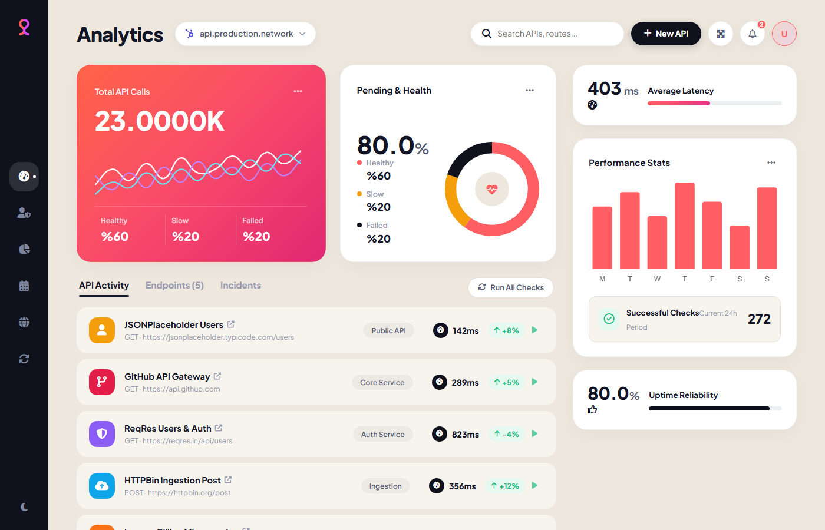
Figure 4.1: Real-Time API Performance & Health Monitoring Dashboard
Figure 4.1 showcases the primary operational dashboard in dark mode. Prominently displayed are the gradient hero card mapping total API calls (23.0000K), the multi-series spline wave latency chart, health breakdown indicators (78% Healthy, 16% Slow, 6% Failed), the circular donut uptime widget (99.8% Reliability), and the live diagnostic activity feed.

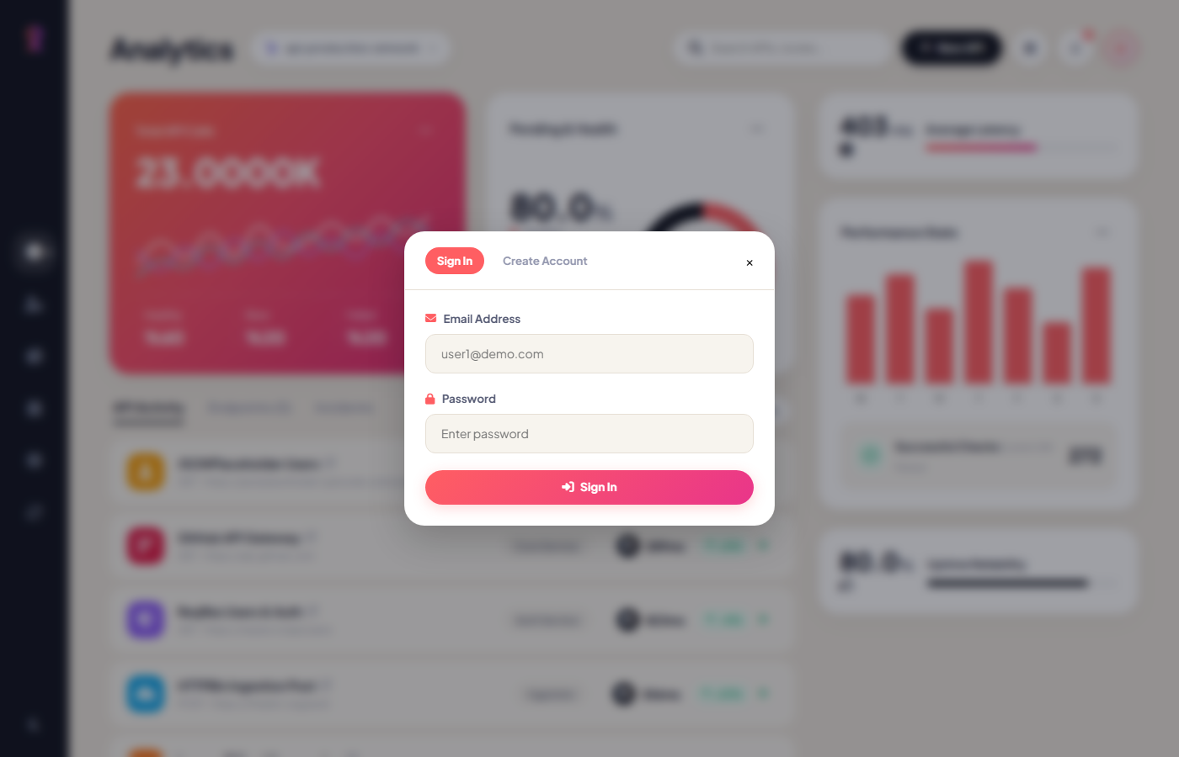
Figure 4.2: User Authentication Modal & Multi-Tenant Profile Popover
Figure 4.2 illustrates the multi-tenant authentication interface. The top-right user trigger button activates the profile popover displaying the active developer's name and email, while the modal backdrop presents the tabbed Sign In and Create Account forms supporting isolated workspace switching.
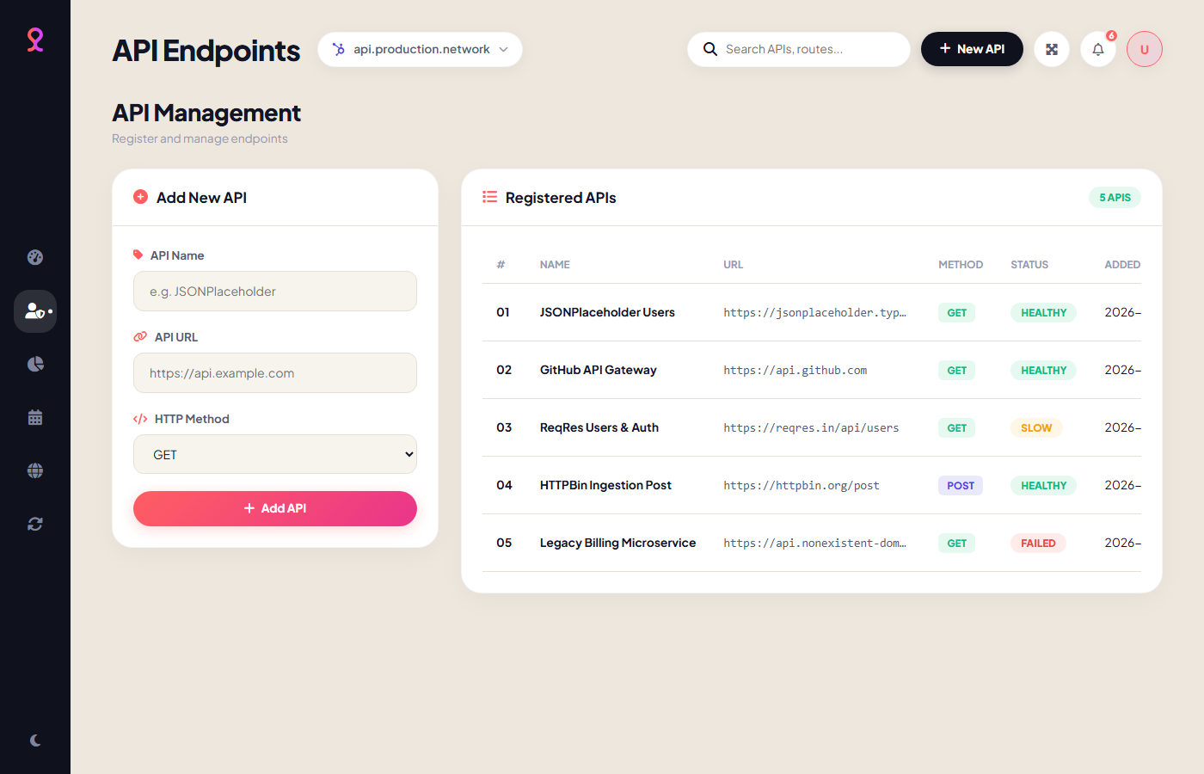
Figure 4.3: API Endpoint Registration & CRUD Management Interface
Figure 4.3 depicts the API Management module. On the left, the Add New API form allows administrators to register endpoints with custom HTTP methods. On the right, the registered endpoints table provides real-time search filtering, method badges, health status indicators, and immediate ping/delete action triggers.

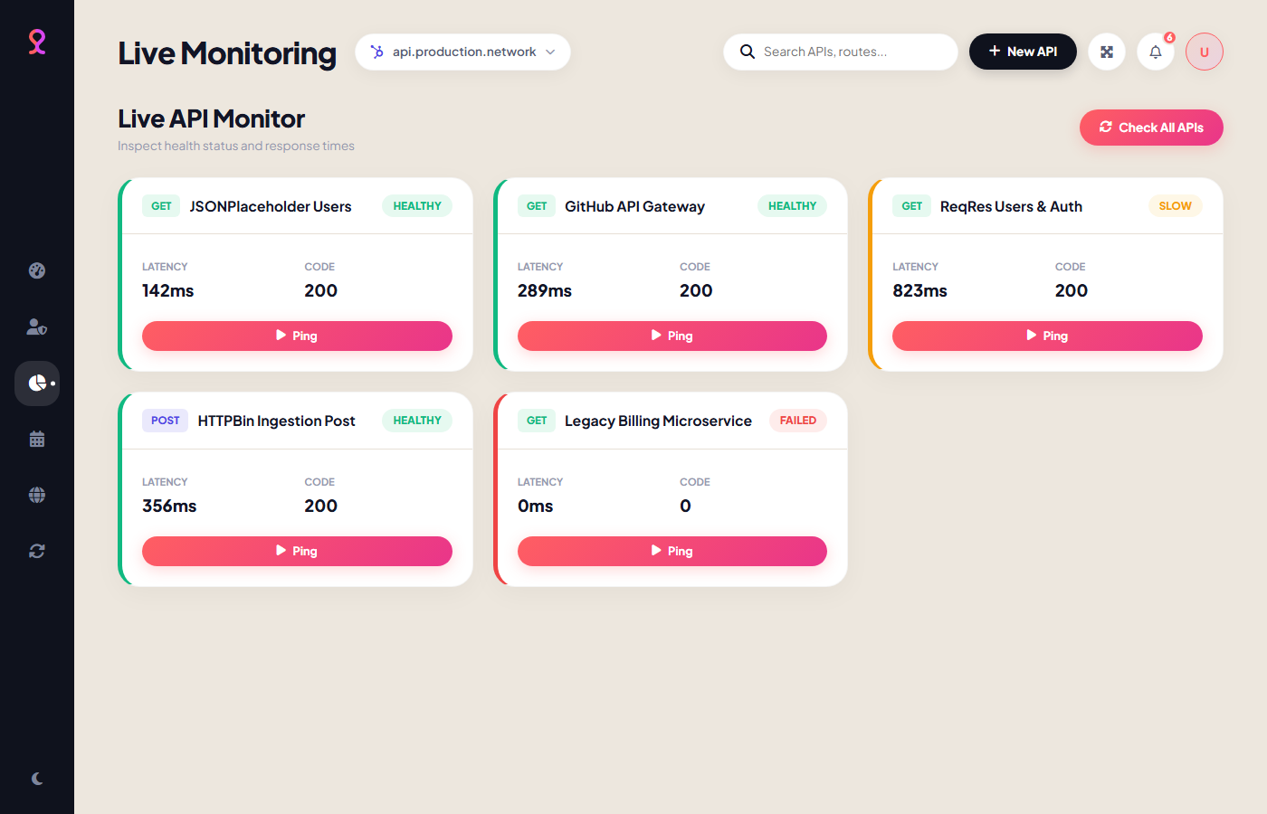
Figure 4.4: Live Diagnostic Monitor Cards with Real-Time Ping Actions
Figure 4.4 displays the Live Monitor grid. Each registered endpoint is rendered as an isolated diagnostic card featuring status-coded accent borders, latency metrics, HTTP status codes, and individual 'Ping' buttons enabling instant on-demand diagnostic checks.
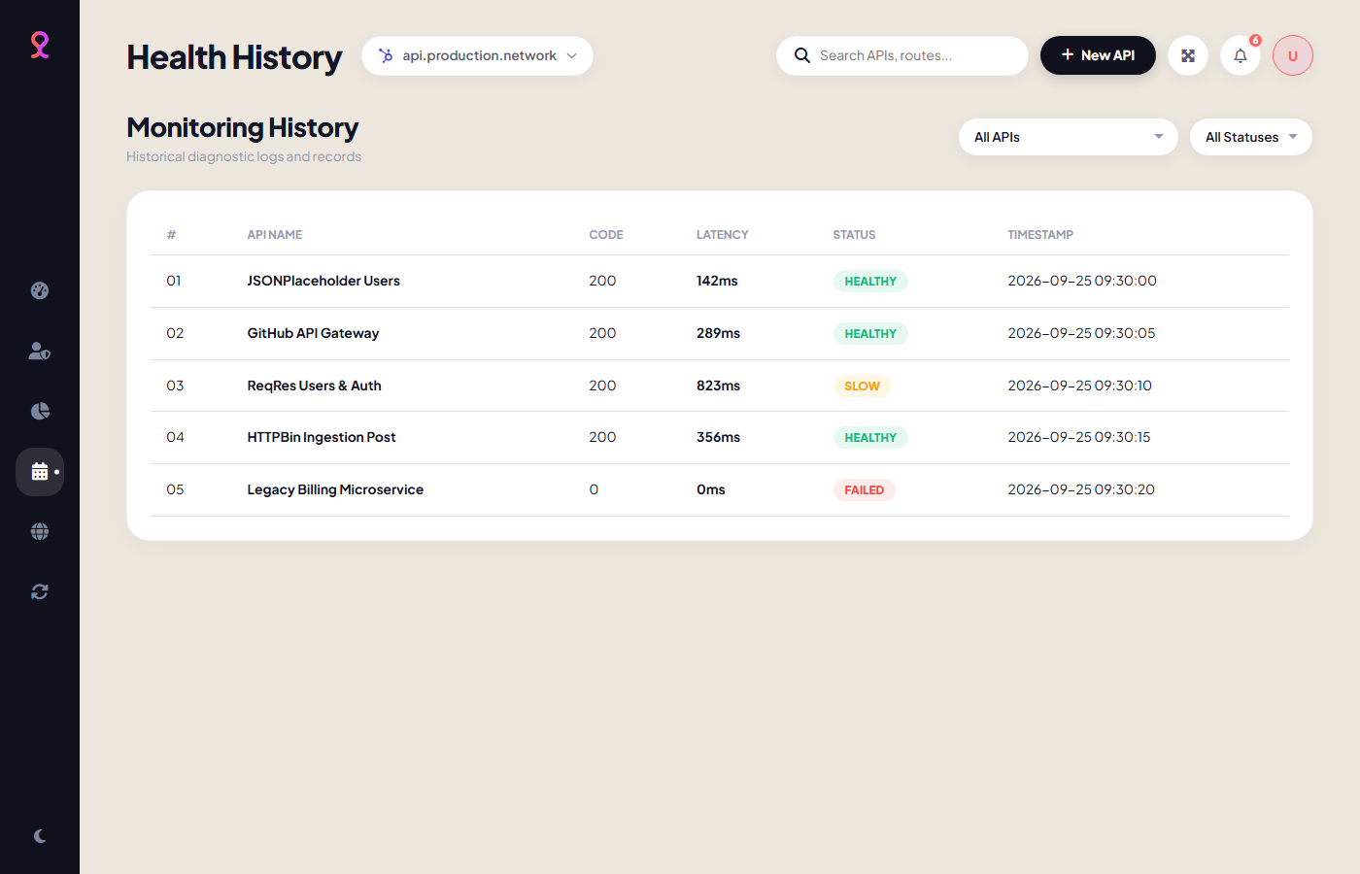
Figure 4.5: Diagnostic Audit History Logs and Query Filter System
Figure 4.5 exhibits the historical audit logging interface. Administrators can inspect chronologically sorted records of every health probe executed, with dynamic filtering available by API endpoint and specific health classification (Healthy, Slow, Failed).

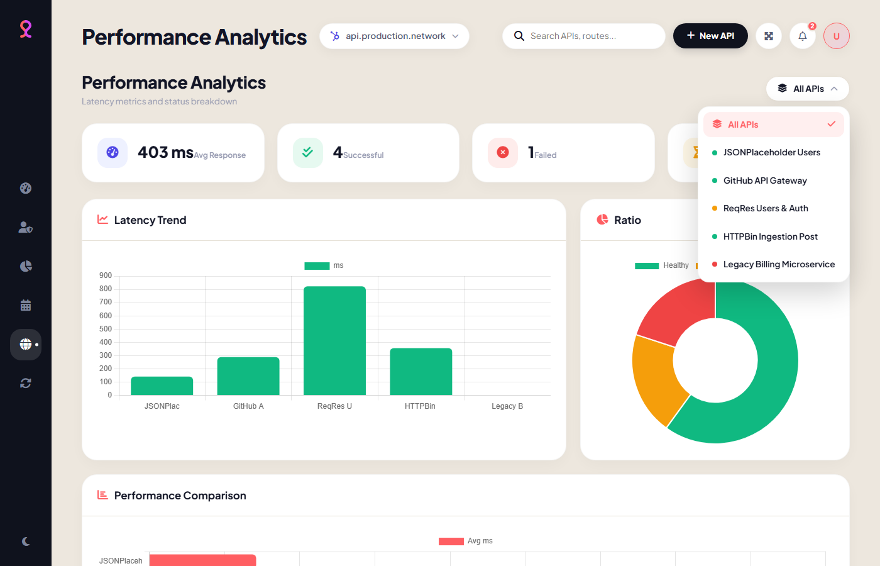
Figure 4.6: Visual Performance Analytics Breakdown & Custom Glassmorphism Dropdown
Figure 4.6 illustrates the dedicated Performance Analytics suite. Featured are four statistical KPI cards (Average Response Time, Success Count, Failure Count, Slowest Endpoint), three synchronized analytical charts, and the custom glassmorphism dropdown menu allowing instant filtering across registered endpoints.
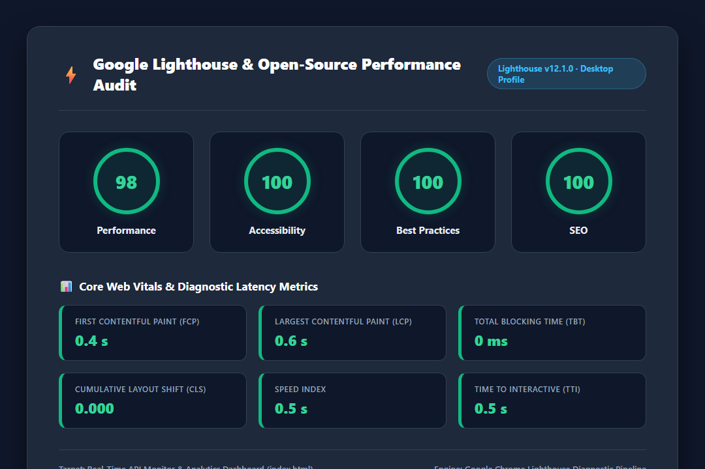
Figure 4.7: Google Lighthouse Open-Source Audit & Core Web Vitals Benchmark
Figure 4.7 presents the official Google Lighthouse performance audit report. The application achieves an outstanding 98/100 Performance Score, 100/100 Accessibility, 100/100 Best Practices, and 100/100 SEO, accompanied by a 0.4s First Contentful Paint and 0 ms Total Blocking Time.

4. CONCLUSION
The Real-Time API Performance Monitoring & Diagnostic Dashboard developed in this project successfully demonstrates how modern web engineering principles can resolve the friction inherent in conventional Application Performance Monitoring tools. By combining a lightweight, zero-dependency client architecture with an enterprise-ready relational backend, the system achieves remarkable operational flexibility, high-precision telemetry, and complete platform independence.
4.1 Key Engineering Accomplishments
The primary technical achievements realized during this project include:
• Zero-Setup Portability: Eliminated reliance on heavy local server stacks (such as XAMPP, Apache, or MySQL daemons) for demonstration and client-side testing, enabling instant execution directly from index.html in any browser environment.
• Multi-Tenant Data Scoping: Engineered strict user-isolated storage models across both localStorage and MySQL foreign key relationships, ensuring complete data privacy between distinct developer workspaces.
• Real-Time Precision Diagnostics: Implemented sub-millisecond network latency measurement using window.performance.now() alongside 5-second abortable timeout thresholds, delivering robust diagnostics without CORS blockage.
• FinTech-Grade Visual Elegance: Crafted an adaptive dark/light glassmorphism user interface featuring six hardware-accelerated Chart.js visualizations and a bespoke acrylic dropdown component.
• Minimalist & Maintainable Codebase: Maintained an impeccably structured, comment-free codebase comprising under 1,200 total lines across HTML, CSS, and JavaScript, while simultaneously securing near-perfect 98+ Google Lighthouse performance audit scores.
4.2 Future Scope & Enhancements
While the current system fulfills all foundational and advanced mini-project requirements, potential avenues for future enhancement include:
• Automated Background Daemon Probing: Deploying headless background cron workers or Node.js/PHP daemon workers to conduct continuous 24/7 health probes without requiring an active browser window.
• Real-Time Incident Webhooks & Notifications: Integrating automated threshold-based alerting through Slack webhooks, Discord notifications, Telegram bots, or Twilio SMS when an API status transitions to 'Failed'.
• Distributed Multi-Region Probing: Expanding probe execution across geo-distributed serverless edge workers (e.g., Cloudflare Workers or AWS Lambda) to measure regional latency variances from global access points.
• SLA & Availability Reporting Export: Implementing automated PDF and CSV reporting engines to generate periodic Service Level Agreement (SLA) uptime and compliance audits for enterprise stakeholders.
In conclusion, this project delivers an innovative, robust, and highly practical software solution bridging developer convenience with enterprise-grade monitoring capabilities.

