**Scenario 1: Library Management System**

**ER Diagram**

Entities and relationships:

* **Book** (Book ID, Title, Author, Publisher, Publication Year)
* **Copy** (Copy ID, Book ID)
* **Member** (Member ID, Name, Address, Phone Number, Email)
* **BorrowingTransaction** (Transaction ID, Member ID, Copy ID, Borrow Date, Due Date)
* **ReturningTransaction** (Transaction ID, Member ID, Copy ID, Return Date)
* **Fine** (Fine ID, Transaction ID, Amount, Payment Status)

**Relationships:**

1. A **Book** can have multiple **Copies**.
2. A **Member** can have multiple **BorrowingTransactions**.
3. A **BorrowingTransaction** involves one **Member** and one **Copy**.
4. A **ReturningTransaction** involves one **Member** and one **Copy**.
5. A **Fine** is associated with one **BorrowingTransaction**.
6. 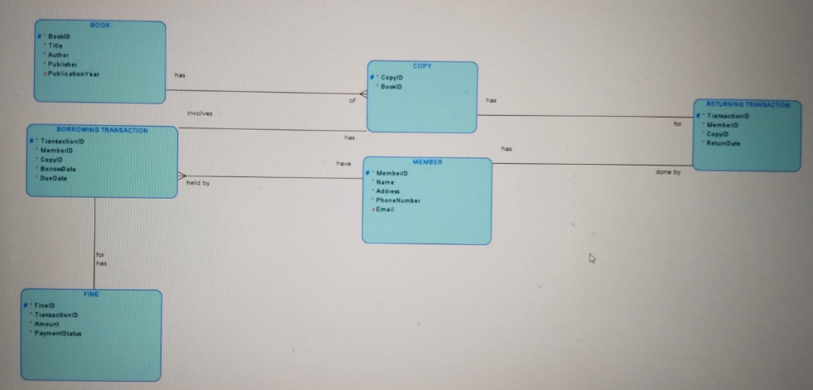

**Scenario 2: Online Retail Store**

**ER Diagram**

Entities and relationships:

* **Product** (ProductID, ProductName, Description, Price, StockQuantity)
* **Customer** (CustomerID, Name, Email, Address, PhoneNumber)
* **Order** (OrderID, CustomerID, OrderDate, TotalAmount)
* **OrderItem** (OrderItemID, OrderID, ProductID, Quantity, Price)
* **Payment** (PaymentID, OrderID, PaymentDate, PaymentAmount, PaymentMethod)

**Relationships:**

1. A **Customer** can place multiple **Orders**.
2. An **Order** can have multiple **OrderItems**.
3. An **OrderItem** is associated with one **Product**.
4. An **Order** can have multiple **Payments**.

