BEGIN

DBMS_OUTPUT.PUT_LINE('PL/SQL is easy!');

END;

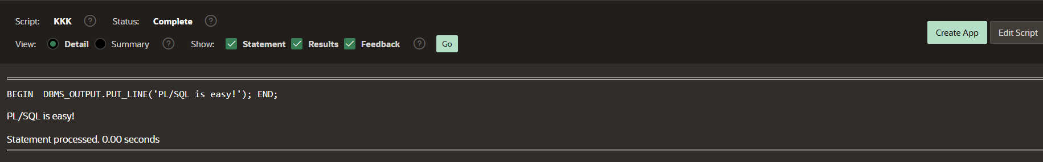

DECLARE

v_date DATE := SYSDATE;

BEGIN

DBMS_OUTPUT.PUT_LINE(v_date);

END;

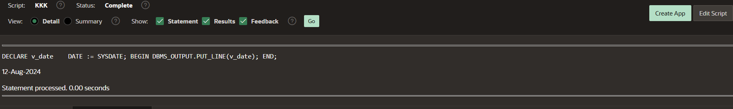

**DECLARE**

**v_FIRST_NAME VARCHAR2(35);**

**v_LAST_NAME VARCHAR2(20);**

**BEGIN**

**SELECT FIRST_NAME,LAST_NAME**

**INTO v_FIRST_NAME,v_LAST_NAME**

**FROM EMPLOYEES**

**WHERE LAST_NAME ='KARNATI';**

**DBMS_OUTPUT.PUT_LINE('The employee of the month is:'**

**|| v_FIRST_NAME || ' ' || v_LAST_NAME || '.');**

**EXCEPTION**

**WHEN TOO_MANY_ROWS THEN**

**DBMS_OUTPUT.PUT_LINE('Your select statement retrieved multiple rows.Consider using a cursor or changing the search criteria.');**

**END;**

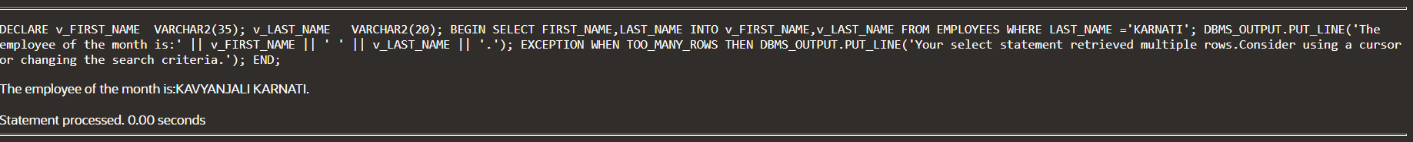

**DECLARE**

**a integer := 10;**

**b integer := 20;**

**c integer;**

**f real;**

**BEGIN**

**c := a + b;**

**dbms_output.put_line('Value of c: ' || c);**

**f := 70.0/3.0;**

**dbms_output.put_line('Value of f: ' || f);**

**END;**

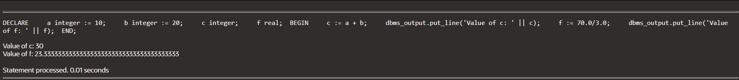

DECLARE

-- constant declaration

pi constant number := 3.141592654;

-- other declarations

radius number(5,2);

dia number(5,2);

circumference number(7, 2);

area number (10, 2);

BEGIN

-- processing

radius := 9.5;

dia := radius * 2;

circumference := 2.0 * pi * radius;

area := pi * radius * radius;

-- output

dbms_output.put_line('Radius: ' || radius);

dbms_output.put_line('Diameter: ' || dia);

dbms_output.put_line('Circumference: ' || circumference);

dbms_output.put_line('Area: ' || area);

END;

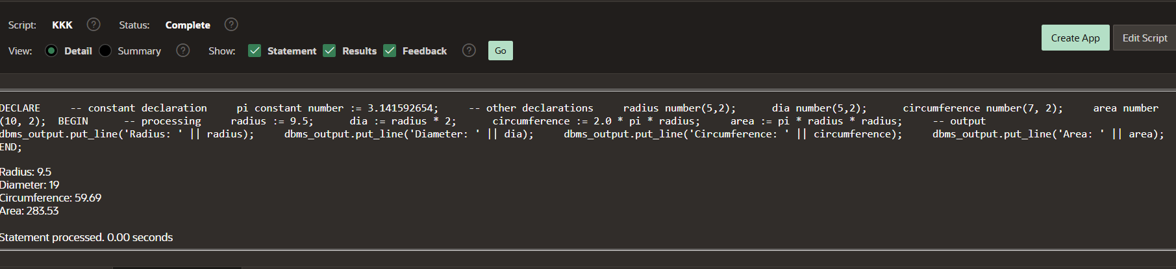

DECLARE

str VARCHAR2(40) := 'Tutorials Point';

nchars NUMBER(4) := 0;

nwords NUMBER(4) := 1;

s CHAR;

BEGIN

FOR i IN 1..Length(str) LOOP

s := Substr(str, i, 1);

nchars:= nchars+ 1;

IF s = ' ' THEN

nwords := nwords + 1;

END IF;

END LOOP;

dbms_output.Put_line('count of characters is:'

||nchars);

dbms_output.Put_line('Count of words are: '

||nwords);

END;

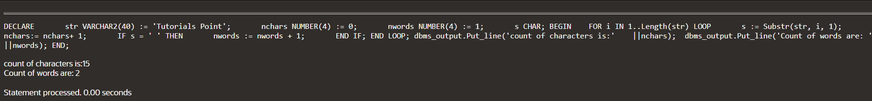

DECLARE

sum_number NUMBER := 0;

BEGIN

FOR i IN 1..5 LOOP

sum_number := sum_number + i;

END LOOP;

dbms_output.put_line('The sum of the first numbers is: ' || sum_number);

END;

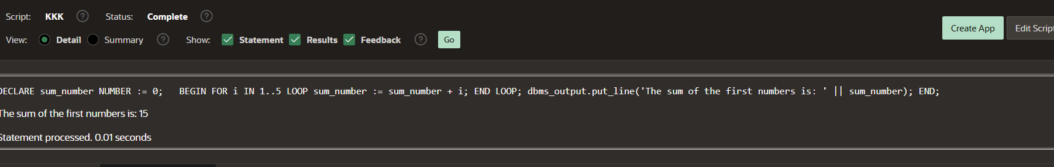

DECLARE

n NUMBER := 20;

BEGIN

FOR i IN 1..n LOOP

IF MOD(i, 2) = 0 THEN

dbms_output.put_line(i);

END IF;

END LOOP;

END;

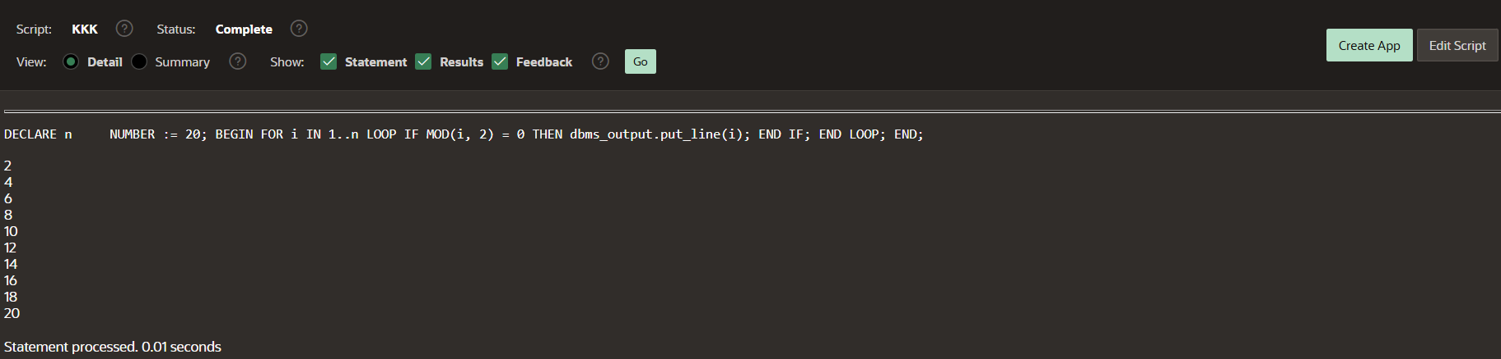

DECLARE

type namesarray IS VARRAY(5) OF VARCHAR2(10);

type grades IS VARRAY(5) OF INTEGER;

names namesarray;

marks grades;

total integer;

BEGIN

names := namesarray('Kavita', 'Pritam', 'Ayan', 'Rishav', 'Aziz');

marks:= grades(98, 97, 78, 87, 92);

total := names.count;

dbms_output.put_line('Total '|| total || ' Students');

FOR i in 1 .. total LOOP

dbms_output.put_line('Student: ' || names(i) || '

Marks: ' || marks(i));

END LOOP;

END;

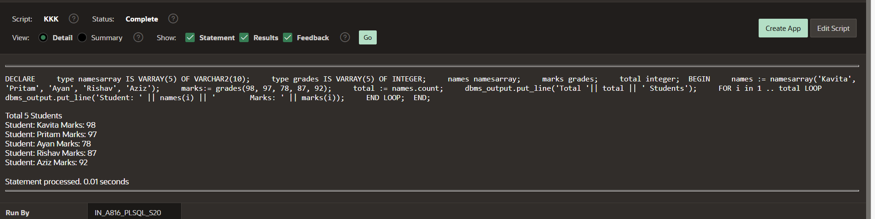

DECLARE

v_num NUMBER;

v_even_count NUMBER := 0;

v_odd_count NUMBER := 0;

BEGIN

-- Array of numbers to check

FOR v_num IN 1..10 LOOP

IF MOD(v_num, 2) = 0 THEN

v_even_count := v_even_count + 1; -- Increment even count

ELSE

v_odd_count := v_odd_count + 1; -- Increment odd count

END IF;

END LOOP;

-- Output the results

DBMS_OUTPUT.PUT_LINE('Number of even numbers: ' || v_even_count);

DBMS_OUTPUT.PUT_LINE('Number of odd numbers: ' || v_odd_count);

END;

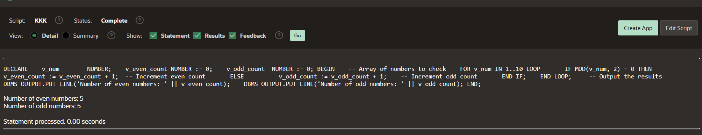

DECLARE

a number;

b number;

c number;

PROCEDURE findMin(x IN number, y IN number, z OUT number) IS

BEGIN

IF x < y THEN

z:= x;

ELSE

z:= y;

END IF;

END;

BEGIN

a:= 23;

b:= 45;

findMin(a, b, c);

dbms_output.put_line(' Minimum of (23, 45) : ' || c);

END;

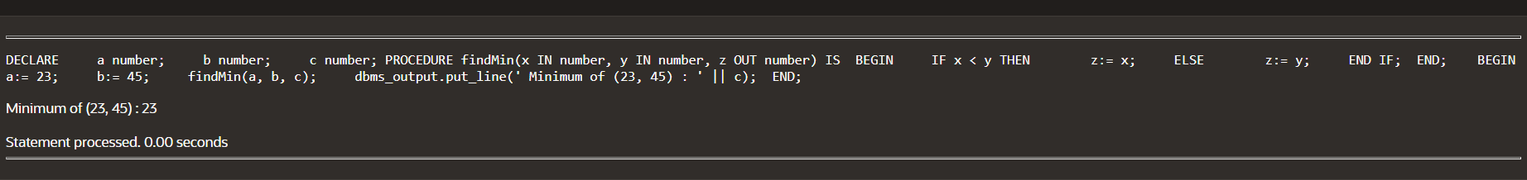

DECLARE

num1 NUMBER;

num2 NUMBER;

operation CHAR(1);

result NUMBER;

BEGIN

num1 := 10;

num2 := 5;

operation := '+';

CASE operation

WHEN '+' THEN

result := num1 + num2;

WHEN '-' THEN

result := num1 - num2;

WHEN '*' THEN

result := num1 * num2;

WHEN '/' THEN

IF num2 = 0 THEN

DBMS_OUTPUT.PUT_LINE('Error: Division by zero');

RETURN;

ELSE

result := num1 / num2;

END IF;

ELSE

DBMS_OUTPUT.PUT_LINE('Error: Invalid operation');

RETURN;

END CASE;

DBMS_OUTPUT.PUT_LINE('Result: ' || result);

END;

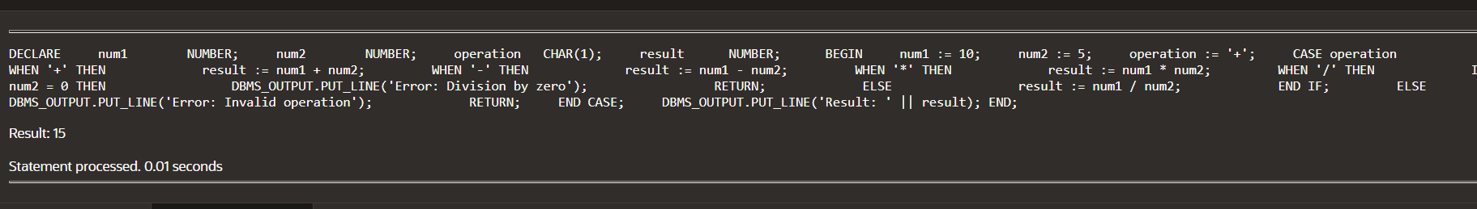

E6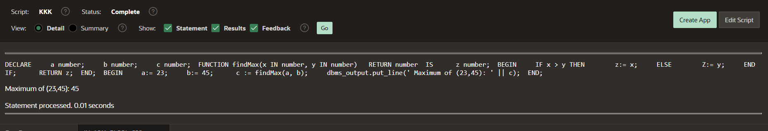7