A Project Report on
Logic Simplification & K-Map Wizard
(Mini Project)
Of Course
Digital Logic Design (DLD)
Submitted By
Kavyansh Goenka
Roll No:
N248
SAP ID:
70472400283
Under The Guidance Of
Prof. Bhushan Inje

Mukesh Patel School of Technology & Management Engineering
Department of Computer Engineering
Shirpur-425405
Year : 2025-26

Signature Of Faculty

Abstract
This mini project titled “Logic Simplification & K-Map Wizard” is an interactive web-based application developed using HTML, CSS (Tailwind framework), and JavaScript. The project automates the process of simplifying Boolean expressions using Karnaugh Maps (K-Maps) and presents the minimized Sum of Products (SOP) and Product of Sums (POS) forms in real-time. It allows users to input either Boolean expressions or min/max terms, automatically generates truth tables, K-map groupings, and logic circuit diagrams for both SOP and POS.
The project aims to bridge theoretical understanding of Boolean algebra and practical circuit design visualization, enhancing the learning experience for undergraduate DLD students.

1. Introduction
Digital Logic Design (DLD) is a core subject in electronics and computer engineering that deals with the representation and simplification of logical operations using Boolean algebra. Boolean simplification is essential for reducing the number of gates and optimizing circuit performance.
The purpose of this project is to create a visual and interactive tool that helps students and engineers understand the process of logic simplification and circuit realization. By integrating computation and visualization, the tool allows learners to quickly experiment with Boolean functions and observe their minimized forms and corresponding circuit diagrams.

2. Objective
The main objectives of this project are:
- To design a web-based tool for simplifying Boolean expressions using K-Maps.
- To display real-time results for truth tables, SOP, and POS forms.
- To visualize the minimized logic using interactive circuit diagrams.
- To enable students to understand the concept of logic minimization more effectively.

3. Tools and Technologies Used

Technology | Purpose
HTML5 | Structure and layout of the web interface
CSS (Tailwind) | Styling and responsive design
JavaScript (ES6) | Logical processing and visualization
KaTeX Library | Mathematical rendering for Boolean expressions
SVG | Logic diagram generation

4. System Description
The Logic Simplification & K-Map Wizard provides multiple functionalities:
4.1 Input Modes
- Expression Mode: Allows the user to input a Boolean function (e.g., A'B + C D' + A B C D).
- Min/Max Term Mode: Accepts inputs like m(0, 1, 3, 4) or M(2, 5, 6) for canonical expressions.
4.2 K-Map Generation
The system creates a 4-variable K-Map (A, B, C, D) and automatically groups 1s or 0s depending on the chosen simplification mode (SOP or POS). Grouping colors visually indicate combined cells for minimized expression.
4.3 Truth Table Generation
A dynamically generated truth table shows all 16 combinations of variables A, B, C, and D with corresponding function output values.
4.4 Logic Circuit Diagram
The project converts simplified SOP and POS equations into corresponding AND-OR and OR-AND logic diagrams respectively using SVG-based gates (AND, OR, NOT). These diagrams represent the hardware implementation of the simplified expression.

5. Understanding Key Concepts

5.1 Boolean Algebra
Boolean algebra is the foundation of digital logic, involving variables that take only two values: 0 and 1. Operations include AND, OR, and NOT, forming the basis for logical reasoning and circuit construction.
5.2 Karnaugh Map (K-Map)
A Karnaugh Map is a graphical tool used to simplify Boolean expressions. It provides a visual method of minimizing logic by grouping adjacent cells representing combinations that yield logical 1s (for SOP) or 0s (for POS). K-Maps help in reducing circuit complexity, minimizing gate count, and improving speed and power efficiency.
5.3 SOP and POS Forms
- Sum of Products (SOP): Logical OR of multiple AND terms. Used when 1s are grouped.
- Product of Sums (POS): Logical AND of multiple OR terms. Used when 0s are grouped.

6. Interface Of Webpage

Link: http://yelping-blush-m3j4ozvvqh.edgeone.app

1) K – Map for SOP
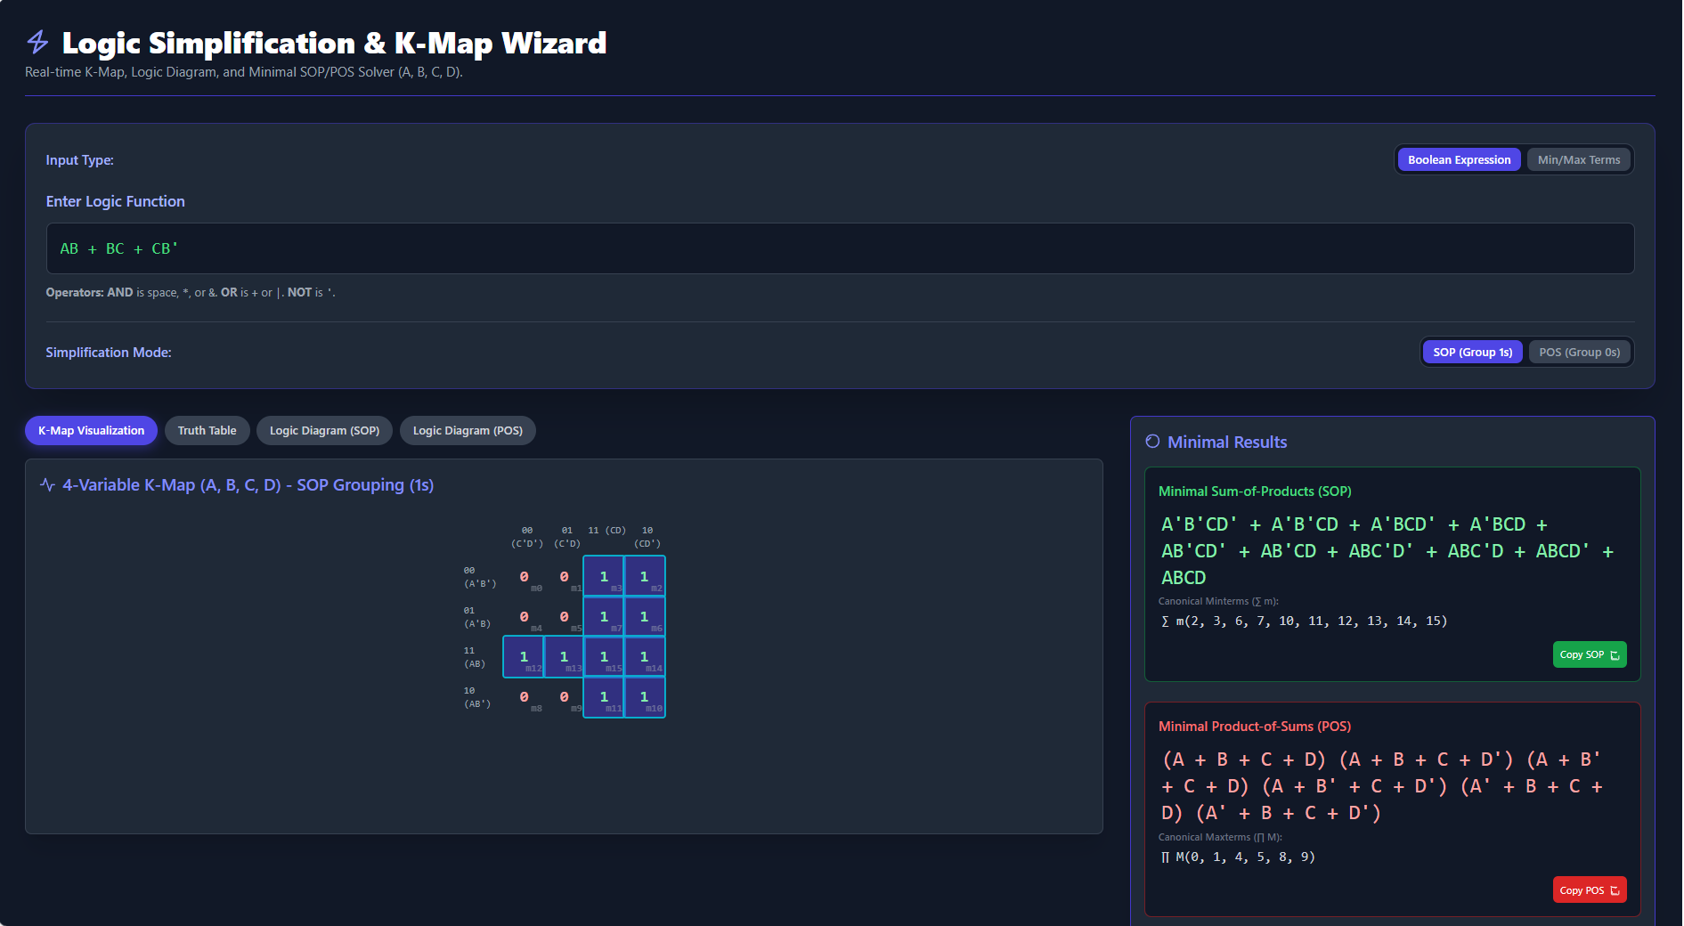

2) K – Map for POS

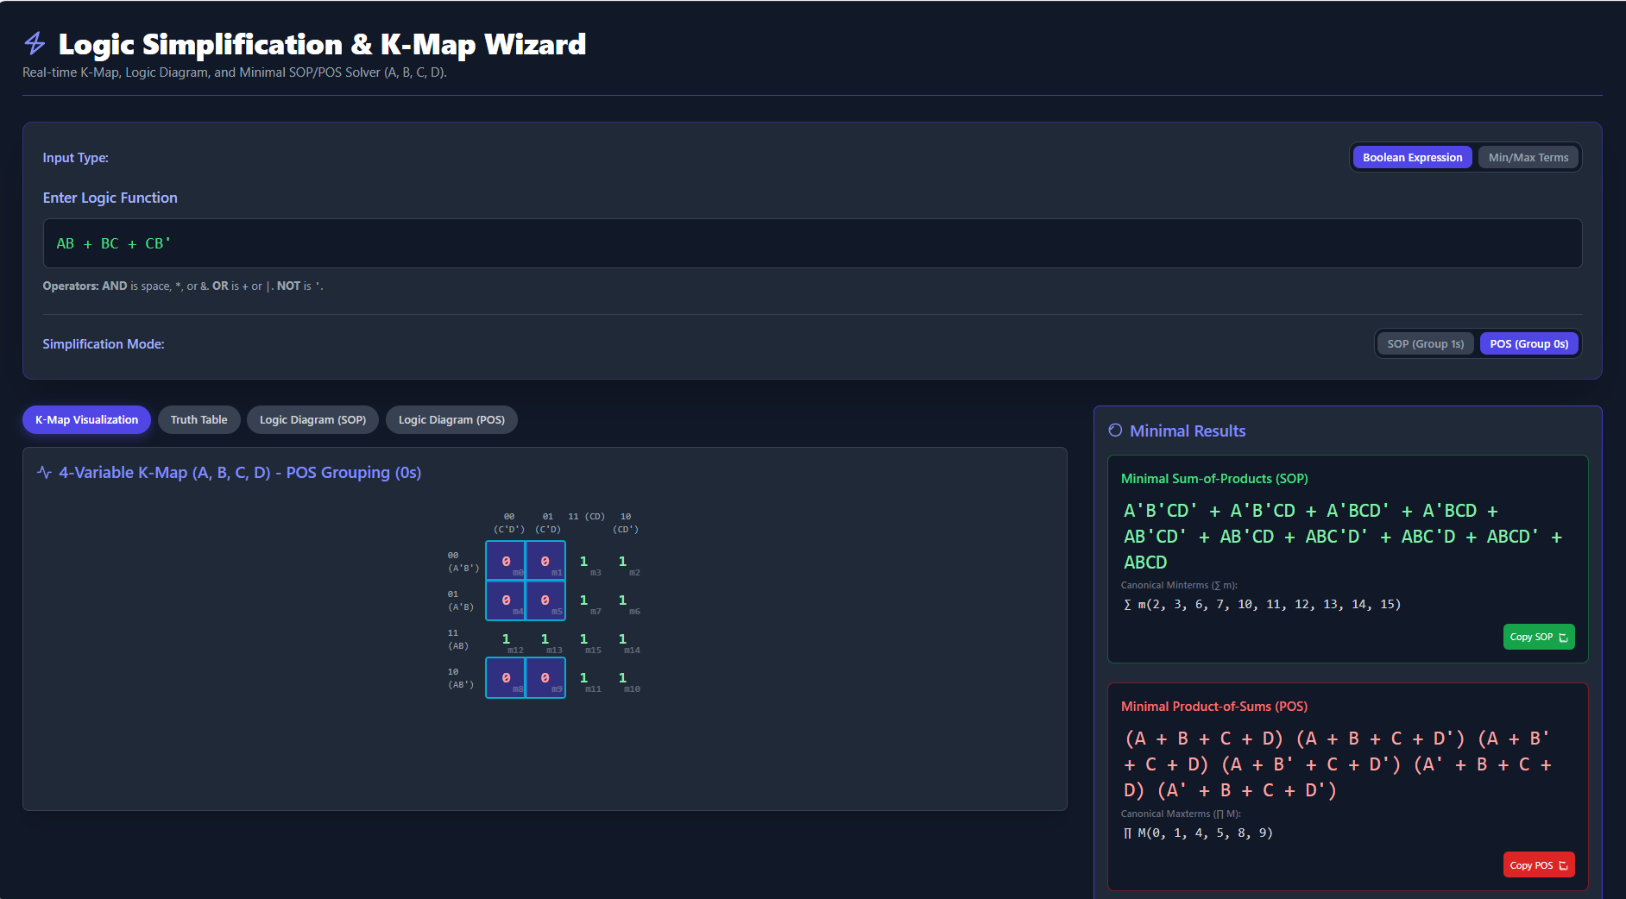

3) Truth Table
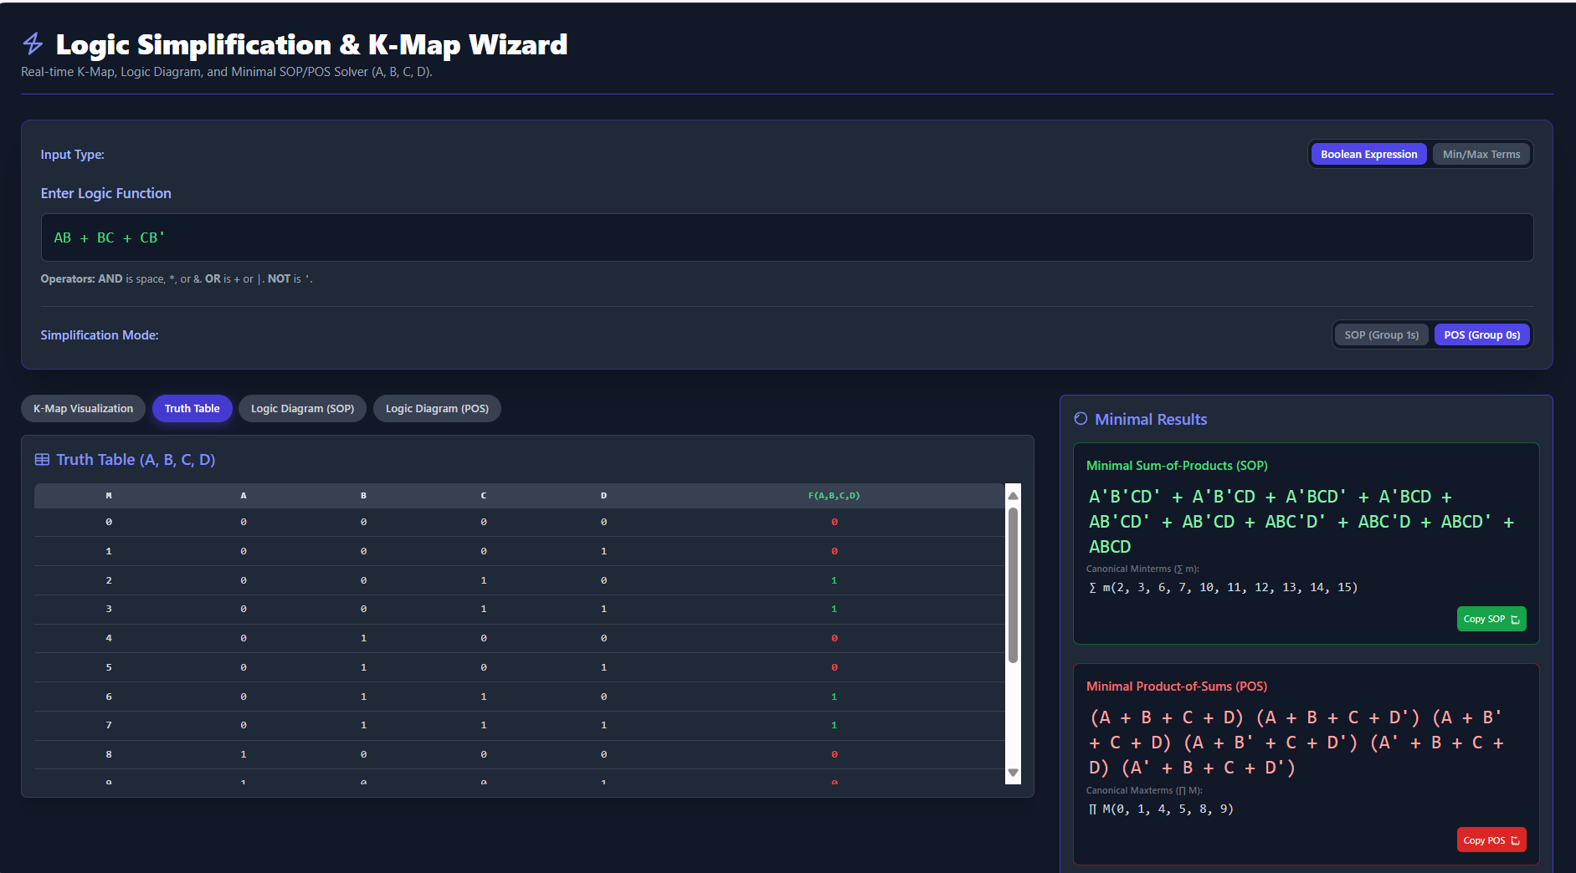

4) Logic Diagram SOP

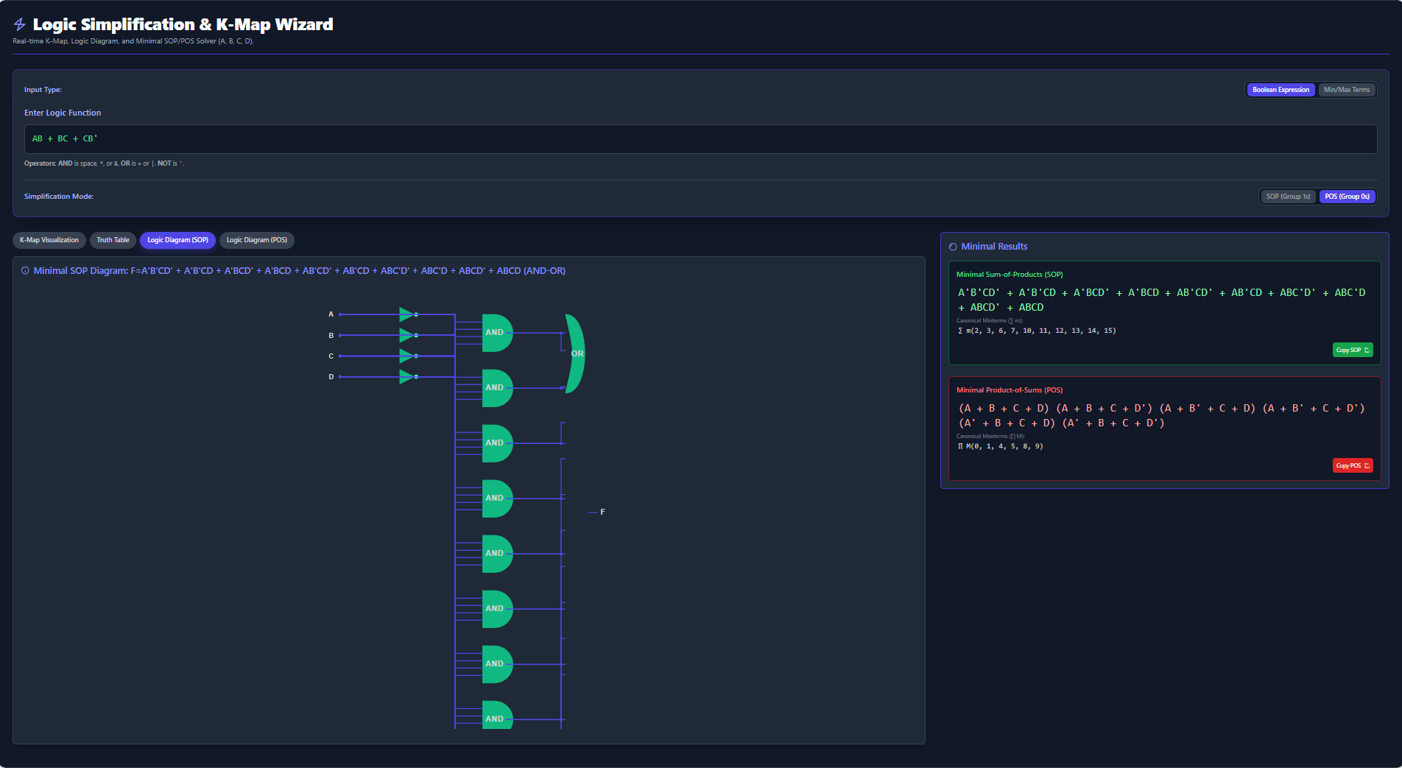

4) Logic Diagram POS
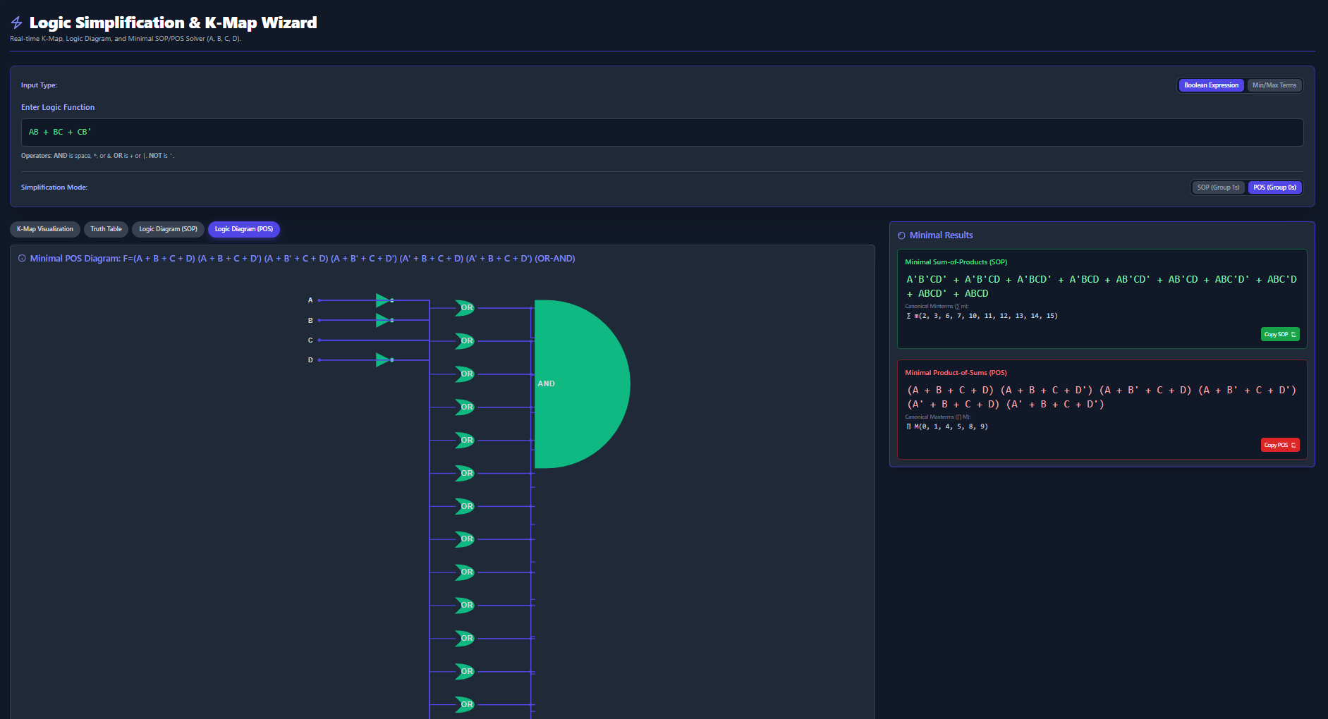

7. Applications and Benefits
- Educational Tool: Helps students learn Boolean simplification visually.
- Circuit Design Aid: Allows quick generation of minimized logic for hardware design.
- Error Reduction: Minimizes human error in manual K-Map simplification.
- Interactive Visualization: Converts abstract algebraic concepts into practical circuit diagrams.
- AI Integration: The interface was enhanced using AI-assisted development to optimize code readability, interactivity, and UI responsiveness.

8. Future Scope
- Multi-variable K-Map Extension: Expand the functionality beyond 4-variable systems.
- Hardware Implementation: Integrate with FPGA or digital trainers for real-time verification.
- AI-based Simplification: Use AI algorithms for heuristic simplification of complex logic functions.
- Step-by-step Explanation: Implement guided explanations for each simplification stage.
- Cloud Storage: Save user projects and diagrams for further analysis or classroom presentations.

9. Conclusion
The Logic Simplification & K-Map Wizard provides an intuitive and powerful platform to simplify Boolean logic functions and visualize their equivalent digital circuits. It strengthens conceptual clarity and enhances learning through interaction and automation. The project effectively combines Digital Logic Design principles with modern web technologies, serving as a bridge between theory and practical application.

10. References
1. Morris Mano, Digital Design, Pearson Education.
2. Floyd, T.L., Digital Fundamentals, Pearson Education.
3. Online documentation of Tailwind CSS and KaTeX.
4. OpenAI and AI-assisted code generation tools.
5. Used Gemini AI for generating and collaborating for the required codes.

