ShopNest Store Capstone
Dashboard Report — With Real Insights & Screenshots

Prepared by: Kavya Panka
Date: 21-Dec-2025

Executive Summary
The Power BI dashboard consolidates retail performance for ShopNest across orders, sales, delivery timeliness, payments, product ratings, geography, seasonality, and revenue trends. Key KPIs with **MonthName = All**, **State = All**, **Category = All**:
- Total Revenue: **16.01M**
- Total Orders: **99.441K**
- Total Sales (units): **10.51K**
- Average Rating: **4.07** / 5

What Was Built in Power BI
• One-page summary with side navigation (Summary, Category, Ratings, Trends).
• Slicers: MonthName, State, Category Name.
• DAX measures for revenue, orders, units, ratings, delayed/on-time flags, YoY and YTD.
• Eight visuals mapped to capstone tasks.

1) Top Categories by Total Price
Visual: Horizontal bar chart — Top 10 categories by Total Sales.
Real insights: small_appliances leads (~900), followed by computers (~700), construction_material (~600), health_beauty (~550), etc.
Action: Prioritize assortment & promos for the top categories.
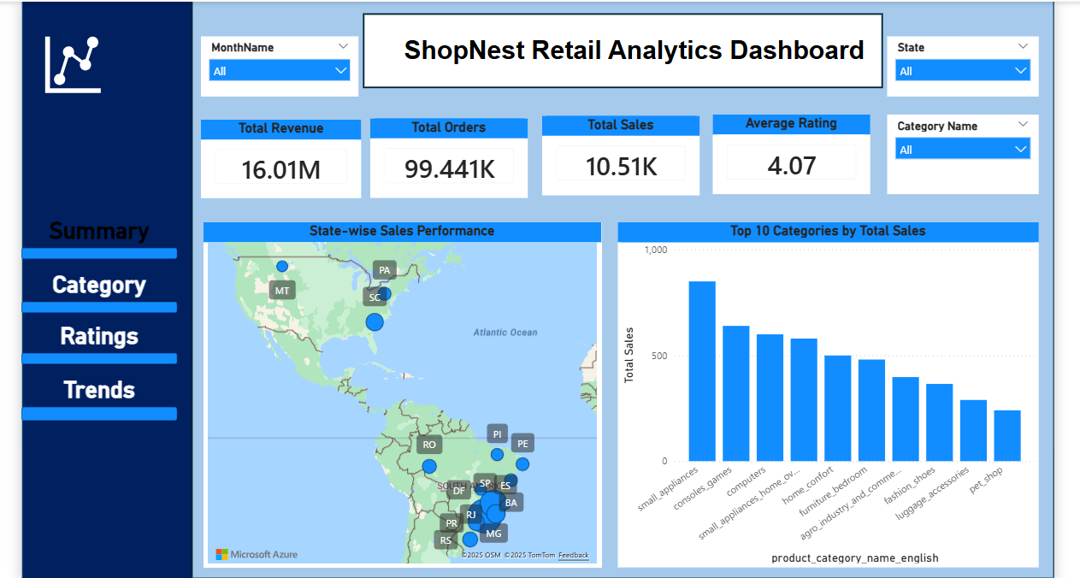
Summary page — Top 10 Categories by Total Sales

2) Delayed Orders Analysis (by Category)
Visual: Clustered bar chart of Delayed Orders per category.
Real insights: computers shows the highest delayed orders; others are comparatively low. Overall on-time ~90–95%.
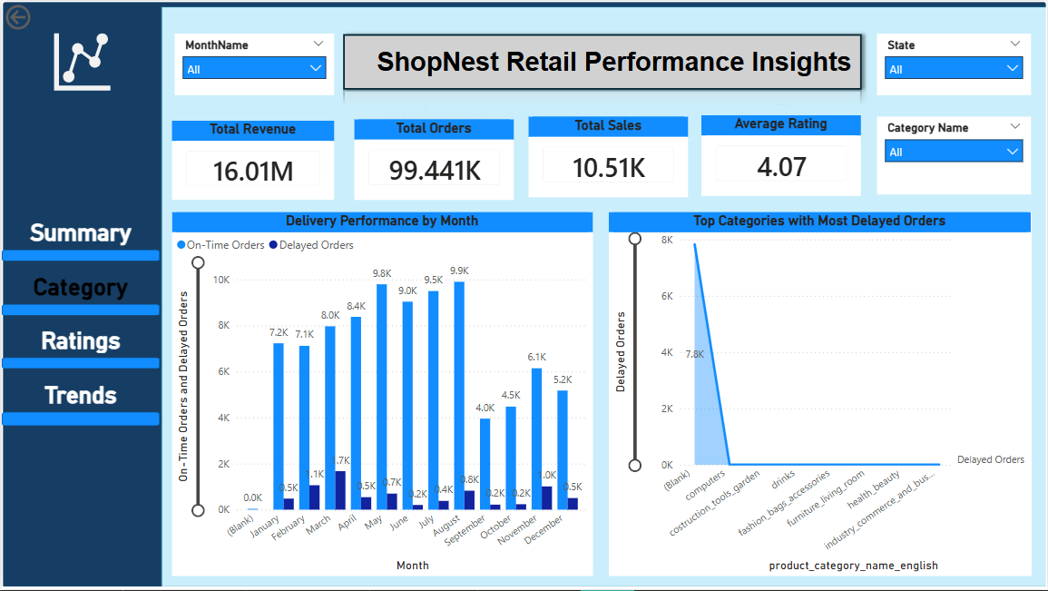
Category page — Top categories with most delayed orders

3) Monthly Comparison of Delayed vs On-Time Orders
Visual: Combo chart (columns for On-Time and Delayed) with drill-through.
Monthly pattern observed: On-time peaks in Jun/Jul; dips in Apr–Jul and Dec. Delayed stays below 1K most months.
Delivery performance by month

4) Payment Method Analysis
Visual: Pie chart of order count by payment type.
Shares: credit_card 77K (73.2%), boleto 20K (19.0%), voucher 6K (5.86%), others small.
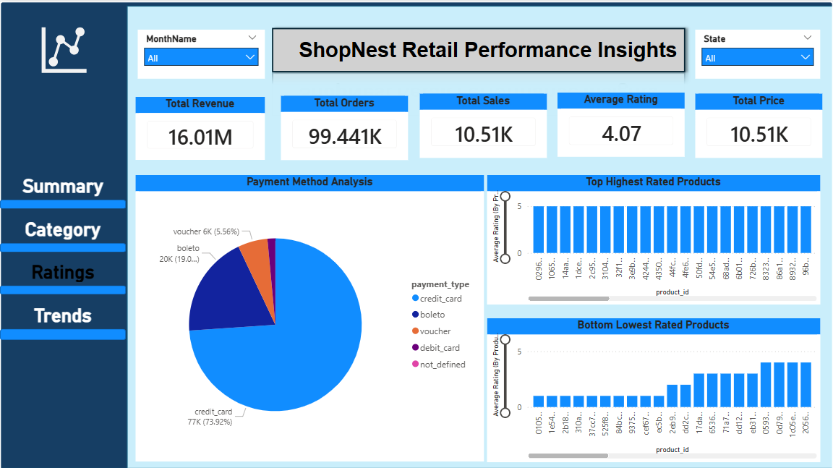
Payment Method Analysis

5) Product Rating Analysis — Top & Bottom 10
Visuals: Two column charts for Top 10 highest-rated and Bottom 10 lowest-rated product IDs.
Average Rating overall = 4.07. Top ~4.8–5.0; Bottom ~3.0–3.4.
Top & Bottom rated products

6) State-wise Sales Analysis
Visual: Filled map of Brazil states.
Strong states: SP, RJ, MG, PR, RS. Opportunities in Northern states (PA, RO, RR).
State-wise Sales Performance map

7) Seasonal Sales Patterns (Monthly/Quarterly)
Visual: Monthly line chart. Peaks: Apr (1,731), Jun (1,401). Trough: Sep (226). Q2 highest; Q3 lags.
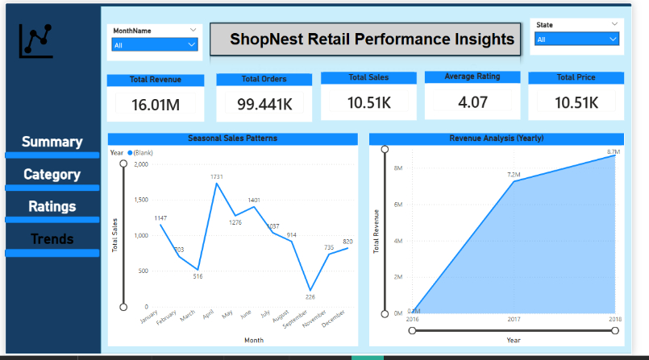
Seasonal Sales Patterns

8) Revenue Analysis (Yearly)
Visual: YoY revenue area/line chart. 2017 ≈ 7.2M; 2018 ≈ 8.7M → ~20.8% YoY growth.
Revenue Analysis (Yearly)

Conclusion & Recommendations
Dashboard fulfills all eight tasks. Recommended next actions: focus top categories, fix computers delays, ramp capacity in peak months, optimize card processing, remediate low-rated SKUs, expand geographically, and plan campaigns around Q2 peaks.

