OOP 25AIML053
Name: | Kavya Patel
Student ID: | 25AIML053
Department: | CSPIT-AIML
Batch: | C

EXPERIMENT 1:
CODE:

1.

import java.util.Scanner;

public class experiment1{

enum Coin {
ONE, TWO, FIVE, TEN
}

public static void main(String[] args) {

// (b) Snack price and running total
int snackPrice = 15;
int total = 0;

Scanner sc = new Scanner(System.in);

while (total < snackPrice) {
System.out.print("Enter coin (ONE, TWO, FIVE, TEN): ");
String input = sc.next().toUpperCase();

Coin coin = Coin.valueOf(input);

int value = switch (coin) {
case ONE -> 1;
case TWO -> 2;
case FIVE -> 5;
case TEN -> 10;
};

total += value;
System.out.println("Total so far: " + total);
}

System.out.println("Paid. Change: " + (total - snackPrice));

sc.close();
}
}

SCREENSHOT:
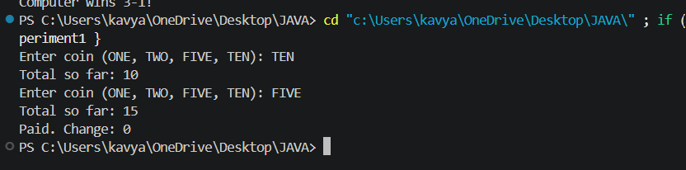

2.

import java.util.Scanner;

public class experiment1toll{

record Vehicle(String number, String type) {}

public static void main(String[] args) {

Scanner sc = new Scanner(System.in);

int totalToll = 0;
int bikeCount = 0;
int carCount = 0;
int truckCount = 0;

while (true) {
System.out.print("Enter vehicle number (or 'done' to stop): ");
String number = sc.next();

if (number.equalsIgnoreCase("done")) {
break;
}

System.out.print("Enter vehicle type (bike/car/truck): ");
String type = sc.next().toLowerCase();

Vehicle vehicle = new Vehicle(number, type);

int toll = switch (vehicle.type()) {
case "bike" -> {
bikeCount++;
yield 20;
}
case "car" -> {
carCount++;
yield 50;
}
case "truck" -> {
truckCount++;
yield 150;
}
default -> {
System.out.println("Invalid vehicle type!");
yield 0;
}
};

totalToll += toll;
}

String mostFrequent;

if (bikeCount >= carCount && bikeCount >= truckCount) {
mostFrequent = "bike";
} else if (carCount >= bikeCount && carCount >= truckCount) {
mostFrequent = "car";
} else {
mostFrequent = "truck";
}

System.out.println("Total toll: " + totalToll);
System.out.println("Most frequent: " + mostFrequent);
sc.close();
}
}

SCREENSHOT:

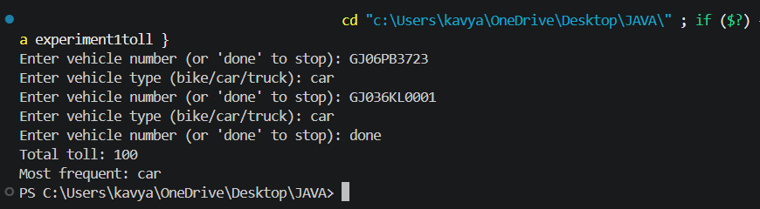

3.

import java.util.Random;
import java.util.Scanner;

public class experiment1RPSLS {

enum Move {
ROCK, PAPER, SCISSORS, LIZARD, SPOCK
}

public static int winner(Move a, Move b) {
if (a == b) {
return 0;
}

return switch (a) {
case ROCK ->
(b == Move.SCISSORS || b == Move.LIZARD) ? 1 : -1;

case PAPER ->
(b == Move.ROCK || b == Move.SPOCK) ? 1 : -1;

case SCISSORS ->
(b == Move.PAPER || b == Move.LIZARD) ? 1 : -1;

case LIZARD ->
(b == Move.SPOCK || b == Move.PAPER) ? 1 : -1;

case SPOCK ->
(b == Move.SCISSORS || b == Move.ROCK) ? 1 : -1;
};
}

public static void main(String[] args) {

Scanner sc = new Scanner(System.in);
Random random = new Random();

Move[] moves = Move.values();

int playerScore = 0;
int computerScore = 0;

System.out.println("=== Rock Paper Scissors Lizard Spock ===");
System.out.println("Available moves: ROCK, PAPER, SCISSORS, LIZARD, SPOCK");

for (int round = 1; round <= 5; round++) {

System.out.println("\nRound " + round);
System.out.print("Enter your move: ");

Move playerMove;

try {
playerMove = Move.valueOf(sc.next().toUpperCase());
} catch (IllegalArgumentException e) {
System.out.println("Invalid move! Round skipped.");
continue;
}

Move computerMove = moves[random.nextInt(moves.length)];

System.out.println("You chose: " + playerMove);
System.out.println("Computer chose: " + computerMove);

int result = winner(playerMove, computerMove);

if (result == 1) {
System.out.println("You win this round!");
playerScore++;
} else if (result == -1) {
System.out.println("Computer wins this round!");
computerScore++;
} else {
System.out.println("It's a tie!");
}
}

System.out.println("\n===== Final Result =====");
System.out.println("Your Score: " + playerScore);
System.out.println("Computer Score: " + computerScore);

if (playerScore > computerScore) {
System.out.println("You win " + playerScore + "-" + computerScore + "!");
} else if (computerScore > playerScore) {
System.out.println("Computer wins " + computerScore + "-" + playerScore + "!");
} else {
System.out.println("Match tied " + playerScore + "-" + computerScore + "!");
}

sc.close();
}
}

SCREENSHOT:
