727721EUAI027

Kavya P

QUESTION:01

**package** com.example.demo.Day10;

**import** org.openqa.selenium.By;

**import** org.openqa.selenium.WebDriver;

**import** org.openqa.selenium.edge.EdgeDriver;

**import** io.github.bonigarcia.wdm.WebDriverManager;

**public** **class** cc1 {

**public** **static** **void** main(String[] arg)

{

WebDriverManager.*edgedriver*().setup();

WebDriver driver=**new** EdgeDriver();

driver.get("https://www.saucedemo.com/");

driver.findElement(By.*xpath*("//*[@id=\"user-name\"]")).sendKeys("standard_user");

driver.findElement(By.*xpath*("//*[@id=\"password\"]")).sendKeys("secret_sauce");

driver.findElement(By.*xpath*("//*[@id=\"login-button\"]")).click();

driver.findElement(By.*xpath*("//*[@id=\"add-to-cart-sauce-labs-backpack\"]")).click();

driver.findElement(By.*xpath*("//*[@id=\"shopping_cart_container\"]/a")).click();

driver.findElement(By.*xpath*("//*[@id=\"checkout\"]")).click();

driver.findElement(By.*xpath*("//*[@id=\"first-name\"]")).sendKeys("standard");

driver.findElement(By.*xpath*("//*[@id=\"last-name\"]")).sendKeys("user");

driver.findElement(By.*xpath*("//*[@id=\"postal-code\"]")).sendKeys("641108");

driver.findElement(By.*xpath*("//*[@id=\"continue\"]")).click();

System.***out***.println();

driver.findElement(By.*xpath*("//*[@id=\"finish\"]")).click();

}

}

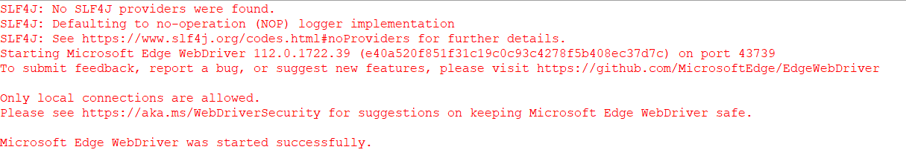

QUESTION:02

**package** com.example.demo.Day10;

**import** org.openqa.selenium.By;

**import** org.openqa.selenium.WebDriver;

**import** org.openqa.selenium.edge.EdgeDriver;

**import** io.github.bonigarcia.wdm.WebDriverManager;

**public** **class** CC1q2 {

**public** **static** **void** main(String[] arg)

{

WebDriverManager.*edgedriver*().setup();

WebDriver driver=**new** EdgeDriver();

driver.get("https://www.saucedemo.com/");

driver.findElement(By.*xpath*("//*[@id=\"user-name\"]")).sendKeys("standard_user");

driver.findElement(By.*xpath*("//*[@id=\"password\"]")).sendKeys("secret_sauce");

driver.findElement(By.*xpath*("//*[@id=\"login-button\"]")).click();

System.***out***.println();

driver.findElement(By.*xpath*("//*[@id=\"header_container\"]/div[2]/div/span/select")).click();

System.***out***.println();

driver.findElement(By.*xpath*("//*[@id=\"header_container\"]/div[2]/div/span/select")).click();

System.***out***.println();

driver.findElement(By.*xpath*("//*[@id=\"header_container\"]/div[2]/div/span/select")).click();

System.***out***.println();

driver.findElement(By.*xpath*("//*[@id=\"header_container\"]/div[2]/div/span/select")).click();

System.***out***.println();

}

}

