**Programming Assignment 1**

**Applied Machine Learning**

Kavya Guruprasad(2000092786)

**Program output when Monk Dataset1 is applied to it:-**

Enter the train file name: MonkDataSet.txt

Enter the test file name: MonkDataSetTest.txt

Enter the delimiter to be used for reading the file:: ,

[58.33]

[0]

Accuracy:: 58.33%

False Negatives 3276

False positives 144

True Negatives 72

True Positives 180

Confusion Matrix

------

| 180 | 3276 |

------

| 144 | 72 |

------

[58.33, 58.33]

[0, 1]

Accuracy:: 58.33%

False Negatives 6552

False positives 288

True Negatives 144

True Positives 360

Confusion Matrix

------

| 360 | 6552 |

------

| 288 | 144 |

------

[58.33, 58.33, 58.33]

[0, 1, 2]

Accuracy:: 58.33%

False Negatives 7644

False positives 456

True Negatives 192

True Positives 564

Confusion Matrix

------

| 564 | 7644 |

------

| 456 | 192 |

------

[58.33, 58.33, 58.33, 58.33]

[0, 1, 2, 3]

Accuracy:: 58.33%

False Negatives 8736

False positives 624

True Negatives 240

True Positives 768

Confusion Matrix

------

| 768 | 8736 |

------

| 624 | 240 |

------

[58.33, 58.33, 58.33, 58.33, 58.52]

[0, 1, 2, 3, 4]

Accuracy:: 58.52%

False Negatives 9464

False positives 792

True Negatives 288

True Positives 976

Confusion Matrix

------

| 976 | 9464 |

------

| 792 | 288 |

------

[58.33, 58.33, 58.33, 58.33, 58.52, 58.87]

[0, 1, 2, 3, 4, 5]

Accuracy:: 58.87%

False Negatives 9646

False positives 960

True Negatives 336

True Positives 1190

Confusion Matrix

------

| 1190 | 9646 |

------

| 960 | 336 |

------

Learning Curve Plotted with accuracy on the y axis and depth on the x axis

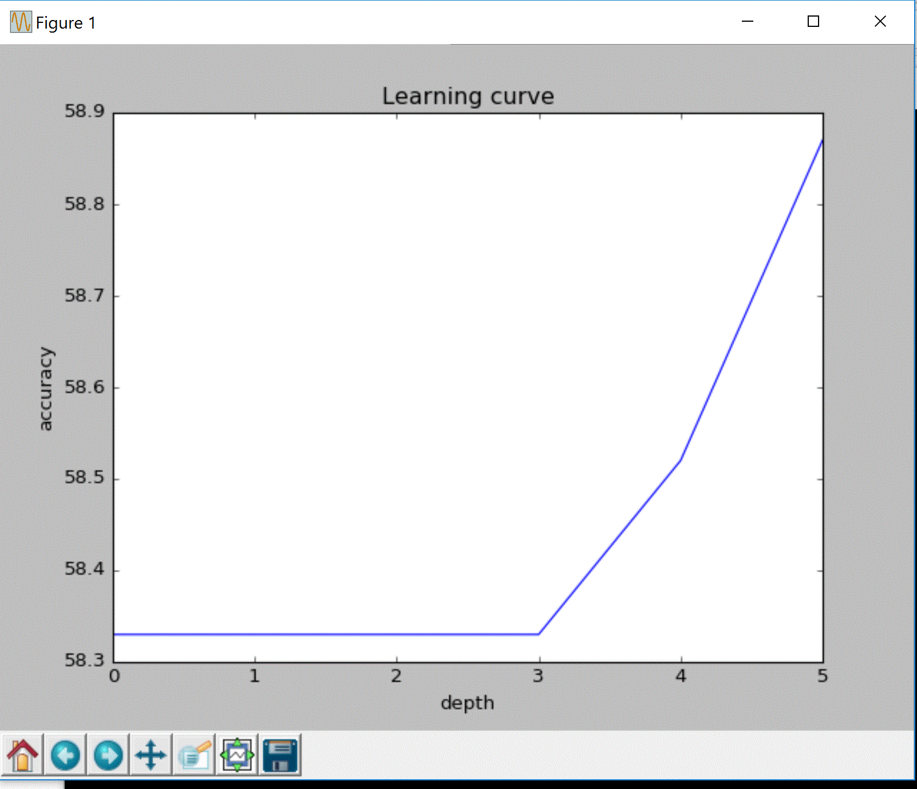

Monk data set3

Enter the train file name: Monktrain3.txt

Enter the test file name: Monktest3.txt

Enter the delimiter to be used for reading the file:: ,

[47.22]

[0]

Accuracy:: 47.22%

False Negatives 20748

False positives 0

True Negatives 204

True Positives 0

Confusion Matrix

------

| 0 | 20748 |

------

| 0 | 204 |

------

[47.22, 47.22]

[0, 1]

Accuracy:: 47.22%

False Negatives 41496

False positives 0

True Negatives 408

True Positives 0

Confusion Matrix

------

| 0 | 41496 |

------

| 0 | 408 |

------

[47.22, 47.22, 47.22]

[0, 1, 2]

Accuracy:: 47.22%

False Negatives 62244

False positives 0

True Negatives 612

True Positives 0

Confusion Matrix

------

| 0 | 62244 |

------

| 0 | 612 |

------

[47.22, 47.22, 47.22, 52.78]

[0, 1, 2, 3]

Accuracy:: 52.78%

False Negatives 72982

False positives 14

True Negatives 802

True Positives 110

Confusion Matrix

------

| 110 | 72982 |

------

| 14 | 802 |

------

[47.22, 47.22, 47.22, 52.78, 58.33]

[0, 1, 2, 3, 4]

Accuracy:: 58.33%

False Negatives 79352

False positives 28

True Negatives 992

True Positives 268

Confusion Matrix

------

| 268 | 79352 |

------

| 28 | 992 |

------

[47.22, 47.22, 47.22, 52.78, 58.33, 62.96]

[0, 1, 2, 3, 4, 5]

Accuracy:: 62.96%

False Negatives 83538

False positives 42

True Negatives 1182

True Positives 450

Confusion Matrix

------

| 450 | 83538 |

------

| 42 | 1182 |

------

Learning Curve Plotted with accuracy on the y axis and depth on the x axis

