**Hackathon Project Document**

Team Project Title: **Fetchly – AI-Powered Web Navigator Agent**

# Abstract (Summary)

Users today spend considerable time navigating multiple websites to perform tasks like searching for products, booking tickets, or filling forms. This process is often repetitive, time-consuming, and difficult for non-technical users. Fetchly proposes an AI-powered Web Navigator Agent that can understand natural language queries and automate browsing actions. The system integrates locally running LLMs for instruction parsing and browser automation (Chrome Headless/VM) to execute tasks. The prototype showcases how users can provide simple commands such as “Search for laptops under 50k and list top 5”, and Fetchly will autonomously perform the browsing, extract results, and present them in a structured format.

# Problem Statement

- Manual navigation across websites is slow and inefficient.  
- Requires multiple clicks, time, and effort.  
- No universal system exists that accepts natural language input and executes browsing actions across platforms.  
- Lack of intelligent assistants reduces accessibility for non-technical users.

# Proposed Solution

Fetchly builds an AI Agent that combines:  
- Instruction Parsing → Understanding natural language queries using a locally running LLM.  
- Browser Control → Automating browsing with Chrome Headless/VM-based browser.  
- Task Execution → Performing actions like search, click, extract text, and fill forms.  
  
**Workflow:**  
User Input → LLM Parsing → Backend (Flask) → Browser Automation (Playwright/Headless Chrome) → Extract Results → Display in Web UI

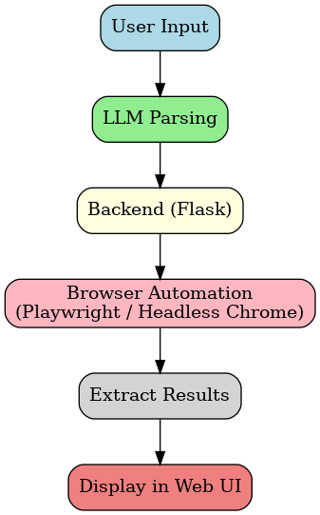

# Core Features

- Instruction Parsing → User intent understood via LLM.  
- Browser Control → Chrome Headless/VM automation.  
- Task Execution → Search, extract, fill forms.  
- Output Formatting → Present results in structured, readable form.  
(Future scope: multi-step reasoning, task memory, advanced GUI, error handling.)

# Technology Stack

- Frontend: HTML, CSS, Tailwind  
- Backend: Python (Flask)  
- Browser Automation: Playwright  
- AI Layer: LangChain / Local LLMs (future scope)

# Applications

- E-commerce product search (Amazon, Flipkart)  
- Ticket booking (IRCTC, flight sites)  
- Food delivery platforms (Zomato, Swiggy)  
- Government portals (form filling, status tracking)  
- Education portals (exam results, admissions)

# Uniqueness & Impact

- Combines AI + Browser Automation in a novel way.  
- Makes the internet more accessible and efficient.  
- Reduces repetitive tasks → saves time and increases productivity.  
- Potential to become a universal web assistant across industries.

# Expected Outcomes

- Working prototype for e-commerce product search.  
- Demonstrates seamless natural language → automated browsing → structured results.  
- Proof of concept for scaling into multiple domains.

# Future Scope

- Integration with advanced LLMs for smarter intent recognition.  
- Voice-enabled assistant for accessibility.  
- Multi-step automation (login, payments, workflows).  
- Mobile app version + browser extensions.

# Team Contribution

- Frontend (UI/UX): Ramavath Kavya Sri Bai  
- Backend (Flask API): Shaik Neehal Pari  
- Browser Automation: Sampathi Lokagna  
- Documentation & Video Pitch: Shaik Shereen Sulthana

# Conclusion

Fetchly demonstrates how AI and browser automation can simplify the way people interact with the web. By combining natural language understanding with automated task execution, it eliminates repetitive manual browsing and delivers structured results in seconds. The Round 1 prototype highlights its ability to handle e-commerce searches, but the same framework can be expanded to domains like ticket booking, food delivery, government portals, and education.

This project is not just about automation — it’s about **making the internet more accessible, efficient, and user-friendly for everyone**.Ultimately, it represents a step toward transforming online navigation into a seamless, intelligent experience.