Jenkins Handbook

# Installing Jenkins

The procedures on this page are for new installations of Jenkins on a single/local machine.

Jenkins is typically run as a standalone application in its own process with the built-in Java servlet container/application server (Jetty).

Jenkins can also be run as a servlet in different Java servlet containers such as Apache Tomcat or GlassFish.

## Prerequisites

Minimum hardware requirements:

* 256 MB of RAM
* 1 GB of drive space

Recommended hardware configuration for a small team:

* 1 GB+ of RAM
* 50 GB+ of drive space Sofware requirements:
* Java 8 - either a Java Runtime Environment (JRE) or a Java Development Kit (JDK) is fine
* Once Java 8 installed then Set JAVA_HOME environment variable and add %JAVA_HOME%\bin to “path” environmental variable.

## Installation platforms

This section describes how to install/run Jenkins on different platforms and operating systems.

### 

### WAR file

The Web application ARchive (WAR) file version of Jenkins can be installed on any operating system or platform that supports Java.

##### To download and run the WAR file version of Jenkins:

1. Download the latest stable Jenkins WAR file from Jenkins official site to an appropriate directory on your machine.
2. Open a terminal/command prompt window to the download directory.
3. Run the command java -jar jenkins.war.
4. Browse to **localhost:8080** and wait until the **Unlock Jenkins** page appears.
5. Continue with the Post-installation setup wizard below.

##### Notes:

* You can change the port by specifying the --httpPort option when you run the java -jar jenkins.war command. For example, to make Jenkins accessible through port 9090, then run Jenkins using the command:

java -jar jenkins.war --httpPort=9090

## Post-installation setup wizard

After downloading, installing and running Jenkins using above procedure, the post- installation setup wizard begins.

This setup wizard takes you through are a few quick "one-off" steps to unlock Jenkins, customize it with plugins and create the first administrator user through which you can continue accessing Jenkins.

### Unlocking Jenkins

When you first access a new Jenkins instance, you are asked to unlock it using an automatically- generated password.

1. Browse to localhost:8080 (or whichever port you configured for Jenkins when installing it) and wait until the **Unlock Jenkins** page appears.

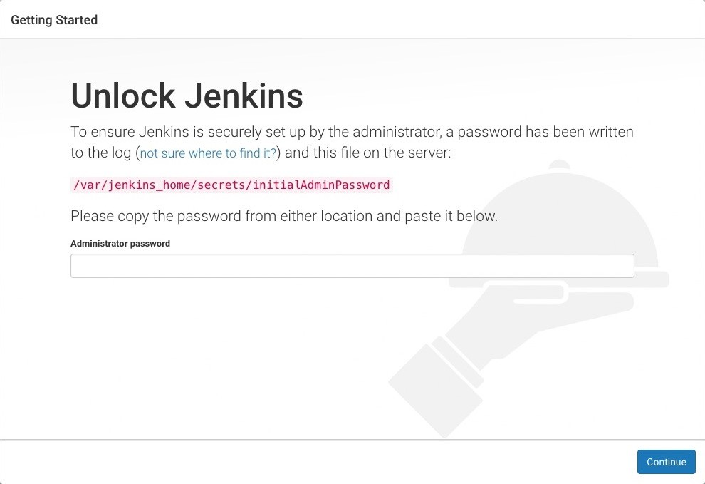

1. From the Jenkins console log output, copy the automatically-generated alphanumeric password (between the 2 sets of asterisks).

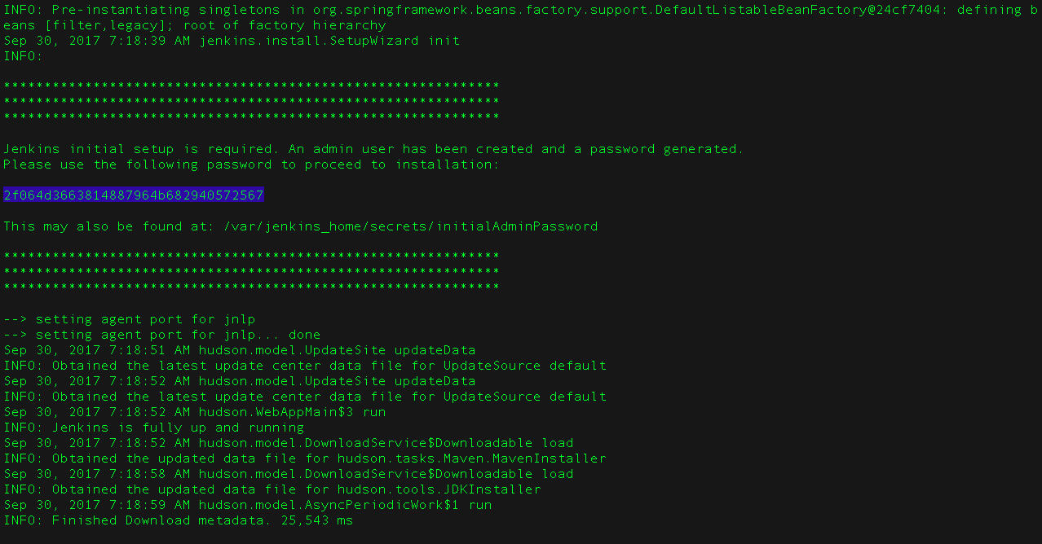

1. On the **Unlock Jenkins** page, paste this password into the **Administrator password** field and click **Continue**.

##### Notes:

* + The Jenkins console log indicates the location (in the Jenkins home directory) where this password can also be obtained. This password must be entered in the setup wizard on new Jenkins installations before you can access Jenkins’s main UI. This password also serves as the default administrator account’s password (with username "admin") if you happen to skip the subsequent user-creation step in the setup wizard.

### Customizing Jenkins with plugins

After unlocking Jenkins, the **Customize Jenkins** page appears. Here you can install any number of useful plugins as part of your initial setup.

Click one of the two options shown:

* **Install suggested plugins** - to install the recommended set of plugins, which are based on most common use cases.
* **Select plugins to install** - to choose which set of plugins to initially install. When you first access the plugin selection page, the suggested plugins are selected by default.

##### NOTE

If you are not sure what plugins you need, choose **Install suggested plugins**. You can install (or remove) additional Jenkins plugins at a later point in time via the **Manage Jenkins** > **Manage Plugins** page in Jenkins.

The setup wizard shows the progression of Jenkins being configured and your chosen set of Jenkins plugins being installed. This process may take a few minutes.

### Creating the first administrator user

Finally, after customizing Jenkins with plugins, Jenkins asks you to create your first administrator user.

1. When the **Create First Admin User** page appears, specify the details for your administrator user in the respective fields and click **Save and Finish**.
2. When the **Jenkins is ready** page appears, click **Start using Jenkins**. **Notes:**
   * This page may indicate **Jenkins is almost ready!** instead and if so, click **Restart**.
   * If the page does not automatically refresh after a minute, use your web browser to refresh the page manually.
3. If required, log in to Jenkins with the credentials of the user you just created, and you are ready to start using Jenkins!

**IMPORTANT** From this point on, the Jenkins UI is only accessible by providing valid username and password credentials.

# Using Jenkins

This chapter will describe how to work with Jenkins as a non-administrator user. It will cover topics applicable to anyone using Jenkins on a day-to-day basis. This includes basic topics such as selecting, running, and monitoring existing jobs, and how to find and review jobs results. It will continue to discuss a number of topics around designing and creating projects.

This chapter is intended to be used by Jenkins users of all skill levels. The sections are structured in a feature-centric way for easier searching and reference by experienced users. At the same time, to help beginners, we’ve attempted to order sections in the chapter from simpler to progressively more complex feature areas. Also, topics within each section will progress from basic to advanced, with expert-level considerations and corner-cases at the end or in a separate section later in the chapter.

# Managing Jenkins

This chapter cover how to manage and configure Jenkins masters and nodes.

This chapter is intended for Jenkins administrators. More experienced users may find this information useful, but only to the extent that they will understand what is and is not possible for administrators to do. Individual sections may assume knowledge of information from previous sections, but such assumptions will be explicitly called out and cross-referenced.

If you are not yet familiar with basic Jenkins terminology and features, start with Getting Started with Jenkins.

If you are already familiar with Jenkins basics and would like to delve deeper into how to use specific features, see Using Jenkins.

If you are a system administrator and want learn how to back-up, restore, maintain as Jenkins servers and nodes, see Jenkins System Administration.

# Managing Security

Jenkins is used everywhere from workstations on corporate intranets, to high-powered servers connected to the public internet. To safely support this wide spread of security and threat profiles, Jenkins offers many configuration options for enabling, editing, or disabling various security features.

As of Jenkins 2.0, many of the security options were enabled by default to ensure that Jenkins environments remained secure unless an administrator explicitly disabled certain protections.

This section will introduce the various security options available to a Jenkins administrator, explaining the protections offered, and trade-offs to disabling some of them.

## Enabling Security

When the **Enable Security** checkbox is checked, which has been the default since Jenkins 2.0, users can log in with a username and password in order to perform operations not available to anonymous users. Which operations require users to log in depends on the chosen authorization strategy and its configuration; by default anonymous users have no permissions, and logged in users have full control. This checkbox should **always** be enabled for any non-local (test) Jenkins environment.

The Enable Security section of the web UI allows a Jenkins administrator to enable, configure, or disable key security features which apply to the entire Jenkins environment.

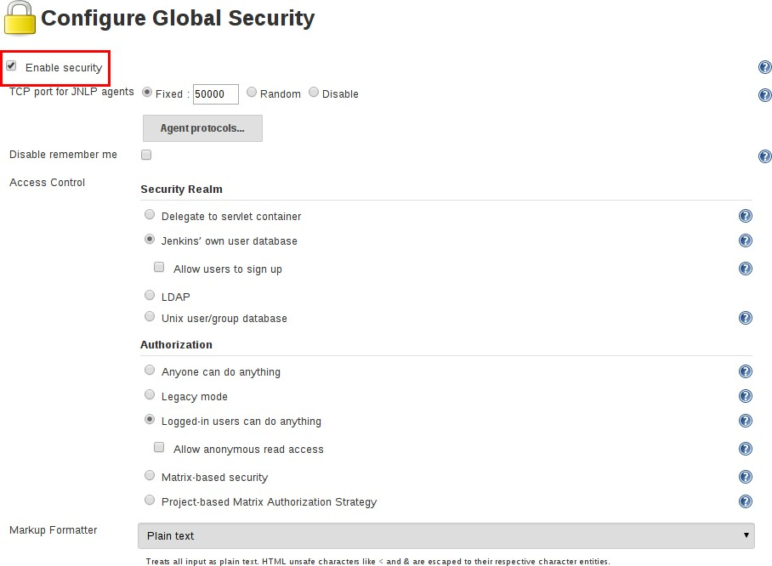

### JNLP TCP Port

Jenkins uses a TCP port to communicate with agents launched via the JNLP protocol, such as Windows-based agents. As of Jenkins 2.0, by default this port is disabled.

For administrators wishing to use JNLP-based agents, the two port options are:

1. **Random**: The JNLP port is chosen random to avoid collisions on the Jenkins master. The downside to randomized JNLP ports is that they’re chosen during the boot of the Jenkins master, making it difficult to manage firewall rules allowing JNLP traffic.
2. **Fixed**: The JNLP port is chosen by the Jenkins administrator and is consistent across reboots of

the Jenkins master. This makes it easier to manage firewall rules allowing JNLP-based agents to connect to the master.

### Access Control

Access Control is the primary mechanism for securing a Jenkins environment against unauthorized usage. Two facets of configuration are necessary for configuring Access Control in Jenkins:

1. A **Security Realm** which informs the Jenkins environment how and where to pull user (or identity) information from. Also commonly known as "authentication."
2. **Authorization** configuration which informs the Jenkins environment as to which users and/or groups can access which aspects of Jenkins, and to what extent.

Using both the Security Realm and Authorization configurations it is possible to configure very relaxed or very rigid authentication and authorization schemes in Jenkins.

Additionally, some plugins such as the plugin:role-strategy[Role-based Authorization Strategy] plugin can extend the Access Control capabilities of Jenkins to support even more nuanced authentication and authorization schemes.

**Security Realm**

By default Jenkins includes support for a few different Security Realms:

##### Delegate to servlet container

For delegating authentication a servlet container running the Jenkins master, such as [Jetty](http://www.eclipse.org/jetty/). If using this option, please consult the servlet container’s authentication documentation.

##### Jenkins’ own user database

Use Jenkins’s own built-in user data store for authentication instead of delegating to an external system. This is enabled by default with new Jenkins 2.0 or later installations and is suitable for smaller environments.

##### LDAP

Delegate all authentication to a configured LDAP server, including both users and groups. This option is more common for larger installations in organizations which already have configured an external identity provider such as LDAP. This also supports Active Directory installations.

**NOTE** This feature is provided by the plugin:ldap[LDAP plugin] that may not be installed on your instance.

##### Unix user/group database

Delegates the authentication to the underlying Unix OS-level user database on the Jenkins master. This mode will also allow re-use of Unix groups for authorization. For example, Jenkins can be configured such that "Everyone in the developers group has administrator access." To support this feature, Jenkins relies on [PAM](http://en.wikipedia.org/wiki/Pluggable_Authentication_Modules) which may need to be configured external to the Jenkins environment.

##### CAUTION

Unix allows an user and a group to have the same name. In order to disambiguate, use the @ prefix to force the name to be interpreted as a group. For example, @dev would mean the dev group and not the dev user.

Plugins can provide additional security realms which may be useful for incorporating Jenkins into existing identity systems, such as:

* plugin:active-directory[Active Directory]
* plugin:github-oauth[GitHub Authentication]
* plugin:crowd2[Atlassian Crowd 2]

**Authorization**

The Security Realm, or authentication, indicates *who* can access the Jenkins environment. The other piece of the puzzle is **Authorization**, which indicates *what* they can access in the Jenkins environment. By default Jenkins supports a few different Authorization options:

##### Anyone can do anything

Everyone gets full control of Jenkins, including anonymous users who haven’t logged in. **Do not use this setting** for anything other than local test Jenkins masters.

##### Legacy mode

Behaves exactly the same as Jenkins <1.164. Namely, if a user has the "admin" role, they will be granted full control over the system, and otherwise (including anonymous users) will only have the read access. **Do not use this setting** for anything other than local test Jenkins masters.

##### Logged in users can do anything

In this mode, every logged-in user gets full control of Jenkins. Depending on an advanced option, anonymous users get read access to Jenkins, or no access at all. This mode is useful to force users to log in before taking actions, so that there is an audit trail of users' actions.

##### Matrix-based security

This authorization scheme allows for granular control over which users and groups are able to perform which actions in the Jenkins environment (see the screenshot below).

##### Project-based Matrix Authorization Strategy

This authorization scheme is an extension to Matrix-based security which allows additional access control lists (ACLs) to be defined for **each project** separately in the Project configuration screen. This allows granting specific users or groups access only to specified projects, instead of all projects in the Jenkins environment. The ACLs defined with Project-based Matrix Authorization are additive such that access grants defined in the Configure Global Security screen will be combined with project-specific ACLs.

##### NOTE

Matrix-based security and Project-based Matrix Authorization Strategy are provided by the plugin:matrix-auth[Matrix Authorization Strategy Plugin] and may not be installed on your Jenkins.

For most Jenkins environments, Matrix-based security provides the most security and flexibility so it is recommended as a starting point for "production" environments.

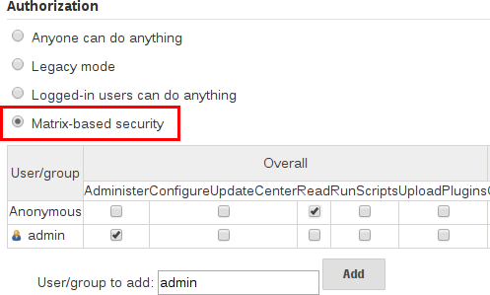

*Figure 2. Matrix-based security*

The table shown above can get quite wide as each column represents a permission provided by Jenkins core or a plugin. Hovering the mouse over a permission will display more information about the permission.

Each row in the table represents a user or group (also known as a "role"). This includes special entries named "anonymous" and "authenticated." The "anonymous" entry represents permissions granted to all unauthenticated users accessing the Jenkins environment. Whereas "authenticated' can be used to grant permissions to all authenticated users accessing the environment.

The permissions granted in the matrix are additive. For example, if a user "kohsuke" is in the groups "developers" and "administrators", then the permissions granted to "kohsuke" will be a union of all those permissions granted to "kohsuke", "developers", "administrators", "authenticated", and "anonymous."

### Markup Formatter

Jenkins allows user-input in a number of different configuration fields and text areas which can lead to users inadvertently, or maliciously, inserting unsafe HTML and/or JavaScript.

By default the **Markup Formatter** configuration is set to **Plain Text** which will escape unsafe characters such as < and & to their respective character entities.

Using the **Safe HTML** Markup Formatter allows for users and administrators to inject useful and information HTML snippets into Project Descriptions and elsewhere.

## Agent/Master Access Control

Conceptually, the Jenkins master and agents can be thought of as a cohesive system which happens to execute across multiple discrete processes and machines. This allows an agent to ask the master process for information available to it, for example, the contents of files, etc.

For larger or mature Jenkins environments where a Jenkins administrator might enable agents provided by other teams or organizations, a flat agent/master trust model is insufficient.

The Agent/Master Access Control system was introduced [25: Starting with 1.587, and 1.580.1, releases] to allow Jenkins administrators to add more granular access control definitions between the Jenkins master and the connected agents.



As of Jenkins 2.0, this subsystem has been turned on by default.

### Customizing Access

For advanced users who may wish to allow certain access patterns from the agents to the Jenkins master, Jenkins allows administrators to create specific exemptions from the built-in access control rules.



By following the link highlighted above, an administrator may edit **Commands** and **File Access**

Agent/Master access control rules.

**Commands**

"Commands" in Jenkins and its plugins are identified by their fully-qualified class names. The majority of these commands are intended to be executed on agents by a request of a master, but some of them are intended to be executed on a master by a request of an agent.

Plugins not yet updated for this subsystem may not classify which category each command falls into, such that when an agent requests that the master execute a command which is not explicitly allowed, Jenkins will err on the side of caution and refuse to execute the command.

In such cases, Jenkins administrators may "whitelist" [26: [en.wikipedia.org/wiki/Whitelist](https://en.wikipedia.org/wiki/Whitelist)] certain commands as acceptable for execution on the master.

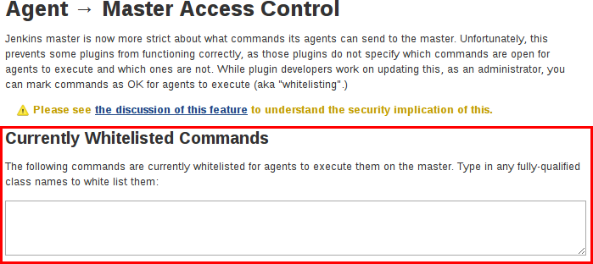

##### Advanced

Administrators may also whitelist classes by creating files with the .conf extension in the directory JENKINS_HOME/secrets/whitelisted-callables.d/. The contents of these .conf files should list command names on separate lines.

The contents of all the .conf files in the directory will be read by Jenkins and combined to create a default.conf file in the directory which lists all known safe command. The default.conf file will be re-written each time Jenkins boots.

Jenkins also manages a file named gui.conf, in the whitelisted-callables.d directory, where commands added via the web UI are written. In order to disable the ability of administrators to change whitelisted commands from the web UI, place an empty gui.conf file in the directory and change its permissions such that is not writeable by the operating system user Jenkins run as.

**File Access Rules**

The File Access Rules are used to validate file access requests made from agents to the master. Each File Access Rule is a triplet which must contain each of the following elements:

1. allow / deny: if the following two parameters match the current request being considered, an allow entry would allow the request to be carried out and a deny entry would deny the request to be rejected, regardless of what later rules might say.
2. *operation*: Type of the operation requested. The following 6 values exist. The operations can also be combined by comma-separating the values. The value of all indicates all the listed operations are allowed or denied.
   * read: read file content or list directory entries
   * write: write file content
   * mkdirs: create a new directory
   * create: create a file in an existing directory
   * delete: delete a file or directory
   * stat: read metadata of a file/directory, such as timestamp, length, file access modes.
3. *file path*: regular expression that specifies file paths that matches this rule. In addition to the base regexp syntax, it supports the following tokens:
   * <JENKINS_HOME> can be used as a prefix to match the master’s JENKINS_HOME directory.
   * <BUILDDIR> can be used as a prefix to match the build record directory, such as

/var/lib/jenkins/job/foo/builds/2014-10-17_12-34-56.

* + <BUILDID> matches the timestamp-formatted build IDs, like 2014-10-17_12-34-56.

The rules are ordered, and applied in that order. The earliest match wins. For example, the following rules allow access to all files in JENKINS_HOME except the secrets folders:

# To avoid hassle of escaping every '\' on Windows, you can use / even on Windows. deny all <JENKINS_HOME>/secrets/.*

allow all <JENKINS_HOME>/.*

Ordering is very important! The following rules are incorrectly written because the 2nd rule will never match, and allow all agents to access all files and folders under JENKINS_HOME:

allow all <JENKINS_HOME>/.*

deny all <JENKINS_HOME>/secrets/.*

##### Advanced

Administrators may also add File Access Rules by creating files with the .conf. extension in the directory JENKINS_HOME/secrets/filepath-filters.d/. Jenkins itself generates the 30-default.conf file on boot in this directory which contains defaults considered the best balance between compatibility and security by the Jenkins project. In order to disable these built-in defaults, replace 30- default.conf with an empty file which is not writable by the operating system user Jenkins run as.

On each boot, Jenkins will read all .conf files in the filepath-filters.d directory in alphabetical order, therefore it is good practice to name files in a manner which indicates their load order.

Jenkins also manages 50-gui.conf, in the filepath-filters/ directory, where File Access Rules added via the web UI are written. In order to disable the ability of administrators to change the File Access Rules from the web UI, place an empty 50-gui.conf file in the directory and change its permissions such that is not writeable by the operating system user Jenkins run as.

### Disabling

While it is not recommended, if all agents in a Jenkins environment can be considered "trusted" to the same degree that the master is trusted, the Agent/Master Access Control feature may be disabled.

Additionally, all the users in the Jenkins environment should have the same level of access to all configured projects.

An administrator can disable Agent/Master Access Control in the web UI by un-checking the box on the **Configure Global Security** page. Alternatively an administrator may create a file in JENKINS_HOME/secrets named slave-to-master-security-kill-switch with the contents of true and restart Jenkins.

# Managing Plugins

Plugins are the primary means of enhancing the functionality of a Jenkins environment to suit organization- or user-specific needs. There are [over a thousand different plugins](https://plugins.jenkins.io/) which can be installed on a Jenkins master and to integrate various build tools, cloud providers, analysis tools, and much more.

Plugins can be automatically downloaded, with their dependencies, from the Update Center. The Update Center is a service operated by the Jenkins project which provides an inventory of open source plugins which have been developed and maintained by various members of the Jenkins community.

This section will cover everything from the basics of managing plugins within the Jenkins web UI, to making changes on the master’s file system.

## Installing a plugin

Jenkins provides a couple of different methods for installing plugins on the master:

1. Using the "Plugin Manager" in the web UI.
2. Using the Jenkins CLI install-plugin command.

Each approach will result in the plugin being loaded by Jenkins but may require different levels of access and trade-offs in order to use.

The two approaches require that the Jenkins master be able to download meta-data from an Update Center, whether the primary Update Center operated by the Jenkins project [27: [updates.jenkins.io](https://updates.jenkins.io/)], or a custom Update Center.

The plugins are packaged as self-contained .hpi files, which have all the necessary code, images, and other resources which the plugin needs to operate successfully.

### From the web UI

The simplest and most common way of installing plugins is through the **Manage Jenkins** > **Manage Plugins** view, available to administrators of a Jenkins environment.

Under the **Available** tab, plugins available for download from the configured Update Center can be searched and considered:

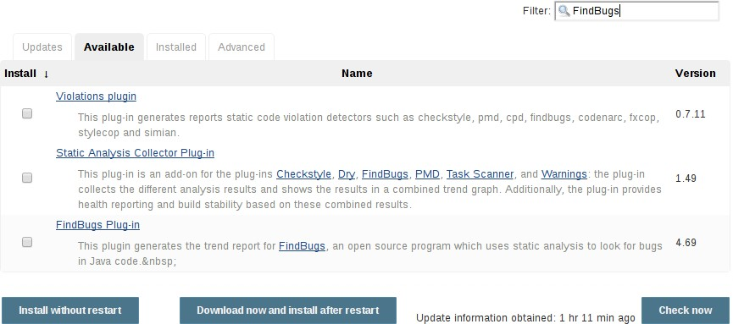

Most plugins can be installed and used immediately by checking the box adjacent to the plugin and clicking **Install without restart**.

##### CAUTION

If the list of available plugins is empty, the master might be incorrectly configured or has not yet downloaded plugin meta-data from the Update Center. Clicking the **Check now** button will force Jenkins to attempt to contact its configured Update Center.

### Using the Jenkins CLI

Administrators may also use the Jenkins CLI which provides a command to install plugins. Scripts to manage Jenkins environments, or configuration management code, may need to install plugins without direct user interaction in the web UI. The Jenkins CLI allows a command line user or automation tool to download a plugin and its dependencies.

-deploy : Deploy plugins right away without postponing them until the reboot.

-name VAL : If specified, the plugin will be installed as this short name (whereas normally the name is inferred from the source name automatically).

-restart : Restart Jenkins upon successful installation.

: If this points to a local file, that file will be installed. If this is an URL, Jenkins downloads the URL and installs that as a plugin.Otherwise the name is assumed to be the short name of the plugin in the existing update center (like "findbugs"),and the plugin will be installed from the update center.

SOURCE

java -jar jenkins-cli.jar -s http://localhost:8080/ install-plugin SOURCE ... [- deploy] [-name VAL] [-restart]

Installs a plugin either from a file, an URL, or from update center.

### Advanced installation

The Update Center only allows the installation of the most recently released version of a plugin. In cases where an older release of the plugin is desired, a Jenkins administrator can download an older .hpi archive and manually install that on the Jenkins master.

**From the web UI**

Assuming a .hpi file has been downloaded, a logged-in Jenkins administrator may upload the file from within the web UI:

1. Navigate to the **Manage Jenkins** > **Manage Plugins** page in the web UI.
2. Click on the **Advanced** tab.
3. Choose the .hpi file under the **Upload Plugin** section.
4. **Upload** the plugin file.

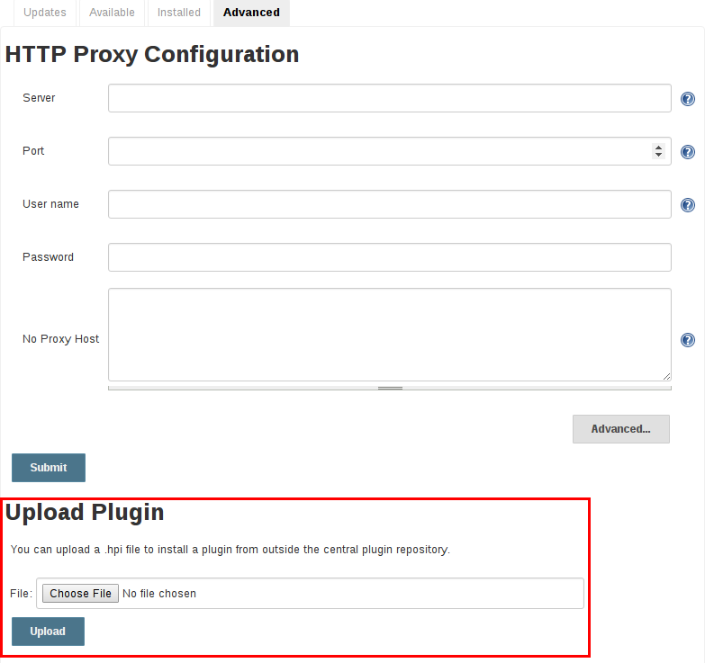

Once a plugin file has been uploaded, the Jenkins master must be manually restarted in order for the changes to take effect.

**On the master**

Assuming a .hpi file has been explicitly downloaded by a systems administrator, the administrator can manually place the .hpi file in a specific location on the file system.

Copy the downloaded .hpi` file into the JENKINS_HOME/plugins directory on the Jenkins master (for example, on Debian systems JENKINS_HOME is generally /var/lib/jenkins).

The master will need to be restarted before the plugin is loaded and made available in the Jenkins environment.

##### NOTE

The names of the plugin directories in the Update Site [27: [updates.jenkins.io](https://updates.jenkins.io/)] are not always the same as the plugin’s display name. Searching [plugins.jenkins.io](https://plugins.jenkins.io/) for the desired plugin will provide the appropriate link to the .hpi files.

## Updating a plugin

Updates are listed in the **Updates** tab of the **Manage Plugins** page and can be installed by checking the checkboxes of the desired plugin updates and clicking the **Download now and install after restart** button.

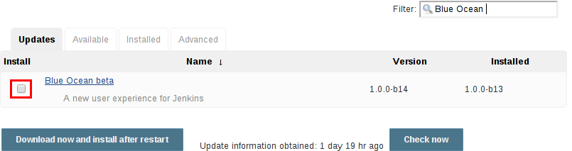

By default, the Jenkins master will check for updates from the Update Center once every 24 hours. To manually trigger a check for updates, simply click on the **Check now** button in the **Updates** tab.

## Removing a plugin

When a plugin is no longer used in a Jenkins environment, it is prudent to remove the plugin from the Jenkins master. This provides a number of benefits such as reducing memory overhead at boot or runtime, reducing configuration options in the web UI, and removing the potential for future conflicts with new plugin updates.

### Uninstalling a plugin

The simplest way to uninstall a plugin is to navigate to the **Installed** tab on the **Manage Plugins** page. From there, Jenkins will automatically determine which plugins are safe to uninstall, those which are not dependencies of other plugins, and present a button for doing so.

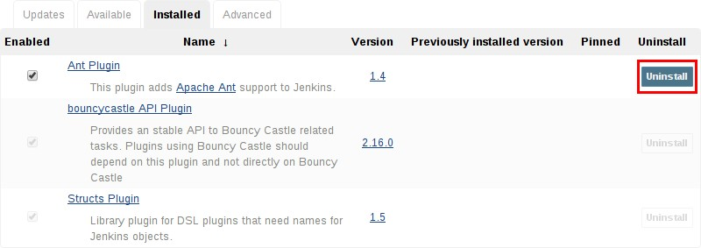

A plugin may also be uninstalled by removing the corresponding .hpi file from the JENKINS_HOME/plugins directory on the master. The plugin will continue to function until the master has been restarted.

**CAUTION** If a plugin .hpi file is removed but required by other plugins, the Jenkins master may fail to boot correctly.

Uninstalling a plugin does **not** remove the configuration that the plugin may have created. If there are existing jobs/nodes/views/builds/etc configurations that reference data created by the plugin, during boot Jenkins will warn that some configurations could not be fully loaded and ignore the unrecognized data.

Since the configuration(s) will be preserved until they are overwritten, re-installing the plugin will result in those configuration values reappearing.

**Removing old data**

Jenkins provides a facility for purging configuration left behind by uninstalled plugins. Navigate to

**Manage Jenkins** and then click on **Manage Old Data** to review and remove old data.

### Disabling a plugin

Disabling a plugin is a softer way to retire a plugin. Jenkins will continue to recognize that the plugin is installed, but it will not start the plugin, and no extensions contributed from this plugin will be visible.

A Jenkins administrator may disable a plugin by unchecking the box on the **Installed** tab of the

**Manage Plugins** page (see below).

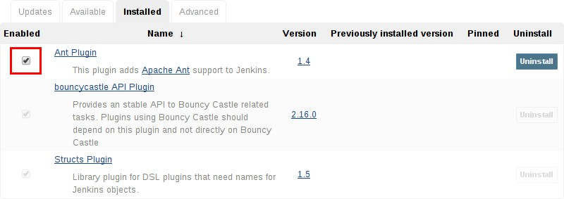

A systems administrator may also disable a plugin by creating a file on the Jenkins master, such as:

JENKINS_HOME/plugins/PLUGIN_NAME.hpi.disabled.

The configuration(s) created by the disabled plugin behave as if the plugin were uninstalled, insofar that they result in warnings on boot but are otherwise ignored.

## Pinned plugins

##### CAUTION

Pinned plugins feature was removed in Jenkins 2.0. Versions later than Jenkins

2.0 do not bundle plugins, instead providing a wizard to install the most useful plugins.

The notion of **pinned plugins** applies to plugins that are bundled with Jenkins 1.x, such as the plugin:matrix-auth[**Matrix Authorization plugin**].

By default, whenever Jenkins is upgraded, its bundled plugins overwrite the versions of the plugins that are currently installed in JENKINS_HOME.

However, when a bundled plugin has been manually updated, Jenkins will mark that plugin as pinned to the particular version. On the file system, Jenkins creates an empty file called JENKINS_HOME/plugins/PLUGIN_NAME.hpi.pinned to indicate the pinning.

Pinned plugins will never be overwritten by bundled plugins during Jenkins startup. (Newer versions of Jenkins do warn you if a pinned plugin is *older* than what is currently bundled.)

It is safe to update a bundled plugin to a version offered by the Update Center. This is often necessary to pick up the newest features and fixes. The bundled version is occasionally updated, but not consistently.

The Plugin Manager allows plugins to be explicitly unpinned. The JENKINS_HOME/plugins/PLUGIN_NAME.hpi.pinned file can also be manually created/deleted to control the pinning behavior. If the pinned file is present, Jenkins will use whatever plugin version the user has specified. If the file is absent, Jenkins will restore the plugin to the default version on startup.

# Jenkins CLI

Jenkins has a built-in command line interface that allows users and administrators to access Jenkins from a script or shell environment. This can be convenient for scripting of routine tasks, bulk updates, troubleshooting, and more.

The command line interface can be accessed over SSH or with the Jenkins CLI client, a .jar file distributed with Jenkins.

##### WARNING

Use of the CLI client distributed with Jenkins 2.53 and older and Jenkins LTS

2.46.1 and older is **not recommended** for security reasons: while there are no currently known vulnerabilities, several have been reported and patched in the past, and the Jenkins Remoting protocol it uses is inherently vulnerable to remote code execution bugs, even “preauthentication” exploits (by anonymous users able to physically access the Jenkins network).

The client distributed with Jenkins 2.54 and newer and Jenkins LTS 2.46.2 and newer is considered secure in its default (-http) or -ssh modes, as is using the standard ssh command.

## Using the CLI over SSH

In a new Jenkins installation, the SSH service is disabled by default. Administrators may choose to set a specific port or ask Jenkins to pick a random port in the Configure Global Security page. In order to determine the randomly assigned SSH port, inspect the headers returned on a Jenkins URL, for example:

% curl -Lv https://JENKINS_URL/login 2>&1 | grep 'X-SSH-Endpoint'

< X-SSH-Endpoint: localhost:53801

%

With the random SSH port (53801 in this example), and Authentication configured, any modern SSH client may securely execute CLI commands.

### Authentication

Whichever user used for authentication with the Jenkins master must have the Overall/Read permission in order to *access* the CLI. The user may require additional permissions depending on the commands executed.

Authentication relies on SSH-based public/private key authentication. In order to add an SSH public key for the appropriate user, navigate to JENKINS_URL/user/USERNAME/configure and paste an SSH public key into the appropriate text area.

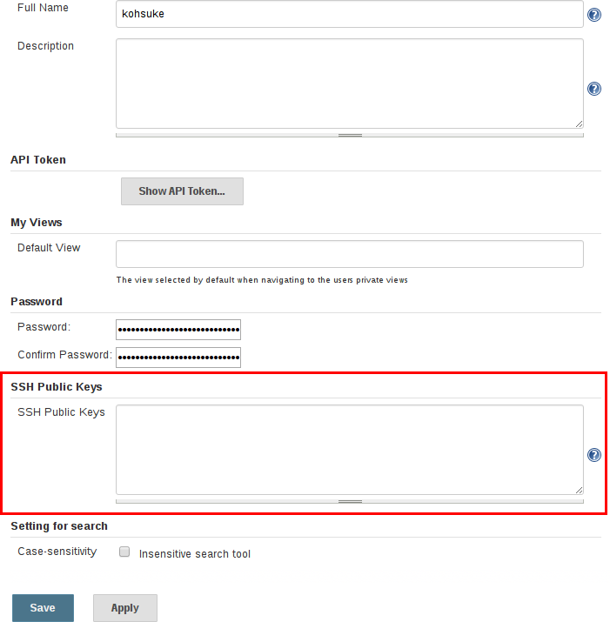

### Common Commands

Jenkins has a number of built-in CLI commands which can be found in every Jenkins environment, such as build or list-jobs. Plugins may also provide CLI commands; in order to determine the full list of commands available in a given Jenkins environment, execute the CLI help command:

% ssh -l kohsuke -p 53801 localhost help

The following list of commands is not comprehensive, but it is a useful starting point for Jenkins CLI usage.

**build**

One of the most common and useful CLI commands is build, which allows the user to trigger any job or Pipeline for which they have permission.

The most basic invocation will simply trigger the job or Pipeline and exit, but with the additional options a user may also pass parameters, poll SCM, or even follow the console output of the triggered build or Pipeline run.

% ssh -l kohsuke -p 53801 localhost help build

java -jar jenkins-cli.jar build JOB [-c] [-f] [-p] [-r N] [-s] [-v] [-w] Starts a build, and optionally waits for a completion. Aside from general scripting use, this command can be used to invoke another job from within a

build of one job. With the -s option, this command changes the exit code based on the outcome of the build (exit code 0 indicates a success) and interrupting the command will interrupt the job. With the -f option, this command changes the exit code based on the outcome of the build (exit code 0 indicates a success) however, unlike -s, interrupting the command will not interrupt the job (exit code 125 indicates the command was interrupted). With the -c option, a build will only run if there has been an SCM change.

JOB : Name of the job to build

-c : Check for SCM changes before starting the build, and if there's no change, exit without doing a build

-f : Follow the build progress. Like -s only interrupts are not passed through to the build.

-p : Specify the build parameters in the key=value format.

-s : Wait until the completion/abortion of the command. Interrupts are passed through to the build.

-v : Prints out the console output of the build. Use with -s

-w : Wait until the start of the command

% ssh -l kohsuke -p 53801 localhost build build-all-software -f -v Started build-all-software #1

Started from command line by admin

Building in workspace /tmp/jenkins/workspace/build-all-software [build-all-software] $ /bin/sh -xe /tmp/hudson1100603797526301795.sh

+ echo hello world hello world Finished: SUCCESS

Completed build-all-software #1 : SUCCESS

%

**console**

Similarly useful is the console command, which retrieves the console output for the specified build or Pipeline run. When no build number is provided, the console command will output the last completed build’s console output.

% ssh -l kohsuke -p 53801 localhost help console

java -jar jenkins-cli.jar console JOB [BUILD] [-f] [-n N]

Produces the console output of a specific build to stdout, as if you are doing 'cat build.log'

JOB : Name of the job

BUILD : Build number or permalink to point to the build. Defaults to the last build

-f : If the build is in progress, stay around and append console output as it comes, like 'tail -f'

-n N : Display the last N lines

% ssh -l kohsuke -p 53801 localhost console build-all-software Started from command line by kohsuke

Building in workspace /tmp/jenkins/workspace/build-all-software [build-all-software] $ /bin/sh -xe /tmp/hudson1100603797526301795.sh

+ echo hello world yes

Finished: SUCCESS

%

**who-am-i**

The who-am-i command is helpful for listing the current user’s credentials and permissions available to the user. This can be useful when debugging the absence of CLI commands due to the lack of certain permissions.

% ssh -l kohsuke -p 53801 localhost help who-am-i

java -jar jenkins-cli.jar who-am-i Reports your credential and permissions.

% ssh -l kohsuke -p 53801 localhost who-am-i Authenticated as: kohsuke

Authorities: authenticated

%

## Using the CLI client

While the SSH-based CLI is fast and covers most needs, there may be situations where the CLI client distributed with Jenkins is a better fit. For example, the default transport for the CLI client is HTTP which means no additional ports need to be opened in a firewall for its use.

### Downloading the client

The CLI client can be downloaded directly from a Jenkins master at the URL /jnlpJars/jenkins- cli.jar, in effect JENKINS_URL/jnlpJars/jenkins-cli.jar

While a CLI .jar can be used against different versions of Jenkins, should any compatibility issues arise during use, please re-download the latest .jar file from the Jenkins master.

### Using the client

The general syntax for invoking the client is as follows:

java -jar jenkins-cli.jar [-s JENKINS_URL] [global options...] command [command options...] [arguments...]

The JENKINS_URL can be specified via the environment variable $JENKINS_URL. Summaries of other general options can be displayed by running the client with no arguments at all.

### Client connection modes

There are three basic modes in which the 2.54+ / 2.46.2+ client may be used, selectable by global option: -http; -ssh; and -remoting.

**HTTP connection mode**

This is the default mode as of 2.54 and 2.46.2, though you may pass the -http option explicitly for clarity.

Authentication is preferably with an -auth option, which takes a username:apitoken argument. Get your API token from /me/configure:

java -jar jenkins-cli.jar [-s JENKINS_URL] -auth kohsuke:abc1234ffe4a command ...

(Actual passwords are also accepted, but this is discouraged.)

You can also precede the argument with @ to load the same content from a file:

java -jar jenkins-cli.jar [-s JENKINS_URL] -auth @/home/kohsuke/.jenkins-cli command

...

Generally no special system configuration need be done to enable HTTP-based CLI connections. If you are running Jenkins behind an HTTP(S) reverse proxy, ensure it does not buffer request or response bodies.

##### WARNING

The HTTP(S) connection mode of the CLI in Jenkins 2.54 and newer does not work correctly behind an Apache HTTP reverse proxy server using mod_proxy. Workarounds include using a different reverse proxy such as Nginx or HAProxy, or using the SSH connection mode where possible. See [JENKINS-](https://issues.jenkins-ci.org/browse/JENKINS-47279) [47279](https://issues.jenkins-ci.org/browse/JENKINS-47279).

**SSH connection mode**

Authentication is via SSH keypair. You must select the Jenkins user ID as well:

java -jar jenkins-cli.jar [-s JENKINS_URL] -ssh -user kohsuke command ...

In this mode, the client acts essentially like a native ssh command.

By default the client will try to connect to an SSH port on the same host as is used in the JENKINS_URL. If Jenkins is behind an HTTP reverse proxy, this will not generally work, so run Jenkins with the system property -Dorg.jenkinsci.main.modules.sshd.SSHD.hostName=ACTUALHOST to define a hostname or IP address for the SSH endpoint.

**Remoting connection mode**

This was the only mode supported by clients downloaded from a pre-2.54 / pre-2.46.2 Jenkins server (prior to the introduction of the -remoting option). Its use is deprecated for security and performance reasons. That said, certain commands or command modes can *only* run in Remoting mode, typically because the command functionality involves running server-supplied code on the client machine.

This mode is disabled on the server side for new installations of 2.54+ and 2.46.2. If you must use it, and accept the risks, it may be enabled in Configure Global Security.

Authentication is preferably via SSH keypair. A login command and --username / --password command (note: **not global**) options are also available; these are discouraged since they cannot work with a non-password-based security realm, certain command arguments will not be properly parsed if anonymous users lack overall or job read access, and saving human-chosen passwords for use in scripts is considered insecure.

Note that there are two transports available for this mode: over HTTP, or over a dedicated TCP socket. If the TCP port is enabled and seems to work, the client will use this transport. If the TCP port is disabled, or such a port is advertised but does not accept connections (for example because you are using an HTTP reverse proxy with a firewall), the client will automatically fall back to the

less efficient HTTP transport.

##### Common Problems with the Remoting-based client

There are a number of common problems that may be experienced when running the CLI client.

**Operation timed out**

Check that the HTTP or TCP port is opened if you are using a firewall on your server. You can configure its value in Jenkins configuration. By default it is set to use a random port.

% java -jar jenkins-cli.jar -s JENKINS_URL help

Exception in thread "main" java.net.ConnectException: Operation timed out at java.net.PlainSocketImpl.socketConnect(Native Method)

at java.net.PlainSocketImpl.doConnect(PlainSocketImpl.java:351)

at java.net.PlainSocketImpl.connectToAddress(PlainSocketImpl.java:213) at java.net.PlainSocketImpl.connect(PlainSocketImpl.java:200)

at java.net.SocksSocketImpl.connect(SocksSocketImpl.java:432) at java.net.Socket.connect(Socket.java:529)

at java.net.Socket.connect(Socket.java:478) at java.net.Socket.<init>(Socket.java:375) at java.net.Socket.<init>(Socket.java:189) at hudson.cli.CLI.<init>(CLI.java:97)

at hudson.cli.CLI.<init>(CLI.java:82) at hudson.cli.CLI._main(CLI.java:250) at hudson.cli.CLI.main(CLI.java:199)

**No X-Jenkins-CLI2-Port**

Go to **Manage Jenkins** > **Configure Global Security** and choose "Fixed" or "Random" under **TCP port for JNLP agents**.

java.io.IOException: No X-Jenkins-CLI2-Port among [X-Jenkins, null, Server, X-Content- Type-Options, Connection,

X-You-Are-In-Group, X-Hudson, X-Permission-Implied-By, Date, X-Jenkins- Session, X-You-Are-Authenticated-As,

X-Required-Permission, Set-Cookie, Expires, Content-Length, Content-Type] at hudson.cli.CLI.getCliTcpPort(CLI.java:284)

at hudson.cli.CLI.<init>(CLI.java:128)

at hudson.cli.CLIConnectionFactory.connect(CLIConnectionFactory.java:72) at hudson.cli.CLI._main(CLI.java:473)

at hudson.cli.CLI.main(CLI.java:384)

Suppressed: java.io.IOException: Server returned HTTP response code: 403 for URL: <http://citest.gce.px/cli>

at sun.net.www.protocol.http.HttpURLConnection.getInputStream0(HttpURLConnection.java:184 0)

at sun.net.www.protocol.http.HttpURLConnection.getInputStream(HttpURLConnection.java:1441

)

at hudson.cli.FullDuplexHttpStream.<init>(FullDuplexHttpStream.java:78) at hudson.cli.CLI.connectViaHttp(CLI.java:152)

at hudson.cli.CLI.<init>(CLI.java:132)

... 3 more

**Server key did not validate**

You may get the error below and find a log entry just below that concerning mismatched keys:

org.apache.sshd.common.SshException: Server key did not validate at

org.apache.sshd.client.session.AbstractClientSession.checkKeys(AbstractClientSession.j ava:523)

at org.apache.sshd.common.session.helpers.AbstractSession.handleKexMessage(AbstractSessio n.java:616)

...

This means your SSH configuration does not recognize the public key presented by the server. It’s often the case when you run Jenkins in dev mode and multiple instances of the application are run under the same SSH port over time.

In a development context, access your ~/.ssh/known_hosts (or in C:/Users/<your_name>/.ssh/known_hosts for Windows) and remove the line corresponding to your current SSH port (e.g. [localhost]:3485). In a production context, check with the Jenkins administrator if the public key of the server changed recently. If so, ask the administrator to do the the steps described above.

**UsernameNotFoundException**

If your client displays a stacktrace that looks like:

org.acegisecurity.userdetails.UsernameNotFoundException: <name_you_used>

...

This means your SSH keys were recognized and validated against the stored users but the username is not valid for the security realm your application is using at the moment. This could occur when you were using the Jenkins database initially, configured your users, and then switched to another security realm (like LDAP, etc.) where the defined users do not exist yet.

To solve the problem, ensure your users exist in your configured security realm.

**Troubleshooting logs**

To get more information about the authentication process:

1. Go into **Manage Jenkins** > **System Log** > **Add new log recorder**.
2. Enter any name you want and click on **Ok**.
3. Click on **Add**
4. Type org.jenkinsci.main.modules.sshd.PublicKeyAuthenticatorImpl (or type PublicKeyAuth and then select the full name)
5. Set the level to **ALL**.
6. Repeat the previous three steps for hudson.model.User
7. Click on **Save**

When you try to authenticate, you can then refresh the page and see what happen internally.

# In-process Script Approval

Jenkins, and a number of plugins, allow users to execute Groovy scripts *in* Jenkins. These scripting capabilities are provided by:

* Script Console.
* Jenkins Pipeline.
* The plugin:email-ext[Extended Email plugin].
* The plugin:groovy[Groovy plugin] - when using the "Execute system Groovy script" step.
* The plugin:job-dsl[JobDSL plugin] as of version 1.60 and later.

To protect Jenkins from execution of malicious scripts, these plugins execute user-provided scripts in a Groovy Sandbox that limits what internal APIs are accessible. Administrators can then use the "In-process Script Approval" page, provided by the plugin:script-security[Script Security plugin], to manage which unsafe methods, if any, should be allowed in the Jenkins environment.

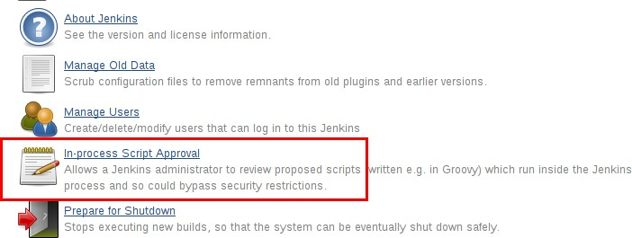

## Getting Started

The plugin:script-security[Script Security plugin] is installed automatically by the Post-install Setup Wizard, although initially no additional scripts or operations are approved for use.

##### IMPORTANT

Older versions of this plugin may not be safe to use. Please review the security warnings listed on plugin:script-security[the Script Security plugin page] in order to ensure that the plugin:script-security[Script Security plugin] is up to date.

Security for in-process scripting is provided by two different mechanisms: the Groovy Sandbox and Script Approval. The first, the Groovy Sandbox, is enabled by default for Jenkins Pipeline allowing user-supplied Scripted and Declarative Pipeline to execute without prior Administrator intervention. The second, Script Approval, allows Administrators to approve or deny unsandboxed scripts, or allow sandboxed scripts to execute additional methods.

For most instances, the combination of the Groovy Sandbox and the [Script Security’s built-in list](https://github.com/jenkinsci/script-security-plugin/tree/master/src/main/resources/org/jenkinsci/plugins/scriptsecurity/sandbox/whitelists) of approved method signatures, will be sufficient. It is strongly recommended that Administrators only deviate from these defaults if absolutely necessary.

## Script Approval

Manual approval of entire scripts, or method signatures, by an administrator provides Administrators with additional flexibility to support more advanced usages of in-process scripting. When the Groovy Sandbox is disabled, or a method outside of the built-in list is invoked, the Script Security plugin will check the Administrator-managed list of approved scripts and methods.

For scripts which wish to execute outside of the Groovy Sandbox, the Administrator must approve the **entire** script in the **In-process Script Approval** page:

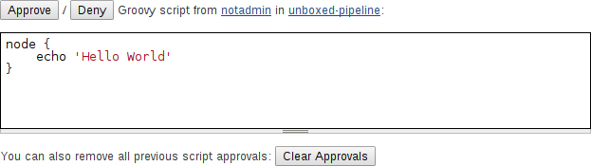

*Figure 5. Approving an unsandboxed Scripted Pipeline*

For scripts which use the Groovy Sandbox, but wish to execute an currently unapproved method signature will also be halted by Jenkins, and require an Administrator to approve the specific method signature before the script is allowed to execute:

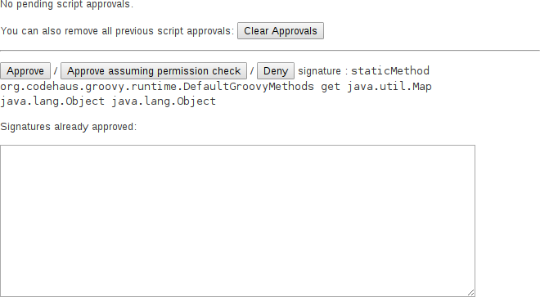

*Figure 6. Approving a new method signature*

## Access Control

You should lock down the access to Jenkins UI so that users are authenticated and appropriate set of permissions are given to them. This setting is controlled mainly by two axes:

* **Security Realm**, which determines users and their passwords, as well as what groups the users belong to.
* **Authorization Strategy**, which determines who has access to what.

These two axes are orthogonal, and need to be individually configured. For example, you might choose to use external LDAP or Active Directory as the security realm, and you might choose "everyone full access once logged in" mode for authorization strategy. Or you might choose to let Jenkins run its own user database, and perform access control based on the permission/user matrix.

* [Quick and Simple Security](https://wiki.jenkins-ci.org/display/JENKINS/Quick%2Band%2BSimple%2BSecurity) --- if you are running Jenkins like java -jar jenkins.war and only need a very simple setup
* [Standard Security Setup](https://wiki.jenkins-ci.org/display/JENKINS/Standard%2BSecurity%2BSetup) --- discusses the most common setup of letting Jenkins run its own user database and do finer-grained access control
* [Apache frontend for security](https://wiki.jenkins-ci.org/display/JENKINS/Apache%2Bfrontend%2Bfor%2Bsecurity) --- run Jenkins behind Apache and perform access control in Apache instead of Jenkins
* [Authenticating scripted clients](https://wiki.jenkins-ci.org/display/JENKINS/Authenticating%2Bscripted%2Bclients) --- if you need to programmatically access security-enabled Jenkins web UI, use BASIC auth
* [Matrix-based security|Matrix-based security](https://wiki.jenkins-ci.org/display/JENKINS/Matrix-based%2Bsecurity) --- Granting and denying finer-grained permissions

## Protect users of Jenkins from other threats

There are additional security subsystems in Jenkins that protect Jenkins and users of Jenkins from indirect attacks.

The following topics discuss features that are **off by default**. We recommend you read them first and act on them immediately.

* [CSRF Protection](https://wiki.jenkins-ci.org/display/JENKINS/CSRF%2BProtection) --- prevent a remote attack against Jenkins running inside your firewall. This feature is **off by default** in Jenkins 1.x and when upgrading to 2.x.
* [Security implication of building on master](https://wiki.jenkins-ci.org/display/JENKINS/Security%2Bimplication%2Bof%2Bbuilding%2Bon%2Bmaster) --- protect Jenkins master from malicious builds
* [Slave To Master Access Control](https://wiki.jenkins-ci.org/display/JENKINS/Slave%2BTo%2BMaster%2BAccess%2BControl) --- protect Jenkins master from malicious build agents

The following topics discuss other security features that are on by default. You’ll only need to look at them when they are causing problems.

* [Configuring Content Security Policy](https://wiki.jenkins-ci.org/display/JENKINS/Configuring%2BContent%2BSecurity%2BPolicy) --- protect users of Jenkins from malicious builds
* [Markup formatting](https://wiki.jenkins-ci.org/display/JENKINS/Markup%2Bformatting) --- protect users of Jenkins from malicious users of Jenkins

## Disabling Security

One may accidentally set up a security realm / authorization in such a way that you may no longer be able to reconfigure Jenkins.

When this happens, you can fix this by the following steps:

1. Stop Jenkins (the easiest way to do this is to stop the servlet container.)
2. Go to $JENKINS_HOME in the file system and find config.xml file.
3. Open this file in the editor.
4. Look for the <useSecurity>true</useSecurity> element in this file.
5. Replace true with false
6. Remove the elements authorizationStrategy and securityRealm
7. Start Jenkins
8. When Jenkins comes back, it will be in an unsecured mode where everyone gets full access to the system.

If this is still not working, trying renaming or deleting config.xml.

# Pipeline

This chapter will cover all aspects of Jenkins Pipeline, from running Pipelines to writing Pipeline code, and even extending Pipeline itself.

## What is Jenkins Pipeline?

Jenkins Pipeline (or simply "Pipeline" with a capital "P") is a suite of plugins which supports implementing and integrating *continuous delivery pipelines* into Jenkins.

A *continuous delivery pipeline* is an automated expression of your process for getting software from version control right through to your users and customers. Every change to your software (committed in source control) goes through a complex process on its way to being released. This process involves building the software in a reliable and repeatable manner, as well as the progression of the built software (called a "build") through multiple stages of testing and deployment.

Pipeline provides an extensible set of tools for modeling simple-to-complex delivery pipelines "as code" via the Pipeline Domain Specific Language (DSL) syntax. [1: [Domain-Specific Language](https://en.wikipedia.org/wiki/Domain-specific_language)]

Typically, the definition of a Jenkins Pipeline is written into a text file (called a Jenkinsfile) which in turn is checked into a project’s source control repository. [2: [Source Control Management](https://en.wikipedia.org/wiki/Source_control_management)] This is the foundation of "Pipeline-as-Code"; treating the continuous delivery pipeline a part of the application to be versioned and reviewed like any other code. Creating a Jenkinsfile provides a number of immediate benefits:

* Automatically create Pipelines for all Branches and Pull Requests
* Code review/iteration on the Pipeline
* Audit trail for the Pipeline
* Single source of truth [3: [en.wikipedia.org/wiki/Single_Source_of_Truth](https://en.wikipedia.org/wiki/Single_Source_of_Truth)] for the Pipeline, which can be viewed and edited by multiple members of the project.

While the syntax for defining a Pipeline, either in the web UI or with a Jenkinsfile, is the same, it’s generally considered best practice to define the Pipeline in a Jenkinsfile and check that in to source control.

Here’s an example of a Jenkinsfile:

// Declarative // pipeline {

agent any ①

stages {

stage('Build') { ②

steps { ③

sh 'make' ④

}

}

stage('Test'){ steps {

sh 'make check'

junit 'reports/**/*.xml' ⑤

}

}

stage('Deploy') { steps {

sh 'make publish'

}

}

}

}

// Script // node {

stage('Build') { sh 'make'

}

stage('Test') {

sh 'make check'

junit 'reports/**/*.xml'

}

stage('Deploy') {

sh 'make publish'

}

}

① agent indicates that Jenkins should allocate an executor and workspace for this part of the Pipeline.

② stage describes a stage of this Pipeline.

③ steps describes the steps to be run in this stage

④ sh executes the given shell command

⑤ junit is a Pipeline step provided by the plugin:junit[JUnit plugin] for aggregating test reports.

## Why Pipeline?

Jenkins is, fundamentally, an automation engine which supports a number of automation patterns. Pipeline adds a powerful set of automation tools onto Jenkins, supporting use cases that span from simple continuous integration to comprehensive continuous delivery pipelines. By modeling a series of related tasks, users can take advantage of the many features of Pipeline:

* **Code**: Pipelines are implemented in code and typically checked into source control, giving teams the ability to edit, review, and iterate upon their delivery pipeline.
* **Durable**: Pipelines can survive both planned and unplanned restarts of the Jenkins master.
* **Pausable**: Pipelines can optionally stop and wait for human input or approval before continuing the Pipeline run.
* **Versatile**: Pipelines support complex real-world continuous delivery requirements, including the ability to fork/join, loop, and perform work in parallel.
* **Extensible**: The Pipeline plugin supports custom extensions to its DSL [1: [Domain-Specific Language](https://en.wikipedia.org/wiki/Domain-specific_language)] and multiple options for integration with other plugins.

While Jenkins has always allowed rudimentary forms of chaining Freestyle Jobs together to perform sequential tasks, [4: Additional plugins have been used to implement complex behaviors utilizing Freestyle Jobs such as the Copy Artifact, Parameterized Trigger, and Promoted Builds plugins] Pipeline makes this concept a first-class citizen in Jenkins.

Building on the core Jenkins value of extensibility, Pipeline is also extensible both by users with Pipeline Shared Libraries and by plugin developers. [5: plugin:github-organization-folder[GitHub Organization Folder plugin]]

The flowchart below is an example of one continuous delivery scenario easily modeled in Jenkins Pipeline:

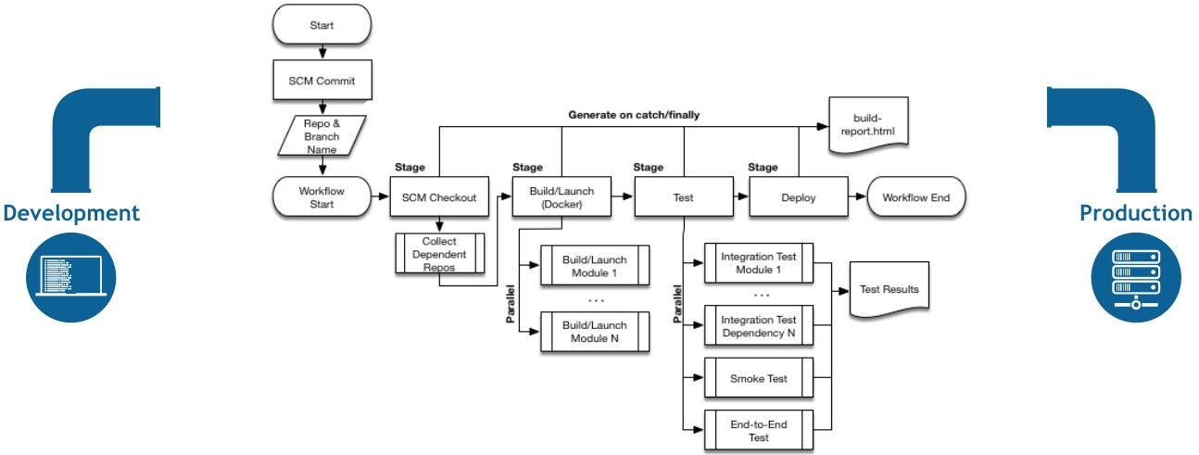

*Figure 1. Pipeline Flow*

## Pipeline Terms

##### Step

A single task; fundamentally steps tell Jenkins *what* to do. For example, to execute the shell command make use the sh step: sh 'make'. When a plugin extends the Pipeline DSL, that typically means the plugin has implemented a new *step*.

##### Node

Most *work* a Pipeline performs is done in the context of one or more declared node steps. Confining the work inside of a node step does two things:

1. Schedules the steps contained within the block to run by adding an item to the Jenkins queue. As soon as an executor is free on a node, the steps will run.
2. Creates a workspace (a directory specific to that particular Pipeline) where work can be done on files checked out from source control.

##### CAUTION

Depending on your Jenkins configuration, some workspaces may not get automatically cleaned up after a period of inactivity. See tickets and discussion linked from [JENKINS-2111](https://issues.jenkins-ci.org/browse/JENKINS-2111) for more information.

##### Stage

stage is a step for defining a conceptually distinct subset of the entire Pipeline, for example: "Build", "Test", and "Deploy", which is used by many plugins to visualize or present Jenkins Pipeline status/progress. [6: Blue Ocean, [Pipeline Stage View plugin](https://wiki.jenkins-ci.org/display/JENKINS/Pipeline%2BStage%2BView%2BPlugin)]

# Getting Started with Pipeline

Jenkins Pipeline is a suite of plugins which supports implementing and integrating continuous delivery pipelines into Jenkins. Pipeline provides an extensible set of tools for modeling simple-to- complex delivery pipelines "as code" via the Pipeline DSL. [7: [Domain-Specific Language](https://en.wikipedia.org/wiki/Domain-specific_language)]

This section introduces some of the key concepts to Jenkins Pipeline and help introduce the basics of defining and working with Pipelines inside of a running Jenkins instance.

## Prerequisites

To use Jenkins Pipeline, you will need:

* Jenkins 2.x or later (older versions back to 1.642.3 may work but are not recommended)
* Pipeline plugin [8: [Pipeline plugin](https://plugins.jenkins.io/workflow-aggregator)]

To learn how to install and manage plugins, consult Managing Plugins.

## Defining a Pipeline

Scripted Pipeline is written in [Groovy](http://groovy-lang.org/). The relevant bits of [Groovy syntax](http://groovy-lang.org/semantics.html) will be introduced as necessary in this document, so while an understanding of Groovy is helpful, it is not required to work with Pipeline.

A basic Pipeline can be created in either of the following ways:

* By entering a script directly in the Jenkins web UI.
* By creating a Jenkinsfile which can be checked into a project’s source control repository.

The syntax for defining a Pipeline with either approach is the same, but while Jenkins supports entering Pipeline directly into the web UI, it’s generally considered best practice to define the Pipeline in a Jenkinsfile which Jenkins will then load directly from source control. [9: [en.wikipedia.org/wiki/Source_control_management](https://en.wikipedia.org/wiki/Source_control_management)]

### Defining a Pipeline in the Web UI

To create a basic Pipeline in the Jenkins web UI, follow these steps:

* Click **New Item** on Jenkins home page.

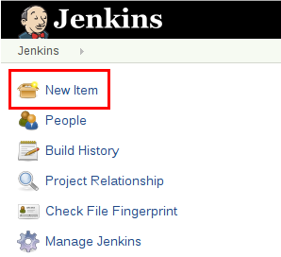

* Enter a name for your Pipeline, select **Pipeline** and click **OK**.

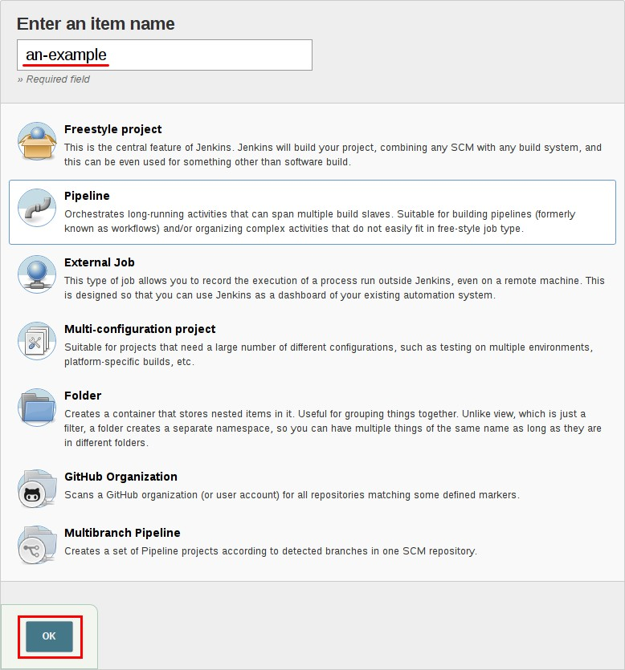

* In the **Script** text area, enter a Pipeline and click **Save**.

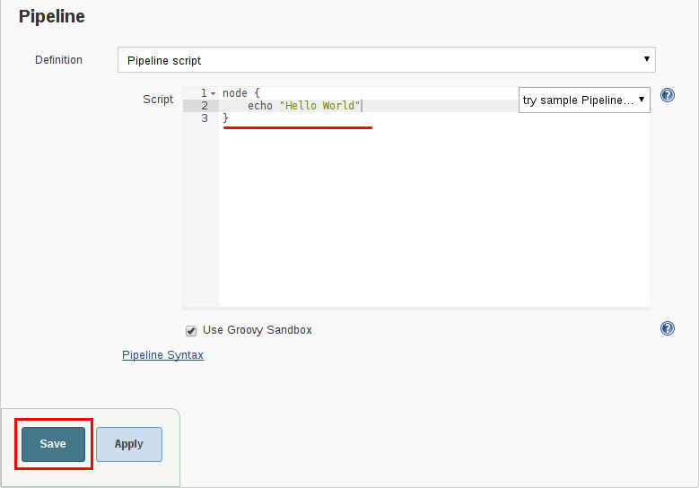

* Click **Build Now** to run the Pipeline.

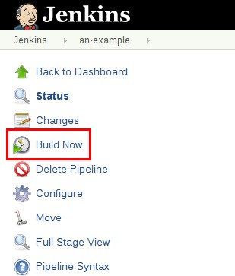

* Click **#1** under "Build History" and then click **Console Output** to see the full output from the Pipeline.

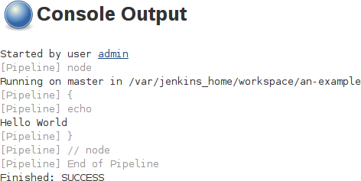

The example above shows a successful run of a basic Pipeline created in the Jenkins web UI, using two steps.

// Script // node { ①

echo 'Hello World' ②

}

// Declarative not yet implemented //

① node allocates an executor and workspace in the Jenkins environment.

② echo writes simple string in the Console Output.

### Defining a Pipeline in SCM

Complex Pipelines are hard to write and maintain within the text area of the Pipeline configuration page. To make this easier, Pipeline can also be written in a text editor and checked into source control as a Jenkinsfile which Jenkins can load via the **Pipeline Script from SCM** option.

To do this, select **Pipeline script from SCM** when defining the Pipeline.

With the **Pipeline script from SCM** option selected, you do not enter any Groovy code in the Jenkins UI; you just indicate by specifying a path where in source code you want to retrieve the pipeline from. When you update the designated repository, a new build is triggered, as long as the Pipeline is configured with an SCM polling trigger.

##### TIP

The first line of a Jenkinsfile should be #!/usr/bin/env groovy [12: [en.wikipedia.org/](https://en.wikipedia.org/wiki/Hashbang) [wiki/Hashbang](https://en.wikipedia.org/wiki/Hashbang)] [13: [groovy-lang.org/syntax.html#_shebang_line](http://groovy-lang.org/syntax.html#_shebang_line)] which text editors, IDEs, GitHub, etc will use to syntax highlight the Jenkinsfile properly as Groovy code.

## Built-in Documentation

Pipeline ships with built-in documentation features to make it easier to create Pipelines of varying complexities. This built-in documentation is automatically generated and updated based on the plugins installed in the Jenkins instance.

The built-in documentation can be found globally at: localhost:8080/pipeline-syntax/, assuming you have a Jenkins instance running on localhost port 8080. The same documentation is also linked as **Pipeline Syntax** in the side-bar for any configured Pipeline project.

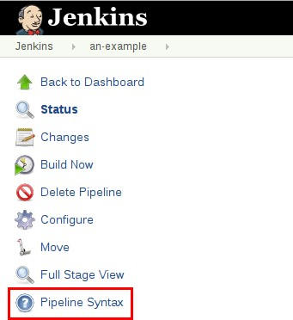

### Snippet Generator

The built-in "Snippet Generator" utility is helpful for creating bits of code for individual steps, discovering new steps provided by plugins, or experimenting with different parameters for a particular step.

The Snippet Generator is dynamically populated with a list of the steps available to the Jenkins instance. The number of steps available is dependent on the plugins installed which explicitly expose steps for use in Pipeline.

To generate a step snippet with the Snippet Generator:

1. Navigate to the **Pipeline Syntax** link (referenced above) from a configured Pipeline, or at localhost:8080/pipeline-syntax.
2. Select the desired step in the **Sample Step** dropdown menu
3. Use the dynamically populated area below the **Sample Step** dropdown to configure the selected step.
4. Click **Generate Pipeline Script** to create a snippet of Pipeline which can be copied and pasted

into a Pipeline.

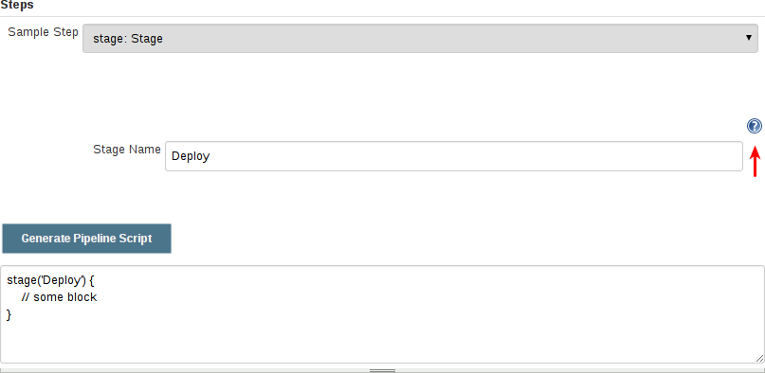

To access additional information and/or documentation about the step selected, click on the help icon (indicated by the red arrow in the image above).

### Global Variable Reference

In addition to the Snippet Generator, which only surfaces steps, Pipeline also provides a built-in "**Global Variable Reference**." Like the Snippet Generator, it is also dynamically populated by plugins. Unlike the Snippet Generator however, the Global Variable Reference only contains documentation for **variables** provided by Pipeline or plugins, which are available for Pipelines.

The variables provided by default in Pipeline are:

##### env

Environment variables accessible from Scripted Pipeline, for example: env.PATH or env.BUILD_ID. Consult the built-in Global Variable Reference for a complete, and up to date, list of environment variables available in Pipeline.

##### params

Exposes all parameters defined for the Pipeline as a read-only [Map](http://groovy-lang.org/syntax.html#_maps), for example:

params.MY_PARAM_NAME.

##### currentBuild

May be used to discover information about the currently executing Pipeline, with properties such as currentBuild.result, currentBuild.displayName, etc. Consult the built-in Global Variable Reference for a complete, and up to date, list of properties available on currentBuild.

## Further Reading

This section merely scratches the surface of what can be done with Jenkins Pipeline, but should provide enough of a foundation for you to start experimenting with a test Jenkins instance.

In the next section, The Jenkinsfile, more Pipeline steps will be discussed along with patterns for implementing successful, real-world, Jenkins Pipelines.

### Additional Resources

* Pipeline Steps Reference, encompassing all steps provided by plugins distributed in the Jenkins Update Center.
* Pipeline Examples, a community-curated collection of copyable Pipeline examples.

# Using a Jenkinsfile

This section builds on the information covered in Getting Started, and introduces more useful steps, common patterns, and demonstrates some non-trivial Jenkinsfile examples.

Creating a Jenkinsfile, which is checked into source control [14: [en.wikipedia.org/wiki/](https://en.wikipedia.org/wiki/Source_control_management) [Source_control_management](https://en.wikipedia.org/wiki/Source_control_management)], provides a number of immediate benefits:

* Code review/iteration on the Pipeline
* Audit trail for the Pipeline
* Single source of truth [15: [en.wikipedia.org/wiki/Single_Source_of_Truth](https://en.wikipedia.org/wiki/Single_Source_of_Truth)] for the Pipeline, which can be viewed and edited by multiple members of the project.

Pipeline supports two syntaxes, Declarative (introduced in Pipeline 2.5) and Scripted Pipeline. Both of which support building continuous delivery pipelines. Both may be used to define a Pipeline in either the web UI or with a Jenkinsfile, though it’s generally considered a best practice to create a Jenkinsfile and check the file into the source control repository.

## Creating a Jenkinsfile

As discussed in the Getting Started section, a Jenkinsfile is a text file that contains the definition of a Jenkins Pipeline and is checked into source control. Consider the following Pipeline which implements a basic three-stage continuous delivery pipeline.

// Declarative // pipeline {

agent any

stages {

stage('Build') { steps {

echo 'Building..'

}

}

stage('Test') { steps {

echo 'Testing..'

}

}

stage('Deploy') { steps {

echo 'Deploying....'

}

}

}

}

// Script // node {

stage('Build') {

echo 'Building....'

}

stage('Test') {

echo 'Building....'

}

stage('Deploy') {

echo 'Deploying....'

}

}

Not all Pipelines will have these same three stages, but it is a good starting point to define them for most projects. The sections below will demonstrate the creation and execution of a simple Pipeline in a test installation of Jenkins.

**NOTE** It is assumed that there is already a source control repository set up for the project and a Pipeline has been defined in Jenkins following these instructions.

Using a text editor, ideally one which supports [Groovy](http://groovy-lang.org/) syntax highlighting, create a new

Jenkinsfile in the root directory of the project.

The Declarative Pipeline example above contains the minimum necessary structure to implement a continuous delivery pipeline. The agent directive, which is required, instructs Jenkins to allocate an executor and workspace for the Pipeline. Without an agent directive, not only is the Declarative Pipeline not valid, it would not be capable of doing any work! By default the agent directive ensures that the source repository is checked out and made available for steps in the subsequent stages`

The stages directive, and steps directives are also required for a valid Declarative Pipeline as they instruct Jenkins what to execute and in which stage it should be executed.

For more advanced usage with Scripted Pipeline, the example above node is a crucial first step as it allocates an executor and workspace for the Pipeline. In essence, without node, a Pipeline cannot do any work! From within node, the first order of business will be to checkout the source code for this project. Since the Jenkinsfile is being pulled directly from source control, Pipeline provides a quick and easy way to access the right revision of the source code

① The checkout step will checkout code from source control; scm is a special variable which instructs the checkout step to clone the specific revision which triggered this Pipeline run.

// Script // node {

checkout scm ①

/* .. snip .. */

}

// Declarative not yet implemented //

### Build

For many projects the beginning of "work" in the Pipeline would be the "build" stage. Typically this stage of the Pipeline will be where source code is assembled, compiled, or packaged. The Jenkinsfile is **not** a replacement for an existing build tool such as GNU/Make, Maven, Gradle, etc, but rather can be viewed as a glue layer to bind the multiple phases of a project’s development lifecycle (build, test, deploy, etc) together.

Jenkins has a number of plugins for invoking practically any build tool in general use, but this example will simply invoke make from a shell step (sh). The sh step assumes the system is Unix/Linux-based, for Windows-based systems the bat could be used instead.

// Declarative // pipeline {

agent any

stages {

stage('Build') { steps {

sh 'make' ①

archiveArtifacts artifacts: '**/target/*.jar', fingerprint: true ②

}

}

}

}

// Script // node {

stage('Build') { sh 'make' ①

archiveArtifacts artifacts: '**/target/*.jar', fingerprint: true ②

}

}

① The sh step invokes the make command and will only continue if a zero exit code is returned by the command. Any non-zero exit code will fail the Pipeline.

② archiveArtifacts captures the files built matching the include pattern (**\*/target/**.jar) and saves them to the Jenkins master for later retrieval.

##### TIP

### Test

Archiving artifacts is not a substitute for using external artifact repositories such as Artifactory or Nexus and should be considered only for basic reporting and file archival.

Running automated tests is a crucial component of any successful continuous delivery process. As such, Jenkins has a number of test recording, reporting, and visualization facilities provided by a [number of plugins](https://plugins.jenkins.io/?labels=report). At a fundamental level, when there are test failures, it is useful to have Jenkins record the failures for reporting and visualization in the web UI. The example below uses the junit step, provided by the plugin:junit[JUnit plugin].

In the example below, if tests fail, the Pipeline is marked "unstable", as denoted by a yellow ball in the web UI. Based on the recorded test reports, Jenkins can also provide historical trend analysis and visualization.

// Declarative // pipeline {

agent any

stages {

stage('Test') { steps {

/* `make check` returns non-zero on test failures,

* using `true` to allow the Pipeline to continue nonetheless

*/

sh 'make check || true' ①

junit '**/target/*.xml' ②

}

}

}

}

// Script // node {

/* .. snip .. */

stage('Test') {

/* `make check` returns non-zero on test failures,

* using `true` to allow the Pipeline to continue nonetheless

*/

sh 'make check || true' ①

junit '**/target/*.xml' ②

}

/* .. snip .. */

}

① Using an inline shell conditional (sh 'make || true') ensures that the sh step always sees a zero exit code, giving the junit step the opportunity to capture and process the test reports. Alternative approaches to this are covered in more detail in the [handling-failures] section below.

② junit captures and associates the JUnit XML files matching the inclusion pattern (**\*/target/**.xml).

### Deploy

Deployment can imply a variety of steps, depending on the project or organization requirements, and may be anything from publishing built artifacts to an Artifactory server, to pushing code to a production system.

At this stage of the example Pipeline, both the "Build" and "Test" stages have successfully executed. In essense, the "Deploy" stage will only execute assuming previous stages completed successfully, otherwise the Pipeline would have exited early.

// Declarative // pipeline {

agent any

stages {

stage('Deploy') { when {

expression {

currentBuild.result == null || currentBuild.result == 'SUCCESS' ①

}

}

steps {

sh 'make publish'

}

}

}

}

// Script // node {

/* .. snip .. */

stage('Deploy') {

if (currentBuild.result == null || currentBuild.result == 'SUCCESS') { ①

sh 'make publish'

}

}

/* .. snip .. */

}

① Accessing the currentBuild.result variable allows the Pipeline to determine if there were any test failures. In which case, the value would be UNSTABLE.

Assuming everything has executed successfully in the example Jenkins Pipeline, each successful Pipeline run will have associated build artifacts archived, test results reported upon and the full console output all in Jenkins.

A Scripted Pipeline can include conditional tests (shown above), loops, try/catch/finally blocks and even functions. The next section will cover this advanced Scripted Pipeline syntax in more detail.

## Advanced Syntax for Pipeline

### String Interpolation

Jenkins Pipeline uses rules identical to [Groovy](http://groovy-lang.org/) for string interpolation. Groovy’s String interpolation support can be confusing to many newcomers to the language. While Groovy supports declaring a string with either single quotes, or double quotes, for example:

def singlyQuoted = 'Hello' def doublyQuoted = "World"

Only the latter string will support the dollar-sign ($) based string interpolation, for example:

def username = 'Jenkins' echo 'Hello Mr. ${username}'

echo "I said, Hello Mr. ${username}"

Would result in:

Hello Mr. ${username}

I said, Hello Mr. Jenkins

Understanding how to use string interpolation is vital for using some of Pipeline’s more advanced features.

### Working with the Environment

Jenkins Pipeline exposes environment variables via the global variable env, which is available from anywhere within a Jenkinsfile. The full list of environment variables accessible from within Jenkins Pipeline is documented at localhost:8080/pipeline-syntax/globals#env, assuming a Jenkins master is running on localhost:8080, and includes:

##### BUILD_ID

The current build ID, identical to BUILD_NUMBER for builds created in Jenkins versions 1.597+

##### JOB_NAME

Name of the project of this build, such as "foo" or "foo/bar".

##### JENKINS_URL

Full URL of Jenkins, such as example.com:port/jenkins/ (NOTE: only available if Jenkins URL set in "System Configuration")

Referencing or using these environment variables can be accomplished like accessing any key in a Groovy [Map](http://groovy-lang.org/syntax.html#_maps), for example:

// Declarative // pipeline {

agent any stages {

stage('Example') { steps {

echo "Running ${env.BUILD_ID} on ${env.JENKINS_URL}"

}

}

}

}

// Script // node {

echo "Running ${env.BUILD_ID} on ${env.JENKINS_URL}"

}

**Setting environment variables**

Setting an environment variable within a Jenkins Pipeline is accomplished differently depending on whether Declarative or Scripted Pipeline is used.

Declarative Pipeline supports an environment directive, whereas users of Scripted Pipeline must use the withEnv step.

// Declarative // pipeline {

agent any environment { ①

CC = 'clang'

}

stages {

stage('Example') { environment { ②

DEBUG_FLAGS = '-g'

}

steps {

sh 'printenv'

}

}

}

}

// Script // node {

/* .. snip .. */ withEnv(["PATH+MAVEN=${tool 'M3'}/bin"]) {

sh 'mvn -B verify'

}

}

① An environment directive used in the top-level pipeline block will apply to all steps within the Pipeline.

② An environment directive defined within a stage will only apply the given environment variables to steps within the stage.

### Parameters

Declarative Pipeline supports parameters out-of-the-box, allowing the Pipeline to accept user- specified parameters at runtime via the parameters directive. Configuring parameters with Scripted Pipeline is done with the properties step, which can be found in the Snippet Generator.

If you configured your pipeline to accept parameters using the **Build with Parameters** option, those parameters are accessible as members of the params variable.

Assuming that a String parameter named "Greeting" has been configuring in the Jenkinsfile, it can access that parameter via ${params.Greeting}:

// Declarative // pipeline {

agent any parameters {

string(name: 'Greeting', defaultValue: 'Hello', description: 'How should I greet the world?')

}

stages {

stage('Example') { steps {

echo "${params.Greeting} World!"

}

}

}

}

// Script //

properties([parameters([string(defaultValue: 'Hello', description: 'How should I greet the world?', name: 'Greeting')])])

node {

echo "${params.Greeting} World!"

}

### Handling Failures

Declarative Pipeline supports robust failure handling by default via its post section which allows declaring a number of different "post conditions" such as: always, unstable, success, failure, and changed. The Pipeline Syntax section provides more detail on how to use the various post conditions.

// Declarative // pipeline {

agent any stages {

stage('Test') { steps {

sh 'make check'

}

}

}

post {

always {

junit '**/target/*.xml'

}

failure {

[mail to: team@example.com,](mailto:team@example.com) subject: 'The Pipeline failed :('

}

}

}

// Script // node {

/* .. snip .. */

stage('Test') { try {

sh 'make check'

}

finally {

junit '**/target/*.xml'

}

}

/* .. snip .. */

}

Scripted Pipeline however relies on Groovy’s built-in try/catch/finally semantics for handling failures during execution of the Pipeline.

In the [test] example above, the sh step was modified to never return a non-zero exit code (sh 'make check || true'). This approach, while valid, means the following stages need to check currentBuild.result to know if there has been a test failure or not.

An alternative way of handling this, which preserves the early-exit behavior of failures in Pipeline, while still giving junit the chance to capture test reports, is to use a series of try

/finally blocks:

### Using multiple agents

In all the previous examples, only a single agent has been used. This means Jenkins will allocate an

executor wherever one is available, regardless of how it is labeled or configured. Not only can this behavior be overridden, but Pipeline allows utilizing multiple agents in the Jenkins environment from within the *same* Jenkinsfile, which can helpful for more advanced use-cases such as executing builds/tests across multiple platforms.

In the example below, the "Build" stage will be performed on one agent and the built results will be reused on two subsequent agents, labelled "linux" and "windows" respectively, during the "Test" stage.

// Declarative // pipeline {

agent none stages {

stage('Build') { agent any steps {

checkout scm sh 'make'

stash includes: '**/target/*.jar', name: 'app' ①

}

}

stage('Test on Linux') { agent { ②

label 'linux'

}

steps {

unstash 'app' ③

sh 'make check'

}

post {

always {

junit '**/target/*.xml'

}

}

}

stage('Test on Windows') { agent {

label 'windows'

}

steps {

unstash 'app'

bat 'make check' ④

}

post {

always {

junit '**/target/*.xml'

}

}

}

}

}

// Script // stage('Build') {

node {

checkout scm sh 'make'

stash includes: '**/target/*.jar', name: 'app' ①

}

}

stage('Test') {

node('linux') { ② checkout scm try {

unstash 'app' ③

sh 'make check'

}

finally {

junit '**/target/*.xml'

}

}

node('windows') { checkout scm try {

unstash 'app'

bat 'make check' ④

}

finally {

junit '**/target/*.xml'

}

}

}

① The stash step allows capturing files matching an inclusion pattern (**\*/target/**.jar) for reuse within the *same* Pipeline. Once the Pipeline has completed its execution, stashed files are deleted from the Jenkins master.

② The parameter in agent/node allows for any valid Jenkins label expression. Consult the Pipeline Syntax section for more details.

③ unstash will retrieve the named "stash" from the Jenkins master into the Pipeline’s current workspace.

④ The bat script allows for executing batch scripts on Windows-based platforms.

### Optional step arguments

Pipeline follows the Groovy language convention of allowing parentheses to be omitted around method arguments.

Many Pipeline steps also use the named-parameter syntax as a shorthand for creating a Map in Groovy, which uses the syntax [key1: value1, key2: value2]. Making statements like the following

functionally equivalent:

git url: 'git://example.com/amazing-project.git', branch: 'master' git([url: 'git://example.com/amazing-project.git', branch: 'master'])

For convenience, when calling steps taking only one parameter (or only one mandatory parameter), the parameter name may be omitted, for example:

sh 'echo hello' /* short form */ sh([script: 'echo hello']) /* long form */

### Advanced Scripted Pipeline

Scripted Pipeline is a domain-specific language [16: [en.wikipedia.org/wiki/Domain-](https://en.wikipedia.org/wiki/Domain-specific_language) [specific_language](https://en.wikipedia.org/wiki/Domain-specific_language)] based on Groovy, most [Groovy syntax](http://groovy-lang.org/semantics.html) can be used in Scripted Pipeline without modification.

**Executing in parallel**

The example in the section above runs tests across two different platforms in a linear series. In practice, if the make check execution takes 30 minutes to complete, the "Test" stage would now take 60 minutes to complete!

Fortunately, Pipeline has built-in functionality for executing portions of Scripted Pipeline in parallel, implemented in the aptly named parallel step.

Refactoring the example above to use the parallel step:

// Script // stage('Build') {

/* .. snip .. */

}

stage('Test') { parallel linux: {

node('linux') { checkout scm try {

unstash 'app' sh 'make check'

}

finally {

junit '**/target/*.xml'

}

}

},

windows: {

node('windows') {

/* .. snip .. */

}

}

}

// Declarative not yet implemented //

Instead of executing the tests on the "linux" and "windows" labelled nodes in series, they will now execute in parallel assuming the requisite capacity exists in the Jenkins environment.

# Pipeline Development Tools

Jenkins Pipeline includes built-in documentation and the Snippet Generator which are key resources when developing Pipelines. They provide detailed help and information that is customized to the currently installed version of Jenkins and related plugins. In this section, we’ll discuss other tools and resources that may help with development of Jenkins Pipelines.

## Command-line Pipeline Linter

Jenkins can validate, or "[lint](https://en.wikipedia.org/wiki/Lint_(software))", a Declarative Pipeline from the command line before actually running it. This can be done using a Jenkins CLI command or by making an HTTP POST request with appropriate parameters. We recommended using the SSH interface to run the linter. See the Jenkins CLI documentation for details on how to properly configure Jenkins for secure command- line access.

*Linting via the CLI with SSH*

# ssh (Jenkins CLI)

# JENKINS_SSHD_PORT=[sshd port on master]

# JENKINS_HOSTNAME=[Jenkins master hostname]

ssh -p $JENKINS_SSHD_PORT $JENKINS_HOSTNAME declarative-linter < Jenkinsfile

*Linting via HTTP POST using* curl

# curl (REST API)

# Assuming "anonymous read access" has been enabled on your Jenkins instance. # JENKINS_URL=[root URL of Jenkins master]

# JENKINS_CRUMB is needed if your Jenkins master has CRSF protection enabled as it should

JENKINS_CRUMB=`curl "$JENKINS_URL/crumbIssuer/api/xml?xpath=concat(//crumbRequestField,\":\",//crumb)"` curl -X POST -H $JENKINS_CRUMB -F "jenkinsfile=<Jenkinsfile" $JENKINS_URL/pipeline- model-converter/validate

### Examples

Below are two examples of the Pipeline Linter in action. This first example shows the output of the linter when it is passed an invalid Jenkinsfile, one that is missing part of the agent declaration.

*Jenkinsfile*

pipeline { agent stages {

stage ('Initialize') { steps {

echo 'Placeholder.'

}

}

}

}

*Linter output for invalid Jenkinsfile*

# pass a Jenkinsfile that does not contain an "agent" section ssh -p 8675 localhost declarative-linter < ./Jenkinsfile Errors encountered validating Jenkinsfile:

WorkflowScript: 2: Not a valid section definition: "agent". Some extra configuration is required. @ line 2, column 3.

agent

^

WorkflowScript: 1: Missing required section "agent" @ line 1, column 1. pipeline &#125;

^

In this second example, the Jenkinsfile has been updated to include the missing any on agent. The linter now reports that the Pipeline is valid.

*Jenkinsfile*

pipeline { agent any stages {

stage ('Initialize') { steps {

echo 'Placeholder.'

}

}

}

}

*Linter output for valid Jenkinsfile*

ssh -p 8675 localhost declarative-linter < ./Jenkinsfile Jenkinsfile successfully validated.

## "Replay" Pipeline Runs with Modifications

Typically a Pipeline will be defined inside of the classic Jenkins web UI, or by committing to a Jenkinsfile in source control. Unfortunately, neither approach is ideal for rapid iteration, or prototyping, of a Pipeline. The "Replay" feature allows for quick modifications and execution of an existing Pipeline without changing the Pipeline configuration or creating a new commit.

### Usage

To use the "Replay" feature:

1. Select a previously completed run in the build history.

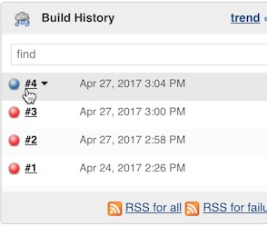

1. Click "Replay" in the left menu

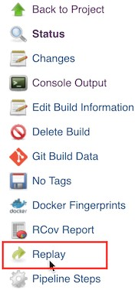

1. Make modifications and click "Run". In this example, we changed "ruby-2.3" to "ruby-2.4".

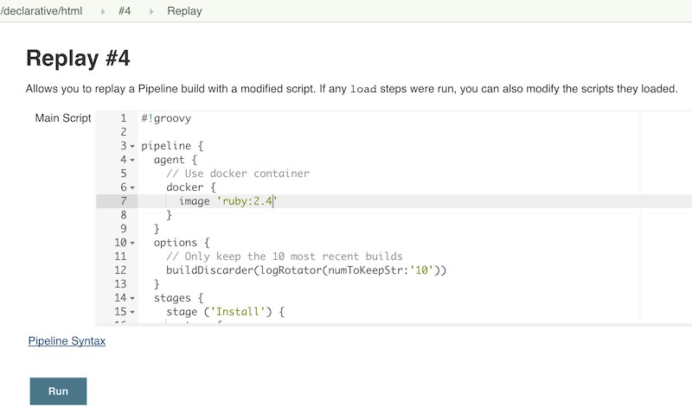

1. Check the results of changes

Once you are satisfied with the changes, you can use Replay to view them again, copy them back to your Pipeline job or Jenkinsfile, and then commit them using your usual engineering processes.

### Features

* **Can be called multiple times on the same run** - allows for easy parallel testing of different changes.
* **Can also be called on Pipeline runs that are still in-progress** - As long as a Pipeline contained syntactically correct Groovy and was able to start, it can be Replayed.
* **Referenced Shared Library code is also modifiable** - If a Pipeline run references a Shared Library, the code from the shared library will also be shown and modifiable as part of the Replay page.

# Pipeline Syntax

This section builds on the information introduced in Getting Started, and should be treated solely as a reference. For more information on how to use Pipeline syntax in practical examples, refer to The Jenkinsfile section of this chapter. As of version 2.5 of the Pipeline plugin, Pipeline supports two discrete syntaxes which are detailed below. For the pros and cons of each, see the Syntax Comparison.

As discussed in Getting Started, the most fundamental part of a Pipeline is the "step." Basically, steps tell Jenkins *what* to do, and serve as the basic building block for both Declarative and Scripted Pipeline syntax.

For an overview of available steps, please refer to the Pipeline Steps reference which contains a comprehensive list of steps built into Pipeline as well as steps provided by plugins.

## Declarative Pipeline

Declarative Pipeline is a relatively recent addition to Jenkins Pipeline [19: Version 2.5 of the "Pipeline plugin" introduces support for Declarative Pipeline syntax] which presents a more simplified and opinionated syntax on top of the Pipeline sub-systems.

All valid Declarative Pipelines must be enclosed within a pipeline block, for example:

pipeline {

/* insert Declarative Pipeline here */

}

The basic statements and expressions which are valid in Declarative Pipeline follow the same rules as [Groovy’s syntax](http://groovy-lang.org/syntax.html) with the following exceptions:

* The top-level of the Pipeline must be a *block*, specifically: pipeline { }
* No semicolons as statement separators. Each statement has to be on its own line
* Blocks must only consist of Sections, Directives, Steps, or assignment statements.
* A property reference statement is treated as no-argument method invocation. So for example, input is treated as input()

### Sections

Sections in Declarative Pipeline typically contain one or more Directives or Steps.

**agent**

The agent section specifies where the entire Pipeline, or a specific stage, will execute in the Jenkins environment depending on where the agent section is placed. The section must be defined at the top-level inside the pipeline block, but stage-level usage is optional.

|  |  |
| --- | --- |
| **Require d** | Yes |
| **Parame ters** | Described below |
| **Allowed** | In the top-level pipeline block and each stage block. |

##### Parameters

In order to support the wide variety of use-cases Pipeline authors may have, the agent section supports a few different types of parameters. These parameters can be applied at the top-level of the pipeline block, or within each stage directive.

##### any

Execute the Pipeline, or stage, on any available agent. For example: agent any

##### none

When applied at the top-level of the pipeline block no global agent will be allocated for the entire Pipeline run and each stage section will need to contain its own agent section. For example: agent none

##### label

Execute the Pipeline, or stage, on an agent available in the Jenkins environment with the provided label. For example: agent { label 'my-defined-label' }

##### node

agent { node { label 'labelName' } } behaves the same as agent { label 'labelName' }, but

node allows for additional options (such as customWorkspace).

##### docker

Execute the Pipeline, or stage, with the given container which will be dynamically provisioned on a node pre-configured to accept Docker-based Pipelines, or on a node matching the optionally defined label parameter. docker also optionally accepts an args parameter which may contain arguments to pass directly to a docker run invocation, and an alwaysPull option, which will force a docker pull even if the image name is already present. For example: agent { docker 'maven:3- alpine' } or

agent {

docker {

image 'maven:3-alpine' label 'my-defined-label' args '-v /tmp:/tmp'

}

}

##### dockerfile

Execute the Pipeline, or stage, with a container built from a Dockerfile contained in the source repository. In order to use this option, the Jenkinsfile must be loaded from either a Multibranch Pipeline, or a "Pipeline from SCM." Conventionally this is the Dockerfile in the root of the source repository: agent { dockerfile true }. If building a Dockerfile in another directory, use the dir option: agent { dockerfile { dir 'someSubDir' } }. You can pass additional arguments to the docker build … command with the additionalBuildArgs option, like agent { dockerfile { additionalBuildArgs '--build-arg foo=bar' } }.

##### Common Options

These are a few options that can be applied two or more agent implementations. They are not required unless explicitly stated.

##### label

A string. The label on which to run the Pipeline or individual stage.

This option is valid for node, docker and dockerfile, and is required for node.

##### customWorkspace

A string. Run the Pipeline or individual stage this agent is applied to within this custom workspace, rather than the default. It can be either a relative path, in which case the custom workspace will be under the workspace root on the node, or an absolute path. For example:

agent {

node {

label 'my-defined-label' customWorkspace '/some/other/path'

}

}

This option is valid for node, docker and dockerfile.

##### reuseNode

A boolean, false by default. If true, run the container on the node specified at the top-level of the Pipeline, in the same workspace, rather than on a new node entirely.

This option is valid for docker and dockerfile, and only has an effect when used on an agent for an individual stage.

##### Example

// Declarative // pipeline {

agent { docker 'maven:3-alpine' } ①

stages {

stage('Example Build') { steps {

sh 'mvn -B clean verify'

}

}

}

}

// Script //

① Execute all the steps defined in this Pipeline within a newly created container of the given name and tag (maven:3-alpine).

**Stage-level** agent **section**

// Declarative // pipeline {

agent none ①

stages {

stage('Example Build') {

agent { docker 'maven:3-alpine' } ②

steps {

echo 'Hello, Maven' sh 'mvn --version'

}

}

stage('Example Test') {

agent { docker 'openjdk:8-jre' } ③

steps {

echo 'Hello, JDK' sh 'java -version'

}

}

}

}

// Script //

① Defining agent none at the top-level of the Pipeline ensures that an Executor will not be assigned unnecessarily. Using agent none also forces each stage section contain its own agent section.

② Execute the steps in this stage in a newly created container using this image.

③ Execute the steps in this stage in a newly created container using a different image from the previous stage.

**post**

The post section defines one or more additional steps that are run upon the completion of a Pipeline’s or stage’s run (depending on the location of the post section within the Pipeline). post can support one of the following post-condition blocks: always, changed, failure, success, unstable, and aborted. These condition blocks allow the execution of steps within the post section depending on the completion status of the Pipeline or stage.

|  |  |
| --- | --- |
| **Require d** | No |
| **Parame ters** | *None* |
| **Allowed** | In the top-level pipeline block and each stage block. |

##### Conditions

always

Run the steps in the post section regardless of the completion status of the Pipeline’s or stage’s run.

changed

Only run the steps in post if the current Pipeline’s or stage’s run has a different completion status from its previous run.

failure

Only run the steps in post if the current Pipeline’s or stage’s run has a "failed" status, typically denoted by red in the web UI.

success

Only run the steps in post if the current Pipeline’s or stage’s run has a "success" status, typically denoted by blue or green in the web UI.

unstable

Only run the steps in post if the current Pipeline’s or stage’s run has an "unstable" status, usually caused by test failures, code violations, etc. This is typically denoted by yellow in the web UI.

aborted

Only run the steps in post if the current Pipeline’s or stage’s run has an "aborted" status, usually due to the Pipeline being manually aborted. This is typically denoted by gray in the web UI.

##### Example

// Declarative // pipeline {

agent any stages {

stage('Example') { steps {

echo 'Hello World'

}

}

}

post { ①

always { ②

echo 'I will always say Hello again!'

}

}

}

// Script //

① Conventionally, the post section should be placed at the end of the Pipeline.

② Post-condition blocks contain steps the same as the [steps] section.

**stages**

Containing a sequence of one or more [stage] directives, the stages section is where the bulk of the "work" described by a Pipeline will be located. At a minimum it is recommended that stages contain at least one [stage] directive for each discrete part of the continuous delivery process, such as Build, Test, and Deploy.

|  |  |
| --- | --- |
| **Require d** | Yes |
| **Parame ters** | *None* |
| **Allowed** | Only once, inside the pipeline block. |

##### Example

// Declarative // pipeline {

agent any stages { ①

stage('Example') { steps {

echo 'Hello World'

}

}

}

}

// Script //

① The stages section will typically follow the directives such as agent, options, etc.

**steps**

The steps section defines a series of one or more steps to be executed in a given stage directive.

|  |  |
| --- | --- |
| **Require d** | Yes |
| **Parame ters** | *None* |
| **Allowed** | Inside each stage block. |

##### Example

// Declarative // pipeline {

agent any stages {

stage('Example') { steps { ①

echo 'Hello World'

}

}

}

}

// Script //

① The steps section must contain one or more steps.

### Directives

**environment**

The environment directive specifies a sequence of key-value pairs which will be defined as environment variables for the all steps, or stage-specific steps, depending on where the environment directive is located within the Pipeline.

This directive supports a special helper method credentials() which can be used to access pre- defined Credentials by their identifier in the Jenkins environment. For Credentials which are of type "Secret Text", the credentials() method will ensure that the environment variable specified contains the Secret Text contents. For Credentials which are of type "Standard username and password", the environment variable specified will be set to username:password and two additional environment variables will be automatically be defined: MYVARNAME_USR and MYVARNAME_PSW respective.

|  |  |
| --- | --- |
| **Require d** | No |
| **Parame ters** | *None* |
| **Allowed** | Inside the pipeline block, or within stage directives. |

##### Example

// Declarative // pipeline {

agent any environment { ①

CC = 'clang'

}

stages {

stage('Example') { environment { ②

AN_ACCESS_KEY = credentials('my-prefined-secret-text') ③

}

steps {

sh 'printenv'

}

}

}

}

// Script //

① An environment directive used in the top-level pipeline block will apply to all steps within the Pipeline.

② An environment directive defined within a stage will only apply the given environment variables to steps within the stage.

③ The environment block has a helper method credentials() defined which can be used to access pre-defined Credentials by their identifier in the Jenkins environment.

**options**

The options directive allows configuring Pipeline-specific options from within the Pipeline itself. Pipeline provides a number of these options, such as buildDiscarder, but they may also be provided by plugins, such as timestamps.

|  |  |
| --- | --- |
| **Require d** | No |
| **Parame ters** | *None* |
| **Allowed** | Only once, inside the pipeline block. |

##### Available Options buildDiscarder

Persist artifacts and console output for the specific number of recent Pipeline runs. For example:

options { buildDiscarder(logRotator(numToKeepStr: '1')) }

##### disableConcurrentBuilds

Disallow concurrent executions of the Pipeline. Can be useful for preventing simultaneous

accesses to shared resources, etc. For example: options { disableConcurrentBuilds() }

##### overrideIndexTriggers

Allows overriding default treatment of branch indexing triggers. If branch indexing triggers are disabled at the multibranch or organization label, options { overrideIndexTriggers(true) } will enable them for this job only. Otherwise, options { overrideIndexTriggers(false) } will disable branch indexing triggers for this job only.

##### skipDefaultCheckout

Skip checking out code from source control by default in the agent directive. For example:

options { skipDefaultCheckout() }

##### skipStagesAfterUnstable

Skip stages once the build status has gone to UNSTABLE. For example: options { skipStagesAfterUnstable() }

##### timeout

Set a timeout period for the Pipeline run, after which Jenkins should abort the Pipeline. For example: options { timeout(time: 1, unit: 'HOURS') }

##### retry

On failure, retry the entire Pipeline the specified number of times. For example: options { retry(3) }

##### timestamps

Prepend all console output generated by the Pipeline run with the time at which the line was emitted. For example: options { timestamps() }

##### Example

// Declarative // pipeline {

agent any options {

timeout(time: 1, unit: 'HOURS') ①

}

stages {

stage('Example') { steps {

echo 'Hello World'

}

}

}

}

// Script //

① Specifying a global execution timeout of one hour, after which Jenkins will abort the Pipeline run.

**NOTE** A comprehensive list of available options is pending the completion of [INFRA-1503](https://issues.jenkins-ci.org/browse/INFRA-1053).

**parameters**

The parameters directive provides a list of parameters which a user should provide when triggering the Pipeline. The values for these user-specified parameters are made available to Pipeline steps via the params object, see the Example for its specific usage.

|  |  |
| --- | --- |
| **Require d** | No |
| **Parame ters** | *None* |
| **Allowed** | Only once, inside the pipeline block. |

##### Available Parameters string

A parameter of a string type, for example: parameters { string(name: 'DEPLOY_ENV', defaultValue: 'staging', description: '') }

##### booleanParam

A boolean parameter, for example: parameters { booleanParam(name: 'DEBUG_BUILD', defaultValue: true, description: '') }

##### Example

// Declarative // pipeline {

agent any parameters {

string(name: 'PERSON', defaultValue: 'Mr Jenkins', description: 'Who should I say hello to?')

}

stages {

stage('Example') { steps {

echo "Hello ${params.PERSON}"

}

}

}

}

// Script //

**NOTE** A comprehensive list of available parameters is pending the completion of [INFRA-](https://issues.jenkins-ci.org/browse/INFRA-1053) [1503](https://issues.jenkins-ci.org/browse/INFRA-1053).

**triggers**

The triggers directive defines the automated ways in which the Pipeline should be re-triggered. For Pipelines which are integrated with a source such as GitHub or BitBucket, triggers may not be necessary as webhooks-based integration will likely already be present. The triggers currently available are cron, pollSCM and upstream.

|  |  |
| --- | --- |
| **Require d** | No |
| **Parame ters** | *None* |
| **Allowed** | Only once, inside the pipeline block. |

##### cron

Accepts a cron-style string to define a regular interval at which the Pipeline should be re- triggered, for example: triggers { cron('H */4 * * 1-5') }

##### pollSCM

Accepts a cron-style string to define a regular interval at which Jenkins should check for new

source changes. If new changes exist, the Pipeline will be re-triggered. For example: triggers { pollSCM('H */4 * * 1-5') }

##### upstream

Accepts a comma separated string of jobs and a threshold. When any job in the string finishes

with the minimum threshold, the Pipeline will be re-triggered. For example: triggers { upstream(upstreamProjects: 'job1,job2', threshold: hudson.model.Result.SUCCESS) }

**NOTE** The pollSCM trigger is only available in Jenkins 2.22 or later.

##### Example

// Declarative // pipeline {

agent any triggers {

cron('H */4 * * 1-5')

}

stages {

stage('Example') { steps {

echo 'Hello World'

}

}

}

}

// Script //

**stage**

The stage directive goes in the stages section and should contain a [steps] section, an optional agent section, or other stage-specific directives. Practically speaking, all of the real work done by a Pipeline will be wrapped in one or more stage directives.

|  |  |
| --- | --- |
| **Require d** | At least one |
| **Parame ters** | One mandatory parameter, a string for the name of the stage. |
| **Allowed** | Inside the stages section. |

##### Example

// Declarative // pipeline {

agent any stages {

stage('Example') { steps {

echo 'Hello World'

}

}

}

}

// Script //

**tools**

A section defining tools to auto-install and put on the PATH. This is ignored if agent none is specified.

|  |  |
| --- | --- |
| **Require d** | No |
| **Parame ters** | *None* |
| **Allowed** | Inside the pipeline block or a stage block. |

##### Supported Tools maven

##### jdk gradle

##### Example

// Declarative // pipeline {

agent any tools {

maven 'apache-maven-3.0.1' ①

}

stages {

stage('Example') { steps {

sh 'mvn --version'

}

}

}

}

// Script //

① The tool name must be pre-configured in Jenkins under **Manage Jenkins** → **Global Tool Configuration**.

**when**

The when directive allows the Pipeline to determine whether the stage should be executed depending on the given condition. The when directive must contain at least one condition. If the when directive contains more than one condition, all the child conditions must return true for the stage to execute. This is the same as if the child conditions were nested in an allOf condition (see the examples below).

More complex conditional structures can be built using the nesting conditions: not, allOf, or anyOf. Nesting conditions may be nested to any arbitrary depth.

|  |  |
| --- | --- |
| **Require d** | No |
| **Parame ters** | *None* |
| **Allowed** | Inside a stage directive |

##### Built-in Conditions branch

Execute the stage when the branch being built matches the branch pattern given, for example:

when { branch 'master' }. Note that this only works on a multibranch Pipeline.

##### environment

Execute the stage when the specified environment variable is set to the given value, for example:

when { environment name: 'DEPLOY_TO', value: 'production' }

##### expression

Execute the stage when the specified Groovy expression evaluates to true, for example: when { expression { return params.DEBUG_BUILD } }

##### not

Execute the stage when the nested condition is false. Must contain one condition. For example:

when { not { branch 'master' } }

##### allOf

Execute the stage when all of the nested conditions are true. Must contain at least one condition.

For example: when { allOf { branch 'master'; environment name: 'DEPLOY_TO', value: 'production' } }

##### anyOf

Execute the stage when at least one of the nested conditions is true. Must contain at least one condition. For example: when { anyOf { branch 'master'; branch 'staging' } }

##### Examples

*Single condition*

// Declarative // pipeline {

agent any stages {

stage('Example Build') { steps {

echo 'Hello World'

}

}

stage('Example Deploy') { when {

branch 'production'

}

steps {

echo 'Deploying'

}

}

}

}

// Script //

*Multiple condition*

// Declarative // pipeline {

agent any stages {

stage('Example Build') { steps {

echo 'Hello World'

}

}

stage('Example Deploy') { when {

branch 'production'

environment name: 'DEPLOY_TO', value: 'production'

}

steps {

echo 'Deploying'

}

}

}

}

// Script //

*Nested condition (same behavior as previous example)*

// Declarative // pipeline {

agent any stages {

stage('Example Build') { steps {

echo 'Hello World'

}

}

stage('Example Deploy') { when {

allOf {

branch 'production'

environment name: 'DEPLOY_TO', value: 'production'

}

}

steps {

echo 'Deploying'

}

}

}

}

// Script //

*Multiple condition and nested condition*

// Declarative // pipeline {

agent any stages {

stage('Example Build') { steps {

echo 'Hello World'

}

}

stage('Example Deploy') { when {

branch 'production' anyOf {

environment name: 'DEPLOY_TO', value: 'production' environment name: 'DEPLOY_TO', value: 'staging'

}

}

steps {

echo 'Deploying'

}

}

}

}

// Script //

*Expression condition and nested condition*

// Declarative // pipeline {

agent any stages {

stage('Example Build') { steps {

echo 'Hello World'

}

}

stage('Example Deploy') { when {

expression { BRANCH_NAME ==~ /(production|staging)/ } anyOf {

environment name: 'DEPLOY_TO', value: 'production' environment name: 'DEPLOY_TO', value: 'staging'

}

}

steps {

echo 'Deploying'

}

}

}

}

// Script //

### Parallel

Stages in Declarative Pipeline may declare a number of nested stages within them, which will be executed in parallel. Note that a stage must have one and only one of either steps or parallel. The nested stages cannot contain further parallel stages themselves, but otherwise behave the same as any other stage. Any stage containing parallel cannot contain agent or tools, since those are not relevant without steps.

In addition, you can force your parallel stage`s to all be aborted when one of them fails, by adding `failFast true to the stage containing the parallel.

**Example**

// Declarative // pipeline {

agent any stages {

stage('Non-Parallel Stage') { steps {

echo 'This stage will be executed first.'

}

}

stage('Parallel Stage') { when {

branch 'master'

}

failFast true parallel {

stage('Branch A') { agent {

label "for-branch-a"

}

steps {

echo "On Branch A"

}

}

stage('Branch B') { agent {

label "for-branch-b"

}

steps {

echo "On Branch B"

}

}

}

}

}

}

// Script //

**Steps**

Declarative Pipelines may use all the available steps documented in the Pipeline Steps reference, which contains a comprehensive list of steps, with the addition of the steps listed below which are **only supported** in Declarative Pipeline.

**script**

The script step takes a block of [scripted-pipeline] and executes that in the Declarative Pipeline. For most use-cases, the script step should be unnecessary in Declarative Pipelines, but it can provide a

useful "escape hatch." script blocks of non-trivial size and/or complexity should be moved into Shared Libraries instead.

##### Example

// Declarative // pipeline {

agent any stages {

stage('Example') { steps {

echo 'Hello World'

script {

def browsers = ['chrome', 'firefox']

for (int i = 0; i < browsers.size(); ++i) { echo "Testing the ${browsers[i]} browser"

}

}

}

}

}

}

// Script //

## Scripted Pipeline

Scripted Pipeline, like [declarative-pipeline], is built on top of the underlying Pipeline sub-system. Unlike Declarative, Scripted Pipeline is effectively a general purpose DSL [20: Domain-specific Language] built with [Groovy](http://groovy-lang.org/syntax.html). Most functionality provided by the Groovy language is made available to users of Scripted Pipeline, which means it can be a very expressive and flexible tool with which one can author continuous delivery pipelines.

### Flow Control

Scripted Pipeline is serially executed from the top of a Jenkinsfile downwards, like most traditional scripts in Groovy or other languages. Providing flow control therefore rests on Groovy expressions, such as the if/else conditionals, for example:

// Scripted // node {

stage('Example') {

if (env.BRANCH_NAME == 'master') {

echo 'I only execute on the master branch'

} else {

echo 'I execute elsewhere'

}

}

}

// Declarative //

Another way Scripted Pipeline flow control can be managed is with Groovy’s exception handling support. When Steps fail for whatever reason they throw an exception. Handling behaviors on- error must make use of the try/catch/finally blocks in Groovy, for example:

// Scripted // node {

stage('Example') { try {

sh 'exit 1'

}

catch (exc) {

echo 'Something failed, I should sound the klaxons!' throw

}

}

}

// Declarative //

### Steps

As discussed in Getting Started, the most fundamental part of a Pipeline is the "step." Fundamentally, steps tell Jenkins *what* to do, and serve as the basic building block for both Declarative and Scripted Pipeline syntax.

Scripted Pipeline does **not** introduce any steps which are specific to its syntax; Pipeline Steps reference which contains a comprehensive list of steps provided by Pipeline and plugins.

### Differences from plain Groovy

In order to provide *durability*, which means that running Pipelines can survive a restart of the Jenkins master, Scripted Pipeline must serialize data back to the master. Due to this design requirement, some Groovy idioms such as collection.each { item → /* perform operation */ } are not fully supported. See [JENKINS-27421](https://issues.jenkins-ci.org/browse/JENKINS-27421) and [JENKINS-26481](https://issues.jenkins-ci.org/browse/JENKINS-26481) for more information.

**General Terms**

##### Agent

An agent is typically a machine, or container, which connects to a Jenkins master and executes tasks when directed by the master.

##### Artifact

An immutable file generated during a Build or Pipeline run which is **archived** onto the Jenkins Master for later retrieval by users.

##### Build

Result of a single execution of a Project

##### Cloud

A System Configuration which provides dynamic Agent provisioning and allocation, such as that provided by the plugin:azure-vm-agents[Azure VM Agents] or plugin:ec2[Amazon EC2] plugins.

##### Core

The primary Jenkins application (jenkins.war) which provides the basic web UI, configuration, and foundation upon which Plugins can be built.

##### Downstream

A configured Pipeline or Project which is triggered as part of the execution of a separate Pipeline or Project.

##### Executor

A slot for execution of work defined by a Pipeline or Project on a Node. A Node may have zero or more Executors configured which corresponds to how many concurrent Projects or Pipelines are able to execute on that Node.

##### Fingerprint

A hash considered globally unique to track the usage of an Artifact or other entity across multiple Pipelines or Projects.

##### Folder

An organizational container for Pipelines and/or Projects, similar to folders on a file system.

##### Item

An entity in the web UI corresponding to either a: Folder, Pipeline, or Project.

##### Job

A deprecated term, synonymous with Project.

##### Label

User-defined text for grouping Agents, typically by similar functionality or capability. For example linux for Linux-based agents or docker for Docker-capable agents.

##### Master

The central, coordinating process which stores configuration, loads plugins, and renders the various user interfaces for Jenkins.

##### Node

A machine which is part of the Jenkins environment and capable of executing Pipelines or Projects. Both the Master and Agents are considered to be Nodes.

##### Project

A user-configured description of work which Jenkins should perform, such as building a piece of software, etc.

##### Pipeline

A user-defined model of a continuous delivery pipeline, for more read the Pipeline chapter in this handbook.

##### Plugin

An extension to Jenkins functionality provided separately from Jenkins Core.

##### Publisher

Part of a Build after the completion of all configured Steps which publishes reports, sends notifications, etc.

##### Stage

stage is part of Pipeline, and used for defining a conceptually distinct subset of the entire Pipeline, for example: "Build", "Test", and "Deploy", which is used by many plugins to visualize or present Jenkins Pipeline status/progress.

##### Step

A single task; fundamentally steps tell Jenkins *what* to do inside of a Pipeline or Project.

##### Trigger

A criteria for triggering a new Pipeline run or Build.

##### Update Center

Hosted inventory of plugins and plugin metadata to enable plugin installation from within Jenkins.

##### Upstream

A configured Pipeline or Project which triggers a separate Pipeline or Project as part of its execution.

##### Workspace

A disposable directory on the file system of a Node where work can be done by a Pipeline or Project. Workspaces are typically left in place after a Build or Pipeline run completes unless specific Workspace cleanup policies have been put in place on the Jenkins Master.

## Install Email-ext plugin

* Install Email-ext plugin at plug-in install page of Jenkins

## Configure System

### “Jenkins Location” section

1. Enter valid email address to “System Admin e-mail address”

### “Extended E-mail Notification” section

1. Enter your email address to “Default Recipients”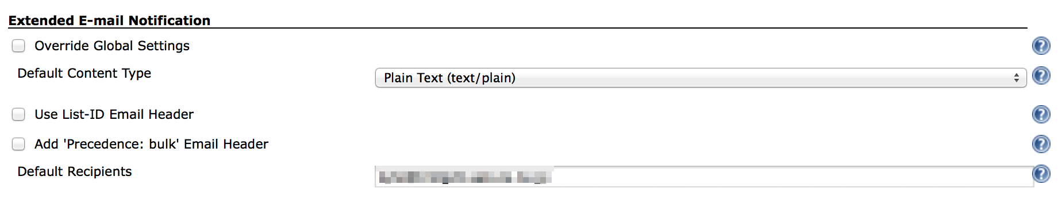

### “E-mail Notification” section

1. Enter your SMTP server name to “SMTP server”
2. Click “Advanced”
3. Click “Use SMTP Authentication”
4. Enter required information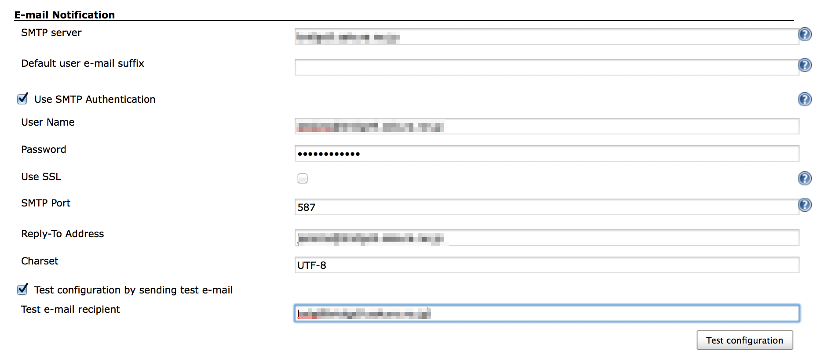
5. Check “Test configuration by sending test e-mail”
6. Click “Test configuration” to send test email
7. Click “Save” in the bottom of the page

## Configure a project to send email at every build

1. Click “Add post-build action”
2. Click “Editable Email Notification”
3. Click “Advanced Settings…”
4. Click “Add Trigger”
5. Click “Always”
6. Save

## Test-run

1. Click “Build Now”
2. Check Console output and received email

[INFO] ------------------------------------------------------------------------

[INFO] BUILD SUCCESS

[INFO] ------------------------------------------------------------------------

[INFO] Total time: 3.497s

[INFO] Finished at: Sat Feb 22 22:27:21 JST 2014

[INFO] Final Memory: 18M/245M

[INFO] ------------------------------------------------------------------------

[JENKINS] Archiving /Users/Shared/Jenkins/Home/jobs/BuildAndTestHead/workspace/hellojenkins/pom.xml to org.nailedtothex/hellojenkins/0.0.1-SNAPSHOT/hellojenkins-0.0.1-SNAPSHOT.pom

channel stopped

Archiving artifacts

Email was triggered for: Always

Sending email for trigger: Always

Sending email to: kyle@example.com

Finished: SUCCESS

