**1. Demonstrate the use of maven in Java project.**

Step1: Go to Eclipse🡪File🡪New file🡪Maven Project.

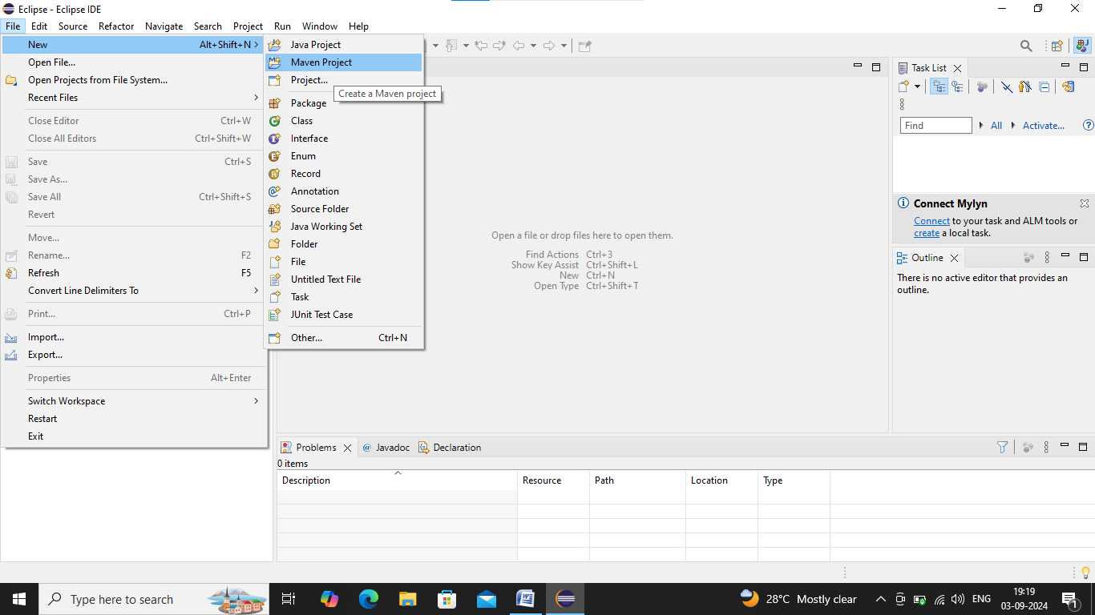

Step2: Select🡪Create a simple project🡪Click on Next.

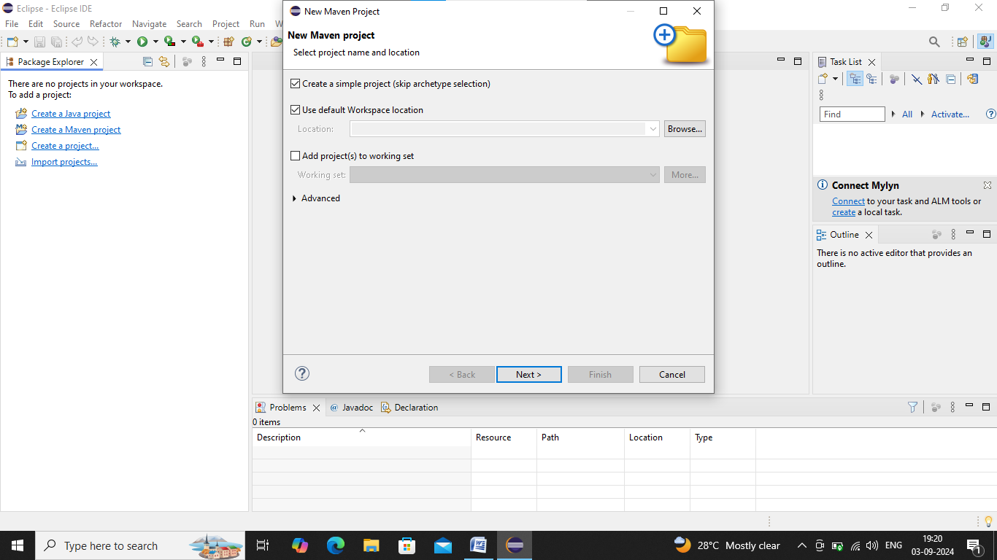

Step3: Give Group Id-com.FSD2425🡪Artifact Id-maven🡪Name-demo🡪Click on Finish.

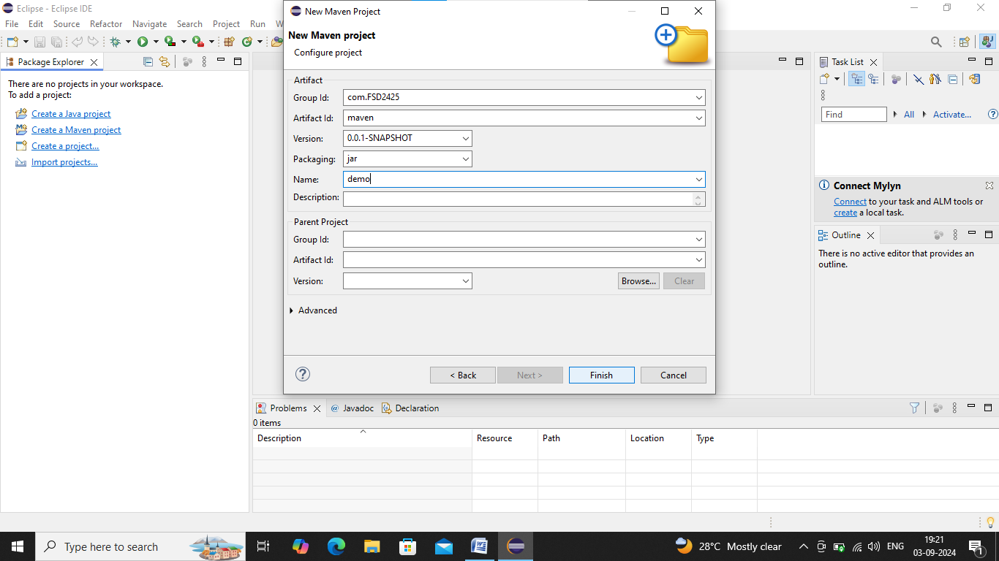

Step4: To change Java version if not in jdk-21:

Right click to your project🡪Build Path🡪Configure Build Path🡪Libraries.

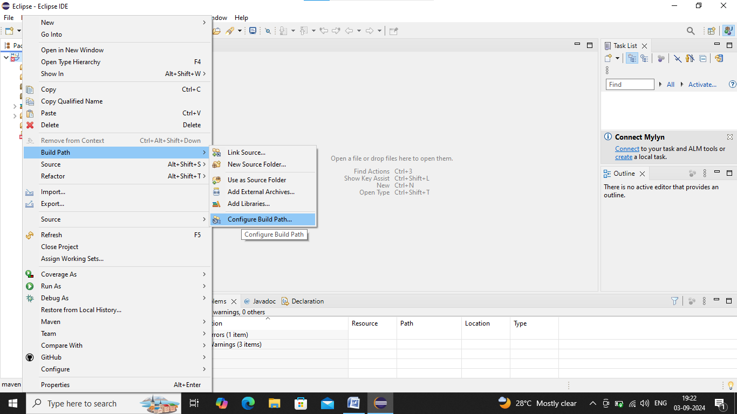

Remove JRE🡪Click on Add Library.

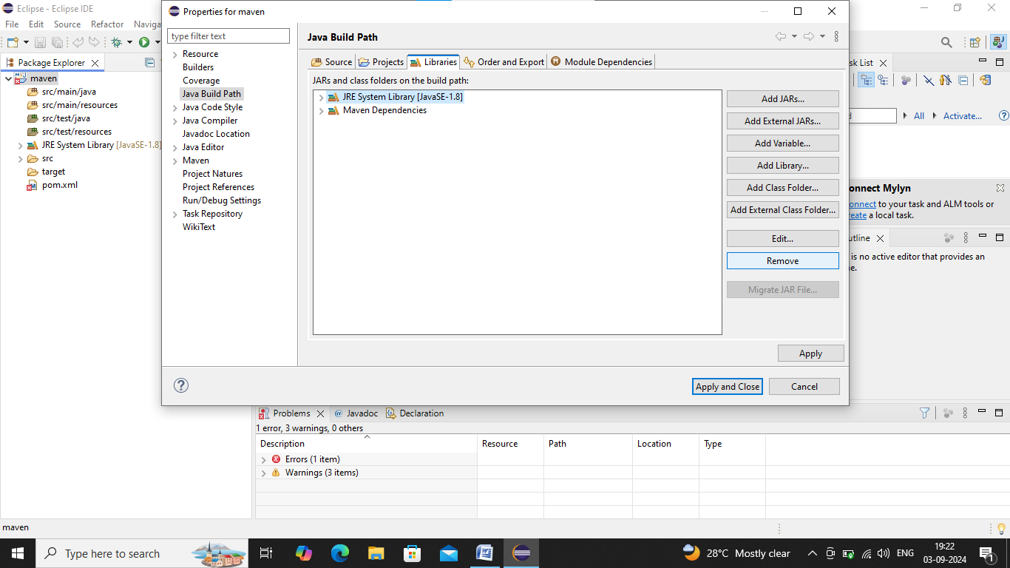

Select JRE_System_Library🡪Click on Next.

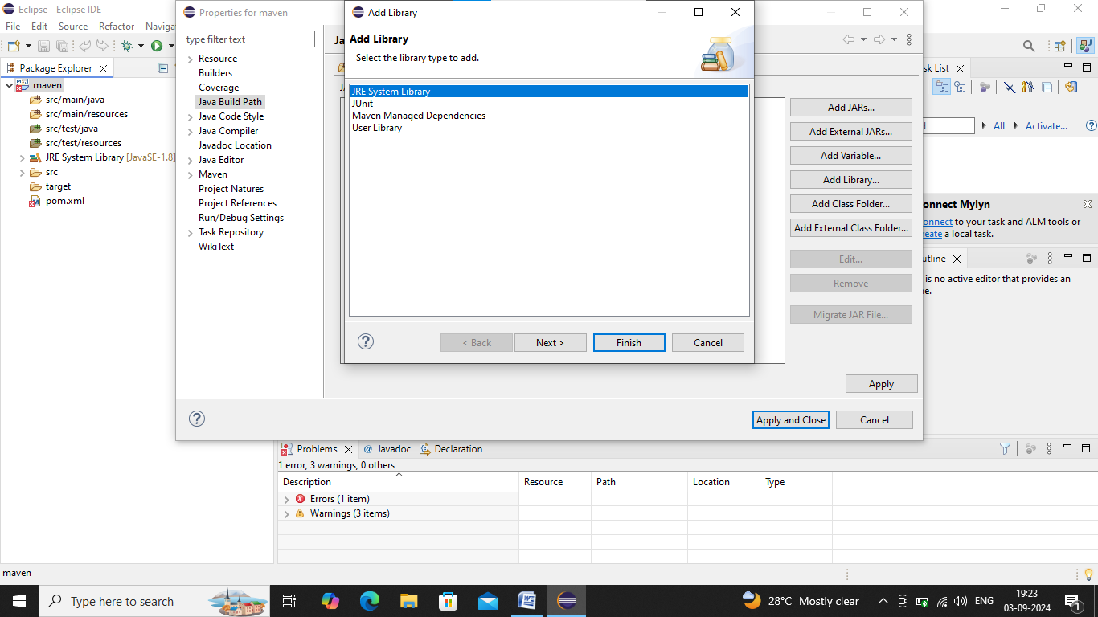

Select Alternate JRE🡪Click on Browser🡪Select JDK-21🡪Click on Next🡪Click on Finish.

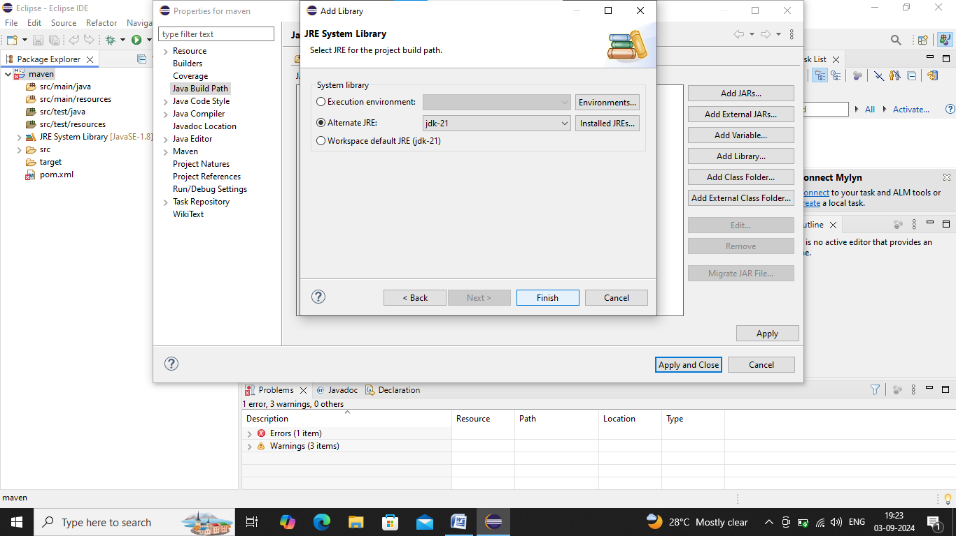

Step5: Java Class creating:

Right click to src/main/java🡪New🡪Class🡪Name it as maven🡪Click on Finish.

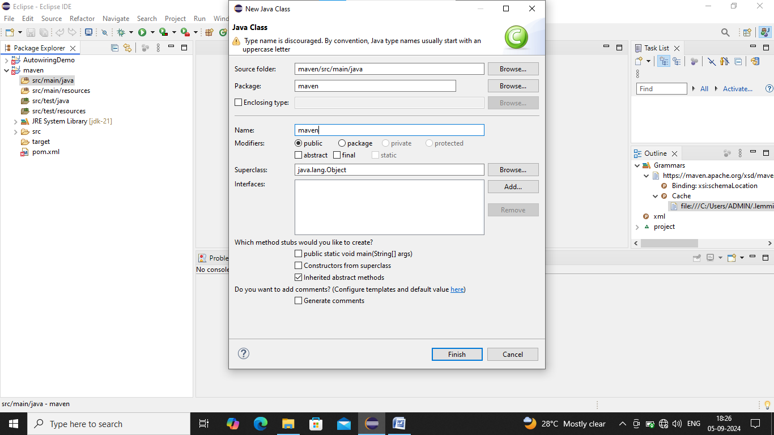

**Maven.java:**

**package** maven;

**public** **class** maven {

**public** **static** **void** main(String [] args) {

System.***out***.println(*msg*("Varshitha"));

}

**public** **static** String msg(String s) {

**return**("Hello"+s);

}

}

Step6: Now write a test for this function (using Junit Jupiter)

Right click src/test/java🡪New🡪Other🡪Junit🡪Select Junit Test Case🡪Click on Next.

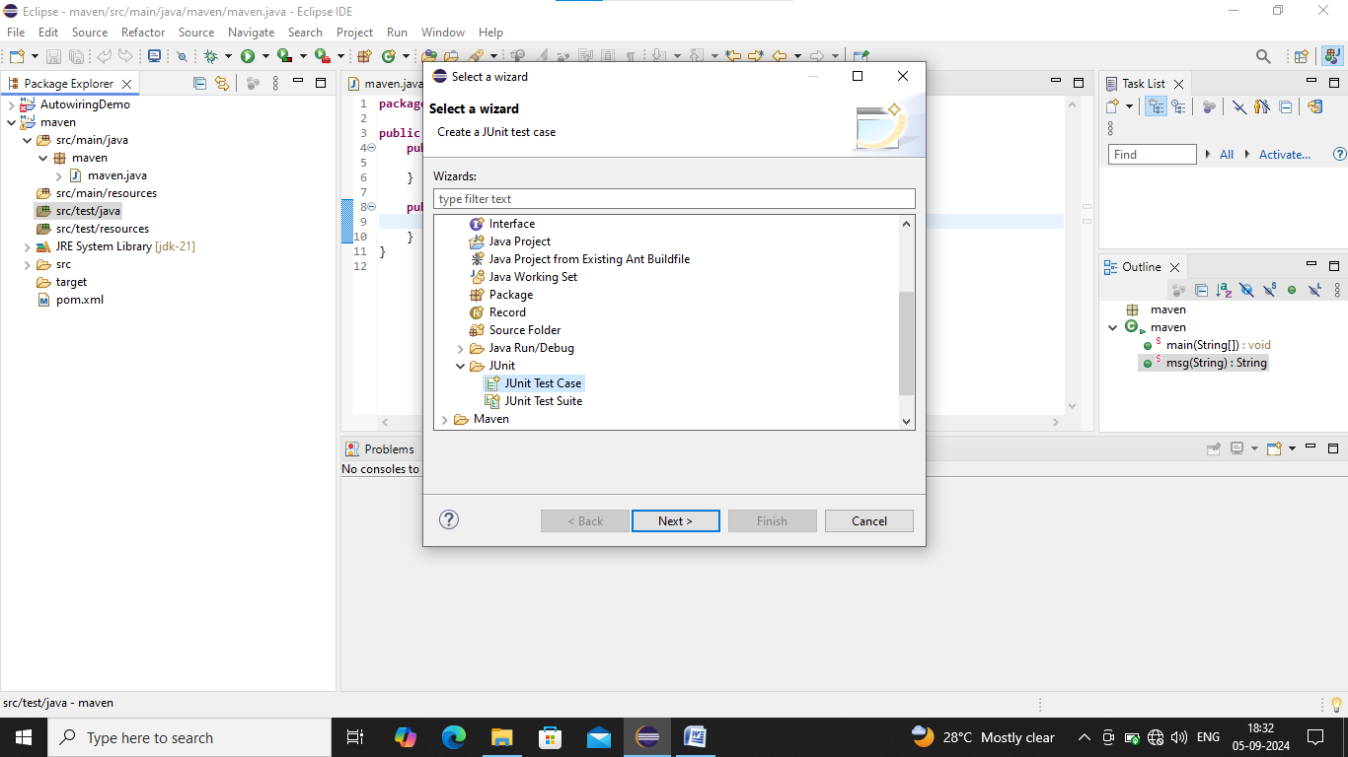

Select New JUnit Jupiter test🡪Name it as mavenTest🡪Click on Finish.

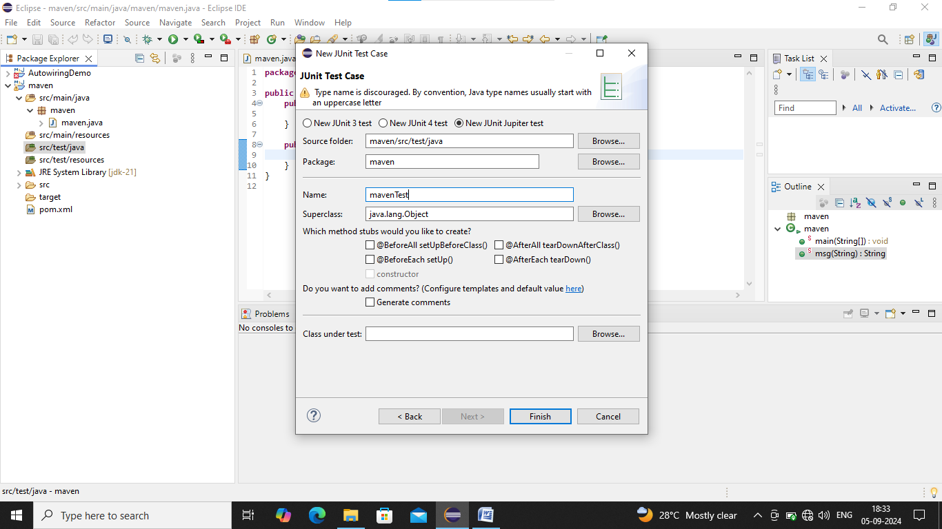

Step7: Go to the Browser🡪Search for Junit Jupiter maven dependency.

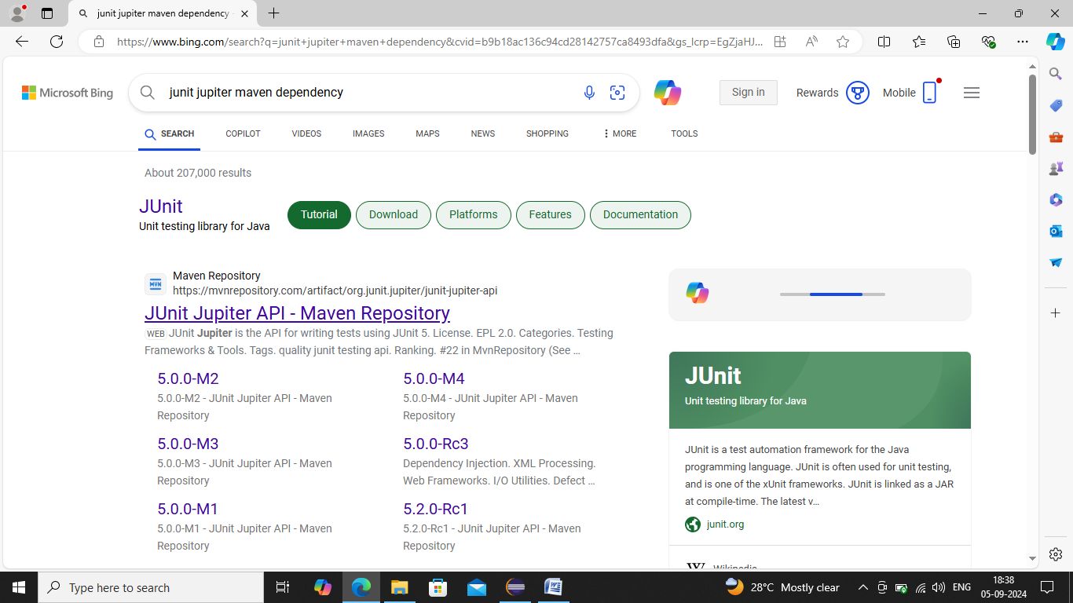

Select version 5.10.2

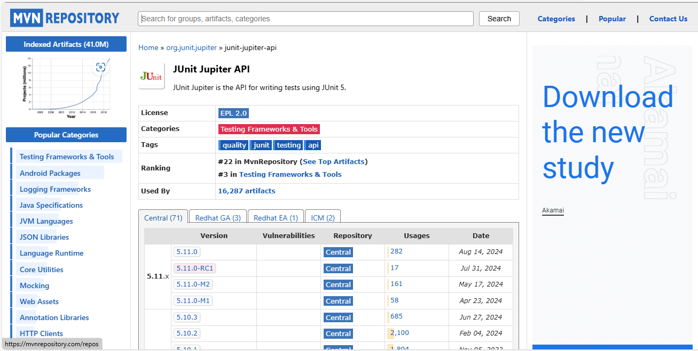

Now copy the dependency.

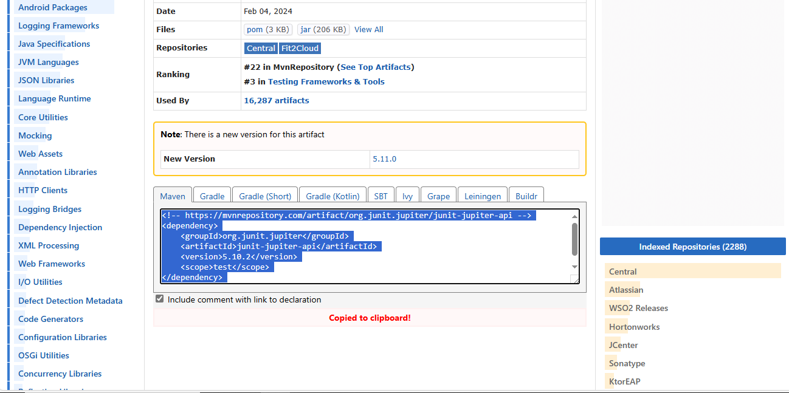

Step8: Now paste it to the pom.xml🡪Save it.

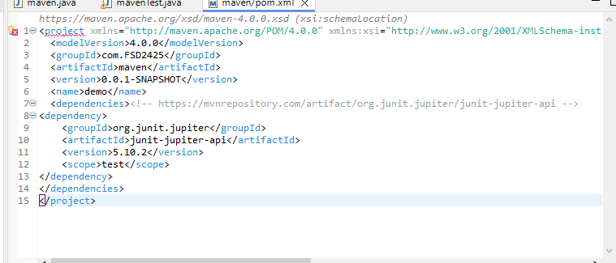

Step9: Next Right click to the project🡪Run as🡪Maven Build.

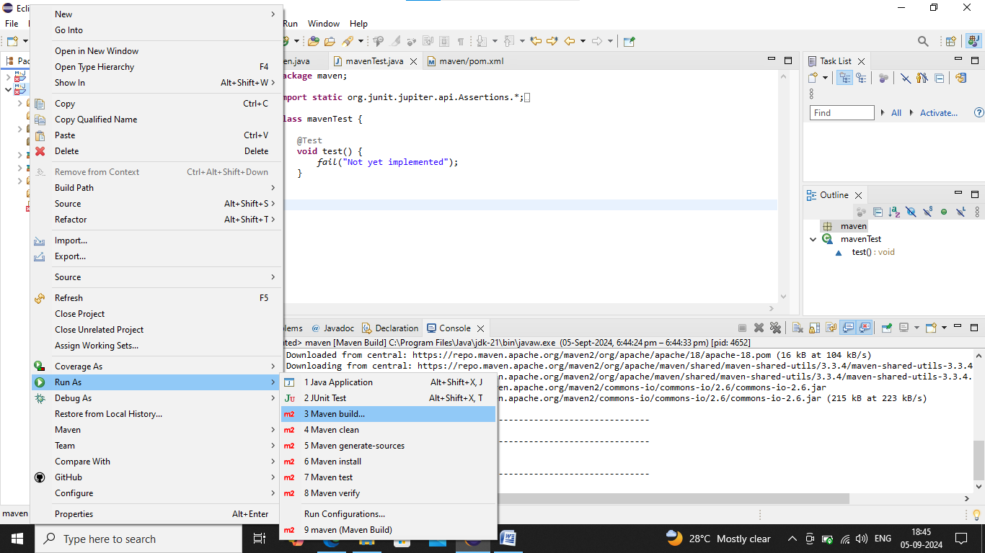

Goal-clean🡪Click on Run.

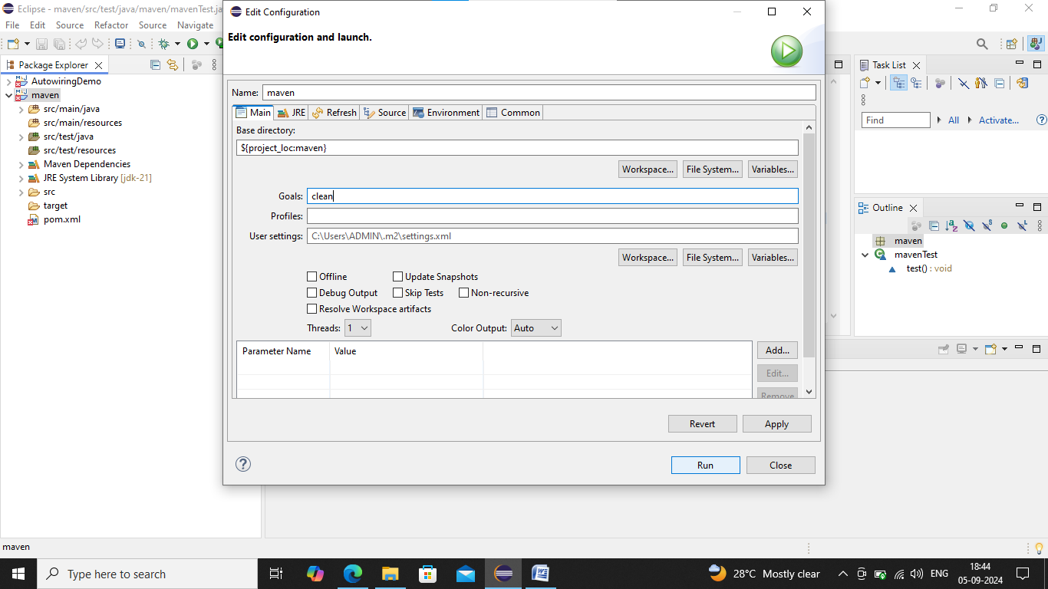

Now we can see output in console.

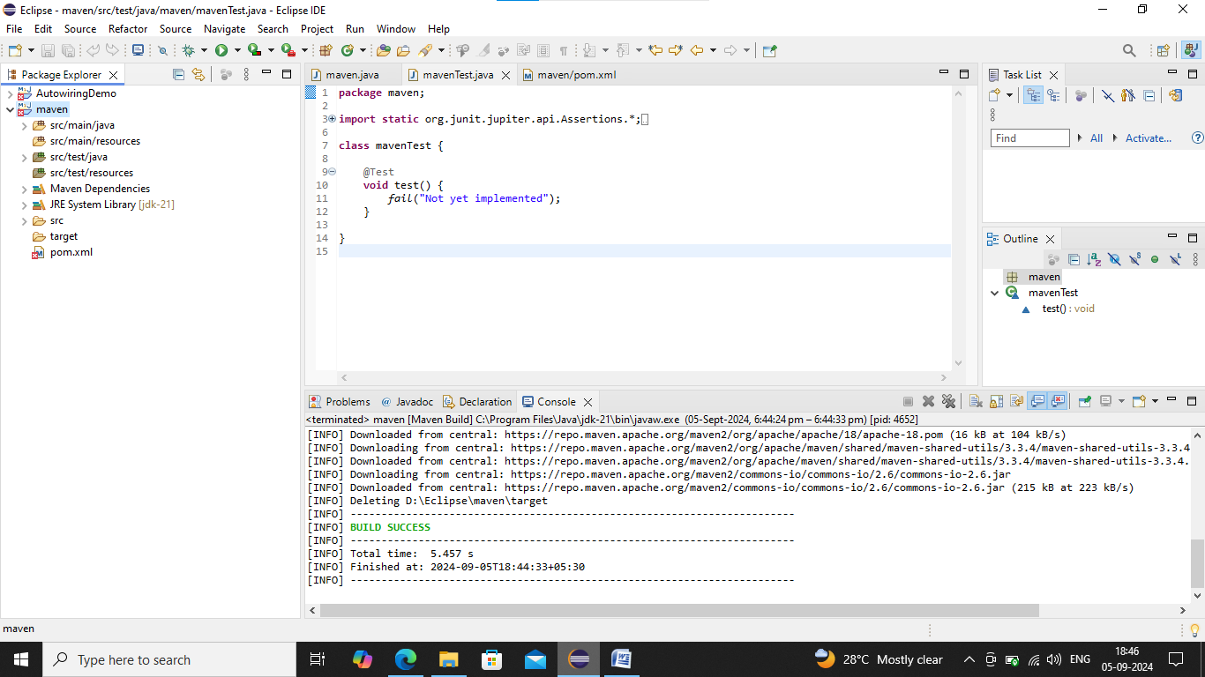

Step10: Next Right click to the project🡪Run as🡪Maven Build🡪Goal-compile🡪Click on Run.

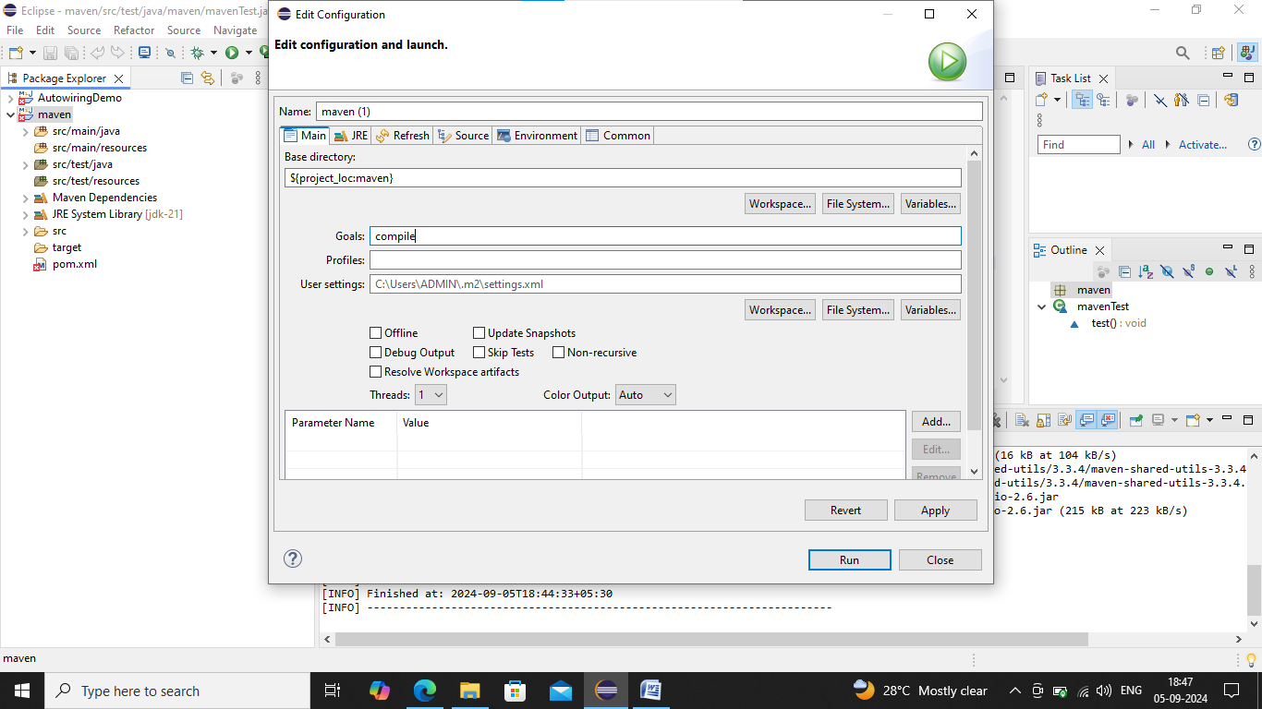

Now we can output in console.

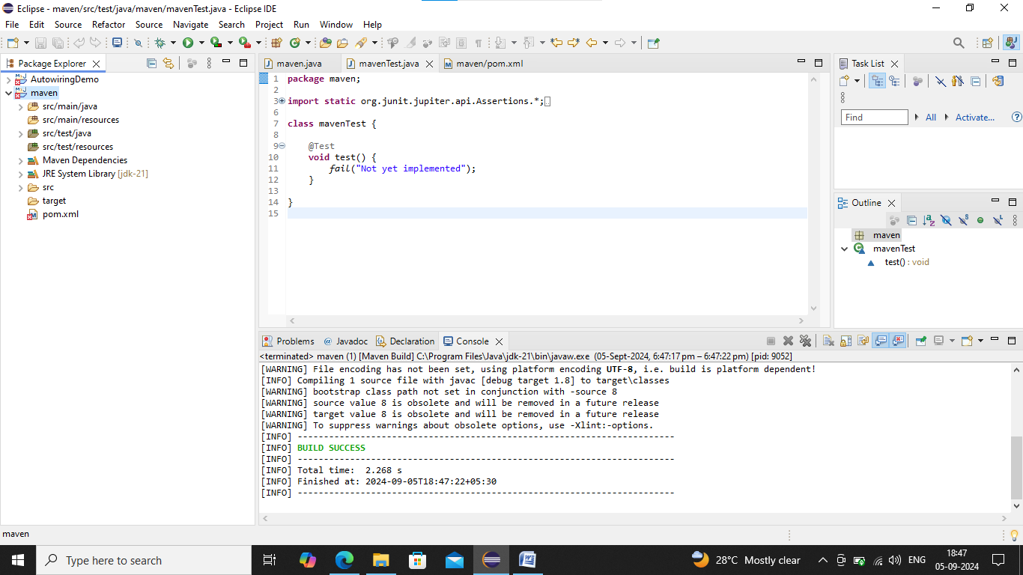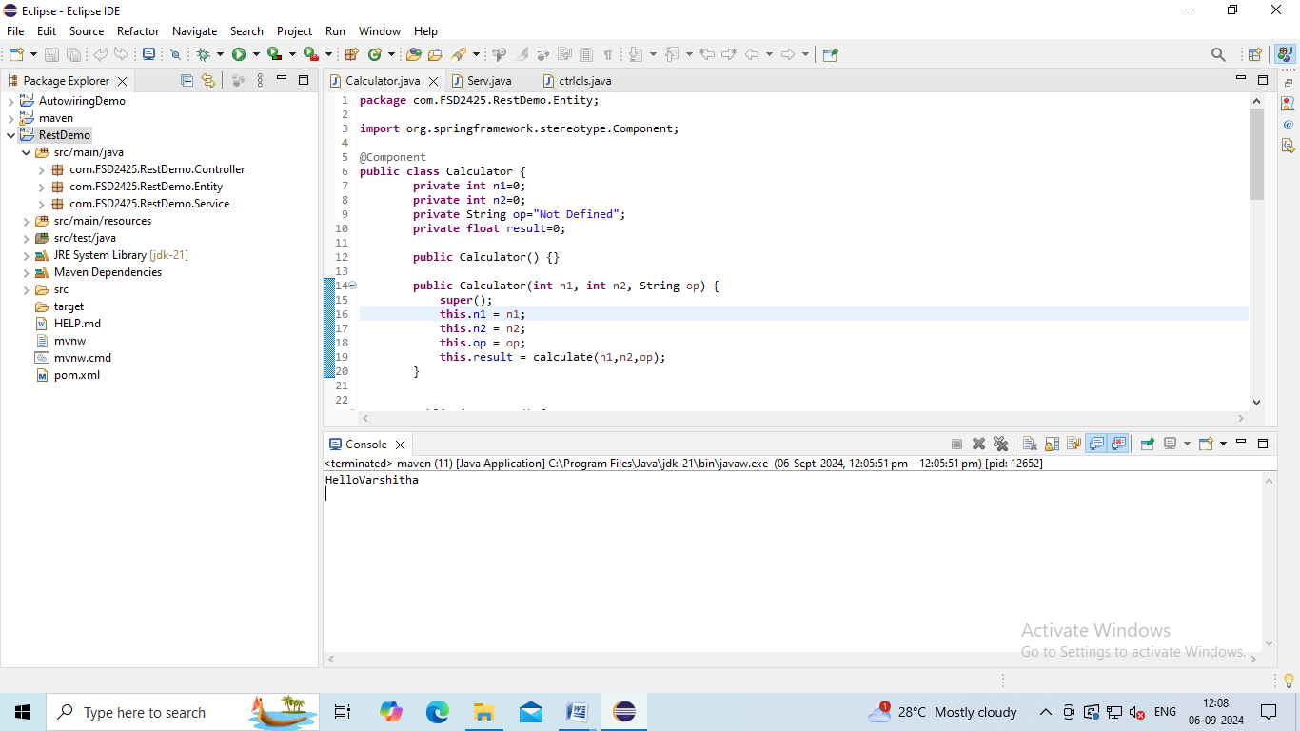

Step11: Next Right click to the project🡪Run as🡪Maven Build🡪Goal-test-compile🡪Click on Run.

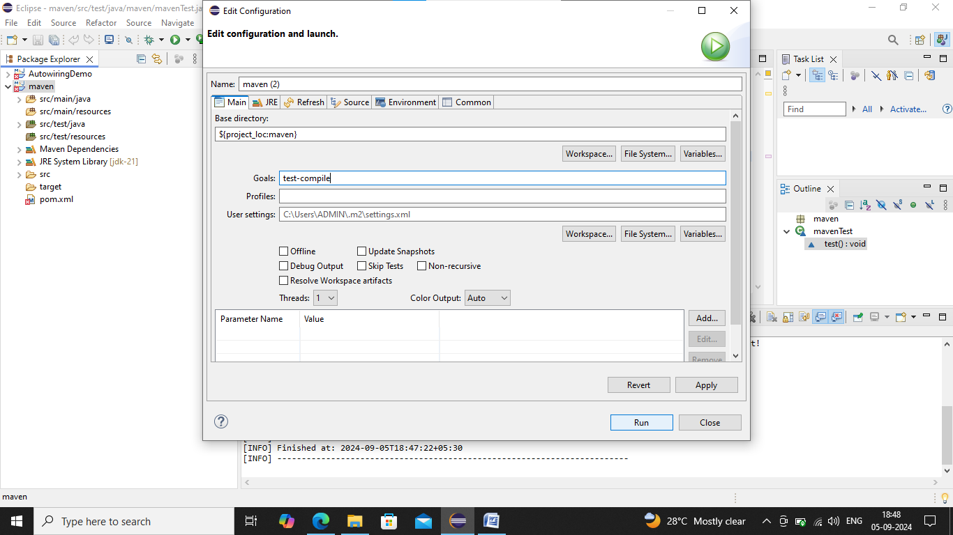

Now we can output in console.

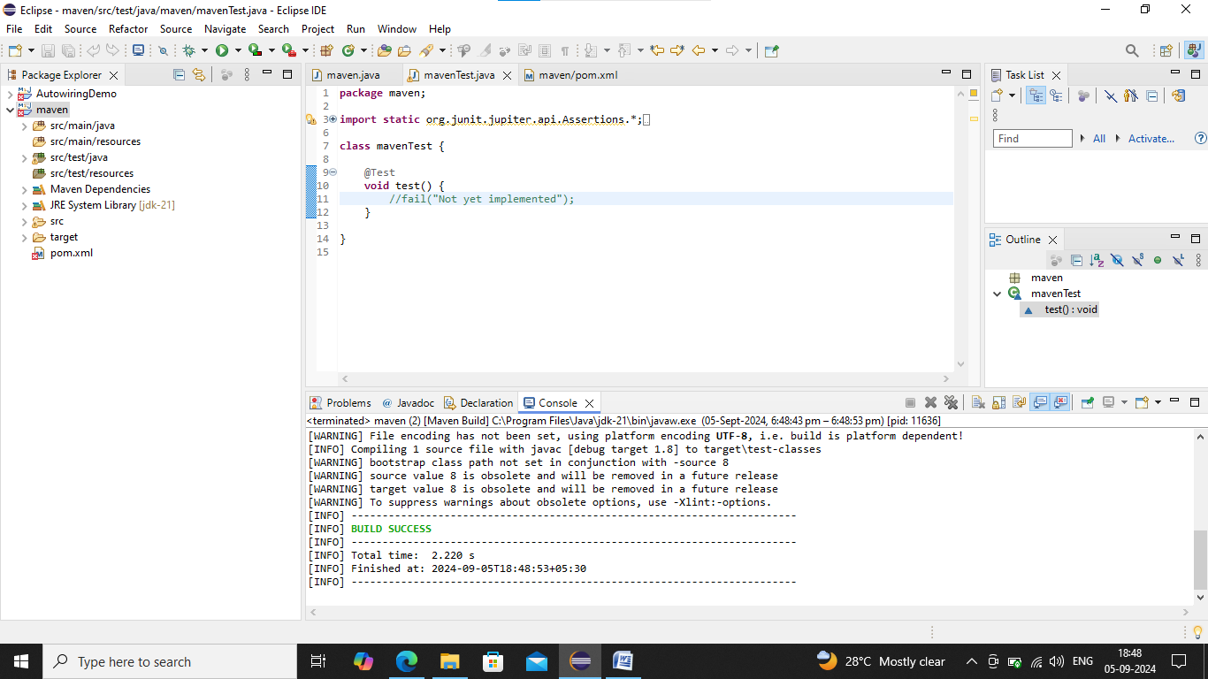

Step12: Next Right click to the project🡪Run as🡪Maven Test.

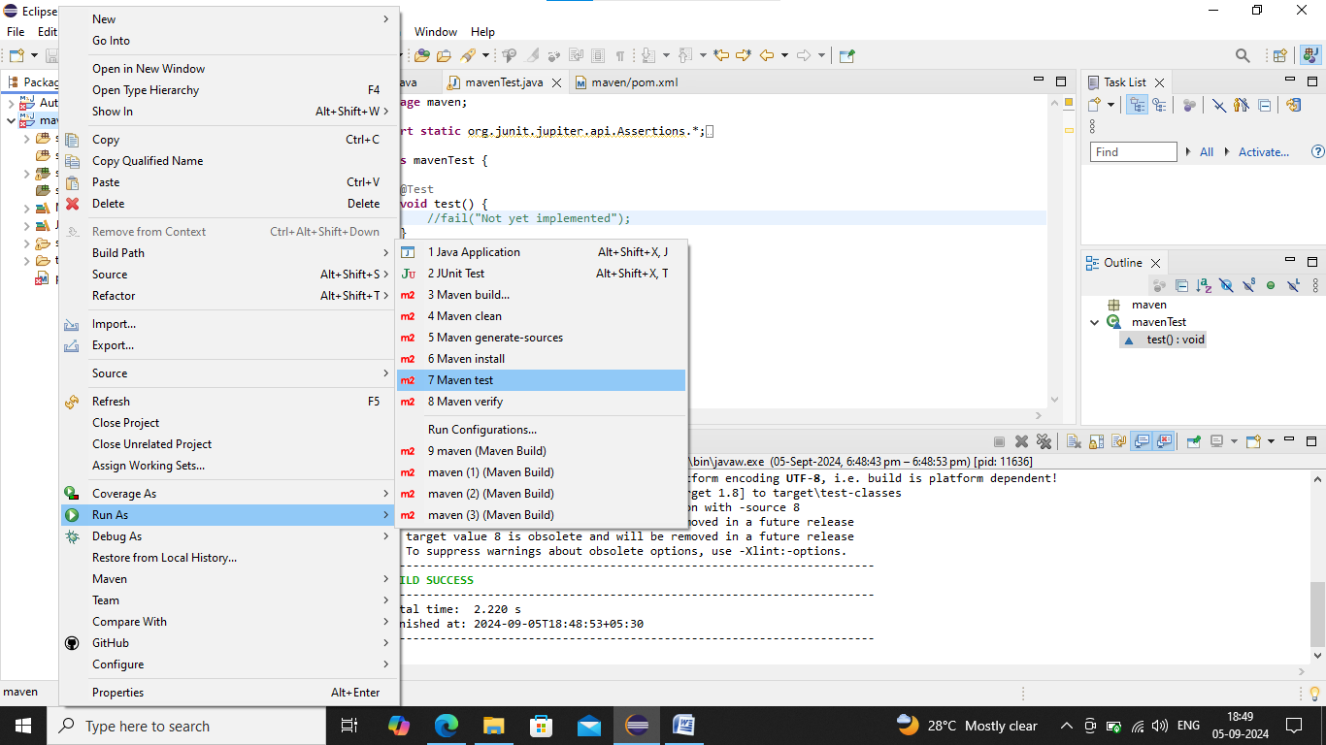

We can output in console.

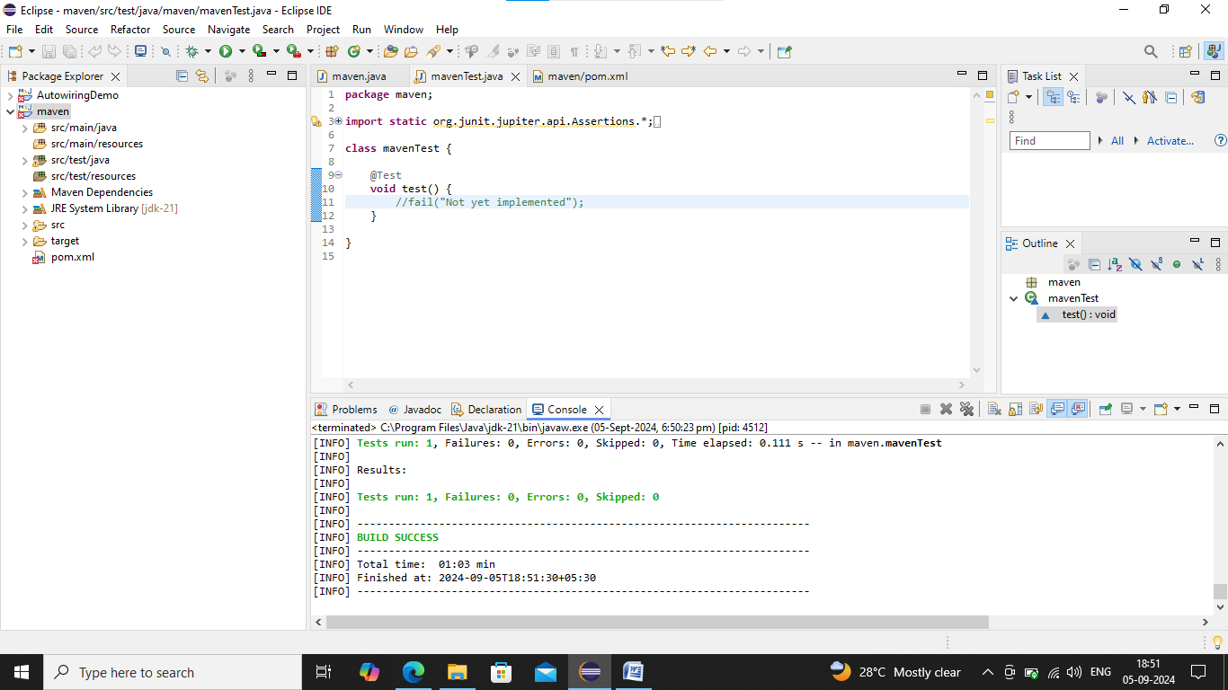

Step13: Next Right click to the project🡪Run as🡪Maven install.

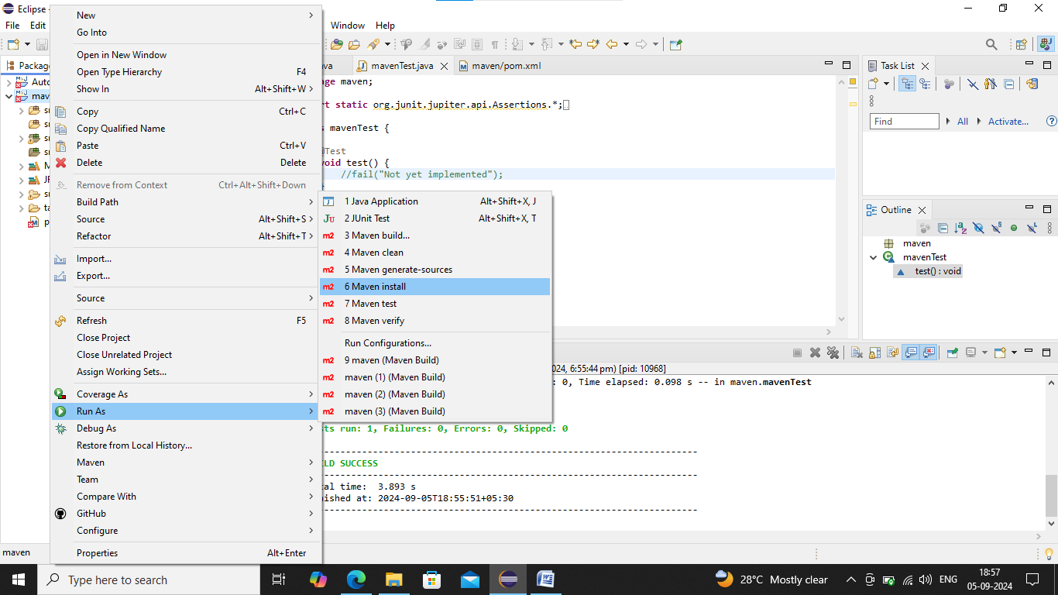

Now we can output in console

