**3. Demonstrate REST controller using spring boot.**

Step1: To set project configuration🡪Go to browser🡪Search **start.spring.io**

Step2: In spring initialize🡪Select Project-Maven🡪Language-Java🡪Spring Boot-3.3.3🡪 Group-com.FSD2425🡪Artifact-RestDemo🡪Description-Demo project for spring boot RestDemo🡪Packaging-Jar🡪Java-21.

Dependencies🡪ADD DEPENDENCIES🡪Select-Spring Boot Dev Tools & Spring Web🡪 Click on Generate.

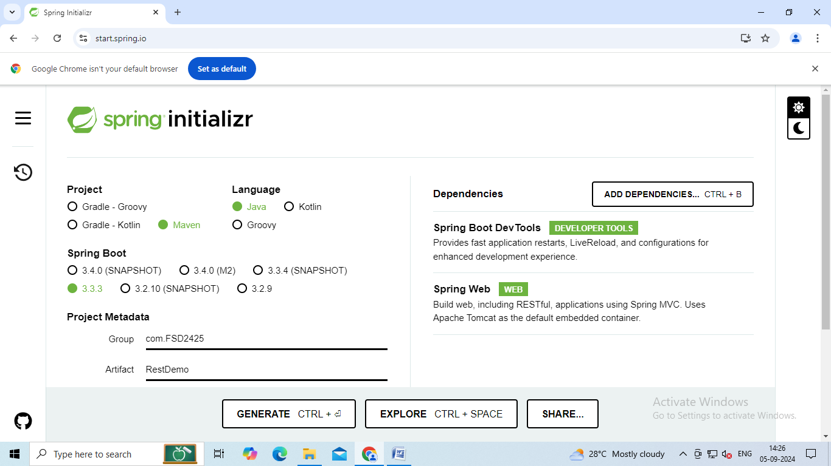

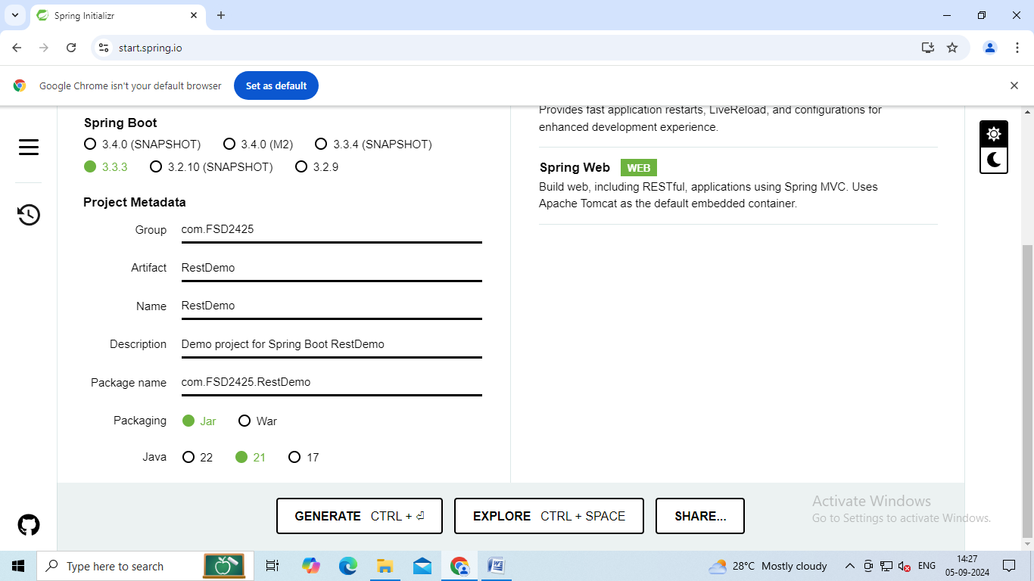

Step2: Next extract your zip file to workspace.

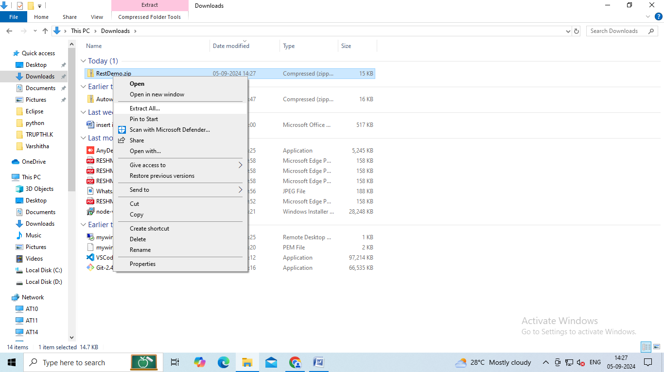

Step3: Select a destination.

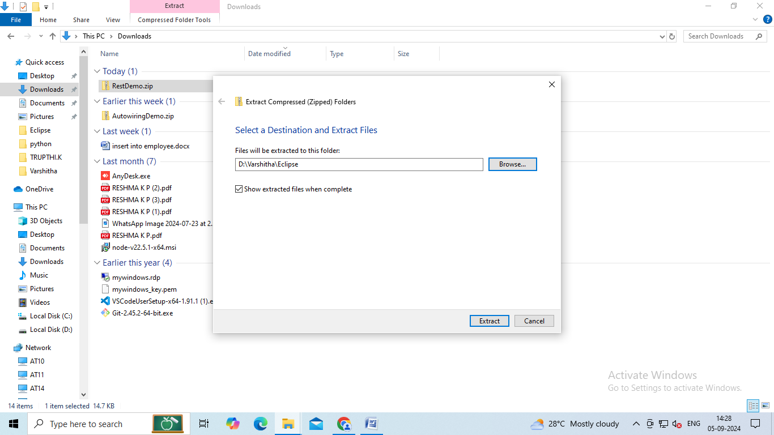

Step4: Go to Eclipse🡪File🡪Import🡪Maven🡪Existing maven🡪Click on Browse and select the folder from where you extracted🡪Tick mark on pom.xml🡪Click on Finish.

Save the pom.xml

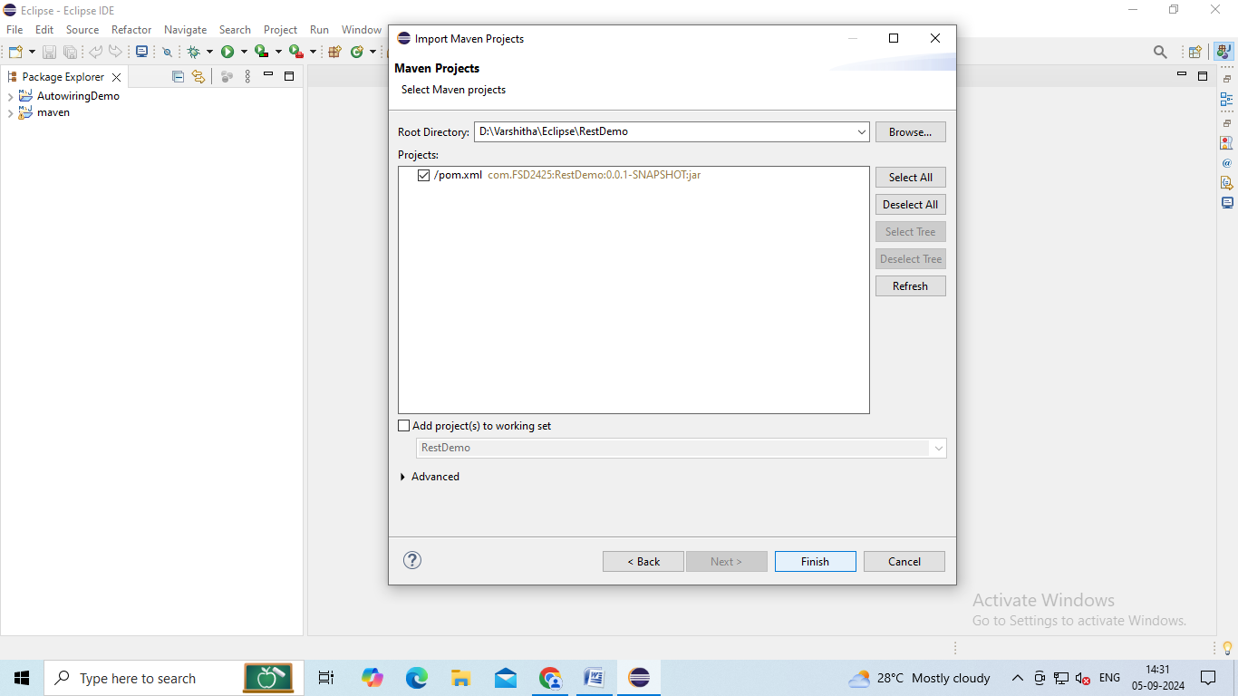

Step5: Now right click to your project🡪New🡪Packages🡪Name it as-com.FDS2425RestDemo.Controller🡪Click on finish.

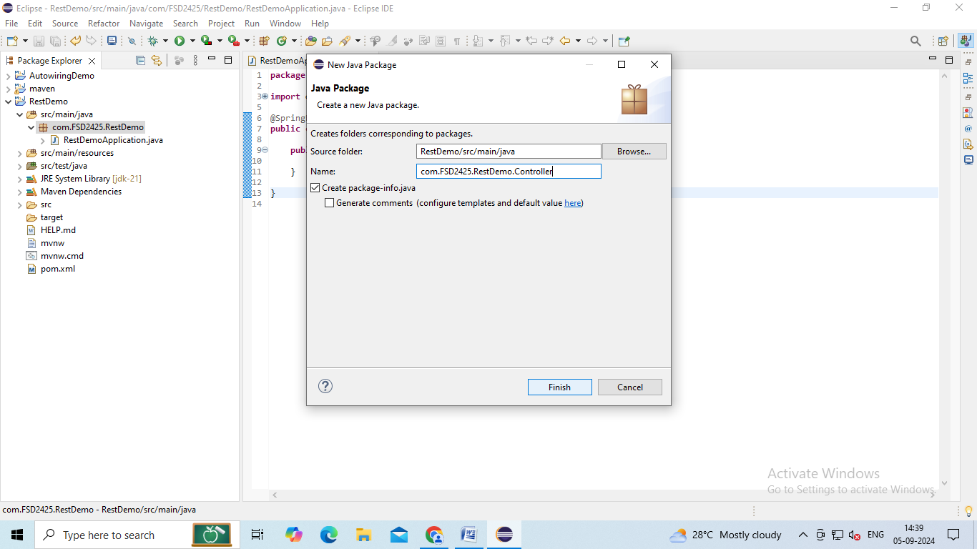

Step6: Now right click to your project🡪New🡪Packages🡪Name it as-com.FDS2425RestDemo.Service🡪Click on finish.

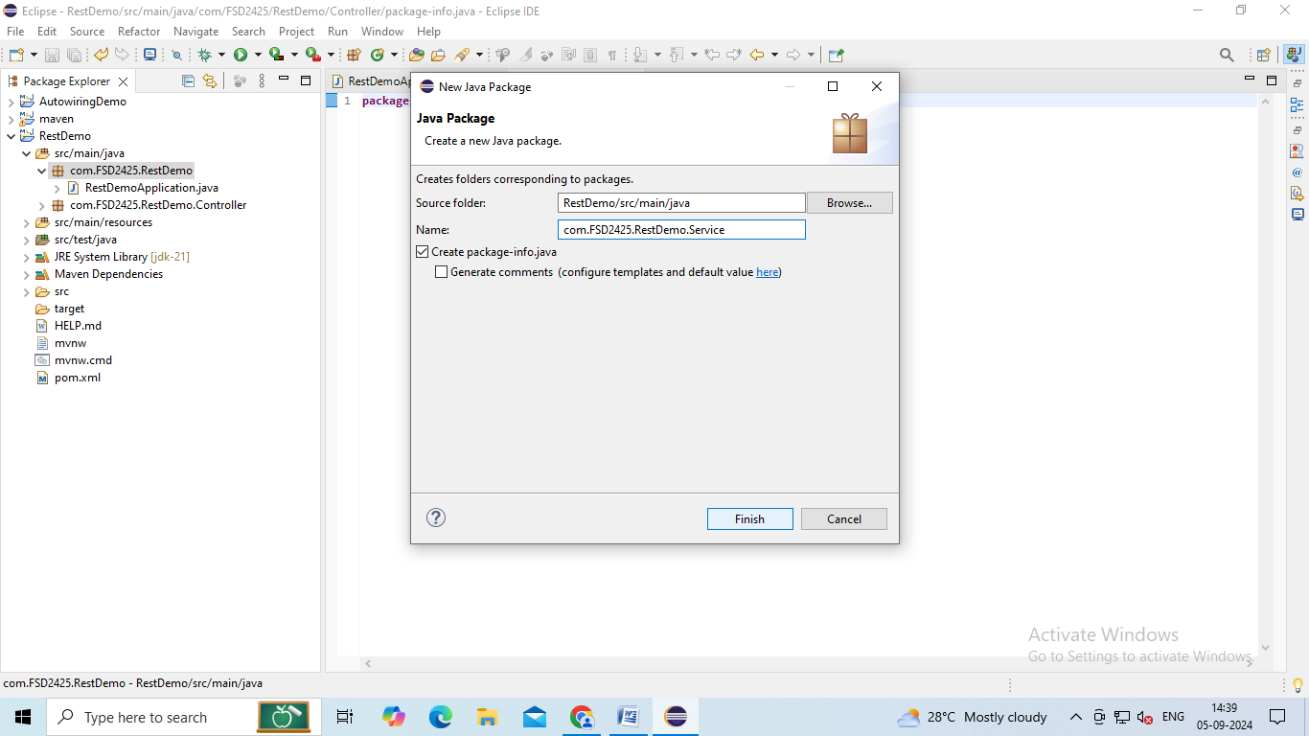

Step7: Now right click to your project🡪New🡪Packages🡪Name it as-com.FDS2425RestDemo.Entity🡪Click on finish.

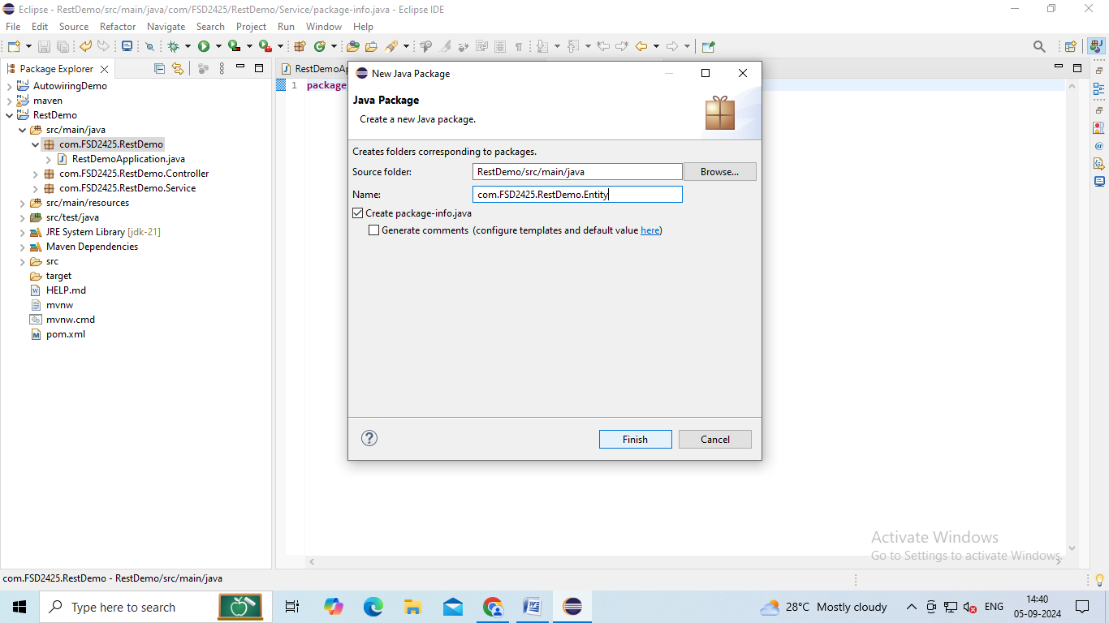

Step8: Now inside com.FDS2425RestDemo.Entity create GreetObj class:

Right click to com.FDS2425RestDemo.Entity🡪New🡪Class🡪Finish.

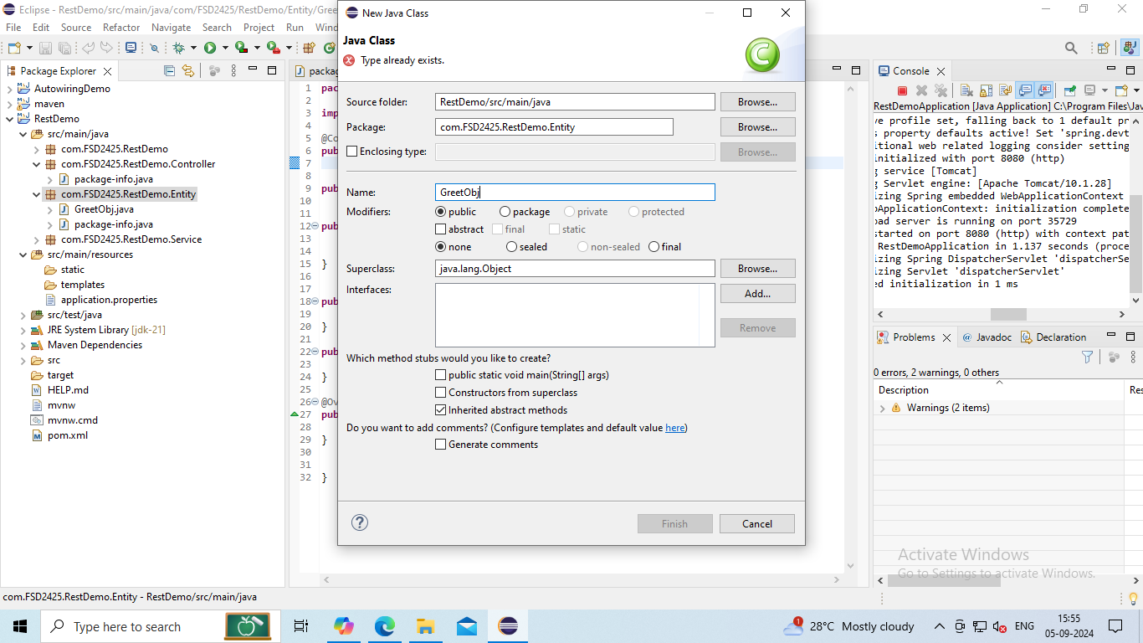

Write the code as follows:

**GreetObj.java:**

**package** com.FSD2425.RestDemo1.Entity;

**import** org.springframework.stereotype.Component;

@Component

**public** **class** GreetObj {

**private** String msg;

**public** GreetObj() {}

**public** GreetObj(String msg) {

**super**();

**this**.msg = msg;

}

**public** String getMsg() {

**return** msg;

}

**public** **void** setMsg(String msg) {

**this**.msg = msg;

}

@Override

**public** String toString() {

**return** ("{\"Message\":\""+msg+"\"}");

}

}

Step9: Create another class Calculator.

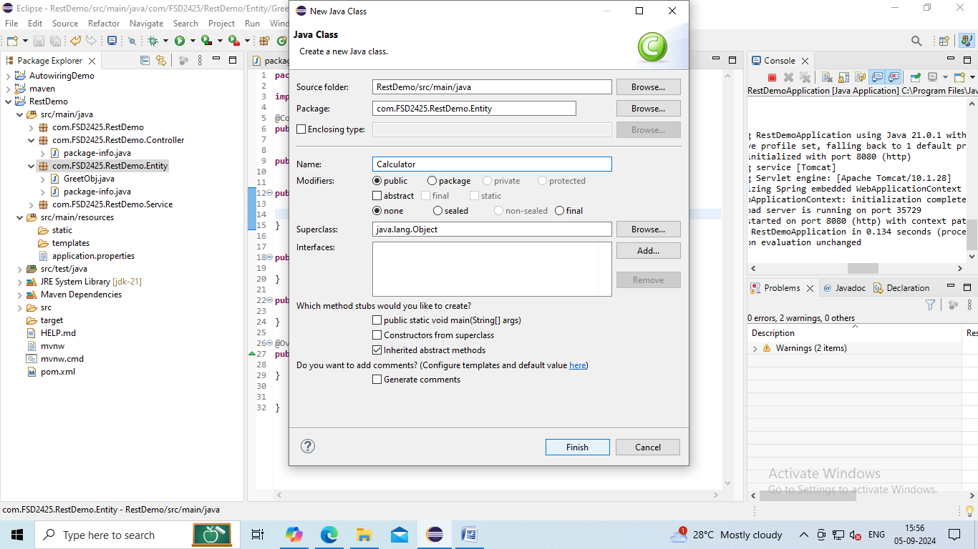

Write the code as follows:

**Calculator.java:**

**package** com.FSD2425.RestDemo1.Entity;

**import** org.springframework.stereotype.Component;

@Component

**public** **class** Calculator {

**private** **int** n1=0;

**private** **int** n2=0;

**private** String op="Not Defined";

**private** **float** result=0;

**public** Calculator() {}

**public** Calculator(**int** n1, **int** n2, String op) {

**super**();

**this**.n1 = n1;

**this**.n2 = n2;

**this**.op = op;

**this**.result = calculate(n1,n2,op);

}

**public** **int** getN1() {

**return** **this**.n1;

}

**public** **void** setN1(**int** n1) {

**this**.n1 = n1;

**this**.result=**this**.calculate(**this**.n1, **this**.n2, **this**.op);

}

**public** **int** getN2() {

**return** **this**.n2;

}

**public** **void** setN2(**int** n2) {

**this**.n2 = n2;

**this**.result=**this**.calculate(**this**.n1, **this**.n2, **this**.op);

}

**public** String getOp() {

**return** **this**.op;

}

**public** **void** setOp(String op) {

**this**.op = op;

**this**.result=**this**.calculate(**this**.n1, **this**.n2, **this**.op);

}

**public** **float** getResult() {

**return** **this**.result;

}

@Override

**public** String toString() {

**return** ("{\"Num1\":\""+**this**.n1+"\",\n\"Num2\":\""+**this**.n2+"\",\n\"Operation\":\""+**this**.op+"\",\n\"Result\":\""+**this**.result+"\"}");

}

**public** **float** calculate(**int** a, **int** b, String opr)

{

**switch**(opr) {

**case** "Add":**return** a+b;

**case** "Sub":**return** a-b;

**case** "Mul":**return** a*b;

**case** "Div":**return** b==0?0:(**float**)a/b;

**default**:**return** 0;

}

}

}

Step10: Now inside com.FDS2425RestDemo.Service create Serv class:

Right click to com.FDS2425RestDemo.Entity🡪New🡪Class🡪Finish.

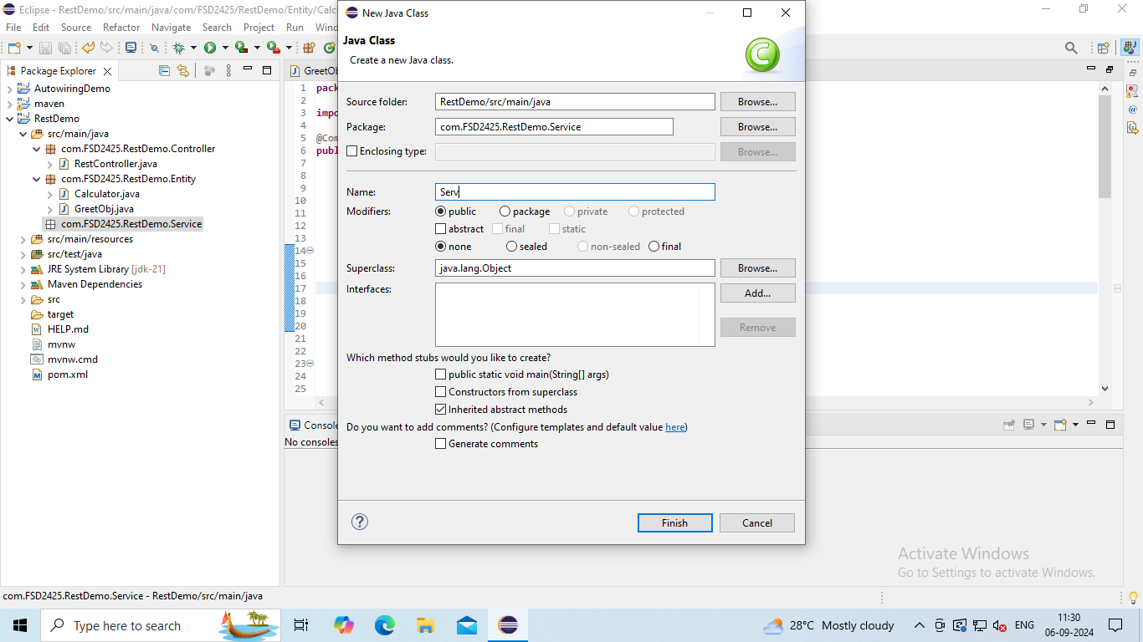

Step11: Write the code as follows:

**Serv.java:**

**package** com.FSD2425.RestDemo1.Service;

**import** org.springframework.beans.factory.annotation.Autowired;

**import** org.springframework.stereotype.Service;

**import** com.FSD2425.RestDemo1.Entity.Calculator;

**import** com.FSD2425.RestDemo1.Entity.GreetObj;

@Service

**public** **class** Serv {

@Autowired

**private** GreetObj gobj;

@Autowired

**private** Calculator calc;

**public** String greetuser() {

gobj.setMsg("Good Day from spring boot");

**return** gobj.toString();

}

**public** String calculations(**int** x, **int** y, String arith) {

calc.setN1(x);

calc.setN2(y);

calc.setOp(arith);

**return** calc.toString();

}

}

Step12:

