**Docker Commands:**

Step1: Download and install docker for desktop.

The first place to start is the [official Docker website](https://www.docker.com/get-started/) from where we can download Docker Desktop.

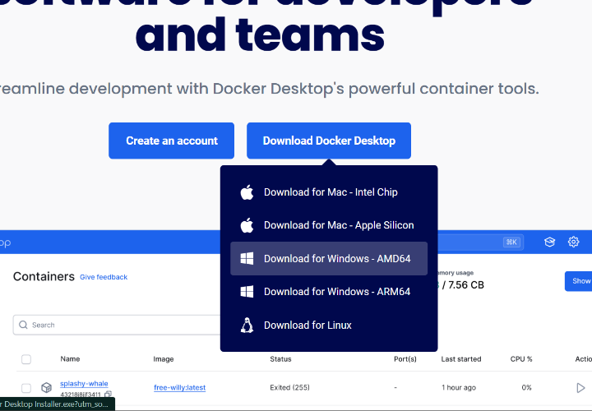

So let’s open the downloaded installer and begin the installation.

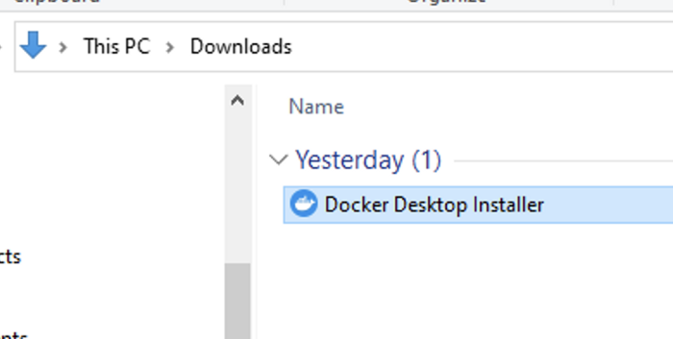

# Step 2: Configuration

To run Linux on Windows, Docker requires a virtualization engine. Docker recommends using WSL 2.

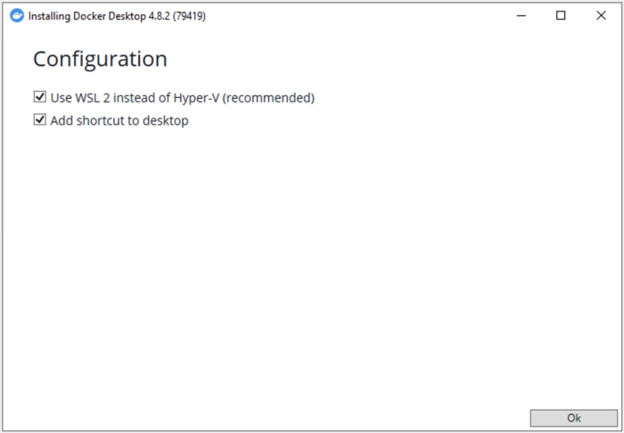

# Step 3: Running the instalation

Click Ok, and wait a bit…

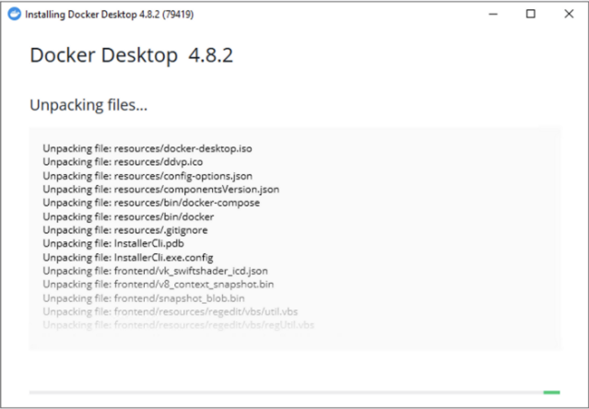

# Step 4: Restart

For Docker to be able to properly register with Windows, a restart is required at this point.

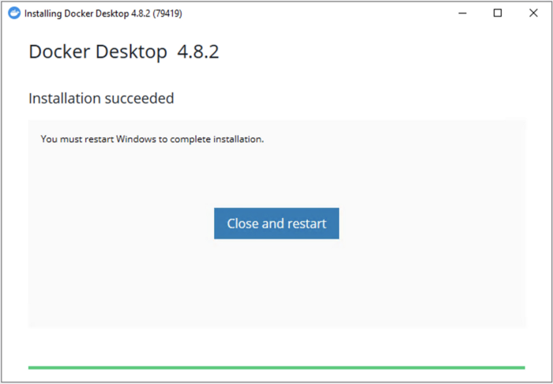

# Step 5: License agreement

After the restart, Docker will start automatically and you should see the window below:

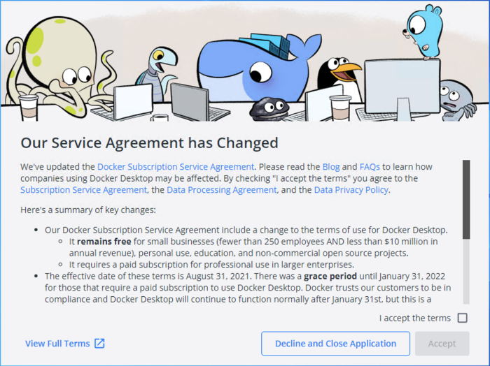

To run the docker just open the docker

Next Go to the command prompt and give command as follows:

* **To work with Ubuntu:**

**//check the docker version**

docker –v

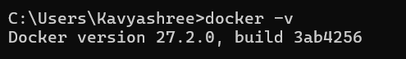

**//to get the docker information**

docker info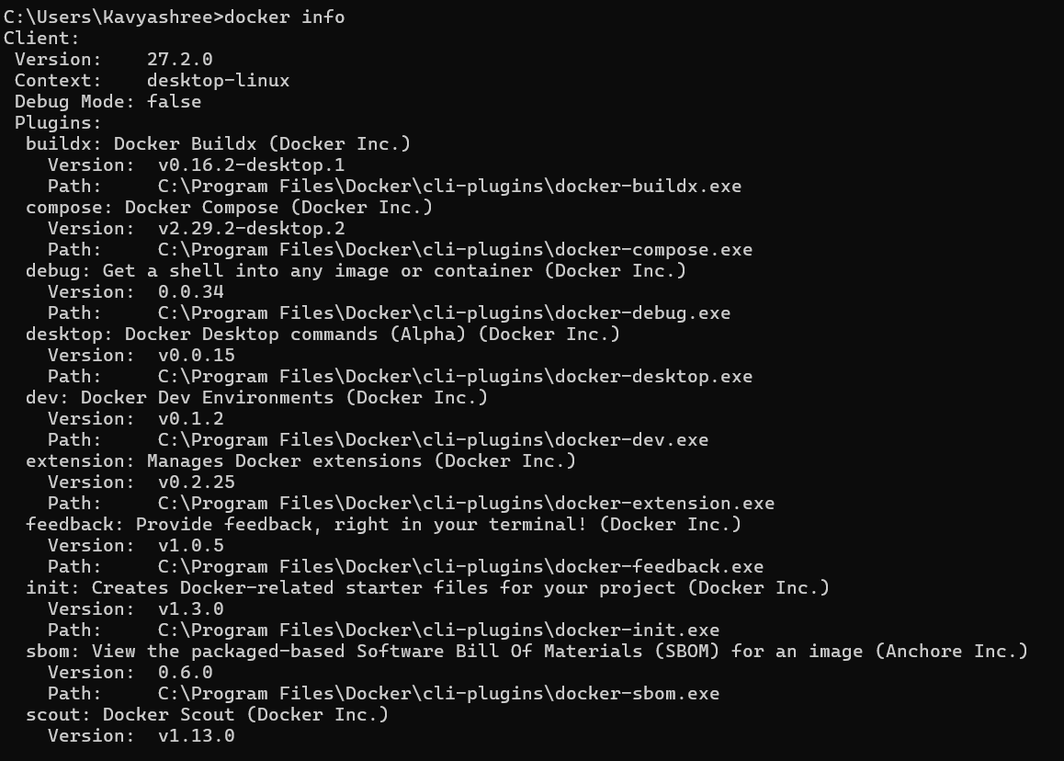

**//to list all Docker images**

docker images

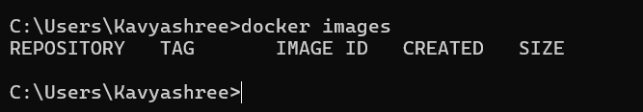

**//to downloads the Ubuntu image from Docker Hub**

docker pull ubuntu

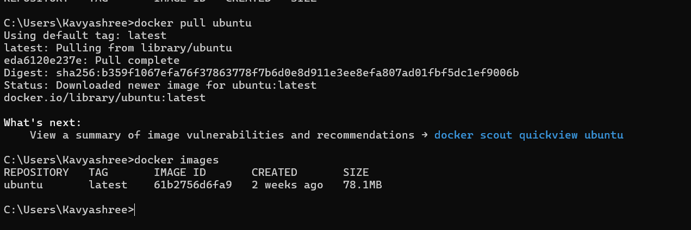

**//to list all Docker images**

docker images



**//to check container list**

docker ps -a

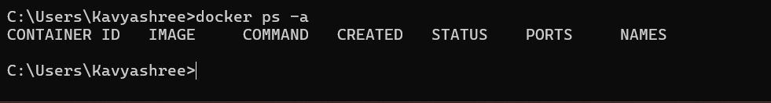

**//to save the image to container**

docker run --name demo –it ubuntu

**>ls**

**>dir**

**>pwd**

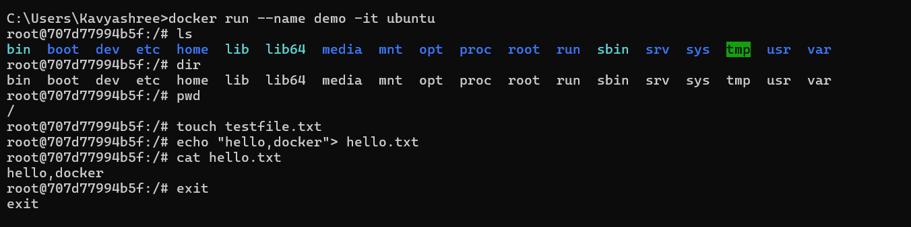

**To create a file in ubuntu**

**>touch testfile.txt**

**>mkdir newfolder**

**>echo “hello,docker”>hello.txt**

**>ls**

**>cat hello.txt**

Press ctrl+d



**//to stop the container**

docker stop demo

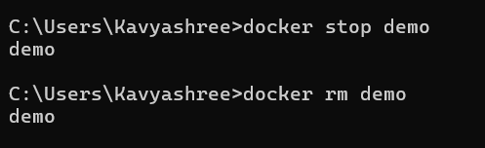

**//to remove the container**

docker rm demo



**//to remove docker image**

docker rmi ubuntu

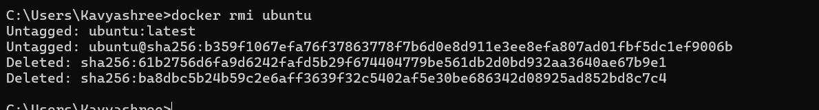

**//to list docker images**

docker images

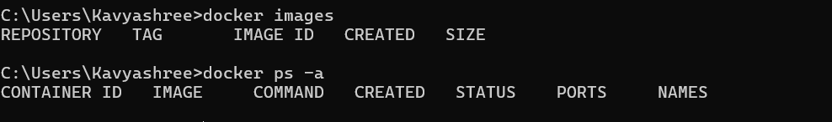

* **To work with Python:**

**//to downloads the Python image from Docker Hub**

docker pull python

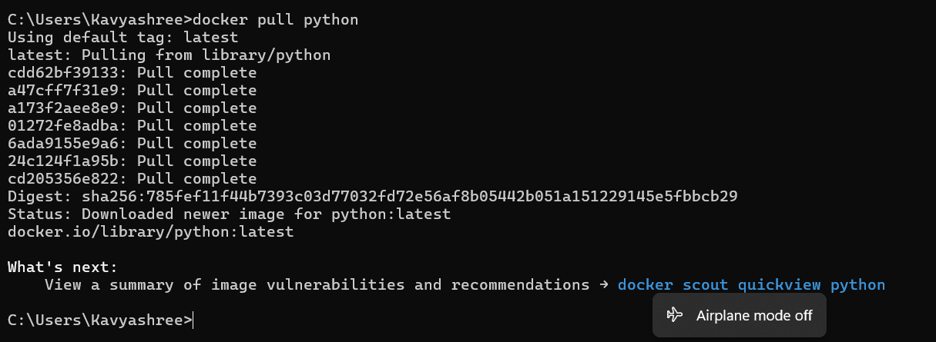

**//to list all Docker images**

docker images

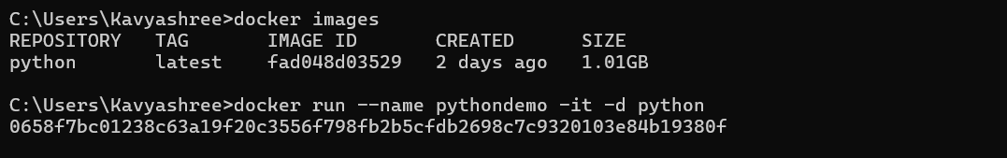

**//to create a container**

docker run --name pythondemo –it –d python



**//to execute python using container & image name**

docker exec –it pythondemo –it –d python

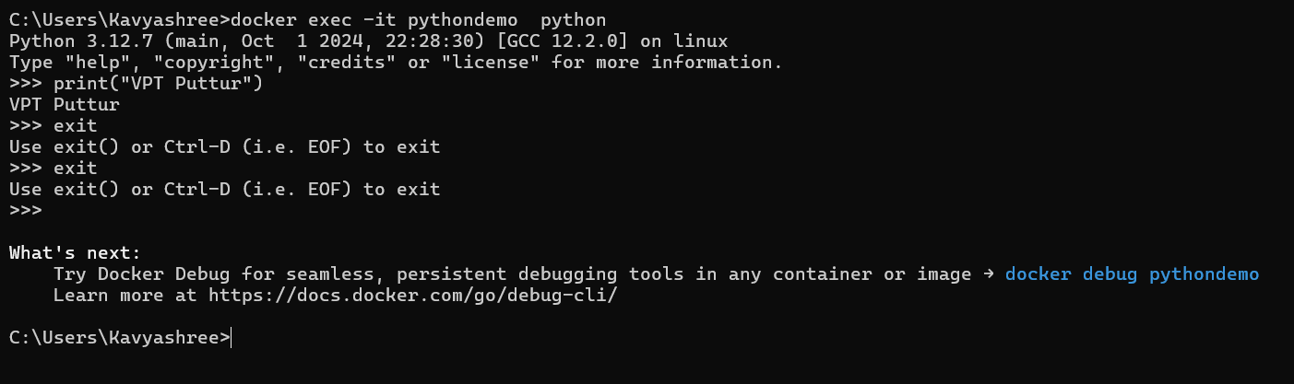

**//to exit**

Press ctrl+d or type exit

**//to stop the container**

docker stop pythondemo

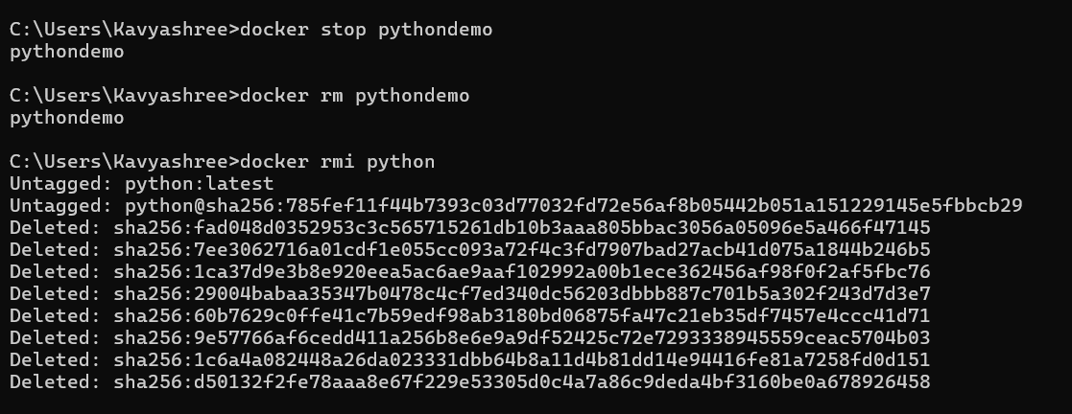

**//to remove the container**

docker rm pythondemo



**//to remove the image**

docker rmi python



**//to list docker images**

docker images

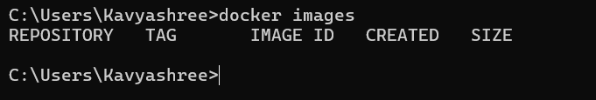

**//to check container list**

docker ps -a



* **To work with Java:**

**//to downloads the Java image from Docker Hub**

docker pull openjdk

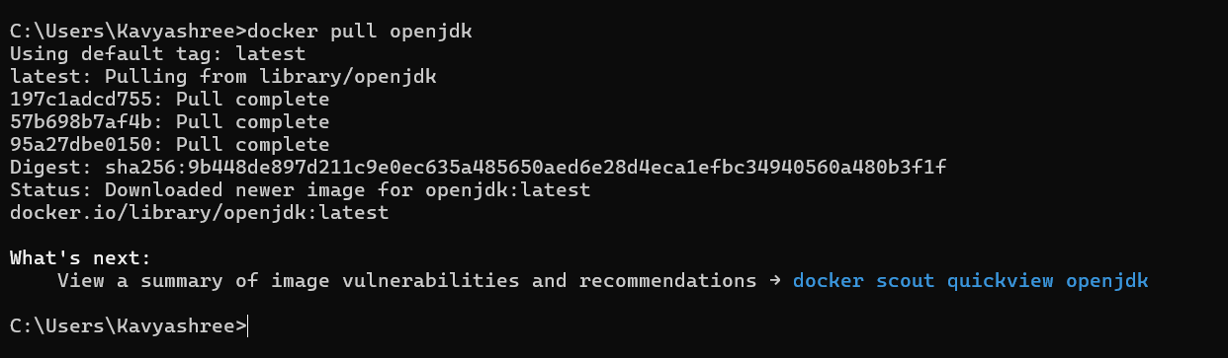

**//to list docker images**

docker images

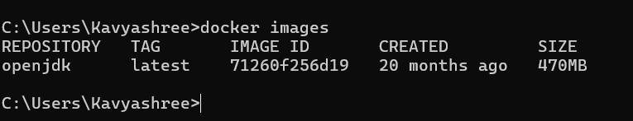

**//to create container**

docker run --name javademo –it –d openjdk

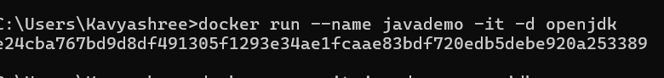

**//to check container list**

docker ps –a

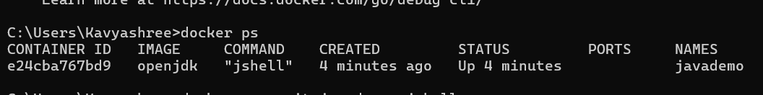

**//to execute the java using container and images**

docker exec –it javademo openjdk jshell

jshell>System.out.println(“hello VPT”)

press cntrl+d

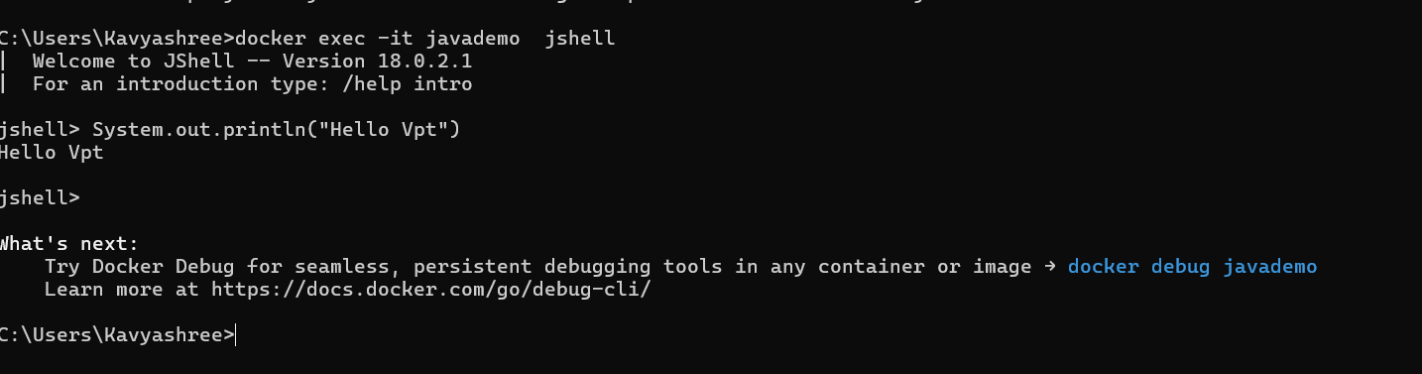

**//to stop the docker container**

docker stop javademo

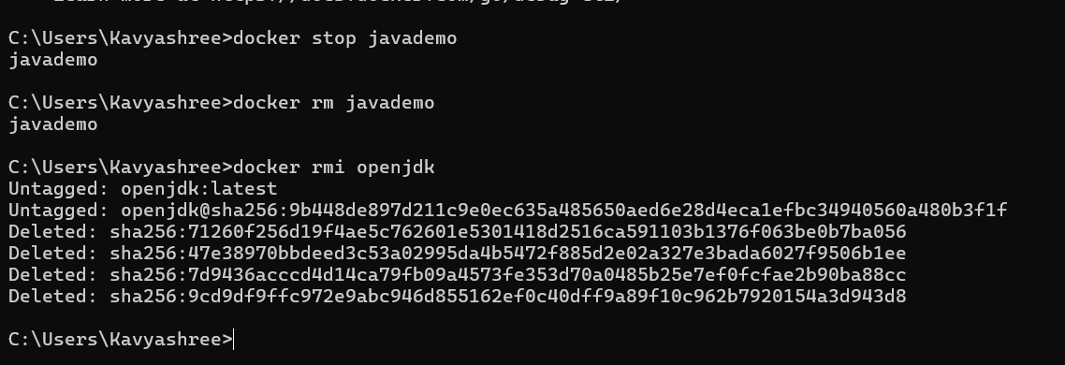

**//to remove the docker container**

docker rm javademo



**//to remove the docker image**

docker rmi openjdk



docker images



**//to check container list**

docker ps -a



* **To work with MySQL:**

**//to downloads the mysql image from Docker Hub**

docker pull mysql

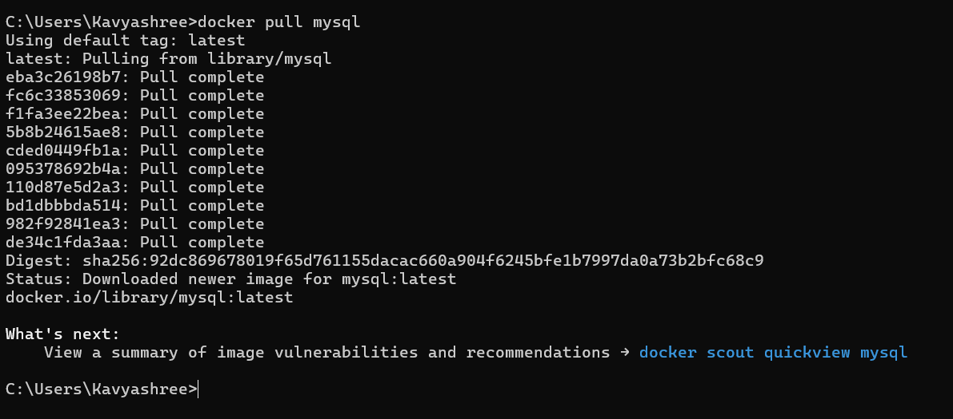

**//to list the docker images**

docker images

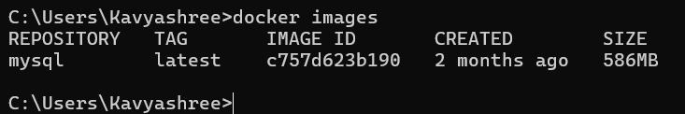

**//to set the username and password**

docker run --name mysqldemo –e MYSQL_ROOT_PASSWORD=test –d mysql



**//to enter the uername and password**

docker exec –it mysqldemo mysql –u root –p

Enter password:test

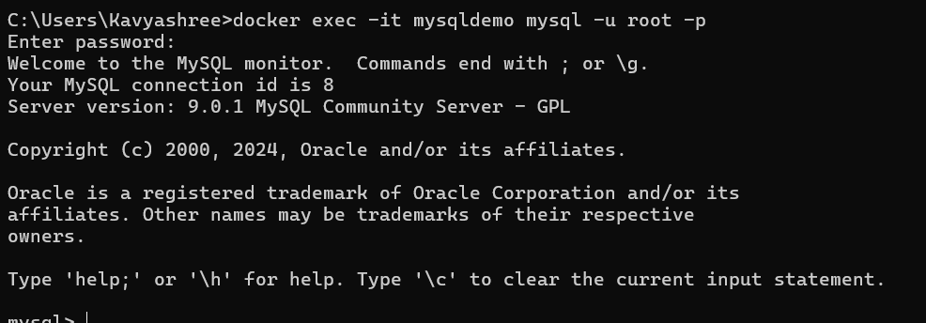

**//give mysql commands**

**mysql>show databases;**

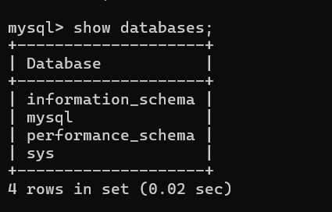

**mysql>create database demo;**

**mysql>show databases;**

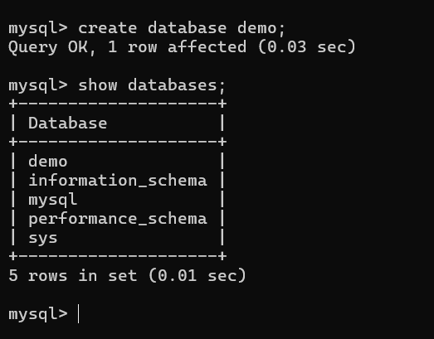

**mysql>use demo;**

**mysql>show tables;**

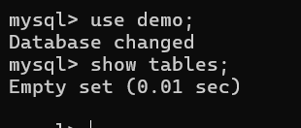

press ctrl+d

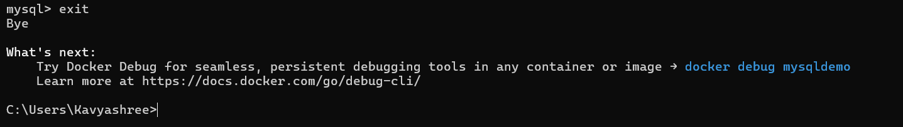

**//to stop docker container**

docker stop mysqldemo

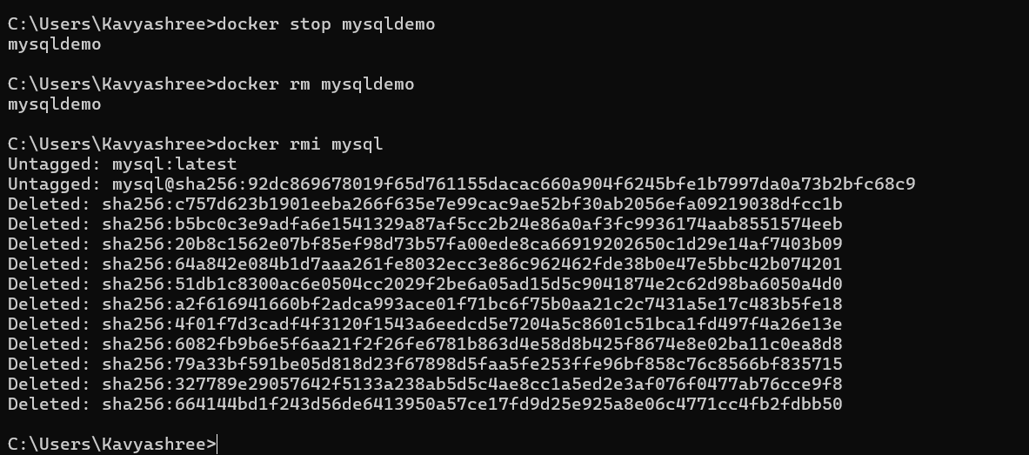

**//to remove docker container**

docker rm mysqldemo



**//to remove docker image**

docker rmi mysql



docker images



**//to check container list**

docker ps -a



* **//to create docker directory**

mkdir dockerdemofile

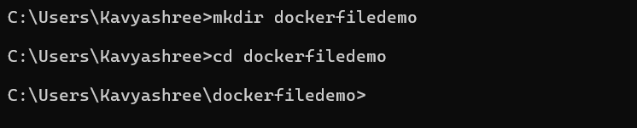

**Next create a dockerfile and the following content**

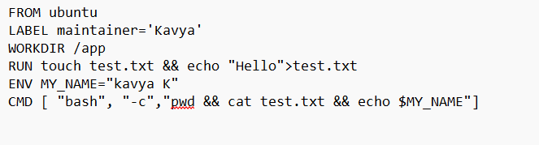

**Then change the file.txt to file🡪**

**//to change directory**

cd dockerdemofile



**//to check the location of the file**

type docker

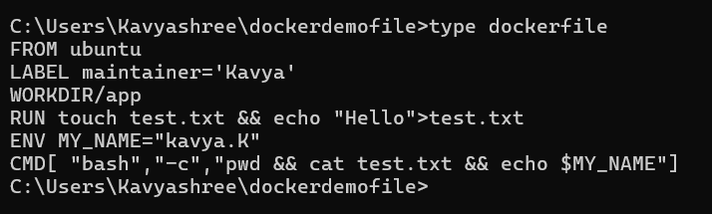

**//create a Docker image from a Dockerfile located in the current directory**

docker build –t demo .

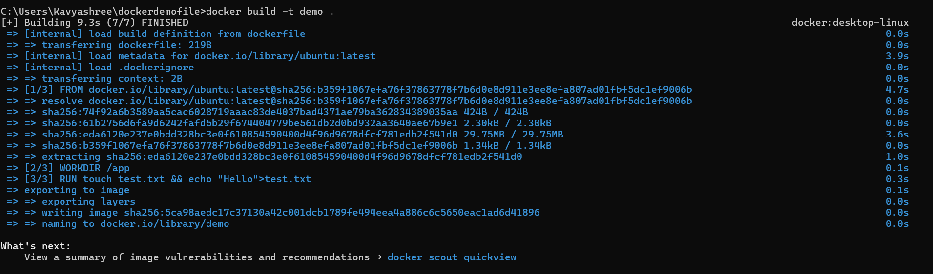

**//to list docker images**

docker images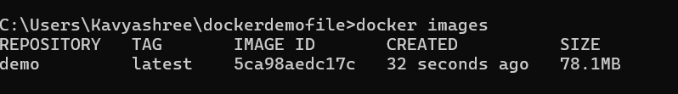

**//to save the images to container**

docker run --name mycontainer –it demo

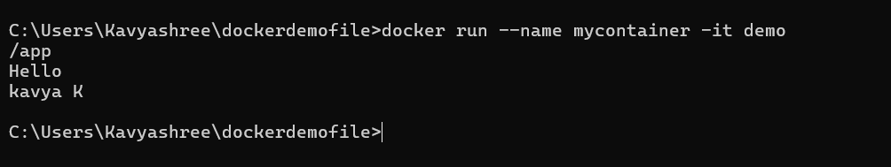

**//to stop the container**

docker stop mycontainer

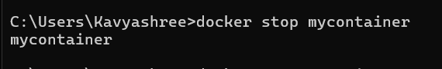

**//to remove the container**

docker rm mycontainer

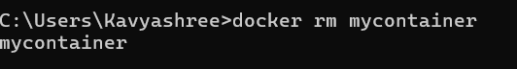

**//to remove the images**

docker rmi demo



**//to check container list**

docker ps -a

