**7. Demonstrate CRUD queries in MongoDB.**

**//Create a student databse**

use students;

**//Create a collection**

db.createCollection(“student”);

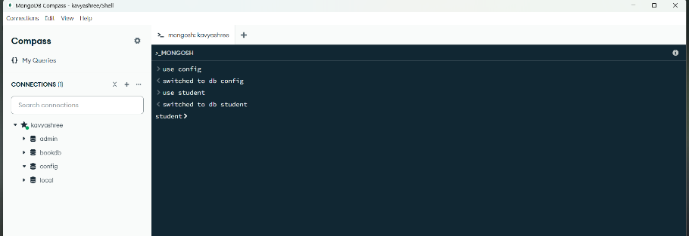

**//insert 1 documents**

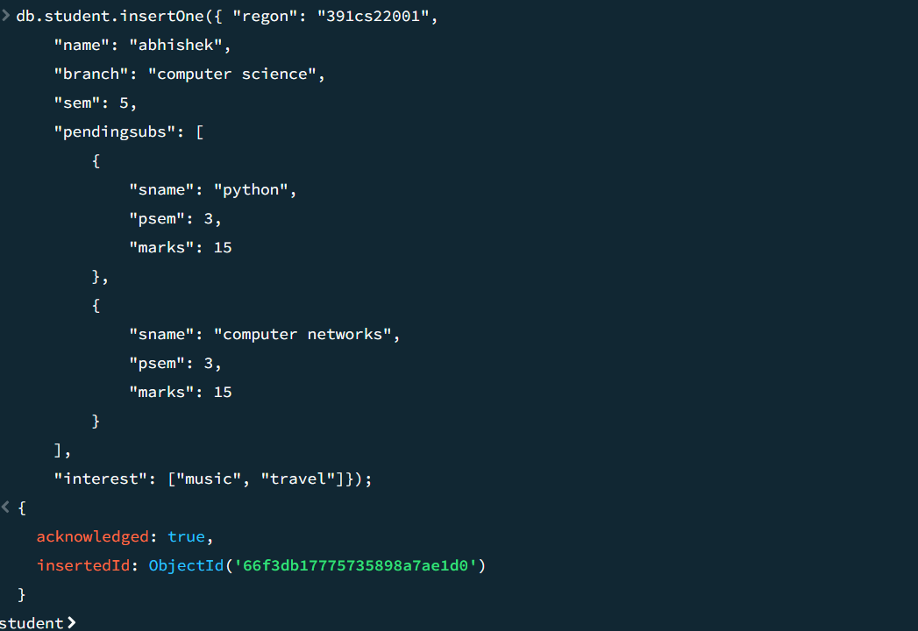

//insert 4 documents

db.student.insertMany([

{

"regon": "391cs22003",

"name": "Sharath",

"branch": "AT",

"sem": 5,

"pendingsubs": [

{

"sname": "dbms",

"psem": 6,

"marks": 20

}

],

"interest": ["music", "travel", "editing"]

},

{

"regon": "391cs22022",

"name": "Kavyashree",

"branch": "CS",

"sem": 5,

"pendingsubs": [],

"interest": ["riding","editing"]

},

{

"regon": "391cs22007",

"name": "bhavya",

"branch": "CE",

"sem": 4,

"pendingsubs": [

{

"sname": "data structures",

"psem": 2,

"marks": 20

}

],

"interest": ["reading"]

},

{

"regon": "391cs22011",

"name": "Disha",

"branch": "CI",

"sem": 5,

"pendingsubs": [

{

"sname": "project management",

"psem": 1,

"marks": 22

}

],

"interest": ["gaming"]

}

]);

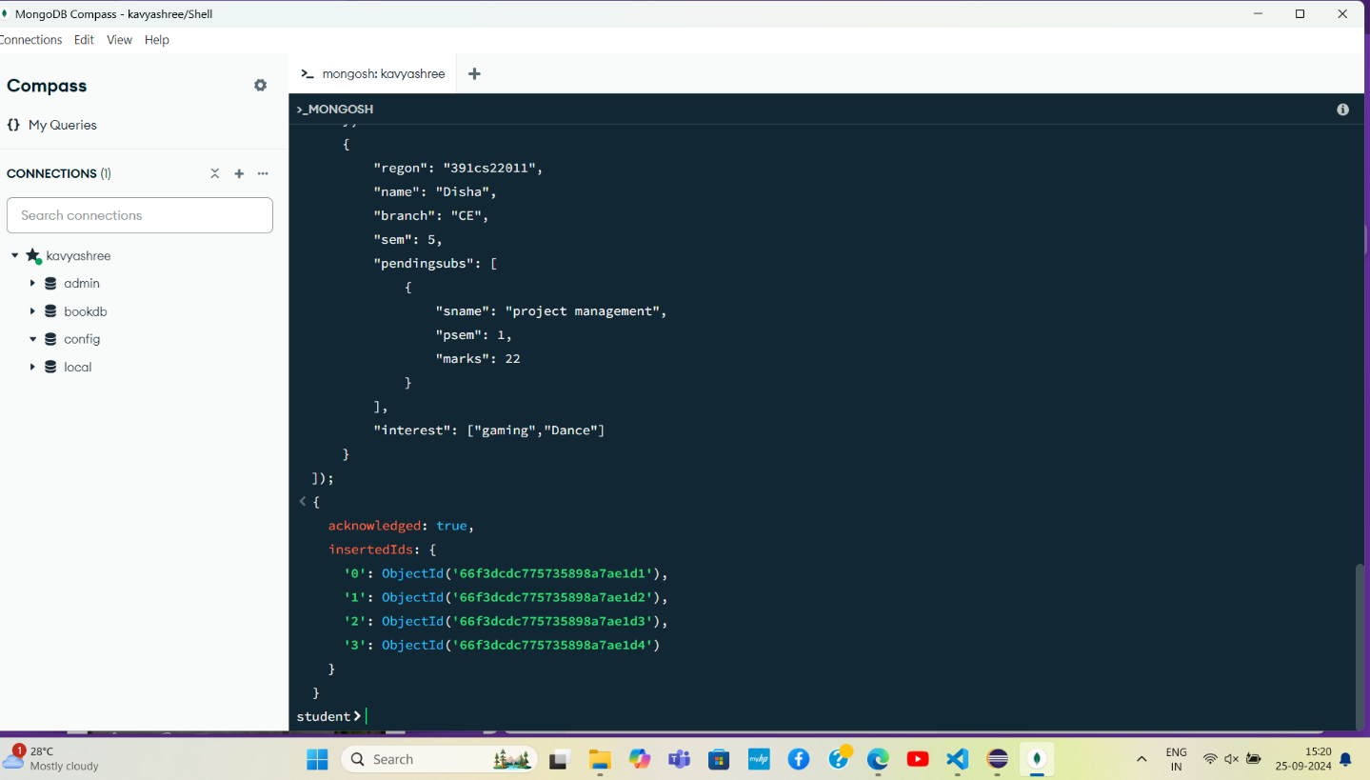

**Read:**

**//get all student details**

db.student.find();

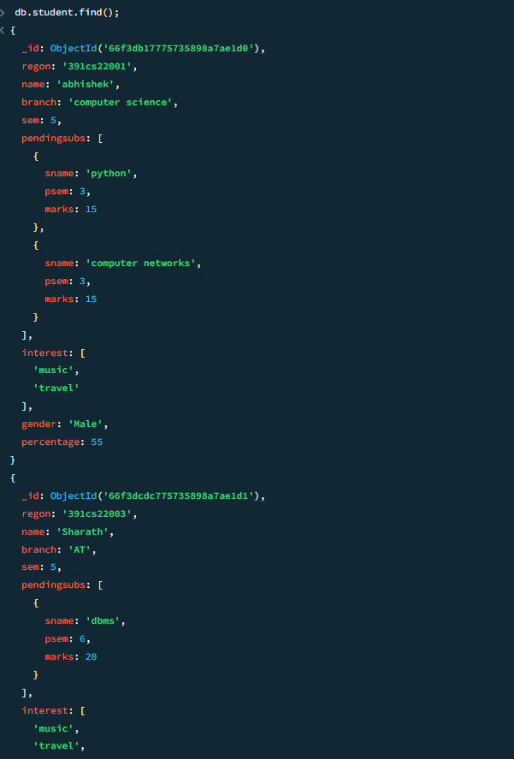 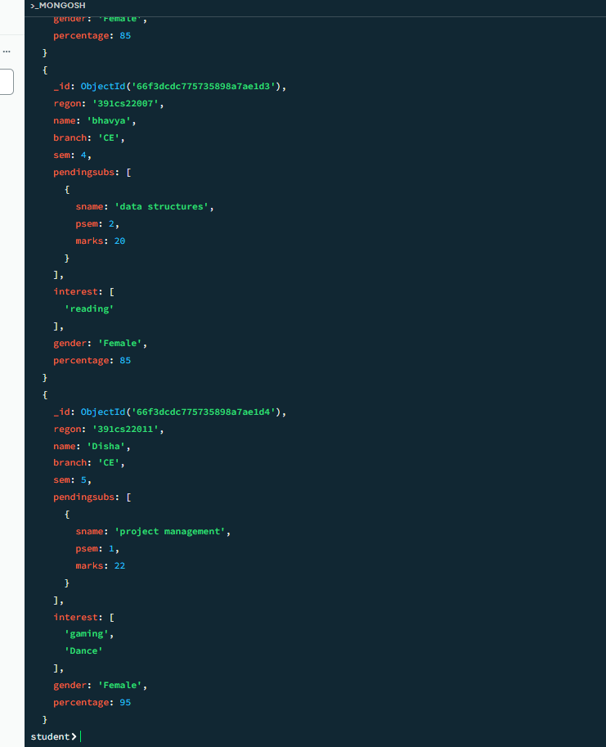

**//get names of all students in EC branch**

db.student.find({branch:"CE"},{_id:0,name:1});

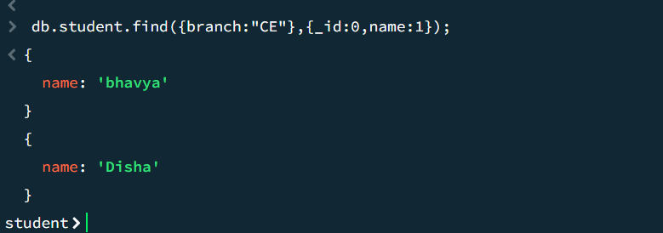

**//get name, branch and sem of students in 5th sem CS**

db.student.find({branch:"CE",sem:5},{_id:0,name:1,branch:1,sem:1});

db.student.find({branch:"AT",sem:5},{_id:0,name:1,branch:1,sem:1});

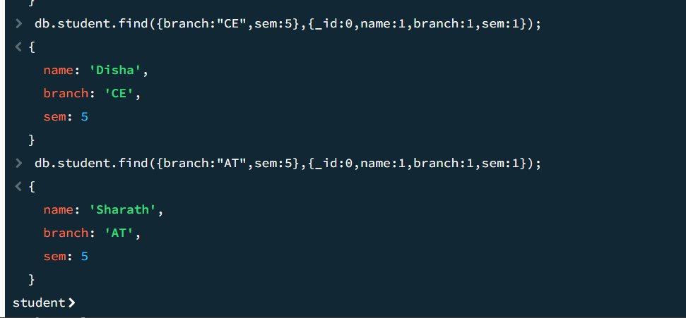

**//get name, branch and sem of students interested in music**

db.student.find({interests:"reading"},{_id:0,name:1,branch:1,sem:1});

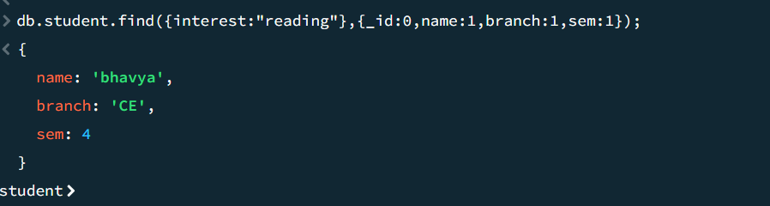

**//get name of students not interested in music**

db.student.find({interests:{$nin:["reading"]}},{_id:0,name:1});

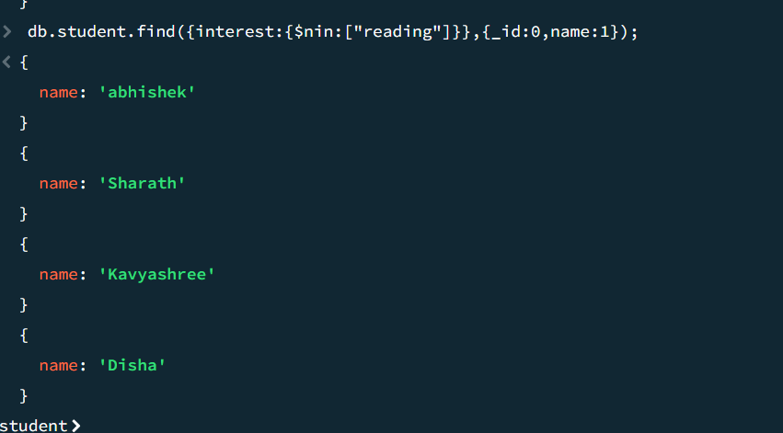

**//get names of students having data structure as pending subject**

db.student.find({pendsubs:{$elemMatch:{sname:" **data structure** "}}},{_id:0,name:1});

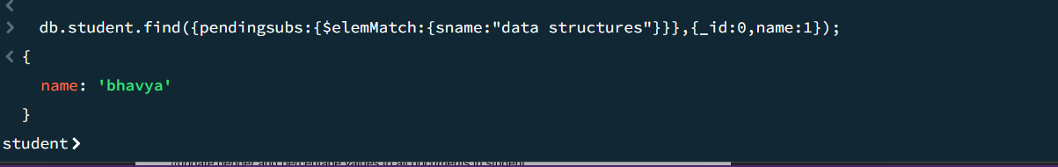

**//get name and branch of students not in AT branch**

db.student.find({branch:{$ne:"AT"}},{_id:0,name:1,branch:1});

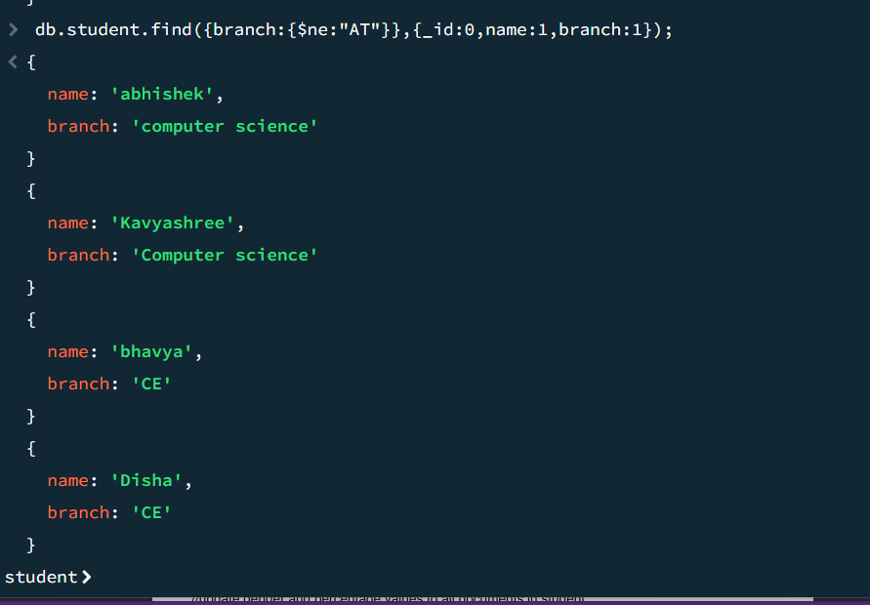

**//get name, branch and sem of students interested in travel and reading**

db.student.find({$and:[{interests:"music"},{interests:"travel"}]},{_id:0,name:1,branch:1,sem:1});

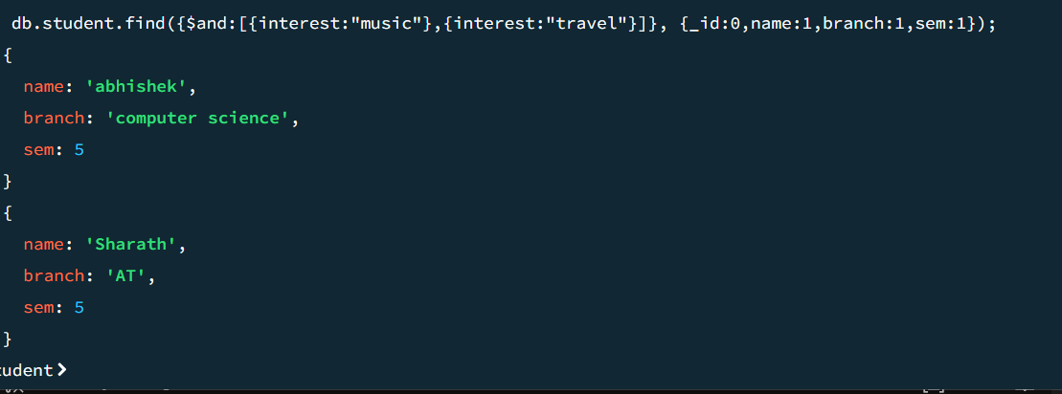

**//get name of all students in ascending order of name**

db.student.find({},{_id:0,name:1}).sort({name:1});

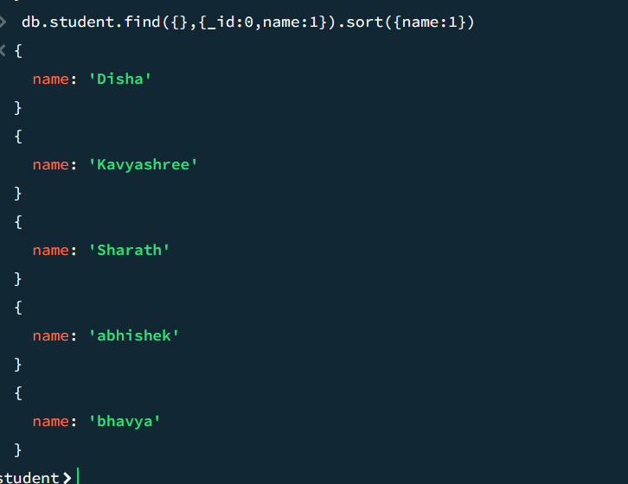

**//get name and sem of all students in descending order of sem**

db.student.find({},{_id:0,name:1,sem:1}).sort({sem:-1});

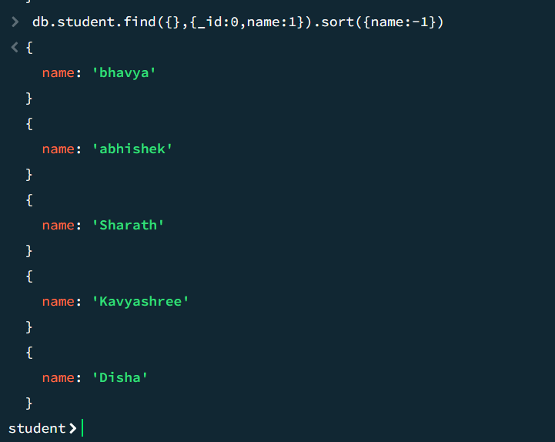

**Update:**

**//add fields gender and percentage to student collection**

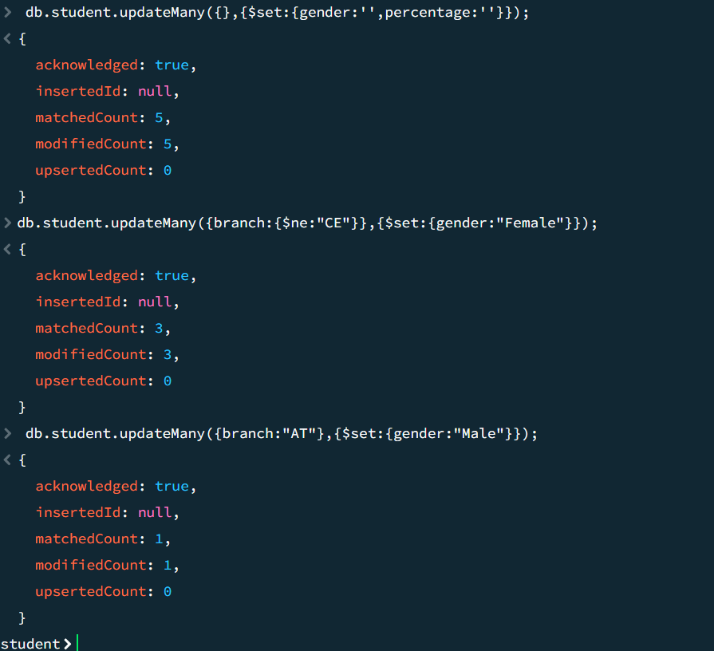

**//update gender and percentage values to all documents in student**

db.student.updateMany({branch:{$ne:"CE"}},{$set:{gender:"Female"}});



db.student.updateMany({branch:"AT"},{$set:{gender:"Male"}});

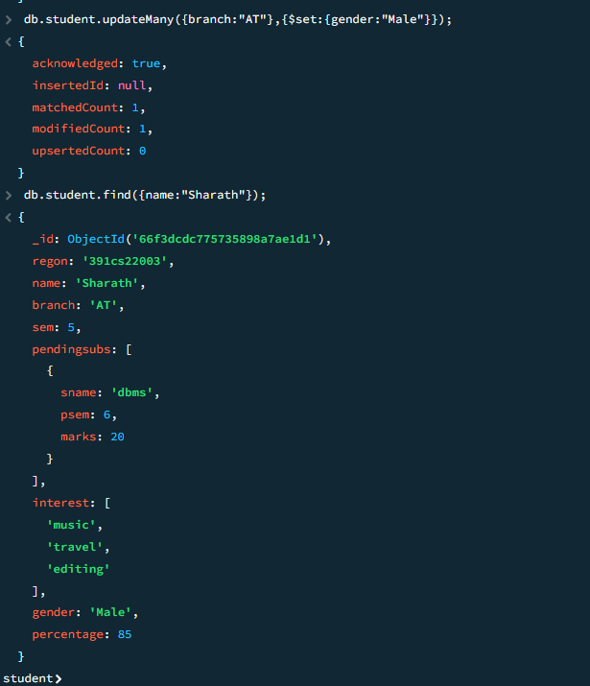

**//update gender and percentage values to all documents in studens**

db.student.updateOne({name:"Kavyashree"},{$set:{percentage:85}});

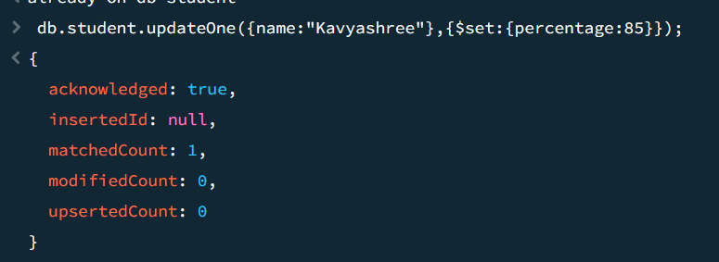

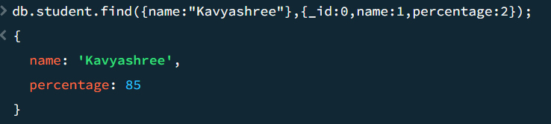

db.student.updateOne({name:"abhishek"},{$set:{percentage:55}});

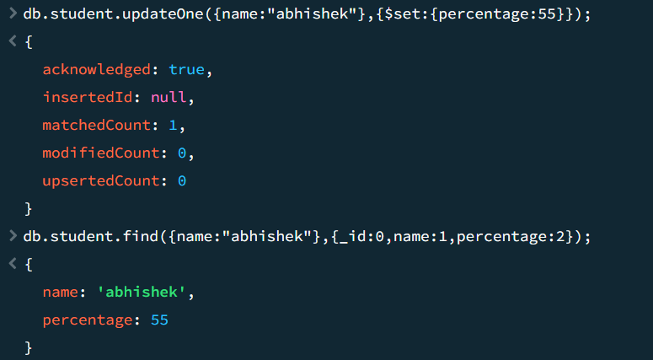

db.student.updateOne({name:"Disha"},{$set:{percentage:95}});

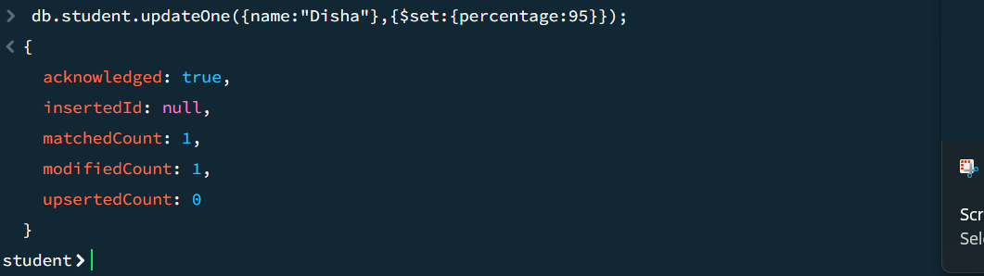

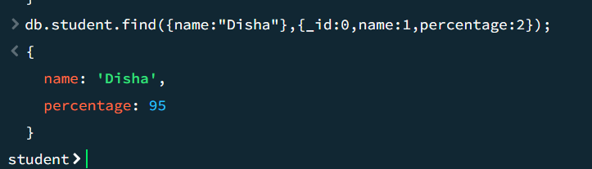

**db.student.updateOne({name:"bhavya"},{$set:{percentage:85}});**

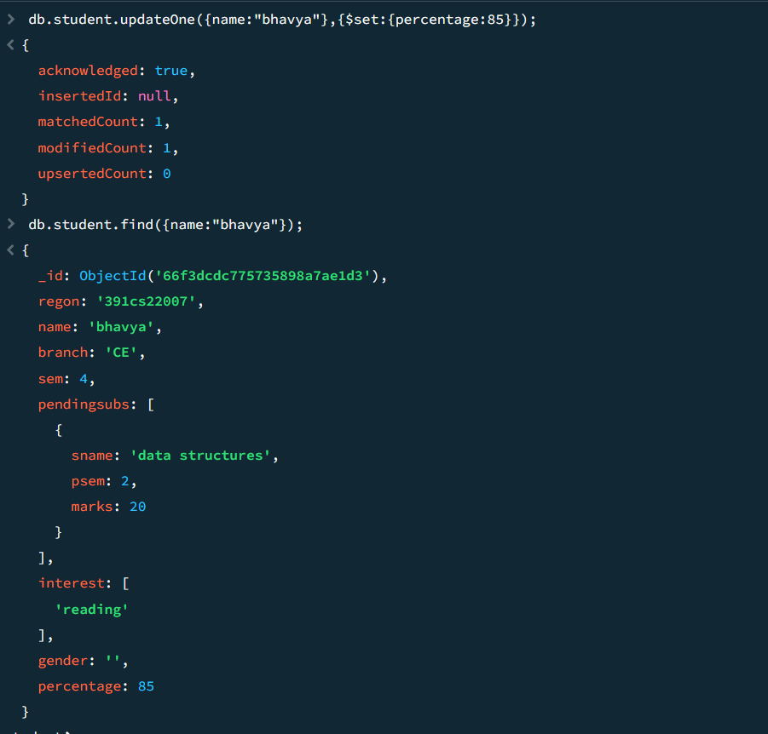

**//add interest ‘painting’ to Shree**

db.student.updateOne({name:"bhavya"},{$addToSet:{interest:"painting"}});

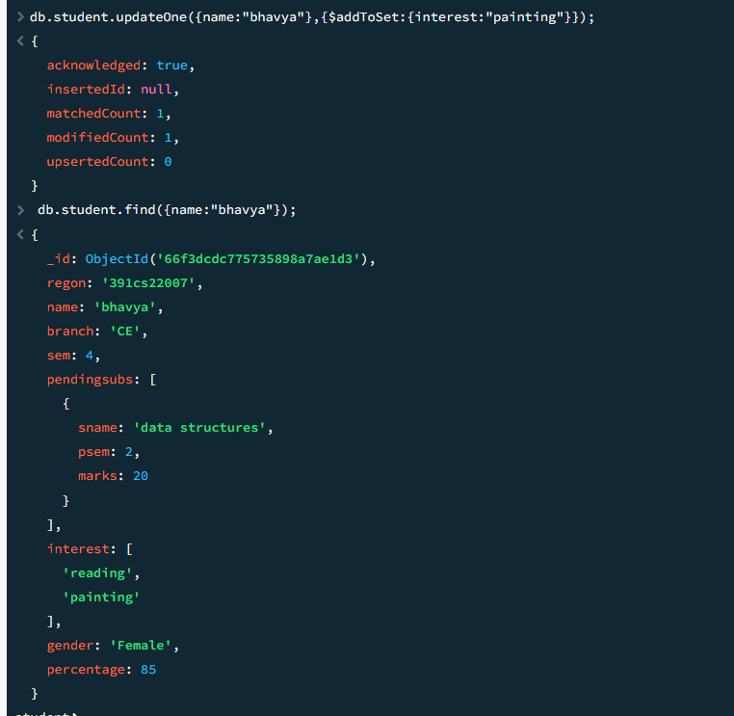

**//remove pendsubs python from Abhishek**

db.student.updateOne({name:"Abhishek"},{$pull:{pendsubs:{sname:"python"}}})

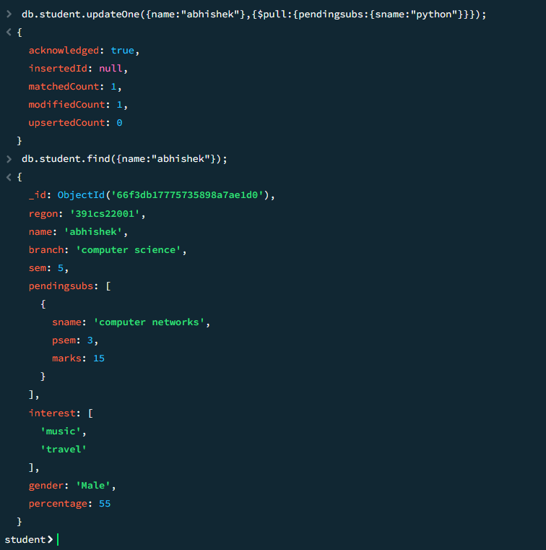

**//display the total no. of students in each branch**

db.student.aggregate([{$group:{_id:"$branch",No_of_Students:{$sum:1}}},{$project:{_id:1,No_of_Students:1}}]);

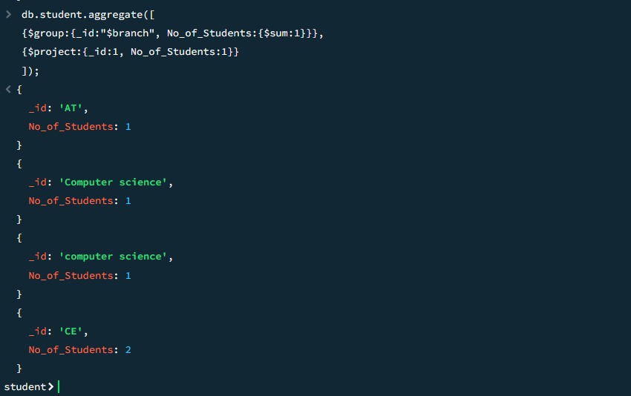

**//get branches having more than 1 student.**

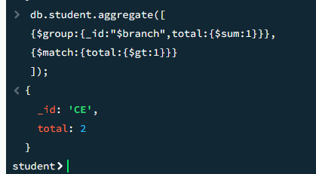

**//get names of students having more than 0 pending subject.**

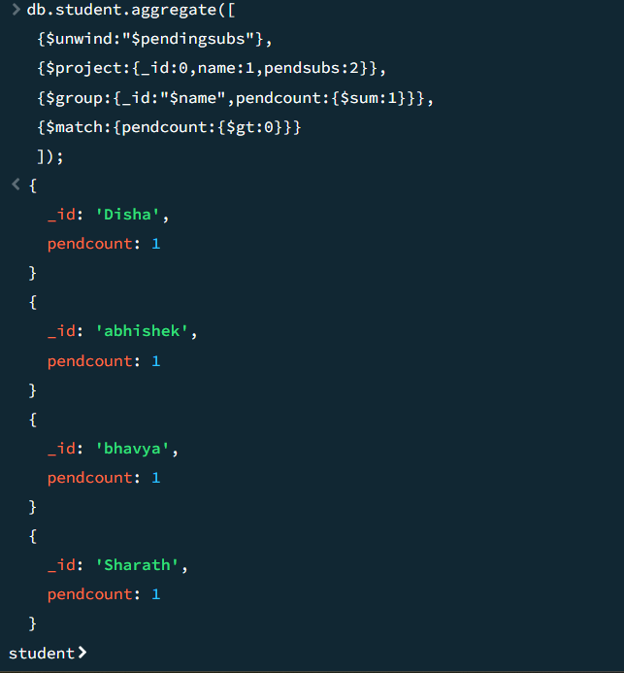

**//create collection department and insert multiple values**

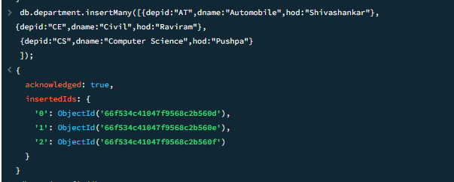

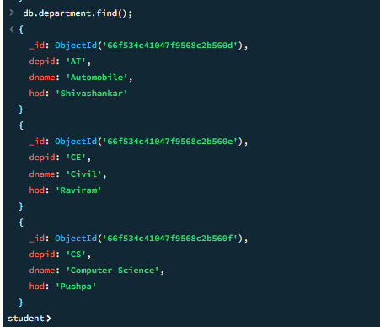

**//get regno, name, sem, dname and hod for all students**

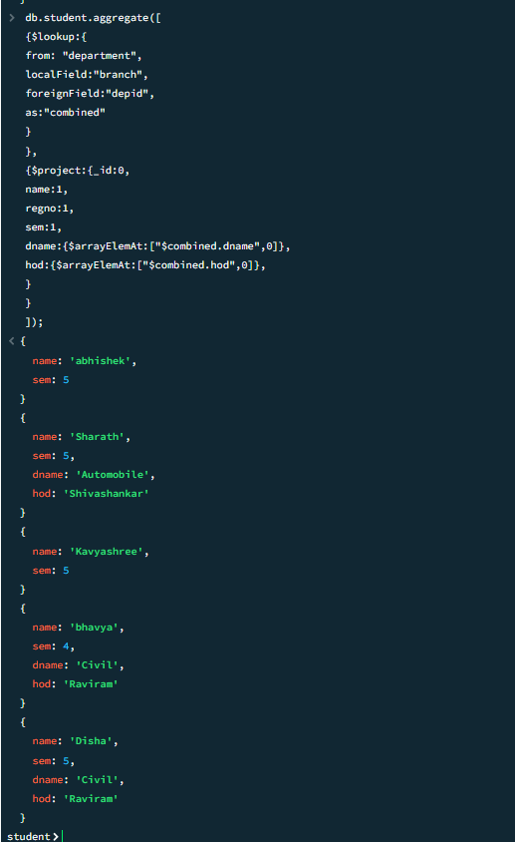

Delete:

//delete students in 4th sem

db.student.deleteMany({sem:4})

