MEDICAL

MEDICAL

STUDENT NAME : KAVYA SHREE M
INSTITUTION : RNS FRIST GRADE COLLEGE
SALES AND BUSINESS DATA CLEANING AND VISUALIZATION
MEDICAL SALES INSIGHTS REPORT

GUIDE : UMAMAHESWARI

PROJECT REPORT
NAME : KAVYA SHREE.M
INSTITUTE : RNS FRIST GRADE COLLEGE
GUIDE : UMAMAHESWARI
BUSINESS PROBLEM STATEMENT
Many medical stores rely on manual billing systems or basic spreadsheets that do not provide meaningful business insights. Sales data is often unclean, unstructured, and unused for decision-making.
- Fast-moving medicines may go out of stock
- Slow-moving products increase inventory holding cost
- Discount strategies are not optimized
- Monthly and seasonal sales trends are ignored
This lack of business intelligence leads to revenue loss, poor inventory planning, and reduced customer satisfaction.

ABSTRACT
Medical stores generate daily sales data, but lack of proper analysis leads to poor inventory planning, missed sales opportunities, and reduced profitability. This project focuses on transforming raw medical sales data into business-ready insights through data cleaning, analysis, and visualization. Using Microsoft Excel and Power BI, sales trends, top-selling products, customer segments, and profitability indicators were analyzed.
The project delivered interactive dashboards that help medical store owners identify fast-moving products, manage slow-moving stock, optimize discounts, and improve sales planning. The solution enables data-driven decision-making, improves operational efficiency, and supports business growth in the medical retail domain.

BUSINESS INTRODUCTION
Medical stores operate in a competitive environment where sales volume, inventory turnover, and customer satisfaction directly affect profitability. Managing hundreds of medicines manually makes it difficult to track performance and demand patterns. Business-oriented data analysis helps store owners understand which products generate revenue, which products block working capital, and how sales change over time. This project applies data analytics to support better business decisions in medical retail.

BUSINESS OBJECTIVES

- To identify top-selling and slow-moving medicines
- To analyze monthly sales growth and decline
- To understand customer purchase behavior
- To evaluate product segment contribution to revenue
- To support inventory and discount decisions
- To improve overall sales and profitability.
- To align procurement decisions with demand fluctuations.
- To compare sales performance across retail, bulk, and hospital customers.
- To create KPIs for tracking business performance.
- To replace manual decision-making with analytics-based insights.
To standardize data analysis processes for future expansion.

BUSINESS DATASET OVERVIEW
The dataset represents real medical store sales transactions consisting of 622 records. Each record captures critical business information such as medicine name, quantity sold, selling price, discount, manufacturer, and customer segment. This transactional data forms the foundation for analyzing revenue performance, demand patterns, and inventory movement.
BUSINESS TOOLS AND TECHNOLOGY
TOOLS | BUSINESS PURPOSE
Excel | Sales validation & operational analysis
Power BI | Executive dashboard & KPIs
Copilot | Faster reporting
GITHUB | Business documentation

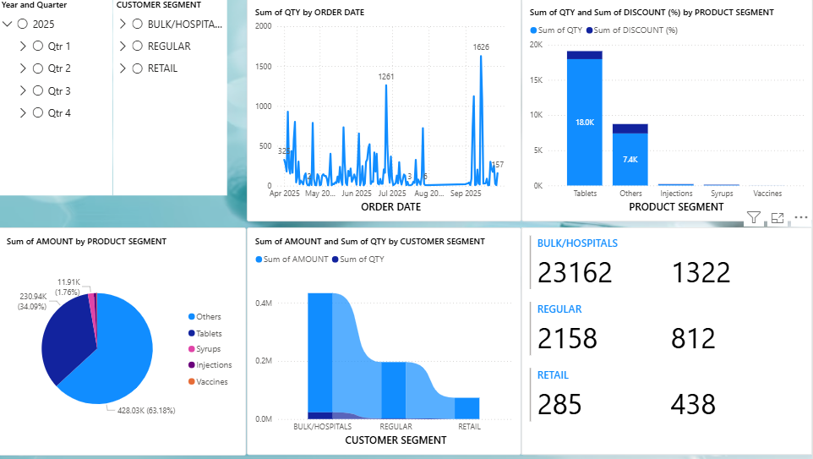
BUSINESS RESULTS AND INSIGHTS

- Tablets contribute the highest sales revenue .
- Certain medicines show consistently high demand .
- Slow-moving products lock working capital .
- Sales peak during specific months .
Retail customers generate the majority of transactions.
BUSINESS CONCLUSION
This project demonstrates how medical sales data can be transformed into a powerful decision-making tool. By using Excel and Power BI dashboards, medical store owners can monitor sales performance, manage inventory effectively, and improve profitability. AI tools enhanced efficiency and reporting quality. The solution provides a scalable model for data-driven medical retail management.

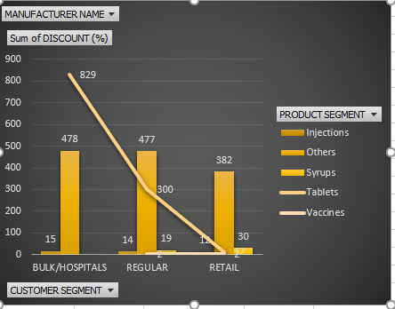

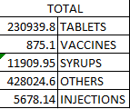
HERE WE CAN SEE THAT TABLETS ARE THE HIGHEST REVENUE GENERATOR.

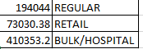
HERE WE CAN SEE BULK/ HOSPITAL AS THE HIGHEST BUYING OF PRODUCTS.

