INTERNSHIP REPORT ON
DEPLOYMENT OF WEB APPLICATION USING AWS Amplify
Submitted by
Kavya S
1. Abstract
This report presents a case study on deploying a web application using AWS Amplify. The focus is on transforming a locally developed application into a cloud-hosted solution. AWS Amplify simplifies deployment by providing continuous integration and hosting directly from a GitHub repository. The deployment demonstrates scalability, ease of use, and fast application delivery.
2. Problem Statement
Traditional application hosting requires manual server setup and maintenance, which can be time-consuming and complex. The challenge is to deploy a web application in a way that ensures:
- High availability
- Remote accessibility
- Minimal configuration effort
- Easy maintenance
3. Proposed Solution
To overcome these challenges, AWS Amplify was used. It provides a fully managed hosting service that connects directly with GitHub and automatically builds and deploys the application.
4. Implementation & Deployment Process
- Connecting GitHub Repository
- The source code of the application was stored in a GitHub repository
- The repository was connected to AWS Amplify
- Repository Link:
https://github.com/kavyasin/fsd.git
- Creating Amplify App
- Logged into AWS Management Console
- Navigated to AWS Amplify
- Selected “New App” → “Host Web App”
- Connected GitHub account
- Selected the repository and branch
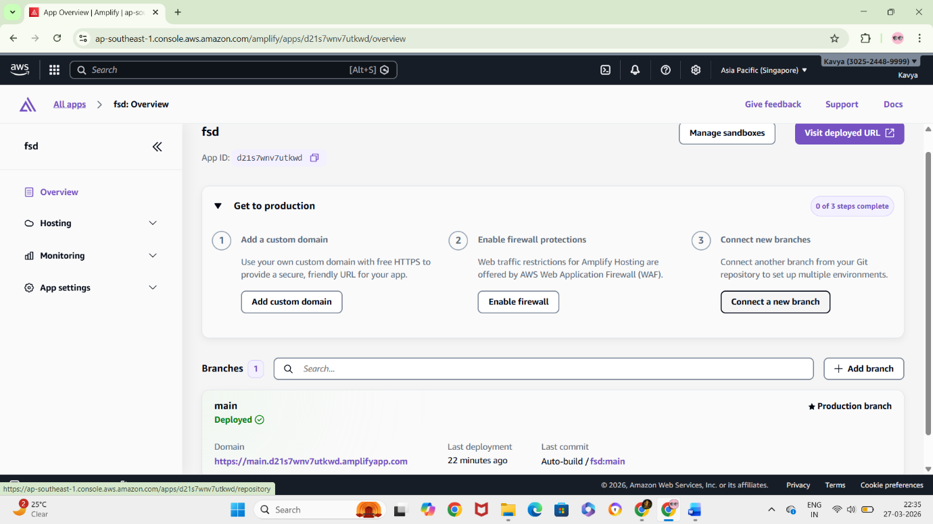

- Build and Deployment Configuration
- Amplify automatically detected the build settings
- Configured build specifications (if required)
- Started the deployment process
- Automatic Deployment
- Amplify built the application
- Deployed it to a live hosting environment
- Generated a public URL for access
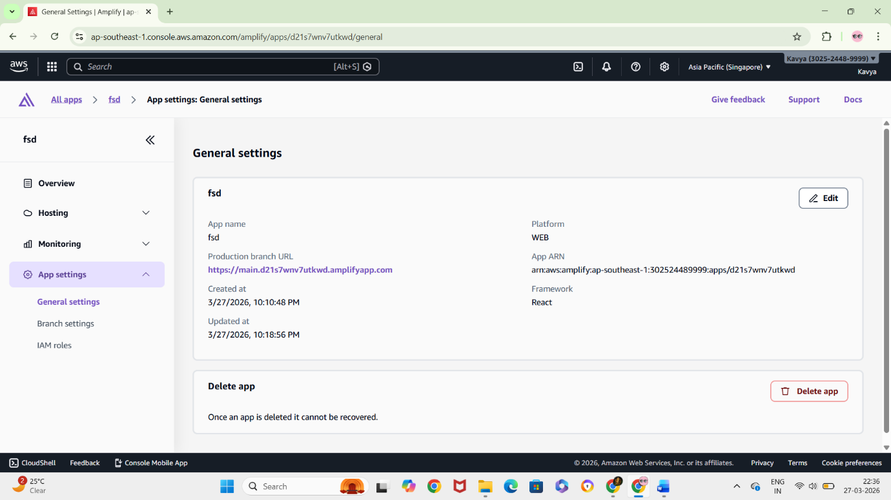
5. Accessing the Application
- The deployed application was accessed using the Amplify-generated domain link
- The application was successfully available over the internet
https://main.d21s7wnv7utkwd.amplifyapp.com/
6. Results
The application was successfully deployed using AWS Amplify
Continuous deployment was enabled through GitHub integration
Application updates were automatically reflected after each commit

7. Conclusion
AWS Amplify simplifies web application deployment by eliminating the need for manual server configuration. It provides an efficient and modern approach to hosting applications with minimal effort and maximum scalability.

