- To Install Linux VM, Configure GCC, Setup Git Repository, Create Project Structure, Understand Shell Architecture, Build Initial Makefile.

Task -1: Create Project Structure as follows:
Note: For creating this structure use mkdir and touch commands.

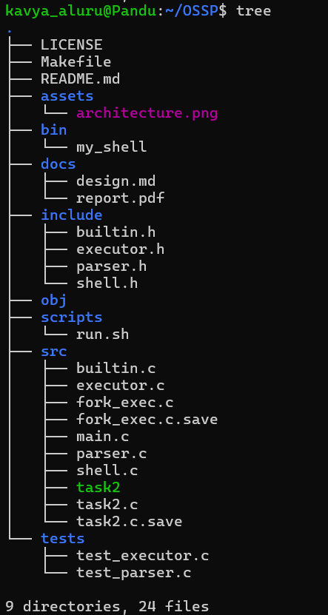

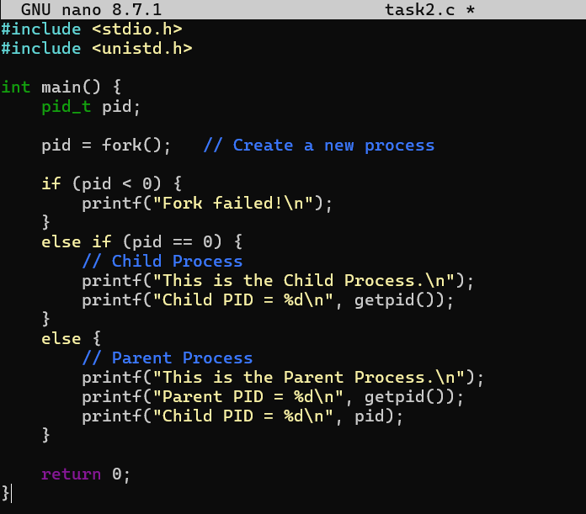

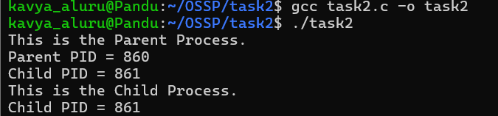

Report: I created the necessary folders and files, initialized a Git repository, and verified the project structure using the tree command. Thus, I successfully completed the task and understood how to organize a project in Linux.

To Analyze process abstraction, execute fork(), understand exec() family, analyze parent-child relationships, inspect process tree, practice system call tracing.

Task-1: Using a manual command understand the fork() and exec() system calls

Fork()
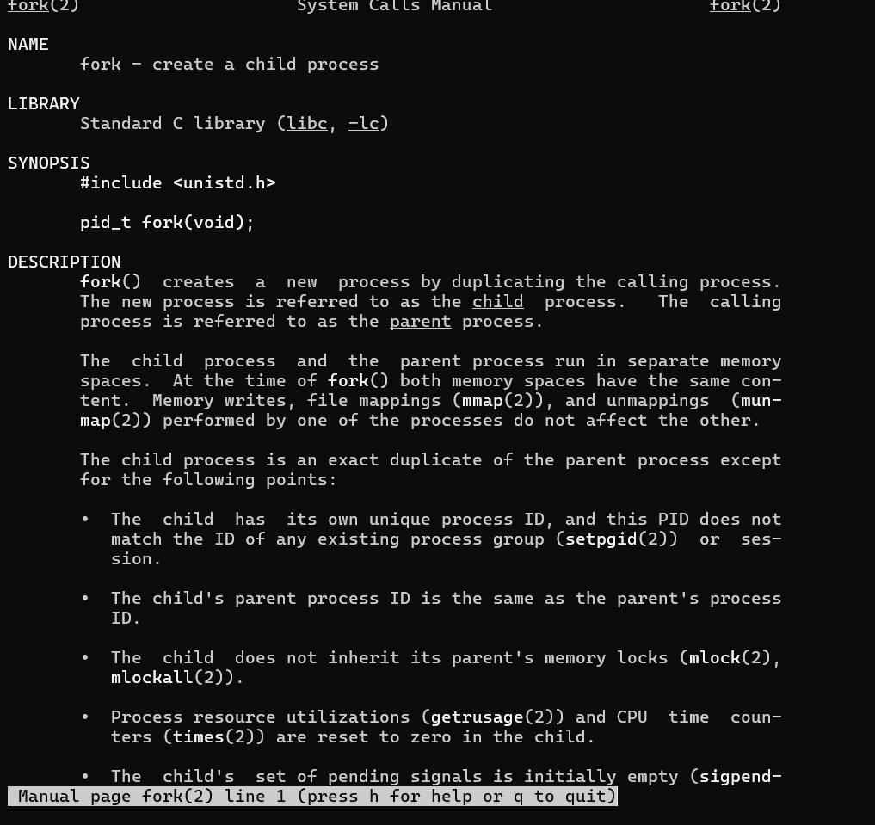

Man exec:
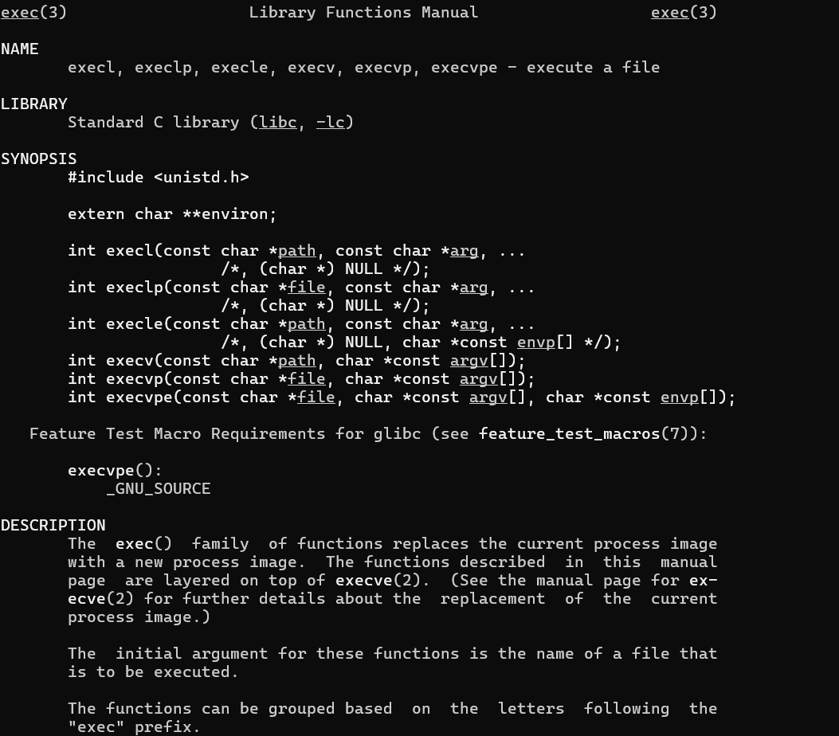

Report: I used the manual commands man fork and man exec to understand the fork() and exec() system calls. I read the manual pages and learned that fork() creates a new child process, while exec() replaces the current process with a new program. Thus, I successfully understood the purpose and working of both system calls.

Task-2: Write a C program to create a new process and accepting the user commands using fork() and exec() system calls.
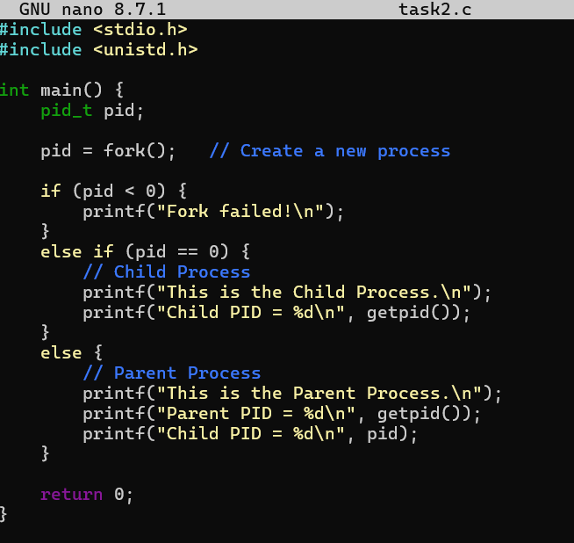

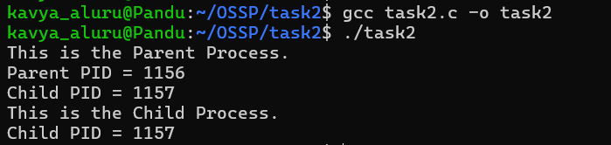
Report: I wrote and executed a C program using the fork() system call to create a child process. I compiled and ran the program successfully and observed the creation of both the parent and child processes along with their Process IDs (PIDs). Thus, I understood the working of the fork() system call and the parent-child process relationship successfully.

