Week 1: Skill

WSL Installation:
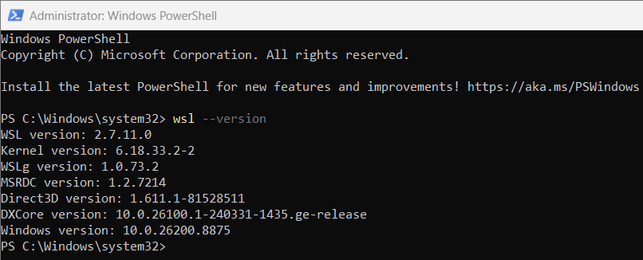
Report: It displays the installed version of Windows Subsystem for Linux (WSL),
The command displayed the installed WSL version (2.7.11.0), Linux kernel version, WSLg version, Direct3D version, DXCore version, and the Windows version, confirming that WSL is installed and working properly.

Simple Commands:

- Pwd:
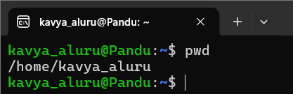

Report: It displays the current working directory. The command(pwd) returned output as /home/kavya_aluru indicating that the user is currently in the home directory.

- Clear:
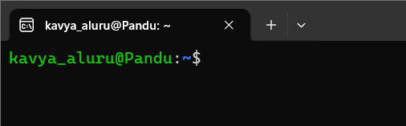
Report: It clears the terminal screen by removing the previously displayed commands and output. The command (clear) successfully cleared the terminal, providing a clean workspace for entering new commands.

- History
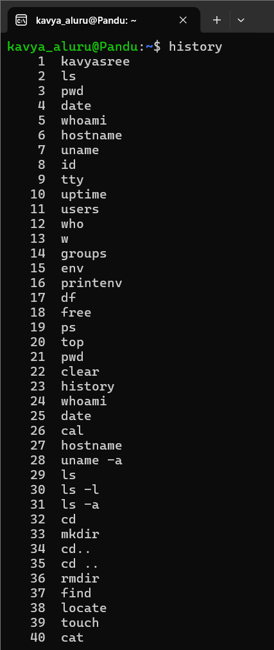
Report: It displays the list of previously executed commands. The command (history) returned the history of commands that were executed in the current terminal session.

- Whoami
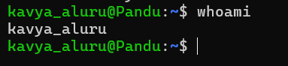
Report: It displays the currently logged-in username. The command (whoami) returned the username kavya_aluru.

- Date
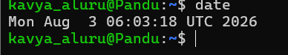
Report: It displays the current system date and time. The command (date) returned the current date and time of the system, that is Aug 3rd.

- Cal
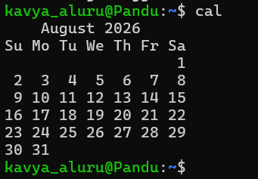
Report: It displays the calendar of the current month. The command (cal) returned the calendar for the current month that is August month calendar

- Hostname
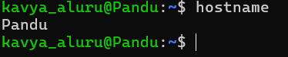
Report: It displays the system hostname. The command (hostname) returned the hostname as Pandu.

- Uname -a
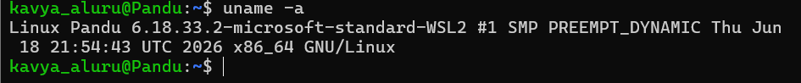
Report: It displays detailed operating system information. The command (uname -a) returned the Linux kernel and system details.

- Exit
Report: It exits the terminal session. The command (exit) closed the current terminal window.

TOPIC 2: Directory Management
- Ls
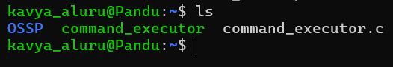
Report: It displays the files and directories in the current location. The command (ls) returned the list of available files and folders they are: OSSP, command_executor, command_executor.c

- Ls -l
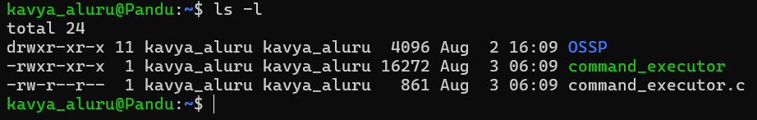
Report: It displays detailed information about files and directories. The command (ls -l) returned the permissions, owner, size, and modification date of each file.

- Ls -a
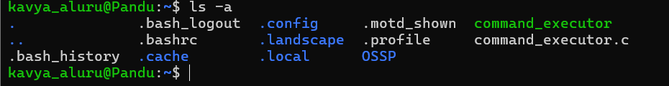
Report: It displays all files, including hidden files. The command (ls -a) returned both visible and hidden files in the current directory.

- Cd

Report: It changes the current working directory. The command (cd) successfully changed the directory to the specified location.

- Cd ..
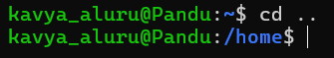
Report: It moves to the parent directory. The command (cd ..) successfully changed the current directory to its parent that is /home.

- Mkdir
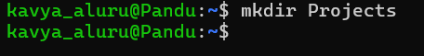
Report: It creates a new directory. The command (mkdir) successfully created the specified directory.

- Rmdir
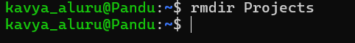
Report: It removes an empty directory. The command (rmdir) successfully deleted the empty directory.

- Find
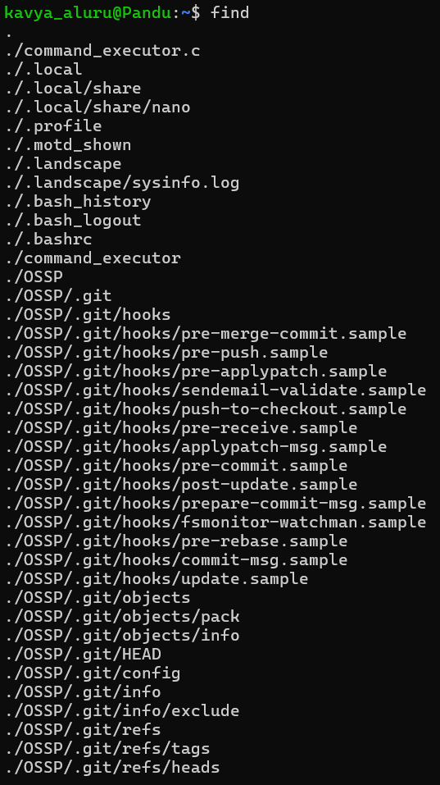
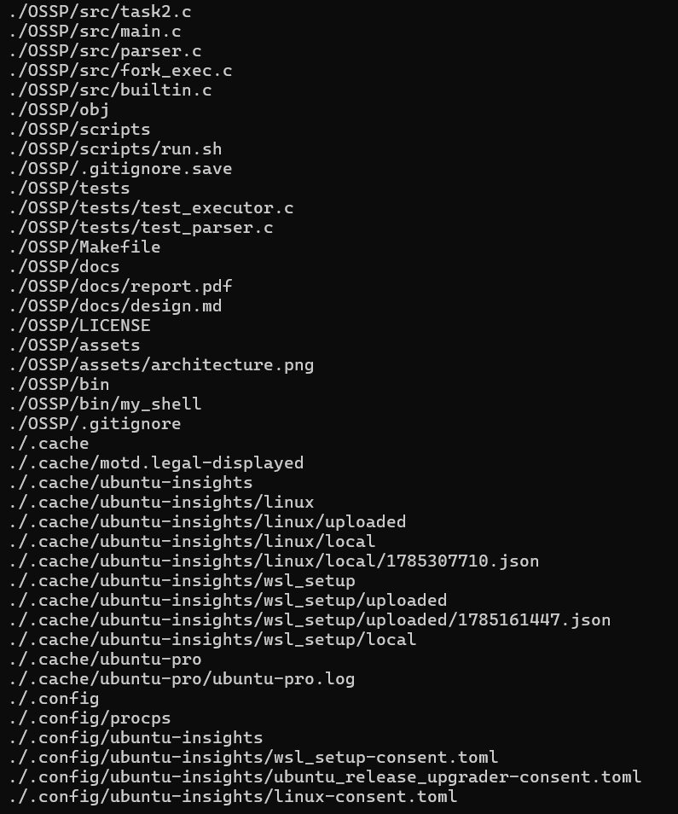

Report: It searches for files and directories. The command (find) returned the location of the specified file

- Locate
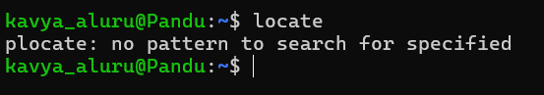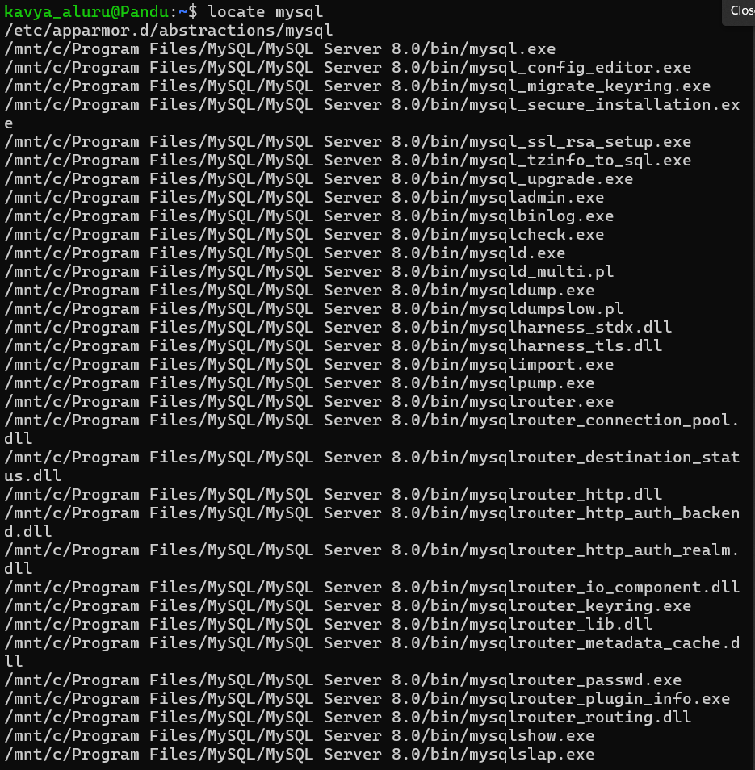

Report: It quickly searches for a file using the system database. The command (locate) returned the path of the requested file if it existed.

TOPIC 3: File Management
- Touch
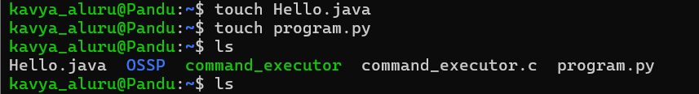
Report: It creates a new empty file. The command (touch) successfully created the specified file.

2.cat
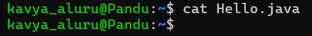
Report: It displays the contents of a file. The command (cat) returned the contents stored in the specified file.

- Cp
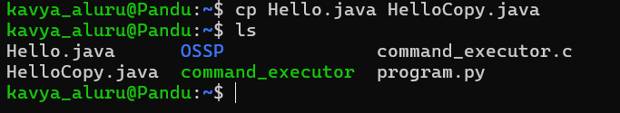
Report: It copies files or directories. The command (cp) successfully created a copy of the specified file.

- Mv
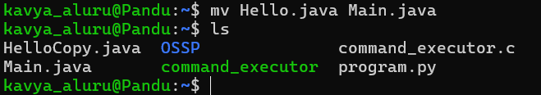
Report: It moves or renames a file. The command (mv) successfully moved or renamed the specified file.

- Rm
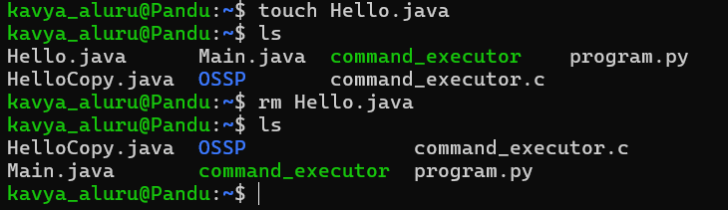
Report: It deletes a file. The command (rm) successfully removed the specified file.

- Head
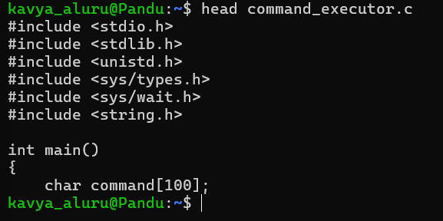
Report: It displays the first few lines of a file. The command (head) returned the first 10 lines of the specified file.

- Tail
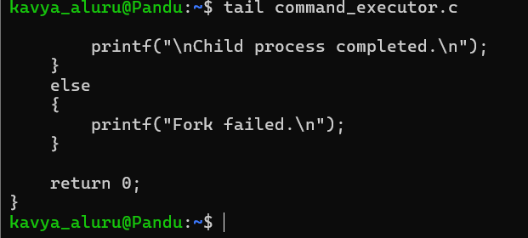
Report: It displays the last few lines of a file. The command (tail) returned the last 10 lines of the specified file.

- More
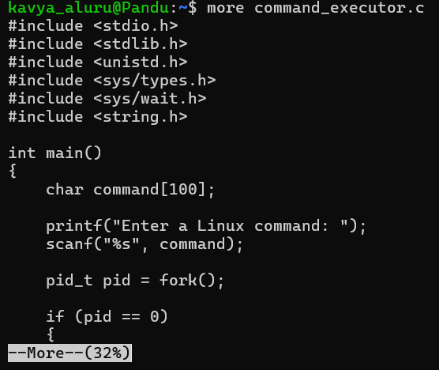
Report: It displays the file one page at a time. The command (more) showed the file contents page by page.

- Less
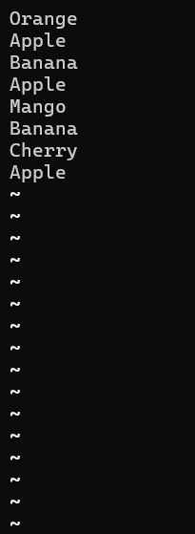
Report: It allows scrolling through a file. The command (less) displayed the file contents and allowed scrolling in both directions.

- Wc
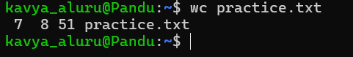
Report: It counts the number of lines, words, and characters in a file. The command (wc) returned these counts for the specified file.

- Diff
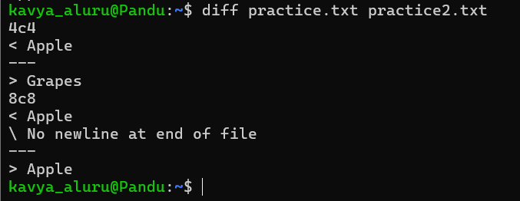
Report: It compares two files. The command (diff) displayed the differences between the specified files.

- Sort
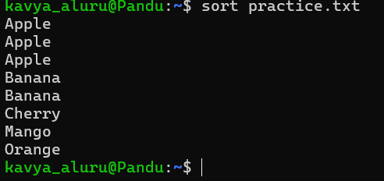
Report: It sorts the contents of a file. The command (sort) returned the file contents in alphabetical order.

- Uniq
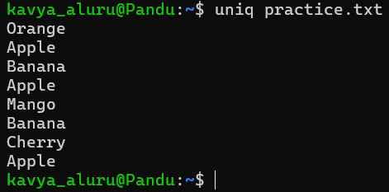
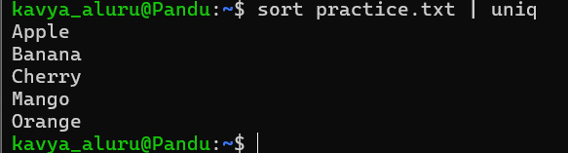
Report: It removes duplicate consecutive lines from a file. The command (uniq) returned the file contents without duplicate consecutive lines.

- Grep
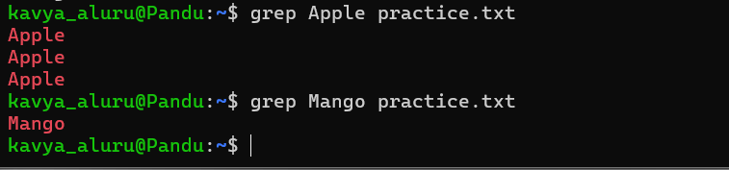
Report: It searches for a specific word or pattern in a file. The command (grep) displayed the lines containing the searched text.

TOPIC 4: File Editing

- Nano
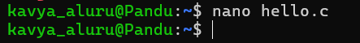
Report: It creates or edits a file. The command (nano) opened the specified file for editing.

- Vi
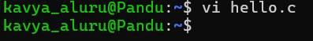
Report: It opens a file in the Vim editor. The command (vi) allowed the file to be edited and saved.

TOPIC 5: C Program Compilation and Execution
- Gcc
Report: It compiles a C program. The command (gcc) successfully compiled the program and created an executable file.

- ./program
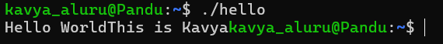
Report: It executes the compiled program. The command (./hello) successfully ran the program and displayed the expected output.

- Which
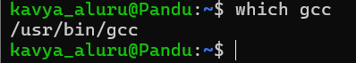
Report: It displays the location of an executable command. The command (which) returned the path where the command is installed.

- Whereis
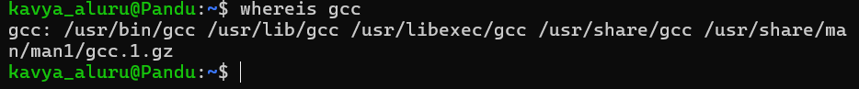
Report: It displays the binary, source, and manual page locations of a command. The command (whereis) returned the available locations for the specified command.

- Man
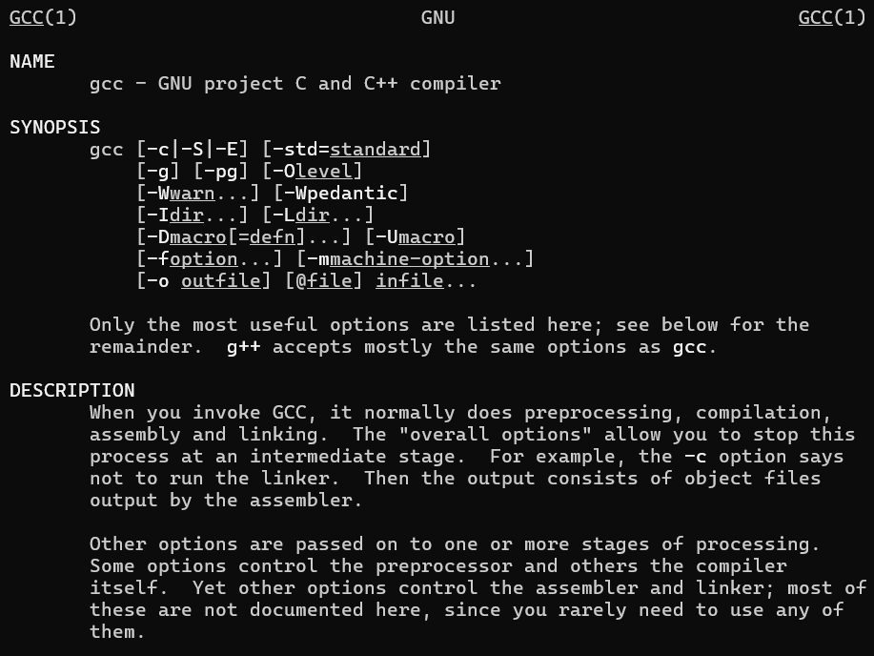
Report: It displays the manual page of a command. The command (man) opened the documentation for the specified command.

TOPIC 6: Process Management

- Ps
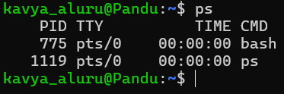
Report: It displays the currently running processes. The command (ps) returned the list of active processes.

- Ps -ef
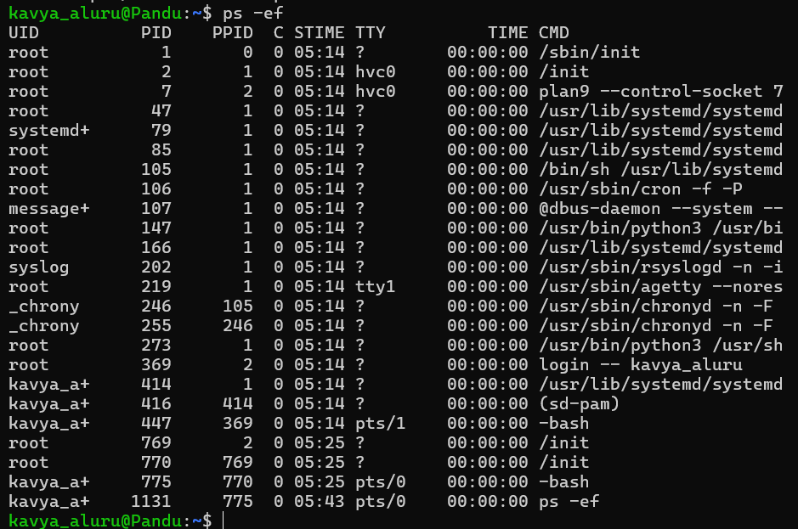
Report: It displays all running processes with detailed information. The command (ps -ef) returned the complete list of active processes.

- Top
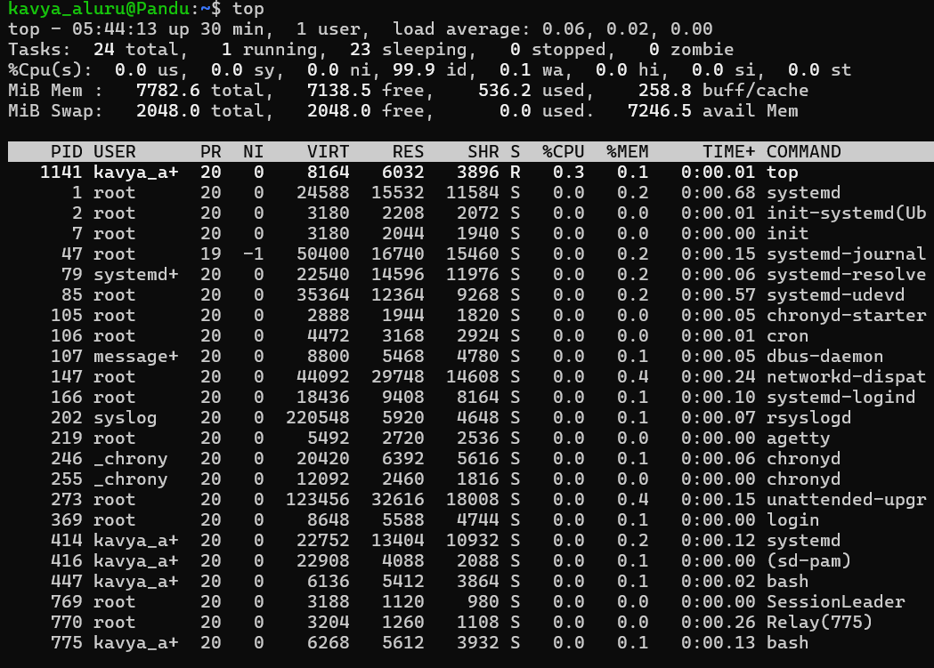
Report: It monitors the running processes in real time. The command (top) displayed the live process and system resource information.

- Kill

Report: It terminates a running process. The command (kill) stopped the specified process.

- Kill -9
Report: It forcefully terminates a running process. The command (kill -9) immediately stopped the specified process.

TOPIC 7: Job Controls

- Jobs
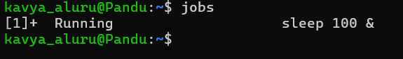
Report: It displays the jobs running in the background. The command (jobs) returned the list of background jobs currently running.

- Bg
Report: It resumes a stopped job in the background. The command (bg) successfully resumed the selected job.

- Fg
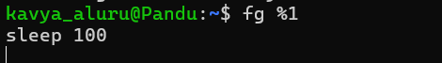
Report: It brings a background job to the foreground. The command (fg) resumed the selected job in the terminal.

- &
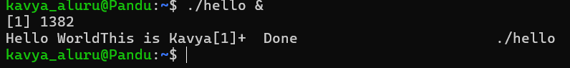
Report: It runs a command in the background. The command executed successfully and continued running while the terminal remained available.

TOPIC 8: File Permissions and Links

- Chmod
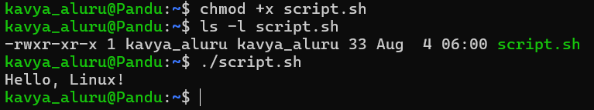
Report: It gives execute permission to a file. The command (chmod +x) successfully made the specified file executable.

- Chmod 755
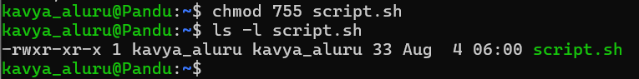
Report: It sets read, write, and execute permissions for the owner and read and execute permissions for others. The command (chmod 755) successfully updated the file permissions.

- Ln
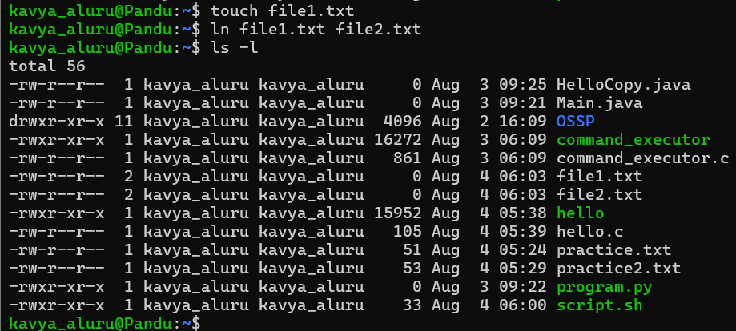
Report: It creates a hard link for a file. The command (ln) successfully created a hard link to the specified file.

- Ln -s
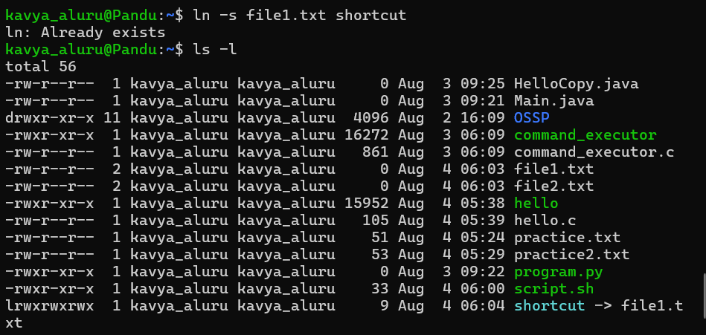
Report: It creates a symbolic (soft) link for a file. The command (ln -s) successfully created a shortcut pointing to the specified file

TOPIC 9: Disk and Memory Information

- Df -h
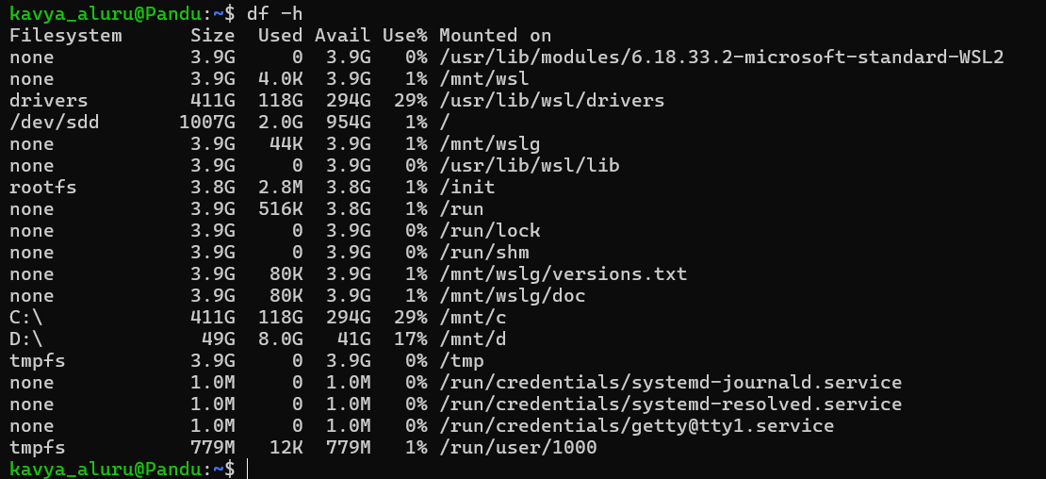
Report: It displays the disk space usage in a human-readable format. The command (df -h) returned the total, used, and available disk space.

- Du -sh
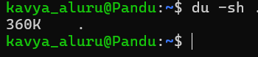
Report: It displays the size of a directory in a human-readable format. The command (du -sh) returned the total size of the specified directory.

- Free -h
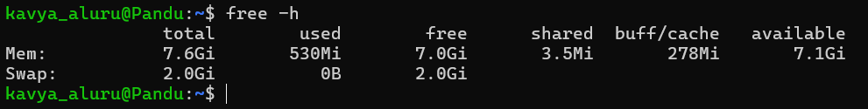
Report: It displays the system memory usage in a human-readable format. The command (free -h) returned the total, used, and available memory.

