Practical: Week-1
Commands
- id
Report: It displays the user ID and group ID of the currently logged-in user. The command (id) returned the user ID, group ID, and the groups associated with the current user.

- env
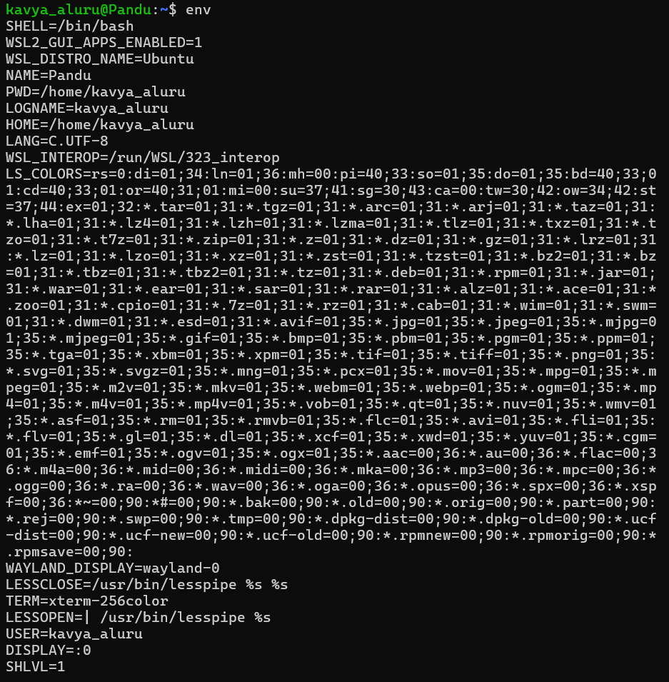
Report: It displays the environment variables of the current session. The command (env) returned the list of environment variables such as HOME, PATH, USER, and SHELL.

- export
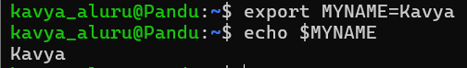

Report: It sets an environment variable for the current session. The command (export MYNAME=Kavya) successfully created the environment variable, and echo $MYNAME displayed the value as Kavya.

- alias
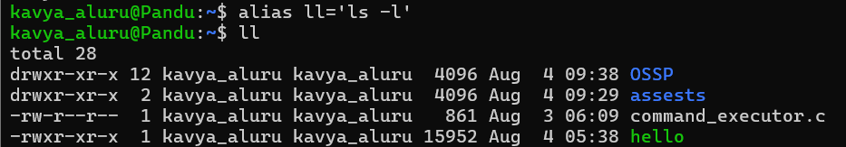

Report: It creates a shortcut for a command. The command (alias ll='ls -l') successfully created the alias ll, and executing ll displayed the detailed list of files and directories in the current directory, similar to the ls -l command.

