CO 1 - ASSESSMENT TOOL - 1
Name : Lanka Kavya Subject Code: CSA0619
Registartion Number : 192472298 Subject Name : DAA

Q7: A search engine builds an index using T(n) = T(n/2) + 1. Apply the substitution method to solve the recurrence. Expand the relation step-by-step and derive complexity. Analyze scalability as data grows. Interpret the result using asymptotic notation.

Analysis (Substitution Method)
Given the recurrence:
T(n)=T(n/2)+1T(n)=T(n/2)+1T(n)=T(n/2)+1

Step 1: Expand the recurrence
T(n)=T(n/2)+1T(n)=T(n/2)+1T(n)=T(n/2)+1
Substitute T(n/2)T(n/2)T(n/2):
T(n)=T(n/4)+1+1T(n)=T(n/4)+1+1T(n)=T(n/4)+1+1
Substitute again:
T(n)=T(n/8)+1+1+1T(n)=T(n/8)+1+1+1T(n)=T(n/8)+1+1+1
After k substitutions:
T(n)=T(n/2k)+kT(n)=T(n/2^k)+kT(n)=T(n/2k)+k

Step 2: Find the stopping condition
The recursion stops when
N/2pow(k) = 1
Therefore,
2pow(k) = n
Taking logarithm base 2,
k=log n (base 2)

Step 3: Substitute back
T(n)=T(1)+logn(base 2 )
Since T(1) is a constant,
T(n)=1+logn( Base 2)
Ignoring the constant,
T(n)=O(logn)​

Complexity Analysis

Time Complexity
Each recursive call reduces the problem size by half.
The total number of recursive calls is
Logn(base 2)
Hence,
Time Complexity =O(logn)​

Space Complexity
Space Complexity =O(logn)​

Source Code :

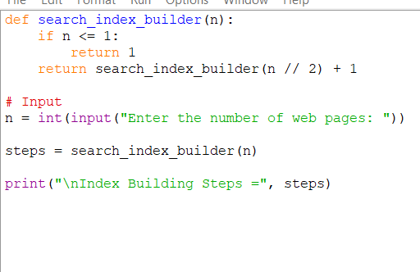

Output :

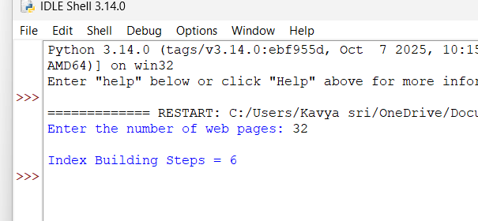

Q36: A search engine indexing algorithm is defined as:T(n) = 2T(n/2) + n². Apply the Master Theorem and determine the time complexity. Clearly explain the chosen case. Analyze how indexing time grows with web pages.

Sol :

Analysis Using Master Theorem
Given the recurrence relation:
T(n)=2T(2n)+n2
Compare it with the standard form:
T(n)=aT(bn)+f(n)
Here,
- a=2a=2a=2
- b=2b=2b=2
- f(n)=n2f(n)=n^2f(n)=n2

Step 1: Calculate nlogb​a
2=n1=n

Step 2: Compare f(n) and nlogb​a
f(n)=n2f(n)=n^2f(n)=n2
Since
n2>nn^2 > nn2>n
or
f(n)=Ω(n1+ε)
where ε=1\varepsilon=1ε=1,
the function n2n^2n2 grows polynomially faster than nnn.

Step 3: Verify Regularity Condition
Check:
(2n)2=2n2​
Since
n2​≤cn2
for some constant c<1 (e.g., c=12c=\tfrac{1}{2}c=21​), the regularity condition is satisfied.
Therefore, Master Theorem Case 3 applies.

Time Complexity
By Master Theorem Case 3,
T(n)=Θ(n2)​
Thus,
- Time Complexity: O(n²)
- Asymptotic Complexity: Θ(n²)

Scalability Analysis
- The algorithm recursively divides the web pages into two equal halves.
- At every recursion level, it performs an indexing operation requiring n2n^2n2 work.
- The quadratic indexing cost dominates the recursive calls.
- As the number of web pages increases, the indexing time grows rapidly.

Source Code :

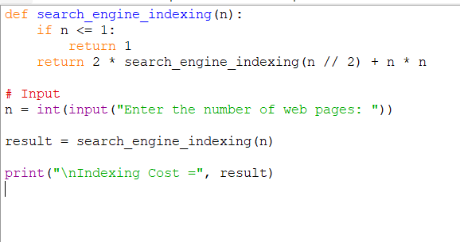

OUTPUT :

