JEEVAN RAKSHA PHARMACY

Theme
A pharmacy wants to manage customers, suppliers, medicine inventory, orders/bills, and the medicines included in each order.

Modules
- Customers
- Suppliers
- Medicines
- Orders (Bills)
- Order Items

Entity Relationship Diagram (ERD)
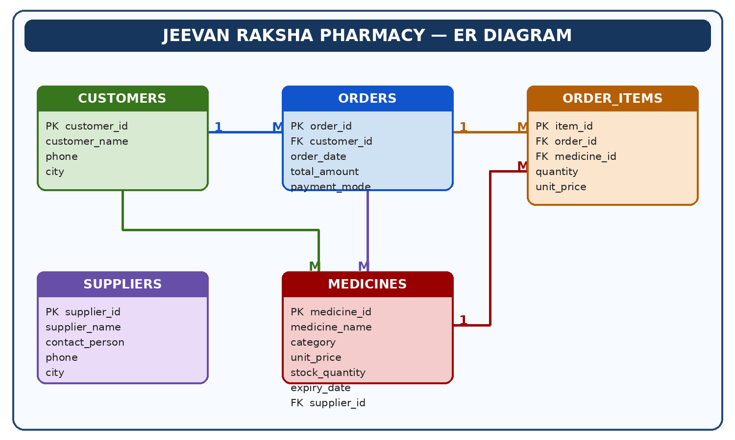

Sample Data
The following illustrative records are provided to demonstrate the pharmacy database tables. They are example data, not records copied from the original project brief.

CUSTOMERS
customer_id | customer_name | phone | city
1 | Ananya Rao | 9876543210 | Mumbai
2 | Rahul Verma | 9876501234 | Hyderabad
3 | Priya Sharma | 9123456780 | Mumbai
4 | Kiran Kumar | 9988776655 | Vijayawada
5 | Sravani Reddy | 9001122334 | Tanuku
6 | Arjun Das | 9012345678 | Chennai
7 | Meena Devi | 9090909090 | Hyderabad
8 | Sai Teja | 9345678120 | Vijayawada

SUPPLIERS
supplier_id | supplier_name | contact_person | phone | city
1 | Apollo Distributors | Ramesh | 040-23456789 | Hyderabad
2 | MedPlus Wholesale | Suresh | 0866-2233445 | Vijayawada
3 | HealthCare Pharma Supply | Anil | 022-45678901 | Mumbai
4 | Sri Lakshmi Medical Agencies | Lakshmi | 08819-223344 | Tanuku
5 | LifeLine Distributors | Karthik | 044-23456789 | Chennai

MEDICINES
medicine_id | medicine_name | category | unit_price (₹) | stock_quantity | expiry_date | supplier_id
1 | Paracetamol 500 mg | Tablet | 2.5 | 500 | 2027-12-31 | 1
2 | Cetirizine 10 mg | Tablet | 4.0 | 180 | 2027-08-31 | 2
3 | Cough Relief | Syrup | 85.0 | 42 | 2027-05-31 | 1
4 | Amoxicillin 250 mg | Capsule | 6.5 | 240 | 2027-03-31 | 3
5 | Vitamin C | Tablet | 3.0 | 320 | 2028-01-31 | 4
6 | Normal Saline | Injection | 35.0 | 35 | 2027-06-30 | 1
7 | Antacid Suspension | Syrup | 68.0 | 75 | 2027-11-30 | 2
8 | Insulin Regular | Injection | 125.0 | 28 | 2027-04-30 | 3
9 | ORS Sachet | Powder | 18.0 | 150 | 2027-09-30 | 4
10 | Ibuprofen 200 mg | Tablet | 5.0 | 95 | 2027-10-31 | 5
11 | Azithromycin 500 mg | Tablet | 22.0 | 48 | 2027-02-28 | 1
12 | Eye Drops | Drops | 42.0 | 62 | 2027-07-31 | 5

ORDERS
order_id | customer_id | order_date | total_amount (₹) | payment_mode
1001 | 1 | 2026-10-20 | 640.0 | UPI
1002 | 2 | 2026-10-21 | 245.0 | Cash
1003 | 3 | 2026-10-21 | 1280.0 | Card
1004 | 1 | 2026-10-22 | 520.0 | UPI
1005 | 4 | 2026-10-23 | 180.0 | Cash
1006 | 5 | 2026-10-24 | 1125.0 | Card
1007 | 6 | 2026-10-24 | 85.0 | UPI
1008 | 2 | 2026-10-25 | 740.0 | Cash
1009 | 7 | 2026-10-25 | 460.0 | Card
1010 | 3 | 2026-10-26 | 950.0 | UPI

ORDER_ITEMS
item_id | order_id | medicine_id | quantity | unit_price (₹)
1 | 1001 | 1 | 20 | 2.5
2 | 1001 | 3 | 2 | 85.0
3 | 1001 | 5 | 10 | 3.0
4 | 1002 | 2 | 10 | 4.0
5 | 1002 | 9 | 5 | 18.0
6 | 1003 | 8 | 8 | 125.0
7 | 1003 | 4 | 20 | 6.5
8 | 1004 | 6 | 4 | 35.0
9 | 1004 | 7 | 5 | 68.0
10 | 1005 | 10 | 12 | 5.0
11 | 1005 | 9 | 3 | 18.0
12 | 1006 | 8 | 5 | 125.0
13 | 1006 | 1 | 40 | 2.5
14 | 1007 | 3 | 1 | 85.0
15 | 1008 | 11 | 10 | 22.0
16 | 1008 | 2 | 10 | 4.0
17 | 1009 | 7 | 4 | 68.0
18 | 1009 | 12 | 4 | 42.0
19 | 1010 | 4 | 20 | 6.5
20 | 1010 | 5 | 20 | 3.0
21 | 1010 | 1 | 20 | 2.5

Queries
1. Customer List: Retrieve the name and city of all customers.
SELECT name, city
FROM customers;
2. Stock Check: Find the names of medicines that are 'Syrup' or 'Injection'.
SELECT name
FROM medicines
WHERE category IN ('Syrup', 'Injection');
3. High Value Bills: List all orders where total_amount is greater than ₹500.
SELECT *
FROM orders
WHERE total_amount > 500;
4. Mumbai Residents: Find the phone numbers of all customers living in 'Mumbai'.
SELECT phone
FROM customers
WHERE city = 'Mumbai';
5. Supplier Count: Count medicines supplied by 'Apollo Distributors'.
SELECT COUNT(*) AS medicine_count
FROM medicines m
JOIN suppliers s ON m.supplier_id = s.supplier_id
WHERE s.supplier_name = 'Apollo Distributors';
6. Order Details: List customer name, order date, and total amount for every order.
SELECT c.customer_name, o.order_date, o.total_amount
FROM orders o
JOIN customers c ON o.customer_id = c.customer_id;
7. Revenue by Mode: Calculate total money earned through each payment mode.
SELECT payment_mode, SUM(total_amount) AS total_revenue
FROM orders
GROUP BY payment_mode;
8. Best Selling Medicine: Find the medicine sold most by total quantity.
SELECT m.medicine_name, SUM(oi.quantity) AS total_quantity
FROM medicines m
JOIN order_items oi ON m.medicine_id = oi.medicine_id
GROUP BY m.medicine_id, m.medicine_name
ORDER BY total_quantity DESC
LIMIT 1;
9. Customer Lifetime Value: Customers who spent more than ₹1000 across all orders.
SELECT c.customer_name, SUM(o.total_amount) AS total_spent
FROM customers c JOIN orders o ON c.customer_id = o.customer_id
GROUP BY c.customer_id, c.customer_name
HAVING SUM(o.total_amount) > 1000;
10. Inventory Audit: List medicines with less than 50 units and their supplier.
SELECT m.medicine_name, m.stock_quantity, s.supplier_name
FROM medicines m JOIN suppliers s ON m.supplier_id = s.supplier_id
WHERE m.stock_quantity < 50;
Prepared by: Akavarapu Kavya Sri

