LIBRARY MANAGEMENT SYSTEM
Project Documentation
Name: Kavya Sree Chittiboina

Built with Python, Flask, and SQLite
Version 1.0
September 2026

1. Project Overview

1.1 Project Title
Library Management System using Python, Flask and SQLite

1.2 Project Description
The Library Management System is a web-based application developed to manage the daily activities of a library.
The system allows the librarian to manage books and members, issue and return books, calculate and manage fines, maintain book acquisitions, track book price changes, and maintain an audit log of important activities.
The application uses Python Flask for the web application, SQLite for database management, HTML/Jinja for web pages, CSS for styling, and JavaScript for client-side form validation.

2. Objectives
The main objectives of the project are:
- Manage library books.
- Register students and teachers as library members.
- Issue books to members.
- Return borrowed books.
- Maintain available book copies.
- Apply library borrowing rules.
- Track overdue books and fines.
- Record fine payments.
- Add new copies of existing books.
- Maintain book price history.
- Record important system activities.
- Generate useful library reports.
- Provide a simple web-based interface.

3. Technologies Used
Technology | Purpose
Python | Backend programming
Flask | Web application framework
SQLite | Database
HTML | Web page structure
Jinja2 | Dynamic HTML templates
CSS | Page styling
JavaScript | Client-side validation
SQLite Viewer | Database viewing
VS Code | Development environment

4. Main Features

4.1 Member Management
The system allows the librarian to:
- Register new members.
- Store member name, email, and phone number.
- Classify members as Student or Teacher.
- Prevent duplicate email registration.

4.2 Book Management
The system allows the librarian to:
- Add new books.
- Store title, author, and category.
- Store total quantity and access level.
- Track available copies.
- Store book price.

4.3 Add New Copies
The librarian can add additional copies of an existing book. When new copies are added, both the total quantity and the available copies increase:
Total Quantity increases
+
Available Copies increases
The system also stores acquisition information such as quantity, supplier, purchase price, and purchase date.

4.4 Book Issue
The system allows members to borrow books. Before issuing a book, the system can check:
- Whether the book is available.
- Whether the member has unpaid fines.
- Whether the member is allowed to access the book.
- The student borrowing limit.
Each borrowing record contains: Borrow ID, Member ID, Book ID, Issue Date, Due Date, Return Date, and Status.

4.5 Student Borrowing Rule
Students can borrow a maximum of 3 active books.
Student
↓
Check active borrowed books
↓
If active books < 3
↓
Issue book
If the student already has 3 active books, another book cannot be issued until one is returned.

4.6 Teacher Borrowing Rule
Teachers are allowed to borrow books without the student limit. Teachers can borrow books according to the library's availability and access rules.

4.7 Access Level
Books can have different access levels. The system checks the member type before allowing the book to be issued. For example:
Student
↓
Student-accessible book → Allowed

Student
↓
Teacher-only book → Not Allowed

4.8 Book Return
When a book is returned:
- Return date is recorded.
- Borrowing status is updated.
- Available copies are increased.
- Return activity is recorded in the audit log.
- Fine information can be handled for overdue books.

4.9 Fine Management
The system maintains fines for overdue books. The Fines table stores: Fine ID, Borrow ID, Fine Amount, and Paid Status.
Possible statuses include: Due, Paid.
The librarian can record fine payments.

4.10 Price Management
The librarian can update the price of a book. Whenever the price changes, the previous and new prices are automatically recorded in the BookPriceHistory table using a database trigger.
Example:
Old Price = ₹400
New Price = ₹450

↓

BookPriceHistory
Old Price = ₹400
New Price = ₹450
Update Date = current date

4.11 Audit Logging
The system maintains an AuditLog table to record important activities, such as:
- New member registered
- Book issued
- Book returned
- Fine paid
This provides a history of important operations performed in the system.
5. Database Tables
The system contains seven main tables.

5.1 Books
Stores information about books.
BookId
BookTitle
Author
Category
Quatity
AccessLevel
AvailableCopies
Price
Primary Key: BookId
Note: Quatity is the actual column name used in the database.

5.2 Members
Stores information about library members.
MemberId
MemberName
Email
Phone
MemberType
Primary Key: MemberId

5.3 Borrowing
Stores book borrowing information.
BorrowId
MemberId
BookId
IssueDate
DueDate
ReturnDate
Status
Primary Key: BorrowId
Foreign Key: MemberId → Members
Foreign Key: BookId → Books

5.4 Fines
Stores fine information.
FineId
BorrowId
Amount
PaidStatus
Primary Key: FineId
Foreign Key: BorrowId → Borrowing

5.5 Acquisitions
Stores information about newly purchased copies.
AcquisitionId
BookId
Quantity
Supplier
PurchasePrice
PurchaseDate
Primary Key: AcquisitionId
Foreign Key: BookId → Books

5.6 BookPriceHistory
Stores changes made to book prices.
HistoryId
BookId
Oldprice
Newprice
Updatedate
Primary Key: HistoryId
Foreign Key: BookId → Books

5.7 AuditLog
Stores important system activities.

AuditId
Action
TableName
Record
Description
ActionDate
Primary Key: AuditId
AuditLog is maintained by database triggers rather than a normal foreign-key relationship.
6. Database Relationships
The database contains the following relationships:
Members
│
│ 1 : M
▼
Borrowing
│
│ 1 : 0..1
▼
Fines

Books
│
├──── 1 : M ──── Borrowing
│
├──── 1 : M ──── Acquisitions
│
└──── 1 : M ──── BookPriceHistory

Relationship Explanation
- Members → Borrowing: One member can have many borrowing records.
- Books → Borrowing: One book can appear in many borrowing records over time.
- Borrowing → Fines: A borrowing record may have zero or one fine.
- Books → Acquisitions: One book can have multiple acquisition records.
- Books → BookPriceHistory: One book can have multiple price-history records.

7. Database Triggers
The project uses SQLite triggers to automate important operations.

7.1 Book Price Update Trigger
Automatically records the old and new price when a book price changes.
Books.Price changes
↓
Bookpriceupdate trigger
↓
BookPriceHistory

7.2 Reduce Available Copies Trigger
When a book is issued, the available copy count is automatically reduced.
Book issued
↓
Borrowing INSERT
↓
reducecopies trigger
↓
AvailableCopies - 1

7.3 Borrowing Audit Trigger
When a book is issued, an audit record is created.
Book issued
↓
log_borrowing trigger
↓
AuditLog

7.4 Return Audit Trigger
When a book is returned, an audit record is created.
Book returned
↓
log_return trigger
↓
AuditLog

7.5 Fine Payment Trigger
When a fine changes to Paid, an audit record is created.
Fine Paid
↓
fine_payment trigger
↓
AuditLog

7.6 Member Registration Trigger
When a new member is registered, the registration activity is recorded.
New Member
↓
log_member trigger
↓
AuditLog

8. Reports
The system provides the following reports:
- Library Summary
- Borrowed Books
- Overdue Books
- Unpaid Fines
- Member Borrowing History
- Book Borrowing Report
- Category-wise Book Report
- Audit Log Report
- Most Borrowed Books
- Most Active Members
- Fine Collection Report
- Available vs Borrowed Copies
- Acquisition Report
- Teacher vs Student Borrowing Report
These reports help the librarian understand the library's books, members, borrowing activity, fines, acquisitions, and usage patterns.

9. Dashboard
The dashboard provides a quick summary of the library. It displays: Total Members, Total Books, Borrowed Books, and Due Fines.
Total Members | Total Books | Borrowed Books | Due Fines
10 | 50 | 8 | ₹150.00

10. Project Structure
Library Management System
│
├── library.db
├── database.py
├── app.py
│
├── static
│ ├── style.css
│
│
└── templates
├── base.html
├── index.html
├── members.html
├── add_member.html
├── books.html
├── add_book.html
├── add_copies.html
├── update_price.html
├── borrowing.html
├── fines.html
├── acquisitions.html
├── bookpricehistory.html
├── auditlog.html
└── reports.html

11. Application Flow
The overall application works as follows:
User
↓
Web Browser
↓
Flask Application
↓
Python / SQLite Operations
↓
library.db
↓
Database Tables
↓
Triggers / Reports

12. Form Validation
JavaScript validation is used on important forms. Validation is implemented for: Add Book, Add Member, Add Copies, and Update Price.

Examples of Validation
- Required fields
- Valid email
- 10-digit phone number
- Positive quantity
- Valid price
- Required member type
- Required access level
- Required book selection

13. User Interface
The application contains a common navigation bar using base.html. Main navigation options include:
Home
Members
Add Member
Books
Add Book
Add Copies
Update Price
Borrowing
Fines
Acquisitions
Price History
Audit Log
Reports
CSS is used to provide: consistent colors, tables, forms, buttons, navigation, responsive layout, and dashboard styling.
14. How to Run the Project

Step 1 — Open the Project
Open the project folder in VS Code.

Step 2 — Open Terminal
Terminal → New Terminal

Step 3 — Run Flask
python app.py

Step 4 — Open the Application
Open the Flask URL shown in the terminal, normally:
http://127.0.0.1:5000/

Step 5 — Use the Application
From the navigation bar, you can access:
- Members
- Books
- Borrowing
- Fines
- Acquisitions
- Price History
- Audit Log
- Reports

15. Testing
The project has been tested for the main operations:
- Member registration
- Duplicate email validation
- Book addition
- Adding copies
- Price update
- Book issue
- Book return
- Fine management
- Reports
- Trigger operations
- Dashboard information
- Form validation

16. Advantages
- Easy to use.
- Centralized library database.
- Reduces manual record keeping.
- Tracks available copies.
- Maintains borrowing history.
- Supports student and teacher members.
- Automatically records important activities.
- Maintains price history.
- Provides useful reports.
- Uses SQLite, so no separate database server is required.
17. Future Enhancements
The system can be extended with:
- Login and authentication.
- Admin and librarian roles.
- Email notifications for due dates.
- Automatic fine calculation.
- Book search and filtering.
- Barcode/QR-code scanning.
- Book reservation.
- Online book availability.
- Export reports to PDF/Excel.
- Cloud database deployment.
- Advanced analytics dashboard.
17. Future Enhancements
Login and Dashboard Screenshots
- User Login Page
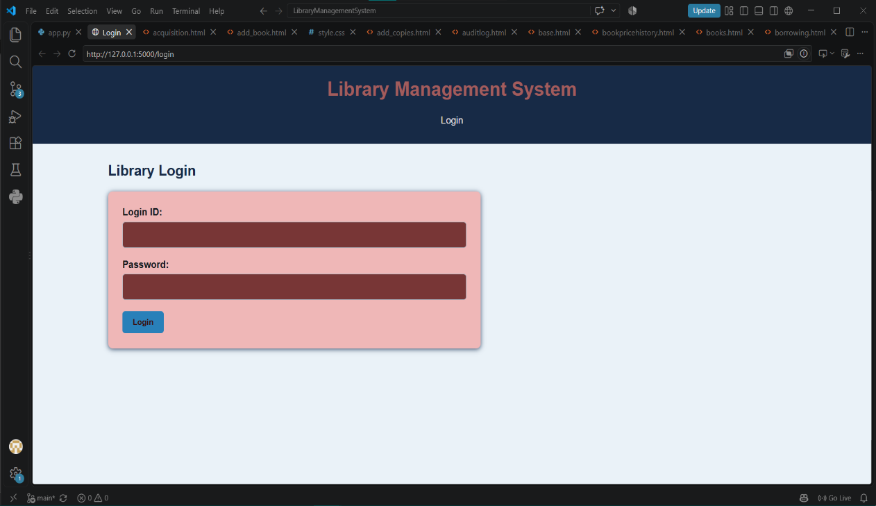

- Student Dashboard
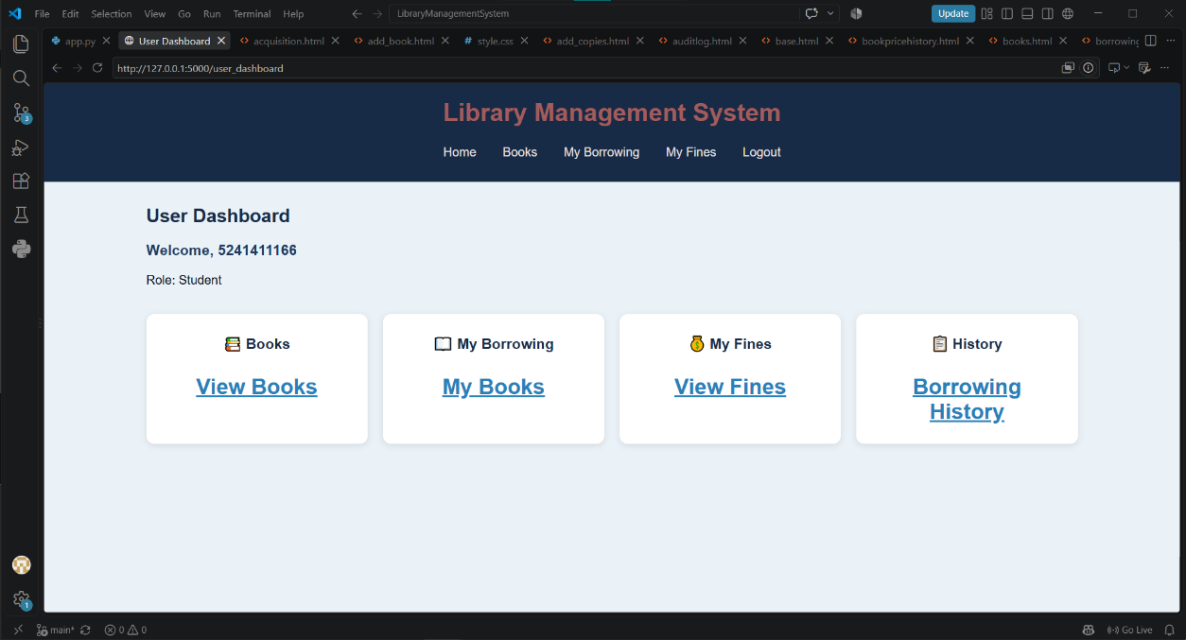

- Teacher Dashboard
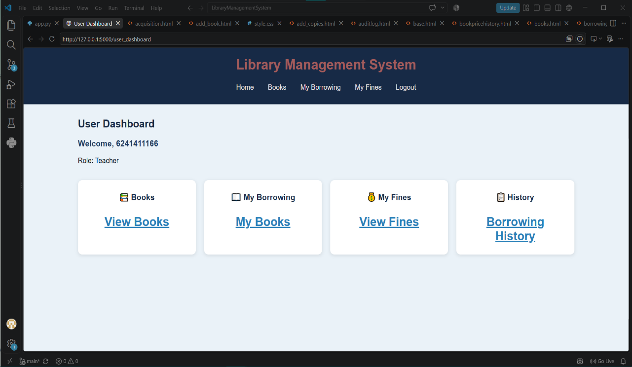
Admin Dashboard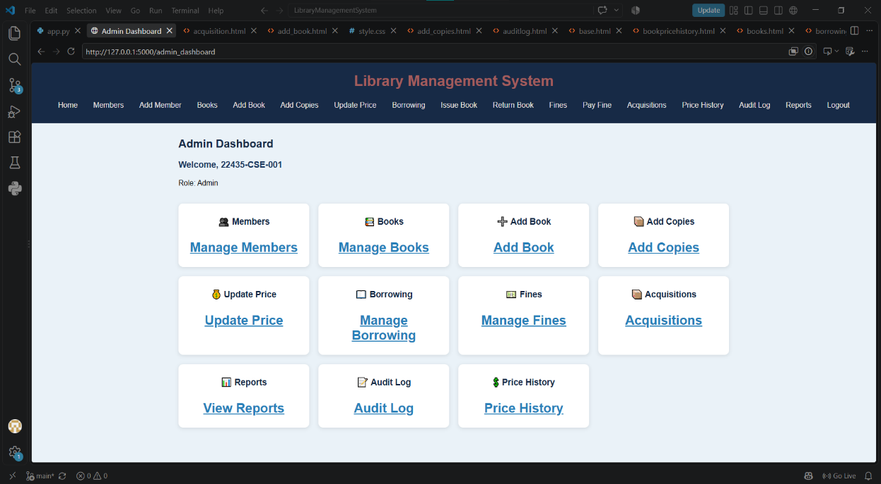

Book Management Screenshots
Books Management Page
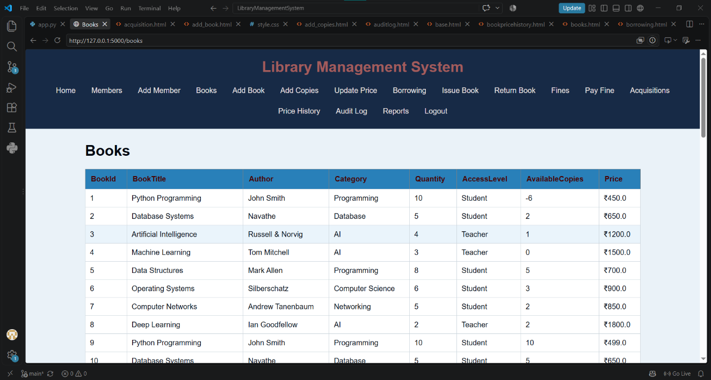

Add New Book Page
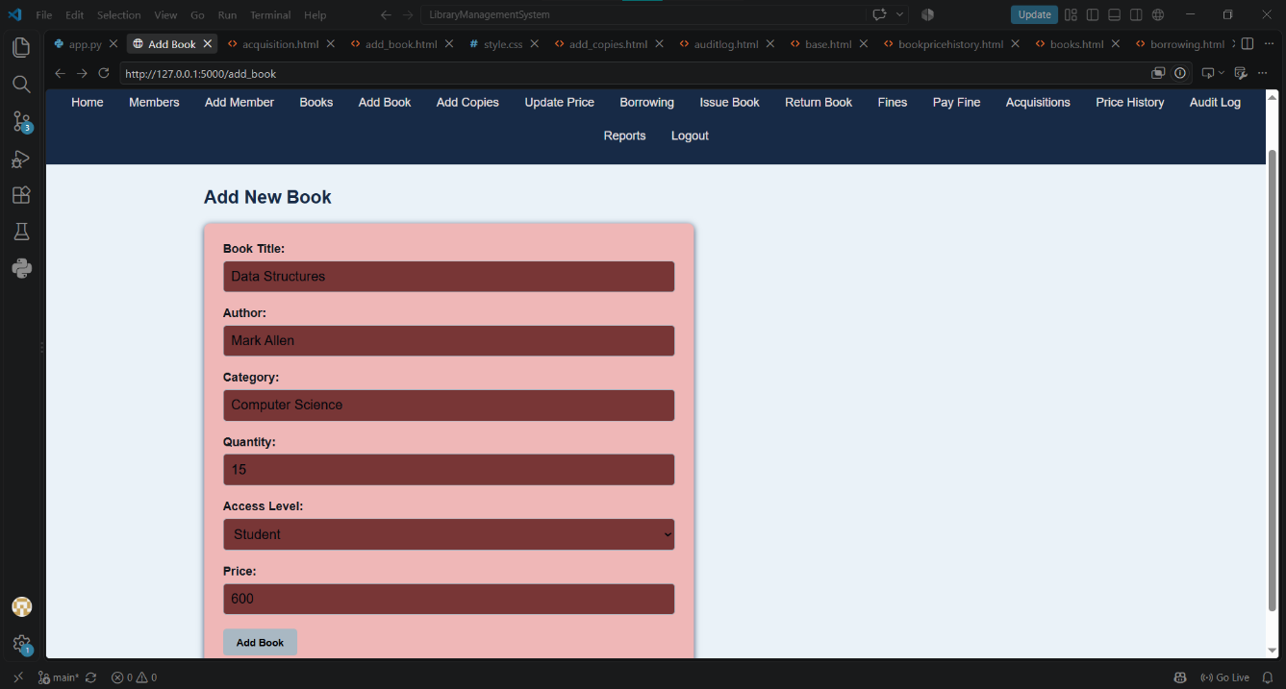

Add Book Copies Page
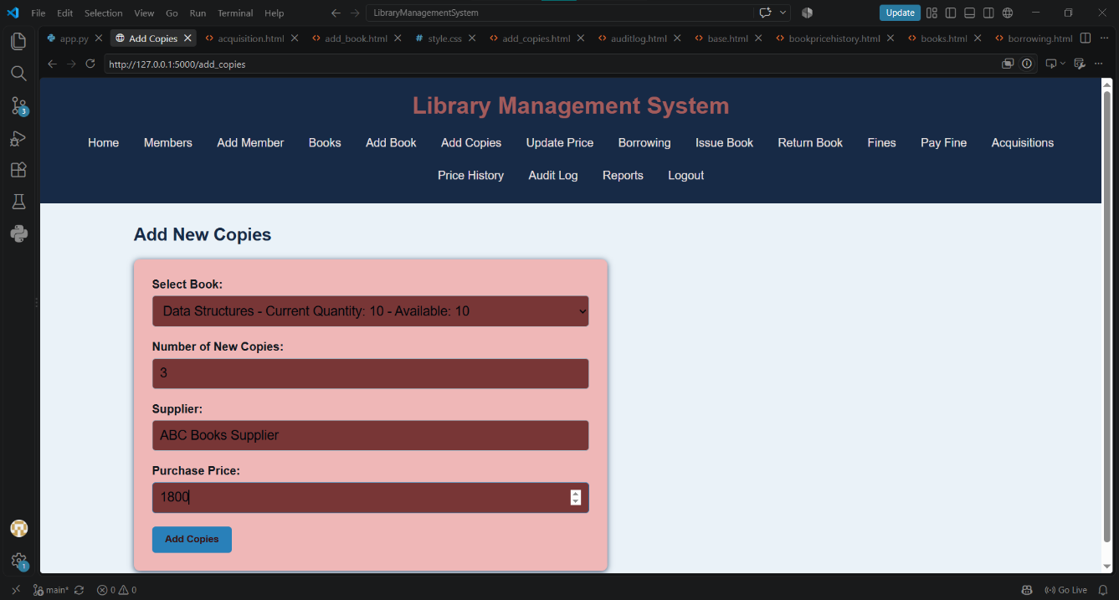

Member Management Screenshots
Members Management Page
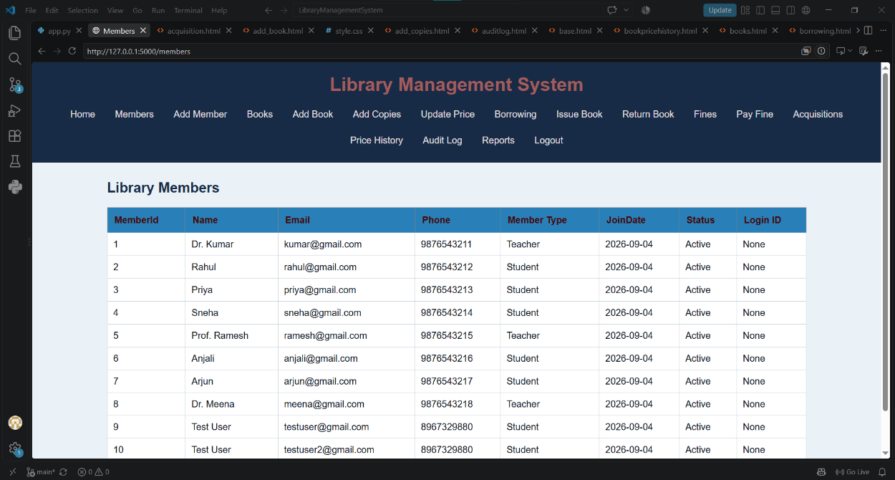
Add New Member Page
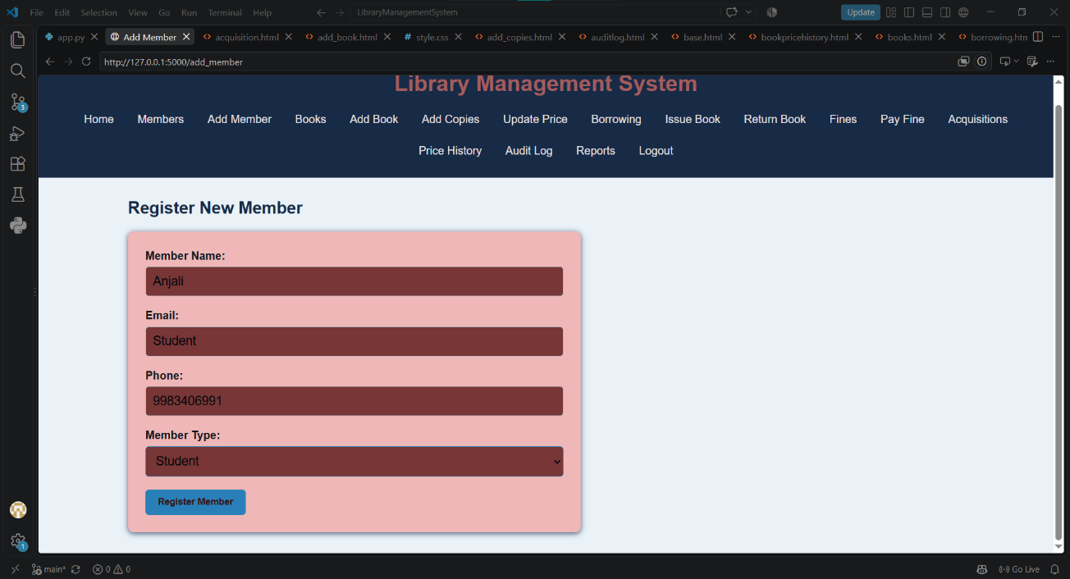
Borrowing and Return Screenshots
Book Issue Page
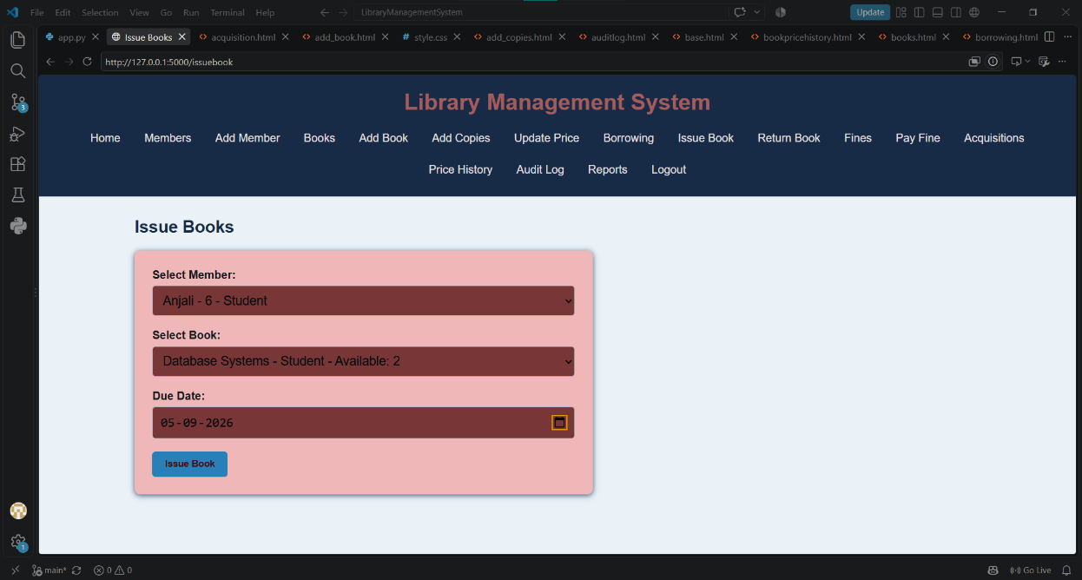
Borrowing Records Page
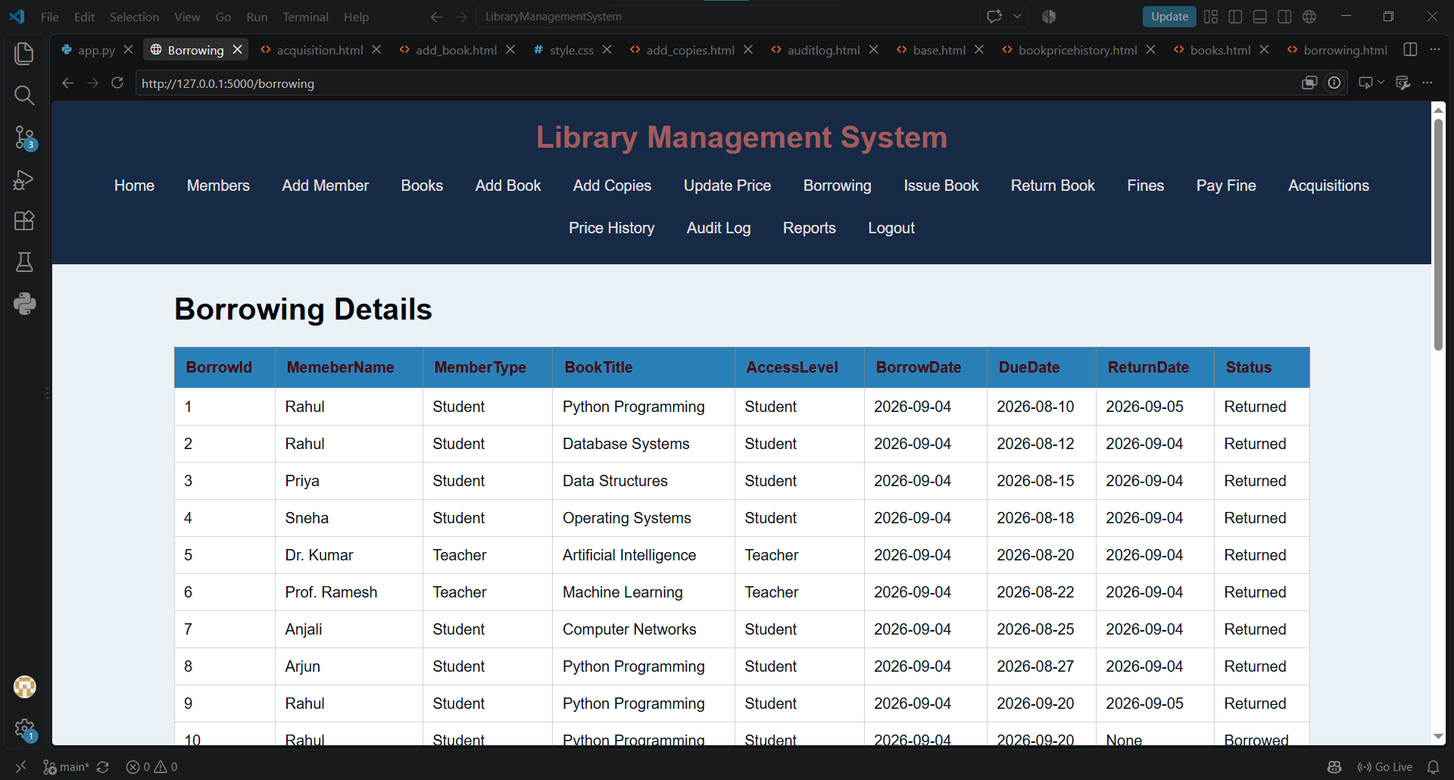
Book Return Page
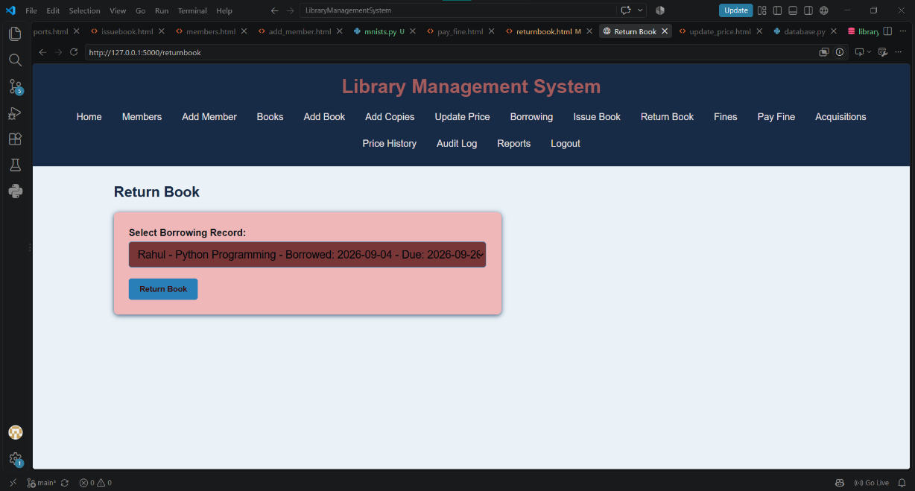
Fine Management Screenshots
Fines Management Page
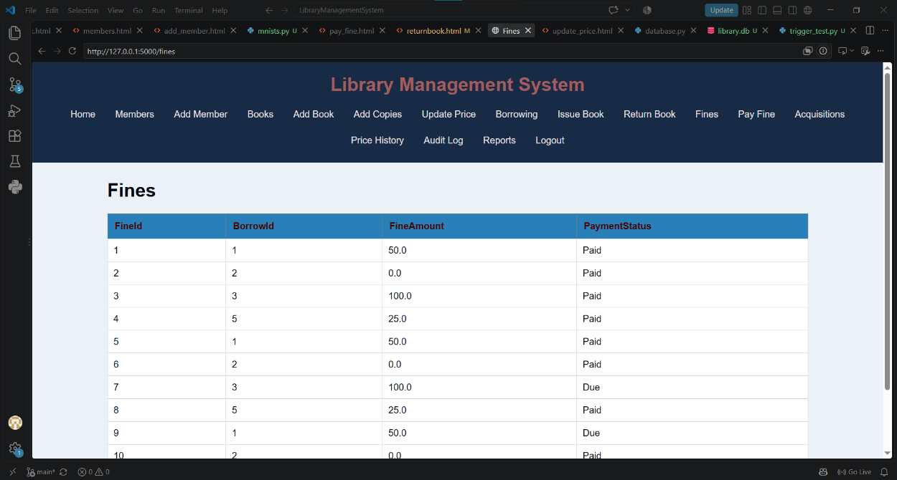
Fine Payment Page
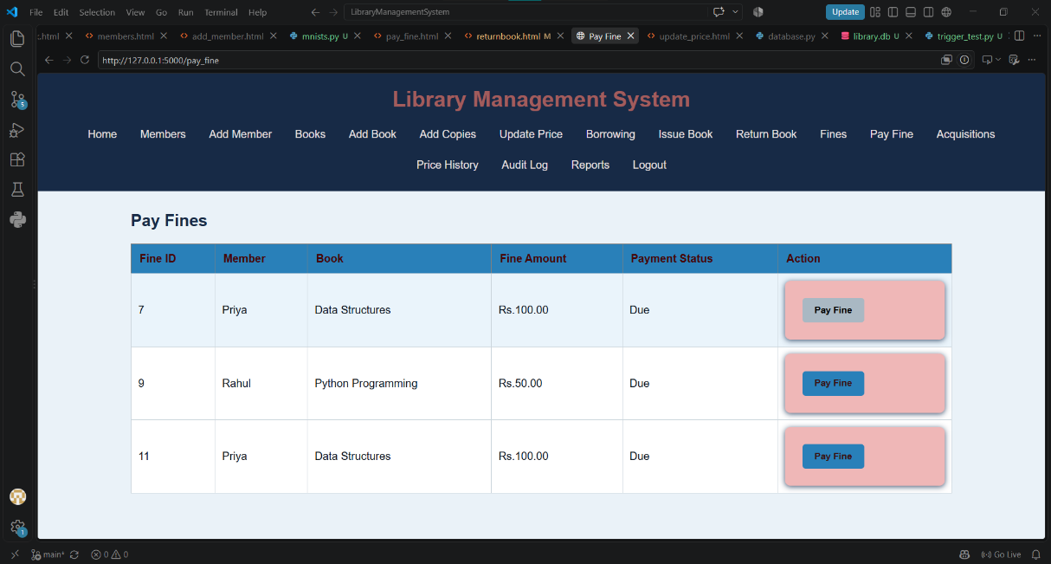
Acquisition and Price History
Acquisitions Management Page
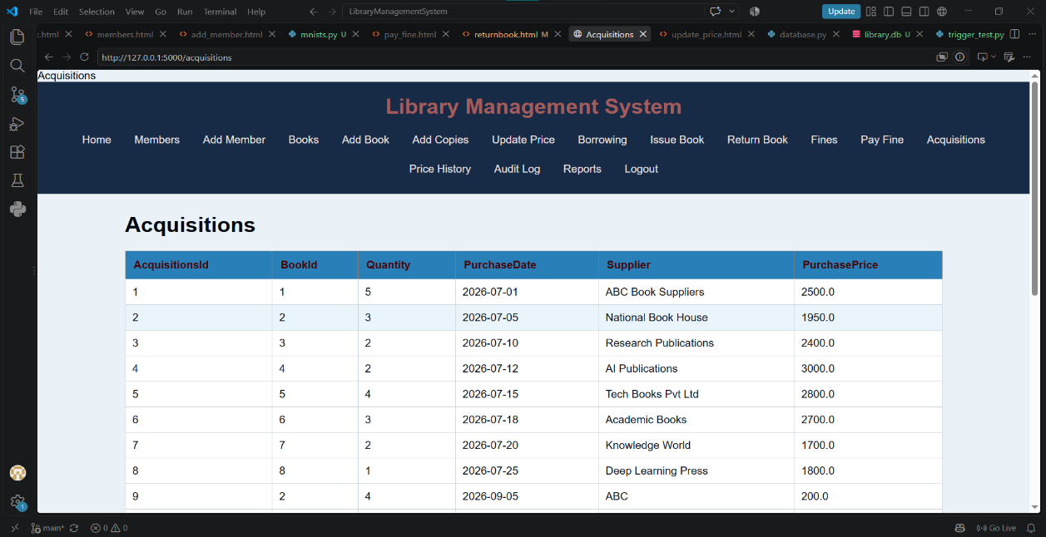
Book Price History Page
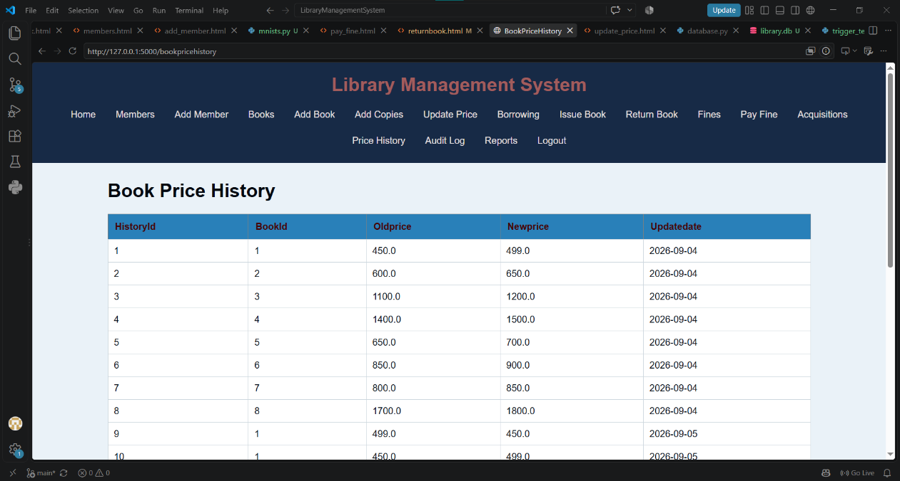
Reports and Audit
Reports
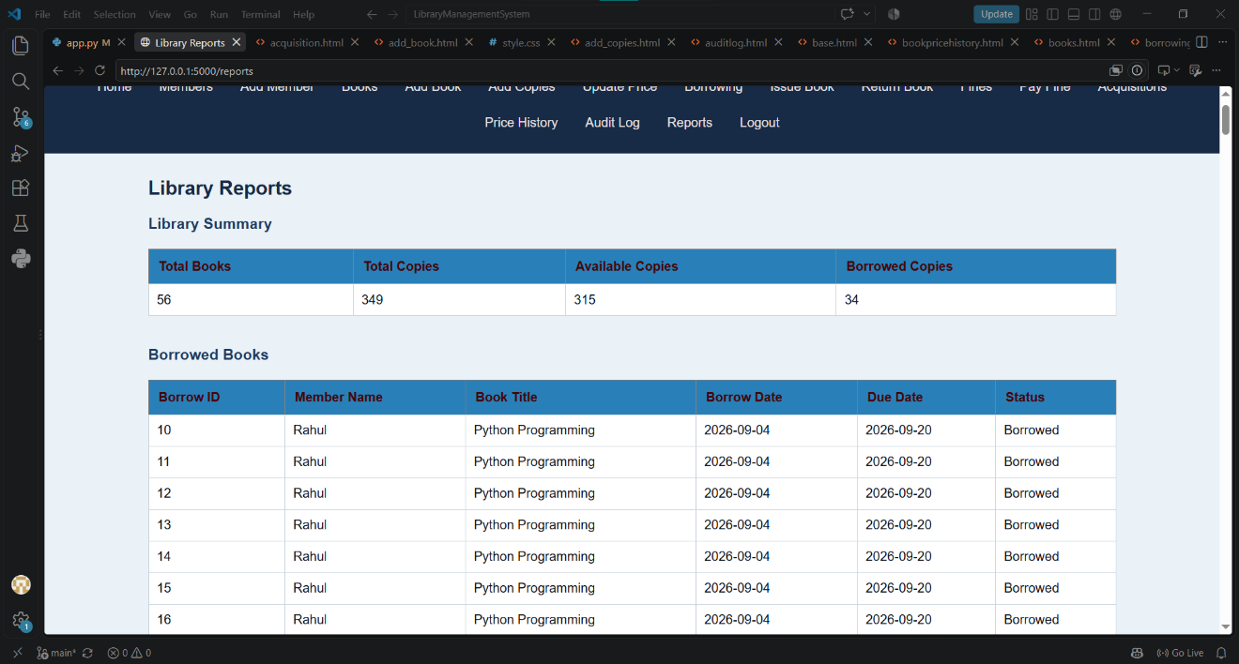
AuditLog
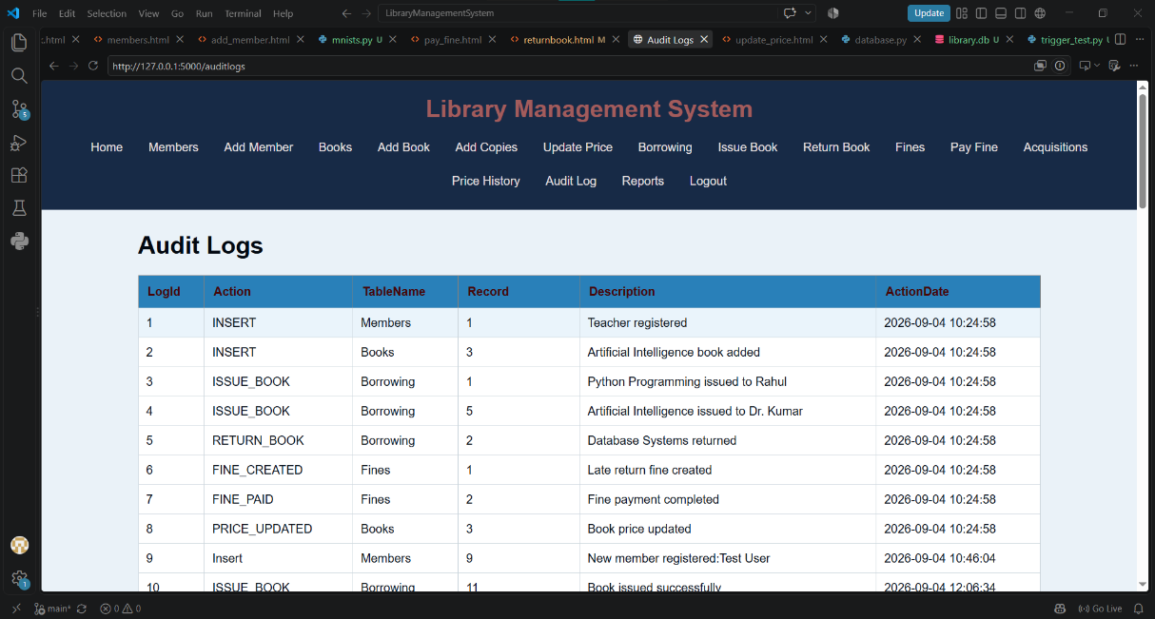

19. Conclusion
The Library Management System provides a complete solution for managing common library operations.
The system combines Flask, Python, SQLite, HTML, CSS, JavaScript, database relationships, triggers, and SQL reports to create a functional web-based library application.
It demonstrates practical knowledge of:
- Python programming
- Flask web development
- SQLite database management
- SQL queries
- Primary and foreign keys
- Database relationships
- Database triggers
- CRUD operations
- Form validation
- Reporting
- Web application development
The project can be further extended with authentication, notifications, advanced search, online reservations, and analytics.

