Experiment 5: Categorize Library Management System Requirements Using MoSCoW
AIM:
To classify Library Management System requirements using the MoSCoW prioritization method based on user impact, feasibility, time, budget, and available resources.
PROCEDURE:
- List all ten requirements of the Library Management System in Excel or Google Sheets.
- Categorize each requirement as Must-Have, Should-Have, Could-Have, or Won’t-Have.
- Consider user needs, stakeholder impact, time, budget, and resource constraints.
- Provide a short justification for each category.
- Save the completed spreadsheet and submit it.
OUTPUT:
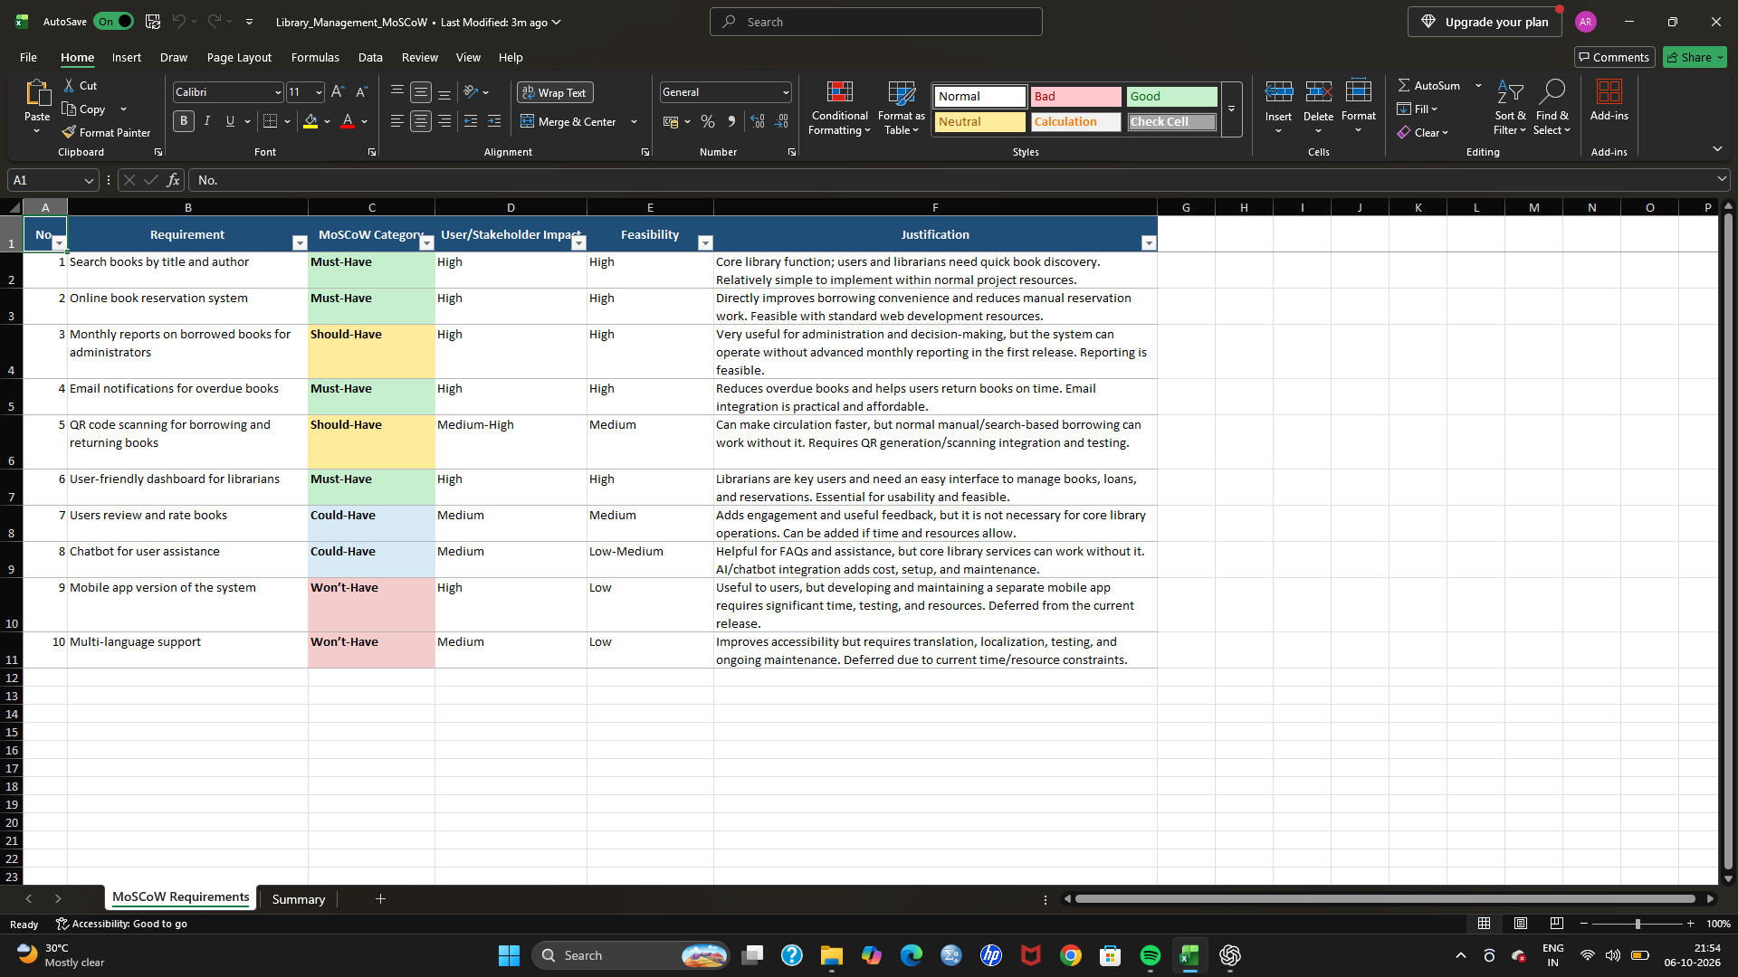

RESULT: All ten Library Management System requirements were categorized using the MoSCoW method and justified according to their priority and feasibility.

