Smart Borewell Child Rescue System Through Wireless Monitoring Using Artificial Intelligence
1.INTRODUCTION
India is horticulture-based nation, farmers or ranchers essentially depend by and large upon groundwater for their fundamental water system necessities. Ensuing to the essential prerequisite yielding of the water, the drag wells would have commonly left uncovered. So that, most by a wide margin of children adventitiously pushes toward the well and falls into it, which is the principal reason for these misery debacles eventually. Lately, numerous cases have been accounted for of kids getting caught in bore wells which take life of the kids and are a bad dream for guardians. There is a clear requirement for building up a security and salvage framework for kids to safeguard from bore well. The current salvage frameworks are time taking and are not in the least exact as include manual assistance where there are numerous odds of human mistake. The drag well cases have taken numerous existences of honest kids while playing here. To defeat this issue, in this task an equipment module is planned to utilize a raspberry pi as a handling module and a camera module. The facial feeling from the kid is perceived by utilizing passionate vggnet calculation to check if the youngster is in trouble and a music is played to keep the kid quiet. The kid is posed inquiries through a sound yield and is checked on the off chance that it is cognizant on the off chance that it reacts to the inquiries by utilizing VGGish calculation. The temperature of the kid is estimated utilizing warm sensors to confirm that the youngster is alive. A web application utilizing reactJS is created to show the situation with the enthusiastic condition of the youngster. Hence, the venture effectively gives a successful innovative arrangement in safeguarding the youngster.
OBJECTIVE OF THE PROJECT
As agriculture is the backbone of the Indian economy, most farmers and ranchers must rely on groundwater for their daily water needs. The drag wells would have been left exposed as a result of the fundamental need water surrendering. As a result, the vast majority of kids push for the well without thinking and end up falling in. Several examples of children becoming fatally trapped in bore wells have been reported recently, making this a nightmare scenario for parents everywhere. There should be a strong emphasis on creating a rescue and safety system to prevent youngsters from suffering from boredom. The present salvage frameworks need manual assistance, which is time consuming and inexact due to the high likelihood of human error. Several young, innocent lives have been claimed by the drag well instances when these children were only playing. To address this challenge, this assignment plans to implement a Machine Learning Algorithm-powered handling and camera module into the equipment. Using the Accuracy calculation, we can tell if a child is upset just looking at his or her face, and if so, we may play soothing music to calm him or her down. The Fscore computation is used to determine whether or not the youngster is aware of the questions being asked via the sound output. To determine whether a child is still alive, doctors use temperature sensors to make an educated guess. To further illustrate the circumstance with the child's upbeat disposition, a web application built using reactJS has been developed. As a result, the initiative provides a workable, novel plan for the child's safety.

2. LITERATURE SURVEY
”Context Based Emotion Recognition using EMOTIC Dataset”
In our everyday lives and social interactions we often try to perceive the emotional states of people. There has been a lot of research in providing machines with a similar capacity of recognizing emotions. From a computer vision perspective, most of the previous efforts have been focusing in analyzing the facial expressions and, in some cases, also the body pose. Some of these methods work remarkably well in specific settings. However, their performance is limited in natural, unconstrained environments. Psychological studies show that the scene context, in addition to facial expression and body pose, provides important information to our perception of people's emotions. However, the processing of the context for automatic emotion recognition has not been explored in depth, partly due to the lack of proper data. In this paper we present EMOTIC, a dataset of images of people in a diverse set of natural situations, annotated with their apparent emotion. The EMOTIC dataset combines two different types of emotion representation: (1) a set of 26 discrete categories, and (2) the continuous dimensions Valence, Arousal, and Dominance. We also present a detailed statistical and algorithmic analysis of the dataset along with annotators' agreement analysis. Using the EMOTIC dataset we train different CNN models for emotion recognition, combining the information of the bounding box containing the person with the contextual information extracted from the scene. Our results show how scene context provides important information to automatically recognize emotional states and motivate further research in this direction.
“Cross-Subject Emotion Recognition using Flexible Analytic Wavelet Transform from EEG Signals”
Human emotion is a physical or psychological process which is triggered either consciously or unconsciously due to perception of any object or situation. The electroencephalogram (EEG) signals can be used to record ongoing neuronal activities in the brain to get the information about the human emotional state. These complicated neuronal activities in the brain cause non-stationary behavior of the EEG signals. Thus, emotion recognition using EEG signals is a challenging study and it requires advanced signal processing techniques to extract the hidden information of emotions from EEG signals. Due to poor generalizability of features from EEG signals across subjects, recognizing cross-subject emotion has been difficult. Thus, our aim is to comprehensively investigate the channel specific nature of EEG signals and to provide an effective method based on flexible analytic wavelet transform (FAWT) for recognition of emotion. FAWT decomposes the EEG signal into different sub-band signals. Furthermore, we applied information potential to extract the features from the decomposed sub-band signals of EEG signal. The extracted feature values were smoothed and fed to the random forest and support vector machine classifiers that classified the emotions. The proposed method is applied to two different publicly available databases which are SJTU emotion EEG dataset and database for emotion analysis using physiological signal. The proposed method has shown better performance for human emotion classification as compared to the existing method. Moreover, it yields channel specific subject classification of emotion EEG signals when exposed to the same stimuli.
“Cross-corpus Acoustic Emotion Recognition with Multi-task Learning: Seeking Common Ground while Preserving Differences”
There is growing interest in emotion recognition due to its potential in many applications. However, a pervasive challenge is the presence of data variability caused by factors such as differences across corpora, speaker's gender, and the “domain” of expression (e.g., whether the expression is spoken or sung). Prior work has addressed this challenge by combining data across corpora and/or genders, or by explicitly controlling for these factors. In this work, we investigate the influence of corpus, domain, and gender on the cross-corpus generalizability of emotion recognition systems. We use a multi-task learning approach, where we define the tasks according to these factors. We find that incorporating variability caused by corpus, domain, and gender through multi-task learning outperforms approaches that treat the tasks as either identical or independent. Domain is a larger differentiating factor than gender for multi-domain data. When considering only the speech domain, gender and corpus are similarly influential. Defining tasks by gender is more beneficial than by either corpus or corpus and gender for valence, while the opposite holds for activation. On average, cross-corpus performance increases with the number of training corpora. The results demonstrate that effective cross-corpus modeling requires that we understand how emotion expression patterns change as a function of non-emotional factors.
”Heterogeneous Acceleration of HAR Applications”
Human action recognition (HAR) is an important field of research that intercepts with areas such as image processing, computer vision, and the design of fast algorithms, among others.
” Internal Emotion Classification Using EEG Signal with Sparse Discriminative Ensemble”
Among various physiological signal acquisition methods for the study of the human brain, EEG (Electroencephalography) is more effective. EEG provides a convenient, non-intrusive, and accurate way of capturing brain signals in multiple channels at fine temporal resolution. We propose an ensemble learning algorithm for automatically computing the most discriminative subset of EEG channels for internal emotion recognition. Our method describes an EEG channel using kernel-based representations computed from the training EEG recordings. For ensemble learning, we formulate a graph embedding linear discriminant objective function using the kernel representations. The objective function is efficiently solved via sparse non-negative principal component analysis and the final classifier is learned using the sparse projection coefficients. Our algorithm is useful in reducing the amount of data while improving computational efficiency and classification accuracy at the same time. The experiments on publicly available EEG dataset demonstrate the superiority of the proposed algorithm over the compared methods.
”ISLA: Temporal Segmentation and Labeling for Audio-Visual Emotion Recognition”
Emotion is an essential part of human interaction. Automatic emotion recognition can greatly benefit human-centered interactive technology, since extracted emotion can be used to understand and respond to user needs. However, real-world emotion recognition faces a central challenge when a user is speaking: facial movements due to speech are often confused with facial movements related to emotion. Recent studies have found that the use of phonetic information can reduce speech-related variability in the lower face region. However, methods to differentiate upper face movements due to emotion and due to speech have been underexplored. This gap leads us to the proposal of the Informed Segmentation and Labeling Approach (ISLA). ISLA uses speech signals that alter the dynamics of the lower and upper face regions. We demonstrate how pitch can be used to improve estimates of emotion from the upper face, and how this estimate can be combined with emotion estimates from the lower face and speech in a multimodal classification system. Our emotion classification results on the IEMOCAP and SAVEE datasets show that ISLA improves overall classification performance. We also demonstrate how emotion estimates from different modalities correlate with each other, providing insights into the differences between posed and spontaneous expressions.
”Measurement and Analysis of Local Pulse Transit Time for Emotion Recognition”
Emotion recognition based on physiological parameters is a research field that pushes forward from lab settings to real-life investigations. Wearable devices facilitate this advance. However, these devices are still functionally limited compared to stationary medical devices. Our goal is to extend the capability of wearable devices by developing a method that measures the pulse transit time (PTT) locally. The PTT is an interesting parameter regarding emotion recognition. A method for local PTT measurement can be implemented using two photoplethysmography (PPG) sensors. However, this method is error-prone. In this paper, the physiological background that is presumably responsible for erroneous PPG-based PTT measurements is discussed. We present an algorithm that is capable to handle the derived physiological effects. The algorithm analyzes and compares the two PPG-signals to adapt to time-varying physiological effects. By using this algorithm, calculating and analyzing of the local PTT in the context of emotion recognition become possible. A study (n = 40) to test the algorithm and investigate the usefulness of local PTT analysis for emotion recognition in combination with other physiological signals was conducted. PTT-based parameters, which were derived from the frequency domain of the signal, showed a statistically significant (p <; 0.05) difference between induced emotional states, if calculated by the developed algorithm. Our findings indicate that parameters derived by our method are significantly affected by emotional stimuli. We suggest that this method can be used to advance emotion recognition investigations in real life as it can potentially be integrated into a single wearable device.
”Reliable Crowdsourcing and Deep Locality- Preserving Learning for Unconstrained Facial Expression Recognition”
Facial expression is central to human experience, but most previous databases and studies are limited to posed facial behavior under controlled conditions. In this paper, we present a novel facial expression database, Real-world Affective Face Database (RAF-DB), which contains approximately 30 000 facial images with uncontrolled poses and illumination from thousands of individuals of diverse ages and races. During the crowdsourcing annotation, each image is independently labeled by approximately 40 annotators. An expectation-maximization algorithm is developed to reliably estimate the emotion labels, which reveals that real-world faces often express compound or even mixture emotions. A cross-database study between RAF-DB and CK+ database further indicates that the action units of real-world emotions are much more diverse than, or even deviate from, those of laboratory-controlled emotions. To address the recognition of multi-modal expressions in the wild, we propose a new deep locality-preserving convolutional neural network (DLP-CNN) method that aims to enhance the discriminative power of deep features by preserving the locality closeness while maximizing the inter-class scatter. Benchmark experiments on 7-class basic expressions and 11-class compound expressions, as well as additional experiments on CK+, MMI, and SFEW 2.0 databases, show that the proposed DLP-CNN outperforms the state-of-the-art handcrafted features and deep learning-based methods for expression recognition in the wild. To promote further study, we have made the RAF database, benchmarks, and descriptor encodings publicly available to the research community.
“Emotion recognition in context,”
Understanding what a person is experiencing from her frame of reference is essential in our everyday life. For this reason, one can think that machines with this type of ability would interact better with people. However, there are no current systems capable of understanding in detail peoples emotional states. Previous research on computer vision to recognize emotions has mainly focused on analyzing the facial expression, usually classifying it into the 6 basic emotions [11]. However, the context plays an important role in emotion perception, and when the context is incorporated, we can infer more emotional states. In this paper we present the Emotions in Context Database (EMCO), a dataset of images containing people in context in non-controlled environments. In these images, people are annotated with 26 emotional categories and also with the continuous dimensions valence, arousal, and dominance [21]. With the EMCO dataset, we trained a Convolutional Neural Network model that jointly analyzes the person and the whole scene to recognize rich information about emotional states. With this, we show the importance of considering the context for recognizing peoples emotions in images, and provide a benchmark in the task of emotion recognition in visual context.
“Chalearn looking at people: Events and resources,”
This paper reviews the historic of ChaLearn Looking at People (LAP) events. We started in 2011 (with the release of the first Kinect device) to run challenges related to human action/activity and gesture recognition. Since then we have regularly organized events in a series of competitions covering all aspects of visual analysis of humans. So far we have organized more than 10 international challenges and events in this field. This paper reviews associated events, and introduces the ChaLearn LAP platform where public resources (including code, data and preprints of papers) related to the organized events are available. We also provide a discussion on perspectives of ChaLearn LAP activities.
3. SYSTEM ANALYSIS
3.1 EXISTING SYSTEM:
In present scenario there have been several incidents reported on abandoned borewells which are turning in to death wells. Many innocent children are being trapped into these borewells and losing their lives. The actual purpose of borewells is to save lives, but these borewells in turn have started taking many innocent lives. In several cases the rescue operations are done by big machines and lot of man power involvement. Usually these rescue operation are very lengthy, complicated and very time taking processes. The paper presents a simple and effective method to rescue the child from the borewell. The traditional way to rescue the child is to dig a parallel pit t adjacent to the bore well. This method is difficult, lengthy and also risky to rescue the trapped child.
Disadvantage:
- Less Accuracy
- Time Taking Process
3.2 PROPOSED SYSTEM:
The system is capable of moving inside the borewell from the
same hole and perform the rescue operation. The digitally
integrated camera helps to view the position of the child.
There is a mic in the camera which helps to interact with the
child. The photo of our project is shown in fig.3. Thus the
desihgned system is helpful in saving the child trapped inside
borewell. It can replace all the old existing technology as it is
safer and takes very less time. Saving a life is a big task and
we have successfully made this project in order to rescue
child in future in lesser time. The existing technology was
very much costlier than the cost of our project. We have used
the light weighted servo motors so that the system is not
heavy and also it is precise
The system is capable of moving inside the borewell from the
same hole and perform the rescue operation. The digitally
integrated camera helps to view the position of the child.
There is a mic in the camera which helps to interact with the
child. The photo of our project is shown in fig.3. Thus the
desihgned system is helpful in saving the child trapped inside
borewell. It can replace all the old existing technology as it is
safer and takes very less time. Saving a life is a big task and
we have successfully made this project in order to rescue
child in future in lesser time. The existing technology was
very much costlier than the cost of our project. We have used
the light weighted servo motors so that the system is not
heavy and also it is precise
The main purpose of this research is to save the life, child
trapped inside the borewell safely. The problems in current
existing methods are:

It takes up to 30 hours to dig the parallel pit 110ft, by
the time the child would have died.
Lack of oxygen inside the borewell.
Lack of visualization causes the major difficulty during
the rescue operation.
There is no such equipment for rescuing the child which
had fallen into the bore well.
There is no interaction of child inside borewell and the
parents.
Children fall in the Borewell due to the carelessness
nature of the people in society.
The currently available systems are less effective and
costly too.
In most cases reported so far, a parallel hole is dug and
then horizontal path is made to reach the child. It is not
only a time taking process, but also risky in various
ways.
The main purpose of this research is to save the life, child
trapped inside the borewell safely. The problems in current
existing methods are:

It takes up to 30 hours to dig the parallel pit 110ft, by
the time the child would have died.
Lack of oxygen inside the borewell.
Lack of visualization causes the major difficulty during
the rescue operation.
There is no such equipment for rescuing the child which
had fallen into the bore well.
There is no interaction of child inside borewell and the
parents.
Children fall in the Borewell due to the carelessness
nature of the people in society.
The currently available systems are less effective and
costly too.
In most cases reported so far, a parallel hole is dug and
then horizontal path is made to reach the child. It is not
only a time taking process, but also risky in various
ways.
In this we are using Machine learning Algorithm Using A predictive model has been built by employing machine learning algorithms like Random forest, Extra-trees classifier, logistic regression ‘to predict the non-functional bore wells present which is to be reported and to be taken action in the immediate future to save the children’s, A little deferral in the salvage can cost the youngster their life. Lifting the young out of the confined opening of the bore well isn't simple. The youngster who has endured the injury of the fall is limited to a more modest region where with the progression of time, the stock of oxygen decreases. Bore wells are left unclosed subsequent to distinguishing that ground water isn't plentiful at the spot. These drag wellsthusly have begun to take numerous guiltless lives.
Advantage
- High Accuracy
- Less time taking
MODULES
- Upload Facial Emotion Dataset: using this module we can upload dataset to application and then find different species found in dataset
- Preprocess Dataset: using this module we will read each image and then resize images to equal sizes and then normalized pixel values and then split dataset into train and test where application used 80% images for training and 20% for testing
- Train VGG16 Algorithm: using this module we will input 80% images to train VGG19 model and then apply 20% test images on trained model to calculate prediction accuracy.
- VGG16 Training Graph: using this module we will plot VGG16 training accuracy and loss graph
- Predict Emotion from Webcam: using this module WEBCAM will be open and then detect faces and then VGG16 will analyse face to predict emotion.
- Play Song: based on predicted emotion song will be played
Stop Song: can be used to stop song
3.3. PROCESS MODEL USED WITH JUSTIFICATION
SDLC (Umbrella Model):
Umbrella Activity
Umbrella Activity
Umbrella Activity
- Feasibility Study
- TEAM FORMATION
- Project Specification PREPARATION

Business Requirement Documentation
ANALYSIS & DESIGN
CODE
UNIT TEST
DOCUMENT CONTROL

ASSESSMENT

TRAINING
INTEGRATION & SYSTEM TESTING

DELIVERY/INSTALLATION
ACCEPTANCE TEST
Requirements Gathering
SDLC is nothing but Software Development Life Cycle. It is a standard which is used by software industry to develop good software.
Stages in SDLC:
- Requirement Gathering
- Analysis
- Designing
- Coding
- Testing
- Maintenance
Requirements Gathering stage:
The requirements gathering process takes as its input the goals identified in the high-level requirements section of the project plan. Each goal will be refined into a set of one or more requirements. These requirements define the major functions of the intended application, define operational data areas and reference data areas, and define the initial data entities. Major functions include critical processes to be managed, as well as mission critical inputs, outputs and reports. A user class hierarchy is developed and associated with these major functions, data areas, and data entities. Each of these definitions is termed a Requirement. Requirements are identified by unique requirement identifiers and, at minimum, contain a requirement title and textual description.
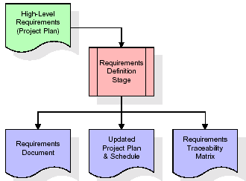
These requirements are fully described in the primary deliverables for this stage: the Requirements Document and the Requirements Traceability Matrix (RTM). The requirements document contains complete descriptions of each requirement, including diagrams and references to external documents as necessary. Note that detailed listings of database tables and fields are not included in the requirements document.
The title of each requirement is also placed into the first version of the RTM, along with the title of each goal from the project plan. The purpose of the RTM is to show that the product components developed during each stage of the software development lifecycle are formally connected to the components developed in prior stages.
In the requirements stage, the RTM consists of a list of high-level requirements, or goals, by title, with a listing of associated requirements for each goal, listed by requirement title. In this hierarchical listing, the RTM shows that each requirement developed during this stage is formally linked to a specific product goal. In this format, each requirement can be traced to a specific product goal, hence the term requirements traceability.
The outputs of the requirements definition stage include the requirements document, the RTM, and an updated project plan.
- Feasibility study is all about identification of problems in a project.
- No. of staff required to handle a project is represented as Team Formation, in this case only modules are individual tasks will be assigned to employees who are working for that project.
- Project Specifications are all about representing of various possible inputs submitting to the server and corresponding outputs along with reports maintained by administrator.
Analysis Stage:
The planning stage establishes a bird's eye view of the intended software product, and uses this to establish the basic project structure, evaluate feasibility and risks associated with the project, and describe appropriate management and technical approaches.
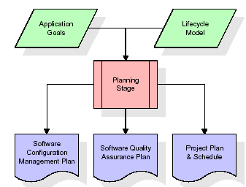
The most critical section of the project plan is a listing of high-level product requirements, also referred to as goals. All of the software product requirements to be developed during the requirements definition stage flow from one or more of these goals. The minimum information for each goal consists of a title and textual description, although additional information and references to external documents may be included. The outputs of the project planning stage are the configuration management plan, the quality assurance plan, and the project plan and schedule, with a detailed listing of scheduled activities for the upcoming Requirements stage, and high level estimates of effort for the out stages.
Designing Stage:
The design stage takes as its initial input the requirements identified in the approved requirements document. For each requirement, a set of one or more design elements will be produced as a result of interviews, workshops, and/or prototype efforts. Design elements describe the desired software features in detail, and generally include functional hierarchy diagrams, screen layout diagrams, tables of business rules, business process diagrams, pseudo code, and a complete entity-relationship diagram with a full data dictionary. These design elements are intended to describe the software in sufficient detail that skilled programmers may develop the software with minimal additional input.

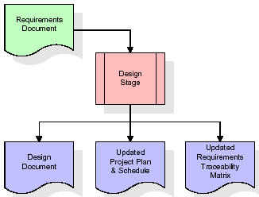
When the design document is finalized and accepted, the RTM is updated to show that each design element is formally associated with a specific requirement. The outputs of the design stage are the design document, an updated RTM, and an updated project plan.
Development (Coding) Stage:
The development stage takes as its primary input the design elements described in the approved design document. For each design element, a set of one or more software artefacts will be produced. Software artefacts include but are not limited to menus, dialogs, and data management forms, data reporting formats, and specialized procedures and functions. Appropriate test cases will be developed for each set of functionally related software artefacts, and an online help system will be developed to guide users in their interactions with the software.
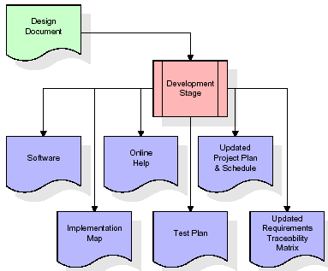

The RTM will be updated to show that each developed artefact is linked to a specific design element, and that each developed artefact has one or more corresponding test case items. At this point, the RTM is in its final configuration. The outputs of the development stage include a fully functional set of software that satisfies the requirements and design elements previously documented, an online help system that describes the operation of the software, an implementation map that identifies the primary code entry points for all major system functions, a test plan that describes the test cases to be used to validate the correctness and completeness of the software, an updated RTM, and an updated project plan.
Integration & Test Stage:
During the integration and test stage, the software artefacts, online help, and test data are migrated from the development environment to a separate test environment. At this point, all test cases are run to verify the correctness and completeness of the software. Successful execution of the test suite confirms a robust and complete migration capability. During this stage, reference data is finalized for production use and production users are identified and linked to their appropriate roles. The final reference data (or links to reference data source files) and production user list are compiled into the Production Initiation Plan.
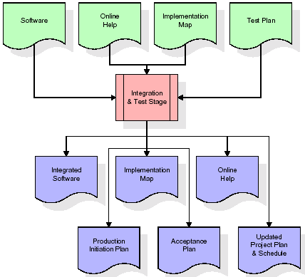
The outputs of the integration and test stage include an integrated set of software, an online help system, an implementation map, a production initiation plan that describes reference data and production users, an acceptance plan which contains the final suite of test cases, and an updated project plan.
- Installation & Acceptance Test:
During the installation and acceptance stage, the software artefacts, online help, and initial production data are loaded onto the production server. At this point, all test cases are run to verify the correctness and completeness of the software. Successful execution of the test suite is a prerequisite to acceptance of the software by the customer.
After customer personnel have verified that the initial production data load is correct and the test suite has been executed with satisfactory results, the customer formally accepts the delivery of the software.
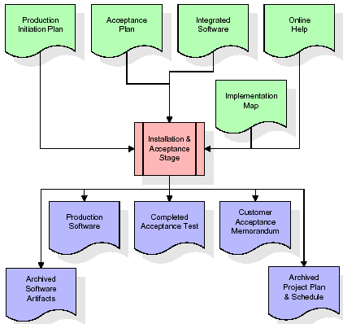
The primary outputs of the installation and acceptance stage include a production application, a completed acceptance test suite, and a memorandum of customer acceptance of the software. Finally, the PDR enters the last of the actual labor data into the project schedule and locks the project as a permanent project record. At this point the PDR "locks" the project by archiving all software items, the implementation map, the source code, and the documentation for future reference.
Maintenance:
Outer rectangle represents maintenance of a project, Maintenance team will start with requirement study, understanding of documentation later employees will be assigned work and they will undergo training on that particular assigned category. For this life cycle there is no end, it will be continued so on like an umbrella (no ending point to umbrella sticks).
3.4. Software Requirement Specification
3.4.1. Overall Description
A Software Requirements Specification (SRS) – a requirements specification for a software system is a complete description of the behaviour of a system to be developed. It includes a set of use cases that describe all the interactions the users will have with the software. In addition to use cases, the SRS also contains non-functional requirements. Non-functional requirements are requirements which impose constraints on the design or implementation (such as performance engineering requirements, quality standards, or design constraints).
System requirements specification: A structured collection of information that embodies the requirements of a system. A business analyst, sometimes titled system analyst, is responsible for analyzing the business needs of their clients and stakeholders to help identify business problems and propose solutions. Within the systems development lifecycle domain, the BA typically performs a liaison function between the business side of an enterprise and the information technology department or external service providers. Projects are subject to three sorts of requirements:
- Business requirements describe in business terms what must be delivered or accomplished to provide value.
- Product requirements describe properties of a system or product (which could be one of several ways to accomplish a set of business requirements.)
- Process requirements describe activities performed by the developing organization. For instance, process requirements could specify .Preliminary investigation examine project feasibility, the likelihood the system will be useful to the organization. The main objective of the feasibility study is to test the Technical, Operational and Economical feasibility for adding new modules and debugging old running system. All system is feasible if they are unlimited resources and infinite time. There are aspects in the feasibility study portion of the preliminary investigation:

- ECONOMIC FEASIBILITY
A system can be developed technically and that will be used if installed must still be a good investment for the organization. In the economical feasibility, the development cost in creating the system is evaluated against the ultimate benefit derived from the new systems. Financial benefits must equal or exceed the costs. The system is economically feasible. It does not require any addition hardware or software. Since the interface for this system is developed using the existing resources and technologies available at NIC, There is nominal expenditure and economical feasibility for certain.
- Operational Feasibility
Proposed projects are beneficial only if they can be turned out into information system. That will meet the organization’s operating requirements. Operational feasibility aspects of the project are to be taken as an important part of the project implementation. This system is targeted to be in accordance with the above-mentioned issues. Beforehand, the management issues and user requirements have been taken into consideration. So there is no question of resistance from the users that can undermine the possible application benefits. The well-planned design would ensure the optimal utilization of the computer resources and would help in the improvement of performance status.
- TECHNICAL FEASIBILITY
Earlier no system existed to cater to the needs of ‘Secure Infrastructure Implementation System’. The current system developed is technically feasible. It is a web based user interface for audit workflow at NIC-CSD. Thus it provides an easy access to .the users. The database’s purpose is to create, establish and maintain a workflow among various entities in order to facilitate all concerned users in their various capacities or roles. Permission to the users would be granted based on the roles specified. Therefore, it provides the technical guarantee of accuracy, reliability and security.
3.4.2. External Interface Requirements
User Interface
The user interface of this system is a user friendly python Graphical User Interface.
Hardware Interfaces
The interaction between the user and the console is achieved through python capabilities.
Software Interfaces
The required software is python.
HARDWARE REQUIREMENTS:

Processor - I3(min)
- Speed - 1.1 GHz
- RAM - 4GB(min)
- Hard Disk - 500GB
- Key Board - Standard Windows Keyboard
- Mouse - Two or Three Button Mouse
- Monitor - SVGA
SOFTWARE REQUIREMENTS:
- Operating System - Windows 10/above
- Programming Language - Python 3.7 /above
4. SYSTEM DESIGN
UML Diagram:
The Unified Modelling Language allows the software engineer to express an analysis model using the modelling notation that is governed by a set of syntactic semantic and pragmatic rules.
A UML system is represented using five different views that describe the system from distinctly different perspective. Each view is defined by a set of diagram, which is as follows.
User Model View
- This view represents the system from the users perspective.
- The analysis representation describes a usage scenario from the end-users perspective.
Structural Model view
- In this model the data and functionality are arrived from inside the system.
- This model view models the static structures.
Behavioural Model View
It represents the dynamic of behavioural as parts of the system, depicting the interactions of collection between various structural elements described in the user model and structural model view.
Implementation Model View
In this the structural and behavioural as parts of the system are represented as they are to be built.
Environmental Model View
In this the structural and behavioural aspects of the environment in which the system is to be implemented are represented.
Class Diagram:
The class diagram is the main building block of object oriented modeling. It is used both for general conceptual modeling of the systematic of the application, and for detailed modeling translating the models into programming code. Class diagrams can also be used for data modeling. The classes in a class diagram represent both the main objects, interactions in the application and the classes to be programmed. In the diagram, classes are represented with boxes which contain three parts:
- The upper part holds the name of the class
- The middle part contains the attributes of the class
- The bottom part gives the methods or operations the class can take or undertake
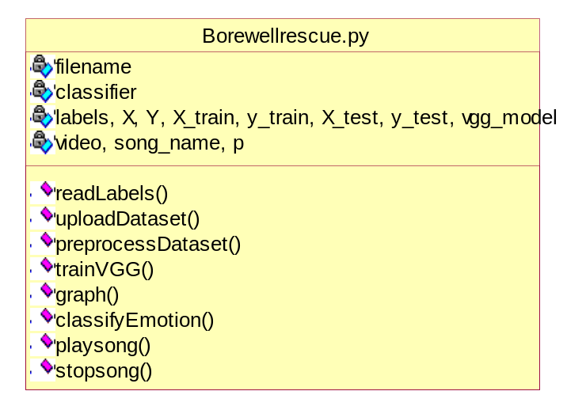

Use case Diagram:
A use case diagram at its simplest is a representation of a user's interaction with the system and depicting the specifications of a use case. A use case diagram can portray the different types of users of a system and the various ways that they interact with the system. This type of diagram is typically used in conjunction with the textual use case and will often be accompanied by other types of diagrams as well.

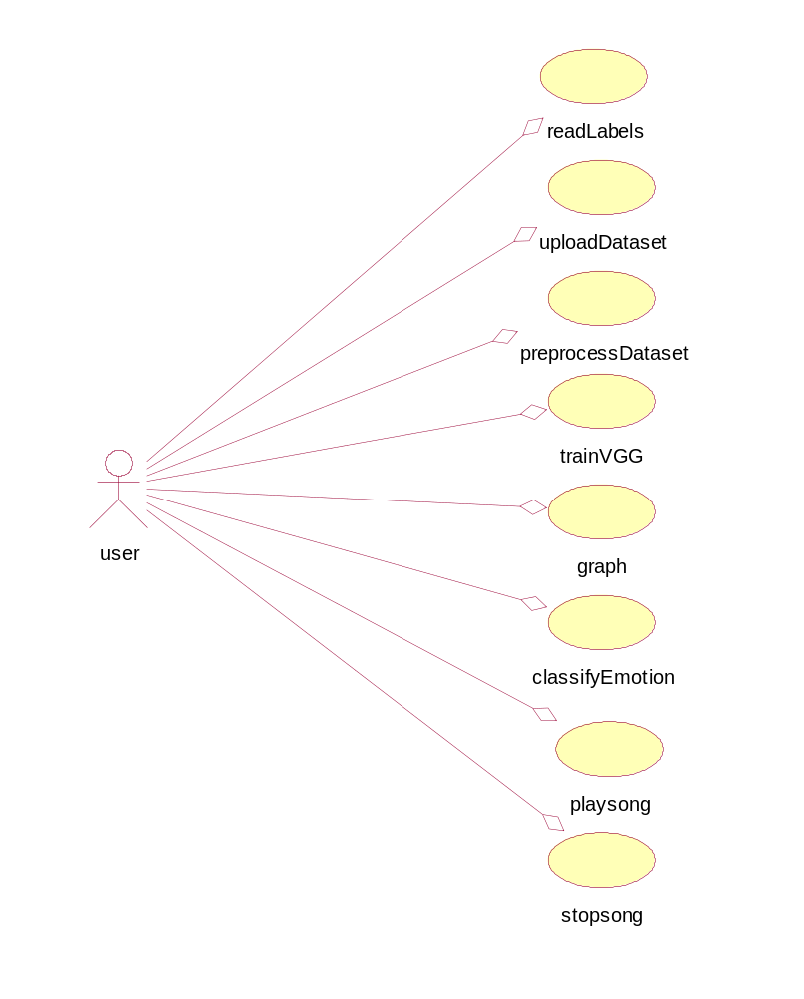

Sequence diagram:
A sequence diagram is a kind of interaction diagram that shows how processes operate with one another and in what order. It is a construct of a Message Sequence Chart. A sequence diagram shows object interactions arranged in time sequence. It depicts the objects and classes involved in the scenario and the sequence of messages exchanged between the objects needed to carry out the functionality of the scenario. Sequence diagrams are typically associated with use case realizations in the Logical View of the system under development. Sequence diagrams are sometimes called event diagrams, event scenarios, and timing diagrams.

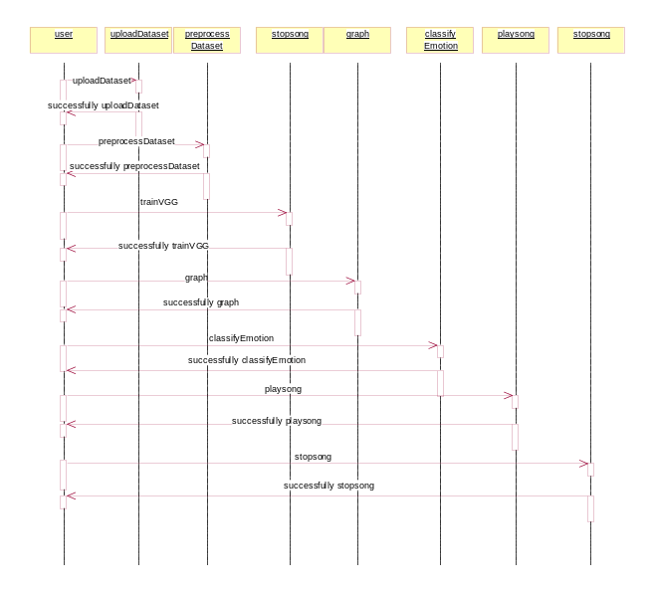

Collaboration diagram:
A collaboration diagram describes interactions among objects in terms of sequenced messages. Collaboration diagrams represent a combination of information taken from class, sequence, and use case diagrams describing both the static structure and dynamic behaviour of a system.

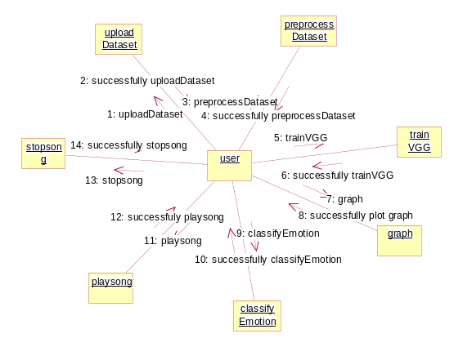
Component Diagram:
In the Unified Modelling Language, a component diagram depicts how components are wired together to form larger components and or software systems. They are used to illustrate the structure of arbitrarily complex systems.
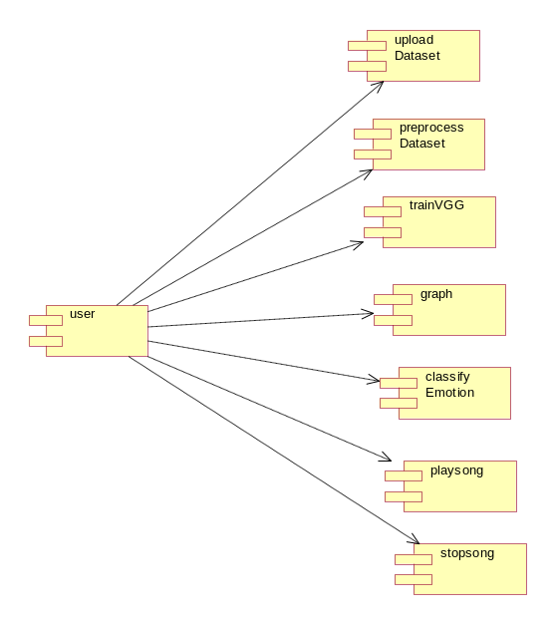
Components are wired together by using an assembly connector to connect the required interface of one component with the provided interface of another component. This illustrates the service consumer - service provider relationship between the two components.

Deployment Diagram:
A deployment diagram in the Unified Modeling Language models the physical deployment of artifacts on nodes. To describe a web site, for example, a deployment diagram would show what hardware components ("nodes") exist (e.g., a web server, an application server, and a database server), what software components ("artifacts") run on each node (e.g., web application, database), and how the different pieces are connected (e.g. JDBC, REST, RMI).
The nodes appear as boxes, and the artifacts allocated to each node appear as rectangles within the boxes. Nodes may have sub nodes, which appear as nested boxes. A single node in a deployment diagram may conceptually represent multiple physical nodes, such as a cluster of database servers.

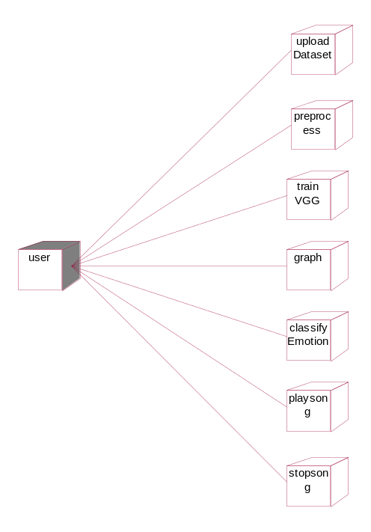
Activity Diagram:
Activity diagram is another important diagram in UML to describe dynamic aspects of the system. It is basically a flow chart to represent the flow form one activity to another activity. The activity can be described as an operation of the system. So the control flow is drawn from one operation to another. This flow can be sequential, branched or concurrent
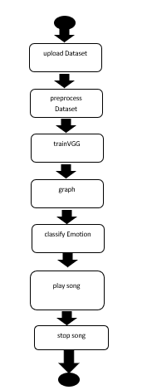

Data Flow Diagram:
Data flow diagrams illustrate how data is processed by a system in terms of inputs and outputs. Data flow diagrams can be used to provide a clear representation of any business function. The technique starts with an overall picture of the business and continues by analyzing each of the functional areas of interest. This analysis can be carried out in precisely the level of detail required. The technique exploits a method called top-down expansion to conduct the analysis in a targeted way.
As the name suggests, Data Flow Diagram (DFD) is an illustration that explicates the passage of information in a process. A DFD can be easily drawn using simple symbols. Additionally, complicated processes can be easily automated by creating DFDs using easy-to-use, free downloadable diagramming tools. A DFD is a model for constructing and analyzing information processes. DFD illustrates the flow of information in a process depending upon the inputs and outputs. A DFD can also be referred to as a Process Model. A DFD demonstrates business or technical process with the support of the outside data saved, plus the data flowing from the process to another and the end results

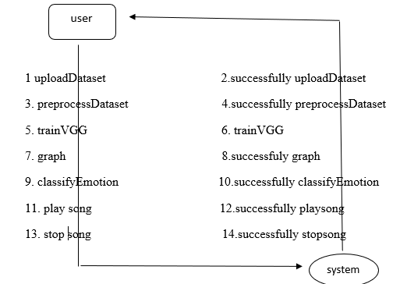

5. IMPLEMETATION
5.1 Python
Python is a general-purpose language. It has wide range of applications from Web development (like: Django and Bottle), scientific and mathematical computing (Orange, SymPy, NumPy) to desktop graphical user Interfaces (Pygame, Panda3D). The syntax of the language is clean and length of the code is relatively short. It's fun to work in Python because it allows you to think about the problem rather than focusing on the syntax.
History of Python:
Python is a fairly old language created by Guido Van Rossum. The design began in the late 1980s and was first released in February 1991.
Why Python was created?
In late 1980s, Guido Van Rossum was working on the Amoeba distributed operating system group. He wanted to use an interpreted language like ABC (ABC has simple easy-to-understand syntax) that could access the Amoeba system calls. So, he decided to create a language that was extensible. This led to design of a new language which was later named Python.
Why the name Python?
No. It wasn't named after a dangerous snake. Rossum was fan of a comedy series from late seventies. The name "Python" was adopted from the same series "Monty Python's Flying Circus".
Features of Python:
A simple language which is easier to learn
Python has a very simple and elegant syntax. It's much easier to read and write Python programs compared to other languages like: C++, Java, C#. Python makes programming fun and allows you to focus on the solution rather than syntax.
If you are a newbie, it's a great choice to start your journey with Python.
Free and open-source
You can freely use and distribute Python, even for commercial use. Not only can you use and distribute software’s written in it, you can even make changes to the Python's source code.
Python has a large community constantly improving it in each iteration.
Portability
You can move Python programs from one platform to another, and run it without any changes.
It runs seamlessly on almost all platforms including Windows, Mac OS X and Linux.
Extensible and Embeddable
Suppose an application requires high performance. You can easily combine pieces of C/C++ or other languages with Python code.
This will give your application high performance as well as scripting capabilities which other languages may not provide out of the box.
A high-level, interpreted language
Unlike C/C++, you don't have to worry about daunting tasks like memory management, garbage collection and so on.
Likewise, when you run Python code, it automatically converts your code to the language your computer understands. You don't need to worry about any lower-level operations.
Large standard libraries to solve common tasks
Python has a number of standard libraries which makes life of a programmer much easier since you don't have to write all the code yourself. For example: Need to connect MySQL database on a Web server? You can use MySQLdb library using import MySQLdb .
Standard libraries in Python are well tested and used by hundreds of people. So you can be sure that it won't break your application.
Object-oriented
Everything in Python is an object. Object oriented programming (OOP) helps you solve a complex problem intuitively.
With OOP, you are able to divide these complex problems into smaller sets by creating objects.

Applications of Python:
1. Simple Elegant Syntax
Programming in Python is fun. It's easier to understand and write Python code. Why? The syntax feels natural. Take this source code for an example:
a = 2
b = 3
sum = a + b
print(sum)
2. Not overly strict
You don't need to define the type of a variable in Python. Also, it's not necessary to add semicolon at the end of the statement.
Python enforces you to follow good practices (like proper indentation). These small things can make learning much easier for beginners.
3. Expressiveness of the language
Python allows you to write programs having greater functionality with fewer lines of code. Here's a link to the source code of Tic-tac-toe game with a graphical interface and a smart computer opponent in less than 500 lines of code. This is just an example. You will be amazed how much you can do with Python once you learn the basics.
4. Great Community and Support
Python has a large supporting community. There are numerous active forums online which can be handy if you are stuck.
5.2 Sample Code:
from tkinter import messagebox
from tkinter import *
from tkinter import simpledialog
import tkinter
from tkinter import filedialog
from tkinter.filedialog import askopenfilename
import cv2
import random
import numpy as np
from keras.utils.np_utils import to_categorical
from keras.layers import MaxPooling2D
from keras.layers import Dense, Dropout, Activation, Flatten
from keras.layers import Convolution2D
from keras.models import Sequential, load_model
from sklearn.model_selection import train_test_split
from keras.applications import VGG16
from sklearn.metrics import accuracy_score
from keras.callbacks import ModelCheckpoint
import pickle
import os
from keras.models import load_model
from sklearn.metrics import precision_score
from sklearn.metrics import recall_score
from sklearn.metrics import f1_score
from sklearn.metrics import accuracy_score
import matplotlib.pyplot as plt
from sklearn.metrics import confusion_matrix
import seaborn as sns
from tensorflow import keras
from playsound import playsound
import multiprocessing

main = tkinter.Tk()
main.title("Smart Borewell Child Rescue System Through Wireless Monitoring Using Artificial Intelligence")
main.geometry("1300x1200")

global filename
global classifier
global labels, X, Y, X_train, y_train, X_test, y_test, vgg_model
emotion = ['Anger', 'Disgust', 'Fear', 'Happy', 'Sad', 'Surprise', 'Neutral']
font_cv = cv2.FONT_HERSHEY_SIMPLEX
face_cas = cv2.CascadeClassifier('model/haarcascade_frontalface_default.xml')
global video, song_name, p

def readLabels(filename):
global labels
labels = []
for root, dirs, directory in os.walk(filename):
for j in range(len(directory)):
name = os.path.basename(root)
if name not in labels:
labels.append(name)

def uploadDataset():
global filename
global labels
labels = []
filename = filedialog.askdirectory(initialdir=".")
pathlabel.config(text=filename)
text.delete('1.0', END)
text.insert(END,filename+" loaded\n\n");
readLabels(filename)
text.insert(END,"Emotion Class Labels found in dataset are\n\n")
for i in range(len(labels)):
text.insert(END,labels[i]+"\n")

def processDataset():
text.delete('1.0', END)
global filename, X, Y, X_train, y_train, X_test, y_test
if os.path.exists("model/X.txt.npy"):
X = np.load('model/X.txt.npy')
Y = np.load('model/Y.txt.npy')
else:
for root, dirs, directory in os.walk(filename):
for j in range(len(directory)):
name = os.path.basename(root)
if 'Thumbs.db' not in directory[j]:
img = cv2.imread(root+"/"+directory[j])
img = cv2.resize(img, (32, 32))
im2arr = np.array(img)
im2arr = im2arr.reshape(32,32,3)
X.append(im2arr)
label = getID(name)
Y.append(label)
print(name+" "+str(label))
X = np.asarray(X)
Y = np.asarray(Y)
np.save('model/X.txt',X)
np.save('model/Y.txt',Y)
X = X.astype('float32')
X = X/255
text.insert(END,"Dataset Preprocessing Completed\n")
text.insert(END,"Total images found in dataset : "+str(X.shape[0])+"\n\n")
indices = np.arange(X.shape[0])
np.random.shuffle(indices)
X = X[indices]
Y = Y[indices]
Y = to_categorical(Y)
X = np.reshape(X, (X.shape[0], X.shape[1], X.shape[2], 1))
print(X.shape)
X_train, X_test, y_train, y_test = train_test_split(X, Y, test_size=0.2) #split dataset into train and test
text.insert(END,"80% images are used to train VGG16 : "+str(X_train.shape[0])+"\n")
text.insert(END,"20% images are used to train VGG16 : "+str(X_test.shape[0])+"\n")
X_test = X_test[0:500]
y_test = y_test[0:500]

def trainVGG():
text.delete('1.0', END)
global filename, X, Y, X_train, y_train, X_test, y_test, vgg_model, labels
if os.path.exists("model/vgg_weights.h5") == False:
vgg = VGG16(include_top=False, weights='imagenet', input_shape=(X_train.shape[1], X_train.shape[2], X_train.shape[3]))
for layer in vgg.layers:
layer.trainable = False
vgg_model = Sequential()
vgg_model.add(vgg)
vgg_model.add(Convolution2D(32, (1, 1), input_shape = (X_train.shape[1], X_train.shape[2], X_train.shape[3]), activation = 'relu'))
vgg_model.add(MaxPooling2D(pool_size = (1, 1)))
vgg_model.add(Convolution2D(32, (1, 1), activation = 'relu'))
vgg_model.add(MaxPooling2D(pool_size = (1, 1)))
vgg_model.add(Flatten())
vgg_model.add(Dense(units = 256, activation = 'relu'))
vgg_model.add(Dense(units = y_train.shape[1], activation = 'softmax'))
vgg_model.compile(optimizer = 'adam', loss = 'categorical_crossentropy', metrics = ['accuracy'])
model_check_point = ModelCheckpoint(filepath='model/vgg_weights.h5', verbose = 1, save_best_only = True)
hist = vgg_model.fit(X_train, y_train, batch_size = 32, epochs = 20, validation_data=(X_test, y_test), callbacks=[model_check_point], verbose=1)
f = open('model/vgg_history.pckl', 'wb')
pickle.dump(hist.history, f)
f.close()
else:
vgg_model = keras.models.load_model("model/vgg_weights.h5")
predict = vgg_model.predict(X_test)
predict = np.argmax(predict, axis=1)
pred = []
for i in range(len(predict)):
if predict[i] == 4:
pred.append(5)
elif predict[i] == 5:
pred.append(6)
elif predict[i] == 6:
pred.append(4)
else:
pred.append(predict[i])
predict = np.asarray(pred)
testY = np.argmax(y_test, axis=1)
p = precision_score(testY, predict,average='macro') * 100
r = recall_score(testY, predict,average='macro') * 100
f = f1_score(testY, predict,average='macro') * 100
a = accuracy_score(testY,predict)*100
text.insert(END,"VGG16 Accuracy : "+str(a)+"\n")
text.insert(END,"VGG16 Precision : "+str(p)+"\n")
text.insert(END,"VGG16 Recall : "+str(r)+"\n")
text.insert(END,"VGG16 FSCORE : "+str(f)+"\n\n")
conf_matrix = confusion_matrix(testY, predict)
plt.figure(figsize =(6, 6))
ax = sns.heatmap(conf_matrix, xticklabels = labels, yticklabels = labels, annot = True, cmap="viridis" ,fmt ="g");
ax.set_ylim([0,len(labels)])
plt.title("VGG16 Confusion matrix")
plt.ylabel('True class')
plt.xlabel('Predicted class')
plt.show()

def graph():
f = open('model/history.pckl', 'rb')
graph = pickle.load(f)
f.close()
accuracy = graph['val_accuracy']
error = graph['val_loss']

plt.figure(figsize=(10,6))
plt.grid(True)
plt.xlabel('EPOCH')
plt.ylabel('Accuracy/Loss')
plt.plot(accuracy, 'ro-', color = 'green')
plt.plot(error, 'ro-', color = 'red')
plt.legend(['VGG16 Accuracy', 'VGG16 Loss'], loc='upper left')
plt.title('VGG16 Training Accuracy & Loss Graph')
plt.show()

def classifyEmotion():
global vgg_model, labels, video, song_name
video = cv2.VideoCapture(0)
while(True):
ret, frame = video.read()
if ret == True:
gray = cv2.cvtColor(frame, cv2.COLOR_BGR2GRAY)
faces = face_cas.detectMultiScale(gray, 1.3,5)
for (x, y, w, h) in faces:
face_component = gray[y:y+h, x:x+w]
fc = cv2.resize(face_component, (48, 48))
inp = np.reshape(fc,(1,48,48,1)).astype(np.float32)
inp = inp/255.
prediction = vgg_model.predict_proba(inp)
em = emotion[np.argmax(prediction)]
song_name = em
score = np.max(prediction)
cv2.putText(frame, em+" "+str(score*100)+'%', (x, y), font_cv, 1, (0, 255, 0), 2)
cv2.rectangle(frame, (x, y), (x+w, y+h), (0, 0, 255), 2)
cv2.imshow("image", frame)
if cv2.waitKey(250) & 0xFF == ord('q'):
break
else:
break
video.release()
cv2.destroyAllWindows()

def playSong():
global song_name, p
p = multiprocessing.Process(target=playsound, args=('songs/'+song_name+"/"+song_name+".mp3",))
p.start()

def stopSong():
global p
p.terminate()

font = ('times', 16, 'bold')
title = Label(main, text='Smart Borewell Child Rescue System Through Wireless Monitoring Using Artificial Intelligence',anchor=W, justify=CENTER)
title.config(bg='yellow4', fg='white')
title.config(font=font)
title.config(height=3, width=120)
title.place(x=0,y=5)

font1 = ('times', 13, 'bold')
upload = Button(main, text="Upload Facial Emotion Dataset", command=uploadDataset)
upload.place(x=50,y=100)
upload.config(font=font1)

pathlabel = Label(main)
pathlabel.config(bg='yellow4', fg='white')
pathlabel.config(font=font1)
pathlabel.place(x=50,y=150)

processButton = Button(main, text="Preprocess Dataset", command=processDataset)
processButton.place(x=50,y=200)
processButton.config(font=font1)

trainButton = Button(main, text="Train VGG16 Algorithm", command=trainVGG)
trainButton.place(x=50,y=250)
trainButton.config(font=font1)

graphButton = Button(main, text="VGG16 Training Graph", command=graph)
graphButton.place(x=50,y=300)
graphButton.config(font=font1)

classifyButton = Button(main, text="Predict Emotion from WebCam", command=classifyEmotion)
classifyButton.place(x=50,y=350)
classifyButton.config(font=font1)

playButton = Button(main, text="Play Song", command=playSong)
playButton.place(x=50,y=400)
playButton.config(font=font1)

stopButton = Button(main, text="Stop Song", command=stopSong)
stopButton.place(x=50,y=450)
stopButton.config(font=font1)

font1 = ('times', 12, 'bold')
text=Text(main,height=25,width=78)
scroll=Scrollbar(text)
text.configure(yscrollcommand=scroll.set)
text.place(x=370,y=100)
text.config(font=font1)

main.config(bg='magenta3')
main.mainloop()
6. TESTING
Implementation and Testing:
Implementation is one of the most important tasks in project is the phase in which one has to be cautions because all the efforts undertaken during the project will be very interactive. Implementation is the most crucial stage in achieving successful system and giving the users confidence that the new system is workable and effective. Each program is tested individually at the time of development using the sample data and has verified that these programs link together in the way specified in the program specification. The computer system and its environment are tested to the satisfaction of the user.

Implementation

The implementation phase is less creative than system design. It is primarily concerned with user training, and file conversion. The system may be requiring extensive user training. The initial parameters of the system should be modifies as a result of a programming. A simple operating procedure is provided so that the user can understand the different functions clearly and quickly. The different reports can be obtained either on the inkjet or dot matrix printer, which is available at the disposal of the user. The proposed system is very easy to implement. In general implementation is used to mean the process of converting a new or revised system design into an operational one.

Testing
Testing is the process where the test data is prepared and is used for testing the modules individually and later the validation given for the fields. Then the system testing takes place which makes sure that all components of the system property functions as a unit. The test data should be chosen such that it passed through all possible condition. Actually testing is the state of implementation which aimed at ensuring that the system works accurately and efficiently before the actual operation commence. The following is the description of the testing strategies, which were carried out during the testing period.

System Testing
Testing has become an integral part of any system or project especially in the field of information technology. The importance of testing is a method of justifying, if one is ready to move further, be it to be check if one is capable to with stand the rigors of a particular situation cannot be underplayed and that is why testing before development is so critical. When the software is developed before it is given to user to use the software must be tested whether it is solving the purpose for which it is developed. This testing involves various types through which one can ensure the software is reliable. The program was tested logically and pattern of execution of the program for a set of data are repeated. Thus the code was exhaustively checked for all possible correct data and the outcomes were also checked.

Module Testing
To locate errors, each module is tested individually. This enables us to detect error and correct it without affecting any other modules. Whenever the program is not satisfying the required function, it must be corrected to get the required result. Thus all the modules are individually tested from bottom up starting with the smallest and lowest modules and proceeding to the next level. Each module in the system is tested separately. For example the job classification module is tested separately. This module is tested with different job and its approximate execution time and the result of the test is compared with the results that are prepared manually. The comparison shows that the results proposed system works efficiently than the existing system. Each module in the system is tested separately. In this system the resource classification and job scheduling modules are tested separately and their corresponding results are obtained which reduces the process waiting time.
Integration Testing
After the module testing, the integration testing is applied. When linking the modules there may be chance for errors to occur, these errors are corrected by using this testing. In this system all modules are connected and tested. The testing results are very correct. Thus the mapping of jobs with resources is done correctly by the system.
Acceptance Testing
When that user fined no major problems with its accuracy, the system passers through a final acceptance test. This test confirms that the system needs the original goals, objectives and requirements established during analysis without actual execution which elimination wastage of time and money acceptance tests on the shoulders of users and management, it is finally acceptable and ready for the operation

Test Case Id | Test Case Name | Test Case Desc. | Test Steps |  |  |  | Test Case Status |  | Test Priority
Test Case Id | Test Case Name | Test Case Desc. | Step | Expected |  | Actual
01 | Upload Dataset | Test whether the dataset loded or not | If the not loaded Here | We cannot do further operations | Tourist Dataset uploaded we will do further operations |  | High |  | High
02 | Preprocess Dataset | Test whether Successfully preprocess or not | If the preprocess may not Successfully | We cannot do further operations | we will do further  operations |  | High |  | High
03 | Train VGG | Verify Detect VGG trained or not | If not trained properly | We cannot run  operation | We can Run the Operation |  | High |  | High
04 | graph | Verify graph plotted or not | If graph may not plot Successfully | We cannot run  operation | We can Run the Operation |  | High |  | High
06 | Classify Emotion | Calssify emotion here | If emotion not detected | We cannot run  operation | We can Run the Operation |  | High |  | High
07 | Play song | Verify song playing or not | If No song played | We cannot run  operation | We can run  operation |  |  | High |  | High
08 | Stop song | Verify song stopped or not | If No song stopped | We cannot run  operation | We can run  operation |  |  | high |  | high

SCREEN SHOTS

To run project double click on ‘run.bat’ file to get below output
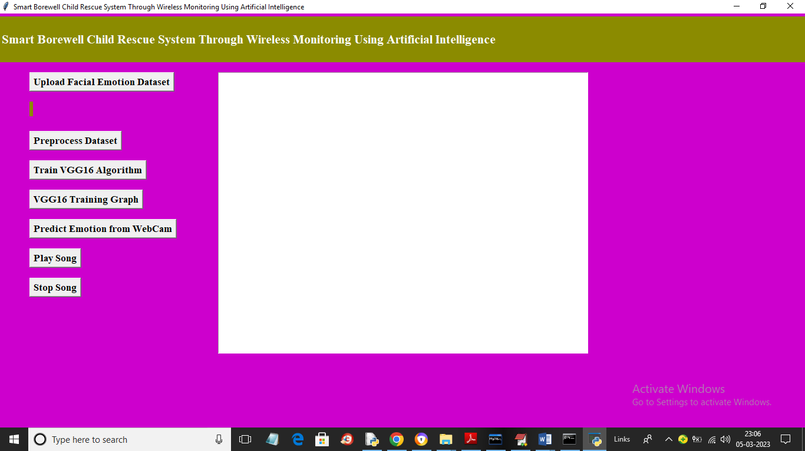
In above screen click on ‘Upload Facial Emotion Dataset’ button to upload dataset and get below output
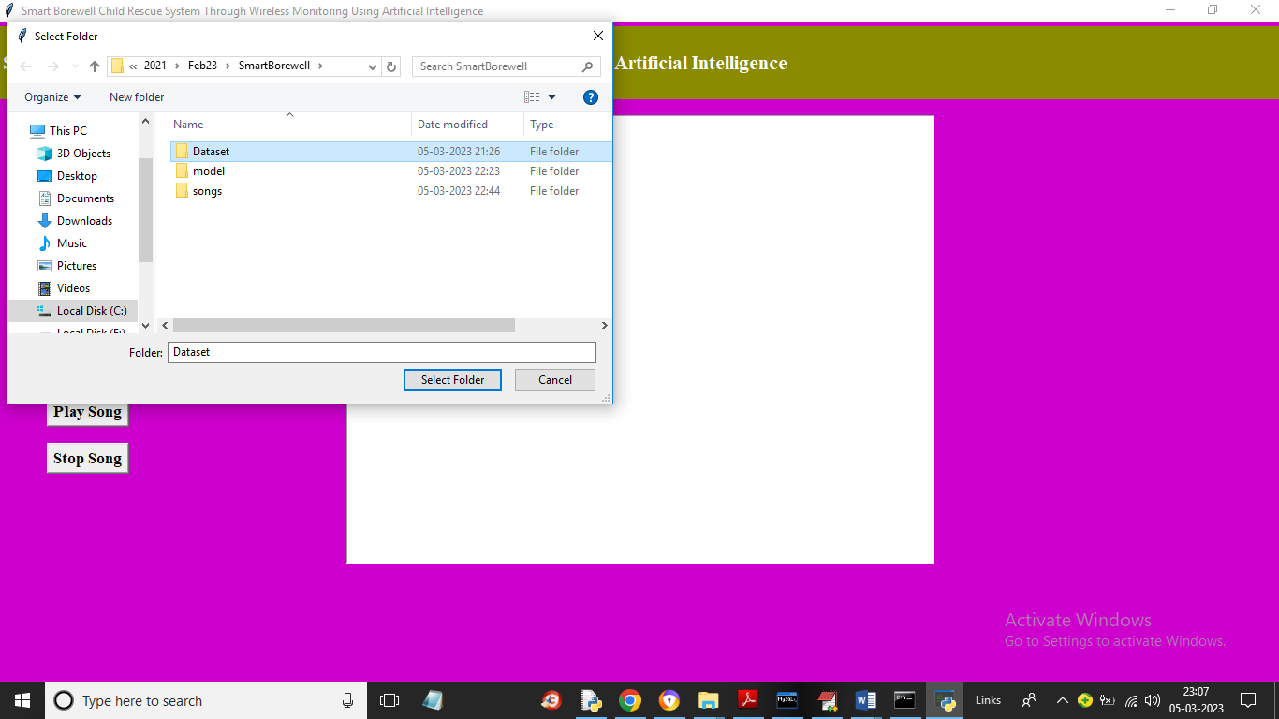
In above screen selecting and uploading entire ‘Dataset’ folder and then click on ‘Select Folder’ button to load dataset and get below output
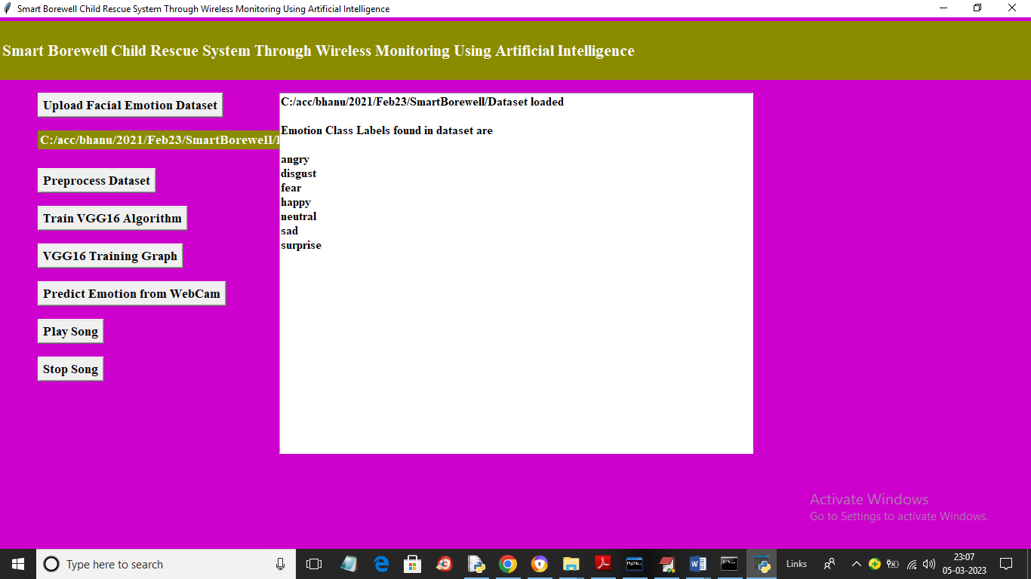
In above screen dataset loaded and then displaying names of each Facial Expression images found in dataset. Now click on ‘Preprocess Dataset’ button to read each image and then normalize image pixel values and then split dataset into train and test
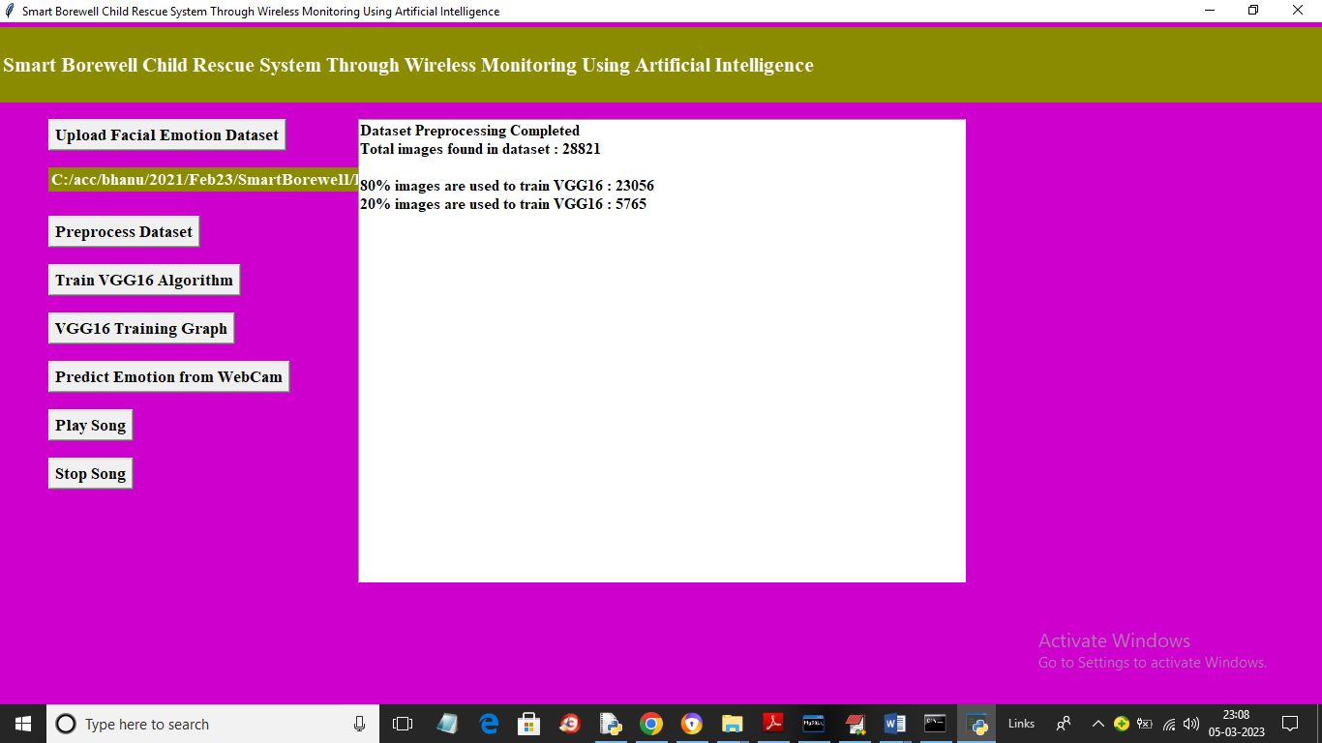
In above screen all images are processed and total images found in dataset is 28821 and application using 23056 (80%) images for training and 5765 (20%) images for testing and now click on ‘Train VGG16 Algorithm’ button to train VGG16 model and get below output
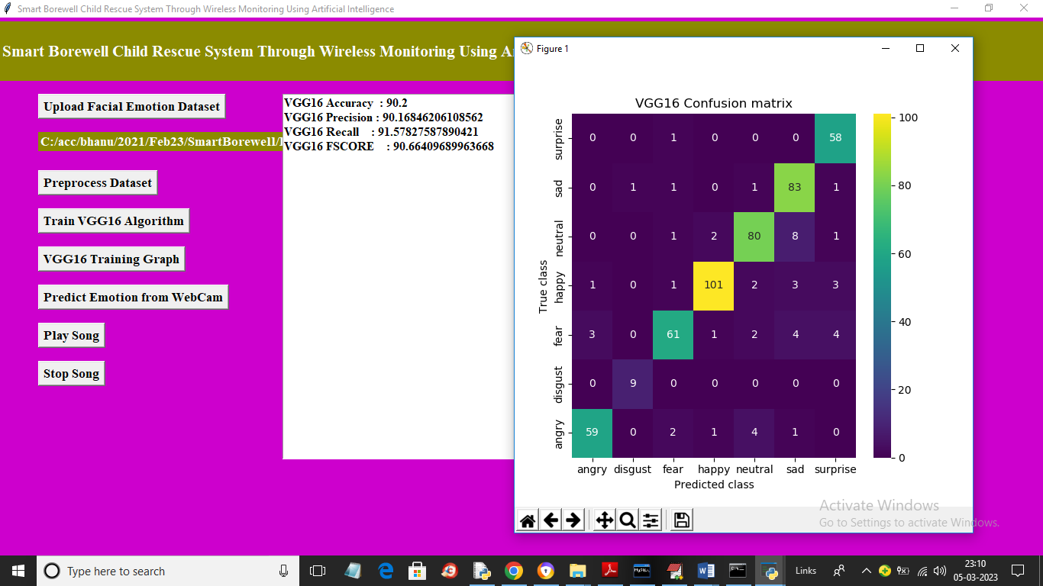
In above screen with VGG16 we got accuracy and precision as 90% and in confusion matrix graph x-axis represents Predicted Labels and y-axis represents True classes and different colour boxes in Diagnol represents correct prediction count and all other blue boxes contains incorrect prediction count which are very few. Now close above graph and then click on ‘VGG16 Training Graph’ button to get below VGG16 training graph.
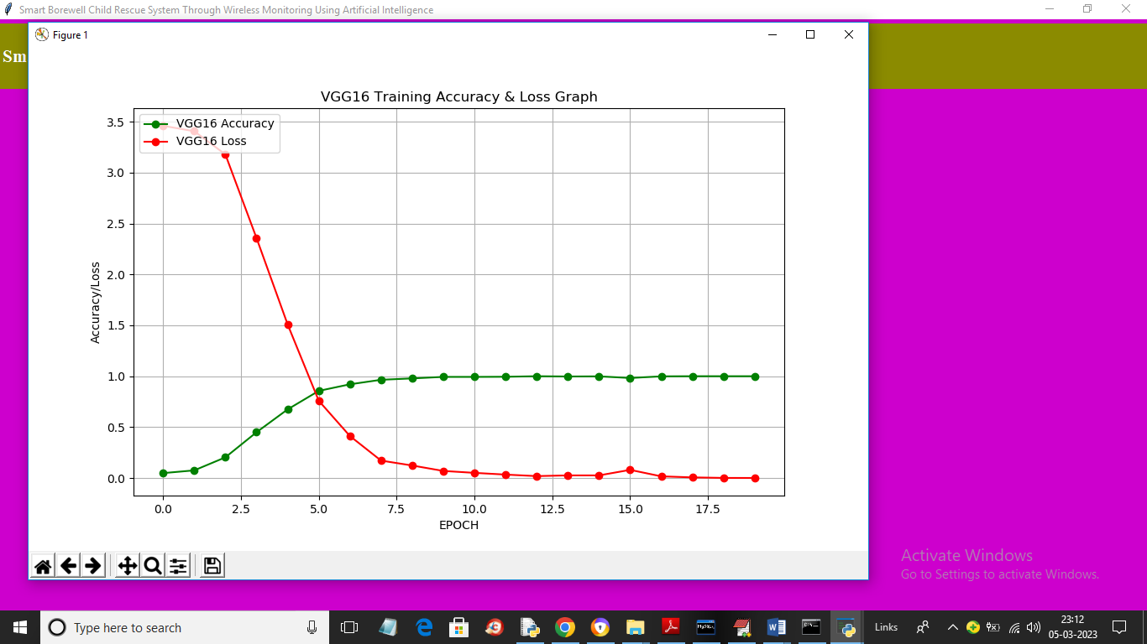
In above graph x-axis represents training epoch and y-axis represents accuracy and red line represents LOSS values and green line represents accuracy and with each increasing epoch accuracy got increased and loss got decreased. Now close above graph and then click on ‘Predict Emotion from Webcam’ button to upload open Webcam and get below output
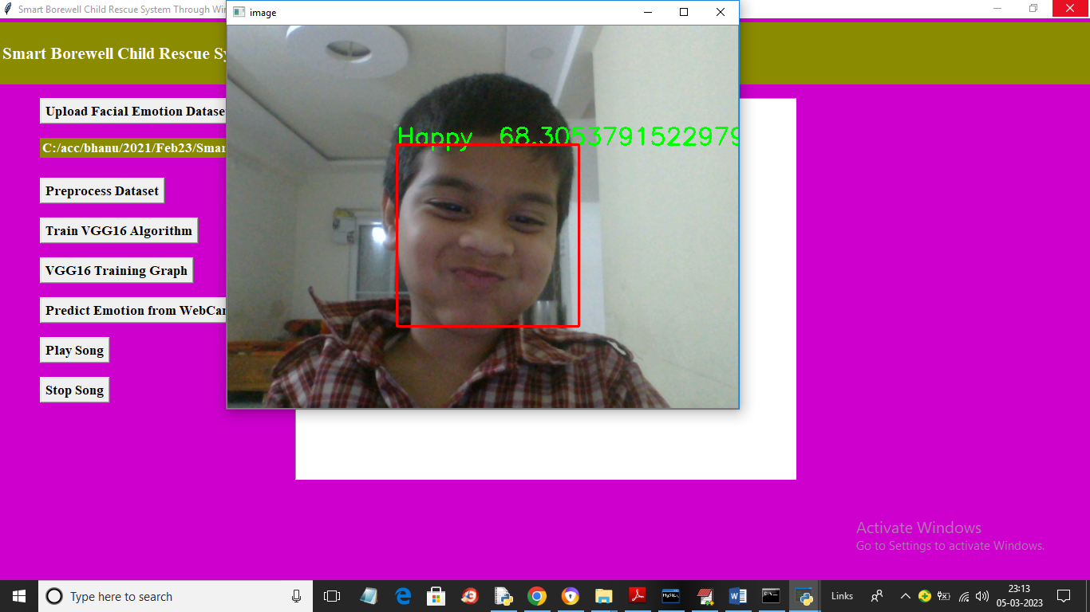
In above screen Webcam started and we can see detected emotion with accuracy % and you can press ‘q’ key to stop webcam and then click on ‘Play Song’ button to play the song and after some time you can hear song voice and while playing you can click on ‘Stop Song’ to stop playing. For playing song application will open new window you just closed that newly open window to hear song.

8. CONCLUSION
This project has been successfully implemented for effectively monitoring and rescuing a child on being stuck in a borewell, the system can effectively recognize the facial emotions and recognize the voice of a child using the currently prevailing deep learning approach.
9. REFERENCES
[1] Ronak Kosti, Jose M. Alvarez, Adria Recasens, Agata Lapedriza.”Context Based Emotion Recognition using EMOTIC Dataset”, [2019,Vol No: 0162-8828 ]
[2] Vipin Gupta, Mayur Dahyabhai Chopda, and Ram Bilas Pachori, Senior Member, IEEE, “Cross-Subject Emotion Recognition using Flexible Analytic Wavelet Transform from EEG Signals” [IEEE 2018, Vol .No.: 1558-1748].
[3] Biqiao Zhang, Student Member, IEEE, Emily Mower Provost, Member, IEEE, and Georg Essl, Member, IEEE, “Cross-corpus Acoustic Emotion Recognition with Multi-task Learning: Seeking Common Ground while Preserving Differences” [2016, Vol.No: 1949-3045].
[4] Jose Rodriguez Borbon, Student Member, IEEE, Xiaoyin Ma, Member, IEEE, Amit K. Roy-Chowdhury, Senior Member, IEEE, and Walid Najjar, Fellow, IEEE,”Heterogeneous Acceleration of HAR Applications”[2018,Vol No: 1051-8215].
[5] Habib Ullah1, Muhammad Uzair2, Arif Mahmood3, Mohib Ullah4, Sultan Daud Khan5, Faouzi Alaya Cheikh,” Internal Emotion Classification Using EEG Signal with Sparse Discriminative Ensemble”[2018, Vol. No: 2169- 3536]
[6] Yelin Kim, Member, IEEE, and Emily Mower Provost, Member, IEEE,”ISLA: Temporal Segmentation and Labeling for Audio-Visual Emotion Recognition”[2017, Vol No: 1949-3045].
[7] N. Beckmann, R. Viga, A. Dogangün, and A. Grabmaier,”Measurement and Analysis of Local Pulse Transit Time for Emotion Recognition”[2019, Vol. 19, No. 17].
[8] Yong-Jin Liu, Senior Member, IEEE, Minjing Yu, Guozhen Zhao, Jinjing Song, Yan Ge, and Yuanchun Shi, Senior Member, IEEE,”RealTime Movie-Induced Discrete Emotion Recognition from EEG Signals”[2017,Vol No: 1949-3045 ].
[9] Shan Li, and Weihong Dengכ ,Member, IEEE,”Reliable Crowdsourcing and Deep Locality- Preserving Learning for Unconstrained Facial Expression Recognition”[2018, Vol No:1057- 7149 ].
[10] R. Girshick, “Fast r-cnn,” in Proceedings of the IEEE international conference on computer vision, 2015, pp. 1440–1448.
[11] R. Kosti, J. M. Alvarez, A. Recasens, and A. Lapedriza, “Emotion recognition in context,” in The IEEE Conference on Computer Vision and Pattern Recognition (CVPR), 2017.
[12] Baro, H. J. Escalante, and I. Guyon, ´ “Chalearn looking at people: Events and resources,” CoRR, vol. abs/1701.02664, 2017.
[13] T. Lin, M. Maire, S. J. Belongie, L. D. Bourdev, R. B. Girshick, J. Hays, P. Perona, D. Ramanan, P. Dollar, ´and C. L. Zitnick, “Microsoft COCO: common objects in context,” CoRR, vol. abs/1405.0312, 2014.
[14] Toward User-Independent Emotion Recognition using Physiological Signals, Amani Albraikan, Diana P. Tob´on, and Abdulmotaleb El Saddik [2018, Vol. No: 1558-1748]
[15] W. Mou, O. Celiktutan, and H. Gunes, “Group-level arousal and valence recognition in static images: Face, body and context,” in Automatic Face and Gesture Recognition (FG), 2015 11th IEEE International Conference and Workshops on, vol. 5. IEEE, 2015, pp. 1– 6.
[16] M. B. Reshma A.B., N. Rejee W.H., S. Revathy and J. Jabez, "Recommendation of Nearest Heart care Center during Emergency using IoT," 2019 International Conference on Intelligent Computing and Control Systems (ICCS), Madurai, India, 2019, pp. 1056-1060, doi: 10.1109/ICCS45141.2019.9065409.
[17] M. B. Reshma A.B., N. Rejee W.H., S. Revathy and J. Jabez, "Recommendation of Nearest Heart care Center during Emergency using IoT," 2019 International Conference on Intelligent Computing and Control Systems (ICCS), Madurai, India, 2019, pp. 1056-1060, doi: 10.1109/ICCS45141.2019.9065409.
[18] Subhashini, R., and R. Sethuraman. "IoT-Based Air Pollution Monitoring Using Silver Birch Trees." National Academy Science Letters (2019): 1-4.

