This page is to be used to set up an account on SecureRelease in order to request documents or information concerning a relevant encounter with the Customs and Border Protection Agency under the FOIA Act. A FOIA Request is a request you submit to the agency to request documents they have concerning any information they have concerning you and encounters you have had with their agency. You will need stable access to the Internet and approximately 30-45 minutes to complete this request. It may take several months for the agency to respond to your request for documents, which is standard given current agency processing times. Good Luck!

**CBP FOIA Request FAQ:**

Create an account on https://www.securerelease.us/account-page/sign-in/ . Enter the email you regularly check, select a password, and then enter your phone number, first and last name, and enter your street address. If you are a community group using a community organization to help you submit a FOIA request, provide the organization’s email.

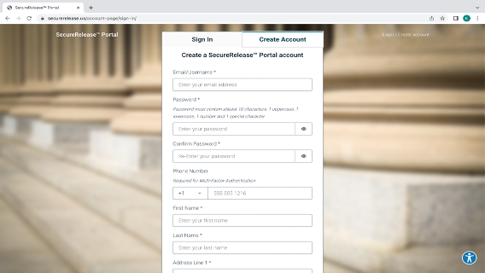

Enter your zip code, city, state, and country of residence (USA) and click ‘Create Account’. If you are a community organization helping someone complete this request, please provide either their mailing address or the community organization’s mailing address.

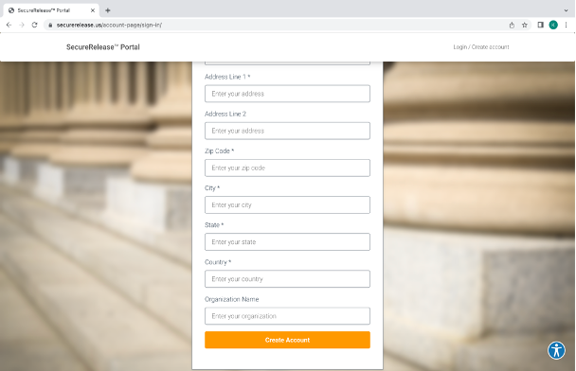

Click on either button that is circled below, and says “CREATE REQUEST” to begin your FOIA Request

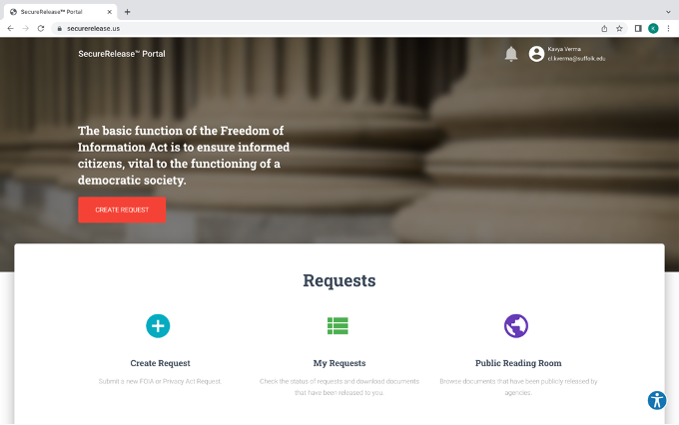

In the Agency dropdown, select ‘Department of Homeland Security’

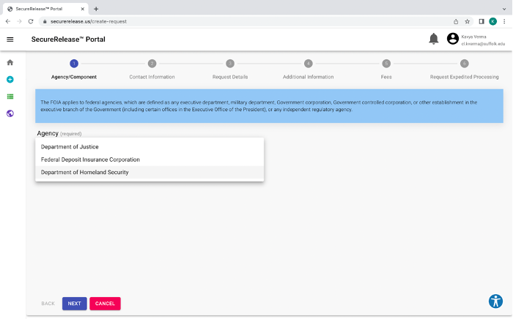

In the Component Dropdown select ‘U.S. Customs & Border Protection’. Then click “Next”, which is circled below.

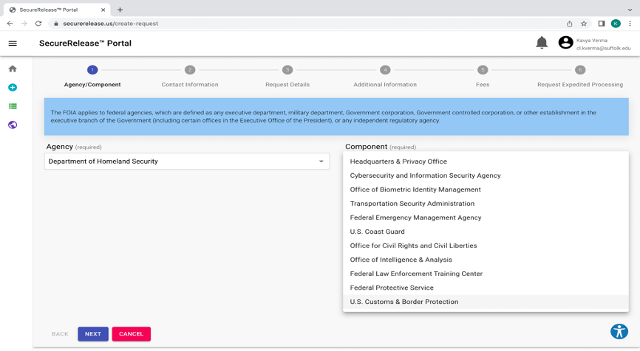

On the following page, select ‘FOIA Request’ in the Request Type dropdown.In the box, indicate that you want all records regarding your arrest by a CBP agent including: Form I-220A, I-213 if it exists, credible fear interview notes and decision. Try to enter an exact date and location or at least a month/year.

When you are done, click “Next”.

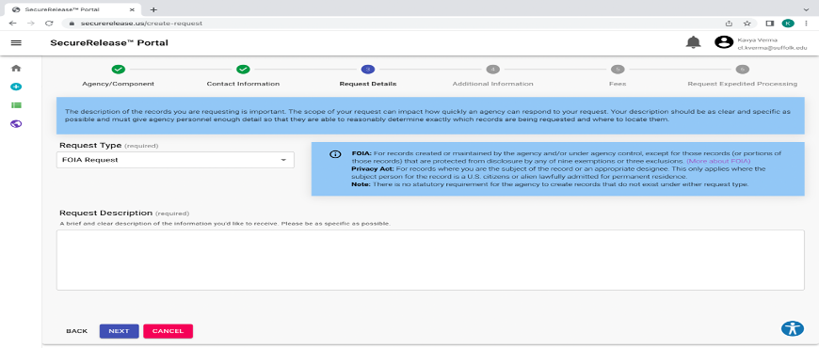

If you have any documents from when you were arrested at the border, upload them here. It is fine if you do not have anything. Click Next.

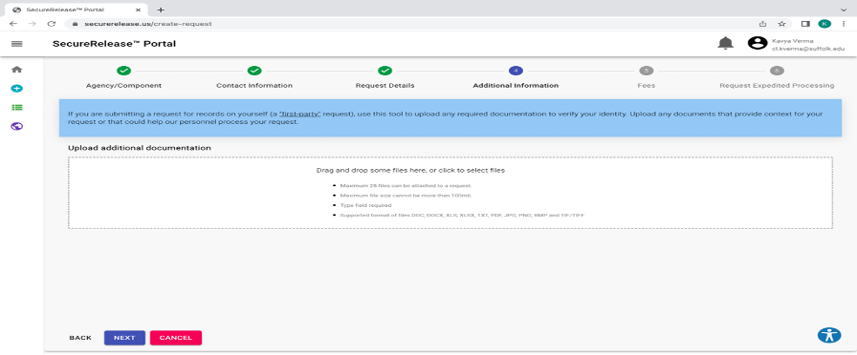

If you can’t pay for this request, select ‘Request Fee Waiver’ and explain the requirements below. Otherwise, input the amount of money that you are willing to pay in fees, if any. If you are an individual, you will likely not be charged a fee for your FOIA Request.

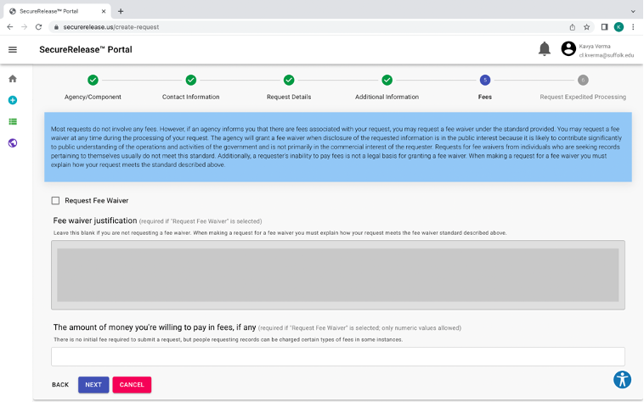

If you have an upcoming hearing before an Immigration Judge, then you should check the box for ‘Request Expedited Processing’ and describe the either the charge against you or the claim that you are making, and provide the date. Then click ‘Submit Request’, circled below.

If you don’t have an upcoming hearing but you are afraid you will be deported, check the box for Request Expedited Processing’ and write that you are afraid of a threat to your life or freedom. Congratulations on completing a lengthy request! It will be helpful for you to have this information.

