⏺ Here's how AI_BRAIN works in this app:

AI Brain Overview

Provider selection (src/app/api/ai/suggest/route.ts:88-91)

The active AI provider is chosen in priority order:
1. Per-request brain field in the POST body (runtime override)
2. AI_BRAIN env var (deployment-level default)
3. Falls back to 'anthropic' if neither is set

Two providers (src/lib/ai/providers/)
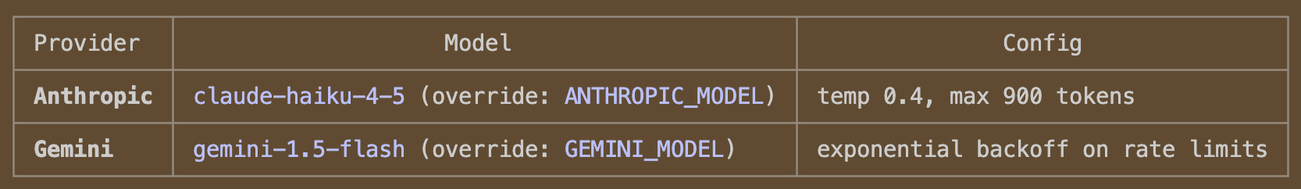
Both implement the same AIProvider interface (adapter.ts): generate(prompt) → { text }.

Automatic fallback (route.ts:99-112)

If the primary provider is Gemini (or anything non-Anthropic) and it hits a rate limit
(429/resource_exhausted), the route automatically falls back to Anthropic for that request without
failing.

Three use cases (/api/ai/suggest)

All three call the same provider.generate(prompt) and expect strict JSON output:

1. note_to_toc_rewrite — rewrites a "Note to TOC" to be clearer; returns { note_to_toc: "..." }
2. lesson_flow_phases — generates/improves lesson flow phases for a block; returns {
lesson_flow_phases: [...] }
3. teacher_lesson_flow_phases — same but uses educator role prompts + Section 1 context from
teacherSuperprompt/; returns same shape

Apply endpoint

After /api/ai/suggest returns phases, they're written to the DB via
/api/admin/dayplans/blocks/[blockId]/lesson-flow/append.

Auth gate

All AI calls require an authenticated Supabase session and the caller must pass the is_staff() RPC
check — unauthenticated or non-staff requests are rejected before any AI call is made.

✻ Sautéed for 32s

❯ explain the teacherSuperprompt

Searched for 1 pattern, read 1 file (ctrl+o to expand)

⏺ The superprompt is a structured prompt framework for AI-assisted lesson planning. Here's how it
works:

Structure

The teacher_lesson_flow_phases AI request assembles a prompt from three pieces:

[Section 1: Teaching Context]
---
[Role Prompt]
---
[Standing Guardrails (Section 3)]
---
[Dayplan context + user's task]

Section 1 — Teaching Context (buildSection1FromFields)

A standardized block of classroom context the teacher fills in once:
- Subject, grade level, class size
- Learner diversity (EAL students, IEPs, etc.)
- Curriculum standards (IB, Common Core, etc.)
- Unit topic + stage (beginning/mid/end)
- Available tools/platforms
- "One thing that hasn't worked well with this group"

This grounds the AI in the actual classroom before any task is given.

Section 2 — Role Prompts (6 roles)

Each role configures the AI's persona and behavior for a different teacher workflow:
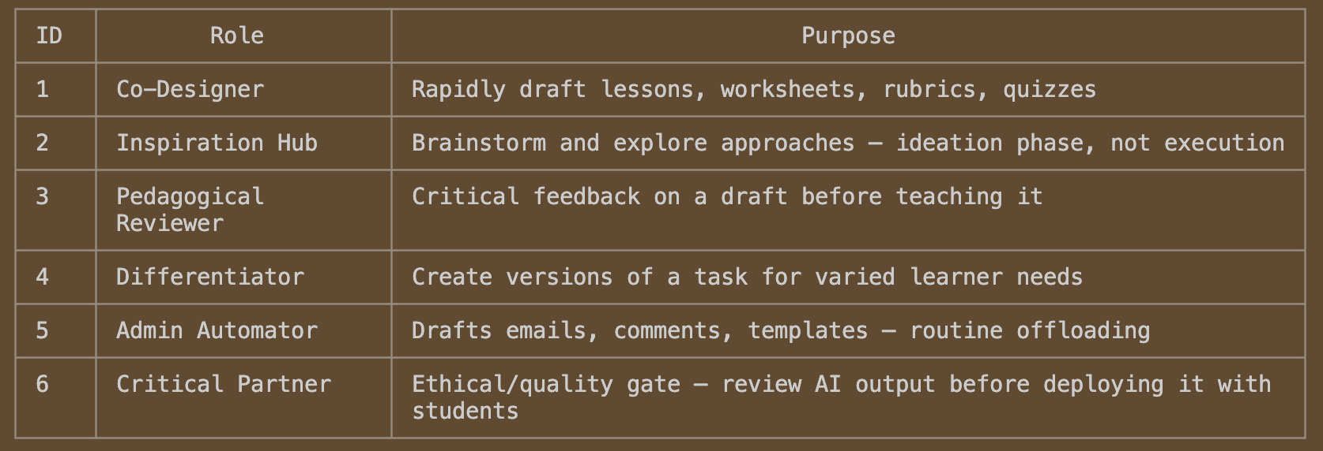
Each role has a detailed system prompt with explicit task constraints and a "begin by" opener — but
in the actual API call, that opener is overridden by the IMPORTANT OVERRIDE block (see below).

Section 3 — Standing Guardrails

Always appended, regardless of role. Instructs the model to:
- Flag factual uncertainty
- Identify assumptions made about students
- Remind the teacher they are the final reviewer
- Never invent student data
- Push back if asked to remove the teacher from the loop entirely

The Override Block (route.ts:213)

Because the role prompts are designed for interactive chat (they ask clarifying questions), the API
route injects a hard override:

IMPORTANT OVERRIDE FOR THIS TOOL:
- Do NOT ask clarifying questions.
- Do NOT output anything except valid JSON.
- The user has provided sufficient context; make reasonable assumptions and proceed.
- Your job is to generate a lesson flow (phases) now.

This forces the model to skip its usual dialogue mode and produce structured JSON output immediately
— since the app collects all context upfront through the form fields.

Output

All three sections are concatenated into a single prompt, sent to the active AI provider, and the
response is expected to be:
{ "lesson_flow_phases": [{ "time_text": "", "phase_text": "", "activity_text": "", "purpose_text":
"" }] }

