Food Waste Prediction for a College Canteen
Machine Learning Project – Report-Ready Results and Analysis

Important note on the dataset
The 120 daily records in the accompanying workbook are simulated example data created for an academic demonstration. They are not actual measurements from a specific college canteen. Replace them with verified canteen records before presenting the results as real-world findings.

1. Objective
The objective is to estimate daily food waste (in kilograms) using operational information such as student attendance, menu type, weather, exam-day status, meals prepared, and day of the week. Better estimates can help canteen staff plan meal quantities and reduce avoidable waste.

2. Dataset description
The example dataset contains 120 daily records. Each record includes date, day, attendance, exam-day status, low-service/holiday status, menu type, weather, meals prepared, food prepared (kg), food consumed (kg), food wasted (kg), and waste percentage. The prediction target is Food_Wasted_kg.

3. Methodology
- Data preparation: categorical fields were one-hot encoded; numerical fields were passed through unchanged.
- Model: Random Forest Regressor with 250 trees and a fixed random seed for reproducibility.
- Evaluation: records were split into 80% training and 20% test data using a fixed random seed.
- Metrics: MAE measures average absolute prediction error; RMSE penalizes larger errors more strongly; R² describes test-set fit relative to a mean baseline.

4. Model evaluation
Metric | Result
Algorithm | Random Forest Regressor
Total records | 120
Training records | 96
Test records | 24
MAE (kg) | 4.459
RMSE (kg) | 6.781
R² score | 0.432
Because this is simulated data, these evaluation scores demonstrate the workflow only; they should not be interpreted as expected accuracy on real canteen data.

5. Results and interpretation
Across the simulated period, average daily food waste was 21.25 kg, and the average waste percentage was 17.82%. The average daily attendance was 282 students.
In this generated dataset, Snacks had the highest average waste (25.34 kg/day), while Special Meal had the lowest (16.05 kg/day). These are patterns in the simulated records, not verified facts about a real canteen.

6. Graphs to include in the report
Figure 1. Daily observed and predicted food waste.
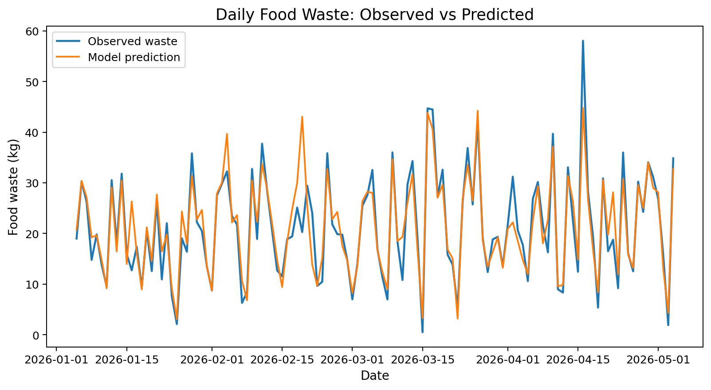
Figure 2. Actual versus predicted food waste on the test set.
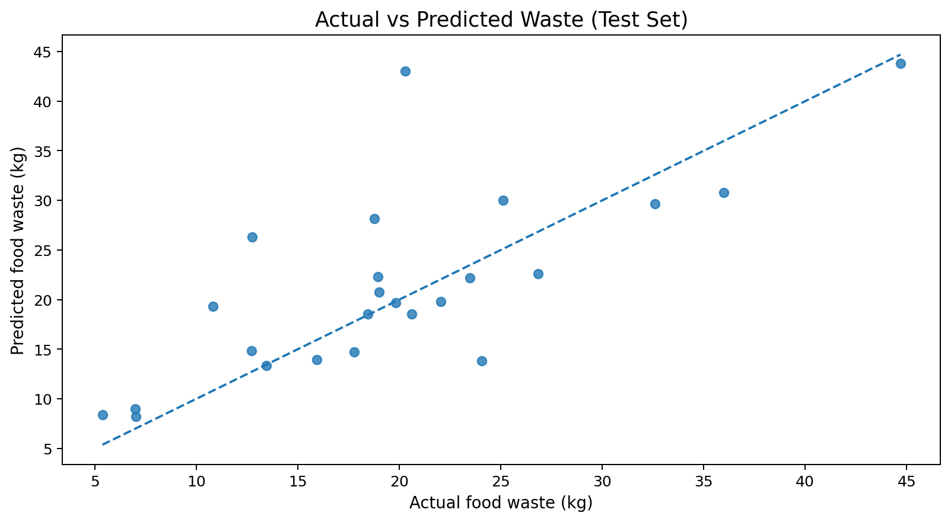
Figure 3. Distribution of daily food waste.
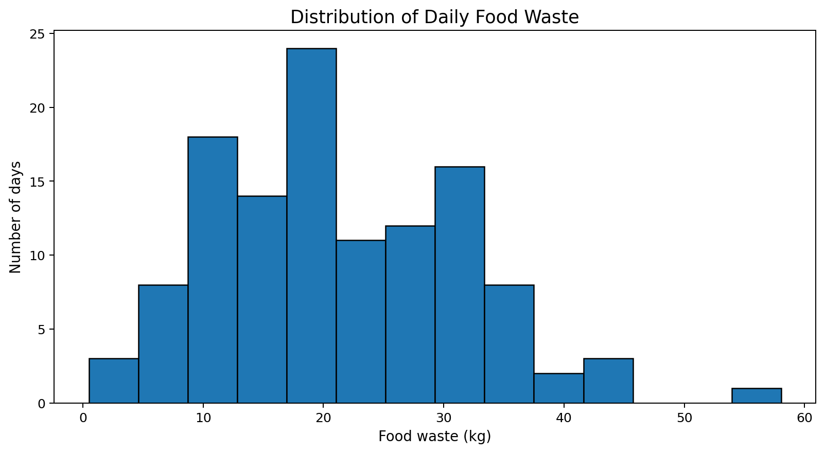
Figure 4. Average waste by menu type.
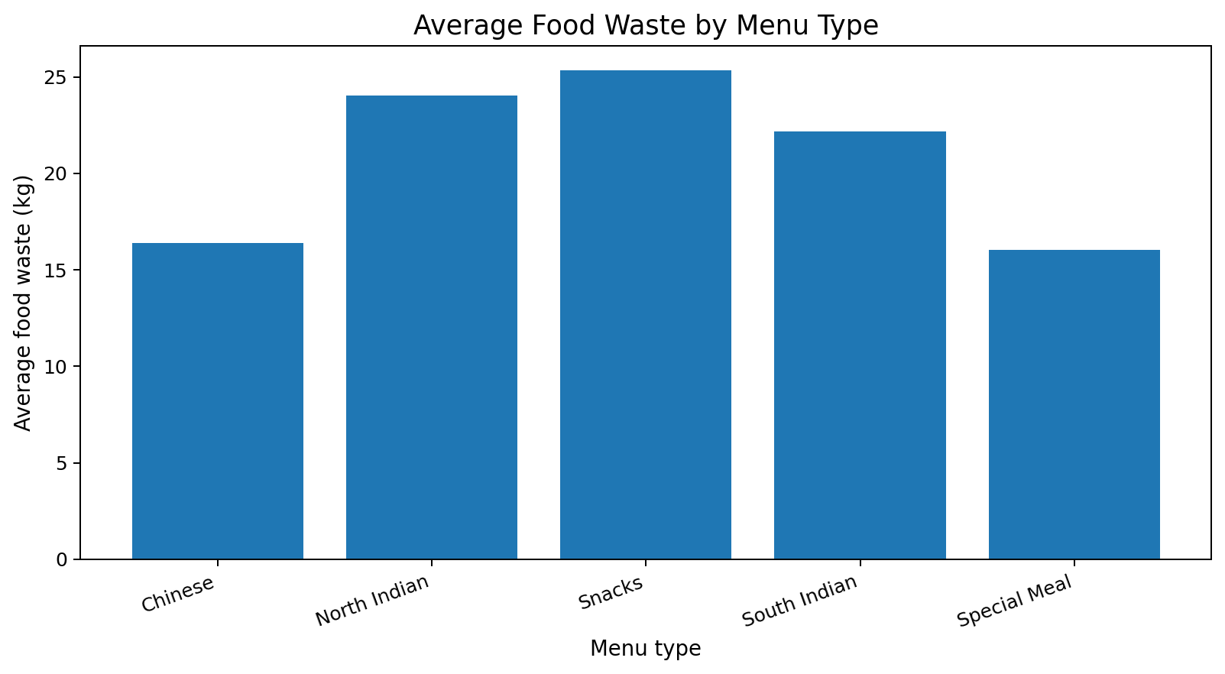
Figure 5. Average waste by day of the week.
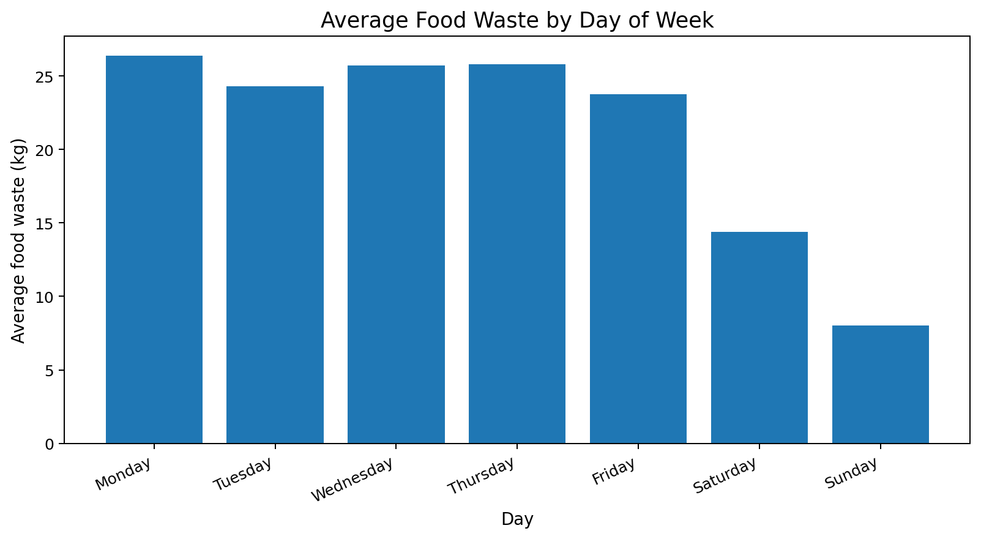
Figure 6. Relationship between attendance and food waste.
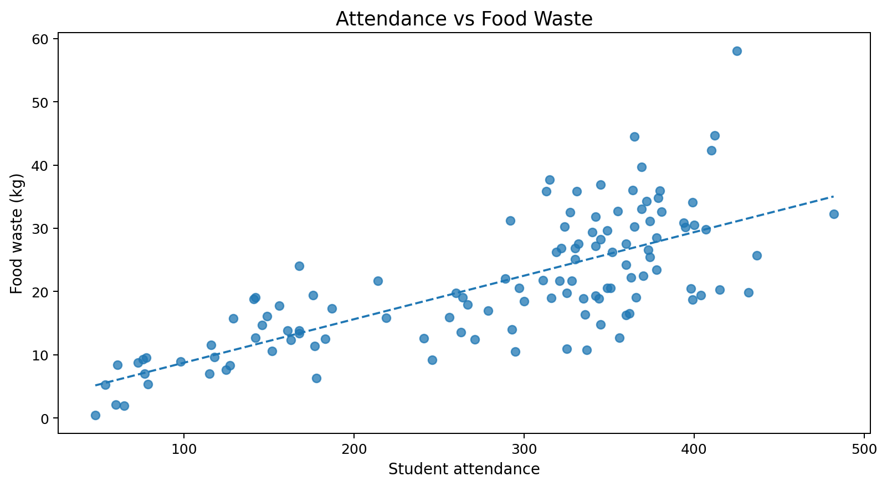
Figure 7. Daily waste as a percentage of food prepared.
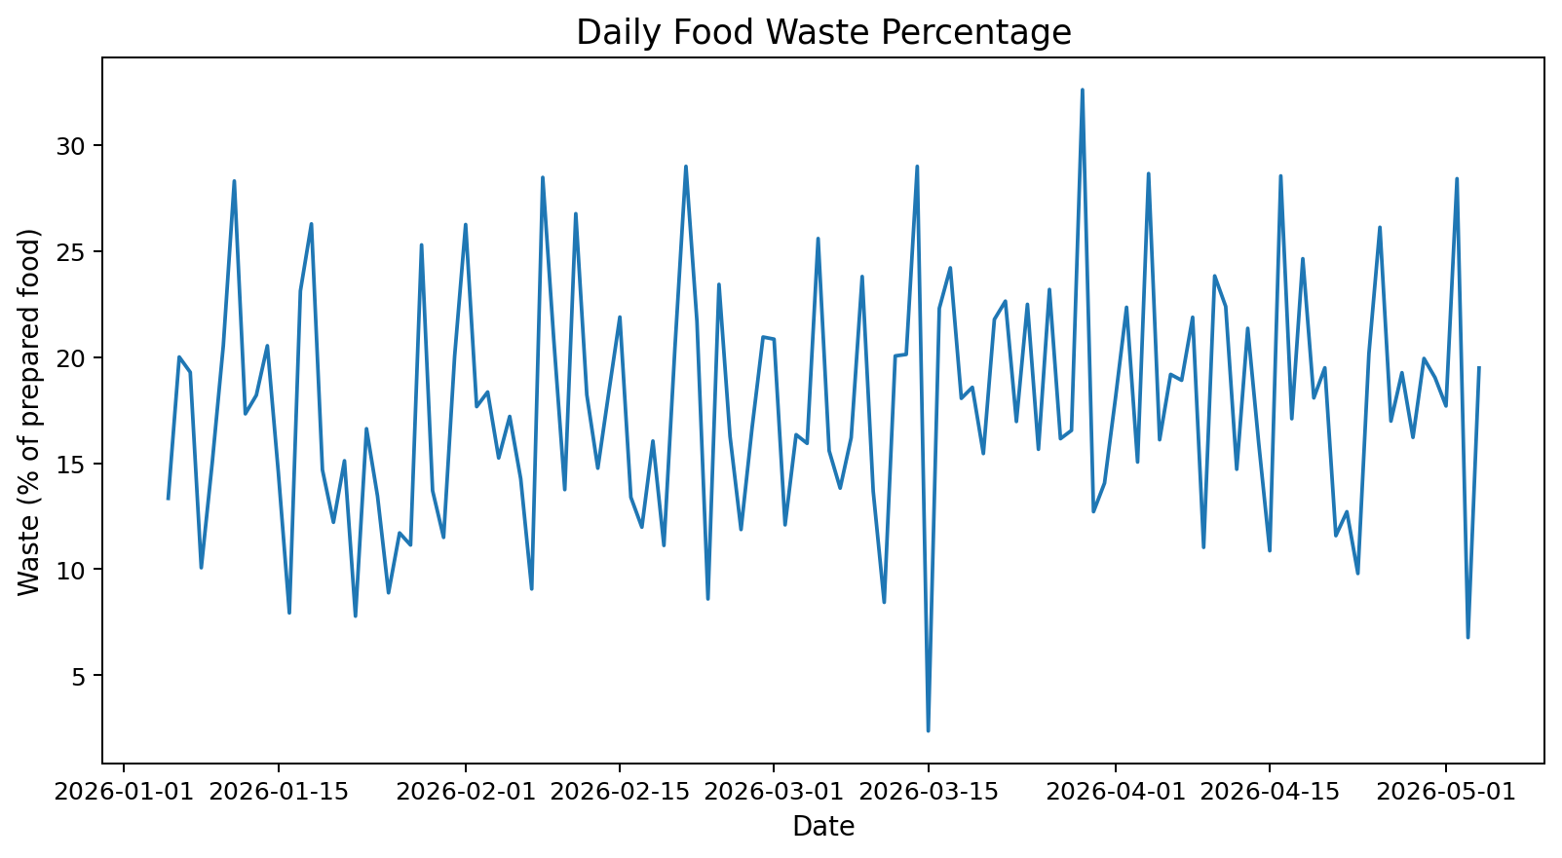
Figure 8. Total waste by month.
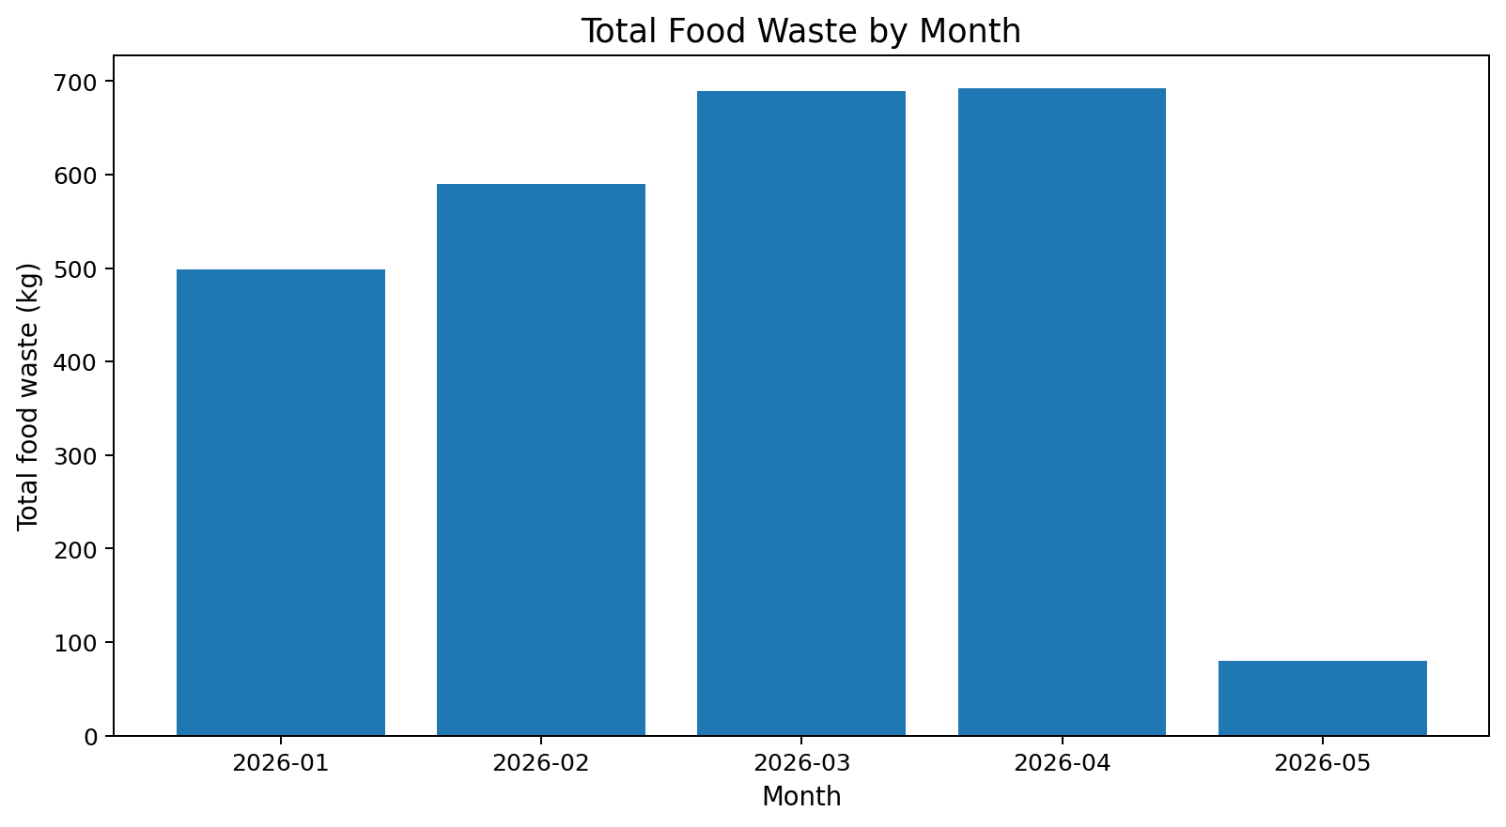

7. Conclusion
A food-waste prediction system can support daily meal planning by estimating leftovers before preparation. A practical deployment should collect reliable daily attendance, menu, preparation, and leftover-weight records; retrain and validate the model on historical data; and review predictions with canteen staff. The model should be treated as a decision-support tool rather than an automatic substitute for staff judgement.

8. Future improvements
- Collect real canteen data for at least one full academic term.
- Add menu item quantities, portion size, price, special events, and previous-day waste.
- Compare Random Forest with Linear Regression, Decision Tree, and Gradient Boosting.
- Use time-based validation for future-date forecasting instead of relying only on a random split.
- Create a simple dashboard showing predicted waste and recommended meal preparation quantities.

