How to debug in play framework with eclipse:

run → debug congifurations

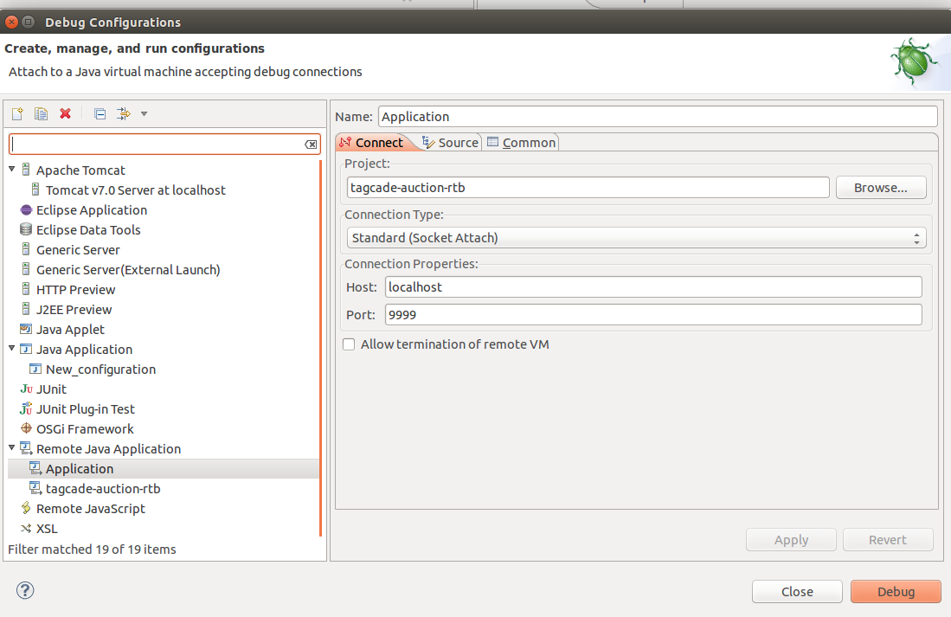

set port -9999; click Debug-> apply → close → test

