Guide: Set up playFramework / Eclipse / window7
1. Configuration environment:
Download elipse
Set up: Path → javac
JAVA_HOME
download playFramework
set up environment variable for play: add path;

2. Create play framework
Open: cmd

play → chạy play
cd download → chuyển về thư mục download
play new demo1 → tạo project mới: demo1
demo1 → chọn tên dự án: demo1
2 → kiểu dự án playFramework tạo sẵn:1 Scala,2 Java,3 empty project
cd demo1 → chuyển về thư mục demo1
play eclipse → play eclipsify: chỉ dùng cho version: play 1.x
: play 2.x trở lên dùng lệnh: eclipse

3. Import play project into eclipse
Open eclipse
Import exist project from workspace → choose project demo1→ success

4. debug eclipse
play debug
~run
Open browser: add link: localhost:9000

Referency:
http://techmaster.vn/2013/09/tao-play-framework/
https://www.youtube.com/watch?v=XPDq7wTf-cM
https://www.youtube.com/watch?v=QaJl_nnSykU
http://stackoverflow.com/questions/18183124/not-a-valid-key-eclipsify

Debug play with eclipse
https://www.youtube.com/watch?v=1SCTOl0qrlM

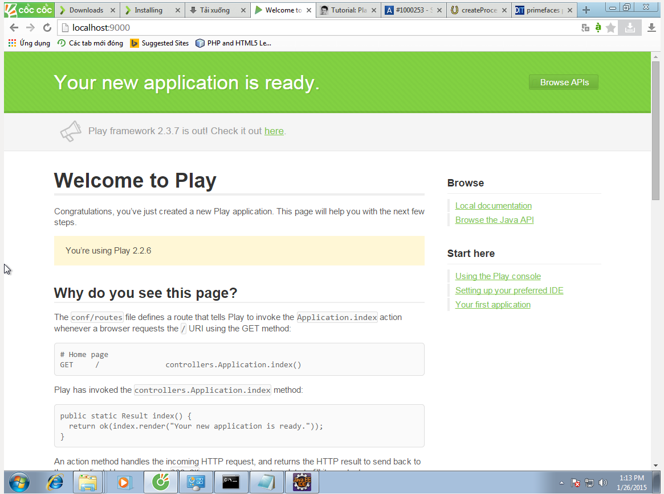

add to build.sbt:
"com.google.inject" % "guice" % "4.0-beta"
→
add them google.inject jar →
→ apply DI into play

Muốn xóa cache trong play: play clean
controller: bắt buộc phải để static → được compile cùng với project;

Sau khi clone play project .
import project by eclipse, hệ thống sẽ không nhận được project, mặc dù vẫn có thể start local host và chạy bình thường bằng cmd.
→ cmd → trỏ vào thư mục dự án → chạy lại lệnh: play eclipse → import project by eclipse - ok

sample-play-with-guice-master

83down voteaccepted | Play uses static methods only when it makes sense:  - in the controller layer, because controllers are not object oriented. Controllers act as mapper between the HTTP world (that is stateless, and request/response based) and the Model layer that is fully object oriented.  - in the model layer for factory methods, like findAll(), count(), create() which of course don't depend of any particular instances  - in some play.libs.* classes that provides purely utility functions
  shareimprove this answer | answered Mar 4 '11 at 12:31    Guillaume Bort  1,25075

http://stackoverflow.com/questions/5192904/play-framework-uses-a-lot-of-statics

