Branches new

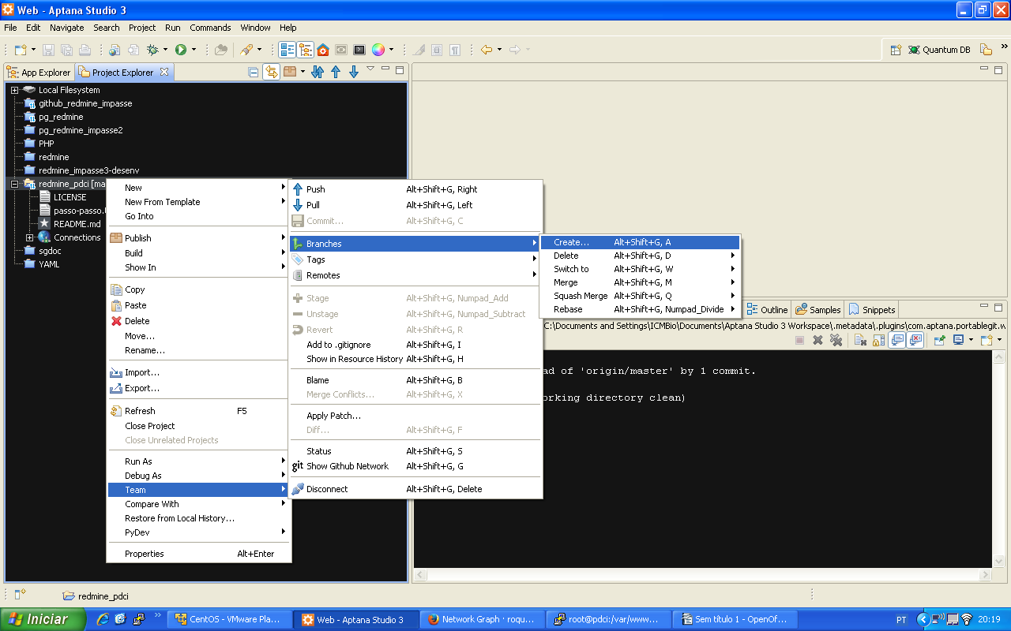

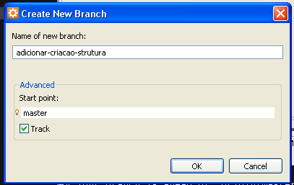

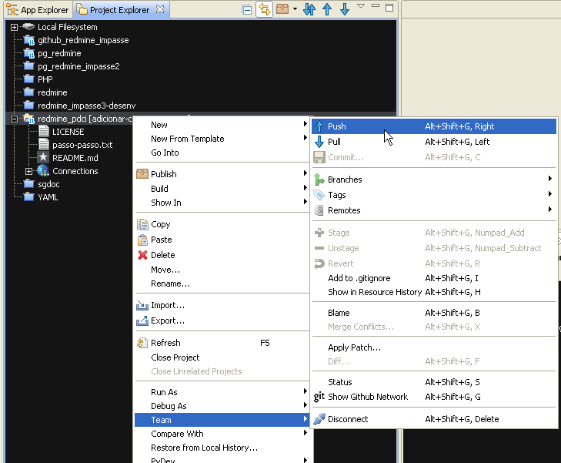
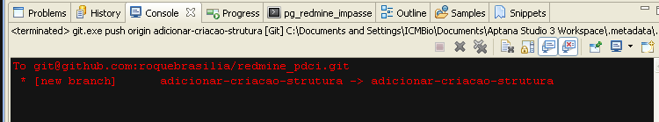
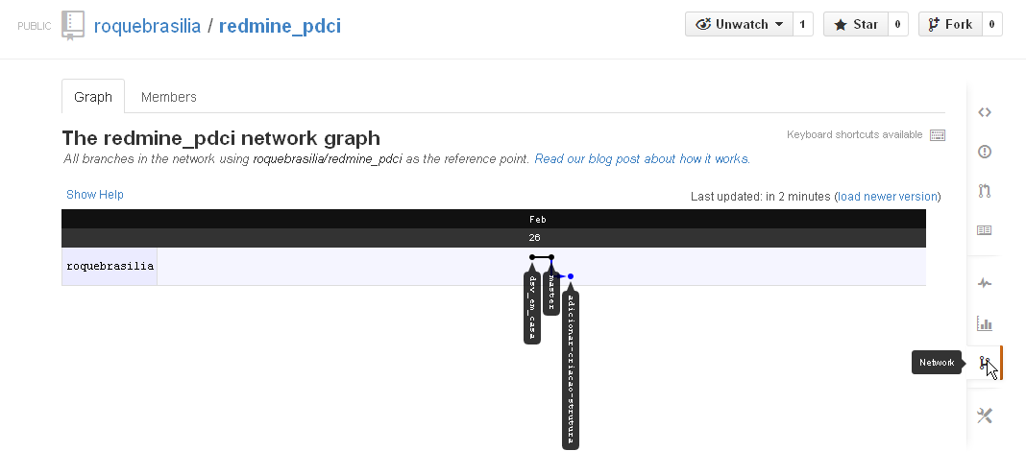
RAILS_ENV=production rails g redmine:plugin polls
RAILS_ENV=production rails g redmine:plugin pdci
create
create init.rb
create config
create config/routes.rb
create config/locales
create config/locales/en.yml
create lib
create lib/redmine_pdci
create lib/redmine_pdci.rb
create lib/redmine_pdci/version.rb
create app
create app/models
create app/models/.gitkeep
create app/controllers
create app/controllers/.gitkeep
create app/helpers
create app/helpers/.gitkeep
create app/views
create app/views/.gitkeep
create Gemfile
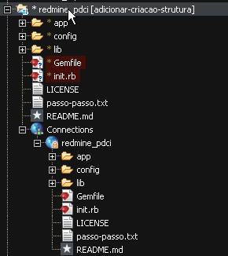
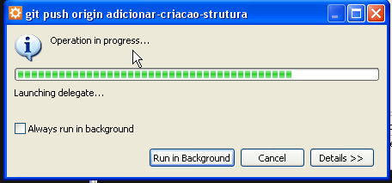
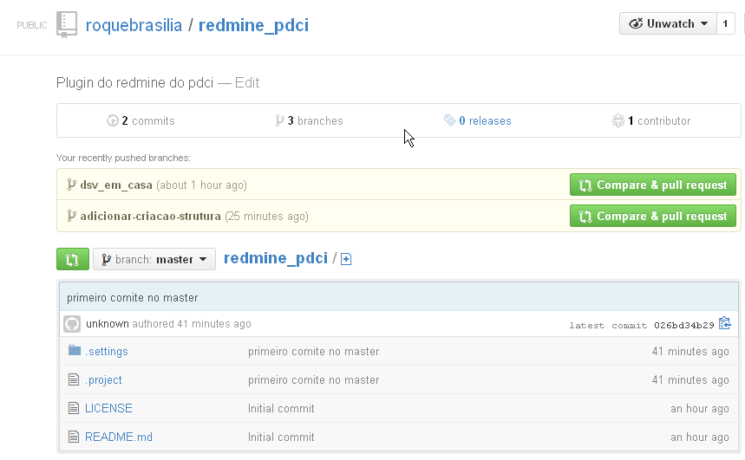
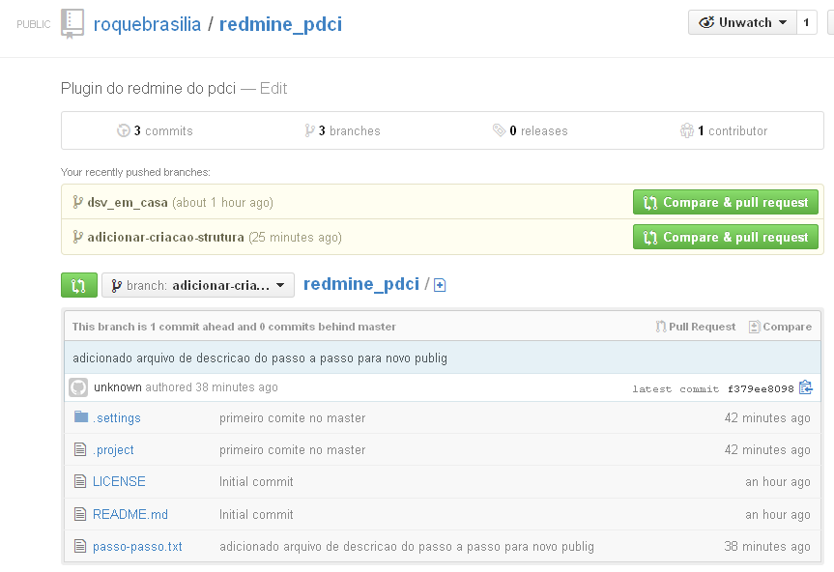
Sem alteracao
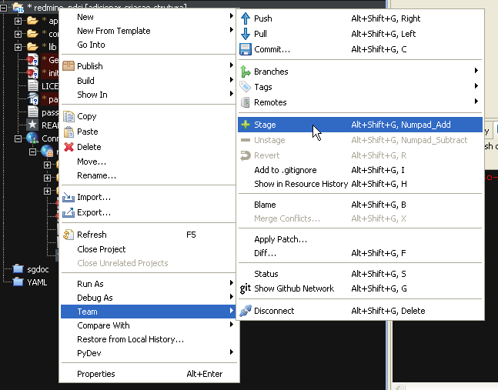
stage
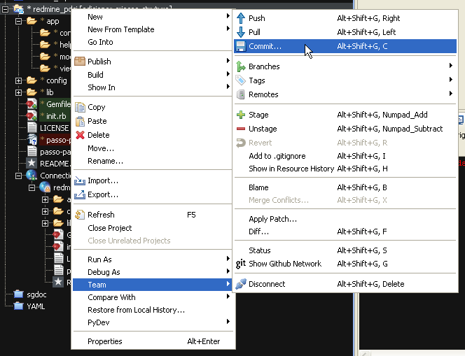
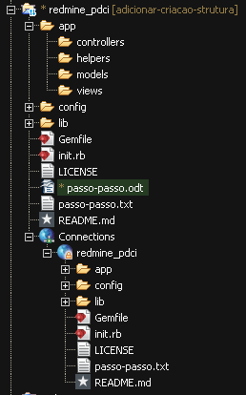
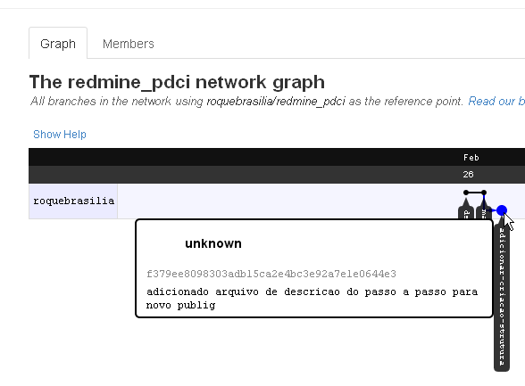
Stage para o arquivo odt

push

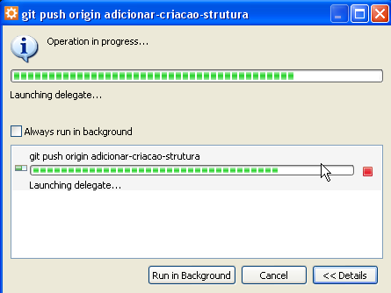
Apareceu o ultimo comite depois do push

só esta faltando o nome do usuário que comitou

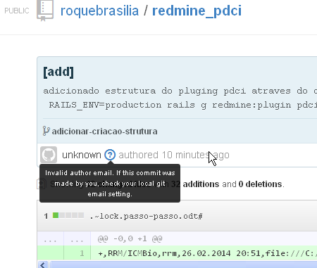
git config --global user.email “roquebrasilia@gmail.com”

verificar comando git config --global user.email
fiz o commit
push
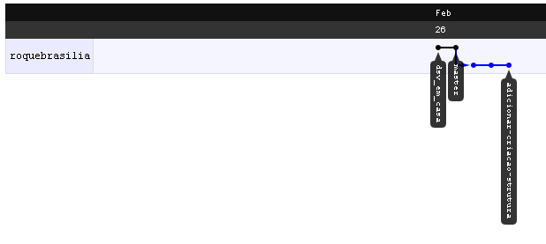
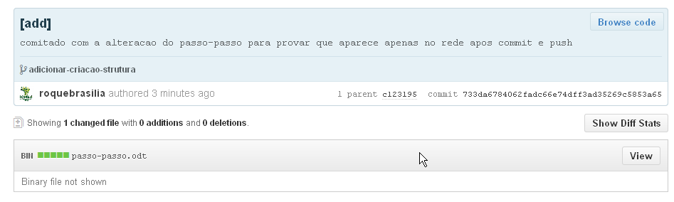
RAILS_ENV=production rails g redmine:scaffold pdci tb_poll question yes:integer no:integer

[root@pdci pg-redmine]# RAILS_ENV=production rails g redmine:scaffold pdci tb_poll question yes:integer no:integer
invoke active_record
create db/migrate/20140227001838_create_tb_polls.rb
create app/models/tb_poll.rb
invoke test_unit
create test/unit/tb_poll_test.rb
create test/fixtures/tb_polls.yml
invoke resource_route
route scope "/projects/:project_id" do
resources :tb_polls
end
invoke scaffold_controller
create app/controllers/tb_polls_controller.rb
invoke erb
create app/views/tb_polls
create app/views/tb_polls/index.html.erb
create app/views/tb_polls/edit.html.erb
create app/views/tb_polls/show.html.erb
create app/views/tb_polls/new.html.erb
create app/views/tb_polls/_form.html.erb
invoke test_unit
create test/functional/tb_polls_controller_test.rb
invoke helper
create app/helpers/tb_polls_helper.rb
invoke test_unit
create test/unit/helpers/tb_polls_helper_test.rb
invoke translation
translation en: label_tb_poll
translation en: label_tb_poll_plural
translation en: label_tb_poll_new
translation en: label_tb_poll_edit
translation en: label_tb_poll_created
translation en: label_tb_poll_updated
translation en: label_tb_poll_destroyed
translation en: field_question
translation en: field_yes
translation en: field_no
invoke project_module
insert init.rb
invoke project_menu
insert init.rb
create app/views/tb_polls/_tb_poll.html.erb
create app/views/tb_polls/_form.js.erb
create app/views/tb_polls/show.js.erb
create app/views/tb_polls/new.js.erb
create app/views/tb_polls/create.js.erb
create app/views/tb_polls/edit.js.erb
create app/views/tb_polls/update.js.erb
create app/views/tb_polls/destroy.js.erb
Stage
commit
push

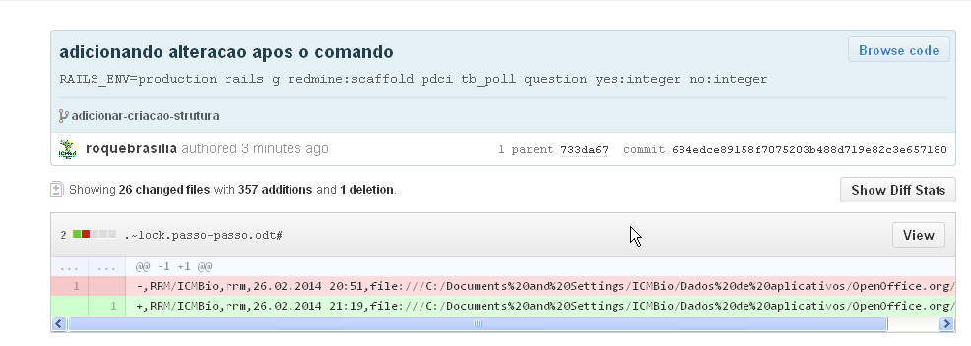
Criar a base de dados

RAILS_ENV=production rake generate_secret_token db:migrate redmine:plugins:migrate

RAILS_ENV=production rake generate_secret_token db:migrate redmine:plugins:migrate
Migrating redmine_pdci (Redmine Pdci)...
== CreateTbPolls: migrating ==================================================
-- create_table(:tb_polls)
NOTICE: CREATE TABLE will create implicit sequence "tb_polls_id_seq" for serial column "tb_polls.id"
NOTICE: CREATE TABLE / PRIMARY KEY will create implicit index "tb_polls_pkey" for table "tb_polls"
-> 0.3373s
-- add_index(:tb_polls, :author_id)
-> 0.0052s
-- add_index(:tb_polls, :project_id)
-> 0.0063s
== CreateTbPolls: migrated (0.3490s) =========================================

