NPC – UNIT 4 ASSIGNMENT
Configure DHCP and Set Up a Network Using Cisco Packet Tracer
Student Name | Yash Kawde
Subject | Network Protocols and Communication (NPC)
Software | Cisco Packet Tracer 9.0.1
Assignment Unit | Unit 4 – DHCP Configuration
Submitted as a step-by-step practical report with screenshots captured during the configuration and testing process.

Aim
To create a small LAN in Cisco Packet Tracer, configure a server with a static IPv4 address, enable DHCP, assign IP configuration automatically to PCs, and verify connectivity using ping.

Network Topology
The topology contains three PCs, one 2960-24TT switch, and one server. Each end device is connected to the switch using Copper Straight-Through Ethernet cables.
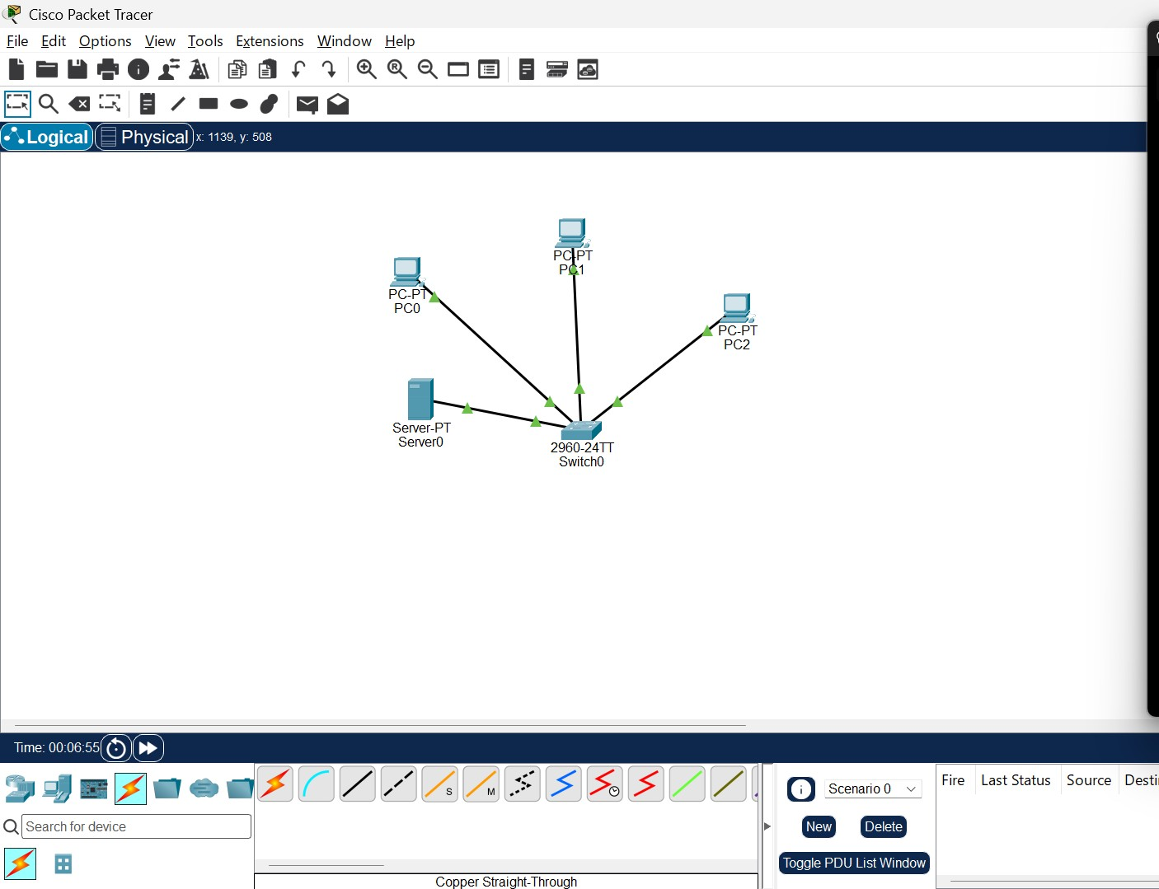
Figure 1. Network topology with PC0, PC1, PC2, Server0, and Switch0.

IP Addressing and DHCP Configuration
Server0 was configured with a static IPv4 address so that clients can communicate with it reliably. The DHCP service was enabled and a pool named NPC_POOL was configured.
Device / Setting | Configured value
Server0 IPv4 address | 192.168.1.2
Subnet mask | 255.255.255.0
DHCP pool name | NPC_POOL
DHCP pool start address | 192.168.1.10
DHCP pool subnet mask | 255.255.255.0
Maximum number of users | 50
Default gateway / DNS | 0.0.0.0 (not configured for this local LAN test)
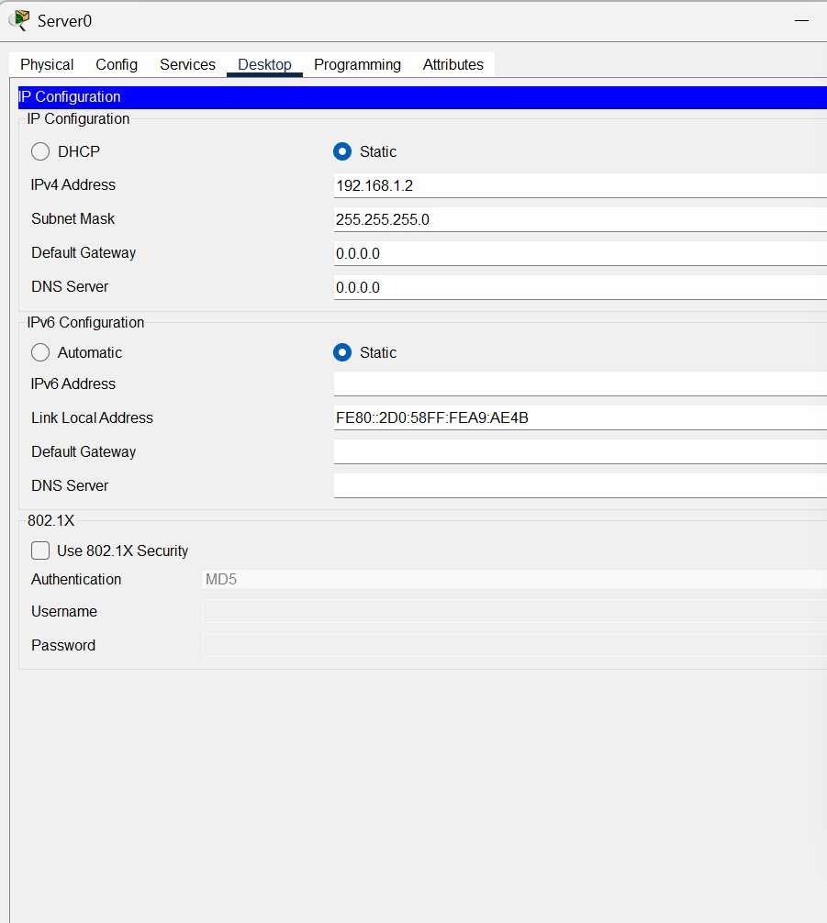
Figure 2. Server0 static IP configuration.

DHCP Service Setup
In Server0, Services → DHCP was opened. DHCP service was switched On, and the NPC_POOL entry was configured with the start IP address 192.168.1.10 and subnet mask 255.255.255.0.
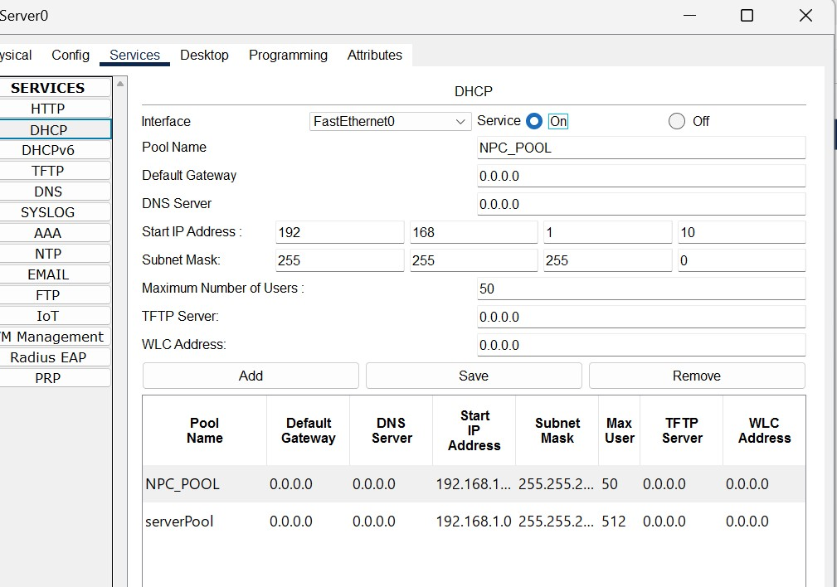
Figure 3. DHCP service and NPC_POOL settings.

Automatic IP Configuration on PCs
On each PC, Desktop → IP Configuration was opened and DHCP was selected. The screenshots show successful DHCP requests and the IPv4 addresses received by the PCs.
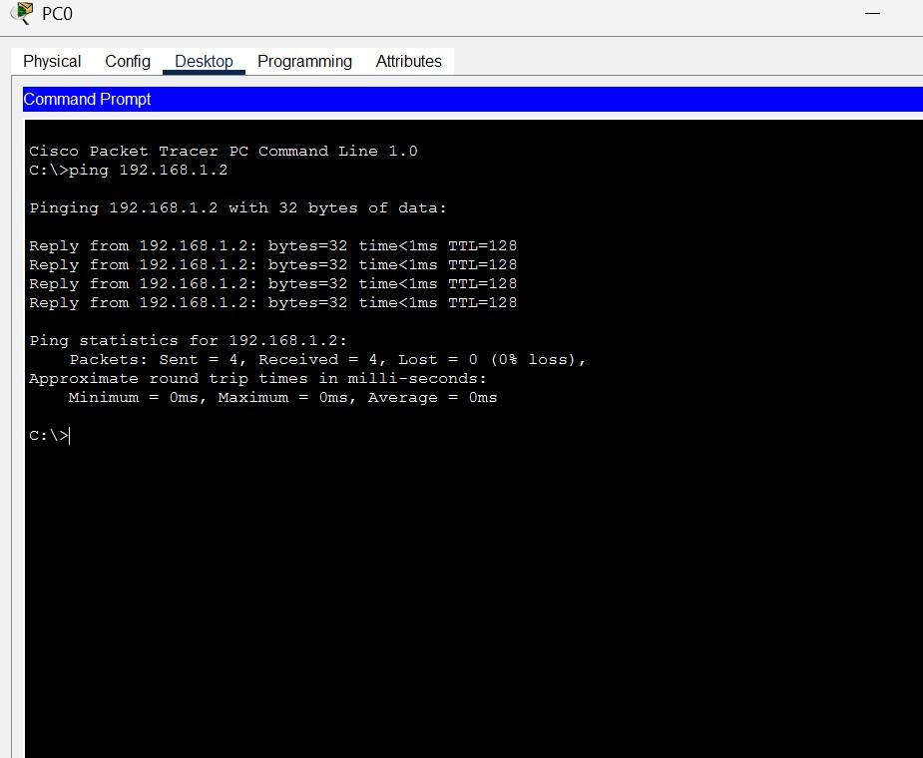
Figure 4. PC0 IP configuration (DHCP successful; IPv4 address shown as 192.168.1.1).
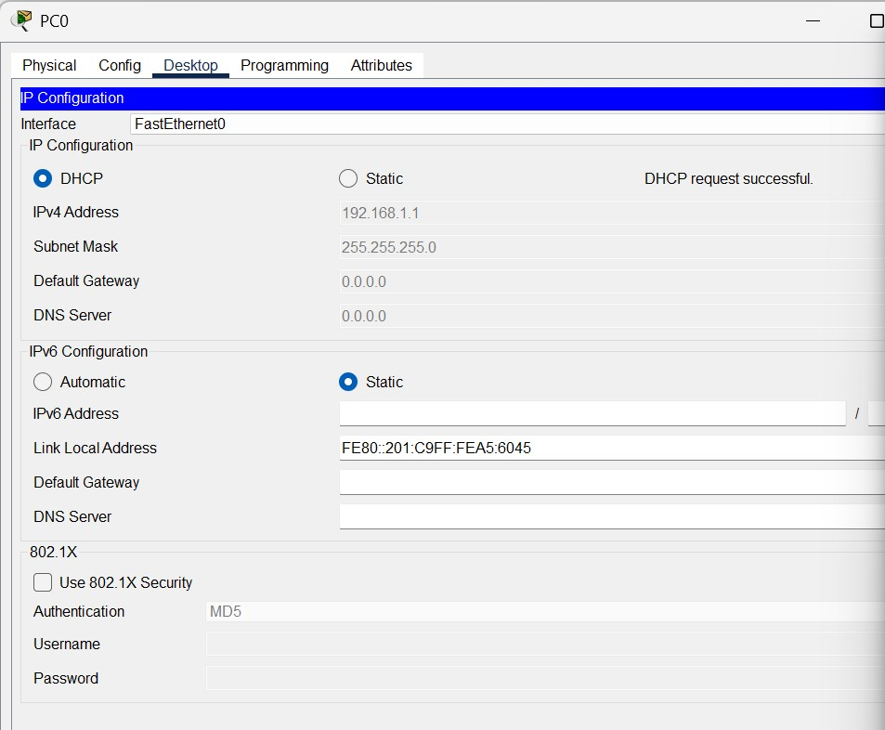
Figure 5. PC1 IP configuration (DHCP successful; IPv4 address shown as 192.168.1.3).
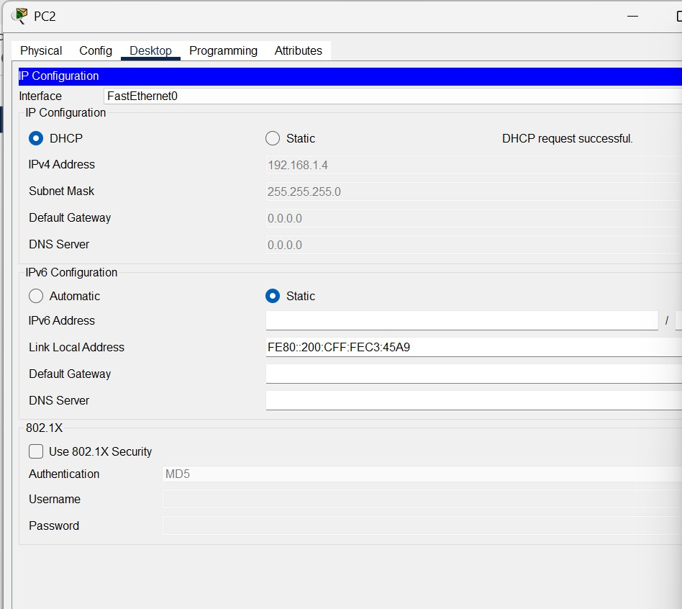
Figure 6. PC2 IP configuration (DHCP successful; IPv4 address shown as 192.168.1.4).

Connectivity Testing
Connectivity was verified from PC0 using the ping command. The tests to Server0 (192.168.1.2), PC1
(192.168.1.3), and PC2 (192.168.1.4) returned replies. The displayed statistics show 4 packets sent, 4 received, and 0% packet loss for each test.
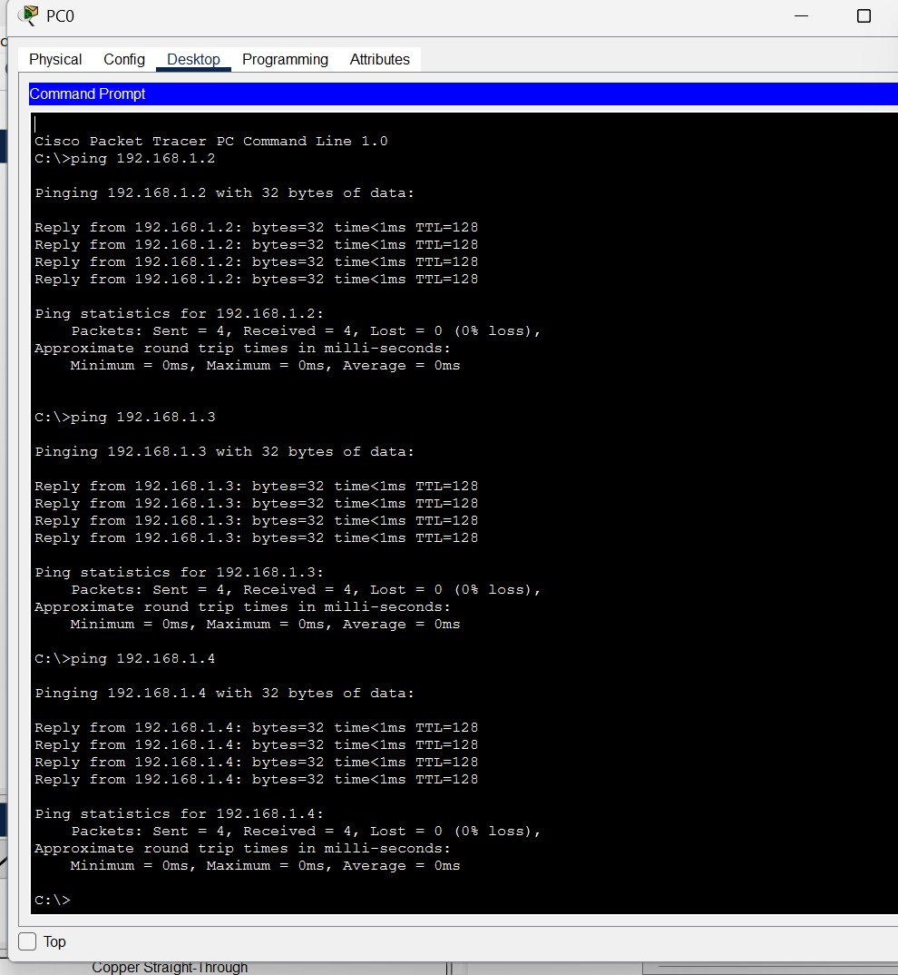
Figure 7. Successful ping tests from PC0 to Server0, PC1, and PC2 (ChatGPT window excluded).

Results and Conclusion
The LAN topology was created successfully in Cisco Packet Tracer. Server0 was assigned a static IP address, the DHCP service was enabled, and the PCs received IPv4 configuration automatically. Ping tests confirmed connectivity between PC0, Server0, PC1, and PC2.
Configuration note: The captured PC screenshots show addresses 192.168.1.1, 192.168.1.3, and 192.168.1.4, although the NPC_POOL was configured to start at 192.168.1.10. This indicates that the default serverPool or an earlier DHCP lease may have supplied the displayed client addresses. The network connectivity tests succeeded; the DHCP pool allocation should be reviewed if the instructor requires the clients to receive addresses specifically from .10 onward.

