**Checking Missing Data and Dropping**

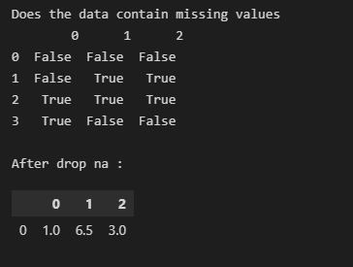

**Filling Missing Data Using Dict**

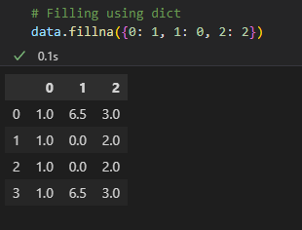

**Filling Data Using Mean**

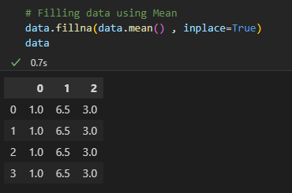

**Removing Duplicates by Dropping**

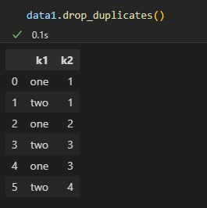

**Data Transformation**

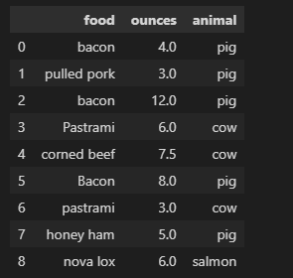

**Replacing Values**

