Food Calorie Estimation using Deep Learning

Chintan D Koticha, Chinmay Keskar and Sneha Kawitkar
Department of College of Engineering, Northeastern University
koticha.c@husky.neu.edu, keskar.c@husky.neu.edu, kawitkar.s@husky.neu.edu

Abstract - As important attribute for a healthy body depends on the number of calories consumed, hence monitoring calorie intake is necessary to maintain good health. In this project, we propose an efficient way classify food objects and to measure the calorie intake by recognizing a fruit and vegetable using object recognition and deep learning neural networks. We propose a CNN-based food classification and food detection model using tensor flow to estimate the number of calories; in an image of food taken; based on the average calorie value of each detected category.

Keywords
Deep Learning; Food Classification; Food Detection; Convolutional Neural Network; Keras; Tensorflow; Hyperparameter Tuning; Pattern Recognition

Introduction
- MOTIVATION
Food is the key of human’s body. Nowadays more and more people care about the dietary intake since unhealthy diet leads to numerous diseases. A diet plan always needs to take into consideration the total number of calories to be consumed to maintain a fit and healthy life. But, in most cases, unfortunately people face difficulties in estimating and measuring the amount of food intake due to the mainly lack of nutritional information, which includes manual process of writing down this information, and other reasons. As such, a system to record and measure the number of calories consumed in a meal is of a great help. Hence accurate prediction of food calorie is equally important in such cases. In the last three years, object classification and detection capabilities have dramatically improved due to advances in deep learning and convolutional networks [1]. Harnessing this technology to accurately classify and detect food objects is significantly essential for a healthy and fit life. But to always refer to the nutritional content in each food item is an extremely tedious task. In this project, we use a deep learning-based fruit image recognition algorithm to improve the accuracy of dietary assessment and analyze each of the network architecture.

- BACKGROUND
For food classification, previous work was concentrated on basic machine learning algorithms like Random Forest and SVM with hand-tailored features. These methods are generally based on relative or spatial relationships of features. But these methods come with computational cost at a large scale. Random forest came up with an accuracy of XXXX whereas SVM came up with an accuracy of XXXX and our CNN model built with Keras and TensorFlow gave an accuracy of 97%. Also, we show here how the model behaves with hyperparameter tuning by changing parameters like the learning rate and number of neurons in each hidden layer which govern how effectively a model behaves. Another feature governing a model’s training pertains to how fast does the loss plateau, which depends on L1 and L2 norms of the hidden layers or else on functions like the initializers and optimizers. In this paper, we show exactly how the model behaves when these characteristics are changed. Our final detection model is purely based on Tensorflow’s Object detection API to detect multiple food items in each image and then using mathematical calculations to find the calorie content of food classes present in the image.

- ALGORITHM
This paper presents various classification algorithms like Random Forest and Support Vector Machines (SVMs) along with neural nets (Convolutional Neural Networks) built on Keras and Tensorflow API to classify 60 categories of fruits. We used LabelImage’s graphical user interface to manually bound input bounding boxes on training images scraped from google and then use SSD_MobileNet_V1_COCO model’s weights to train our dataset using transfer learning approach on 8 categories of food classes. This is then used with raccoon object detector [6]. Finally, layers are changed in Tensorflow’s object detection API to fine tune model for own dataset training. Evaluation is done using TensorBoard’s Evaluation of our trained model. The final detection is then used to count the respective class count of food objects to calculate the total diet/ calorie count in the provided image.

METHODS

Image classifier
To understand image classification, we have used various classification methods such as Random Forest classifier and Support Vector machine along with Keras’s deep learning library on top of Google’s Tensorflow API in python to build our CNN (Convolutional Neural Network). Dataset used for training the model was Fruit - 360 dataset [2].

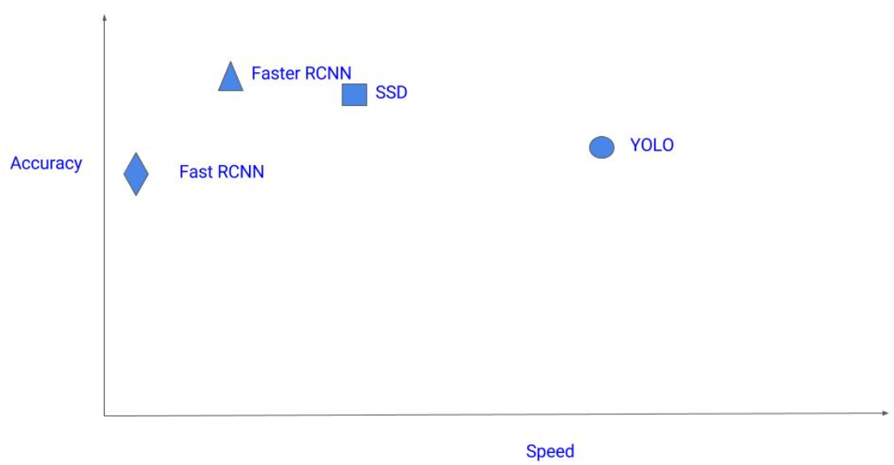

Fig 1: Comparison of detection algorithms [8]

CNN was built with following major steps:

1.Sequential: It is used to create a linear stack of layers. A sequential model by passing a list of layer instances to the constructor. We then pass an input shape to the first layer which is generally a tuple. Along with the input shape a batch size dimension is included useful for specifying a fixed batch size. [9]

2.Convolutional: In a convolutional layer, all neurons apply convolution operation to the inputs. The most important parameter in a convolutional neuron is the filter size on which the output of this layer is dependent. [3]

3.Pooling: Pooling layer used is Max pooling which is used to reduce the spatial size. which reduces number of parameters, hence computation is reduced.

4.Full connection: After receiving inputs from the previous neurons, final layer is the fully connected one.
Following image can correctly depict the classifier operation for our model.

We can use Keras provided initializers to set the random initial weights of Keras layers like ones, zeros, a constant value or randomly uniform or truncated normal weights which we decide how the neurons fire based on predefined weights to see how the accuracy varies.

Another important factor driving accuracy and loss is activation functions. Activations can either be used through an activation layer or added as an argument to any of the dense layers.

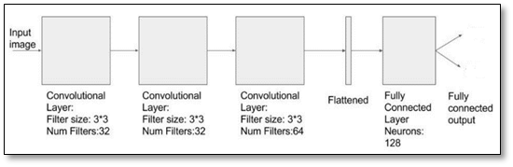
Fig 2: CNN Model Architecture; Classifier Network [3]

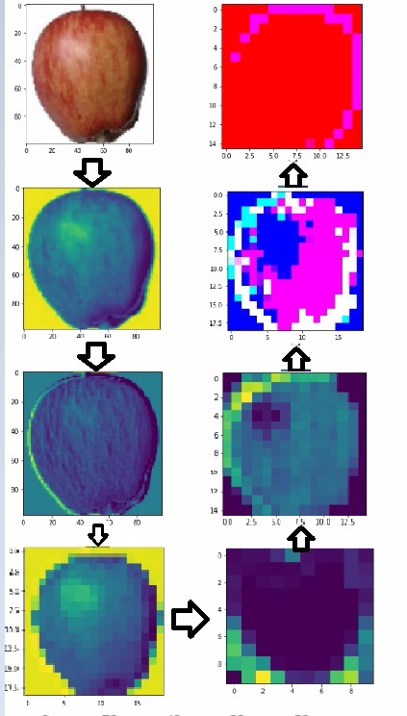
Fig 3: Steps of Image when passed through classification network

We started our classification with a binary classification detecting 2 classes of fruits using the Fruit-360 dataset on Kaggle [2]: Apple and Banana which gave us 100% accuracy for a CNN model with 6 layers. Seeing the promising results, we moved on to classifying 60 classes of fruits with 6 layers of neural nets based CNN model. We determined the accuracy based on different parameters such as activation function, initializers and optimizers where-in RMSProp is used as the loss function and categorical-crossentropy was the loss type. Accuracy observed was maximum in case of ‘RMSprop’ as optimizer, ‘categorical cross entropy’ as loss function, ‘zero bias’s initializer and ‘ReLu’ as intermediate layer activation function.
We have also performed hyper parameter tuning to determine the effect of how the accuracy varies with respect to the learning rate and number of neurons per layer. The results showed learning rate clearly affects the training process.

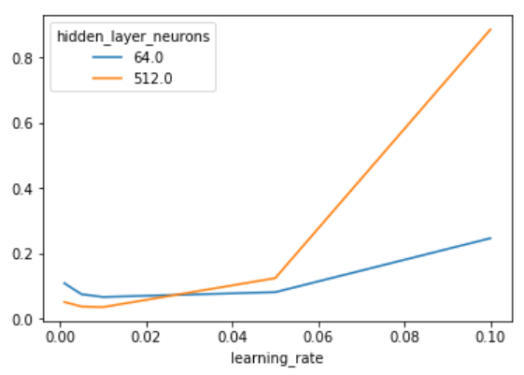
Fig 4: Hyperparameter tuning w.r.t. Learning rate and number of neurons per hidden layer

The results curve validated the following results:

- The learning rate is critical: if it is too low, the neural network does not learn anything (high test error), hidden in above as maximum error limit is kept to 0.8 and original error came out near to 2. If it is too high, the training process may oscillate randomly and even diverge in some configurations.

- The number of neurons is not as important for getting a good performance, and networks with many neurons are much more sensitive to the learning rate. This is Occam’s Razor principle: simpler model tends to be “good enough” for most purposes. If you have the time and resource to go after the missing 1% test error, you must be willing to invest a lot of resources in training, and to find the proper hyperparameters that will make the difference. [10]

Multiple-Image Multiple-Class Detection

First, we scraped about 500 images pertaining to 8 classes of images and labelled each image with all the classes it contained in it using LabelImage’s graphical user interface.
The dataset image count looks like this:

CATEGORY | COUNT
POMEGRANATE | 37
BANANA | 58
CARROT | 57
KIWI | 100
GUAVA | 79
EGGPLANT | 58
CUSTARD APPLE | 41
TOMATO | 75

Each image was manually labelled for multiple fruits per image. This creates an XML per image that basically has the filename, path and the coordinates of the boxes with their labels so that the model can understand where the object of interest is present.

Secondly, each xml is converted into csv for easy tensor vector creation. Tensor Vectors are generated into a TFRecord file format; which is nothing but a simple record-oriented binary format; that the tensorflow application uses for training data. This approach makes it easier to mix and match data for network architectures as all the features are in a field format.

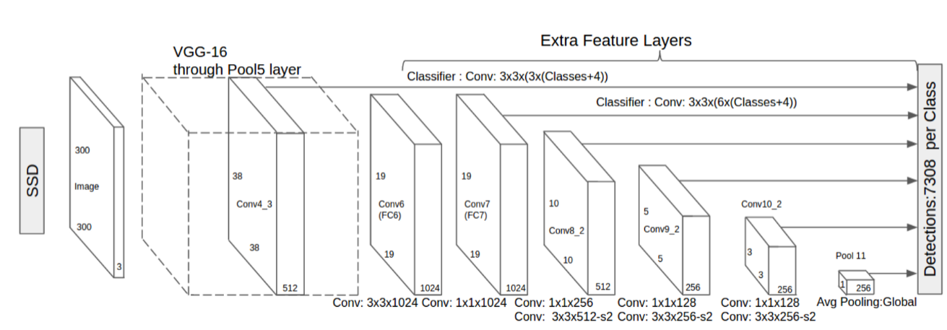

Fig 5: SSD Object Detection Dataset [11]

This is then used in Tensorflow’s object detection API in accordance with SSD_MobileNet_V1_COCO dataset’s weights to train a model from scratch. We trained the model for 1200 epochs with the training loss falling to 1 mAP (mean average precision). The trained model generates a set of meta files and index files that contains the metadata of trained data and a serialized MetaGraphDef protocol buffer. This file describes the data flow, annotations and pipeline related information. These files are finally used to generate a frozen inference graph. We used tensorboard for loss metrics and to view other evaluations visually.

In case, of multiple items in an image, we simply count the number of objects of each food class in the image and then multiple each with their respective calorie amount to finally summing up the individual counts to get the total calories in the image. Further analysis was conducted on topics like which model results in the best accuracy, how the loss curve looks like, and how the optimizers like RMSprop or Adam optimizes the model.

RESULTS
The following graphs are taken from tensorboard:

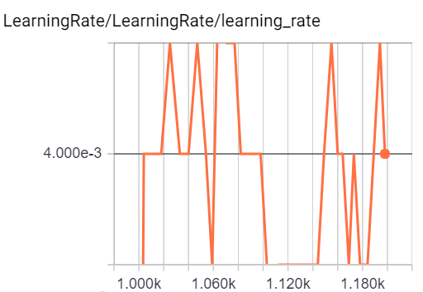

Fig 6: Learning rate

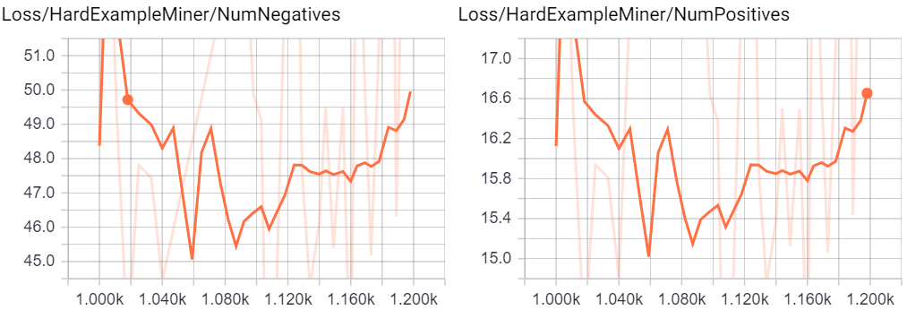

Fig 7: Learning rate

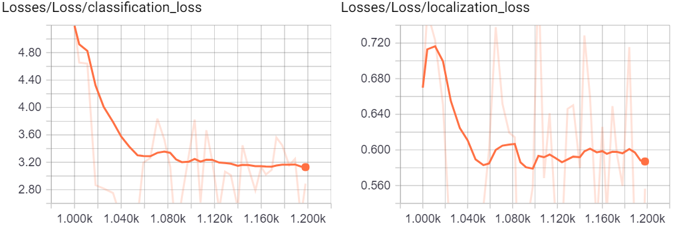

Fig 8: Classification and Localization losses

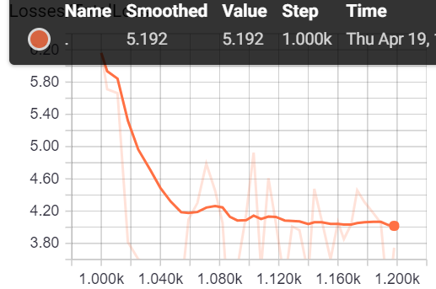

Fig 9: Total losses

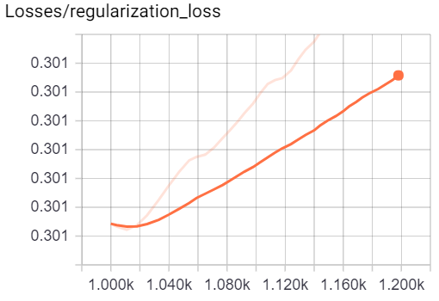
Fig 10: Regularization losses

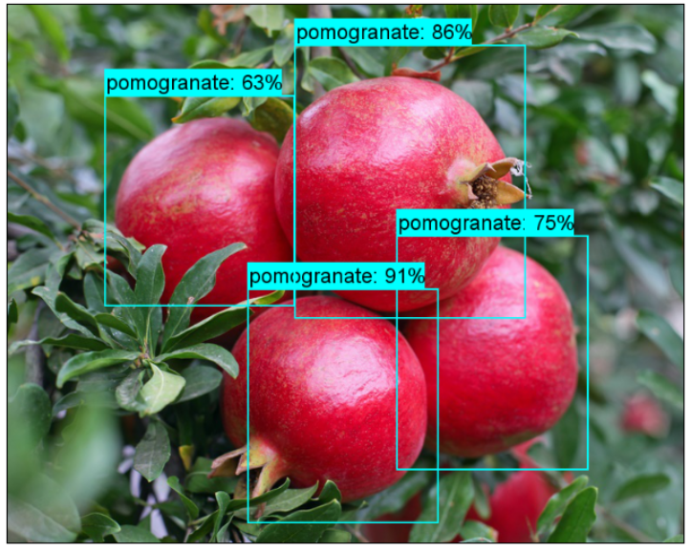
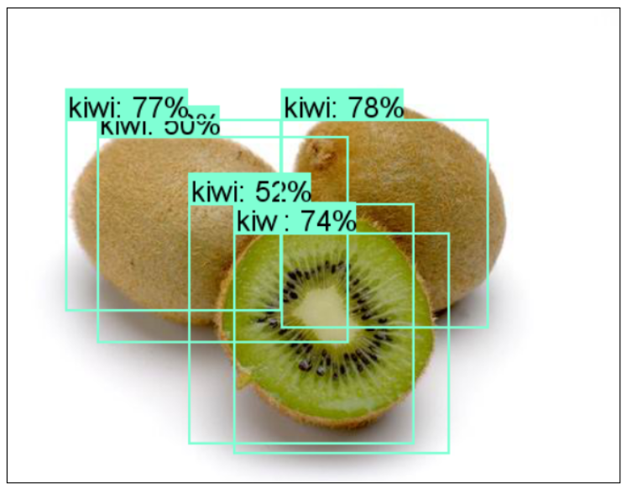
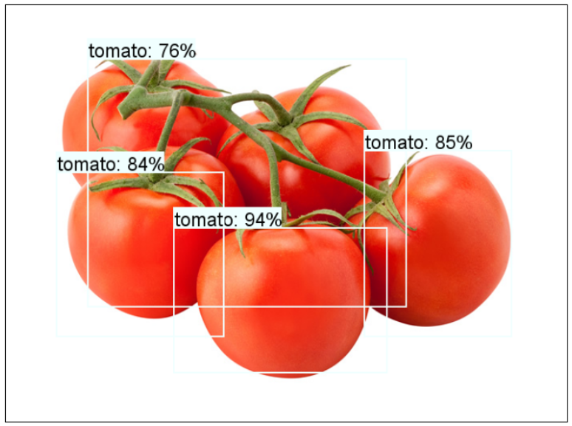

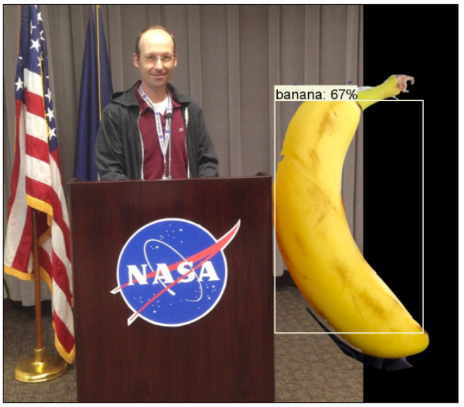

Fig 11: Model detected and boxed images
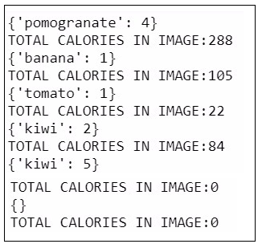
Fig 12 : Code result displaying total calories in Image

CONCLUSION
In this paper, we present the fruit detection and recognition system that we built, using deep convolutional neural network for the recognition of food images from the 8-class dataset that we acquired using Google image searches, while keeping the model training time low to enable faster fine-tuning. Training the model with different epochs further improvement in test accuracy data expansion, which could also be achieved by collecting more training data or by optimizing the architecture and hyper-parameters of the network, considering overtraining problem at the same time. We have written a function which determines calories based on the fruit detected by taking in consideration the average calorie value of that fruit.

References
- Y. LeCun, B. Boser, J. S. Denker, D. Henderson, R. E.Howard, W. Hubbard, and L. D. Jackel. Backpropagation applied to handwritten zip code recognition.Neural Comput., 1(4):541–551, Dec. 1989.
- https://www.kaggle.com/moltean/fruits
- http://cv-tricks.com/tensorflow-tutorial/training-convolutional-neural-network-for-image-classification/
- https://becominghuman.ai/tensorflow-object-detection-api-tutorial-training-and-evaluating-custom-object-detector-ed2594afcf73
- https://github.com/tzutalin/labelImg
- https://github.com/datitran/raccoon_dataset
- https://towardsdatascience.com/how-to-train-your-own-object-detector-with-tensorflows-object-detector-api-bec72ecfe1d9
- http://cv-tricks.com/object-detection/faster-r-cnn-yolo-ssd/
- https://faroit.github.io/keras-docs/1.0.1/getting-started/sequential-model-guide/
- https://databricks.com/blog/2016/01/25/deep-learning-with-apache-spark-and-tensorflow.html
- https://towardsdatascience.com/deep-learning-for-object-detection-a-comprehensive-review-73930816d8d9

