HRMS QA ASSIGNMENT
I.SUMMARY SHEET
These reflections are based on my experience testing the Employee Salary Management System (SiPeKa) as part of this assignment.

1. What does this HRMS exist to deliver, and to whom?
This HRMS exists to ensure employees receive accurate and timely salaries based on attendance and payroll data. The people who depend on it most are the workers whose livelihoods rely on being paid correctly.

2. What is the single most dangerous bug pattern you found across your testing?
The most dangerous pattern was missing validation and broken critical workflows, where a failure in one step could silently affect downstream processes. It is dangerous because payroll errors can impact many employees before anyone notices.

3. Which test in your suite are you most proud of, and why?
I am most proud of the regression test idea around critical payroll routes because it protects against blank pages or broken flows like the Data Gaji issue I encountered. It would prevent failed payroll operations from reaching production and protect payroll operators and employees.

4. What did you choose NOT to automate, and why was that the right call?
I chose not to automate visual checks and low-risk UI styling issues because they change frequently and offer limited business value. Focusing automation on critical payroll paths provided better protection with limited time.

5. What's one thing in your submission that you're not fully confident about, and why you included it anyway?
I am not fully confident that my understanding of construction-specific payroll nuances is complete because I have not worked in that domain. I included my best assumptions after researching and clearly acknowledged where I lacked expertise.

6. What changed between your first approach and your final submission?
Initially, I approached the assignment as a checklist of test cases. After exploring the actual HRMS and finding real issues, I rewrote my work to focus on who gets affected, the business impact, and realistic quality trade-offs.

7. What do you not know that you would need to learn before doing this job?
I would need to learn construction payroll rules such as overtime and statutory deductions, how large payroll teams actually process salaries in practice, and how experienced QA engineers design scalable test strategies in fast-moving teams.

8. If you had one more day, what would you test that you didn't get to?
I would thoroughly test the complete salary generation and payslip workflow, especially the Data Gaji functionality that appeared broken. This is important because payroll failures directly affect employees' income and the trust placed in the system.

II.EMPLOYEE SALARY MANAGEMENT APPLICATION

1. Application Testing Summary
The application was successfully configured and executed. Frontend ran on localhost:5173 and backend on localhost:5000 after resolving the MySQL authentication issue.

2. Bug Report

BUG-001: Data Gaji page displays a blank page
Steps to Reproduce:
1. Login as admin (Aldi).
2. Navigate to Transaksi → Data Gaji.
3. Observe the screen.
Expected Result:
The salary data page should display salary records.
Actual Result:
The page becomes blank and no salary information is displayed, even after refresh.
Possible Cause:
Frontend route/component error, failed API response, or unhandled exception.

BUG-002: Employee profile images not loading
Expected Result:
Employee photos should display correctly.
Actual Result:
Broken image placeholders are displayed.
Possible Cause:
Missing files in public directory or incorrect image URL mapping.

BUG-003: Payroll Calculation Integration Requires
The payroll calculation workflow could not be completely tested because the Data Gaji (Salary Data) page fails to load. This prevents validation of whether attendance, job position, allowances, and deductions are correctly integrated into salary calculations.
Steps to Reproduce:
- Login as admin (Aldi).
- Ensure employee, attendance, job position, and deduction data exist.
- Navigate to Transaksi → Data Gaji.
- Observe the application behavior.
Expected Result:
The salary page should display generated salary records showing the complete payroll calculation, including attendance, allowances, deductions, and net salary values.
Actual Result:
The application displays a blank page, preventing users from viewing or validating payroll calculations.
Possible Cause:
The Data Gaji component may be failing due to an unhandled frontend exception, missing API endpoint, incorrect route configuration, or an error occurring during salary data retrieval and integration.

3. Screenshots Captured
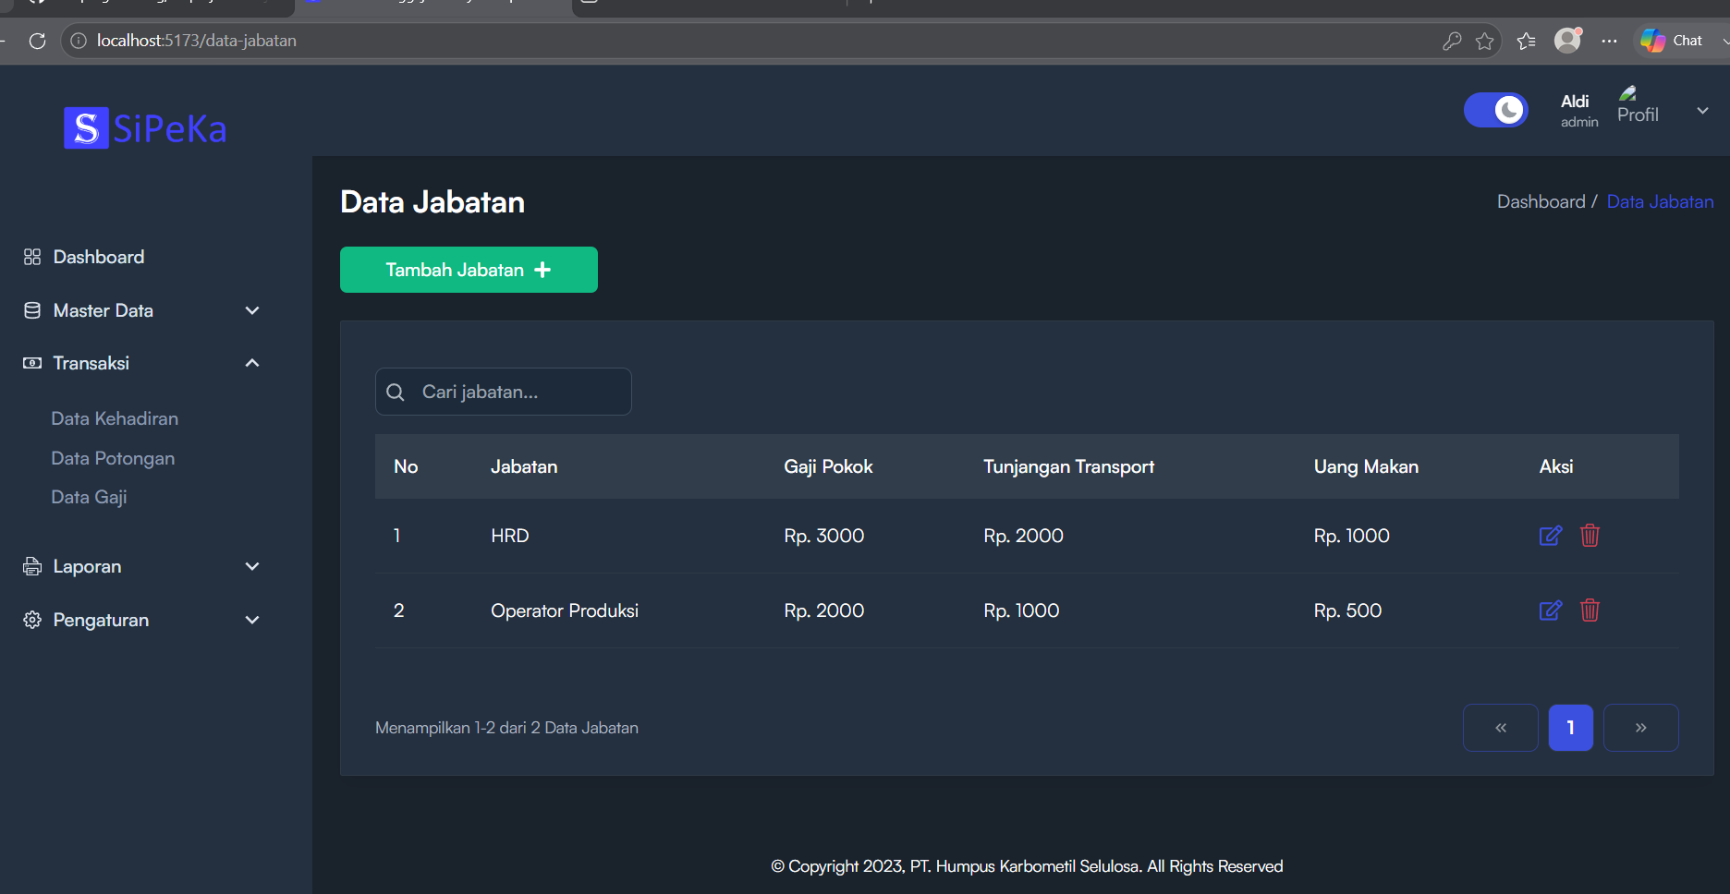
Fig 1: data-jabatan.png
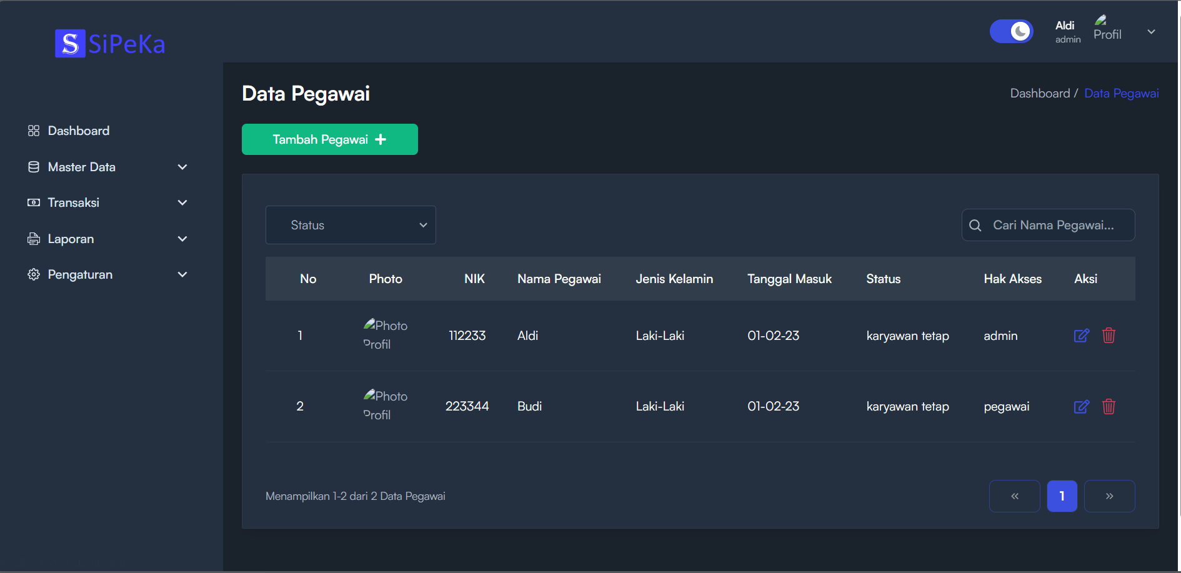
Fig 2: data-pegawai.png
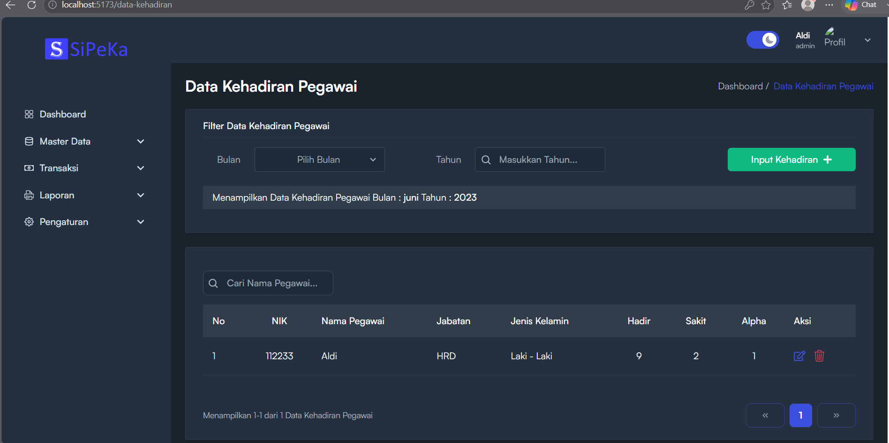
Fig 3: data-kehadiran.png
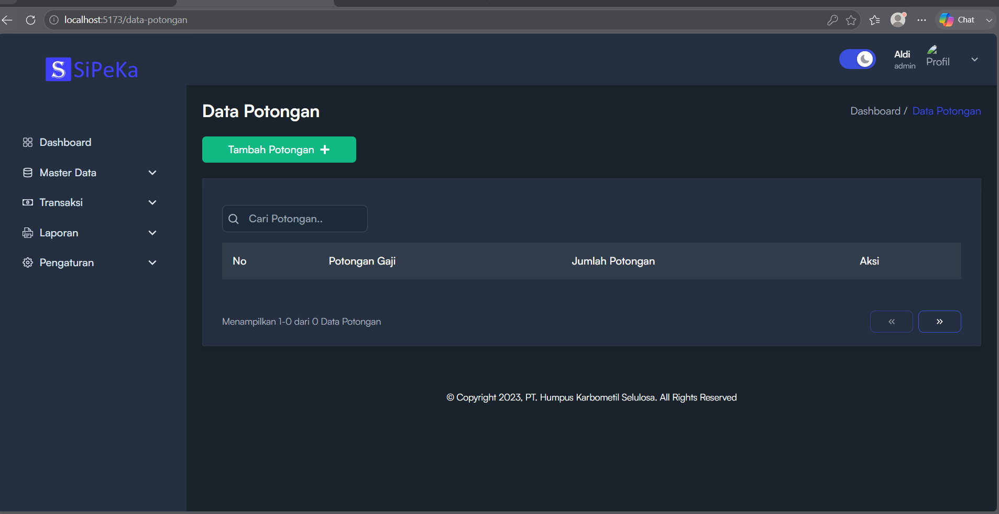
Fig 4: data-potongan.png
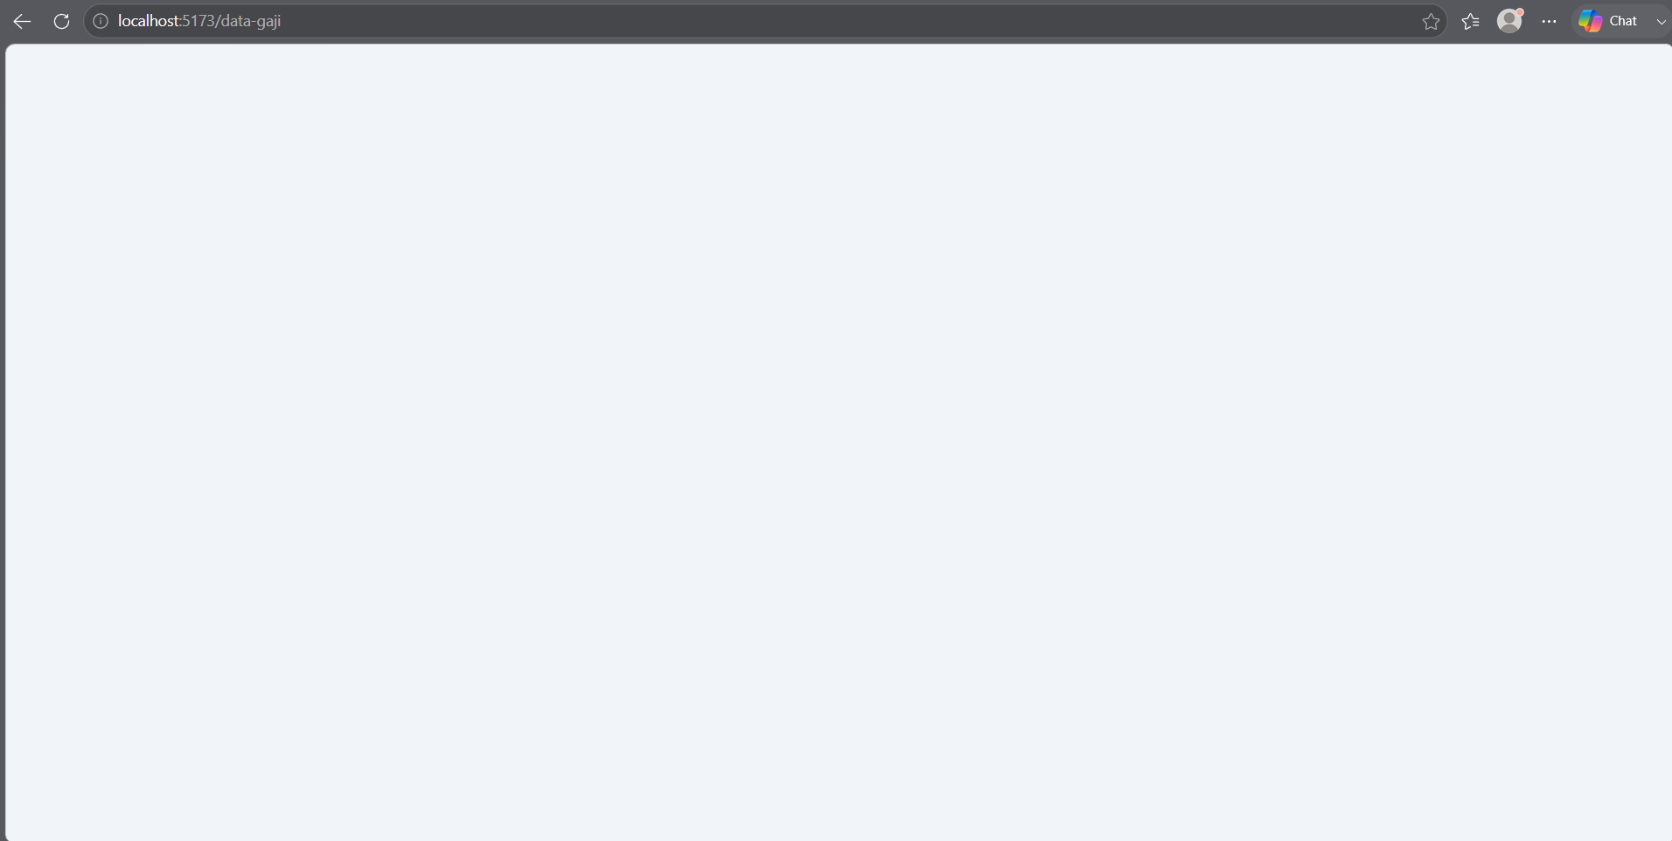
Fig 5: data-gaji.png
BUG SUMMARY
Bug ID | Title | Severity | Who Is Affected
BUG-001 | Data Gaji page displays a blank page | High | Payroll Operators, Employees
BUG-002 | Employee profile images not loading | Low | HR/Admin Users
BUG-003 | Payroll calculation integration cannot be verified | High | Payroll Operators, Construction Workers

III. MINDMAP
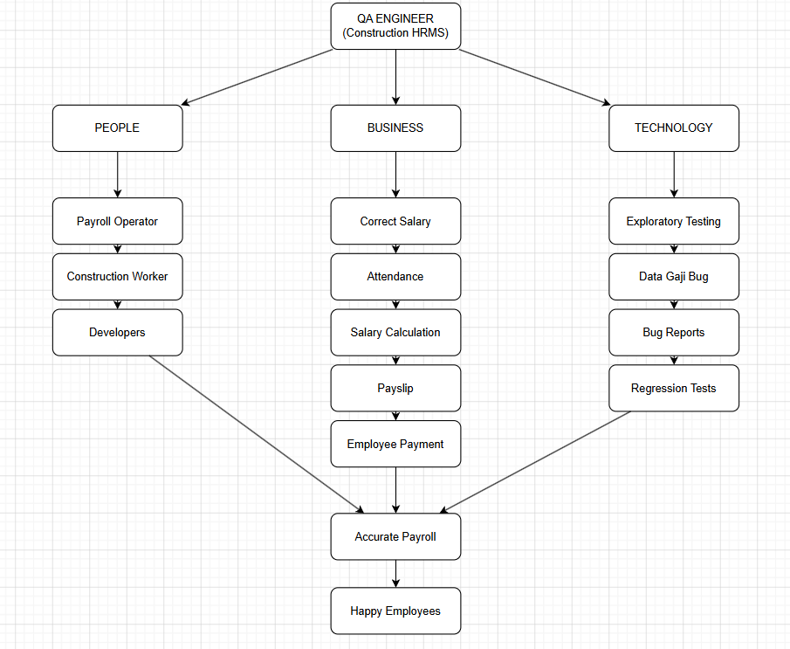
Fig 6: Mindmap
This mind map shows how a QA Engineer in a Construction HRMS is not only responsible for finding software bugs, but also for protecting the people and business processes that depend on the system.
The People branch represents the stakeholders affected by the quality of the application. The Payroll Operator uses the HRMS to process salaries, the Construction Workers depend on receiving correct and timely payments, and the Developers build and maintain the system. A failure in quality can negatively impact all of them.
The Business branch illustrates the main purpose of the HRMS. Employee attendance is used for Salary Calculation, which generates Payslips and leads to Employee Payments. The ultimate business goal is to ensure employees receive the correct salary without delays or errors.
The Technology branch represents the quality activities performed during this assignment. Through Exploratory Testing, I discovered issues such as the Data Gaji (Salary Data) page failure. These findings were documented through Bug Reports, and important scenarios were protected through Regression Tests to prevent the same defects from reappearing in future releases.
All three branches connect at Accurate Payroll, because people, business processes, and technology work together to achieve the same outcome. When payroll is processed accurately, employees are paid correctly and on time, which ultimately leads to Happy Employees and trust in the system.
Key Insight
The biggest lesson from this assignment is that quality engineering is not just about testing software. It is about understanding who can be affected by failures, identifying risks before they reach production, and ensuring that technology supports business goals while protecting the people who rely on it every day.

