



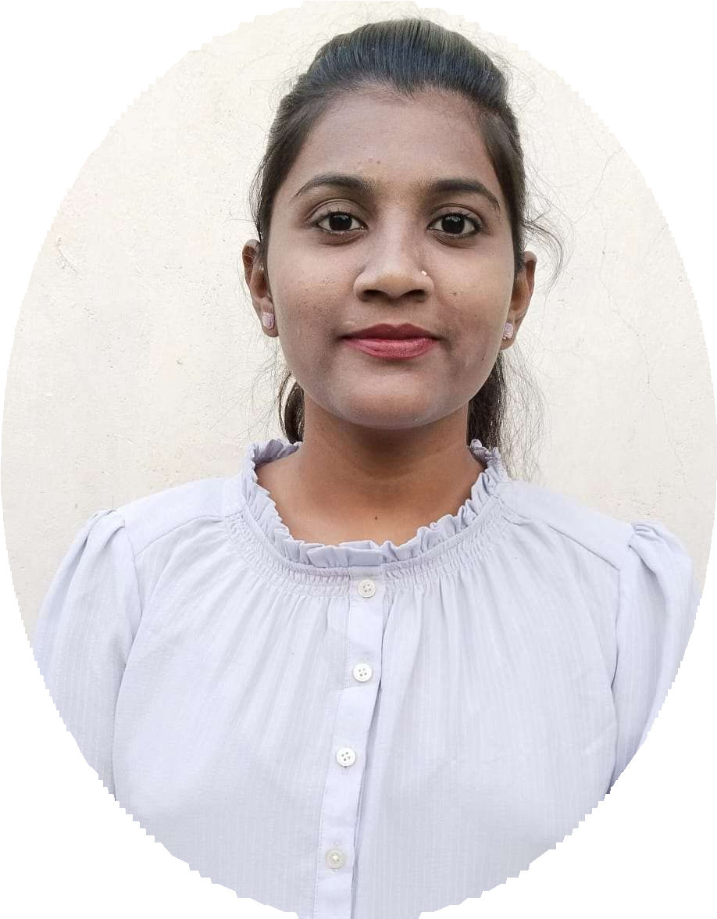
CAREER OBJECTIVE:
I am looking for the challenging job where I can utilize my talent and knowledge. I want to learn from the organization with growth of organization.
Nagpur, India
9834736149
payalkaw7@gmail.com

https://www.linkedin.co m/in/payalkawle- 92436b295

PAYAL KAWLE
B.PHARM

EDUCATION
- Bachelor of Pharmacy,
Nagpur College of Pharmacy, Nagpur, 06/2020 to 06/2024 7.80 CGPA
- HSC
Nehru Junior College, Hingna
06/2019 to 02/2020 58.92 %
- SSC
Nehru Vidyalaya, Hingna
06/2017 to 03/2018 71.20 %
- MS-CIT
JULY – 2023 84 %

INTERNSHIP EXPERIENCE
INTERN
Shehal Pharma & Surgical Pvt. Ltd.
- 09/2023-10/2023 Nagpur, India
- One month training is done by QA department.
- I come to know about the importance of quality control department & this Q.C department is responsible for the monitoring the production.
Understood workplace culture.

Lata Mangeshkar Hospital, Digdoh, Nagpur,
- Staff in hospital pharmacy at Lata Mangeshkar Hospital, from 1st August 2024 to Till date.

STRENGTHS
  - Self confidence
  - Creating ideas
  - Hard working
  - Problem solving

CERTIFICATES
  - Certificate of participation in pharm Quiz competition in the 72nd Indian pharmaceuticals congress, Nagpur
  - Certificate of participation is a delegate in the 72nd IPC held at Department of pharmaceutical sciences, RTMNU, Nagpur during January 20 to 22, 2023.
  - Certificate of copy right publication during April 10, 2024.
  - Certificate of participation is a delegate in the 73rd IPC held at Hitex Exhibition Center, Hyderabad, during 05th – 07th July 2024.
  - Certificate of poster presentation delivered during the 73rd IPC held from 05th – 07th July 2024 at Hitex Exhibition Center, Hyderabad.
  - Pursuing basic certification course in medical coding, clinical research, CDM, PV from RACE Institute Nagpur, Maharashtra.

CO-CURRICULAR ACTIVITES
  - Industrial visit at” Arco Life Sciences Pvt. Ltd “
  - Industrial visit at “NISHA HERBAL Pvt. LIMITED”.
  - Attended 72^{n} ^{I}ndian Pharmaceutical Congress conference held at RTMNU, Nagpur (2023)

SELF DECLARATION
I declare that all the information mentioned above is correct to the best of my knowledge. If given an opportunity I promise to give the best abilities to the organization.

