

BSc (Hons) Web & Mobile Development

A Comparative Performance Analysis of PHP MVC Frameworks: Laravel, Symfony, CodeIgniter, and Yii

Computing Honours Project (COMP10034)

Honours Project Dissertation

Corey Black
B01651145

April 2026

Supervisor: Dr. Pablo Salva Garcia
Moderator: Mr. Sajjad Bagheri

Table of Contents
2 Introduction 3
3 Background and Literature Review 5
3.1 PHP and the MVC Architectural Pattern 5
3.2 Overview of Selected PHP Frameworks 6
3.3 Summary of Framework Characteristics 7
3.4 Performance Metrics in Web Applications 8
3.5 Existing Comparative Studies 8
4 Research Methodology 9
4.1 Research Approach and Experimental Design 9
4.2 Methodological Justification 10
4.3 Benchmarking Tools and Load Testing Frameworks 11
4.4 Experimental environment Configuration 12
5 Application Design and Implementation 13
5.1 Application Architecture Overview 13
5.2 REST API Endpoint Specification 14
5.3 Database Schema Design 14
5.4 Framework Implementation Overview 14
6 Benchmark Scenarios 15
6.1 Scenario Design Rationale 15
6.2 Scenario 1: Read-Heavy CRUD Workload 15
6.3 Workload Configuration and Parameters 17
7 Results 17
7.1 Scenario 1 Benchmark Results 17
7.2 Response Time Analysis 17
7.3 Throughput Analysis 17
7.4 Resource Utilization 17
8 Analysis and Discussion 17
8.1 Comparative Framework Performance 17
8.2 Architectural Factors Affecting Performance 17
8.3 Implications for Framework Selection 17
9 Limitations and Threats to Validity 17
10 Conclusion and Future Work 17
11 References 17
12 Appendices 18
13 Student Declaration 18

Introduction
PHP remains one of the most widely used server-side programming languages in modern web development, underpinning a substantial proportion of websites and web-based applications worldwide. Despite the emergence of newer backend technologies, PHP continues to play a significant role in industry due to its maturity, extensive ecosystem, and strong framework support. Over time, the PHP ecosystem has evolved from primarily procedural scripting toward structured, framework-driven development practices that emphasise scalability, maintainability, and developer productivity. Central to this evolution is the adoption of the Model–View–Controller (MVC) architectural pattern, which has become the dominant design paradigm within contemporary PHP frameworks.
The MVC architectural pattern promotes a clear separation of concerns by dividing applications into models responsible for data and business logic, views responsible for presentation, and controllers that mediate user interaction and application flow. This separation improves code organization, facilitates testing, and supports long-term maintenance, particularly in larger and more complex web applications. Modern PHP MVC frameworks extend this pattern through features such as routing systems, object–relational mapping (ORM), dependency injection, middleware pipelines, and security abstractions. While these features improve developer experience and long-term maintainability, they may also introduce computational overhead that can influence application performance under load.
As PHP MVC frameworks have matured, developers are presented with a wide range of options, each offering distinct architectural philosophies and trade-offs. Popular frameworks such as Laravel, Symfony, CodeIgniter, and Yii are widely adopted in real-world PHP development, yet framework selection is often driven by familiarity, community popularity, or perceived ease of use rather than empirical performance evidence. This lack of data-driven decision-making can lead to suboptimal technical choices, particularly in contexts where performance, scalability, and efficient resource utilisation are critical, such as high-traffic or resource-constrained environments.
Despite the prevalence of PHP frameworks in industry, existing comparative studies frequently suffer from methodological limitations. Many benchmarks rely on synthetic micro-tests, inconsistent server configurations, or non-equivalent application logic, making it difficult to attribute observed performance differences to framework architecture alone. Furthermore, some studies prioritize isolated performance metrics without considering realistic application behavior or workload patterns. These limitations highlight the need for a standardized and reproducible benchmarking approach that reflects real-world usage while maintaining strict experimental control.
The primary aim of this honors project is to assess and compare the performance, scalability, and developer experience of four widely used PHP MVC frameworks: Laravel, Symfony, CodeIgniter, and Yii. These frameworks were selected due to their widespread adoption and their contrasting design philosophies, ranging from lightweight, minimal-abstraction approaches to feature-rich, highly modular architectures. To ensure a fair and meaningful comparison, the study involves the development of functionally equivalent CRUD-based web applications implemented in each framework and evaluated under identical conditions.
Performance benchmarking is conducted using industry-standard load testing tools to measure key quantitative metrics, including response time, throughput, and resource utilisation. In addition to quantitative evaluation, the project also considers qualitative factors such as framework setup complexity, configuration effort, and overall developer experience encountered during implementation. By combining empirical performance data with contextual qualitative analysis, the project aims to provide a balanced and practically useful comparison of PHP MVC frameworks.
The contribution of this dissertation lies in its adoption of a controlled experimental methodology that emphasizes functional equivalence, configuration consistency, and reproducibility. By clearly defining application behavior, database schema, benchmark scenarios, and testing environments, the study seeks to minimize confounding variables and produce defensible performance insights. The findings are intended to support developers and organizations in making informed framework selection decisions based on evidence rather than assumption.
The remainder of this dissertation is structured as follows. Chapter 3 presents a review of relevant background literature and existing comparative studies. Chapter 4 outlines the research methodology and experimental design adopted in this project. Chapter 5 describes the design and implementation of the benchmark applications and database schema. Chapter 6 defines the benchmark scenarios used for evaluation, followed by the presentation of experimental results in Chapter 7. Chapter 8 provides a critical analysis and discussion of the findings, including their implications and limitations. Finally, Chapter 9 concludes the dissertation and outlines directions for future work.

Background and Literature Review

PHP and the MVC Architectural Pattern
The Model–View–Controller (MVC) architectural pattern is a widely adopted software design paradigm that structures application logic into three interconnected components: the model, the view, and the controller. The model is responsible for managing data and business logic, the view handles presentation and user interface concerns, and the controller interprets user input and coordinates interaction between the model and the view. By separating these responsibilities, MVC promotes modularity and separation of concerns, which are key principles in the development of maintainable and scalable software systems.
Within the context of web-based applications, MVC provides a structured approach to handling HTTP requests, application logic, and dynamic content generation. This separation simplifies reasoning about application behavior and reduces coupling between components, making systems easier to test, extend, and refactor. These benefits become increasingly important as application complexity grows, particularly in large-scale or collaborative development environments where multiple developers may work on different parts of the system simultaneously.
PHP MVC frameworks implement the MVC architectural pattern in a consistent and opinionated manner, providing developers with a suite of built-in tools such as routing mechanisms, database abstraction layers, templating engines, and security features. Compared to ad-hoc procedural development approaches, the use of MVC frameworks has been shown to improve code quality and reduce development time, especially in long-term projects that require ongoing maintenance and evolution. By enforcing architectural conventions, frameworks also reduce the likelihood of architectural drift and inconsistent coding practices over time.
The theoretical foundations of the MVC pattern are rooted in established software design principles. Gamma et al. (1994) describe design patterns as reusable solutions to recurring software design problems, emphasizing separation of concerns as a strategy for managing complexity in large systems. By isolating presentation logic from business rules and data management, MVC reduces the cognitive complexity associated with understanding and modifying individual components. This enables developers to reason about specific aspects of an application in isolation, supporting parallel development and improving overall development efficiency.
As a result of these advantages, MVC has become a foundational pattern in modern web frameworks across a range of programming languages, including those within the PHP ecosystem. However, while MVC improves maintainability and structure, its implementation within frameworks often introduces additional abstraction layers. These abstractions, while beneficial from a design and productivity perspective, can introduce runtime overhead that may affect performance under certain workloads. Understanding how MVC-based frameworks balance architectural structure with runtime efficiency is therefore essential when evaluating their suitability for performance-sensitive applications.

Overview of Selected PHP Frameworks
PHP frameworks provide a standardised development environment that abstracts common web application concerns, allowing developers to focus on application-specific logic rather than low-level implementation details. While these frameworks offer significant benefits in terms of productivity, maintainability, and security, their internal architectural design choices can have a direct impact on runtime performance. Differences in abstraction depth, request handling pipelines, and dependency management strategies can lead to measurable variations in response time, throughput, and resource consumption.
Frameworks such as Laravel and Symfony prioritize flexibility, extensibility, and developer ergonomics. These frameworks commonly employ features such as service containers, middleware pipelines, event dispatching systems, and dependency injection mechanisms. Such features support clean architecture and long-term maintainability, particularly in large or enterprise-scale applications. However, the additional processing steps involved in resolving dependencies, executing middleware stacks, and managing framework services may introduce computational overhead, especially under high levels of concurrency (Pautasso et al., 2017).
In contrast, lightweight frameworks such as CodeIgniter adopt a more minimalistic design philosophy. By reducing abstraction and favoring more direct execution paths, CodeIgniter aims to minimize overhead and maximize execution speed. This approach can result in faster response times and lower memory consumption, making lightweight frameworks attractive for performance-critical or resource-constrained environments. However, the reduced level of built-in abstraction may require developers to implement additional functionality manually when building more complex systems, potentially increasing development effort.
Yii adopts a hybrid architectural approach that attempts to balance performance with modern framework features. It incorporates performance-oriented techniques such as lazy loading, efficient caching mechanisms, and code generation tools, while still providing structured MVC support and developer conveniences. This positions Yii as a framework that seeks to achieve competitive runtime performance without fully sacrificing maintainability or developer experience. The effectiveness of this balance, however, is highly dependent on workload characteristics and application design.
Understanding how these differing architectural philosophies manifest in real-world performance scenarios is essential for informed framework selection. Developers must often trade off development speed, maintainability, and runtime efficiency based on project requirements. Despite this, many framework comparisons rely on anecdotal evidence or popularity metrics rather than systematic performance evaluation. This project addresses this gap by empirically measuring the performance implications of these design philosophies using standardized benchmarks and functionally equivalent application logic, allowing architectural trade-offs to be examined under controlled and reproducible conditions.

Summary of Framework Characteristics
Laravel is a feature-rich PHP framework designed to maximize developer productivity through expressive syntax and extensive built-in functionality. It provides integrated support for routing, authentication, database migrations, task scheduling, and object–relational mapping through the Eloquent ORM. Laravel also incorporates modern development practices such as dependency injection, middleware pipelines, and service containers, which promote clean architecture and maintainability. These features make Laravel particularly attractive for rapid application development and long-term projects. However, the framework’s layered abstraction model can introduce additional processing overhead, which may result in increased response times and memory consumption under high-concurrency workloads.
Symfony is a highly modular and configurable PHP framework that is widely adopted in enterprise-level applications. Its component-based architecture allows developers to utilize individual components independently or as part of the full framework, offering a high degree of flexibility and architectural control. Symfony places strong emphasis on best practices, extensibility, and long-term maintainability, making it suitable for large and complex systems. This flexibility, however, often comes at the cost of increased configuration complexity and a steeper learning curve. From a performance perspective, Symfony’s extensive use of abstraction layers and event-driven mechanisms may introduce additional overhead, particularly in comparison to more lightweight frameworks.
CodeIgniter is a lightweight PHP framework that prioritizes simplicity, minimal configuration, and low runtime overhead. It provides essential MVC functionality while deliberately avoiding strict conventions and heavy abstraction. This design philosophy results in a small framework footprint and direct execution paths, which can lead to faster response times and lower memory usage. CodeIgniter is therefore well suited to performance-sensitive or resource-constrained environments. However, its reduced feature set may require developers to implement additional functionality manually when developing complex applications, potentially increasing development effort and reducing consistency across larger codebases.
Yii is a performance-oriented PHP framework that aims to balance efficiency with modern development features. It incorporates optimization techniques such as lazy loading, efficient caching mechanisms, and code generation tools, while still providing structured MVC support and developer conveniences. Yii is designed to minimize overhead without sacrificing maintainability, positioning itself as a high-performance alternative to more heavyweight frameworks. Its hybrid approach makes it particularly interesting from a benchmarking perspective, as it seeks to combine the performance advantages of lightweight frameworks with the architectural benefits of more feature-rich solutions.
Together, these frameworks represent a broad spectrum of architectural philosophies within the PHP ecosystem. Comparing them under controlled and equivalent conditions provides valuable insight into how design decisions influence real-world performance, scalability, and developer experience.

Performance Metrics in Web Applications
Performance evaluation in web applications typically focuses on quantitative metrics that reflect both user experience and server-side efficiency. One of the most commonly used metrics is response time, which represents the duration required to process a request and return a response to the client. Response time has a direct impact on perceived application responsiveness and user satisfaction, particularly in interactive systems where latency is highly visible.
Throughput is another critical metric, measuring the number of requests an application can handle within a given time period. High throughput indicates the ability of a system to scale under increasing load and is especially important for applications expected to serve large numbers of concurrent users. Throughput measurements provide insight into how efficiently a framework manages resources when subjected to sustained or peak workloads.
Resource utilisation metrics, such as memory usage and CPU consumption, offer additional perspective on application efficiency. Memory usage is particularly important in environments with limited resources or cost constraints, such as shared hosting or containerized deployments. Excessive memory consumption can limit scalability and increase operational costs, even if response times remain acceptable.
When considered in isolation, individual performance metrics may provide an incomplete or misleading view of application behavior. Meaningful performance evaluation therefore requires the combined analysis of multiple metrics under controlled conditions. By measuring response time, throughput, and resource utilisation simultaneously, it is possible to identify trade-offs between responsiveness, scalability, and efficiency. Consistent testing environments, workloads, and configurations are essential to ensure that observed differences are attributable to framework behavior rather than external factors.

Existing Comparative Studies
Several academic and industry studies have attempted to compare the performance characteristics of PHP frameworks; however, their findings often vary significantly due to methodological inconsistencies. Many benchmarks rely on synthetic micro-benchmarks that measure isolated request handling without accounting for realistic application behaviour. While such tests may highlight low-level performance characteristics, they often fail to represent real-world usage patterns involving database interaction, routing logic, and framework services.
Other studies employ non-equivalent application logic across frameworks, making it difficult to determine whether observed performance differences arise from framework architecture or implementation choices. Variations in server configuration, framework versions, caching strategies, and database interaction patterns further limit the generalizability and reproducibility of reported results. Consequently, conclusions drawn from these benchmarks may not translate reliably to production environments.
In addition, some comparative analyses prioritise raw response time while neglecting scalability, resource utilisation, or developer experience. Others focus primarily on qualitative factors such as ease of use or community support, providing limited insight into runtime performance. This fragmented approach highlights a broader gap in existing research: the lack of comprehensive, standardised benchmarking studies that balance realism with experimental control.
These limitations underline the need for a reproducible benchmarking methodology based on functionally equivalent applications and consistent testing conditions. By implementing identical CRUD-based applications across frameworks and executing benchmarks within a controlled environment, this project seeks to isolate framework-level performance characteristics from confounding variables. In doing so, the study aims to provide more reliable and practically meaningful insights into the performance trade-offs associated with different PHP MVC frameworks.

Research Methodology

Research Approach and Experimental Design
This project adopted an experimental benchmarking research methodology to investigate performance differences between PHP MVC frameworks under controlled conditions. An experimental approach was selected as it enables systematic manipulation of a single independent variable—framework choice—while holding all other relevant variables constant. This methodology is particularly well suited to performance evaluation, where isolating the effects of architectural and runtime differences is essential for producing valid and reproducible results.
In this study, the independent variable was the PHP MVC framework used to implement the application, specifically Laravel, Symfony, CodeIgniter, and Yii. Dependent variables included quantitative performance metrics such as response time, throughput, and resource utilisation. To ensure fairness and experimental validity, all other factors were controlled, including database schema, application logic, request types, dataset size, server configuration, and testing environment. This controlled experimental design reduces the risk of confounding variables influencing observed performance differences and supports reliable comparison between frameworks (Kitchenham et al., 2009).
To reflect realistic web application behaviour, the experimental artefact consisted of functionally equivalent CRUD-based web applications implemented in each framework. CRUD functionality was selected as it represents a common and foundational pattern in real-world web systems, incorporating database access, routing, controller logic, and response generation. By benchmarking complete request lifecycles rather than isolated micro-operations, the experiment aimed to capture framework behaviour under workloads representative of practical use cases rather than synthetic or artificial tests.
Each framework implementation adhered to its recommended architectural conventions while maintaining identical business logic and request workflows. All applications interacted with the same relational database schema and executed equivalent database operations to minimise variability arising from implementation differences. This approach ensured that measured performance characteristics could be attributed primarily to framework architecture and runtime behaviour rather than disparities in application design or data access patterns.
All benchmarking experiments were conducted using PHP 8.x to ensure consistency in language features and runtime performance across frameworks. The testing environment was configured to closely resemble a production-like setup, with debugging disabled and consistent server and database configurations applied across all tests. Performance metrics were collected under identical hardware and software conditions to minimise environmental variance and ensure comparability between experimental runs.
Quantitative performance evaluation focused on response time, throughput, and resource utilisation, as these metrics collectively reflect user experience, scalability, and system efficiency. Response time was used to assess application latency, throughput to evaluate scalability under load, and resource utilisation to examine the efficiency with which each framework consumed system resources. Benchmarks were executed multiple times to reduce the influence of transient system behaviour, with results analysed using aggregated and percentile-based measures to provide a more robust representation of performance characteristics.
In addition to quantitative benchmarking, a qualitative evaluation component was incorporated to assess non-functional aspects of each framework, including ease of setup, configuration complexity, documentation quality, and overall developer experience encountered during implementation. This mixed-methods approach enabled the project to combine objective performance measurement with contextual evaluation, recognising that framework selection in practice is influenced not only by runtime efficiency but also by developer productivity and maintainability considerations.
By combining controlled experimental benchmarking with qualitative assessment, this methodology provides a balanced and comprehensive evaluation of PHP MVC frameworks. The approach emphasises reproducibility, fairness, and practical relevance, forming a robust foundation for the performance analysis and discussion presented in subsequent chapters.

Methodological Justification
The benchmarking methodology adopted in this project is grounded in established principles of empirical software engineering research. Controlled experimentation provides a rigorous foundation for performance evaluation by enabling reliable comparison through the isolation of a single independent variable—framework choice—while holding all other variables constant. This approach is widely recognised as essential for producing valid and generalisable performance results, particularly in studies where small implementation or configuration differences can significantly influence outcomes (Kitchenham et al., 2009).
A key justification for this methodological choice lies in its emphasis on reproducibility and experimental control. By employing identical workloads, execution environments, and application behaviour across all framework implementations, the study minimises the influence of external variance and confounding factors. This level of control is critical in performance benchmarking, where differences in server configuration, runtime settings, or data access patterns can otherwise obscure or distort framework-level performance characteristics.
Repeated execution of benchmark tests further strengthens the reliability of the results. Performance measurements are inherently subject to transient system behaviour, including background processes, caching effects, and operating system scheduling. Jain (1991) identifies repeated test execution and result aggregation as standard practices for reducing the impact of measurement noise and improving the statistical stability of observed results. In this study, benchmarks were executed multiple times under identical conditions, with aggregated and percentile-based metrics used to provide a more representative view of performance behaviour.
The decision to benchmark functionally equivalent CRUD-based applications rather than isolated micro-benchmarks is also methodologically justified. Micro-benchmarks, while useful for examining low-level operations, often fail to capture the complexity of real-world web applications, where performance is influenced by factors such as routing, controller logic, database interaction, and framework services. By evaluating complete request lifecycles, this study provides a more realistic assessment of framework behaviour under workloads representative of practical usage scenarios.
Alternative benchmarking approaches, such as synthetic request generators or non-equivalent test applications, were deliberately avoided due to their limited external validity. Comparisons based on differing application logic or framework-specific optimisations risk attributing performance differences to implementation choices rather than underlying framework architecture. The use of functionally equivalent applications and a standardised database schema mitigates this risk and supports fair, framework-level comparison.
Taken together, these methodological choices support the validity, reliability, and credibility of the benchmarking approach employed in this project. By combining controlled experimentation, repeated measurement, and realistic workload design, the methodology provides a defensible foundation for the performance analysis presented in subsequent chapters and ensures that the resulting findings can be interpreted with confidence.

Benchmarking Tools and Load Testing Frameworks
Load testing tools play a critical role in evaluating the scalability, robustness, and performance characteristics of web applications under concurrent load. In this project, Apache JMeter and Locust were selected as the primary benchmarking tools due to their complementary testing paradigms, widespread adoption in industry and academia, and suitability for controlled performance experimentation.
Apache JMeter was used as the primary benchmarking tool for this study. JMeter is widely recognised for its ability to simulate high volumes of concurrent HTTP requests through configurable test plans and detailed performance reporting (Apache Software Foundation, 2024). Its graphical interface enables precise control over thread groups, ramp-up periods, loop counts, and request sampling, making it particularly well suited to repeatable and standardised benchmarking scenarios. These features allow fine-grained control over workload intensity and execution order, which is essential for ensuring consistency across framework comparisons.
JMeter’s sampling and reporting capabilities were used to collect key performance metrics, including response time distributions, throughput, and error rates. The tool’s support for percentile-based analysis further enabled examination of tail latency behaviour, which provides more meaningful insight into user experience under load than simple average response times. As a result, JMeter served as the primary source of quantitative benchmark data presented in this study.
Locust was employed as a complementary load testing tool to support behavioural modelling and cross-verification of results. Locust adopts a Python-based, event-driven architecture that allows load scenarios to be defined programmatically as user behaviour scripts rather than static request sequences (Locust.io, 2024). This approach is particularly effective for modelling realistic user interaction patterns, including sequential requests, think time, and conditional workflows, which are difficult to represent using purely declarative test plans.
By incorporating both JMeter and Locust, the study benefited from the strengths of each tool. JMeter provided a highly controlled and repeatable benchmarking environment suitable for direct framework comparison, while Locust enabled validation of observed performance trends under more behaviour-driven load scenarios. This multi-tool approach reduced reliance on a single testing paradigm and strengthened confidence in the robustness of the results.
To ensure validity and reliability, all benchmark scenarios were executed multiple times under identical conditions. Concurrency levels, request sequences, execution order, and dataset size were kept consistent across all framework implementations. Aggregated metrics and percentile-based measurements were used to reduce the influence of transient system fluctuations and measurement noise. Where discrepancies between tools were observed, results were analysed in context rather than treated in isolation, allowing differences in testing models to be interpreted appropriately.
Overall, the combined use of Apache JMeter and Locust enhanced the methodological robustness of the benchmarking process. By balancing standardised, repeatable load testing with behaviour-oriented validation, the study achieved a more comprehensive and defensible evaluation of PHP MVC framework performance.

Experimental environment Configuration
All benchmarking experiments in this project were conducted within a controlled and standardised execution environment to ensure fairness, repeatability, and reproducibility of results. Establishing a fixed experimental environment was essential to minimise external variance and to ensure that observed performance differences could be attributed to framework behaviour rather than environmental or configuration inconsistencies.
The testing environment was configured using a local development stack designed to closely approximate a production-like setup while maintaining full control over system variables. All frameworks were executed on the same hardware and operating system, with identical software versions, runtime settings, and database configurations applied throughout the benchmarking process. Debugging, development aids, and framework-specific profiling tools were disabled to avoid introducing additional overhead or bias into performance measurements.
Each PHP MVC framework—Laravel, Symfony, CodeIgniter, and Yii—was configured to operate using the same PHP runtime version and web server configuration. Framework dependencies were installed using standard package management tools and frozen for the duration of benchmarking to prevent version drift. Default production-oriented configuration settings were applied wherever possible to ensure that results reflected realistic deployment conditions rather than development environments.
A single, standardised relational database schema was used across all framework implementations. All applications interacted with the same database instance and executed identical CRUD operations against equivalent datasets. This approach ensured that database access patterns, query complexity, and data volume remained consistent, thereby isolating framework-level differences in request handling and execution flow.
Benchmark execution was performed exclusively within this fixed environment. Load testing tools were executed under identical conditions for all frameworks, with concurrency levels, request sequences, and execution parameters held constant. Prior to formal benchmarking, test plans were validated to confirm correct endpoint behaviour, response integrity, and dataset consistency across all framework implementations.
By freezing the experimental environment and standardising application configuration, database interaction, and execution parameters, this project established a robust foundation for performance evaluation. This controlled setup supports the reliability and reproducibility of the benchmarking results presented in subsequent chapters and strengthens the validity of the comparative analysis conducted in this study.

Application Design and Implementation

Application Architecture Overview
To ensure a fair, controlled, and reproducible comparison between frameworks, a standardised application architecture was defined and implemented across all framework implementations. Each PHP MVC framework—Laravel, Symfony, CodeIgniter, and Yii—was used to develop a functionally equivalent CRUD-based web application that exposed identical RESTful endpoints and interacted with the same underlying database schema. This standardisation was critical to isolating framework-level performance characteristics and minimising variance arising from differences in application logic or design.
Each application followed the recommended MVC conventions of its respective framework while preserving identical business logic, request workflows, and data access patterns. Controllers were responsible for handling HTTP requests and coordinating responses, models encapsulated database interaction and data representation, and views or response layers were used solely for output formatting. By adhering to framework-specific best practices without introducing framework-specific optimisations, the study ensured that performance measurements reflected inherent architectural differences rather than implementation bias.
Routing structures and endpoint definitions were standardised across all implementations to ensure consistency in request handling. Each framework exposed the same set of CRUD endpoints, supporting create, read, update, and delete operations on a shared resource. Request validation, controller flow, and database interaction logic were implemented in an equivalent manner to ensure that each request followed the same logical execution path regardless of framework choice.
The database interaction layer was implemented consistently across frameworks, with each application executing equivalent queries against the same relational schema. Where frameworks provided object–relational mapping facilities, these were used in accordance with framework conventions while maintaining equivalent query behaviour and data access patterns. This approach ensured that differences in database performance were attributable to framework integration rather than query complexity or schema design.
By defining and enforcing a consistent application architecture prior to benchmarking, the project ensured that observed performance differences could be attributed primarily to framework architecture and runtime behaviour. This design approach provides a robust foundation for the benchmarking scenarios and performance analysis presented in subsequent chapters, supporting fair comparison and defensible experimental results.

REST API Endpoint Specification

Database Schema Design

Framework Implementation Overview
Each PHP MVC framework was implemented using its standard installation process and recommended project structure to ensure consistency and realism across implementations. Laravel, Symfony, CodeIgniter, and Yii were configured in non-production environments using equivalent runtime and server settings, allowing each framework to operate under comparable conditions while avoiding the additional variability introduced by live deployment environments.
All implementations focused exclusively on core framework functionality required to support the standardised CRUD-based application architecture defined in this project. Framework features such as routing, controller handling, database abstraction, and request processing were utilised in accordance with official documentation and best practices. Optional extensions, advanced optimisations, and third-party packages were deliberately excluded unless required for basic framework operation. This decision ensured that performance measurements reflected inherent framework behaviour rather than the influence of external libraries or custom tuning.
The applications were designed to execute synchronous CRUD operations representative of common web application workloads. More complex use cases, such as background job processing, real-time communication, or event-driven architectures, were not included in the implementation scope. While such features are relevant in many production systems, excluding them allowed the study to maintain functional equivalence across frameworks and to focus specifically on request–response performance characteristics.
All performance testing was conducted within a controlled, non-production environment. As a result, factors such as network latency, hardware diversity, and unpredictable user behaviour were intentionally excluded from the experimental scope. This controlled setup prioritised internal validity and reproducibility, ensuring that observed performance differences could be attributed to framework architecture and runtime execution rather than external deployment conditions.
The scope of the implementation was deliberately constrained to ensure feasibility within the available timeframe while maintaining methodological rigour. By focusing on core framework capabilities and a well-defined application workload, the project provides a controlled and reproducible comparison that offers practical insight into the relative performance and developer experience of widely used PHP MVC frameworks.

Benchmark Scenarios

Scenario Design Rationale
Benchmark scenarios were designed to evaluate PHP MVC framework performance under controlled and representative workloads while maintaining strict functional equivalence across implementations. The primary objective of the scenario design was to simulate realistic web application behaviour that reflects common request–response patterns observed in production systems, while preserving sufficient experimental control to allow meaningful comparison between frameworks.
A scenario-based benchmarking approach was adopted rather than isolated micro-benchmarks in order to capture full request lifecycles, including routing, controller execution, database interaction, and response generation. This approach provides a more realistic assessment of framework behaviour under load and aligns with recommendations in empirical software performance evaluation literature, which emphasise workload realism alongside experimental control.
Each benchmark scenario was executed using identical request sequences, concurrency levels, and execution parameters across all framework implementations. By standardising scenario definitions and execution order, the study minimised variability arising from workload design and ensured that observed performance differences could be attributed to framework architecture and runtime behaviour rather than differences in test configuration.
Scenario 1 was selected as the initial evaluation workload due to its strong representativeness of common web application usage patterns. Read-heavy access is characteristic of many real-world systems, such as content management platforms, dashboards, and API-driven services, where read operations significantly outnumber write operations. Evaluating framework behaviour under such conditions provides practical insight into performance characteristics that are directly relevant to typical deployment scenarios.

Scenario 1: Read-Heavy CRUD Workload
Scenario 1 was designed to evaluate framework performance under a read-heavy CRUD workload, with the majority of requests consisting of data retrieval operations. This scenario focused primarily on HTTP GET requests targeting a standardised resource endpoint, while maintaining a smaller proportion of create, update, and delete operations to preserve realistic CRUD interaction patterns.
All framework implementations exposed identical RESTful endpoints and interacted with the same underlying database schema. Each request executed equivalent controller logic and database queries, ensuring functional equivalence across frameworks. Dataset size and query structure were kept constant throughout testing to prevent data-related variance from influencing results.
Load was applied using predefined concurrency levels and ramp-up configurations, simulating increasing numbers of simultaneous users accessing the application. This allowed framework scalability and request-handling efficiency to be evaluated under progressively higher load conditions. The scenario was executed multiple times for each framework to reduce the impact of transient system behaviour and measurement noise.
Performance metrics collected during Scenario 1 included response time, throughput, and resource utilisation. In addition to average values, percentile-based response time metrics were analysed to capture tail latency behaviour, which provides a more accurate representation of user experience under load. These metrics were selected to jointly assess responsiveness, scalability, and efficiency across frameworks.
Scenario 1 served as a baseline workload for comparative analysis and provided the foundation for the results and discussion presented in subsequent chapters. By focusing on a realistic and widely applicable access pattern under controlled conditions, this scenario enabled a robust and defensible evaluation of PHP MVC framework performance.

Workload Configuration and Parameters
All benchmark workloads were executed using a standardised configuration to ensure consistency and comparability across framework implementations. Workload parameters were defined prior to execution and applied uniformly to all tests, ensuring that each framework was subjected to identical request patterns, concurrency levels, and execution conditions.

Load was generated using predefined concurrency configurations designed to simulate increasing numbers of simultaneous users accessing the application. Thread counts and user spawn rates were incremented in a controlled manner to observe how each framework responded under progressively higher load. A ramp-up period was applied to gradually introduce concurrent requests, reducing the likelihood of artificial load spikes and allowing the system to reach a stable operating state before measurements were recorded.

Each benchmark execution consisted of a fixed sequence of HTTP requests corresponding to the defined CRUD workload. In Scenario 1, this sequence was dominated by read operations, with a smaller proportion of write, update, and delete requests included to preserve realistic application behaviour. The execution order, request frequency, and endpoint targets were kept constant across all frameworks to prevent workload-related variance.

Test duration and iteration counts were configured to ensure that sufficient data was collected for meaningful analysis. Each scenario was executed multiple times for each framework, with identical parameters applied to every run. Repeated execution helped mitigate the influence of transient system behaviour, such as caching effects or background operating system processes, and improved the reliability of aggregated results.

All workload executions were performed against the same dataset size and database state. Prior to each test run, the database was reset to a known baseline state to ensure consistency in data distribution and query behaviour. This prevented data growth or fragmentation from influencing performance measurements across different executions or framework implementations.

Performance metrics were captured throughout each test run, including response time distributions, throughput, and resource utilisation. In addition to average values, percentile-based response time measurements were collected to provide insight into tail latency behaviour under load. These parameters collectively enabled assessment of responsiveness, scalability, and efficiency under the defined workload conditions.

By standardising workload configuration and execution parameters across all frameworks, this study ensured that observed performance differences reflected framework-level behaviour rather than variations in load design or execution. This controlled approach provides a robust foundation for the presentation and analysis of benchmark results in the following chapter.

Results

Scenario 1 Benchmark Results
This section presents the results obtained from Scenario 1, which evaluated framework performance under a read-heavy CRUD workload. All benchmarks were executed using identical workload configurations and environmental conditions as described in Chapter 6. The results reported in this section are descriptive in nature and focus on observed performance behaviour across frameworks. Interpretation and comparative analysis of these findings are deferred to Chapter 8.
Benchmark data was collected using Apache JMeter, with each test scenario executed multiple times for each framework to reduce the influence of transient system behaviour. Aggregated metrics were calculated from the raw JMeter output files and analysed using spreadsheet-based post-processing. The full set of processed results is provided in the accompanying analysis workbook.
Appendix A contains raw JMeter CSV outputs and processed analysis tables derived from the jmeter_S1_analysis.xlsx workbook.

Response Time Results
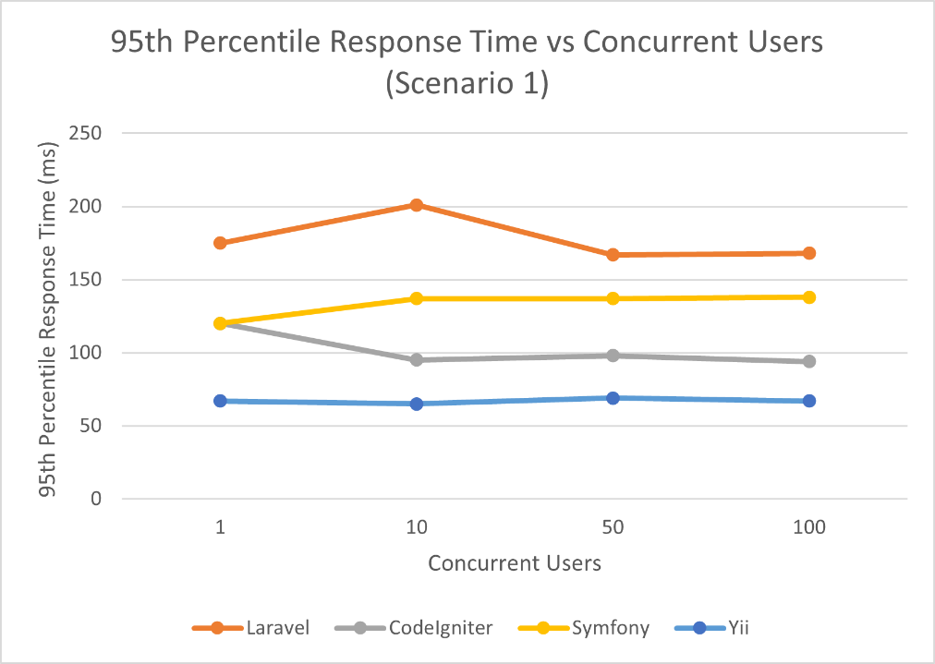
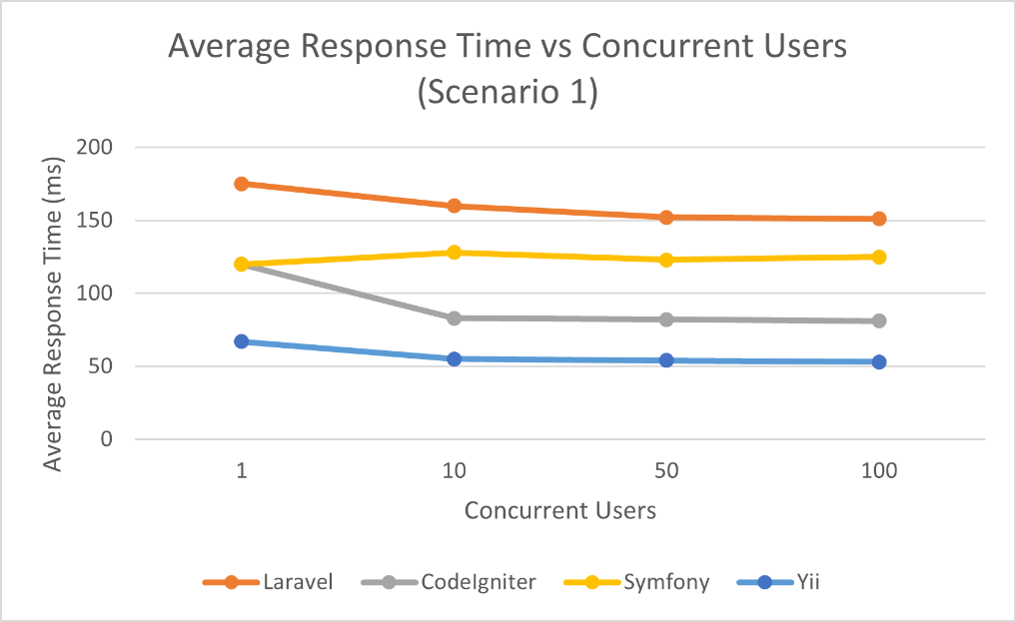
Response time measurements were collected for all requests executed during Scenario 1. Both average response time and percentile-based metrics were recorded to provide insight into overall responsiveness and tail latency behaviour under load. Percentile metrics are particularly relevant for assessing user experience, as they capture worst-case response behaviour that may not be reflected in average values.

As shown in Figures 7.1 and 7.2, measurable differences in response time were observed across the evaluated frameworks under identical workload conditions. While average response times provide an indication of overall request handling efficiency, P95 response times highlight variation in tail latency and performance consistency under concurrent load.

Throughput Results
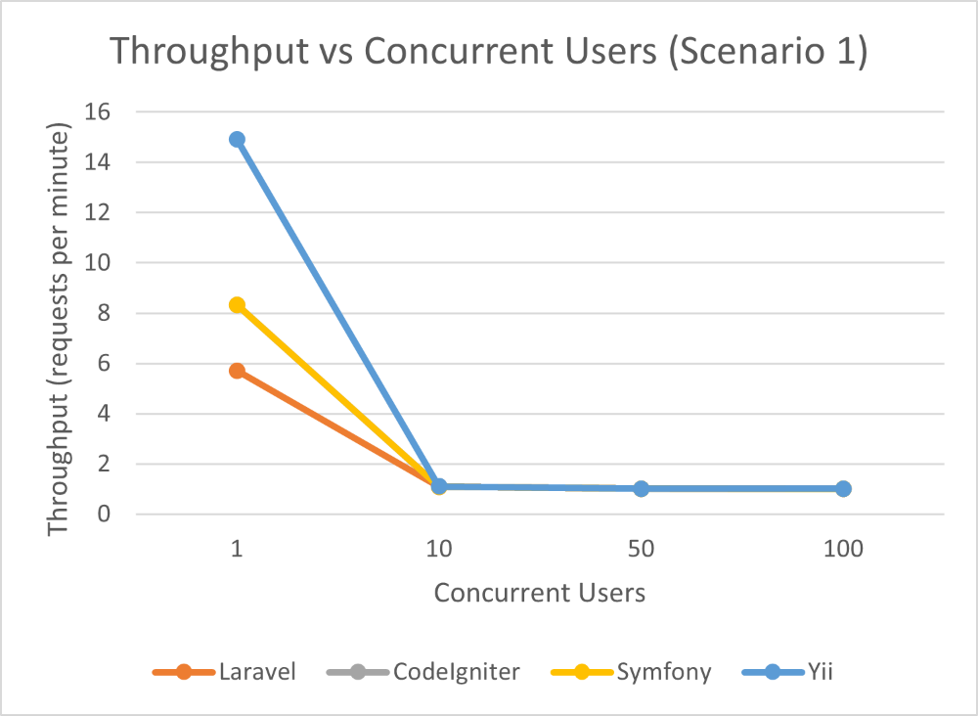
Throughput was measured as the number of successfully completed requests per unit time and used as an indicator of scalability under concurrent access. Higher throughput values indicate a greater ability to process simultaneous requests without degradation in service.
Observed throughput values varied between frameworks, reflecting differences in request processing efficiency and concurrency handling. Throughput results are presented alongside response time metrics to provide a more complete view of framework performance characteristics under load.

Resource Utilisation Results
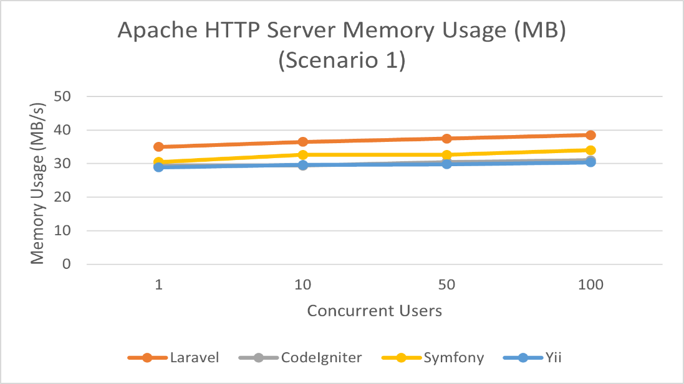
Resource utilisation metrics were collected to assess the efficiency with which each framework used system resources during benchmarking. Memory usage was monitored throughout each test run and recorded alongside response time and throughput metrics.
Resource utilisation data provides additional context for interpreting performance results, particularly in environments where hardware constraints or hosting costs are a consideration. These measurements complement response time and throughput metrics by highlighting trade-offs between performance and resource consumption.

Summary of Scenario 1 Results
Overall, Scenario 1 produced clear and consistent performance measurements across all frameworks under a controlled read-heavy workload. Differences were observed in response time, throughput, and resource utilisation, indicating variation in how each framework handles concurrent read-oriented requests.

This summary table provides an overview of key quantitative results and serves as a reference point for the comparative analysis presented in Chapter 8. The findings reported in this section form the empirical basis for evaluating architectural trade-offs and performance implications associated with each PHP MVC framework.

Response Time Analysis

Throughput Analysis

Resource Utilization

Analysis and Discussion

Comparative Framework Performance

Architectural Factors Affecting Performance

Implications for Framework Selection

Limitations and Threats to Validity

Conclusion and Future Work

References
Apache Software Foundation, 2024. Apache JMeter. [Online]
Available at: https://jmeter.apache.org/
[Accessed 17 December 2025].
Gamma, E., Helm, R., Johnson, R. & Vlissides, J., 1994. Design Patterns: Elements of Reusable Object-Oriented Software. Boston: Addison-Wesley.
Jain, R., 1991. The Art of Computer Systems Performance Analysis. New York: Wiley.
Kitchenham, B. et al., 2009. Systematic Literature Reviews in Software Engineering – A Systematic Literature Review. Information and Software Technology, 51(1), pp. 7-15.
Locust.io, 2024. Locust Documentation. [Online]
Available at: https://locust.io/
[Accessed 17 December 2025].
Pautasso, C., Zimmermann, O. & Leymann, F., 2017. RESTful Web Services vs. Big Web Services: Making the Right Architectural Decision. World Wide Web, 20(1), pp. 87-133.
Suraski, J., 2019. PHP Architect's Guide to PHP Design Patterns. San Diego: PHP Architect.

Appendices

Student Declaration

UWS Assessment Student Declaration
This Declaration must be completed and submitted along with your assessment. Please ensure sections 1 and 2 are completed before submission.
- For written assessments, insert the Declaration as the first page of your document.
- For assessments not in the written format (e.g. video, audio, presentation, or practical work), submit the Declaration as a separate file.
- For group assessments, unless otherwise directed by your lecturer, the group may submit a single shared declaration.

- Declaration that this is your OWN work
All UWS students are expected to uphold the values of academic integrity: UWS Student Academic Integrity Procedure.
Academic Integrity means a commitment to, and upholding of, the values of honesty, trust, fairness, respect, responsibility and courage in learning, teaching, research and engagement with the University community.
You are responsible for ensuring that the work you submit is your own, and that any use of Generative AI follows the guidance provided for the assessment.
I confirm this assessment is my own work and complies with the guidance provided. | YES
- Declaration of appropriate use of Generative AI
You must check the assessment guidance to understand what uses, if any, of Generative AI are permitted for this assessment.
I used Generative AI for this assessment. | NO

Extenuating Circumstances
The University recognises that, from time to time, you may encounter circumstances that affect your ability to complete or submit an assessment. If this happens you can submit an Extenuating Circumstances Submission (ECS). In submitting each piece of coursework or completing an examination or class test, you are confirming that you are ‘fit to sit’ the assessment and wish that any mark achieved for that assessment should stand. You can submit an ECS up to 48 hours after the assessment deadline, including where you have submitted the assessment but believe your academic performance has been affected by extenuating circumstances. The School Assessment Board will know that an ECS has been submitted when recording your module marks. See the UWS Extenuating Circumstances Submission Procedure for further guidance.

