My Services
I help businesses transform data into actionable insights through data analysis, machine learning, and interactive visualization. My goal is to turn complex data into practical solutions that support better decisions and business growth.

1. Data Analysis
I transform raw data into meaningful insights that help businesses understand performance, identify trends, and make data-driven decisions.
What I offer
- Data cleaning and preprocessing
- Exploratory Data Analysis (EDA)
- Statistical analysis and hypothesis testing
- Customer behavior and sales analysis
- Business performance reporting
Tools: Python, Pandas, NumPy, SQL & Excel.

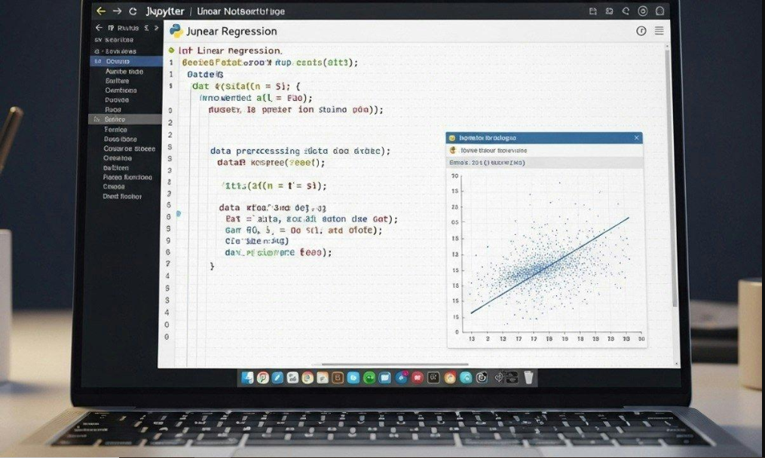
2. Machine Learning & Predictive Modeling
I develop and evaluate machine learning models that uncover patterns in data, predict future outcomes, and support smarter business decisions.
What I offer
- Predictive modeling and forecasting
- Customer churn prediction
- Customer segmentation
- Recommendation systems
- Model evaluation and performance optimization
Tools: Python, Scikit-learn, Pandas, NumPy, XGBoost

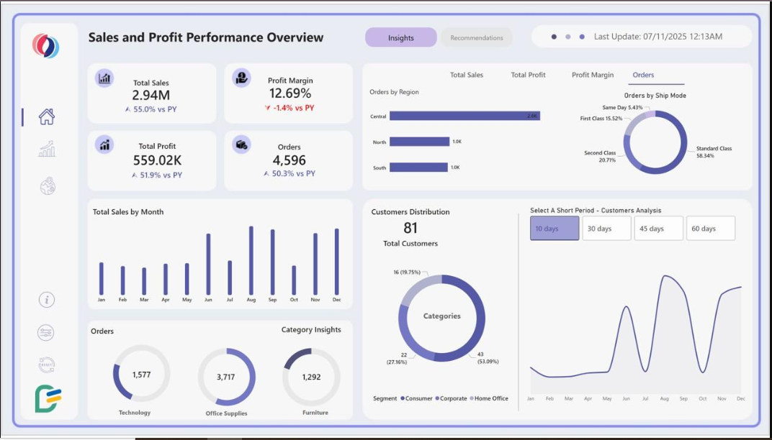
3. Data Visualization & Dashboard Development
I create clear, interactive visualizations and dashboards that turn complex datasets into actionable business insights.
What I offer
- Interactive business intelligence dashboards
- Sales and financial performance dashboards
- KPI tracking and reporting
- Trend and pattern visualization
- Data storytelling and insight presentation
Tools: Power BI, Matplotlib, Seaborn, Plotly, Excel.

