BASKETLY
Online Grocery Shopping Mobile App
Semester 5 Project Report
Details
Project Title | Basketly - Online Grocery Shopping App
Subject / Course | [Write subject name and code]
Submitted By | [Student name(s) and enrollment number(s)]
Semester | 5
Guided By | [Guide / faculty name]
College | [College name]
Academic Year | 2026 - 27

Index
No. | Topic
1 | Introduction
2 | Scope of the Project
3 | Tools and Technology Used
4 | System Architecture
5 | Modules and Features
6 | Flow Diagrams
7 | Backend Details (Database and API)
8 | Project Folder Structure
9 | Screens of the App
10 | Testing
11 | Limitations and Future Scope
12 | Conclusion
13 | References

1. Introduction
Basketly is a mobile app for buying groceries online. A customer can browse products, add them to a cart, apply a coupon, choose a delivery address and place an order. After ordering, the customer can check the order status until it is delivered.
The app is made with Flutter, so the same code runs on Android and iOS. All data such as products, cart, addresses and orders is stored on our own backend server and the app gets it through a REST API.

1.1 Problem
Going to a shop for daily items takes time. Customers also cannot check the price, discount or stock of an item before going to the shop.

1.2 Solution
Basketly shows all products with price, MRP, discount and stock in one place. The customer orders from home and the order is delivered to their address.

1.3 Objectives
- Build a simple and easy-to-use grocery shopping app.
- Allow users to register, log in and manage their profile safely.
- Show products by category with search, sort and filter options.
- Support cart, coupons, checkout and order placing.
- Let users see their past orders and track each order.
- Connect the app with a real backend server and database using REST APIs.

2. Scope of the Project
This project covers the customer mobile app and the backend API it uses.
- Customer app (this project): register, login, browse, search, wishlist, cart, coupons, address, checkout, orders and order tracking.
- Backend API: stores all data and handles login, cart, orders and payments. It also has APIs for an admin panel and a delivery partner app.
- Not included in this app: the admin panel and the delivery partner app. Their APIs are ready on the backend and can be used to build those apps later.

2.1 Users of the System
User | What they do
Customer | Uses the Basketly app to buy groceries and track orders.
Admin | Manages products, categories, coupons and orders using admin APIs.
Delivery Partner | Sees assigned orders and updates delivery status using delivery APIs.

3. Tools and Technology Used

3.1 Mobile App (Frontend)
Tool / Package | Use in the project
Flutter (Dart) | To build the app for Android and iOS from one code base
flutter_riverpod | State management (keeps data and refreshes screens)
go_router | Navigation between screens and login redirect
dio | To call the REST API (HTTP client)
flutter_secure_storage | To save the login token safely on the phone
shared_preferences | To save small data like cache and recent searches
cached_network_image | To load and cache product images
shimmer | Loading animation while data is coming
connectivity_plus | To check if the internet is on or off
intl, google_fonts | Price / date formatting and fonts
flutter_launcher_icons | To create the app icon for all platforms

3.2 Backend
Tool | Use in the project
NestJS (Node.js, TypeScript) | Backend framework used to build the REST API
SQL Database | Stores users, products, cart, orders and other data
Swagger | API documentation (grocery-api-zeta.vercel.app/api/docs)
Vercel | Cloud hosting for the backend API

3.3 Other Tools
Tool | Use
VS Code / Android Studio | Writing code and running the app
Postman | Testing the APIs
Android phone | Testing the app on a real device

4. System Architecture
The project has two parts: the Flutter mobile app and the backend server. The app sends an HTTPS request to the backend, and the backend reads or writes the database and sends back a JSON response.
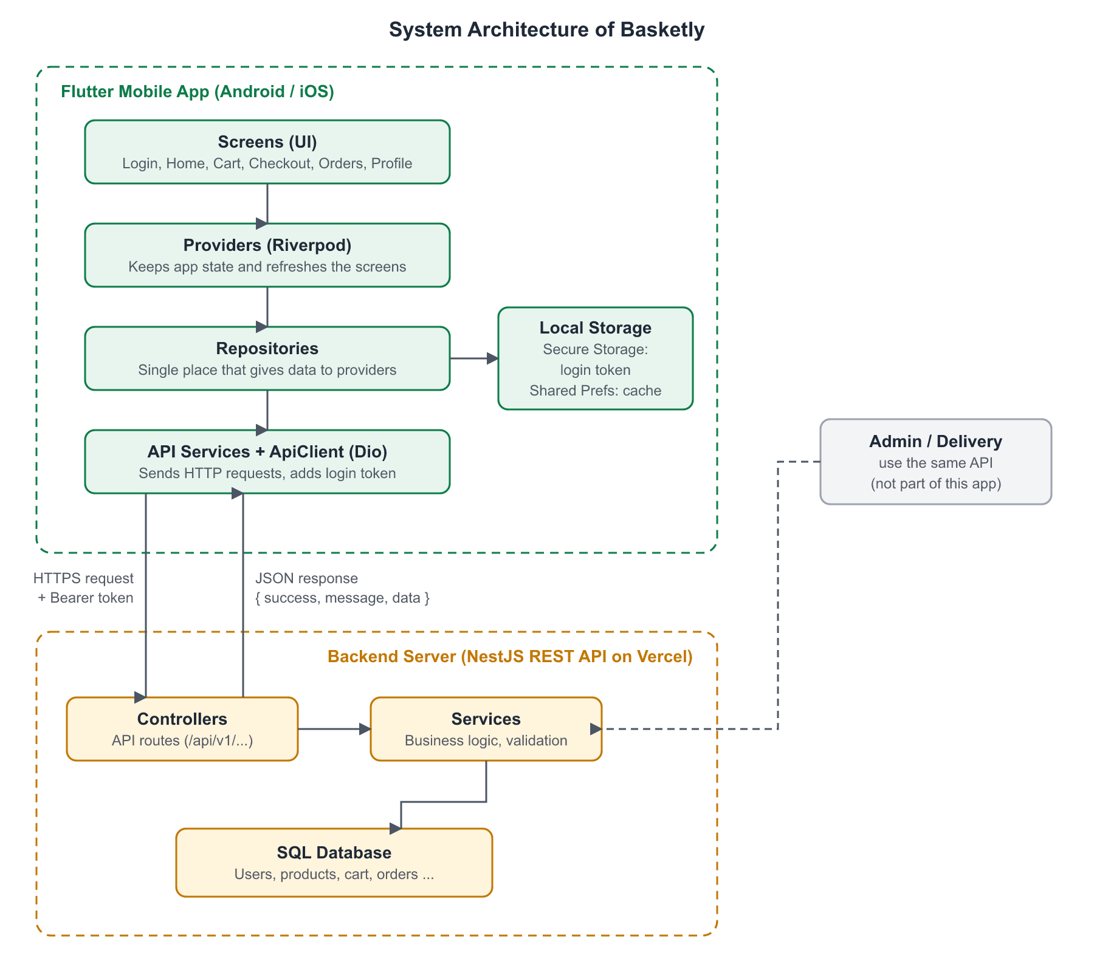
Figure 1: System architecture

4.1 Layers in the App
- Screens (UI): what the user sees, like Home, Cart and Checkout.
- Providers (Riverpod): hold the data for the screens and update them when data changes.
- Repositories: one place from where providers get data. They call the API services.
- API Services and ApiClient: make the actual HTTP calls using Dio. The ApiClient adds the login token to every request and converts errors into simple messages.
- Local storage: the login token is kept in secure storage. Categories, recently viewed items and recent searches are cached in shared preferences.
Because of these layers, a screen never talks to the server directly. This keeps the code clean and easy to change.

5. Modules and Features
Module | What the user can do
Login / Register | Create an account with OTP email verification, log in with email and password, log out
Forgot Password | Get an OTP on email, verify it and set a new password
Home | See banners, categories, deals, popular, new and featured products
Categories | See all categories and the products in each category
Product List | Sort by price, rating, newest or discount. Filter by price, brand and rating
Search | Search products by name and see recent searches
Product Details | See images, price, MRP, discount, stock, rating and description
Wishlist | Save products for later and remove them
Cart | Add items, change quantity, remove items and see the bill
Coupons | See available coupons and apply one to get a discount
Address | Add, edit and delete addresses, and set a default address
Checkout | Choose address and payment method (Cash on Delivery, UPI or Card) and place the order
My Orders | See all orders and order details, and cancel an order if allowed
Order Tracking | See the status timeline of an order from Pending to Delivered
Profile | Edit name, email and phone. See order and wishlist count
Settings | Clear saved cache, see app version and About page
Offline support | Shows a message when the internet is off and uses saved data where possible

Note: The notification screen is built but hidden for now. Online payment (UPI / Card) needs a payment gateway to be set up on the server, so Cash on Delivery is used for testing.

6. Flow Diagrams

6.1 App Navigation Flow
When the app opens, it checks if the user is already logged in. A logged-in user goes straight to the Home screen. A new user sees the onboarding screens and then the login screen.
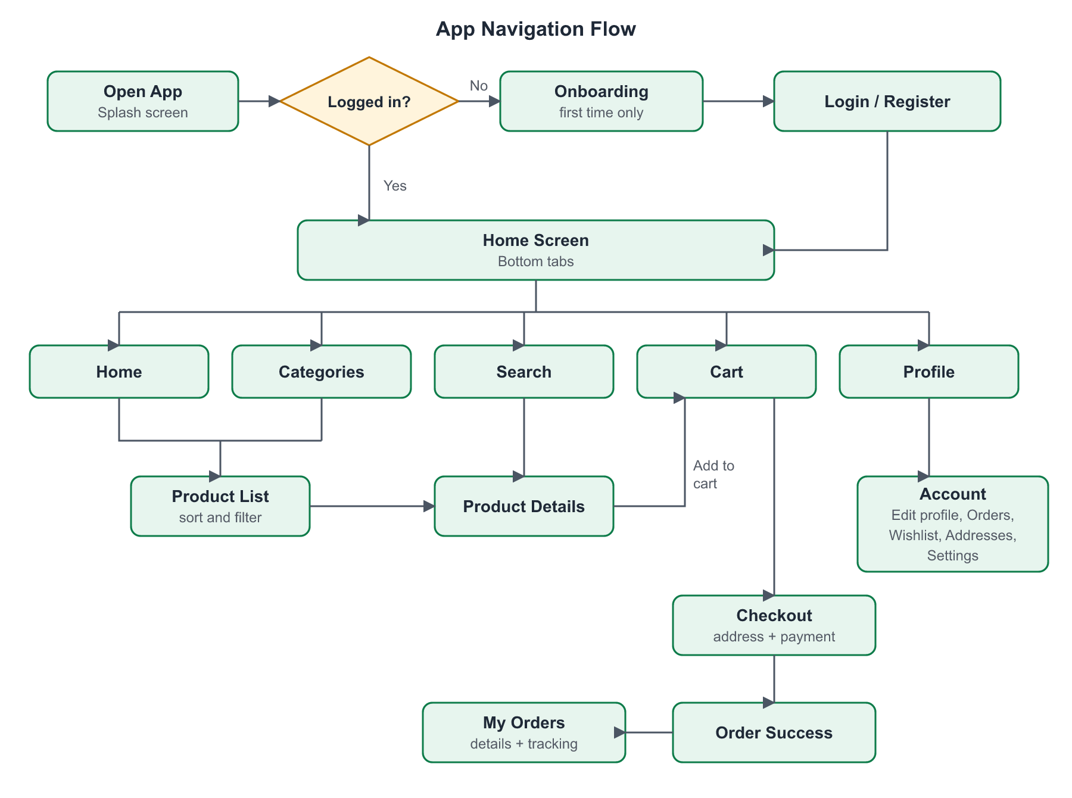
Figure 2: App navigation flow

6.2 Login, Register and Forgot Password Flow
A new user registers and verifies the email with an OTP. After a successful login or registration, the server gives a token which the app saves and sends with every request.
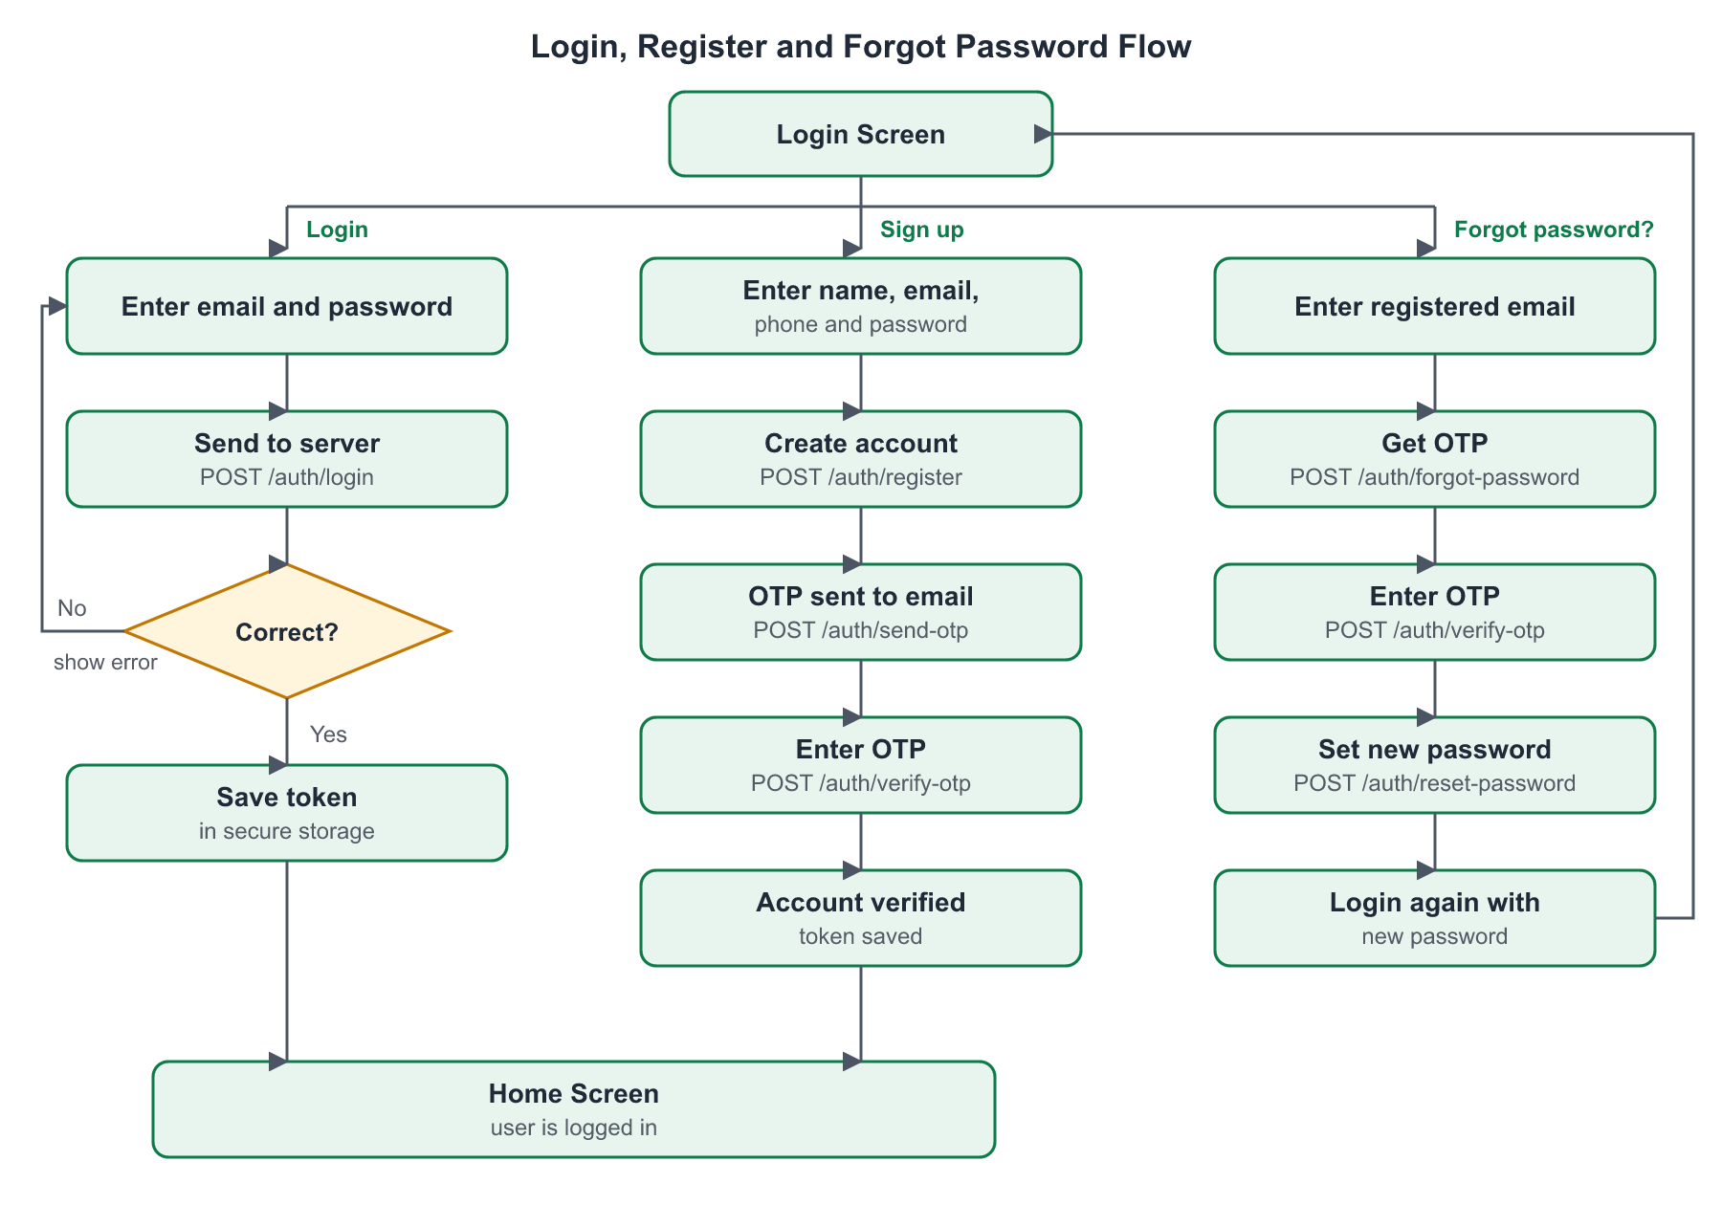
Figure 3: Login, register and forgot password flow

6.3 Order Placing Flow
The user adds products to the cart, picks an address and payment method, and places the order. The server calculates the final price, so the app never decides the price by itself.
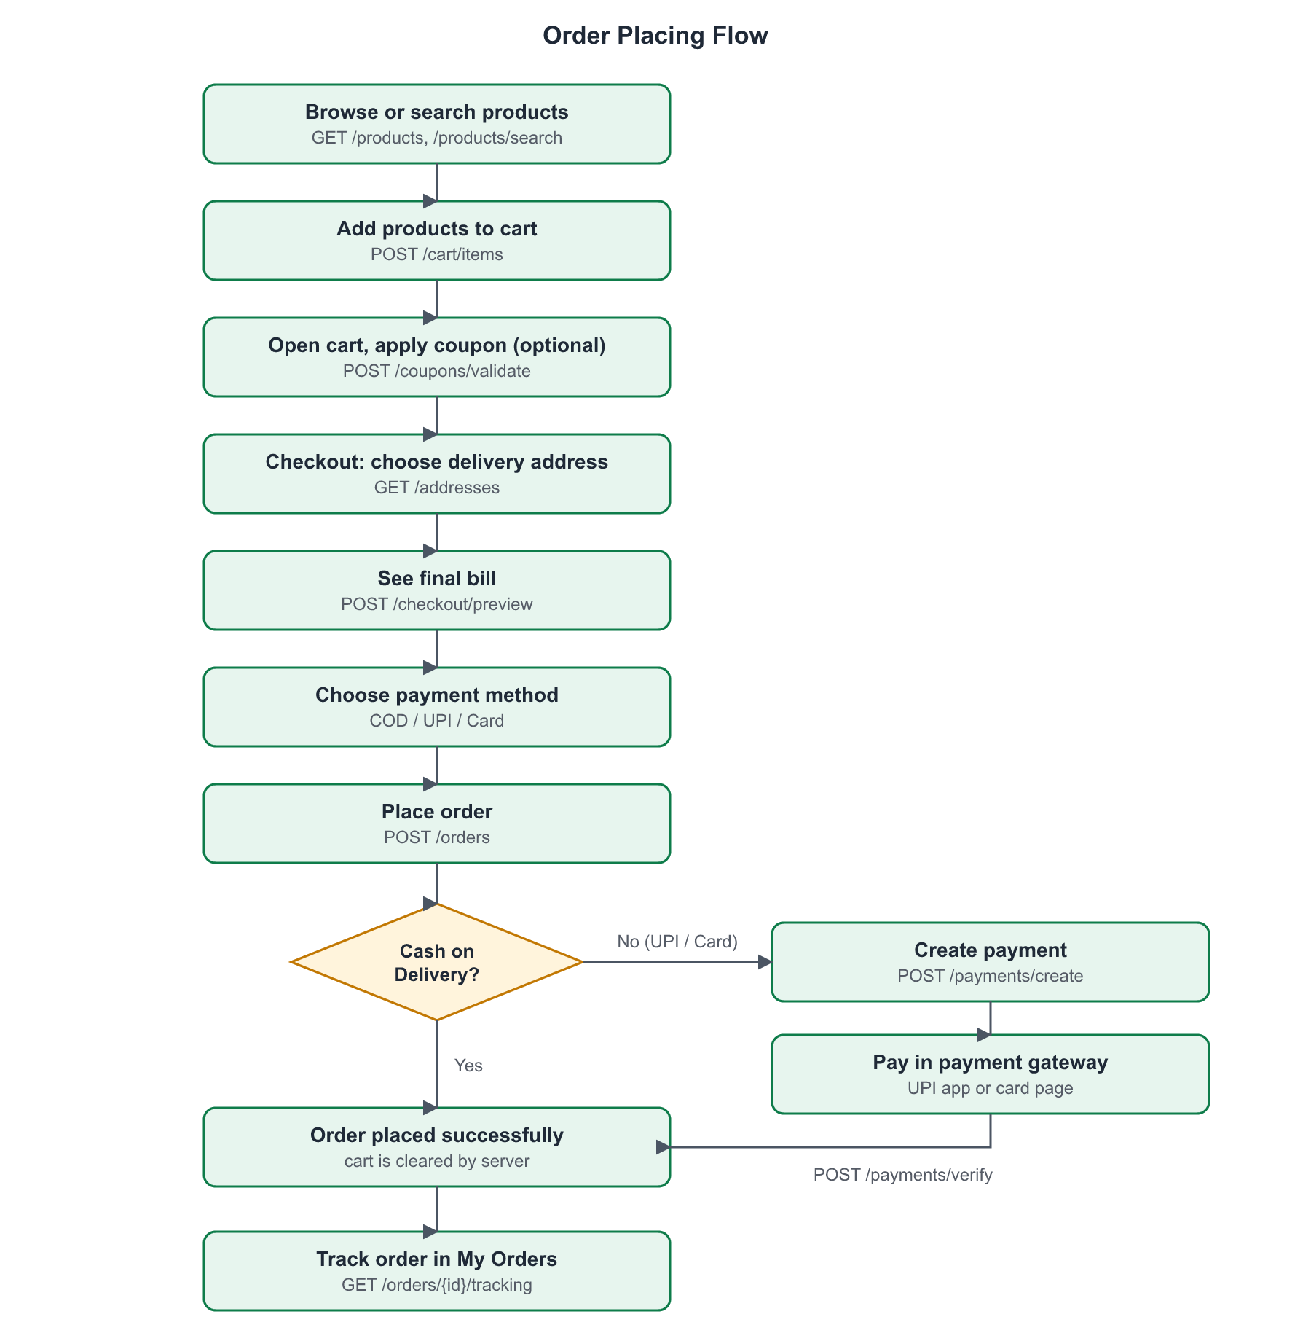
Figure 4: Order placing flow

6.4 Order Status Flow
Every order moves through these statuses. The customer sees them on the Order Tracking screen.
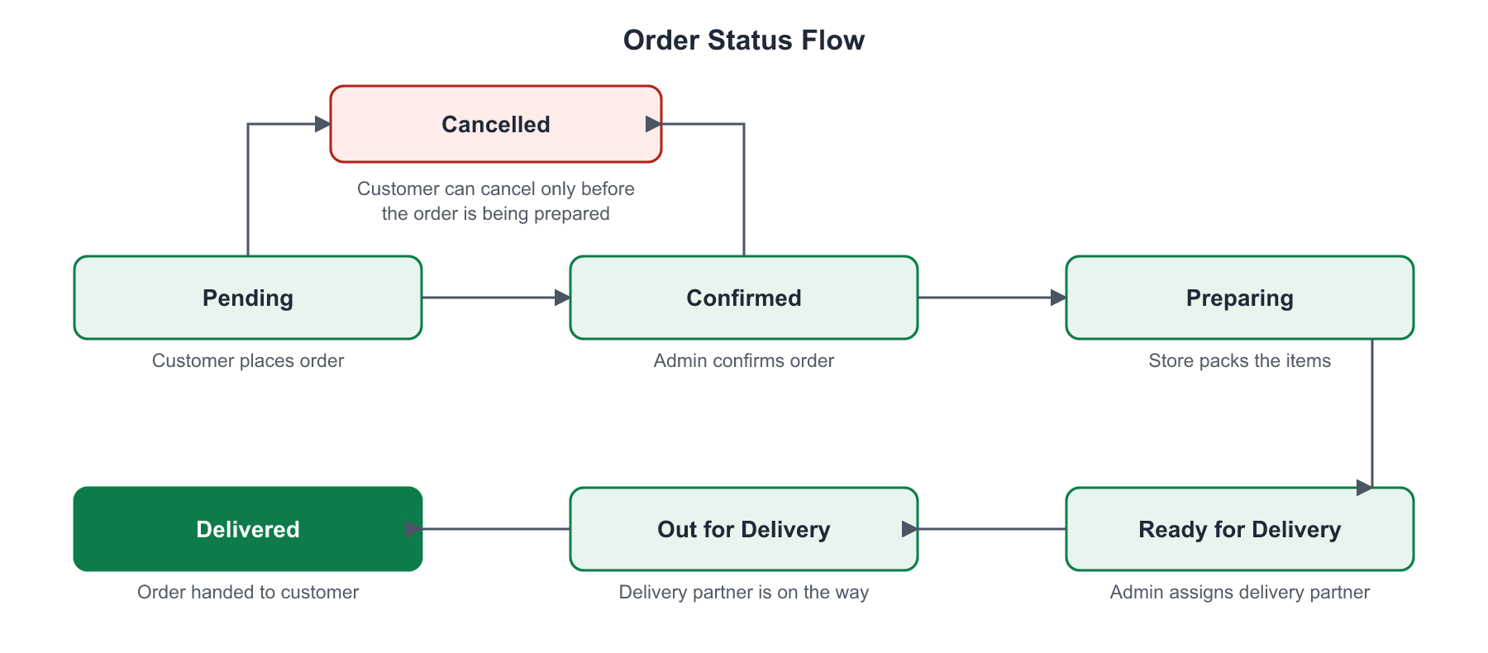
Figure 5: Order status flow

7. Backend Details

7.1 Overview
- Base URL: https://grocery-api-zeta.vercel.app/api/v1
- API documentation (Swagger): https://grocery-api-zeta.vercel.app/api/docs
- Data format: JSON for request and response. Image upload uses multipart form data.
- Login security: after login the server returns a token. The app sends it in every request as "Authorization: Bearer <token>". Passwords are stored in hashed form, never as plain text.
- Pagination: list APIs accept page and per_page, and return items with a pagination object.

7.2 Response Format
Every API returns the same format, so the app can handle all responses in one place.
Success response:
{
"success": true,
"message": "Login successful",
"data": {
"user": {
"id": 2,
"name": "Priya S.",
"email": "customer@grocery.test",
"role": "customer"
},
"token": "514c7f12...b7b0a"
}
}
Error response:
{
"success": false,
"message": "Validation failed",
"code": "VALIDATION_ERROR",
"errors": {
"email": ["The email must be a valid email address."]
}
}
List response (with pagination):
"data": {
"items": [
{ "id": 14, "name": "Lays Classic Salted", "price": 20 },
...
],
"pagination": {
"current_page": 1, "per_page": 20,
"total": 24, "last_page": 2
}
}

7.3 Database Structure
The backend uses a relational (SQL) database. The main tables and how they are linked are shown below.
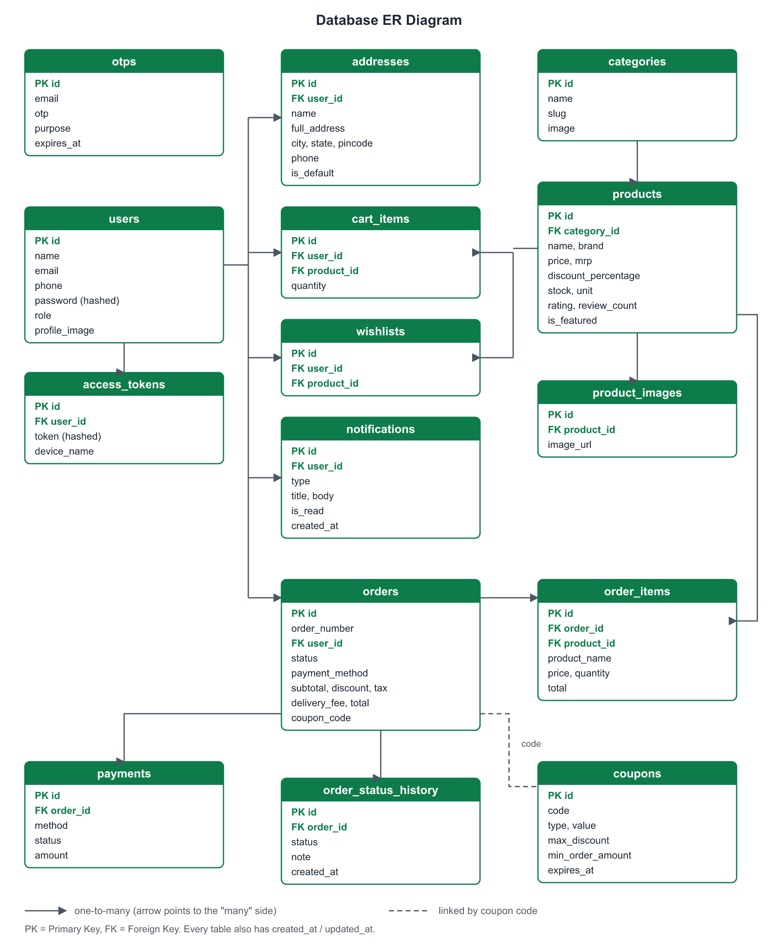
Figure 6: Database ER diagram

7.4 Table Details
1. users - Stores all users: customers, admins and delivery partners.
Column | Type | Description
id | INT (PK) | Unique user id
name | VARCHAR | Full name
email | VARCHAR (unique) | Login email
phone | VARCHAR | Mobile number
password | VARCHAR | Hashed password
role | ENUM | customer / admin / delivery
profile_image | VARCHAR | Profile photo URL
email_verified_at | TIMESTAMP | When the email was verified
created_at, updated_at | TIMESTAMP | Record dates
2. access_tokens - Login tokens. One user can be logged in on many devices.
Column | Type | Description
id | INT (PK) | Token id
user_id | INT (FK) | Owner of the token (users.id)
token | VARCHAR | Hashed token
device_name | VARCHAR | Device that logged in
created_at | TIMESTAMP | Login time
3. otps - One-time passwords for email verification and password reset.
Column | Type | Description
id | INT (PK) | OTP id
email | VARCHAR | Email the OTP was sent to
otp | VARCHAR | Hashed OTP code
purpose | ENUM | verification / password_reset
expires_at | TIMESTAMP | OTP is valid for 10 minutes
4. categories - Product categories like Fruits and Vegetables, Dairy and Eggs.
Column | Type | Description
id | INT (PK) | Category id
name | VARCHAR | Category name
slug | VARCHAR | Name used in URLs
description | TEXT | Short description
image | VARCHAR | Category image URL
5. products - All products sold in the app.
Column | Type | Description
id | INT (PK) | Product id
category_id | INT (FK) | Category of the product
name, slug | VARCHAR | Product name
brand | VARCHAR | Brand name
description | TEXT | Product details
price | DECIMAL | Selling price
mrp | DECIMAL | Maximum retail price
discount_percentage | INT | Discount on MRP
unit | VARCHAR | Pack size, e.g. 500 ml
stock | INT | Quantity available
rating, review_count | DECIMAL, INT | Customer rating
is_featured | BOOLEAN | Show in Featured list
6. product_images - Images of a product (a product can have many).
Column | Type | Description
id | INT (PK) | Image id
product_id | INT (FK) | Product (products.id)
image_url | VARCHAR | Image link
7. wishlists - Products saved by a user.
Column | Type | Description
id | INT (PK) | Row id
user_id | INT (FK) | User
product_id | INT (FK) | Saved product
8. cart_items - Products in a user's cart.
Column | Type | Description
id | INT (PK) | Cart item id
user_id | INT (FK) | Owner of the cart
product_id | INT (FK) | Product in cart
quantity | INT | How many
9. addresses - Delivery addresses of a user.
Column | Type | Description
id | INT (PK) | Address id
user_id | INT (FK) | Owner
name | VARCHAR | Label like Home or Work
full_address | VARCHAR | House, street and area
city, state, pincode | VARCHAR | Location details
phone | VARCHAR | Contact number
latitude, longitude | DECIMAL | Map location (optional)
is_default | BOOLEAN | Default delivery address
10. coupons - Discount coupons like SAVE10.
Column | Type | Description
id | INT (PK) | Coupon id
code | VARCHAR (unique) | Code the user enters
description | VARCHAR | Offer text
type | ENUM | percentage / flat
value | DECIMAL | Percent or amount off
max_discount | DECIMAL | Maximum discount
min_order_amount | DECIMAL | Minimum cart total
starts_at, expires_at | TIMESTAMP | Valid dates
11. orders - Orders placed by customers.
Column | Type | Description
id | INT (PK) | Order id
order_number | VARCHAR | e.g. ORD20260930664429
user_id | INT (FK) | Customer
status | ENUM | pending, confirmed, preparing, ready_for_delivery, out_for_delivery, delivered, cancelled
payment_method | ENUM | cod / upi / card
payment_status | ENUM | pending / paid / failed / refunded
subtotal, discount, coupon_discount | DECIMAL | Price details
delivery_fee, tax, total | DECIMAL | Final bill
coupon_code | VARCHAR | Coupon used, if any
shipping_address | JSON | Copy of the address at order time
delivery_partner_id | INT (FK) | Assigned delivery partner (users.id)
notes, cancel_reason | TEXT | Extra info
cancelled_at, delivered_at | TIMESTAMP | Important dates
12. order_items - Products inside an order.
Column | Type | Description
id | INT (PK) | Row id
order_id | INT (FK) | Order
product_id | INT (FK) | Product
product_name, product_image, unit | VARCHAR | Copy of product details at order time
price, mrp | DECIMAL | Price at order time
quantity | INT | How many
total | DECIMAL | price x quantity
13. order_status_history - Every status change of an order, used for tracking.
Column | Type | Description
id | INT (PK) | Row id
order_id | INT (FK) | Order
status | ENUM | New status
note | VARCHAR | e.g. "Order placed"
created_at | TIMESTAMP | Time of change
14. payments - Payment record for each order.
Column | Type | Description
id | INT (PK) | Payment id
order_id | INT (FK) | Order
method | ENUM | cod / upi / card
status | ENUM | pending / paid / failed
amount | DECIMAL | Amount to pay
gateway_order_id, gateway_payment_id | VARCHAR | Ids from the payment gateway
paid_at | TIMESTAMP | Payment time
15. notifications - Messages for users, like "Order delivered".
Column | Type | Description
id | INT (PK) | Notification id
user_id | INT (FK) | User
type | VARCHAR | e.g. order_delivered
title, body | VARCHAR, TEXT | Message
data | JSON | Extra data like order_id
is_read, read_at | BOOLEAN, TIMESTAMP | Read status

7.5 Relationships
- One user can have many addresses, cart items, wishlist items, orders and notifications.
- One category has many products. One product has many images.
- One order has many order items and many status history rows, and one payment.
- Order items keep a copy of the product name and price, so old orders do not change if the product price changes later.
- Orders store a copy of the delivery address for the same reason.

7.6 Business Rules on the Server
- Delivery fee is Rs. 30. Delivery is free when the cart value is above Rs. 499.
- Tax is 5% of the amount after discounts.
- A coupon works only if the cart total is above its minimum order amount. The discount cannot go above max_discount.
- The server checks stock and price again when the order is placed, so the app cannot send a wrong price.
- An order can be cancelled by the customer only before it is being prepared (the server sends can_cancel).
- The cart is cleared after an order is placed successfully.

7.7 API List (used by the app)
All paths start with the base URL /api/v1. "Yes" in the Login column means the request needs the Bearer token.
Authentication
Method | Endpoint | Purpose | Login
POST | /auth/register | Create a new account | No
POST | /auth/login | Login with email and password, returns token | No
POST | /auth/send-otp | Send OTP to email | No
POST | /auth/verify-otp | Verify the OTP | No
POST | /auth/forgot-password | Send OTP to reset password | No
POST | /auth/reset-password | Set a new password | No
GET | /auth/me | Get logged-in user details | Yes
POST | /auth/logout | Logout (token is removed) | Yes
User Profile
Method | Endpoint | Purpose | Login
GET | /user/profile | Get profile | Yes
PUT | /user/profile | Update name, email and phone | Yes
POST | /user/profile-image | Upload profile photo | Yes
PUT | /user/change-password | Change password | Yes
Categories and Products
Method | Endpoint | Purpose | Login
GET | /categories | List all categories | No
GET | /categories/{id}/products | Products of a category (sort, filter, page) | No
GET | /products | List all products | No
GET | /products/featured | Featured products | No
GET | /products/popular | Popular products | No
GET | /products/latest | New arrivals | No
GET | /products/deals | Deals of the day | No
GET | /products/search?q= | Search products by name | No
GET | /products/{id} | Product details | No
Wishlist
Method | Endpoint | Purpose | Login
GET | /wishlist | Get wishlist | Yes
POST | /wishlist | Add product to wishlist | Yes
DELETE | /wishlist/{product_id} | Remove product from wishlist | Yes
Cart, Coupons and Checkout
Method | Endpoint | Purpose | Login
GET | /cart | Get cart with bill summary | Yes
POST | /cart/items | Add product to cart | Yes
PUT | /cart/items/{item_id} | Change quantity | Yes
DELETE | /cart/items/{item_id} | Remove item | Yes
DELETE | /cart | Clear cart | Yes
GET | /coupons | List available coupons | Yes
POST | /coupons/validate | Check a coupon and get discount | Yes
POST | /checkout/preview | Final bill for address and coupon | Yes
Addresses
Method | Endpoint | Purpose | Login
GET | /addresses | List addresses | Yes
POST | /addresses | Add address | Yes
PUT | /addresses/{id} | Edit address | Yes
DELETE | /addresses/{id} | Delete address | Yes
PATCH | /addresses/{id}/default | Set default address | Yes
Orders and Payments
Method | Endpoint | Purpose | Login
POST | /orders | Place an order | Yes
GET | /orders | List my orders | Yes
GET | /orders/{id} | Order details | Yes
GET | /orders/{id}/tracking | Order status timeline | Yes
POST | /orders/{id}/cancel | Cancel order | Yes
POST | /payments/create | Start online payment | Yes
POST | /payments/verify | Verify online payment | Yes
Notifications (hidden in app for now)
Method | Endpoint | Purpose | Login
GET | /notifications | List notifications | Yes
PATCH | /notifications/{id}/read | Mark one as read | Yes
PATCH | /notifications/read-all | Mark all as read | Yes

7.8 Other APIs on the Backend
These APIs are for the admin panel and delivery partner app. They are not used in the customer app but are ready on the server.
Group | Main endpoints | Purpose
Admin | /admin/login, /admin/dashboard | Admin login and dashboard numbers
Admin | /admin/products, /admin/categories, /admin/coupons | Add, edit, delete products, categories and coupons; upload images; update stock
Admin | /admin/orders, /admin/orders/{id}/status, /admin/orders/{id}/assign | See orders, change status, assign delivery partner
Admin | /admin/users, /admin/delivery-partners | See customers and delivery partners
Admin | /admin/reports/sales, orders, products, customers | Reports between two dates
Delivery | /delivery/login, /delivery/orders | Delivery partner login and assigned orders
Delivery | /delivery/orders/{id}/status, /delivery/location | Update delivery status and live location
Health | /health | Check that the server and database are running

8. Project Folder Structure
The Flutter code is inside the lib folder and is divided by its job:
lib/
main.dart, app.dart -> app start point
core/ -> config, colors, ApiClient, router
models/ -> User, Product, Cart, Order, Address
services/api/ -> one API service per module
repositories/ -> get data from API services
providers/ -> Riverpod state of each module
screens/ -> all screens (home, cart, orders)
widgets/ -> reusable widgets (cards, buttons)
assets/icon/ -> app icon files
The app also has a demo mode (mock repositories) that works without the server. It is turned on with USE_MOCK=true while building the app.

9. Screens of the App
No. | Screen | Purpose
1 | Splash | App logo while checking login
2 | Onboarding | Short intro shown the first time
3 | Login | Login with email and password
4 | Register | Create a new account
5 | OTP Verification | Enter the OTP sent on email
6 | Forgot / Reset Password | Reset a forgotten password
7 | Home | Banners, categories and product lists
8 | Categories | All categories
9 | Product Listing | Products with sort and filter
10 | Product Details | Full product information
11 | Search | Search products
12 | Wishlist | Saved products
13 | Cart | Cart items, coupon and bill
14 | Checkout | Address, payment method and place order
15 | Payment | Online payment step
16 | Order Success | Confirmation after placing an order
17 | My Orders | List of orders
18 | Order Details / Tracking | Items, bill and status timeline
19 | Address List / Address Form | Manage delivery addresses
20 | Profile / Edit Profile | User details
21 | Settings / Info pages | Cache, About, Help, Privacy, Terms

[Add screenshots of the main screens here: Home, Product Details, Cart, Checkout, My Orders, Order Tracking.]

10. Testing
The app was tested on a real Android 13 phone with the live backend. The APIs were also tested separately.
No. | Test case | Expected result | Result
1 | Login with correct email and password | User goes to Home screen | Pass
2 | Login with wrong password | Shows "Invalid credentials" | Pass
3 | Register with wrong email format | Shows validation error under the field | Pass
4 | Open app with an expired token | User is sent back to the login screen | Pass
5 | Sort products by price (low to high) | Cheapest product comes first | Pass
6 | Filter by brand and price | Only matching products are shown | Pass
7 | Search "milk" | Milk products are shown | Pass
8 | Add to cart and change quantity | Cart total updates correctly | Pass
9 | Apply coupon SAVE10 | Discount is added to the bill | Pass
10 | Add, edit and delete an address | Address list updates | Pass
11 | Place order with Cash on Delivery | Order is placed and cart is cleared | Pass
12 | Cancel a pending order | Status changes to Cancelled | Pass
13 | Open order tracking | Status timeline is shown | Pass
14 | Pay with UPI / Card | Payment screen opens | Needs gateway setup on server

11. Limitations and Future Scope

11.1 Limitations
- Online payment (UPI / Card) needs a payment gateway like Razorpay to be set up on the server.
- Uploaded images (like profile photos) need cloud storage, because the hosting server does not keep uploaded files.
- Notifications are hidden in the app for now.
- The admin panel and delivery partner app are not built yet (only their APIs are ready).

11.2 Future Scope
- Add Razorpay payment gateway for UPI and card payments.
- Add push notifications for order updates.
- Build an admin web panel and a delivery partner app using the existing APIs.
- Live location tracking of the delivery partner on a map.
- Product reviews and ratings by customers.
- Voice search and multiple language support.

12. Conclusion
Basketly is a working online grocery shopping app built with Flutter and connected to a NestJS REST API with a SQL database. A user can register, browse products, manage the cart, apply coupons, place orders and track them.
While making this project we learned how a mobile app talks to a backend using REST APIs, how to design a database with related tables, how to manage state with Riverpod, and how to keep user data safe using tokens and hashed passwords.

13. References
- Flutter documentation - https://docs.flutter.dev
- Dart language - https://dart.dev
- Riverpod - https://riverpod.dev
- Dio package - https://pub.dev/packages/dio
- go_router package - https://pub.dev/packages/go_router
- NestJS documentation - https://docs.nestjs.com
- Project API documentation (Swagger) - https://grocery-api-zeta.vercel.app/api/docs

