**INTEGER IN AN RANGE**

**FLOW CHART**

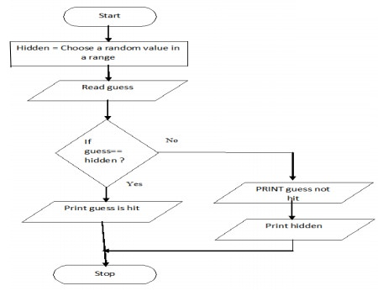

**PROGRAM**

BEGIN

COMPUTE hidden=random value in range

READ guess

IF guess=hidden, then

PRINT Guess is hit

ELSE

PRINT Guess not hit

PRINT hidden

END IF-ELSE

END