**TOWER OF HANOI**

**FLOW CHART**

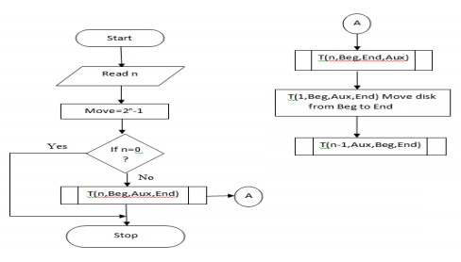

**PROGRAM**

BEGIN

READ n

CALCULATE move=pow(2,n)-1

FUNCTION T(n,Beg,Aux,End) Recursiv ly until n=0

PROCEDURE

IF n=0 then,

No disk to move

Else

T(n-1,Beg,End,Aux)

T(1,Beg,Aux,End), move  isk from source to destination

T(n-1,Aux,Beg,En )

END PROCEDURE

END